**LINES AND ANGLES**

**Basic terms in Geometry:**

**Point:**

* The geometrical figure which has no parts is a ‘Point’.
* The points are represented by capital letters in English Alpha beta.

.A

.B .C

**Line:**

* A line is breathless length.
* A line is set of infinitely many points.
* Line AB is denoted by AB
* A line can be extended in both directions endlessly.
* Line AB can also written as line BA
* A line has no definite length.
* We will give the name to a line in two ways. They are (i) by taking two points on the line (ii) by small letters.(l, m, n ….)

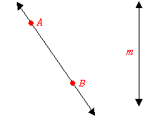

**Ray:**

* A ray is a part of a line having one end point.
* The ray AB is denoted by AB.
* A ray can be extended in only one direction.
* A ray has no definite length.
* The ray AB means it starts from the point A and passes in the direction of the point B.
* The ray BA means it starts from the point B and passes in the direction of the point A
* The ray AB is not same as the ray BA.

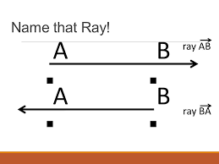

**Line segment:**

* The part of the line having two end points is called ‘line segment’.
* The line segment AB is denoted by AB.
* Á line segment has definite length.
* The length of the line is denoted by AB.
* The line segment AB is same as line segment BA.

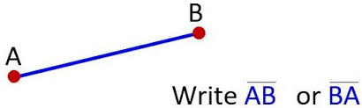

* If a line segment have ‘n’ points on it, then total number of line segments formed is $\frac{n(n-1)}{2}$.

**Collinear points:**

* If three or more points lies on a same line, then they are called ‘Collinear Points’.

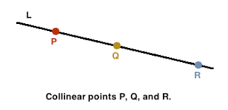

* If P,Q and R are collinear points, then PQ + QR = PS.
* We can’t draw a triangle through 3 collinear points.

**Parallel lines and Intersecting lines:**

* If two lines have no common points, then they are said to be as ‘Parallel lines’.
* If two lines have a common point, then they are said to be as ‘Intersecting lines’.

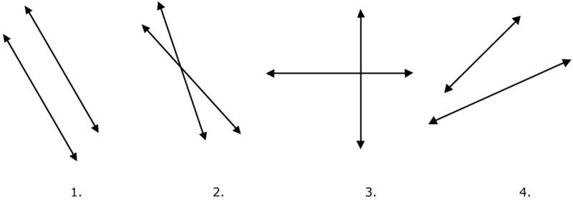

* The lines which are parallel to same line are parallel to each other.

If l ‖ n and m ‖ n then l ‖ m.

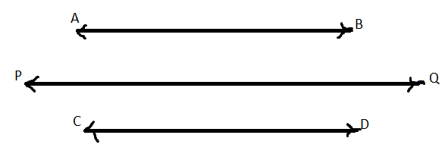

* The lines which are perpendicular to same line are parallel to each other.

If $l ⊥n and m ⊥n then l ∥m.$

**Angle:**

* The figure formed by two rays having a common initial point is called ‘Angle’.

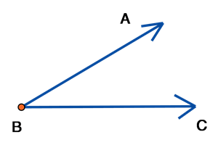

* An angle is represented by the symbol ∠. Here, the angle in the above is ∠AOB.
* The common point is called ‘Vertex’ and the rays are called ‘Arms of the angle’.
* The change of a ray from initial position to terminal position around the fixed point is called ‘Rotation’ and the measure of rotation is called ‘Angle’.

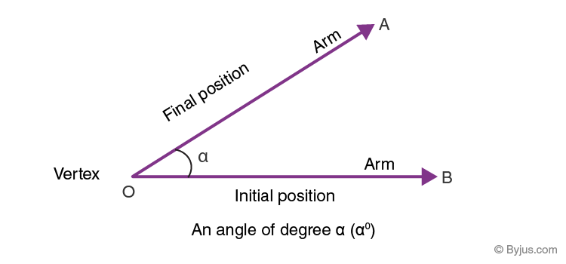

* The unit to measure angle is ‘Degree’.
* The 360th part of a complete rotation is called ‘Degree’.
* One complete rotation gives 3600 angle.
* Different amounts of rotation form different angles.

|  |  |  |
| --- | --- | --- |
| **Type of angle** | **Measure**  **of angle** | **Example** |
| Zero angle | 00 |  |
| Acute angle | 00 < A0 < 900 |  |
| Right angle | 900 |  |
| Obtuse angle | 900 < B0 < 1800 |  |
| Straight angle | 1800 | C:\Users\praka\AppData\Local\Microsoft\Windows\INetCache\Content.MSO\F4D1C85E.tmp |
| Reflex angle | 1800 < C0 < 3600 |  |
| Complete angle | 3600 | Angles: Types | Acute Angle | Complementary | Obtuse - Cuemath |

Difference between zero angle and complete angle:

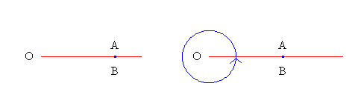

**Pair of angles:**

* The angles having a common vertex and a common arm are called ‘**Adjacent angles**’.

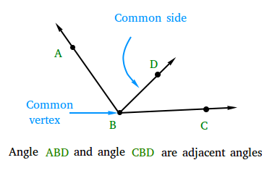

* The adjacent angles whose sum is 1800 are called ‘**Linear pair angles**’.

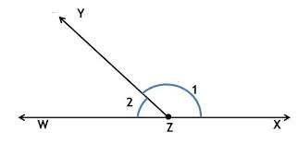

* When two lines intersected, then the pair of angles having common vertex and not having common arm are called ‘**vertically opposite angles’**.

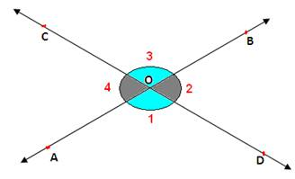

Vertically opposite angles are always equal.

* If sum of two angles is 900, then the two angles are called ‘**Complementary angles**’.

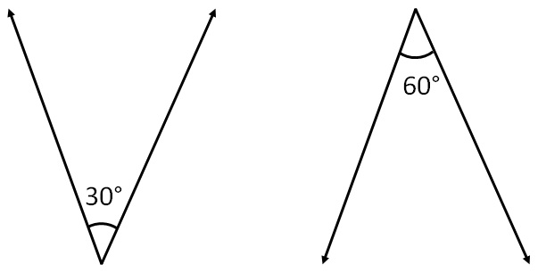

1. Complementary angles are acute angles.
2. A right angle is not complementary angle.
3. If two complementary angles are equal, each angle is 450.
4. The complementary angle of x0 is (90 – x)0.

* If sum of two angles is 1800, then the two angles are called ‘**Supplementary angles’**.

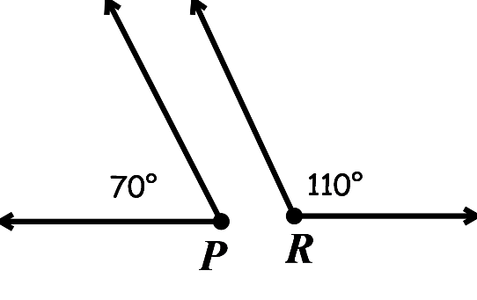

1. Two acute angles never be supplementary.
2. Two obtuse angles never be supplementary.
3. Two right angles are supplementary.
4. The supplementary angle of acute angle is obtuse angle.
5. The supplementary angle of obtuse angle is acute angle.
6. If two supplementary angles are equal, then each angle is 900
7. The supplementary angle of x0 is (180 – x)0.‑

* If the sum of two angles is 3600, then the two angles are called ‘**Conjugate angles**’.

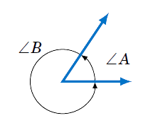

1. Two acute angles never conjugate.
2. Two obtuse angles never conjugate.
3. Two right angles never conjugate.
4. Two straight angles are conjugate.
5. Two reflex angles never conjugate.
6. The conjugate angle of an acute angle is reflex angle.
7. The conjugate angle of a right angle is also reflex angle.(2700)
8. The conjugate angle of an obtuse angle is also reflex angle.
9. The conjugate angle of a straight angle is straight angle.
10. The conjugate angle of a reflex angle is may be obtuse or right or acute.
11. Two conjugate angles are equal then each angle is 1800.
12. The conjugate angle of x0 is (360– x)0.

**Two lines and a transversal:**

* The line which intersect the given two lines at distant points is called ‘**Transversal** of the two lines’.

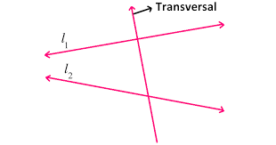

* If a transversal intersects two lines, then 8 angles will form. In them 4 are interior angles and remaining 4 are exterior angles.

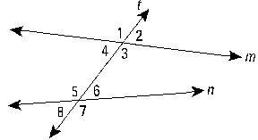

The angles 1, 2, 7, 8 are exterior angles and the angles 3, 4, 5, 6 are interior angles.

* These angles divided into some pair of angles. They are

1. Corresponding angles
2. Alternate interior angles
3. Alternate exterior angles
4. Co-interior angles
5. Co-exterior angles

* When a transversal intersects two lines, then the pair of angles which satisfies the following are called ‘**Corresponding angles**’.

1. One is interior angle and the other is exterior angle
2. Both are on the same side of the transversal
3. Both are not adjacent angles.

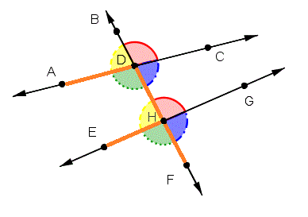

There are 4 pairs of corresponding angles.

* When a transversal intersects two lines, then the pair of angles which satisfies the following are called ‘**Alternate interior angles**’.

1. Both are interior angles
2. Both are on either side of the transversal
3. Both are not adjacent angles.

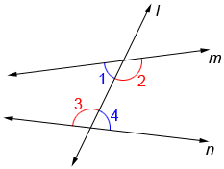

There are 2 pairs of alternate interior angles.

* When a transversal intersects two lines, then the pair of angles which satisfies the following are called ‘**Alternate exterior angles**’.

1. Both are exterior angles
2. Both are on either side of the transversal
3. Both are not adjacent angles.

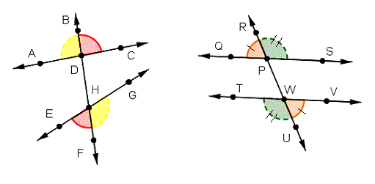

There are two pairs of alternate exterior angles.

* When a transversal intersects two lines, then the pair of interior angles which are on the same side of the transversal are called ‘**Co-interior angles or Consecutive interior angles or Allied interior angles**’.

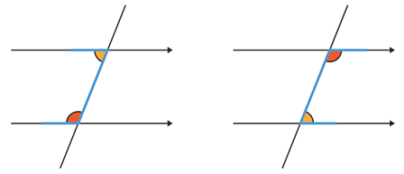

There are 2 pairs of co-interior angles.

* When a transversal intersects two lines, then the pair of exterior angles which are on the same side of the transversal are called ‘**Co-exterior angles or consecutive exterior angles or Allied exterior angles’**.

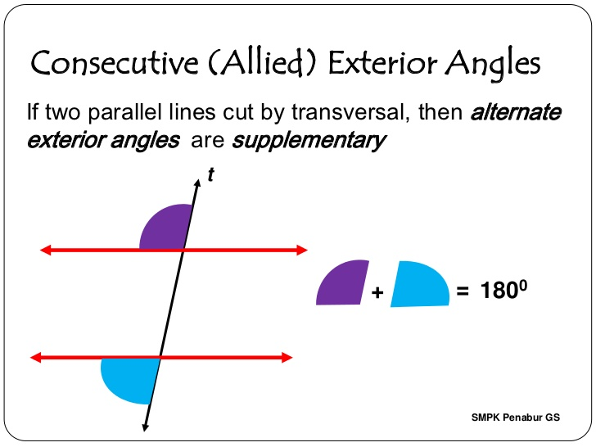

There are two pairs of co-exterior angles.

**Two parallel lines and a transversal:**

* If a transversal intersects two parallel lines, then

1. Corresponding angles are equal.
2. Alternate interior angles are equal.
3. Alternate exterior angles are equal.
4. Co-interior angles are supplementary.
5. Co-exterior angles are supplementary.

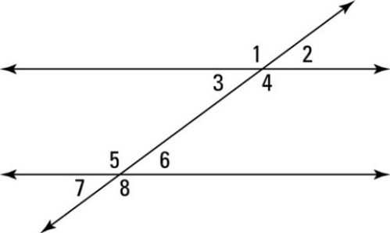

Corresponding angles : (∠1=∠5, ∠2=∠6, ∠3=∠7, ∠4=∠8)

Alternate interior angles: (∠3 = ∠6, ∠4 = ∠5)

Alternate exterior angles: (∠2 = ∠7, ∠1 = ∠8)

Co-interior angles : (∠3 + ∠5 = 1800, ∠4 + ∠6 = 1800)

Co-exterior angles : (∠1 + ∠7 = 1800, ∠2 + ∠8 = 1800)

* The converse of the above statement is also true. It means, if (i) corresponding angles are equal or

(ii) alternate interior angles are equal or

(iii) alternate exterior angles are equal or

(iv) co-interior angles are supplementary or

(v) co-exterior angles are supplementary, then the two lines are parallel to each other.

**Angles of a triangle:**

* A triangle has three interior angles.
* Sum of the three interior angles of a triangle is 1800 or two right angles.

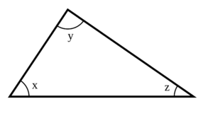

∠x + ∠y + ∠z = 1800

* A triangle can have only one right angle and the remaining angles are acute and complementary angles.
* A triangle can have only one obtuse angle and the remaining angles are acute angles.
* A triangle can have at least two acute angles.
* A triangle has three exterior angles.

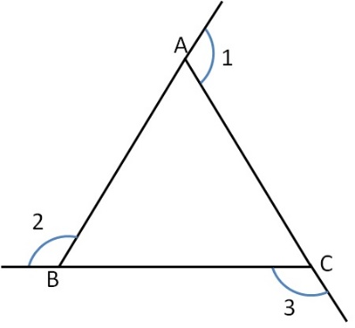

* Sum of the three exterior angles of a triangles is 3600

∠1 + ∠2 + ∠3 = 3600

* The exterior angle of a triangle is equal to sum of the interior opposite angles.

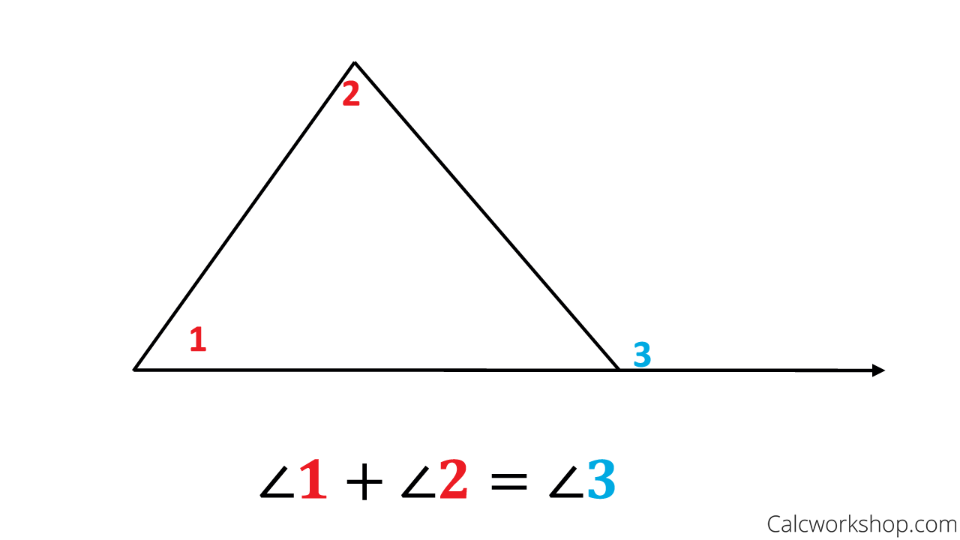

* Every exterior angle is greater than its interior opposite angles.

∠3 > ∠1 and ∠3 > ∠2 in the above diagram.