**Half mark and one-mark questions**

1. Write the complementary and supplementary angles of the angle 360?
2. What is the angle between two hands of a clock at 4.20 PM?
3. What is the supplementary angle of the complementary angle of 720?
4. Define ‘degree’?
5. If ∠POQ = 1380, find reflex ∠POQ?
6. If a line have 6 points on it, then how many total number of line segments will form by them?
7. If the lines l, m and n have a common point, then what can you say about the lines?
8. Are the following angles adjacent angles? Why?

1. If two complementary angles are in the ratio 1: 2, find the angles?
2. Raffi said, “Vertically opposite angles are adjacent angles”. Do you agree with him? Justify?
3. From the following figure, find the value of ‘x’?

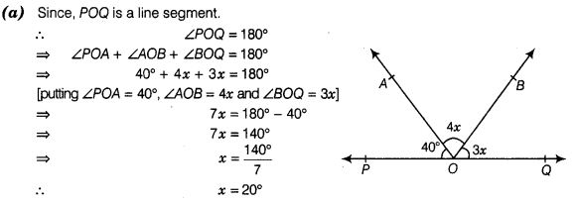

1. What happens to the measure of angle after the extension of its arms?
2. Double B) Triples C) remains same D) can’t say
3. The measure of an angle is four times to the measure of its supplementary angle. Find the angle?
4. If OP is a ray standing on the line QR at the point ‘O’. if ∠POQ = ∠POR, then find the measure of angle ∠POQ?
5. The exterior angle of a triangle is 1240. And the both interior opposite angles are equal. Find the angles?
6. If one of the three angles of a triangle is equal to sum of the other two angles, then find the angle?
7. Write any two different ways to prove two lines are parallel if a transversal intersects?
8. Prove that the vertically opposite angles are always equal?
9. Prove that the lines which are perpendicular to same line are parallel to each other?
10. If P, Q and R are collinear points, then name all the line segments determined by them?

**Two marks questions**

1. An exterior angle of a triangle is 1150. If one of its interior opposite angles is 350. Find the other angles of the triangle?
2. In the given figure  https://ncerthelp.com/ncertimages/class9/math/CH6/hj.jpg are bisectorshttps://ncerthelp.com/ncertimages/class9/math/CH6/dfwq.jpg respectively findhttps://ncerthelp.com/ncertimages/class9/math/CH6/us.jpg

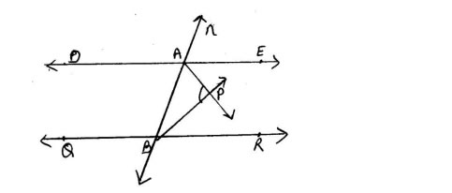

1. In the following figure, ∠A - ∠B = 1000 then find ∠A and ∠B?

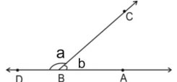

1. Two adjacent angles are equal. Is it necessary that each of these angles will be right angle? Justify your answer?
2. Prove that the angle formed by the bisector of interior angle A and the bisector of exterior angle B of a triangle ABC is half of angle C?
3. The exterior angles obtained on producing the base of a triangle both ways are 100° and 120°. Find all the angles?
4. Find the value of ‘x’ in the following figure?

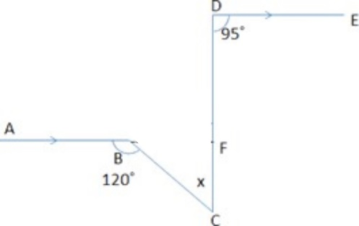

1. Sum of two angles of a triangle is 90o and their difference is 50o. Find all the angles of the triangle?
2. Find the value of ‘x’ in the following figure?

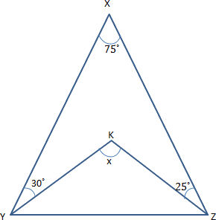

1. Prove that vertically opposite angle are equal?
2. If the supplementary angle of an angle is 50 more than six times its complementary angle, find the angle?
3. BO and CO are external bisectors of angles ∠B and ∠C of ∆ABC intersecting at ‘O’. If ∠A = 600 and ∠ABC = 700, then find ∠BOC?
4. Find the values of ‘x’ and ‘y’ in the following figure?

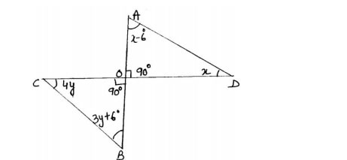

1. Find the value of ‘x’ in the following figure?

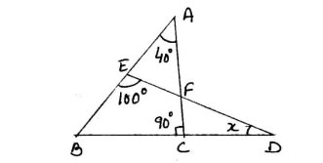

1. In ∆ABC, the bisectors of ∠B and ∠C intersect at ‘O’. If ∠A = 1300, then find ∠BOC?
2. In ∆ABC, if 2∠A = 3∠B = 6∠C, then find the measure of the angles of the triangle?
3. If two complementary angles are such that two times of one angle is three times of another then find the measure of both angles?
4. If twice of ∠y is 300 less than ∠x in the following figure, then find the measure of the angles?

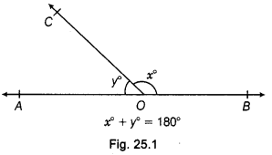

1. In ∆ABC, if ∠A - ∠B = 150 and ∠B - ∠C = 300, then find the measure of the angles?
2. Prove that the bisectors of angles of linear pair are at right angle?
3. Find the value of ‘x’?

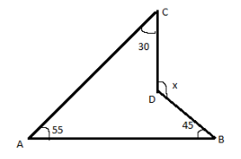

1. In ∆ABC, if ∠A = $\frac{∠B}{2}$ = $\frac{∠C}{6}$, then find the measure of ∠A?
2. Find ‘x’ from the following figure?

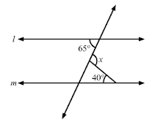

1. Find measure of ∠PRQ from the following figure?

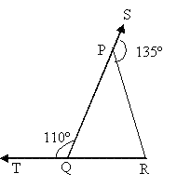

1. In the following figure $l ∥m$ and ‘n’ is transversal, then find ‘x’?

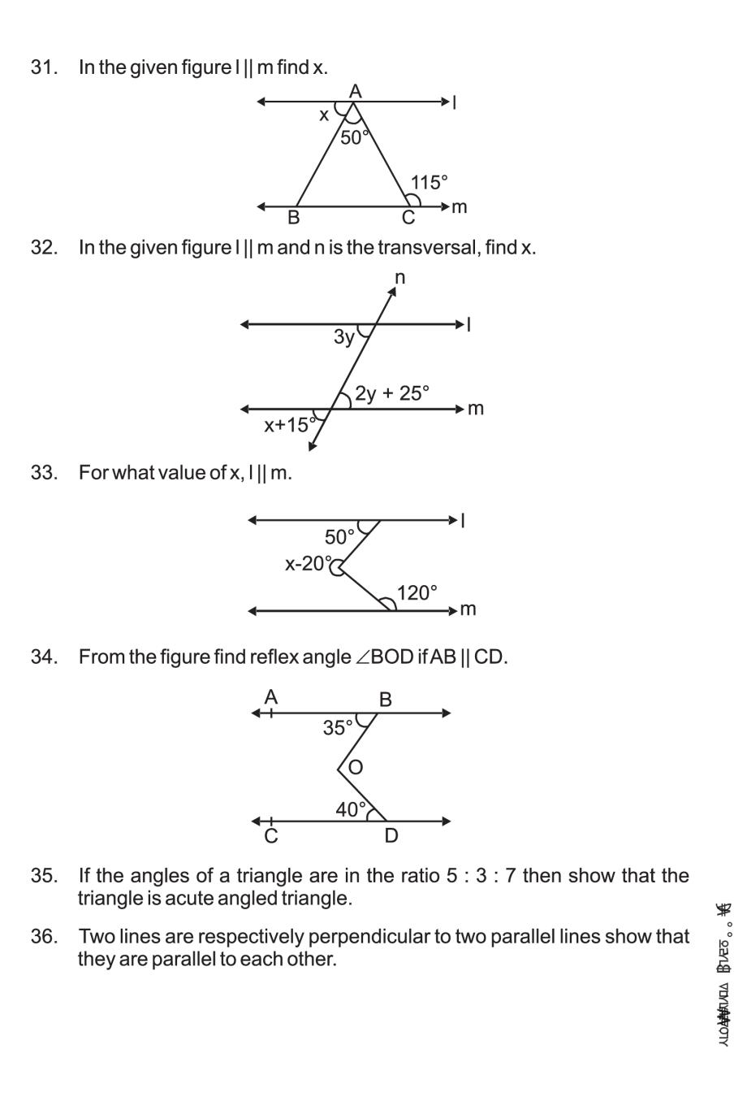

1. In the following figure, find the values of ‘x’ and ‘y’?

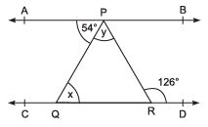

**Four mark questions**

1. In the following figure if AB and CD are two parallel rays, then find ‘x’?

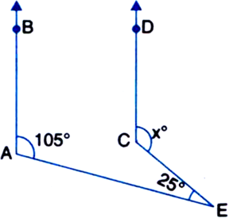

1. Find the value of ‘x’ in the following figure?

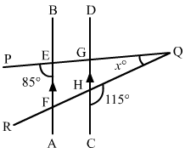

1. Find the value of ‘x’, ‘y’ and ‘z’ from the figure?

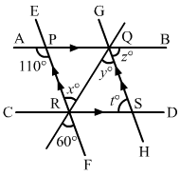

1. Find the values of ‘x’ and ‘y’ from the figure if $AB∥CD ∥EF$?

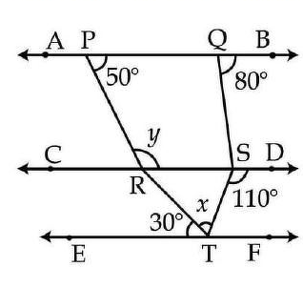

1. Prove that “Sum of three angles of a triangle is two right angles”?
2. Show that, “If a transversal intersects two parallel lines, then the alternate interior angles are equal”?
3. If a transversal intersects two parallel lines, then prove that the angle bisectors of the co-interior angles are parallel to each other?
4. Prove that, “The exterior angle of a triangle is equal to sum of interior opposite angles”?
5. Prove that, “The sum of exterior angles of a triangle is 3600”?
6. In the following figure 0 then find ∠XMY?

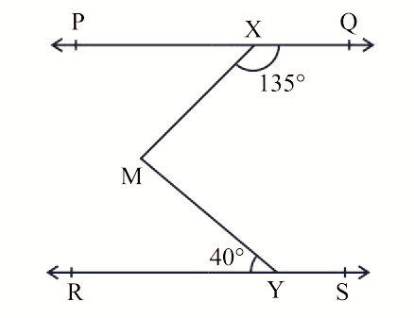

1. For what value of ‘x’ the lines l and m will be parallel?



1. If $p ∥q ∥r$, then find x, y and z?

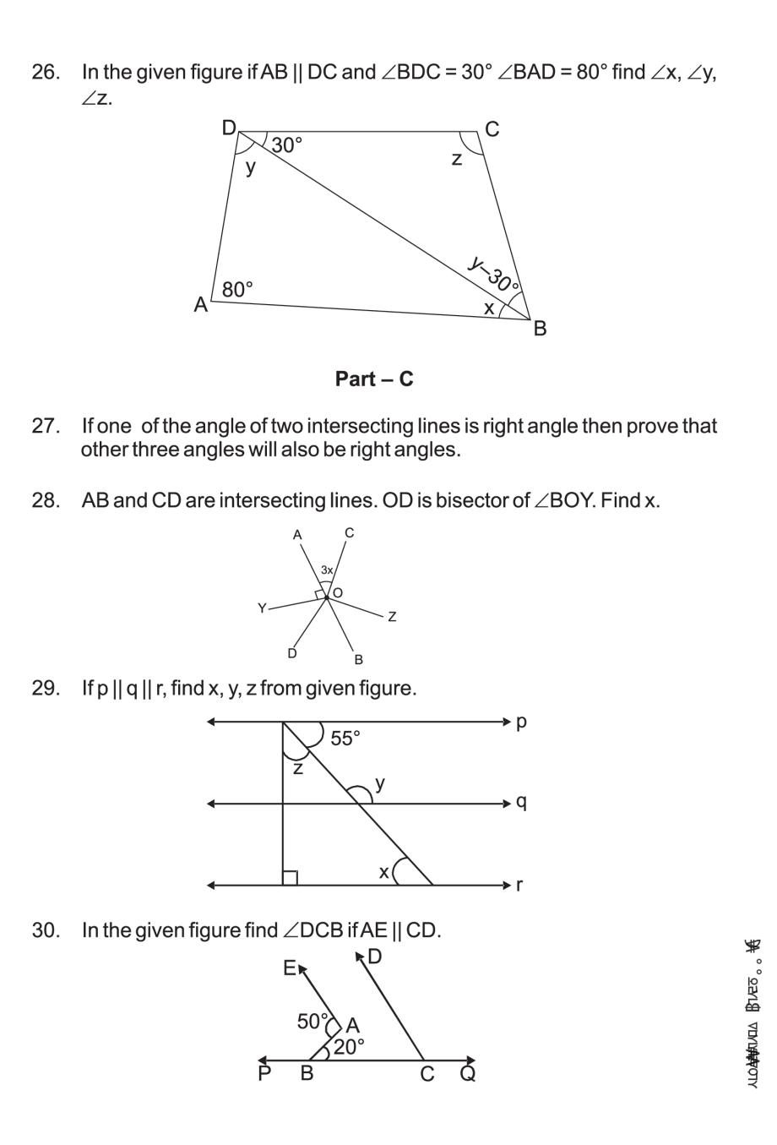

1. In the given figure find ∠DCB, if AE ‖ CD?



1. In ∆PQR, the sides PQ and PR are extended to S and T respectively. OQ and OR are the bisectors of the angles ∠RQS and ∠QRT meeting at ‘O’. Then show that 2∠QOR = ∠PQR + ∠PRQ?

