**MENSURATION**

**Basic concepts:**

* The object having two dimensions is called 2-D object or plane figure.

Ex: Triangle, Quadrilateral, circle……

* The objects having three dimensions is called 3-D objects or solid figures.

Ex: Cube, Cuboid, Cylinder, ……..

* The amount of space inside the boundary of a plane figure is called ‘Area’ of the figure.
* Area is measured in square units such as cm², m² ….etc.
* The total length of the boundaries of a plane figure is called ‘Perimeter’ of the figure.
* A 3 – D object is formed by combining some 2 – D objects. For example

1. A Cube is formed by combining 6 squares.
2. A Cylinder is formed by combining a rectangle and two congruent circles.

* A solid figure has vertices, edges, surfaces (lateral surfaces and bases), diagonals, volume.
* The volume of a solid figure is the measure of how much space that object takes up.
* Volume is measured in cubic units such as cm3, m3,…
* Volume of liquids is measured in liters
* 1 liter = 1000 cubic cm
* 1 kilo liter = 1 cubic metre
* The great Indian mathematician ‘Brahma Gupta’ gave the rules to find volume of prism.
* ‘Bhaskaracharya’ gave the value of π as $\frac{3927}{1250}$.

**Plane figures:**

* **Triangle:**

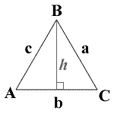 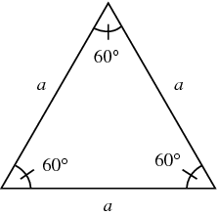 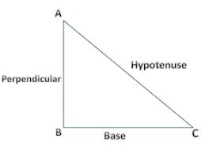

1. Area of a triangle = $\frac{1}{2}$ × base × height
2. Perimeter of a triangle = AB + BC + CA
3. If the sides of a triangle are ‘a’, ‘b’, ‘c’ then area of the triangle is

Δ = $\sqrt{s\left(s-a\right)(s-b)(s-c)}$

here s = $\frac{a+b+c}{2}$ (half of the perimeter)

This is called Heron’s formula.

1. Area of an equilateral triangle = $\frac{\sqrt{3}}{4}$ a² ( a – side of the triangle)
2. Height of an equilateral triangle = $\frac{\sqrt{3}}{2}$ × a
3. Area of a right-angled triangle = $\frac{1}{2}$ × base × perpendicular
4. Area of an isosceles right triangle = $\frac{1}{2}$ × a²
5. Hypotenuse of a right-angled triangle = $\sqrt{base^{2}+aititude²}$
6. Hypotenuse of an isosceles right triangle = $\sqrt{2}$ × side
7. Area of an isosceles triangle = $\frac{b}{2}$ $\sqrt{a^{2}- \frac{b²}{4}}$

Here a – length of equal side

b – base

* **Quadrilateral:**

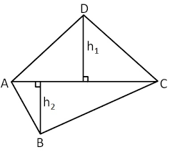 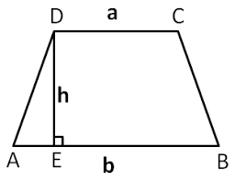 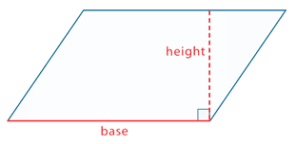 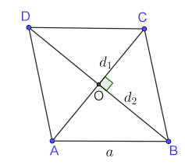

1. Area of a quadrilateral = d (h1 +h2)
2. Area of a trapezium = $\frac{1}{2}$ h (a +b)
3. Area of a parallelogram = base × height
4. Area of a rectangle = length × breadth
5. Area of a rhombus = × d1 × d2
6. Area of a square = (side)² = $\frac{(diagonal)²}{2}$
7. Diagonal of a rectangle = $\sqrt{l^{2}+b²}$
8. Diagonal of a square = $\sqrt{2}$.a
9. Perimeter of a rectangle = 2(l + b)
10. Perimeter of a square = 4 × side.

* **Circle:**

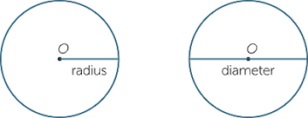 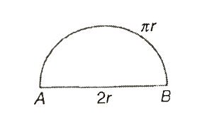 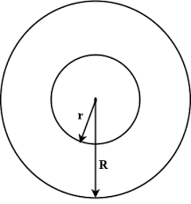

1. Area of a circle = πr² = $\frac{πd²}{4}$
2. Circumference of a circle = 2πr = πd
3. Area of a semi-circle = $\frac{πr²}{2}$ = $\frac{πd^{2}}{4}$
4. Perimeter of a semi-circle = πr + 2r = $\frac{36 r}{7}$
5. Area of a ring = π (R + r) (R – r)

* **sector:** The region enclosed by two radii and an arc joining the both radii is called ‘Sector’.

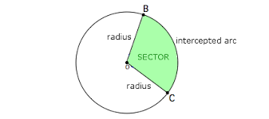

1. Area of a sector = $\frac{θ}{360}× πr²$ = $\frac{lr}{2}$
2. Length of the arc of a sector = $\frac{θ}{360}× 2πr$
3. perimeter of sector = l + 2r

**Solid figures:**

* **Polyhedron:** A solid shape whose faces are all polygons is called ‘Polyhedron’.

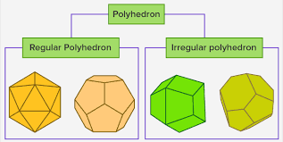

* **Pyramid:** A pyramid is a polyhedron with a polygon as its base and all other faces as triangles that meet at a point (Apex). A pyramid whose altitude is perpendicular to the base is called ‘***Right Pyramid***’.

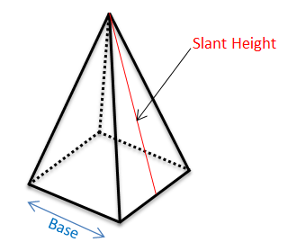

1. No. of edges of a pyramid = N0. of sides of the base × 2
2. No. of vertices = No. of sides of the base + 1
3. No. of total surfaces = No. of sides of the base + 1
4. No. of lateral surfaces = No. of sides of the base
5. Shape of lateral surfaces of a pyramid is triangle.
6. A pyramid has only one base (Polygon)
7. L.S.A = $\frac{1}{2}$ × perimeter of the base × slant height
8. T.S.A = L.S.A + area of the base
9. Volume = $\frac{1}{3}$ × area of the base × height

* **Prism:**

1. A prism is a polyhedron with two identical faces (polygons) that are parallel and all other faces are parallelograms.
2. If the line segment joining the centers of the two identical faces (bases) is perpendicular to the base then it is called ‘*Right Prism’.*
3. The other faces (lateral surfaces) of right prism are rectangles.
4. The name of the prism is given by the shape of the base.

ex: Triangular prism, square prism, pentagonal prism

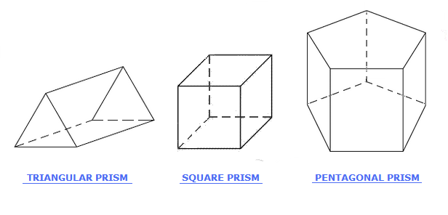

1. No of edges of a prism = 3 × No of sides of the base
2. No. of vertices = No. of sides of the base × 2
3. No of total surfaces = No. of sides of the base + 2
4. No. of lateral surfaces = No. of sides of the base
5. No. of bases = 2
6. L.S.A = perimeter of the base × height
7. T.S.A = L.S.A + 2 × area of the base
8. volume = area of the base × height

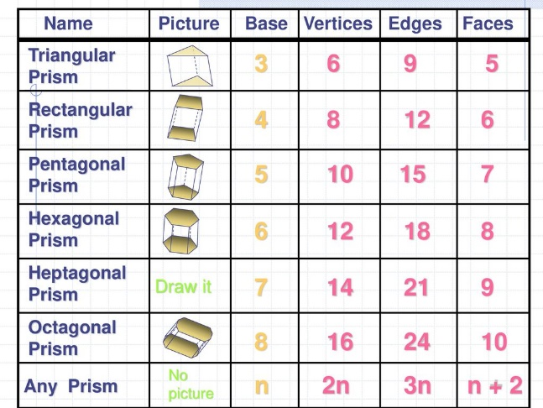

* **Cube:** A cube is a three-dimensional object bounded by six square faces with three faces meeting at each vertex.

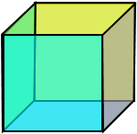

1. No. of edges of a cube = 12
2. No. of vertices = 8
3. No. of total surfaces = 6
4. No. of lateral surfaces = 4
5. No. of bases = 2
6. L.S.A = 4s²
7. T.S.A. = 6s²
8. Volume = s3
9. Diagonal = $\sqrt{3}$ × side

* **Cuboid:** A cuboid is a convex polyhedron bounded by six rectangular faces with three faces meeting at each vertex.

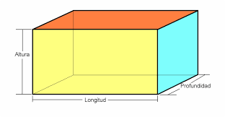

1. No. of edges of a cuboid = 12
2. No. of vertices = 8
3. No. of total surfaces = 6
4. No. of lateral surfaces = 4
5. No. of bases = 2
6. L.S.A = 2h (l + b)
7. T.S.A = 2 (lb + bh + hl)
8. Volume = lbh
9. Diagonal = $\sqrt{l^{2}+b^{2}+h²}$

* **Cylinder:**

1. A cylinder is a closed solid figure with two congruent and parallel circular bases connected by a curved surface.
2. The line segment joining the centers of the two circular bases is called ‘***Axis***’ of the cylinder.
3. If the axis is perpendicular to the base then it is called ‘***Right Cylinder***’.

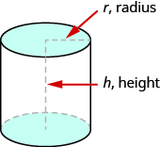

1. No. of total surfaces = 3
2. No. of lateral surfaces = 1
3. No. of bases = 2
4. A cylinder has two circular edges and no vertices.
5. Area of the base = πr²
6. Perimeter of the base = 2πr
7. C.S.A = 2πrh
8. T.S.A = 2πr (r + h)
9. Volume = πr²h
10. Volume of hollow cylinder = π (R² - r²) h
11. If we prepare a cylinder by combining the breadths of a rectangle, then

height of the cylinder = breadth of the rectangle circumference of the base of the cylinder = length of the rectangle

* **Cone:**

1. A cone is a solid object that has a circular base joined with a point by a curved surface.
2. The point is called ‘Vertex’ of the cone.
3. The length of the line segment joining the vertex and a point on the boundary of the base is called ‘***Slant height of the cone***’ and is represented by ‘l’.
4. The length of the line segment joining the vertex and centre of the circle is called ‘***Height of cone***’ and is represented by ‘h’.
5. If the line segment joining the vertex and centre of the circle is perpendicular to the base then the cone is called ‘Right Cone’

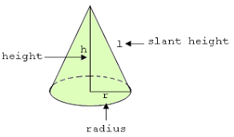

1. The relation between slant height (l), height (h) and radius (r) is

l² = h² + r²

l = $\sqrt{h^{2}+r^{2}}$

h = $\sqrt{l^{2}- r^{2}}$

r = $\sqrt{l^{2}- h^{2}}$

1. No. of total surfaces =
2. No. of lateral surfaces = 1
3. No. of bases = 1
4. No. of vertices = 1
5. Area of the base = πr²
6. Perimeter of the base = 2πr
7. C.S.A = πrl
8. T.S.A = πr (l + r)
9. Volume = $\frac{1}{3}$ πr²h
10. If a cylinder and a cone have same base and same height, then the ratio of their volumes is 3 : 1
11. If we prepare a cone by combining the radii of a sector, then

circumference of the base of cone = length of the arc of sector

Slant height of the cone = radius of the sector.

* **Sphere:** The set of all points in three-dimensional space lying at the same distance from the given point is called ‘Sphere’.

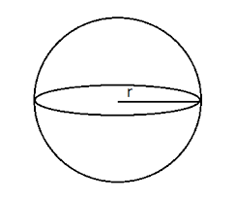

1. No. of total surfaces = 1
2. No. of lateral surfaces = 1
3. No. of edges = 0
4. No. of vertices = 0
5. C.S.A or T.S.A = 4πr²
6. Volume = πr3
7. Volume of hollow sphere = π (R3 – r3)
8. The surface areas of two spheres are in the ratio of the squares of their radii.

* **Hemi- Sphere:** A plane through the centre of the sphere divides the sphere into two equal parts. Each part is called ‘Hemi- Sphere’.

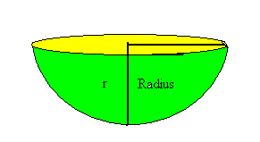

1. No. of total surfaces = 2
2. No. of curved surfaces = 1
3. No. of bases = 1
4. C.S.A = 2πr²
5. T.S.A = 3πr²
6. Volume = πr3