**PAIR OF LINEAR EQUATIONS IN TWO VARIABLES**

**Basic concepts:**

* The first degree equation is called ‘Linear equation’.
* The general form of the linear equation in one variable is ax + b = 0 where a, b € R and a ≠ 0.
* The general form of the linear equation in two variables is ax + by + c = 0 where a, b, c € R and |a| + |b| ≠ 0 or a² + b² ≠ 0 or a ≠ 0 and b ≠ 0.
* The value of the variable which satisfies the given equation is called ‘Solution’ or ‘root’ of the equation.
* A linear equation in one variable have only one solution.
* A linear equation in two variables have infinitely many solutions.
* The solution of a linear equation in two variables is represented by an ordered pair.
* The graph of a linear equation is a straight line.
* The equation of the line which passes through the origin is y = mx.
* The equation of the line which is not passing through the origin is y = mx + c.
* The equation of the line which is parallel to X – axis is y = k.
* The equation of the line which is parallel to Y – axis is x = k.
* Equation of the X – axis is y = 0
* Equation of the Y – axis is x = 0.

**Pair of linear equations in two variables – Solutions**

* The general form of pair of linear equations is

a 1x + b1y + c1 = 0

a 2x + b2y + c2  = 0

* The values of x and y which together satisfy each one the equations is called ‘Solution of the pair of linear equations’.
* The graph of pair of linear equations will be in three ways. They are

1. Intersecting lines
2. Parallel lines
3. Coincident lines (Dependent lines)

* The intersecting lines have only one solution.
* Parallel lines have no solutions.
* Dependent lines have infinitely many solutions.

**Consistent and Inconsistent lines:**

* The lines having at least one solution are called ‘Consistent lines’.
* The lines having no solution are called ‘Inconsistent lines’.
* Intersecting lines and dependent lines are consistent lines.
* Parallel line are inconsistent lines.

**Relation between coefficients and nature of system of equations:**

* In the following table, the relation between coefficients of term in pair of linear equations and their nature is given by example.

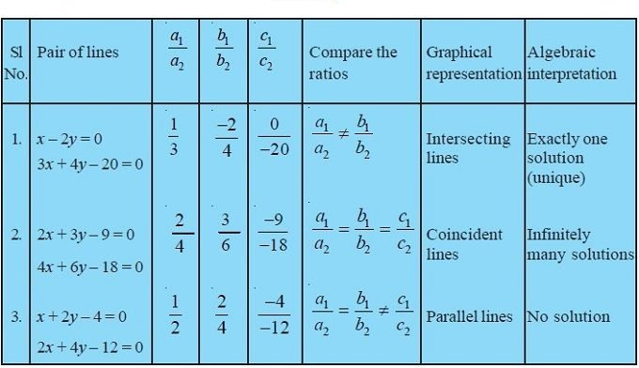

**Graphical method to find the solution of pair of linear equations in two variables:**

* To find the solution of the pair of linear equations, first the graph of both linear equations in a single graph.
* If the lines are intersecting lines then the coordinates of the intersecting point are solutions of the given system of equations.
* If they are parallel lines then they have no real solutions.
* It they are dependent lines they have infinitely many solutions.

**Substitution method to find the solution of pair of linear equations in two variables:**

* This method is useful for solving a pair of linear equations in two variables where one variable can easily be written in term of the other variable.
* To solve the system of equations in this method, we will follow these steps:

1. In one of the equations, express one variable in terms of other variable. Say ‘y’ in terms of ‘x’.
2. Substitute the value of y obtained in step A, in the second equation.
3. Simplify the equation obtained in step B, and find the value of ‘x’.
4. Substitute the value of ‘x’ obtained in step C, in either of the equations and solve it for y.
5. Check the obtained solutions by substituting the values of x and y in both the original equations.

**Elimination method to find solution of the pair of linear equations in two variables:**

* To solve the pair of linear equations in two variables in elimination method, we will following these steps.

1. Write both the equations in the form ax + by = c.
2. Make the coefficients of one of the variables, say ‘x’ numerically equal by multiplying each equation by suitable real numbers.
3. If the variable to be eliminated has the same sign in both equations, subtract the two equations to get an equation in one variable. If they have opposite sign, then add them.
4. Solve the equation for the remaining variable.
5. Substitute the value of this variable in any one of the original equations and find the value of the eliminated variable.

**Some additional points:**

* The equations of parallel lines differ in constant terms only.
* The equation of the line parallel to ax + by + c = 0 is ax + by + k = 0 or kax + kby + p = 0.
* The equation of the line which coincident to the line ax + by + c = 0 is kax + kby + kc = 0.