**POLYNOMIALS**

**Basic key concepts:**

* A symbol having a fixed numerical value is called a ‘***Constant***’.

Ex: 4, 1/3. √5, 8.76….

* A symbol which takes various numerical values is known as a ‘***Variable***’.

Ex: x, y, z, m, n…

* A constant or a variable or product of constants and variables is called a ‘***Term***”.

Ex: 4x2y, 6xy3

* A term or combination of terms obtained by any binary operation is called “***Expression***”.

Ex:1) 4x3 + 5x2 – x + 1

2) 5√x + 3

3) x + 1/x

* The sum of powers of variables of a term is called ‘*Degree of the term*’.

Ex: Degree of 7x2y is 3

* The degree of any constant is ‘0’ except zero.
* Degree of zero is not define.

**Polynomial**

* An algebraic expression in which the variables involved have only non-negative integral powers is called ‘***Polynomial***’.

Ex: P(x) = 3x2 + 5x -2

P(t) = 3t + 7

* All polynomials are algebraic expressions. But all algebraic expressions are not polynomials.
* The degree of a polynomial is the highest degree of its variables.
* The general form of a nth degree polynomial is

an xn + an-1 xn-1 + an-2 xn-2 + ……… + a0

**Types of polynomial according to number of terms:**

|  |  |  |
| --- | --- | --- |
| **Number of non zero terms** | **Name of the polynomial** | **Example** |
| 1 | Monomial | 6x3 |
| 2 | Binomial | 7x4 + 6 |
| 3 | Trinomial | 6x2 + 5x – 2 |
| More than 3 | Multinomial | 3x4 + 4x3 + x + 1 |

* Every polynomial is multinomial
* But every multinomial need not be polynomial.
* A polynomial can have any finite number of terms.

**Types of polynomials according to degree:**

|  |  |  |  |
| --- | --- | --- | --- |
| **Degree of the polynomial** | **Name of the polynomial** | **General form (a ≠ 0)** | **Maximum No.of terms** |
| Not define | Zero polynomial | 0 | 1 |
| 0 | Constant polynomial | Any constant | 1 |
| 1 | Linear polynomial | ax + b | 2 |
| 2 | Quadratic polynomial | ax2 + bx + c | 3 |
| 3 | Cubic polynomial | ax3 + bx2 + cx + d | 4 |
| 4 | Bi quadratic polynomial | ax4 + bx3 + cx2 + dx + e | 5 |

* A linear polynomial with one variable may be monomial or binomial.
* A quadratic polynomial with one variable may be monomial or binomial or trinomial.

**Zero of a polynomial:**

* The ***zero of a polynomial*** p(x) is the value of ‘x’ for which p(x) = 0.
* Zero of polynomial is also called *a root of the polynomial*.

Ex: p(x) = x2 + 4x + 4

P(-2) = (-2)2 + 4(-2) + 4

= 4 – 8 + 4

= 0.

P(-2) = 0.So -2 is zero of the polynomial.

* If the degree of a polynomial is ‘n’ then the polynomial **may** have maximum ‘n’ zeroes.
* A constant polynomial does not have a zero.
* Zero polynomial have infinitely many zeroes.
* A linear polynomial may have maximum one zero.
* A quadratic polynomial may have at most two zeroes.
* If p + √q is zero of ax² + bx + c, then p - √q is another zero o
* Zeroes of a polynomial are related to its coefficients of the terms including the constant term.

**Graphical representation of linear polynomial**

* The graph of a linear polynomial is a *straight line*.

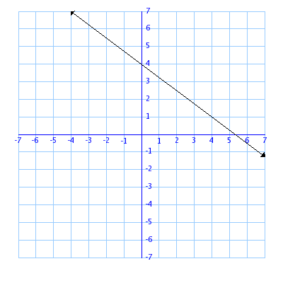

* In general, for the graph of linear polynomial ax + b (a≠0), the graph of y = ax + b is a straight line which intersects the X-axis at only one point ( $\frac{-b}{a}$, 0).
* The **x coordinate** of the point where the line intersects X-axis is the ***zero of the polynomial.***

**Graphical representation of quadratic polynomial**

* The graph of a quadratic polynomial is a ‘***parabola***’.
* If **a > 0** then the graph of the quadratic polynomial ax2 + bx + c represents a parabola opens **upwards**.

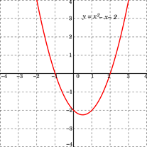

* If **a < 0** then the graph of the quadratic polynomial ax2 + bx + c represents a parabola opens **downwards**.

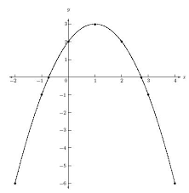

* The **x coordinates** of the points where the parabola intersects the X- axis are the **zeroes** of the quadratic polynomial.
* If the quadratic polynomial has two zeroes then the parabola intersects the X – axis at two points.

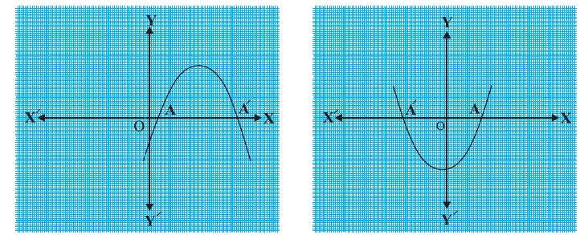

* If the quadratic polynomial has one zero then the parabola intersects the X – axis at one point.

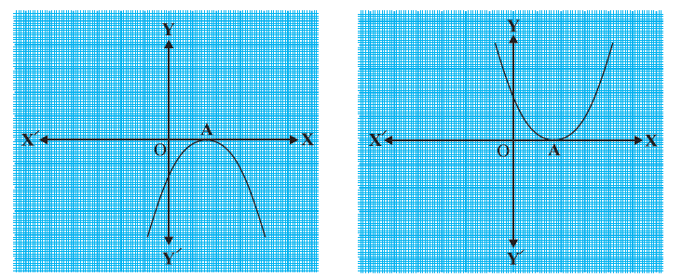

* If the quadratic polynomial has no real zeroes then the parabola doesn’t intersect the X – axis.

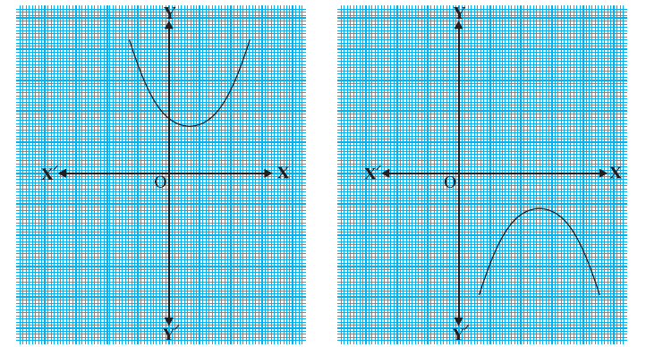

* If the degree of a polynomial is ‘n’ then its graph intersects the X – axis at most ‘n’ times. Means it has at most ‘n’ zeroes.

**Relationship between zeroes and coefficients of a polynomial**

* The zeroes of a polynomial have relationship with the coefficient of the terms.
* Zero of a linear polynomial = $\frac{- constant term}{coefficient of x}$
* Sum of the zeroes of a quadratic polynomial

= $\frac{- (coefficient of x)}{coefficient of x²}$

* Product of the zeroes of a quadratic polynomial

= $\frac{ constant term}{coefficient of x²}$

* If the zeroes of a quadratic polynomial ax2 + bx + c are α and β then the relationship between zeroes and the coefficients

α + β = $\frac{- b}{a}$

α.β = $\frac{c}{a}$

* If the zeroes of a cubic polynomial ax3 + bx2 + cx + d are α, β and γ then the relationship between zeroes and coefficients is

α + β + γ = $\frac{- b}{a}$

αβ + βγ + γα = $\frac{ c}{a}$

α.β.γ = $\frac{- d}{a}$

* If the zeroes of a quadratic polynomial are α and β then the polynomial is

**P(x) = k [ x2 - x (α + β) + α.β]** where k is a constant.

* If the zeroes of a cubic polynomial are α, β and γ then the polynomial is

**P(x) = x3 – x2(α + β + γ) + x (αβ + βγ + γα) – αβγ**

**Division Algorithm for Polynomials**

* The division algorithm is

Dividend = Divisor × Quotient + Remainder.

* If p(x) and g(x) are two polynomials with g(x) ≠ 0 then we can find two polynomials q(x) and r(x) such that

P(x) = g(x) × q(x) + r(x)

Where either r(x) = 0 or degree of r(x) < degree of g(x).

* If degree of p(x) is ‘m’ and degree of g(x) is ‘n’ then degree of q(x) is ‘m – n’
* If g(x) is linear polynomial then degree of r(x) is zero mean r(x) is constant.
* Degree of p(x) = Degree of g(x) + Degree of r(x)
* According to ***Remainder theorem***

|  |  |
| --- | --- |
| **Divisor** | **Remainder** |
| x – a | P(a) |
| x + a | P(-a) |
| ax - b | P(b/a) |
| ax + b | P(-b/a) |

* If the remainder r(x) = 0 then g(x) and q(x) are factor of p(x).