**QUADRATIC EQUATIONS**

**Quadratic equation:**

* The second-degree equation is called ‘Quadratic equation’.
* The general form of a quadratic equation in the variable ‘x’ is ax2 + bx + c = 0 where a,b,c are real numbers and a ≠ 0.
* ax2 + bx + c = 0 (a ≠ 0) is called standard form a ‘*quadratic equation*’ and y = ax2 + bx + c is called ‘*quadratic function’*.
* In our daily life, there are various uses of quadratic function

Ex:1) The path of rocket when it is fired

2) Shapes of satellite dish

3) Reflecting mirror in a telescope

4) Lens of the eye glasses

5) The path of a projectile

**Solutions of a quadratic equation:**

* The value of the variable which satisfies the given equation is called ‘Solution’ or ‘root’ of the equation.
* A quadratic equation has at most two solutions.
* To find the solutions of a quadratic equation, we different methods.

1. By factorization
2. By completing the square
3. By using formula

* The real number ‘k’ is called a solution of ax2 + bx + c = 0 if ak2 + bk + c = 0.
* The zeroes of the quadratic polynomial ax2 + bx + c and the solutions of quadratic equation ax2 + bx + c = 0 are the same.

**Solution of a quadratic equation by factorization:**

* To solve a quadratic equation by factorization method, we have to follow these following steps:

1. Say the given equation is ax2 + bx + c = 0
2. Split the middle term.
3. To split the middle term, we have to find two numbers ‘p’ and ‘q’ such that p + q = b and p × q = a × c.
4. Then write bx as px + qx.
5. By simplifying that equation, we will get two linear factors whose product is zero.
6. By equaling the factors to zero, we will get the solutions of the equation.

Ex: Solve 6x2 – x – 2 = 0

Sol: Given equation is

6x2 – x – 2 = 0

6x2 + 3x – 4x – 2 = 0

3x (2x + 1) – 2(2x + 1) = 0

(2x + 1) (3x – 2) = 0

If 2x + 1 = 0 then if 3x – 2 = 0 then

2x = -1 3x = 2

x = -1/2 x = 2/3

**∴** The solutions are -1/2 or 2/3.

**Solution of a quadratic equation by Completing the square**

* We can’t solve all quadratic equations by factorization when the roots are **irrationals.**
* Then we can solve them by completing the square method.
* In this method, we adjust the left side of the quadratic equation so that it becomes a perfect square.
* We can solve a quadratic equation in this method by following these steps:

1. Take the quadratic equation ax2 + bx + c = 0
2. Divide both sides by ‘a’ to make coefficient of x2 as 1.
3. Rearrange the equation so that the constant term c/a on the right side. (R.H.S)
4. Add $\left[\frac{1}{2} \left(\frac{b}{a}\right)\right]²$ to both sides to make L.H.S, a perfect square.
5. Write the L.H.S as a square and simplify the R.H.S.
6. Then we will get the solutions of the given quadratic equation.

**Solution of a quadratic equation by using formula:**

* We can solve a quadratic equation ax2 + x + c = 0 by using the following formula:

x = $\frac{-b ± \sqrt{b^{2}-4ac}}{2a}$

* This is called ‘*Quadratic Formula’*
* If one of the root is ‘α’ and the other is ‘β’ then

α = $\frac{-b + \sqrt{b^{2}-4ac}}{2a}$

β = $\frac{-b - \sqrt{b^{2}-4ac}}{2a}$

α + β = $\frac{-b}{a}$

α.β = $\frac{-c}{a}$

**Nature of roots:**

* The nature of roots of a quadratic equation ax2 + bx + c = 0 is determine by the value of b² - 4ac.
* The value of **b² - 4ac** is called ‘***discriminant***’.
* It is denoted by ‘D’ or ‘**Δ’.**

D = b2 – 4ac

* If b² - 4ac > 0, then the roots are distinct real.
* If b² - 4ac = 0, then the roots are equal real.
* If b² - 4ac < 0, then the roots are not real.
* In the case **Δ** > 0, if we draw the graph of the equation, we will get a parabola which intersects the X – axis at two points.

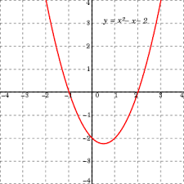

* In the case **Δ** = 0, if we draw the graph of the equation, we will get a parabola which intersects the X – axis at one point.

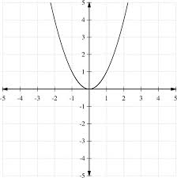

* In the case **Δ** < 0, if we draw the graph of the equation, we will get a parabola which is neither intersects nor touches X- axis

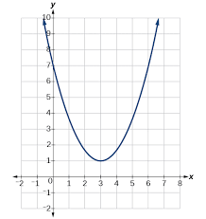

**Additional concepts:**

* If the roots of the quadratic equation ax2 + bx + c = 0 are equal then each root is $\frac{-b}{2a}$.
* Difference of the roots α – β = $\frac{\sqrt{b^{2}-4ac}}{a}$
* If the roots are multiplicative inverse to each other then ‘c = a’.
* If the coefficient of x2 is 1 then it is called ‘***Monic quadratic equation***’.

Ex: x² + 3x + 7 = 0

* If coefficient of x is zero then it is called ‘***pure quadratic equation***’.

Ex: 4x² - 1 = 0