**REAL NUMBERS**

**Basic key concepts:**

* The counting numbers are called as Natural numbers.
* The set of Natural numbers is represented by ‘N’.
* N = {1, 2, 3, 4,……}
* Natural numbers together with ‘0’ are called as whole numbers.
* The set of whole numbers is represented by ‘w’.
* W = {0, 1, 2, 3,4, …….}
* The whole numbers together with negative numbers are called as Integers.
* The set of integers is represented by ‘Z’.
* Z = {…..,-3,-2,-1,0,1,2,3,4, …… }
* The numbers which are having only two factors 1 and itself are called prime numbers
* The number which has more than two factors is called composite number.
* The numbers having no common factors except 1 are called as ‘Co-prime numbers’ or ‘Relative prime numbers’.

Ex: (9, 10), (15, 16),(21, 44),……

* All prime numbers are co-prime numbers but convers is not true.
* Any two consecutive numbers are co-primes.
* Decimal numbers are two types. They are

1) Terminating decimal

2) Non terminating decimal

* If we can count the number of digits in the decimal part then the decimal is “Terminating decimal”.i

Ex: 23.45907

* If we can’t count the number of digits in the decimal part then the decimal is called as “Non-terminating decimal”.
* The nonterminating decimals are two types. They are

1) Non terminating repeating decimal

Ex: 34.5676767…….

2) Non terminating non repeating decimal.

Ex: 34.5674583982961……….

* Division algorithm is

Dividend = Divisor × quotient + remainder.

**Rational numbers:**

* The numbers which can be written in p/q form where p and q are integers and q ≠ 0 are called “Rational numbers”.
* Rational numbers are also called as “Quotient numbers”.
* The set of rational numbers is represented by ‘Q’.
* Every rational number has a decimal expansion.
* The decimal expansion of a rational number is either terminating decimal or non-terminating repeating decimal.

Ex:

= 1. 3333…..

* The rational number p/q has a *terminating decimal* expansion if the prime factorization of the denominator ‘q’ is in the form 2m × 5n where m and n are nonnegative integers.
* The rational number p/q has a *nonterminating repeating decimal* expansion if the denominator ‘q’ has any other prime factor other than 2 or 5.

Ex: ---- Terminating decimal

---- Non-terminating repeating decimal.

* The square root of a perfect square number is also a rational number.

Ex: √4, √49, √169 …..

* If ‘a’ is a positive real number and can’t written nth power of any rational number then is also a rational number.

Ex: , …..

**Properties of rational numbers:**

* Rational numbers satisfy ***closure property*** under the four fundamental operations. Mean sum, difference, product and quotient of two rational numbers is a rational number.

Rational + Rational = Rational

Rational – Rational = Rational

Rational × Rational = Rational

Rational ÷ Rational = Rational

* If and are two rational numbers then + = .
* If and are two rational numbers then × = .
* If and are two rational numbers then ÷ = .
* Rational numbers satisfies *commutative, associative, identity and inverse* properties under addition and multiplication.(multiplicative inverse except 0).
* The additive identity element in the set of rational numbers if zero.

+ 0 =

* The multiplicative identity element is 1’

× 1 =

* The additive inverse of the rational number ‘’ is ‘-’.
* The multiplicative inverse of the rational number ‘’ is .
* ‘0’ is additive inverse to itself.
* ‘0’ has no multiplicative inverse.
* ‘1’and ‘-1’ are multiplicative inverse to their self.
* In set of rational numbers, multiplication is distributive over addition and subtraction.

× =

× =

* Rational numbers satisfy densitive property. Means we can insert infinitely many numbers between any two rational numbers.

Example:

1. The rational numbers between 2 and 3 are 2.1, 2.2, 2.3, ,,,,,,, ,2.9
2. The rational numbers between 2.1 and 2.2 are 2.11, 2.12, 2.13, ……. , 2.19
3. The rational numbers between 2.11 and 2.12 are 2.111, 2.112, 2.113,…….. , 2.119.
4. Like these we can continue and also between 2.2 and 2.3 and also remaining.

**Finding rational numbers between the given numbers:**

* A rational number between ‘a’ and ‘b’ is .
* If we need ‘n’ rational numbers between ‘a’ and ‘b’ (when a, b are non-fractional numbers), then we use the formula

,

* If we need ‘n’ rational numbers between ‘a’ and ‘b’ (when a, b are fractional numbers), then we use the formula

d =

Then the rational numbers between ‘a’ and ‘b’ are (a + d), (a + 2d), (a + 3d)………., (a + nd).

* The rational number between and is .

**Conversion of non-terminating and repeating decimal in the form of p/q:**

* Non terminating repeating decimals are basically two types.

1. Pure recurring decimal
2. Mixed recurring decimal

* A non-terminating decimal in which all the digits after the decimal point are repeated, is known as ‘***Pure recurring decimal****’.*

Ex: 7.36363636……..

* A non-terminating decimal in which at least one of the digits after the decimal point is not repeating and then some digit or digits are repeating, is known as ‘***Mixed recurring decimal*’**.

Ex: 7.36565656565…….

* There are several methods to convert non-terminating repeating decimal into p/q form.
* By using the following formula we can convert it into p/q form directly.

Ex: 13.3454545……… =

= .

**Representation of rational numbers on number line:**

* We can represent rational numbers of number line.
* In the rational number, the **denominator** tells the number of equal parts in which each unit has been divided.
* The **numerator** tells ‘how many’ of these parts are considered.
* For example if we want to represent 6/5 on number line, we have to divide each unit into 5 equal parts (denominator) and then the 6th part (numerator) from ‘0’ represents 6/5.

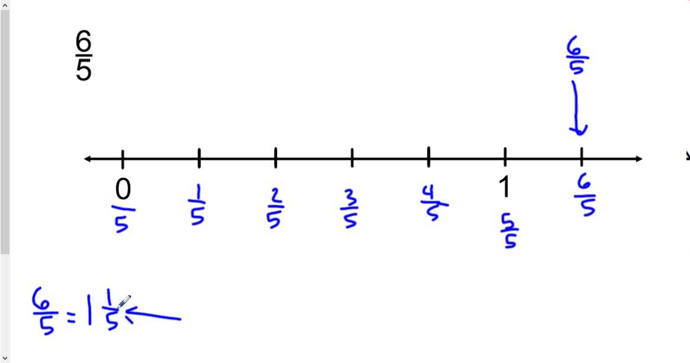

**Representation of rational numbers (Decimal form) on number line by successive magnification:**

* In this method, we represent rational numbers, which are in decimal form, on number line.
* The process of visualization of presentation of numbers on the number line through a magnifying glass is known as process of successive magnification.
* Let us see this process by *an example* that representing **3.765** on number line by successive magnification.

1. Let us see the range of the given number. 3.765 lies between **3** and **4**.
2. Now let us look closely at the portion of number lies between 3 and 4. Divide into 10 equal parts and then mark first point to the right of 3 will represent 3.1, second point 3.2 and so on.
3. Now let us magnify the portion between **3.7** and **3.8**. Again divide it into 10 equal parts and mark them as 3.71, 3.72, ….. , 3.79.
4. Now again divide the portion between **3.76** and **3.77** into 10 equal parts and mark them as 3.761, 3.762, …….
5. Finally, we will get 3.765 on number line.

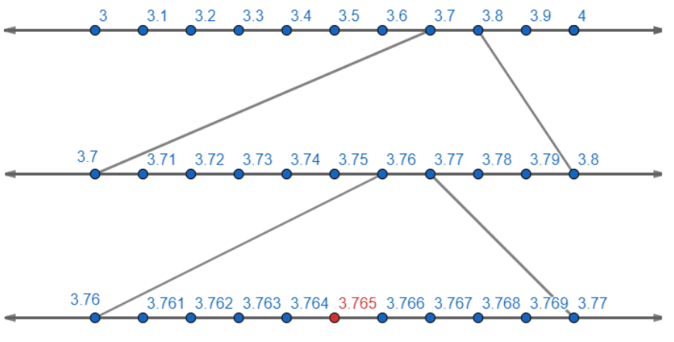

**Irrational numbers**

* The numbers which can’t be written in p/q form where p and q are integers and q ≠ 0 are called as “***Irrational numbers***”.
* The set of irrational numbers is represented by **Q’** or **S.**
* The **PYTHAGOREAN** in Greece, the follower of the famous mathematician PYTHAGORAS, were the first to discover the irrational numbers.
* The Pythagoreans proved that is an irrational number.
* Later **Theodorus** of Cyrene showed that , , , , , and are irrational numbers.
* Before them there is a reference of irrational numbers in **Baudhayana Sulba Sutra of INDIA**.
* The nonterminating non repeating decimals are irrational numbers.

Ex: 3.485297……….

* 𝛑 is an irrational number.
* If ‘p’ is not a perfect square number then is an irrational number.

Ex: , , , ……

* If ‘a’ is a positive rational number and can’t written nth power of any other rational number then is an irrational number.

Ex: , ….

* If is an irrational number then and also irrational numbers.
* If ‘p’ is a prime number then is an irrational number.

Ex: , ,……

**Surds:**

* If ‘n’ is a positive integer greater than 1 and ‘a’ is a positive rational number but not nth power of any rational number then is called a ‘**Surd or radical**’.
* If is a surd then

1. ‘a’ is called ‘Radicand’
2. ‘n’ is called order of surd
3. is called ‘Radical sign.

* = (a)1/n.
* n = a
* = (a)m/n
* = (a)1/2
* =
* = = (a)1/mn
* A surd is an irrational number.
* An irrational number is need not be a surd

Ex: 𝛑

* The surds which are multiples of a surd are called like surds.

Ex: , 2, 3, 4

* We can add or subtract only like surds by using distributive property.

P + Q = (P + Q)

* We can multiply or divide any surds having same order.

P × Q = PQ

P × Q = aPQ

**Fundamental operations on irrational numbers:**

* The sum of two irrational numbers need not be irrational.

Ex: 1) + is an irrational number.

2) = 0 which is a rational number.

* The difference of two irrational numbers need not be irrational.

Ex: 1) is an irrational number.

2) is a rational number.

* The product of two irrational numbers need not be irrational.

Ex: 1) is an irrational number

2) is a rational number.

* The quotient of two irrational numbers need not be irrational.

Ex:1) = is an irrational number

2) = is a rational number.,

* If ‘p’ and ‘q’ are prime numbers then + is an irrational number.
* The set of irrational numbers does not satisfy *closure property* under any binary operations.

**Finding irrational numbers between two numbers:**

* The irrational number between ‘a’ and ‘b’ is where ‘ab’ is not a perfect square number.
* We can insert infinitely many irrational numbers between two numbers.

Ex: A) Two irrational numbers between 3 and 4 are

1. 3.5734970976431………
2. 3.87947936978316……….

B) Two irrational numbers between 3 and 4

are

**Representing an irrational number on number line:**

* We have different methods to represent an irrational number on number.
* If ‘x’ is a positive real number, then we can represent on number line by following these steps:

1. Draw a line segment AC such that AC = x + 1units and extend it.
2. Mark the point ‘B’ on AC such that AB = x units and BC = 1 unit.
3. Find the midpoint of AC and mark it as ‘M’.
4. Draw a semi-circle with centre ‘M’ and radius MA or MC.
5. Now draw a perpendicular to AC passing through B and intersecting the semi-circle at D.
6. ‘B’ as centre and BD as radius, draw an arc which is intersecting the extend AC at E.
7. Let us treat BC as number line and B as zero.
8. Then BE represents.

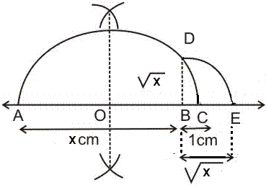

**REAL NUMBERS**

* The rational numbers together with irrational numbers are called “*Real numbers*”.
* The set of real numbers is represented by ‘R’.
* The sum or difference of a rational number and an irrational number is an irrational.

Ex: + 8, – 3 are irrational.

* The product or quotient of a rational number and an irrational number is an irrational.

Ex: 2√5, are irrational.

* If ‘a’ is a rational number and ‘b’ is an irrational number, then a + b, a – b, a × b and are irrational numbers.
* If ‘p’ be a prime number and ‘p’ divides a2 then ‘p’ divides ‘a’.
* The sum, difference, product and quotient of two real numbers is also real number.
* Any point on number line represent either rational of irrational number. So the number line is known as ‘Real number line’.

**Some Laws of Real numbers:**

* (b ≠ 0)
* = a – b
* = a² - b
* =
* ² = a + b + 2
* ² = a + b – 2

Let a > 0 and p and q are rational numbers, then

* ap × aq = ap+q
* = ap-q
* (ap)q = apq
* ap × bp = (ab)p
* = (a)1/n
* = (a)1/2

**Rationalizing Factor:**

* If the product of two irrational numbers is a rational number, then they are said to be as ‘Rationalizing Factor’ to each other.

Ex: × = = 4.

R.F of is

R.F of is

* R.F of an irrational number is **not unique**.

Ex: × = = 2

× = = 4

× = = 6

× = = 8

From the above examples, R.F of are, , , , .etc.

* Every irrational number is a rationalizing factor to itself.
* Generally, we will take the **smallest positive** rationalizing factor.
* If ‘p’ is a **prime number**, then the smallest rationalizing factor of is itself.

Ex: Find the simplest R.F of ?

Sol: =

= 2 × 3 ×

= 6

So simplest R.F of is .

**Simplest R.F of some irrational numbers:**

Let and are irrational numbers which are in lowest

terms then

* R.F of is
* R.F of is
* R.F of b is
* R.F of is
* R.F of (a + is (a -
* R.F of (a - is (a +
* R.F of is
* R.F of is
* R.F of is .
* R. F of is .