**Self-Assignment – 1**

**Topic: sets**

**Class: 10th Max. Marks: 25**

**Answer all questions. Each question carries ½ mark. 10 × ½ = 5M**

1. Write the set builder form of A – B?
2. If n(A) = 7 and n(B) = 5 then what are the maximum number of elements in A **∩** B?
3. Give an example of void set in set builder form?
4. If A = {x, y, z}, then find A U ∅?
5. Draw the Venn diagram of A **∩** B?
6. Dinesh says, “The set {x/ x € N, x + 4 = 4} is a finite set”. Do you agree with him? Justify.
7. Statement A: The null set is subset to any set.

Statement B: Very set is subset to itself.

Which statement(s) is/are correct?

1. (A – B), (A **∩** B) and (B – A) are always disjoint sets. Justify?
2. Express the following set in roster form.

“A is set of letters is the word ASSASSINATION”.

1. If A = {1, 3, 5, 7}, which of the following is true?
2. {3} € A B) {3, 7} € A C) 3 € A D) all the above

**Answer all questions. Each question carries 1 mark. 4 × 1 = 4M**

1. Write the set builder form of $\left\{1, \frac{1}{4}, \frac{1}{9}, \frac{1}{16}, \frac{1}{25}\right\}$?
2. If A ⊂ B and n (A) = 3, n (B) = 5 then find n (A U B)?
3. Represent the sets A = {1, 2, 5, 7} and B = {2, 3, 7, 8, 9} in Venn diagram?
4. Write all possible subsets to the set A = {5, 7, 9}?

**Answer all questions. Each question carries 2 marks. 4 × 2 = 8M**

1. A is set of prime numbers less than 20 and B is the set of whole numbers less than 10 then find A **∩** B and A – B?
2. State the reason: {9, 15, 25, 45} ≠ {x/ x is a divisor of 45}?
3. Classify the following sets as null set, finite set and infinite set?
4. P = {x/ x € N and x² + 5x + 6 = 0}
5. Q = {x/ x² = 4 and x + 3 = 7}
6. R = {x/ x € N and -3 < x < 3}
7. S = {x/ x is a multiple of 24}
8. If n (A U B) = 43, n (A **∩** B) = 11 and n (A) = 25 then find n (B)?

**Answer all questions. Each question carries 4 marks. 2 × 4 = 8M**

1. A = {2, 3, 4, 5}, B = {1, 3, 4, 5, 6} and C = {1, 3, 4, 5, 7, 8} then find (1) A **∩** B (2) A **∩** C (3) B U C (4) A **∩** (B U C) (5) (A **∩** B) U (A **∩** C). What do you notice?

0r

A = {x: x = 2n + 1, n € N, n ≤ 5},

B = {x: x is a composite number and x ≤12},

then show that (A U B) – (A ∩ B) = (A – B) U (B – A).

1. From the Venn diagram, write the elements of the sets A and B. And verify n(A U B) + n(A ∩ B) = n(A) + n(B)?

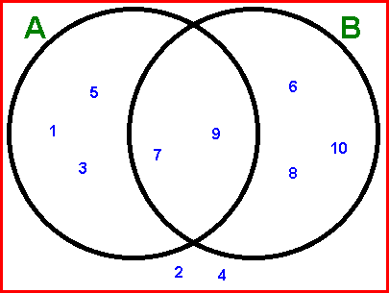

Or

Study the following Venn diagram and answer the following questions?

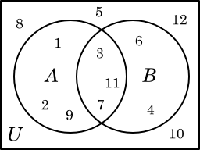

1. Write the elements A – B?
2. Write the elements in B – A?
3. Write the elements in A **∩** B?
4. Write the elements in the universal set which are not in A U B?