Sets

The set concept and the set language play an important role in Mathematics. The theory of set was developed by German Mathematician “**George Canter**”.

**set**

* A set is a well-defined collection of objects.
* Well defined means that

1. There is a universe of objects which are allowed into consideration.
2. Any object in the universe is either an element or is not n element of the set.

* The objects in a set are called ‘***Elements****’*.
* A set will be named by capital letters such as A, B, C ,……
* In a set, all elements are written in a row and separated by commas.
* The elements of a set are enclosed in braces.
* If any element repeated more than one time, we will write only time in the set.

Ex:1) A is set of the letters in the word “Mathematics”.

A = {m, a, t, h, e, i, c, s}

2) B is a set of factors of 6.

B = {1,2,3,6}

* If ‘x’ is an element in the set A then we represent it as x € A (x belongs to set A)
* If ‘x’ is not an element in the set A then we represent it as x ∉ A ( x doesn’t belong to A).

**Describing a set**

* We can describe a set in two forms. They are

1) Roster form (list form)

2) Set builder form (Rule form).

* To describe a set, if we list out all the elements in the set, such form is called “***Roster form*”.**
* To describe a set, if we write the common property of the elements without listing the elements, such form is called “***set builder form****”.*

Ex: A is set of multiples of 2 less than 10.

Roster form A = {2,4,6,8}

Set builder form A = {x/ x = 2n, n € N and n<5}

**Cardinal number of a set**

* The number of elements in a set is called “***Cardinal number*** of the set”.
* The cardinal number of a set A is denoted by n(A).

Ex: A = {a, e, i, o, u}, then n(A) = 5

**Types of set**

**i. Null set:**

* A set having no elements is called ‘***Null set****’*
* Null set is also called as ‘***Empty set***’ or ‘***Void set***’.
* Null set is denoted by ∅.

Ex:1) set of even prime numbers less than 2.

2) B = {x/x ≠ x}

* ∅ = { }
* ∅ ≠ {0}
* ∅ ≠ 0
* ∅ ≠ {∅}
* n(∅) = 0

**ii) Singleton set:**

* A set having only one element is called “***Singleton set***”.
* If A is singleton set then n(A) = 1

Ex: A is set of even prime numbers.

A = {2}.

**iii) Finite set, Infinite set:**

* If the number of elements of a set are countable then it is called *‘****finite set’***.
* The set having uncountable number of elements then it is called ‘***infinite set’***.

Ex: Set of factors of 8 is finite set

Set of multiples of 8 is infinite set

**iv) Sub set of a set:**

* A and B are two sets. If all elements of set A are also belonging to set B then we will say that set A is ***subset*** of set B. It is denoted by A ⊆ B.
* If A ⊆ B then ∀ x € A ⇒ x € B.
* If A ⊆ B then n(A) ≤ n(B).
* Null set is subset to any set.

∅ ⊆ A

* Every set is subset to itself.

A ⊆ A

* The set having only one subset is null set.
* If n(A) = k then number of subsets of set A is 2k.
* Number of non-empty subsets of A is 2k-1.
* If A ⊆ B and B ⊆ C then A ⊆ C

**v) Equal sets**

* If the elements of two sets are equal then the two sets are called “***equal sets***”.
* If A and B are equal sets then it is denoted by A=B.

Ex: A = {2,3,4,5}

B = {4,3,5,2} then A = B.

* If A and B are two sets and all elements in set A belongs to set B and all elements in set B are also belongs to set A then we will say that the two sets are equal sets.( A = B).
* That means if A ⊆ B and B ⊆A then A=B.

**vi) Universal set**

* The set containing all elements in the given problem is called “***Universal set***”.
* It is denoted by μ or M or Ώ
* Every set is subset to universal set.

**Union of two sets**

* A and B are two sets. The set of all elements of set A together with all elements of set B is called ‘**Union set of A and B**’ and denoted by AUB.

Ex: A = {1,3,5,6}

B = {2,3,7,8,9} then

AUB = {1,2,3,5,6,7,8,9}.

* AUB = {x/x € A or x € B}
* x € AUB ⇒ x € A or x € B.
* AUB = BUA
* AU(BUC) = (AUB)UC
* AU∅ = ∅UA = A
* AUµ = µUA = µ
* AUA = A
* A ⊆ AUB
* B ⊆ AUB
* Generally, n(AUB) ≠ n(A) + n(B).
* If A ⊆ B then AUB = B

**Intersection of two sets**

* A and B are two sets. The set of elements which are common to set A and set B is called ‘**Intersection of set A and set B**’. It is denoted by A∩B.

Ex: A = {1,3,5,7}

B = {2,3,6,7,9} then

A∩B = {3,7}

* A∩B = {x/x € A and x € B}
* x € A∩B ⇒ x € A and x € B
* A∩B = B∩A
* A∩(B∩C) = (A∩B)∩C
* A ∩ ∅ = ∅ ∩ A = ∅
* A ∩ µ = µ ∩ A = A
* A∩A = A
* A∩B ⊆ A
* A∩B ⊆ B
* A∩B ⊆ AUB
* If A⊆B then A∩B = A
* n(AUB) + n(A∩B) = n(A) + n(B)
* n(AUB) = n(A) + n(B) - n(A∩B)
* if A=B then n(AUB) = n(A∩B)
* AU(B∩C) = (AUB) ∩ (AUC)
* A∩(BUC) = (A∩B) U (A∩C)

**Difference of two sets**

* A and B are two sets. The set of elements which belongs to set A and doesn’t belong to set B is called ‘**Difference of set A and set B’**.

Ex: A = {1,3,5,7}

B = {2,3,4,5,6} then

A – B = {1,7}

B – A = {2,4,6}

* A – B = {x/x € A and x ∉ B}
* B – A = {x/x € B and x ∉ A}
* A – B ≠ B – A
* A – ∅ = A
* ∅ – A = ∅
* A – A = ∅
* If A ⊆ B then A – B = ∅ and n(A – B) = 0
* If A ⊆ B then n (B – A) = n(B) – n(A)
* A – (A – B) = A∩B
* A – (A ∩ B) = A – B
* n(A – B) = n(A) – n(A ∩ B)
* n(B – A) = n(B) – n(A ∩ B)
* n(A – B) + n(A∩B) + n(B – A) = n(AUB)
* (AUB) – (A∩B) = (A – B) U (B – A)
* (A – B) ∩ (B – A) = ∅
* A – (BUC) = (A – B) ∩ (A – C)
* A – (B∩C) = (A – B) U (A – C)

**Disjoint sets:**

* The sets having no common elements are called “**Disjoint sets**”.

Ex: A is set of even numbers.

B is set of odd numbers.

* A – B and B – A are always disjoint sets.

**Some more properties**

* If A and B are ***disjoint sets*** then

1. A∩B = Φ
2. n(A∩B) = 0
3. n(AUB) = n(A) + n(B)
4. A – B = A
5. B – A = B

* If **A⊆B** then

1. AUB = B
2. A∩B = A
3. A – B = Φ
4. n(A – B) = 0
5. n(B – A) = n(B) – n(A)

* The maximum number of elements in A∩B is n(A) if n(A) < n(B).
* The maximum number of elements in A∩B is n(B) if n(A) > n(B).

**Venn diagrams**

* To represent the sets generally we will use simple closed figures like the following.

* These closed figures are first used by an English mathematician ‘**John Venn**’ in 1880. These figures were also used by another mathematician ‘**Leonard Euler**’. So, these diagrams are called “Venn-Euler” diagrams. Simply we can call them as “**Venn diagrams**”.
* Generally, ***rectangle*** is used to represent universal set.

µ

* If A ⊆ B then we will represent the sets in Venn diagram as follows.

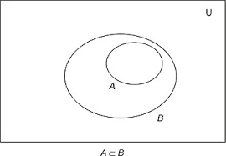

* If A and B are disjoint sets then we will represent the sets in Venn diagram as follows.

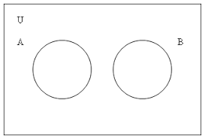

* Generally, we will represent two sets as over lapping circles in Venn diagrams.

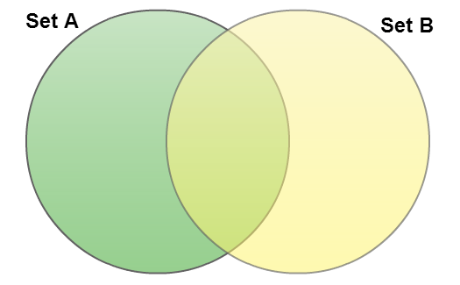

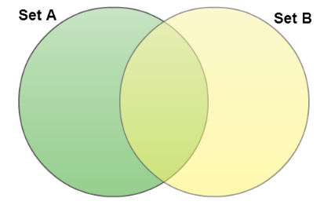

* The Venn diagram of AUB is

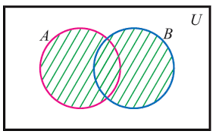B

* The Venn diagram of A∩B is

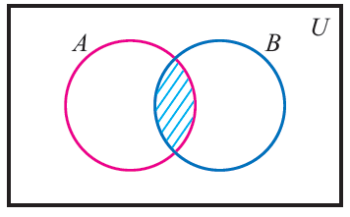

* The Venn diagram of A – B is

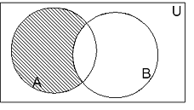

* The Venn diagram of B – A is

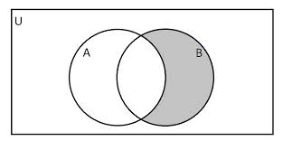

* A – B, A∩B and B – A in a single diagram

