**Self-Assignment - 1**

**Topic: Similar Triangles**

**Class: 10th Max. Marks: 25**

**Answer all questions. Each question carries ½ mark 10 × ½ = 5M**

1. Write any two geometric figures which are always similar?
2. Draw the diagram corresponding to basic proportionality theorem?
3. If the ratio of two similar triangles is 1: 2, then what is the ratio of their corresponding sides?
4. ∆ABC ~ ∆PQR and ∠A + ∠B = 1050 then find ∠R?
5. Write the properties of similar triangles?
6. Define converse of Pythagoras theorem?
7. Jahnavi said, “All squares are similar”. Do you agree with her statement? Justify your answer?
8. Define scale factor of similar triangles?
9. “In ∆ABC, if AB = AC, then ∠B = ∠C”. Write the converse of the statement?
10. What is meant by negation of a statement?

**Answer all questions. Each question carries 1 mark. 4 × 1 = 4M**

1. If the following pair of triangles are similar, find DE?

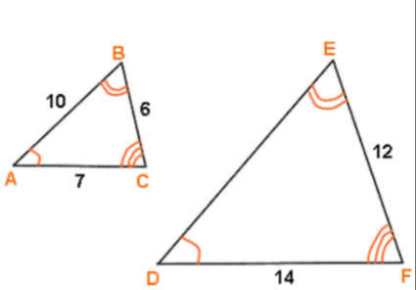

1. Given ∆ABC ~ ∆PQR, AB = 6, BC = 4, AC = 8and PR = 4. Then find the value of PQ + QR?
2. How similarity of triangles are differ from similarity of polygons?
3. Srivani walks 12m due East and turns left and walks another 5m. How far is she from the place she started?

**Answer all questions. Each question carries 2 marks. 4 × 2 = 8M**

1. A ladder of 3.9 m length is laid against a wall. The distance between the foot of the wall and the ladder is 1.5 m. Find the height at which ladder touches the wall?
2. In ∆ABC, AD ⊥ BC and AD² = BD × CD. Prove that ∆ABC is right angled triangle?
3. Draw a line segment of length 6.2cm and divide it in the ratio 3: 2?
4. Prove that in a rhombus sum of squares of sides is equal to sum of the squares of its diagonals?

**Answer all questions. Each question carries 4 marks. 2 × 4 = 8M**

1. Define Thales theorem and prove it?

Or

Define Pythagoras theorem and prove it?

1. Show that the ratio areas of two similar triangles is equal to the ratio of squares of its corresponding sides?

Or

ABC is a right angled triangle right angled at C. Let BC = a, CA = b and AB = c and let ‘p’ be the length of perpendicular from C on AB. Prove that (i) pc = ab (ii) $\frac{1}{p^{2}}= \frac{1}{a²}$ + $\frac{1}{b²}$?