**Similar triangles**

**Similar figures:**

* The figures having same shape are called ‘Similar figures’.
* Two circles, two lines, two squares, two equilateral triangles, two isosceles right-angled triangles are always similar figures,
* Two polygons are said to be similar to each other, if

1. Their corresponding angles are equal and
2. Their corresponding sides are in proportion.

* If two polygons ABCD and PQRS are similar then

**∠**A = **∠**P

**∠**B = **∠**Q

**∠**C = **∠**R

**∠**D = **∠**S and

$\frac{AB}{PQ}$ = $\frac{BC}{QR}$ = $\frac{CD}{RS}$ = $\frac{DA}{SP}$

* If two polygons ABCD and PQRS are similar, then we write it as ABCD **~** PQRS.
* The symbol ‘**~**’ stands for ‘*is similar to*’.
* There is one – one correspondence between the parts of two similar figures.
* The figures having same shape and same size are called ‘Congruent figures
* The symbol for congruent is ‘**≅’ .**
* All congruent figures are similar.
* But all similar figures need not be congruent.

**Similar triangles:**

* Two triangles are said to be similar if they have same shape.
* Triangles are special type of polygons in similarity.
* In case of triangles, if either of the two conditions given in the above definition holds, then the other holds automatically.
* That means “if corresponding angles are equal, then automatically the corresponding sides will be in proportion” or “if corresponding sides are in proportion, then automatically the corresponding angles are equal”.
* Two triangles are said to be similar, if they satisfy any one of the following:

1. Corresponding angles are equal
2. Corresponding sides are in proportion.

* If ΔABC is similar to ΔPQR then we will write it as ΔABC ~ ΔPQR.

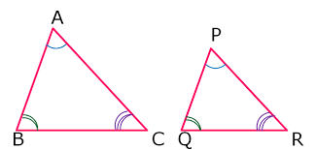

* If ΔABC ~ ΔPQR, then **∠**A = **∠**P

**∠**B = **∠**Q

**∠**C = **∠**R and

$\frac{AB}{PQ}$ = $\frac{BC}{QR}$ = $\frac{AC}{PR}$

**Some basic results on proportionality:**

* If a line is drawn parallel to one side of a triangle interesting the other two sides, then it divides the to sides in the same ratio.

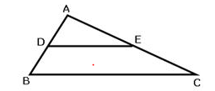

If DE is parallel to BC then $\frac{AD}{DB}$ = $\frac{AE}{EC}$

This is called “***Basic Proportionality Theorem***” or “***Thales Theorem***”.

* If a line divides any two sides of a triangle in the same ratio, then the line must be parallel to the third side.

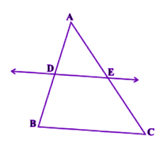

If $\frac{AD}{DB}$ = $\frac{AE}{EC}$, then DE is parallel to the side BC. This is called “***Converse of Basic Proportionality Theorem***”.

* In ΔABC, if DE║BC then

1. $\frac{AD}{DB}$ = $\frac{AE}{EC}$
2. $\frac{AD}{AB}$ = $\frac{AE}{AC}$
3. $\frac{DB}{AB}$ = $\frac{EC}{AC}$

* The internal bisector of an angle of triangle divides the opposite side internally in the ratio of the sides containing the angle.

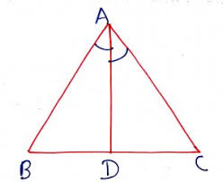

If AD bisects the **∠A** , then $\frac{BD}{DC}$ = $\frac{AB}{AC}$

* In a Trapezium, the diagonals intersect in proportion.

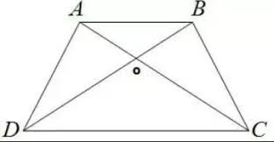 $\frac{AO}{OC}$ = $\frac{BO}{OD}$

* The line drawn from the mid-point of one side of a triangle parallel to another side bisects the third side.
* The line joining the midpoints of any two sides of a triangle is parallel to the third side.

**Criteria for similarity of triangles**:

1. A.A similarity criterion:

“Two triangles are similar, if their corresponding angles are equal”. This is called A.A similarity criterion.

i.e. if **∠**A = **∠**P and **∠**B = **∠**Q then ΔABC ~ ΔPQR.

1. S.S.S similarity criterion:

“Two triangles are similar, if their corresponding sides are in proportion”. This is called S.S.S similarity criterion.

i.e. if $\frac{AB}{PQ}$ = $\frac{BC}{QR}$ = $\frac{AC}{PR}$, then ΔABC ~ ΔPQR.

1. S.A.S similarity criterion:

“If in two triangles, one pair of corresponding sides are in proportional and the included angles are equal then the two triangles are similar”. This is called S.A.S similarity criterion.

i.e. If $\frac{AB}{PQ}$ = $\frac{BC}{QR}$ and **∠**B = **∠**Q then ΔABC ~ ΔPQR.

**Some more characteristic properties of similar triangles:**

* If two triangles are similar, then the ratio of their corresponding sides is same as

1) ratio of corresponding medians

2) ratio of corresponding altitudes

3) ratio of corresponding angle bisectors

4) ratio of corresponding perimeters.

* The ratio of areas of two similar triangles is equal to ratio of squares of corresponding sides.

If ΔABC ~ ΔPQR then, $\frac{(arΔABC)}{ar(ΔPQR)}$ = $\frac{AB²}{PQ²}$ = $\frac{BC²}{QR²}$ = $\frac{AC²}{PR²}$

* The ratio of areas of two similar triangles is equal to

1) ratio of squares of corresponding medians

2) ratio of squares of corresponding altitudes

3) ratio of squares of corresponding angle bisectors

4) ratio of squares of corresponding perimeters.

**Pythagoras theorem:**

* In a right-angled triangle, the square of hypotenuse is equal to the sum of squares of other two sides.

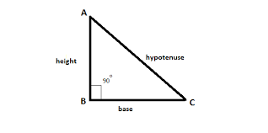AC² = AB² + BC²

* In a triangle, if the square of one side is equal to the sum of other two sides then the angle opposite to the first side is right angle. This is called ‘Converse of Pythagoras theorem’.

**Some applications of Pythagoras theorem:**

* In ΔABC, if **∠**A = 900 and AD⏊ BC then

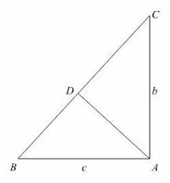

1) BC² = AB² + AC²

2) AB² = BD. BC

3) AC² = CD. BC

4) AD² = BD. DC

5) If AD = p, AB = c, BC = a and AC = b then pa = bc

6) = +

**Some additional concepts:**

* ΔABC is an obtuse angled triangle, obtuse angle of B. If AD⏊ BC, then AC² = AB² + BC² + 2BC. BD

⇒ AC² > AB² + BC².

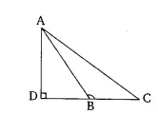

* ΔABC is an acute angled triangle, acute angle of B. If AD⏊ BC, then AC² = AB² + BC² - 2BC. BD

⇒ AC² < AB² + BC².

