**Half mark and one-mark questions**

1. In ∆DEF, A, B and C are the midpoints of EF, FD and DE respectively. If the area of ∆DEF is `14.4 cm², then find area of ∆ABC?
2. In a ∆PQR and ∆XYZ, it is given that ∆PQR ~ ∆XYZ, ∠Y + ∠Z = 900 and XY : XZ = 3 : 4. Then find the ratio of the sides in ∆PQR?
3. In the given figure, ∆ABC ~ ∆ADE, then find the value of ‘x’?

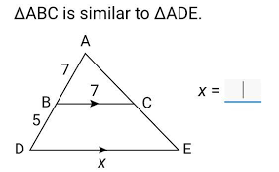

1. It is given that ∆ABC ~ ∆DEF. Is it true to say that $\frac{BC}{CD}$ = $\frac{AB}{EF}$? Justify your answer?
2. Draw the diagram corresponding to basic proportionality theorem?
3. Write the similarity by criterion by which pair of triangles are similar?

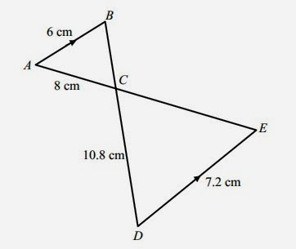

1. Jahnavi said, “All squares are similar”. Do you agree with her statement? Justify your answer?
2. Draw a line segment of length 7.3 cm and divide it in the ratio 3 : 4?
3. in ∆ABC, LM ∥BC and $\frac{AL}{LB}$ = $\frac{2}{3}$, AM = 5 cm, find AC?
4. ∆ABC ~ ∆PQR and ∠A + ∠B = 1150 then find ∠R?
5. If ∆ABC, DE ∥ BC, AD = 2cm, DE = 3cm and AB = 6 cm then find BC?
6. Areas of two similar triangles are 100m² and 64m², If the median of bigger triangle is 10m, then find the median of the smaller triangle?
7. From the following figure find ‘x’?

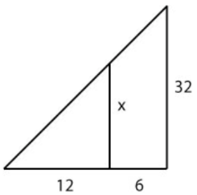

1. What value of ‘x’ will make DE ∥ AB in the given figure? BD = 8x + 9, AD = x + 3, CE = 3x + 4, AE = x?

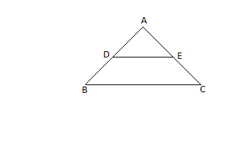

1. What are similar triangles?
2. Write two examples of geometric figures which are always similar?
3. If AB: ZY = BC: XY = AC: ZX, then what is the similar triangle to ∆ABC?
4. Given ∆ABC ~ ∆PQR, AB = 6, BC = 4, AC = 8and PR = 4. Then find the value of PQ + QR?
5. ∆ABC is a isosceles right angled triangle and ∠C = 900 then prove that AB² = 2AC²?
6. If ratio of areas of two similar triangles is 1: 2, then what is the ratio of their corresponding sides?
7. Define Thales’s theorem?
8. Define the converse of Pythagoras theorem?
9. Write the properties of similar triangles?
10. Define scale factor of similar triangles?

**Two marks questions**

1. A ladder of 3.9 m length is laid against a wall. The distance between the foot of the wall and the ladder is 1.5 m. Find the height at which ladder touches the wall?
2. Observe the diagram and find the values of ‘x’ and ‘y’? 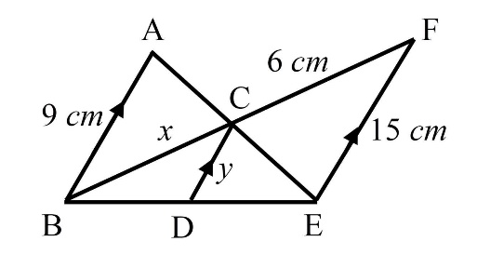
3. Observe the following figure. In ∆PQR, if ST ∥ QR and Ps = x – 2, SQ = x + 5, PT = x – 3 and TR = x + 3, then find the value of ‘x’?

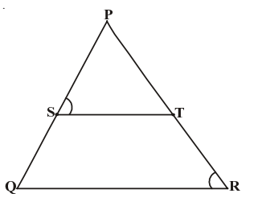

1. In ∆ABC, AD ⊥ BC and AD² = BD × CD. Prove that ∆ABC is right angled triangled?
2. In ∆ABC, D and E are points on AB and AC respectively. If AB = 14 cm, AD = 3.5 cm, AE = 2.5cm and AC = 10 cm. Show that DE ∥ BC?
3. ∆ABC ~ ∆DEF and their areas are 64 cm² and 121 cm² respectively. If EF = 15.4 cm then find BC?
4. Give two different examples of pair of

i) Similar triangles

ii) Non similar triangles.

1. The length of shadow of a vertical stick of length 12 cm is 8 cm. At that same time the length of shadow of a pole is 40 cm. find the height of the pole?
2. Show that the diagonals of a trapezium intersects in proportion?
3. Prove that “if areas of two similar triangles are equal, then they are congruent”.
4. Prove that “in a rhombus ABCD, AB² + BC² + CD² + DA² = AC² + BD²”?
5. ABC is an isosceles triangle where AB = AC and BD is perpendicular to AC. Then prove that BD² - CD² = 2 CD.AD?
6. ∆ABC is an isosceles triangle with AB = AC = 13 cm. The length of altitude from A on BC is 5 cm. find BC?

**Four mark questions**

1. Observe the figure given below: In ∆PQR, if XY ‖ PQ, $\frac{YP}{XP}$ = $\frac{5}{3}$ and XY = 7.2 cm, then find the length of XQ?

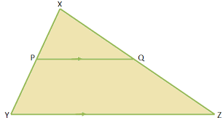

1. ABC is a right angled triangle right angled at C. Let BC = a, CA = b and AB = c and let ‘p’ be the length of perpendicular from C on AB. Prove that (i) pc = ab (ii) $\frac{1}{p^{2}}= \frac{1}{a²}$ + $\frac{1}{b²}$?
2. Construct a triangle of sides 5cm, 6cm and 7cm then construct a triangle similar to it whose sides are 2/3 of the corresponding sides of the first triangle?
3. ABCD is a trapezium with AB ‖ DC, the diagonals AC and BD are intersecting at E. If ∆AED is similar to ∆BCE, then prove that AD = BC?

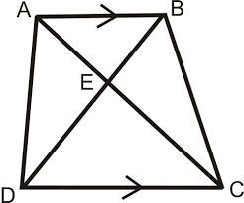

1. State and prove ‘Basic Proportionality Theorem’?
2. Show that the ratio of areas of two similar triangles is equal to the ratio of the squares of their corresponding sides?
3. State and prove ‘Pythagoras Theorem’?
4. A girl of height 90 cm is walking away from the base of lamp post at a speed of 1.2 m/s. If the lamp post is 3.6m above the ground, find the length of her shadow after 4 seconds?
5. AB, CD, PQ are perpendicular to BD. AB = x, CD = y and PQ = z, then prove that $\frac{1}{x}+ \frac{1}{y}= \frac{1}{z}$?

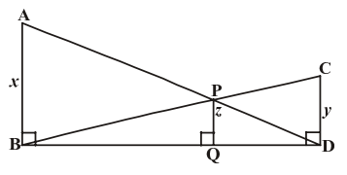

1. ∆ABC is a triangle right angled at B and D is the midpoint of BC. Prove that AC² = 4AD² - 3AB²?
2. In an equilateral triangle, prove that three times of the square of one side is equal to four times to the square of one of its altitudes?
3. The side of an equilateral triangle is ‘a’ units. Then prove that
4. Altitude of the triangle = $\frac{\sqrt{3}}{2}$ a
5. Area of the triangle = $\frac{\sqrt{3}}{4}$ a².
6. A ladder 25m long reaches a window which is 7m above the ground, On one side of the street. Keeping its foot at the same point, the ladder is turned to the other side of the street to reach a window a height of 24m. Find the width of the street?
7. In the given figure ABC is an obtuse angled triangle. ∠B is obtuse angle and AD is perpendicular to CB. Then prove that AC² = AB² + BC² + 2BC.BD?
8. In ∆ABC, AB = AC and D is a point on BC. Then prove that AB² - AD² = BD.CD?