**Half mark and one-mark questions**

1. When an observation in a data is abnormally more than or less than the remaining observations in the data. Does it affect the mean or median or mode? Why?
2. Write the formula to find the mean of a grouped data, using assumed mean and explain each term?
3. The median of observations -2, 5, 3, -1, 4, 6 is 3.5. Is it correct?
4. Write the first 10 prime numbers and find their median?
5. Write the formula to find median of grouped data and explain the alphabet in it?
6. Raju stated that the average of first 10 odd numbers is also 10. Do you agree with him? Justify your answer?
7. Find the median of first seven composite numbers?
8. Find the mode of the data 6, 8, 3, 6, 7, 4, 3, 6, 7, 6?
9. The average of 19, 5, 13, 7, x, 21 is x. Find ‘x’?
10. In calculation of mean, when is the step deviation method appropriate to use?
11. Ravi said, “Mode is always at the centre of the data”. Is it true? Justify?
12. If the mean and median of the data x1, x2, x3, x4, x5 are same? Then what can you say about the observations? (When it is possible?)
13. Find the median of the data $15\frac{2}{3}, 15.03, 15, 15\frac{1}{3}, 15.3$?
14. If the median of the data $\frac{x}{3}, \frac{x}{6}, \frac{2x}{3}, \frac{x}{2}, x$ (x > 0) is 8. Find the value of ‘x’?
15. Find the mean of first ‘n’ natural numbers?
16. What is an Ogive?
17. Santhosh said, “We use mid value of the class to find median of the grouped data”. Do you agree to him? Justify.
18. Find the mean of the factors of 10?
19. What is the median of the data from the graph?

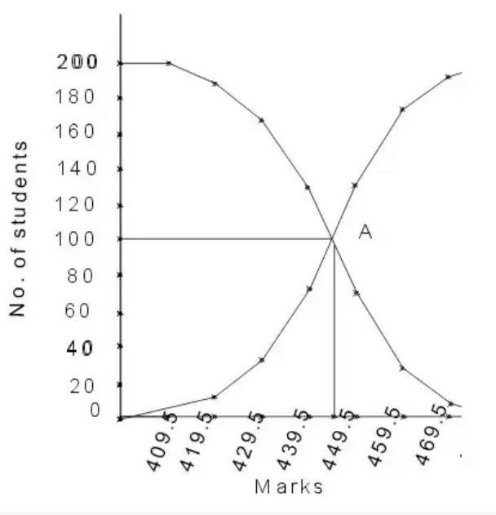

1. The mean of 25 observations is 27. If each observation is decreased by 7, then find the mean of the new data?
2. If the mean of frequency distribution is 7.5 and ∑fi xi = 120 + 3k, ∑fi = 30, then find the value of k?
3. If the mean of first n natural numbers is 3n/5, then find the value of n?
4. To find the mean of grouped frequency distribution in assumed mean method, we are calculating deviation from ________
5. For the following distribution

|  |  |  |  |  |  |
| --- | --- | --- | --- | --- | --- |
| Classes | 0 – 5 | 5 – 10 | 10 – 15 | 15 – 20 | 20 - 25 |
| Frequency | 10 | 15 | 12 | 20 | 9 |

What is the sum of lower limits of median class and modal class?

1. If 35 is removed from the data, 30, 34, 35, 36, 37, 38, 39, 40 then find how much the median increased?
2. Construction of a cumulative frequency table is useful to determining the ____________
3. The median of set of 9 distinct observations is 20.5. If each of the largest 4 observations of the set is increased by 2, then find the median of the new set?

**Two marks questions**

1. The heights of six members of a family are given below in the table.

Find the mean height of the family members.

|  |  |  |  |  |
| --- | --- | --- | --- | --- |
| Height (in ft.) | 5 | 5.2 | 5.4 | 5.6 |
| Number of family members | 1 | 2 | 2 | 1 |

|  |  |  |  |  |  |
| --- | --- | --- | --- | --- | --- |
| Class interval | 10 - 20 | 20 - 30 | 30 - 40 | 40 - 50 | 50 - 60 |
| Frequency | 5 | 8 | 10 | 5 | 2 |

1. Find the values of fixi for the following data, where xi is mid value of each class.
2. Write the less than cumulative frequency and greater than cumulative frequency to the following data?

|  |  |  |  |  |  |
| --- | --- | --- | --- | --- | --- |
| Class interval | 5 - 10 | 10 - 15 | 15 - 20 | 20 - 25 | 25 – 30 |
| Frequency | 4 | 45 | 20 | 13 | 9 |

1. Calculate the mean of the following data?

|  |  |  |  |  |  |
| --- | --- | --- | --- | --- | --- |
| Xi | 5 | 6 | 7 | 8 | 9 |
| Fi | 4 | 8 | 14 | 11 | 3 |

1. Write mark wise frequency to the following data?

|  |  |  |  |  |  |
| --- | --- | --- | --- | --- | --- |
| Marks | 0 - 5 | Below 6 | Below 7 | Below 8 | Below 9 |
| No. of students | 4 | 12 | 21 | 35 | 40 |

1. In the given data, if l = 125, n = 68, c.f = 22, f = 20 and h = 20. Find the median of the data?
2. Write any two difference between the central tendency values mean and median?
3. The average of 13 scores is 8. If one score 20 is deleted from them, find the average of the remaining scores?
4. The mean mark of 30 students is 42. Among them two got zero marks. Find the mean mark of remaining students?
5. If the mean of the observations x, x + 2, x + 4, x + 6 and x + 8 is 11. Find the value of ‘x’?
6. There are four unknown numbers. The mean of first two numbers is 4 and the mean of the first three numbers is 9. If the mean of all observations is 15 and one of them is 2, then find the remaining other numbers?
7. The mean weight of three students is 40kg. One of the students Sathish weighs 46kg. The other two students Santhosh and Shekhar have same weight. Find the weight of Shekhar?
8. Write the median class of the following data?

|  |  |  |  |  |  |  |  |  |
| --- | --- | --- | --- | --- | --- | --- | --- | --- |
| Class | 0 - 10 | 10 -20 | 20 - 30 | 30 -40 | 40 - 50 | 50 - 60 | 60 - 70 | 70 - 80 |
| frequency | 5 | 8 | 7 | 12 | 28 | 20 | 10 | 10 |

**Four marks questions**

1. Find the mean age of 100 residents of a colony from the following data?

|  |  |  |  |  |  |  |  |
| --- | --- | --- | --- | --- | --- | --- | --- |
| Age | 0 - 10 | 10 - 20 | 20 -30 | 30 - 40 | 40 - 50 | 50 -60 | 60 - 70 |
| No. of persons | 10 | 15 | 25 | 25 | 10 | 10 | 5 |

1. If the mean of the following distribution is 50. Then find the value of ‘k’?

|  |  |  |  |  |  |
| --- | --- | --- | --- | --- | --- |
| Class | 0 - 20 | 20 - 40 | 40 – 60 | 60 - 80 | 80 - 100 |
| frequency | 17 | 20 | 32 | k | 19 |

|  |  |  |  |  |  |  |
| --- | --- | --- | --- | --- | --- | --- |
| Weight in kg | 30 - 35 | 35 - 40 | 40 - 45 | 45 - 50 | 50 - 55 | 55 - 60 |
| No. of students | 4 | 5 | 10 | 8 | 8 | 5 |

1. The below distribution gives the weight of 40 students in a class. Find the median weight of the students?
2. Incomes of the families in a locality are given. Find the mode of the data

|  |  |  |  |  |  |
| --- | --- | --- | --- | --- | --- |
| Income | 1 - 200 | 201 - 400 | 401 - 600 | 601 - 800 | 801 - 1000 |
| Number of families | 7 | 10 | 16 | 12 | 3 |

1. Find the missing frequencies f1 and f2 if mean of 50 observations given below is 36.4?

|  |  |  |  |  |  |  |  |
| --- | --- | --- | --- | --- | --- | --- | --- |
| Class | 0 - 10 | 10 - 20 | 20 - 30 | 30 - 40 | 40 - 50 | 50 - 60 | 60 - 70 |
| Frequency | 3 | 5 | F1 | 10 | F2 | 8 | 5 |

1. The following distribution gives the daily profits earned by 50 shops in a locality. Convert the distribution to a “less than type “cumulative frequency distribution and draw it’s Ogive?

|  |  |  |  |  |  |  |
| --- | --- | --- | --- | --- | --- | --- |
| Profit | 0 - 50 | 50 - 100 | 100 - 150 | 150 - 200 | 200 - 250 | 250 - 300 |
| No. of shops | 6 | 9 | 13 | 10 | 8 | 4 |

1. If the median of the 60 observations given below is 28.5. Then find the values of ‘x’ and ‘y’?

|  |  |  |  |  |  |  |
| --- | --- | --- | --- | --- | --- | --- |
| Class intervals | 0 - 10 | 10 - 20 | 20 - 30 | 30 - 40 | 40 - 50 | 50 - 60 |
| Frequency | 5 | x | 20 | 15 | y | 5 |

1. The literacy rate of 35 cities is given in the following table. Prepare more than type cumulative frequency table and draw ogive curve for this data?

|  |  |  |  |  |  |
| --- | --- | --- | --- | --- | --- |
| Literacy | 40 - 50 | 50 – 60 | 60 - 70 | 70 - 80 | 80 - 90 |
| No. of cities | 3 | 11 | 10 | 8 | 3 |

1. The following data gives the information on the observed lifespan of 90 electrical components. Draw both ogive for the data?

|  |  |  |  |  |  |  |
| --- | --- | --- | --- | --- | --- | --- |
| Lives span | 0 - 20 | 20 - 40 | 40 - 60 | 60 - 80 | 80 - 100 | 100 - 120 |
| Frequency | 8 | 12 | 15 | 23 | 18 | 14 |

1. Draw less than ogive for the following frequency distribution. Find the median from obtained curve?

|  |  |  |  |  |  |  |  |
| --- | --- | --- | --- | --- | --- | --- | --- |
| I Q | 60 - 70 | 70 - 80 | 80 - 90 | 90 - 100 | 100 - 110 | 110 - 120 | 120 - 130 |
| No.of students | 2 | 5 | 12 | 31 | 39 | 10 | 4 |