**TRIGONOMETRY**

**Basic concepts:**

* The word ‘Trigonometry’ is derived from the Greek words ‘Trigonon’ and ‘metron’.
* The word trigonon means a triangle and the word metron means measure.
* Trigonometry means the science of measuring triangles.
* Father of Trigonometry is ‘***Hipparchus***’.
* Indian mathematician ‘***Aryabhata***’ discovered sine function.

**Trigonometric Ratios:**

* Trigonometric ratios are ratios of the sides in a right-angle triangle.

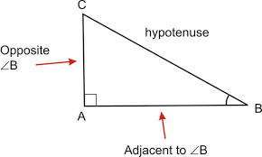

* There are six trigonometric ratios defined as follows.

Sine θ = Sin θ = $\frac{opposite side of θ}{hypotenuse }$

Cosine θ = Cos θ = $\frac{adjacent side of θ}{hypotenuse }$

Tangent θ = Tan θ = $\frac{opposite side of θ}{adjacent side of θ }$

Cosecant θ = Cosec θ = $\frac{hypotenuse}{opposite side of θ}$

Secant θ = Sec θ = $\frac{hypotenuse}{adjacent side of θ}$

Cotangent θ = Cot θ = $\frac{adjacent side of θ}{opposite side of θ}$

* Trigonometric ratios are real numbers.
* It should be noted that *sin θ* is an abbreviation for ‘*sine of angle θ’*. It is not the product of sin and θ.
* The trigonometric ratios are same for the same angle.

**Relations between trigonometric ratios:**

* Sin θ × cosec θ = 1
* cos θ × sec θ = 1
* tan θ × cot θ = 1
* tan θ × cosec θ = sec θ
* cot θ × sec θ = cosec θ
* sin θ = $\frac{1}{cosec θ}$
* cos θ = $\frac{1}{\sec{θ}}$
* tan θ = $\frac{1}{\cot{θ}}$ = $\frac{\sin{θ}}{\cos{θ}}$ = $\frac{\sec{θ}}{cosec θ}$
* cosec θ = $\frac{1}{\sin{θ}}$
* sec θ = $\frac{1}{\cos{θ}}$
* cot θ = $\frac{1}{\tan{θ}}$ = $\frac{\cos{θ}}{\sin{θ}}$ = $\frac{cosec θ}{\sec{θ}}$

**Values of trigonometric ratios:**

* If θ is an acute angle then sin θ value lies between 0 and 1. And it is increasing function.

If 00 < θ < 900, then 0 < sin θ < 1

If A ≥ B, then sin A ≥ sin B

* If θ is an acute angle then cos θ value lies between 0 and 1. And it is decreasing function

If 00 < θ < 900, then 1 < cos θ < 0

If A ≥ B, then cos A ≤ cos B

* If θ is an acute angle then tan θ value lies between 0 and infinite. And it is increasing function.

If 00 < θ < 900, then 0 < tan θ < ∞

If A ≥ B, then tan A ≥ tan B

* If 00 < θ ≤ 450 then sin θ ≤ cos θ.

⇒ sin θ – cos θ is negative.

⇒ cos θ – sin θ is positive.

* If 450 < θ ≤ 900 then sin θ > cos θ.

⇒ sin θ – cos θ is positive.

⇒ cos θ – sin θ is negative

**Values of trigonometric ratios for standard angles:**

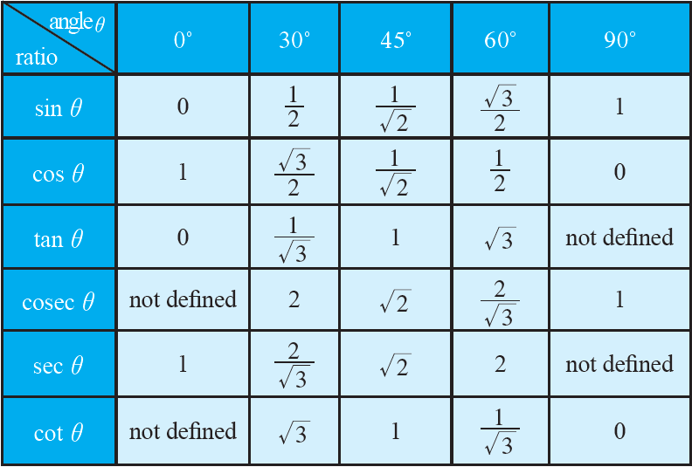

* From the table, we can notice that

a) At 450, sin θ = cos θ

tan θ = cot θ

cosec θ = sec θ

b) If A + B = 900, then sin A = cos B

tan A = cot B

cosec A = sec B

**Trigonometric ratios for complementary angles:**

* If sum of two angles is 900, then are called as ‘Complementary angles.’
* The complementary angle of ‘θ’ is (900 – θ).
* Sin (900 – θ) = Cos θ
* Cos (900 – θ) = Sin θ
* Tan (900 – θ) = Cot θ
* Cosec (900 – θ) = Sec θ
* Sec (900 – θ) = Cosec θ
* Cot (900 – θ) = Tan θ

**Identities in Trigonometry:**

* The equations which are true for any value of the variable(s) involved in it are called ‘Identities’.

ex: (a + b)² = a² + 2ab + b²

a² - b² = (a + b) (a – b)

* An identity equation having trigonometric ratios of an angle is called ‘***Trigonometric identity***’.
* Trigonometric identities are true for all the values of angles involved in it.
* We have mainly three trigonometric identities. They are

sin² θ + cos² θ = 1

sec² θ – tan² θ = 1

cosec² θ – cot² θ = 1

* ***First identity:*** sin² θ + cos² θ = 1

sin² θ = 1 – cos² θ

cos² θ = 1 – sin² θ

sin θ = $\sqrt{1-cos^{2}θ}$

cos θ = $\sqrt{1-sin^{2}θ}$

* ***Second identity:*** sec² θ – tan² θ = 1

tan² θ – sec² θ = -1

sec² θ = 1 + tan² θ

tan² θ = sec² θ – 1

sec θ = $\sqrt{1+tan^{2}θ}$

tan θ = $\sqrt{sec^{2}θ-1}$

(sec θ + tan θ) (sec θ – tan θ) = 1

sec θ + tan θ = $\frac{1}{\sec{θ - \tan{θ}}}$

sec θ – tan θ = $\frac{1}{\sec{θ + \tan{θ}}}$

* ***Third identity:*** cosec² θ – cot² θ = 1

cot² θ – cosec² θ = -1

cosec² θ = 1 + cot² θ

cot² θ = cosec² θ – 1

cosec θ = $\sqrt{1+cot^{2}θ}$

cot θ = $\sqrt{cosec^{2}θ-1}$ (cosec θ + cot θ) (cosec θ – cot θ) = 1

cosec θ + cot θ = $\frac{1}{cosec θ -\cot{θ}}$

cosec θ – cot θ = $\frac{1}{cosec θ +\cot{θ}}$

NOTE: 1) sec² θ – tan² θ = 1 is true if 00 ≤ θ < 900.

2) cosec² θ – cot² θ = 1 is true if 00 < θ ≤ 900.

3) sin² θ + cos² θ = 1 is true if 00 ≤ θ ≤ 900.

**s**