CSCI 547- Image Processing

Histogram Equalization and Image Enhancement

Samrajya Thapa

Project Report

02/20/2020

**Image Histogram and CDF**

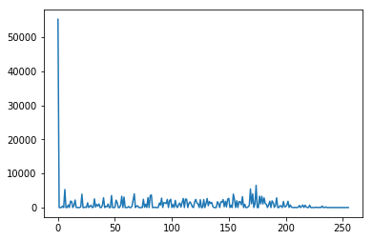Firstly, Let’s look at the histogram(pdf) and the Cumulative Distribution Function(cdf) of the original images of the fish and the jet.

Fig : Fish PDF

Fig : Fish CDF

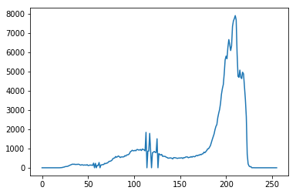

Fig : Jet PDF

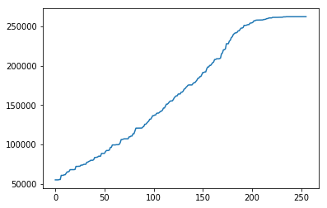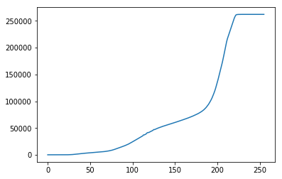

Fig : Jet CDF

The histogram of the images shows the number of pixels at a certain grey level(r) and the cdf of the image shows the probability of observing a certain grey level(r).

We can observe that there are a lot of pixels of grey level 0 in the fish image since it is a very dark image. For jet there are lot more white pixels rather than dark as we see a surge in pixels of grey level of around 200.

**Contrast Stretching Image and Histogram**

Secondly, Let’s take a look at the images and histograms of the images after a contrast stretch in between pixels 10% and 90% of the cdf is done. The pixels below and above 10% and 90% are set to 0 and 255 (black and white) respectively.

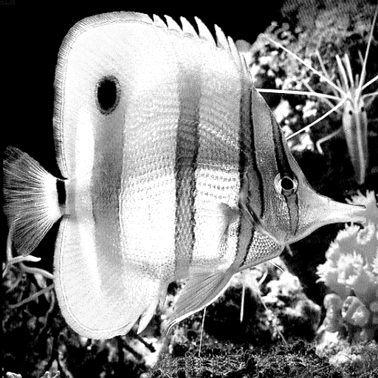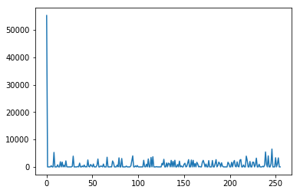

Fig : Fish Contrast Stretched PDF

Fig : Fish Contrast Stretched CDF

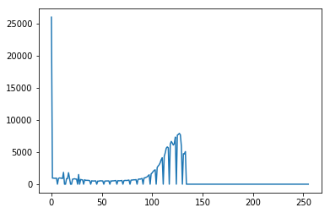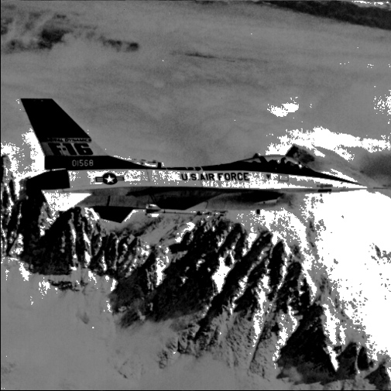

Fig : Jet Contrast Stretched CDF

Fig : Jet Contrast Stretched PDF

Here, we can observe in both cases that the contrast of the has gotten brighter. When we compare the cdf of the new images with the old ones, we can see that in the fish image the pixels above 90% of cdf is changed to white and since 10% of cdf was just 0 in case of fish, no pixels were changed under 10%. But for Jet we can see a big difference in the histogram since all pixels below 10% of cdf has been changed to black and all pixels above 90% has been changed to white, and the pixels in between has been linearly stretched.

**Image Level Slicing**

Next, Let’s take a look at the images and histogram of the images when we do level slicing of the images with grey level 150.

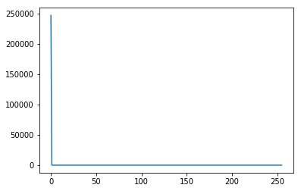

Fig : Fish Level Sliced Histogram

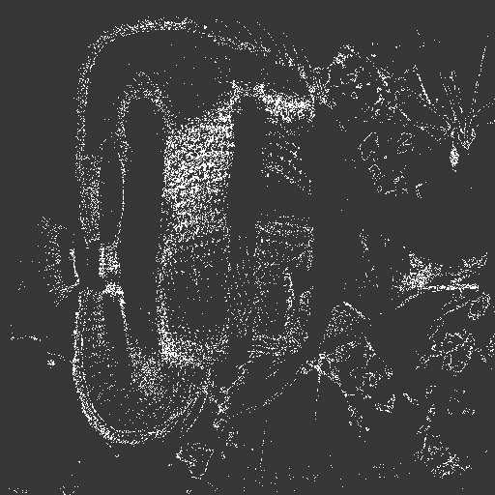

Fig : Fish Level Sliced 150

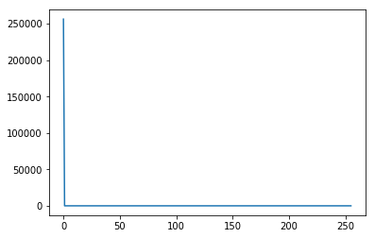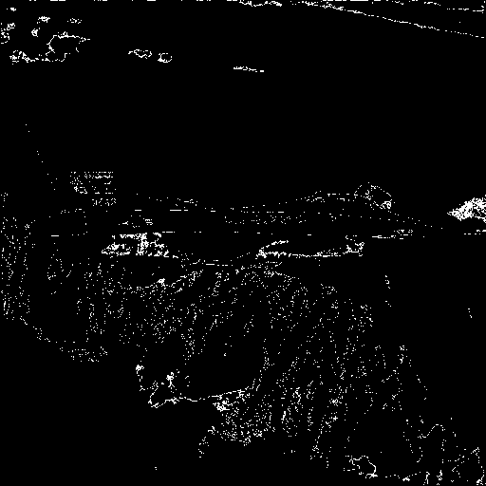

Fig : Jet Level Sliced Histogram

Fig : Jet Level Sliced 150

Here, what’s happening is that we are selecting a grey level, in this case L=150, and we are changing all pixels from, L to L+10, to intensity value of 255(white) and all other pixels to 0(black). This showcases the feature of certain pixel values and brings out it’s outline. In the fish image, we can almost see the outline of the whole fish. In the Jet image the lower part of the image is focused. In the cdf we can see, there is only white and black pixels.

**Histogram Equalization**

Lastly, Let’s take a look at the images and histogram of the images after we normalize the images.

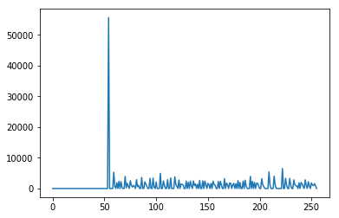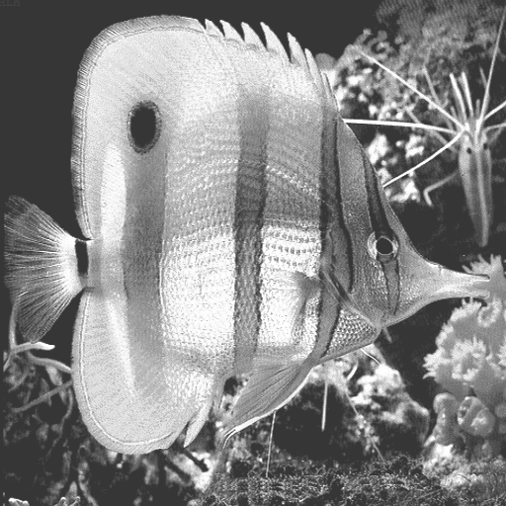

Fig : Fish Equalized Histogram

Fig : Fish Equalized

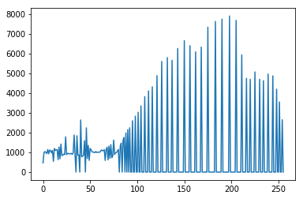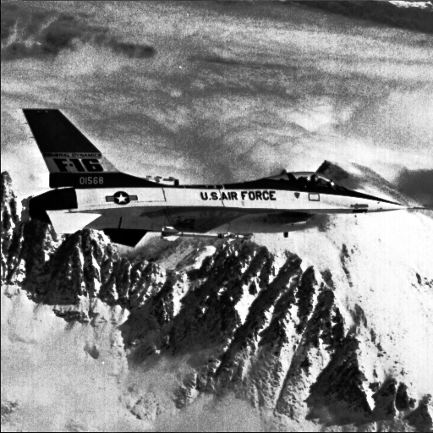

Fig :Jet Equalized

Fig : Jet Equalized Histogram

Here, we observe that both the images are more normalized and almost uniform. That is what histogram equalization does, it normalizes the image. Due to this normalization, the pixels of low contrast values gained a higher contrast allowing the image to look sharper. We can observe this from the histogram, in the jet image the pixel intensity around 200 which was clustered before has spread out more.