PA3 Write-up: Augmented Reality Website with Hit-Testing
Student ID: 241487. Variant: bedside table (0.45 × 0.40 × 0.55 m), multi mode (up to 5 products), 12° surface tolerance, product keeps the orientation of the hit pose.
Test setup: MacBook, Chrome, Immersive Web Emulator v2.0.0 (Meta Quest 3 profile), as agreed in the lecture. No Android device was available. Repository: github.com/svulee-jpg/AR-VR-XR-Assignments, folder PA3_241487_Amangeldyyeva. In my emulator session the DOM overlay panel was not visible, so the values I report come from console logs that I added to the code.

E1. Reference spaces
Prediction: in local space the origin is where the session started, so the camera starts at about (0, 0, 0). A hit on the floor in front of me should be about 1 to 2 m away in viewer space, along −z, because the viewer looks down its −z axis.
Result: camera in local space at start: (0.00, 0.00, 0.00). For one hit, hit.getPose(viewerSpace) gave (0.00, 0.00, −1.69) and hit.getPose(localSpace) gave (−0.68, −1.55, −0.04) (Figure 4). In my second placement the camera was still (0.00, 0.00, 0.00): I rotated the view with the mouse and did not move the headset 1 m, so the 1 m walk test is incomplete.
Explanation: both poses are the same point described in two coordinate systems. Their distance from the camera is equal: √(0.68² + 1.55² + 0.04²) ≈ 1.69 m. Viewer space is attached to the camera, so a hit straight ahead is (0, 0, −d) and changes whenever the camera moves. Local space is fixed to the room, so the same hit keeps its coordinates; here y = −1.55 means the floor is 1.55 m below the start point of the camera. The hit-test source is created from viewer because the ray must start at the camera and follow where it looks. Results are read in local because placed products must stay fixed in the world and not move with the camera.
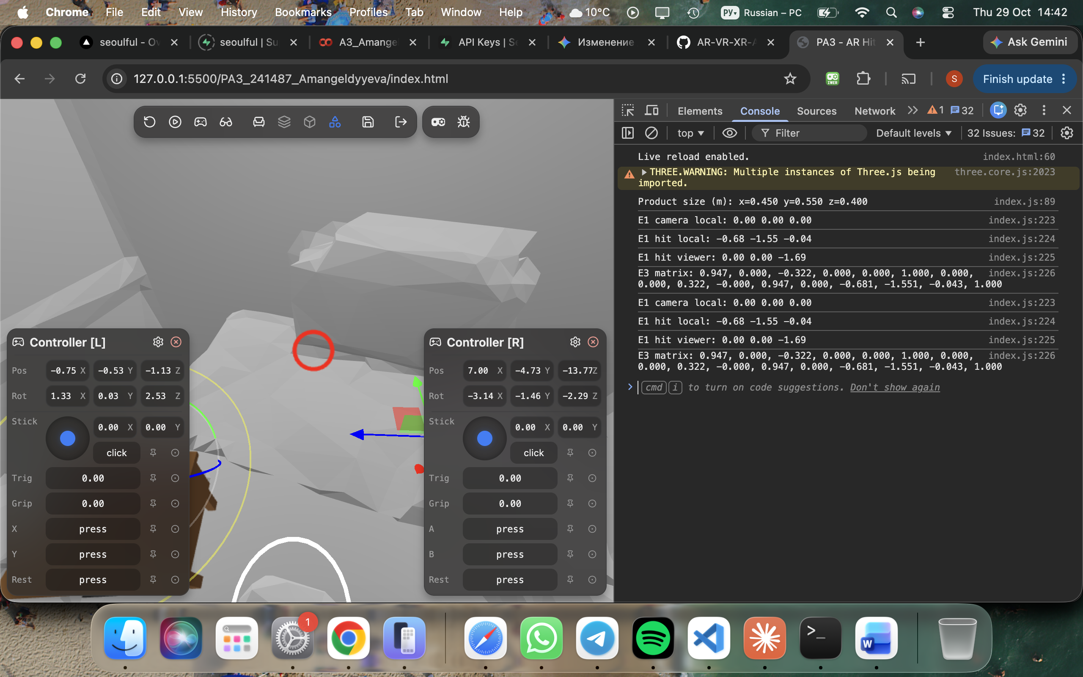
Figure 4. Console: camera, hit in local and viewer space, matrix, product size.

E2. Checking Chapter 7
(a) Prediction: with anchors the products stay fixed after I walk away and come back; without anchors they may drift, because a hit result is a one-time pose.
Result: the emulator has perfect tracking and I did not move the headset 3 m, so I could not measure drift with anchors on or off; I report this limitation honestly.
Explanation: a hit result is a snapshot of where a ray met a surface at one moment and is never updated. An anchor is an object that the system keeps attached to the real world and corrects as tracking improves. My code follows each anchor every frame with frame.getPose(anchor.anchorSpace, localSpace).
(b) local-floor puts the origin on the floor and gives the real height of the viewer. It changes where (0, 0, 0) is, not how surfaces are found, so it does not help hit testing. I use local, as in the book.
(c) In WebXRManager.js (Three.js r186) setSession already performs the book's three critical tasks: it makes the WebGL context XR-compatible (makeXRCompatible, line 429, only if xrCompatible was not set), it creates the XRWebGLLayer and passes it with session.updateRenderState (lines 451 to 453, used when the browser has no projection layers; otherwise a projection layer is created at about lines 488 to 498), and it requests the reference space (line 526). So setupWebGLLayer() from the book is not needed.
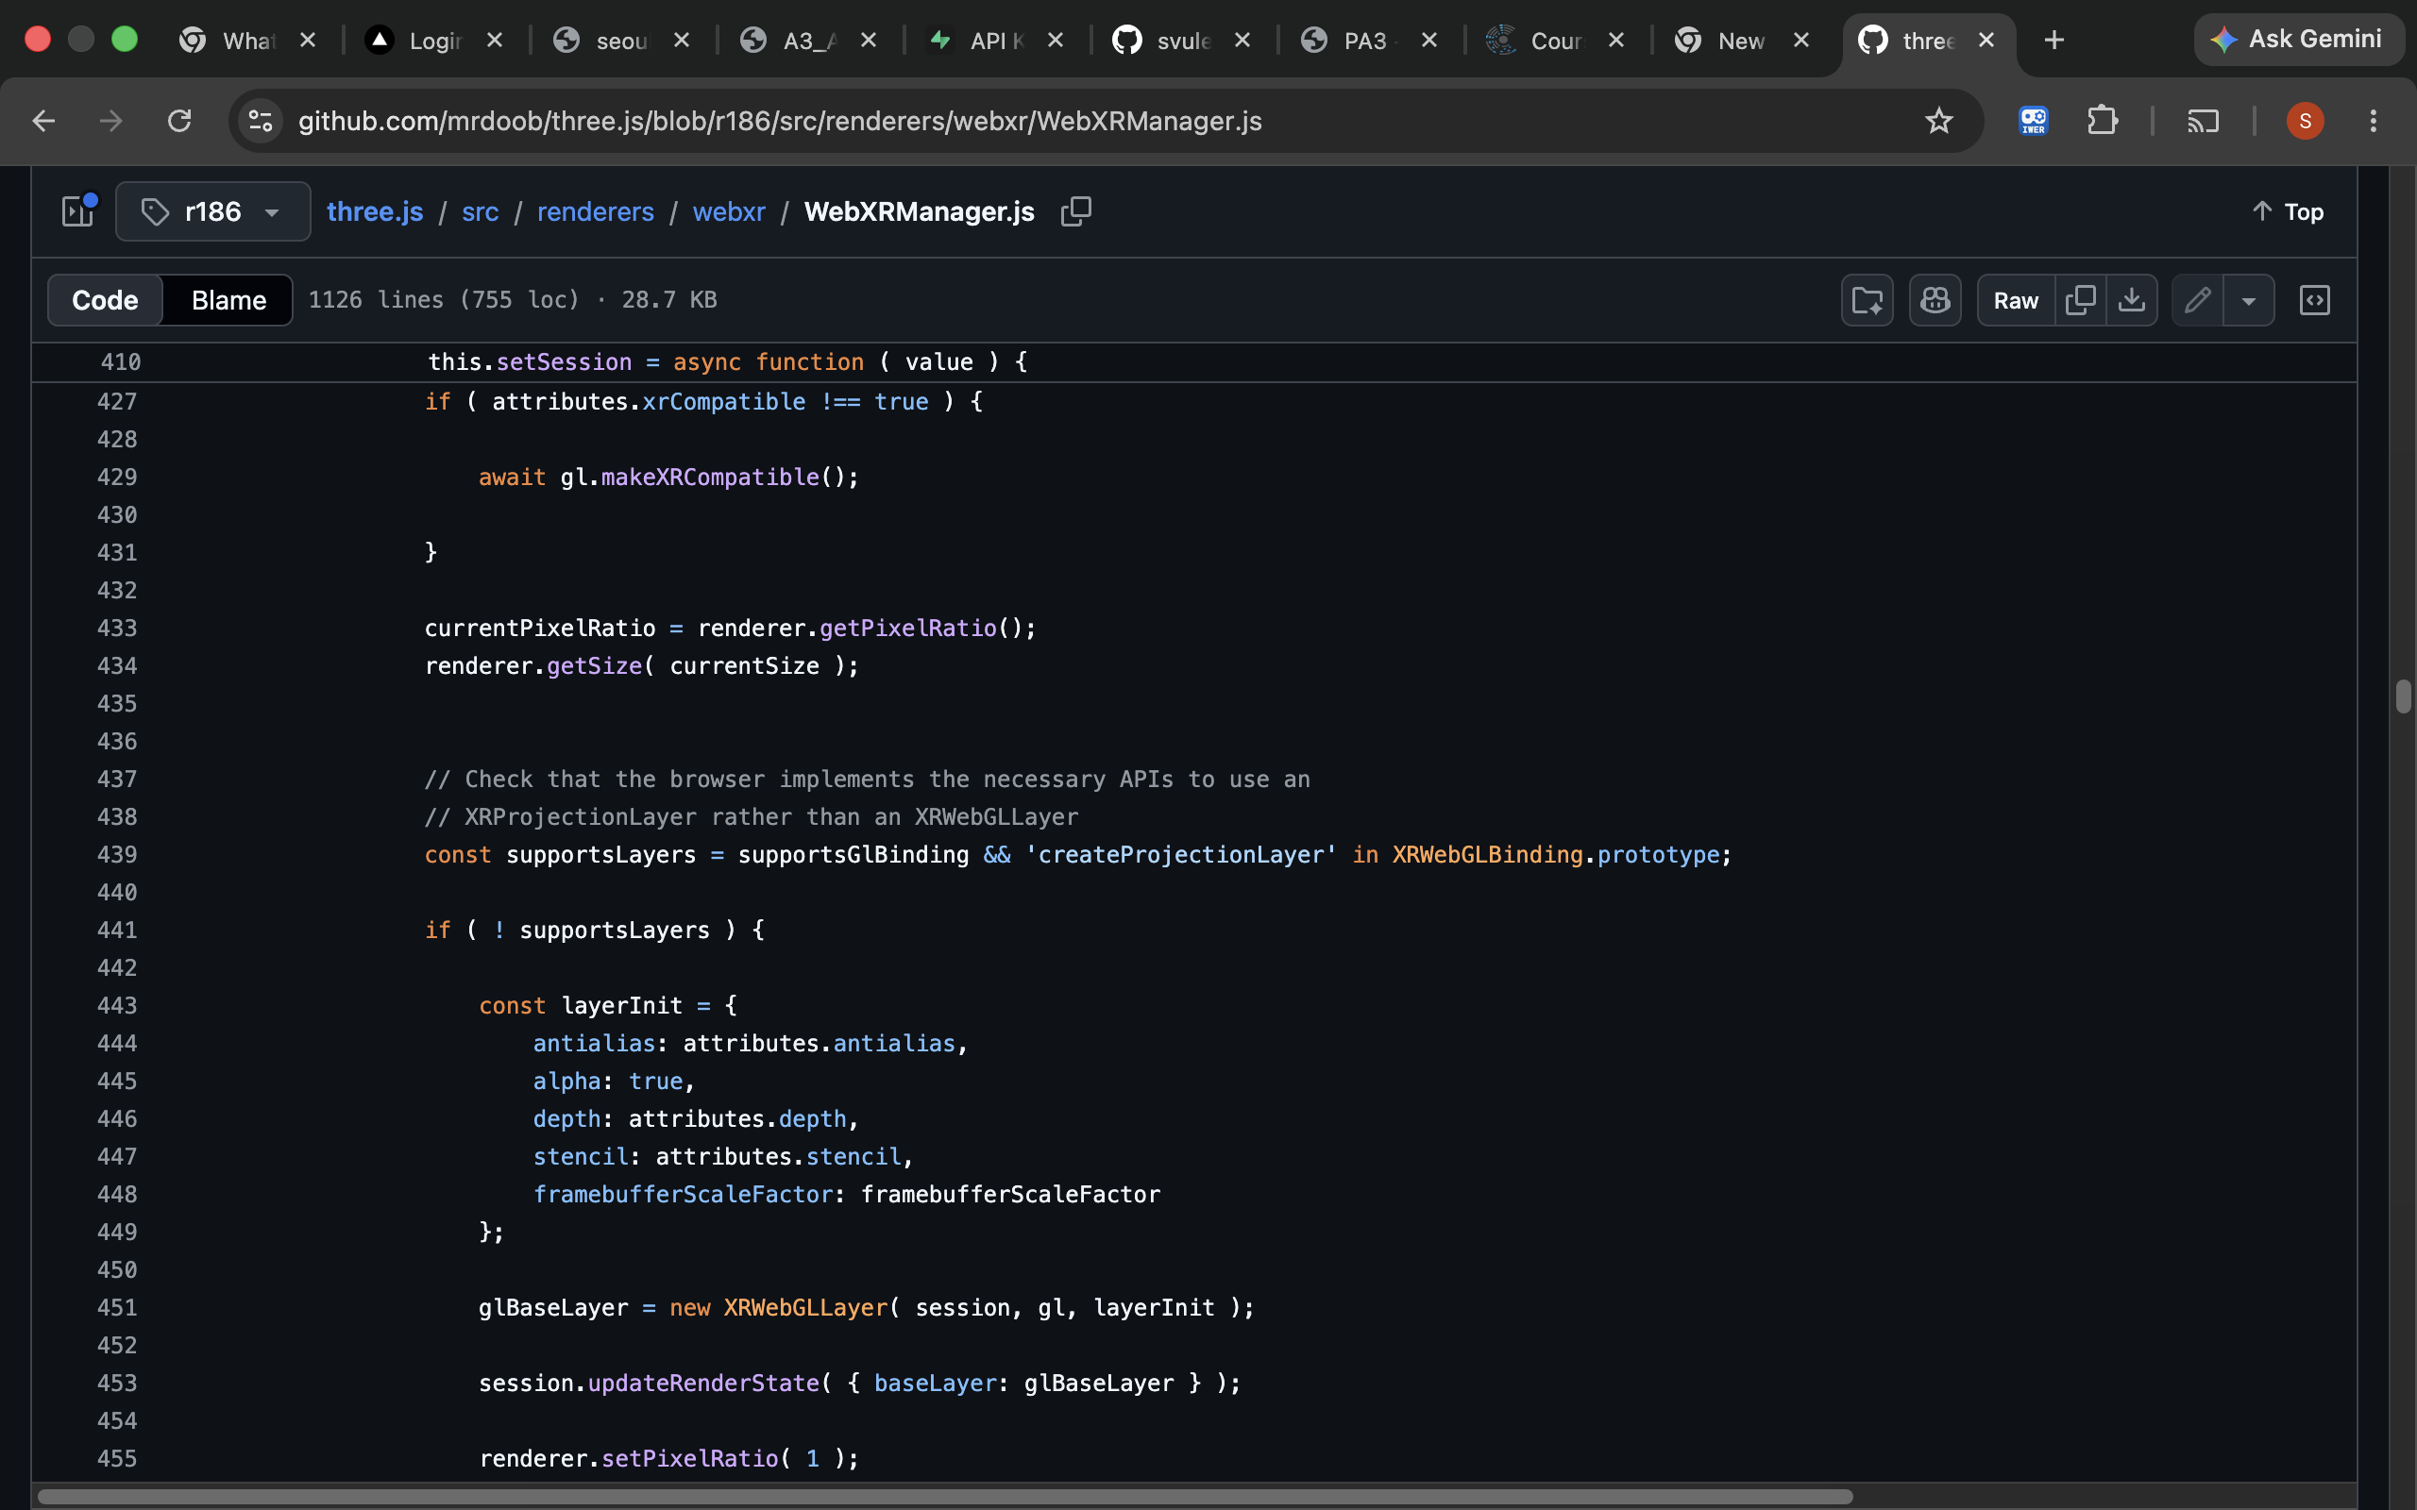
Figure 5. WebXRManager.js (r186), setSession: makeXRCompatible (line 429), XRWebGLLayer (line 451) and updateRenderState (line 453).
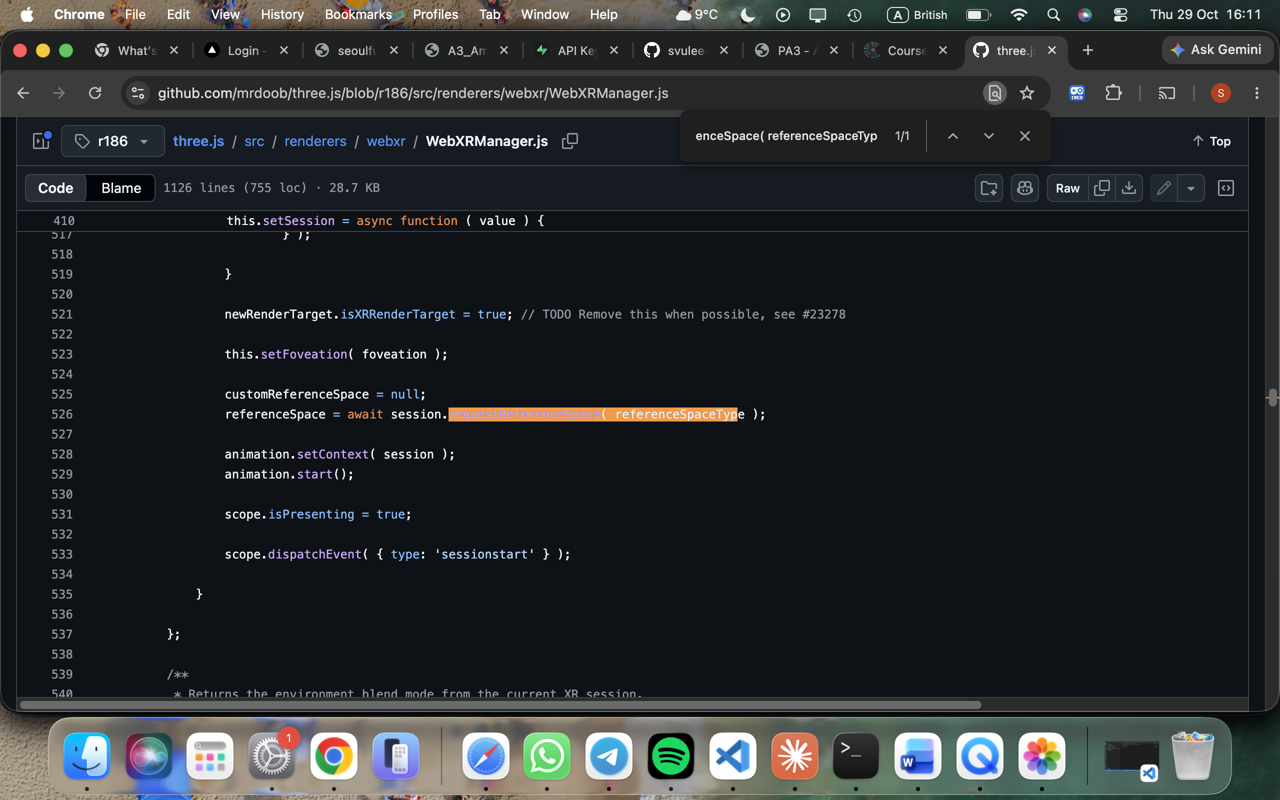
Figure 6. WebXRManager.js (r186), setSession: session.requestReferenceSpace at line 526.

E3. Reading the pose matrix
Prediction: on flat ground the y column of the matrix (elements 4, 5, 6) is about (0, 1, 0), so the tilt is about 0° and the reticle is green. On a steep rock or a wall the angle is above 12° and the reticle is red.
Result: for one placement the 16 values were: 0.947, 0.000, −0.322, 0.000, 0.000, 1.000, 0.000, 0.000, 0.322, 0.000, 0.947, 0.000, −0.681, −1.551, −0.043, 1.000. Position = elements 12 to 14 = (−0.681, −1.551, −0.043). Surface normal = elements 4 to 6 = (0, 1, 0).
By hand: tilt = arccos(n · up) = arccos(0·0 + 1.000·1 + 0·0) = arccos(1) = 0°, which is below 12°, so the reticle is green and placement is allowed. The other columns show a rotation about y of about 19° (arcsin 0.322); this is why the table is not aligned with the view.
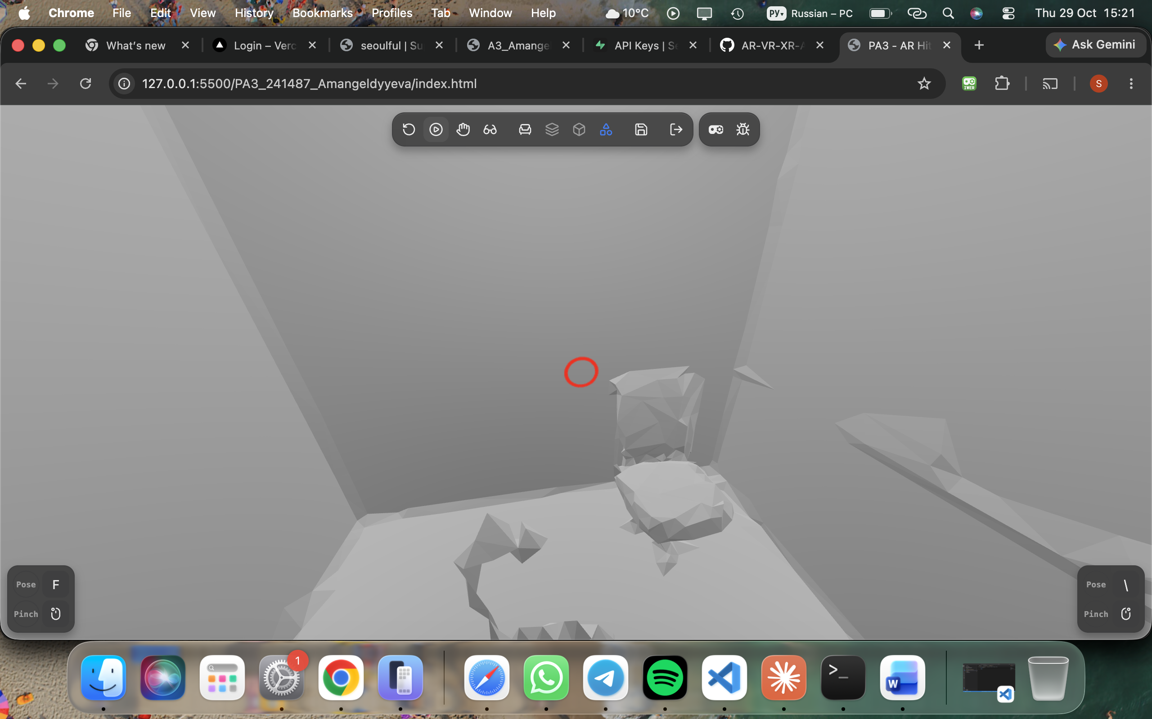
Figure 1. Red reticle: surface too tilted, a tap places nothing.
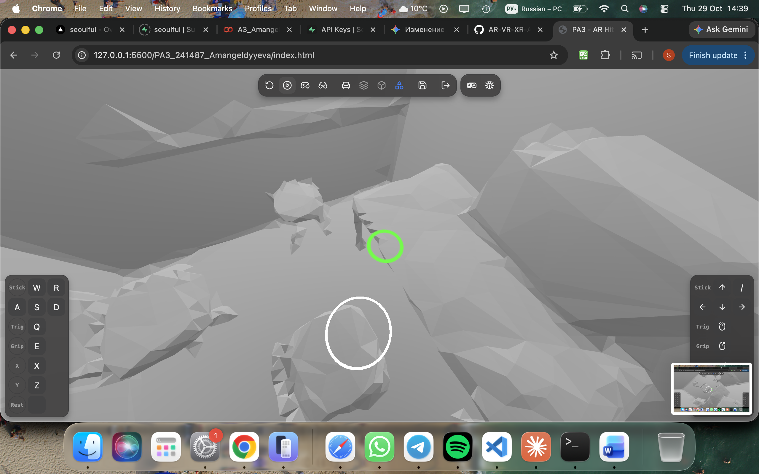
Figure 2. Green reticle on flat floor: placement allowed.
The overlay was not visible in the emulator, so I could not read the exact tilt of the red case.

E4. How the device finds surfaces
The camera finds feature points (corners, texture) in every frame. The motion sensors (accelerometer, gyroscope) measure how the device moved between frames. Visual-inertial odometry combines both to estimate the device position and orientation. Many feature points lying on one flat area become a detected plane. A plain white or glossy surface has few features, so it is harder to detect.
Result: seconds to first hit were not measured, because the emulator uses a fixed simulated environment and I had no real device.

E5. Scale check
Prediction: the table is 0.55 m high, so any size error should be below 2 cm. Result: Box3 in my code logs x = 0.450, y = 0.550, z = 0.400 m (Figure 4), so the error against the variant table is 0.000 m in every dimension. I did not compare the table with a real object because I used the emulator. On a real device, two likely sources of error are tracking drift and the reticle sitting slightly above or below the real floor.
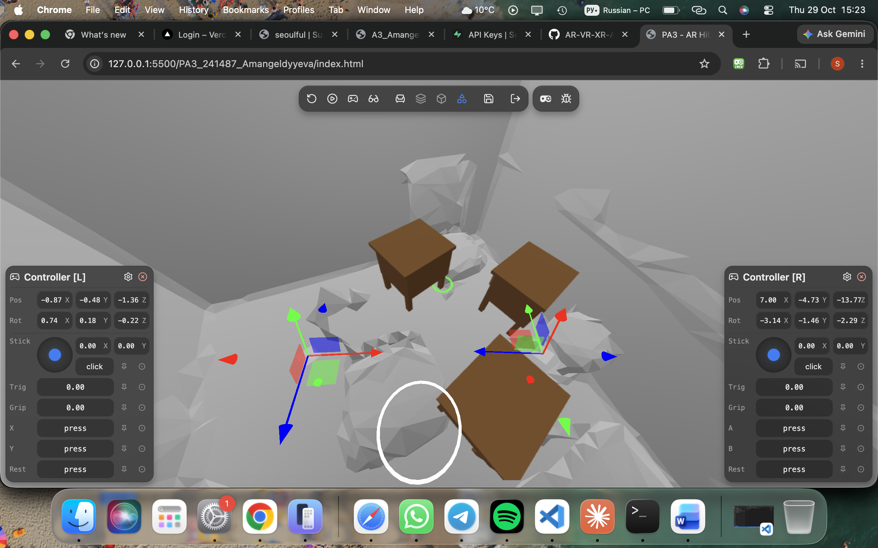
Figure 3. Three tables placed in multi mode (up to 5; the 6th tap removes the oldest).

E6. Product preview for a retailer
Failure mode 1: no surface is found on a plain or glossy floor, so the customer cannot place the product. Fix: show a hint such as 'point at a textured floor and move slowly'. Failure mode 2: tracking is lost and products slide. Fix: use anchors and a tracking-lost warning that blocks placement (my code does this). A WebXR page receives surface and pose data only after the user agrees to AR; it does not receive the raw camera video or photos of the room. Users should be told this, and that the page stores nothing.

Development log
Bug: the Chapter 7 code requested a new hit-test source on every frame, because hitTestSourceRequested was never set to true. Found by reading the render loop against the porting notes. Fixed by setting the flag before the single request from viewer space and cancelling the source in onSessionEnd, in commit e415de1.

AI use
Claude (Anthropic) was used as an assistant for this work, as allowed by the instructor in the lecture. I tested the application and checked the results myself.

