PA3 Write-up: Augmented Reality Website with Hit-Testing
Student ID: 241487. Variant: bedside table (0.45 × 0.40 × 0.55 m), multi mode (up to 5), 12° tolerance, product keeps the hit-pose orientation.
Setup: MacBook, Chrome, Immersive Web Emulator v2.0.0 (Meta Quest 3 profile), as agreed in the lecture; no Android device was available. Repository: github.com/svulee-jpg/AR-VR-XR-Assignments, folder PA3_241487_Amangeldyyeva. The DOM overlay was not visible inside the emulator session, so values come from console logs I added to the code.

E1. Reference spaces
Prediction: in local space the origin is where the session started, so the camera is at about (0, 0, 0). A floor hit 1 to 2 m ahead is along −z in viewer space.
Result: camera in local space at start: (0.00, 0.00, 0.00). One hit: viewer-space (0.00, 0.00, −1.69), local-space (−0.68, −1.55, −0.04) (console screenshot in Test process). The camera stayed at (0, 0, 0) in later placements because I rotated the view with the mouse and did not move the headset 1 m, so the 1 m walk test is incomplete.
Explanation: both poses are the same point in two coordinate systems; the distance from the camera is equal, √(0.68² + 1.55² + 0.04²) ≈ 1.69 m. Viewer space is attached to the camera, so a hit straight ahead is (0, 0, −d) and changes when the camera moves. Local space is fixed to the room, so the same hit keeps its coordinates; y = −1.55 means the floor is 1.55 m below the camera start point. The source is created from viewer because the ray starts at the camera and follows where it looks. Results are read in local because placed products must stay fixed in the world.

E2. Checking Chapter 7
(a) Prediction: with anchors products stay fixed after I walk away and back; without them they may drift, because a hit result is a one-time pose. Result: the emulator has perfect tracking and I did not move the headset 3 m, so I could not measure drift. Explanation: a hit result is a snapshot of where a ray met a surface and is never updated; an anchor is an object the system keeps attached to the world and corrects as tracking improves. My code follows each anchor every frame with frame.getPose(anchor.anchorSpace, localSpace).
(b) local-floor puts the origin on the floor and gives the viewer's real height. It changes where (0, 0, 0) is, not how surfaces are found, so it does not help hit testing. I use local, as in the book.
(c) In WebXRManager.js (r186) setSession already does the book's three critical tasks: makeXRCompatible (line 429, only if xrCompatible was not set), creating the XRWebGLLayer and calling session.updateRenderState (lines 451 to 453, used when projection layers are unsupported; otherwise a projection layer is created at about lines 488 to 498), and requestReferenceSpace (line 526). So setupWebGLLayer() is not needed.
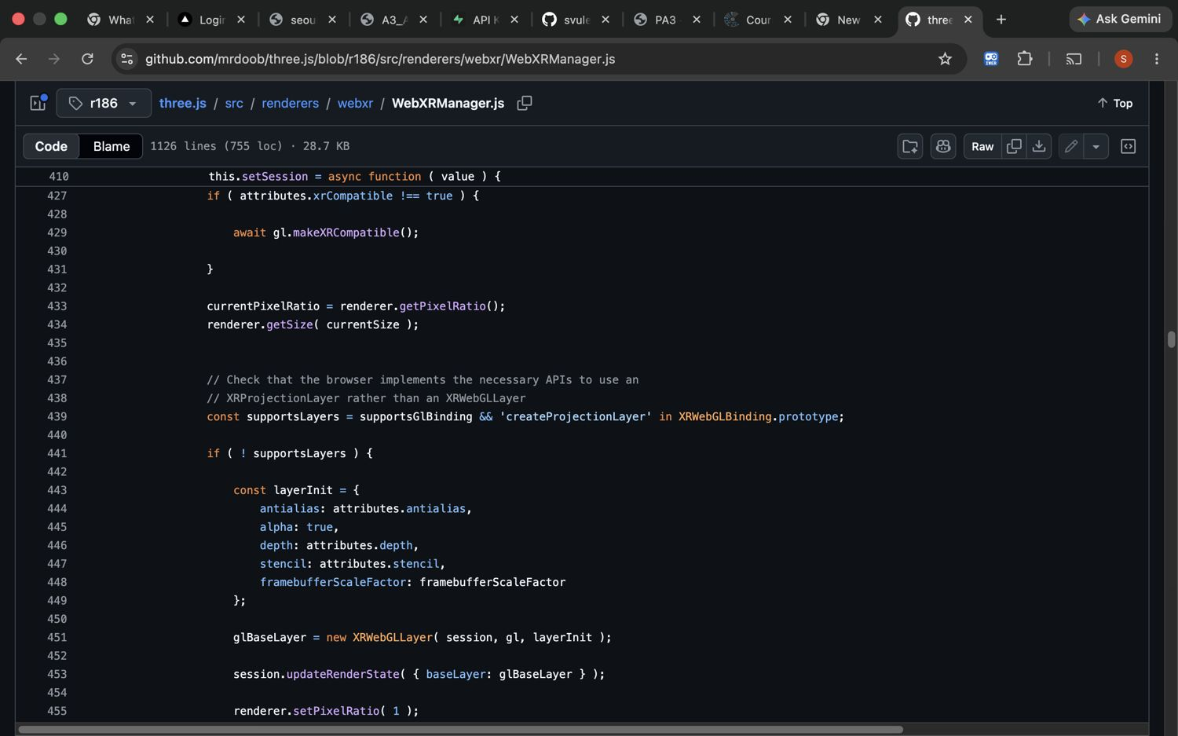
Figure 1. WebXRManager.js, lines 427 to 455.
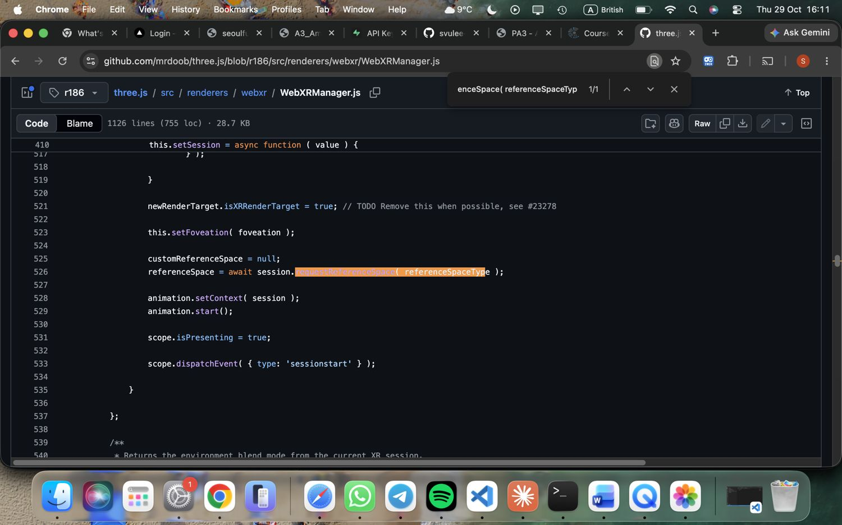
Figure 2. WebXRManager.js, line 526.

E3. Reading the pose matrix
Prediction: on flat ground the y column (elements 4, 5, 6) is about (0, 1, 0), so the tilt is about 0° and the reticle is green; on a steep rock or wall it is above 12° and red.
Result: the 16 values for one placement: 0.947, 0.000, −0.322, 0.000, 0.000, 1.000, 0.000, 0.000, 0.322, 0.000, 0.947, 0.000, −0.681, −1.551, −0.043, 1.000. Position = elements 12 to 14 = (−0.681, −1.551, −0.043). Normal = elements 4 to 6 = (0, 1, 0). By hand: tilt = arccos(n · up) = arccos(1.000) = 0°, below 12°, so the reticle is green. The other columns show a rotation about y of about 19° (arcsin 0.322). The overlay was not visible, so I could not read the exact tilt of the red case.
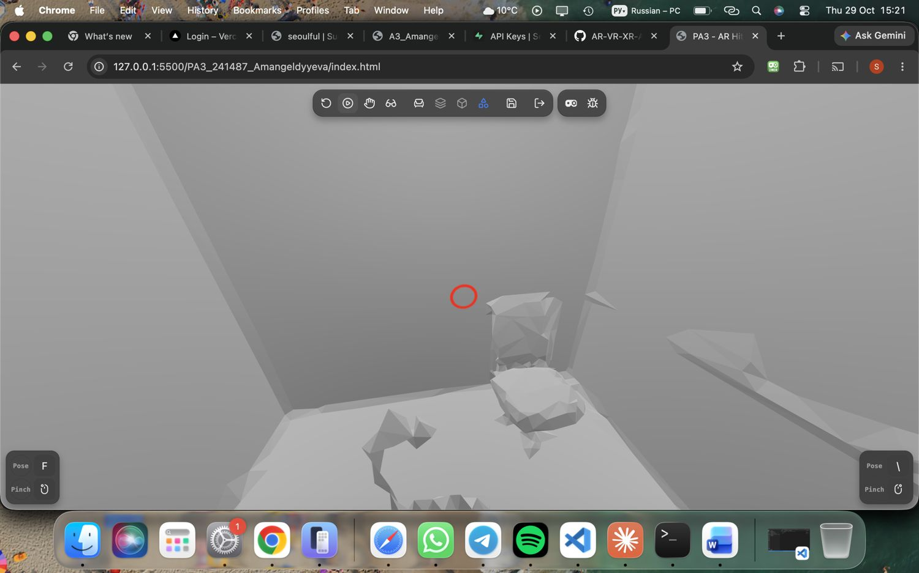
Figure 3. Red reticle: too tilted, a tap places nothing.
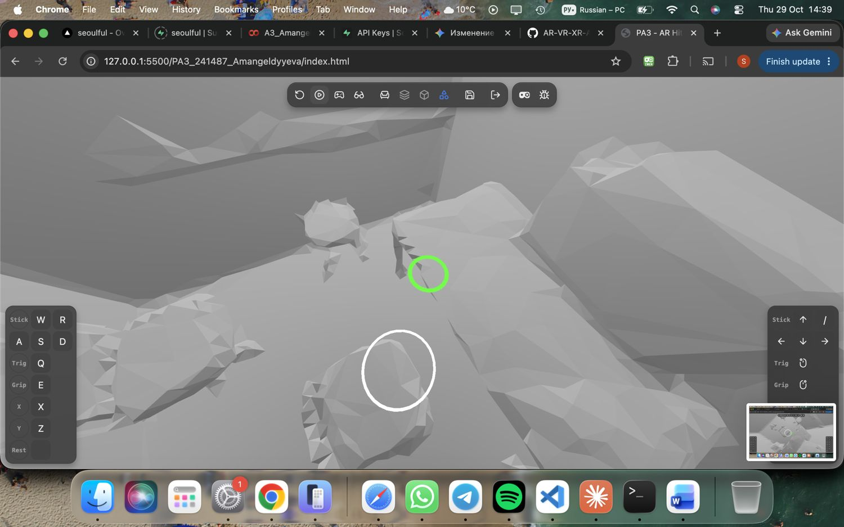
Figure 4. Green reticle on flat floor: placement allowed.

E4. How the device finds surfaces
The camera finds feature points (corners, texture) in every frame. Motion sensors (accelerometer, gyroscope) measure how the device moved between frames. Visual-inertial odometry combines both to estimate position and orientation. Many feature points on one flat area become a detected plane. A plain white or glossy surface has few features, so it is harder to detect. Result: seconds to first hit were not measured, because the emulator uses a fixed simulated environment and I had no real device.

E5. Scale check
Prediction: the table is 0.55 m high, so any size error should be below 2 cm. Result: Box3 logs x = 0.450, y = 0.550, z = 0.400 m (console screenshot in Test process), so the error against the variant table is 0.000 m. I did not compare with a real object because I used the emulator. On a real device, likely errors are tracking drift and the reticle sitting slightly above or below the floor.

E6. Product preview for a retailer
Failure mode 1: no surface is found on a plain or glossy floor, so the customer cannot place the product. Fix: show a hint such as 'point at a textured floor and move slowly'. Failure mode 2: tracking is lost and products slide. Fix: use anchors and a tracking-lost warning that blocks placement (my code does this). A WebXR page receives surface and pose data only after the user agrees to AR; it does not receive the raw camera video or photos of the room. Users should be told this, and that the page stores nothing.

Test process
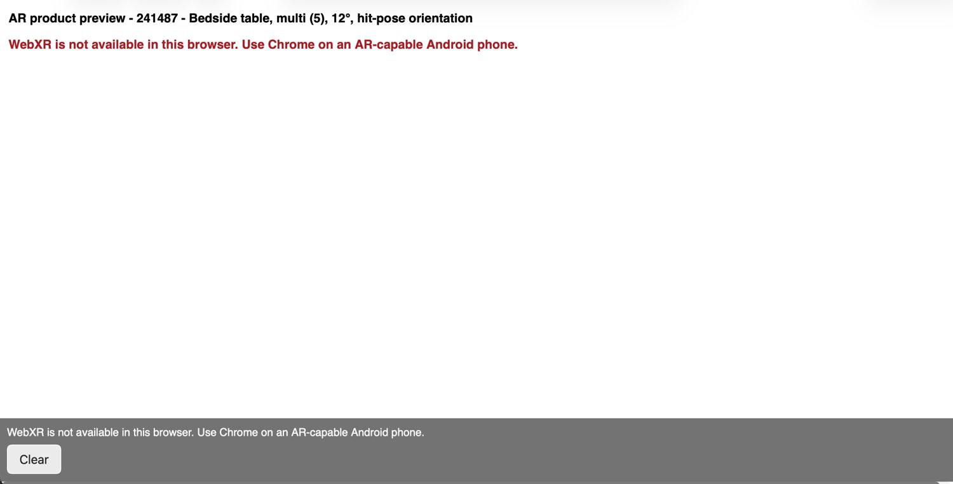
Figure 5. Task A: fallback message when WebXR is unavailable.
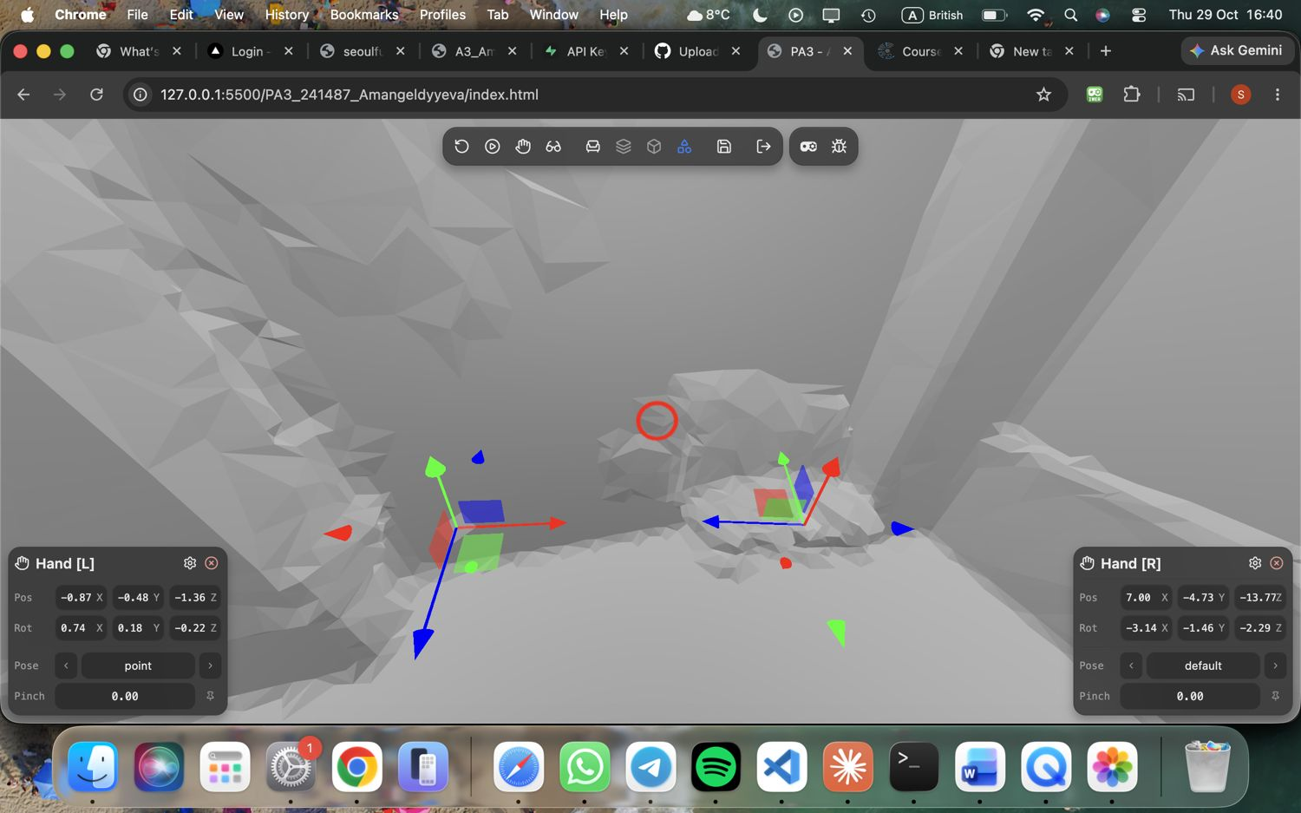
Figure 6. Task A: new session, scene empty.
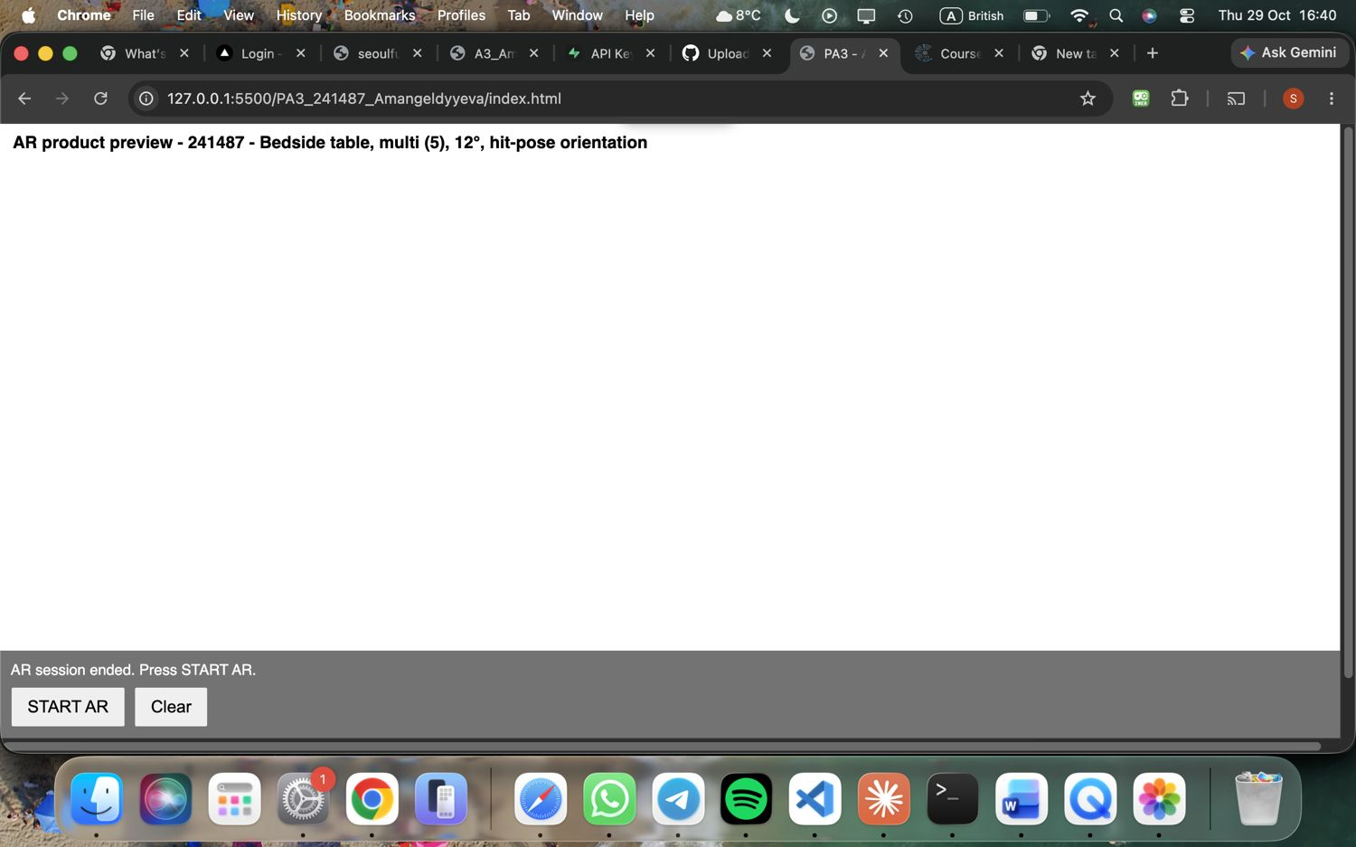
Figure 7. Task A: after the session ends, START AR returns.
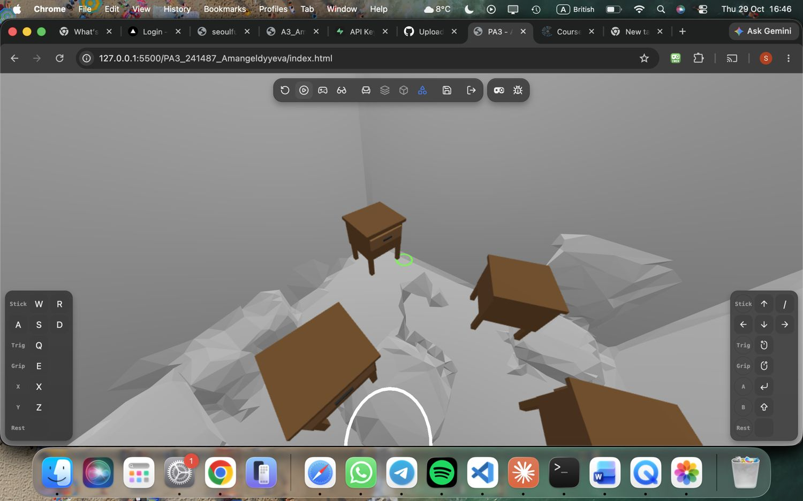
Figure 8. Task C: bedside table with drawer front and four legs.
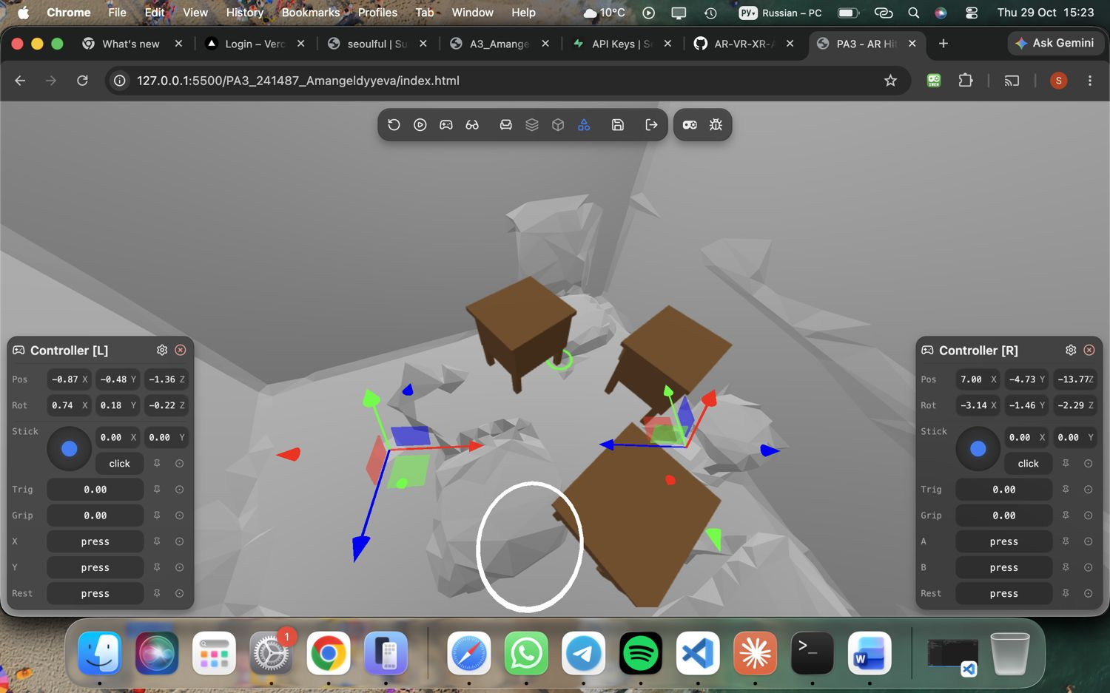
Figure 9. Task D: three tables placed (multi mode).
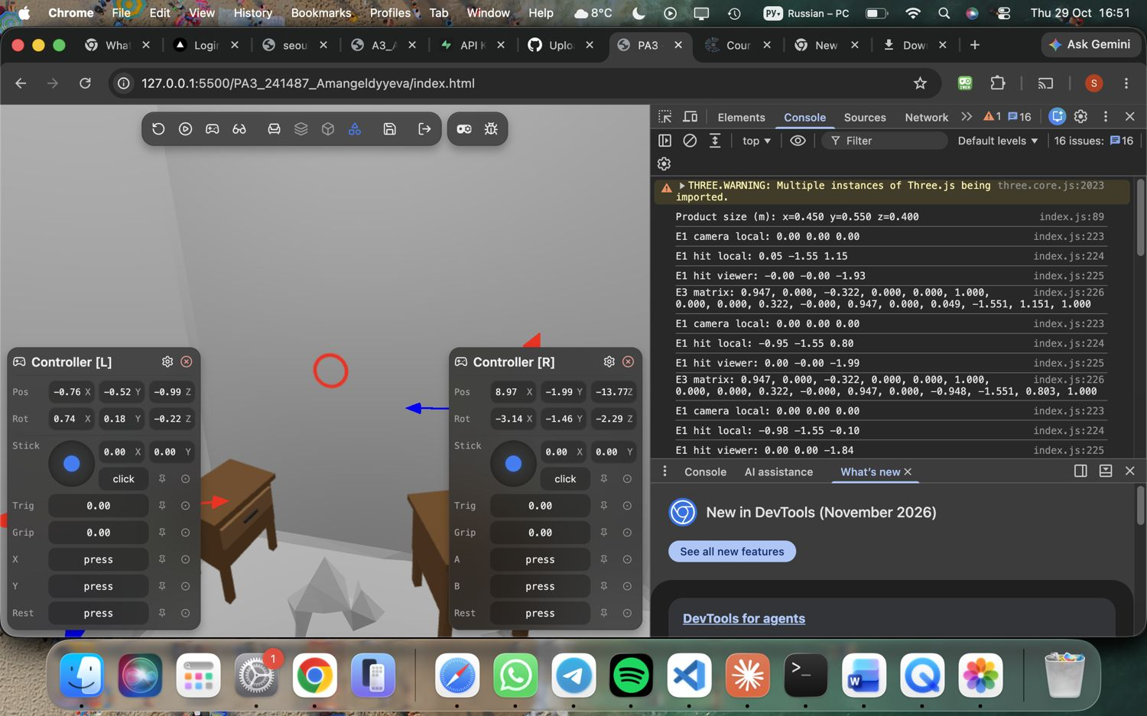
Figure 10. Console: Box3 size and logs, no errors.
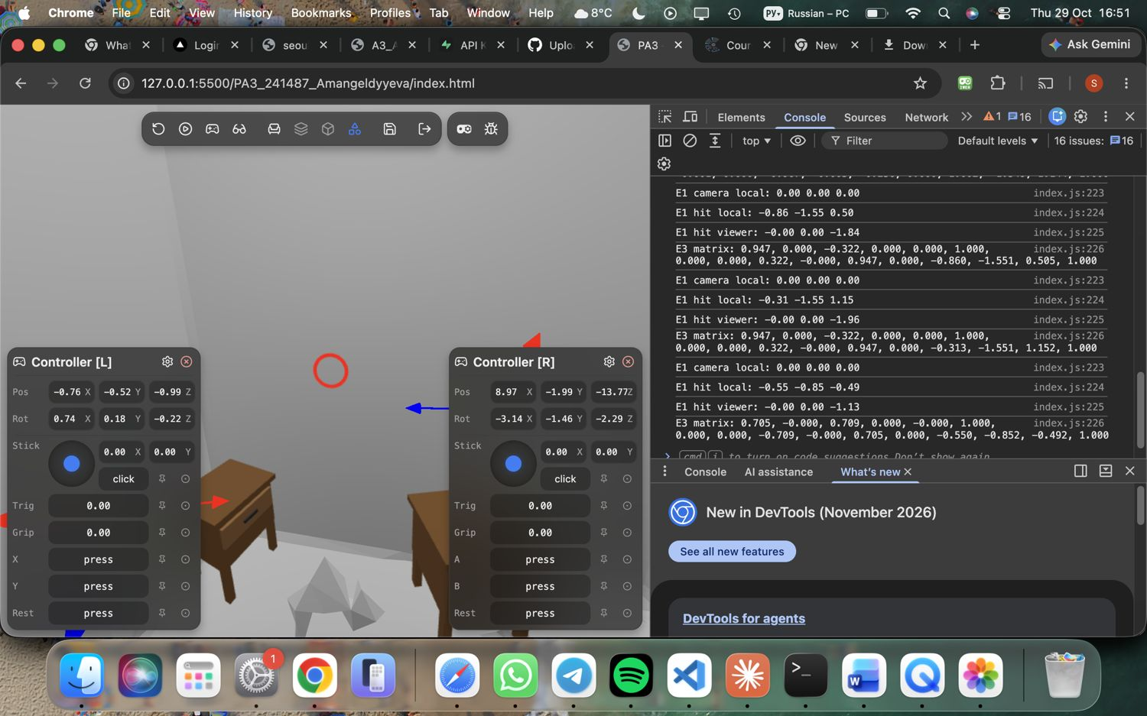
Figure 11. Console after several placements, no errors.

Development log
Bug: the Chapter 7 code requested a new hit-test source on every frame, because hitTestSourceRequested was never set to true. Found by reading the render loop against the porting notes. Fixed by setting the flag before the single request from viewer space and cancelling the source in onSessionEnd, in commit e415de1.
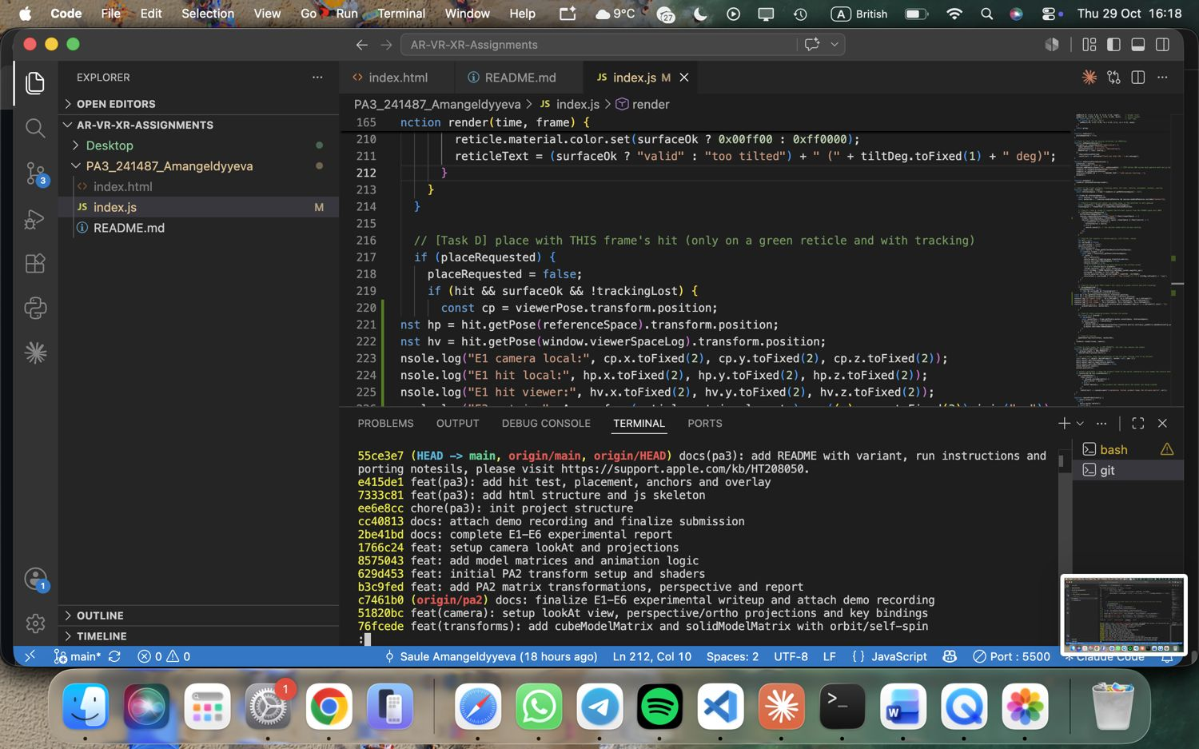
Figure 12. git log --oneline.

AI use
Claude (Anthropic) was used as an assistant for this work, as allowed by the instructor in the lecture. I tested the application and checked the results myself.

