

| **AY**  **CLASS** | **: 2023_24**  **: BE E&TC** | **Sem**  **DATE** | **: II**  **:** |
| --- | --- | --- | --- |
| **SUBJECT** | **: Mobile Computing** | **EXPT. No.** | **: 02** |

# ROLL NO : 42314

# 

**TITLE**: GLOBAL SYSTEM FOR MOBILE COMMUNICATION (GSM)

**OBJECTIVE**: Draw GSM architecture and describe different signaling techniques used in GSM

# Theory:

1. **GSM architecture and its need:**

The development of Global System for Mobile Communication (GSM) started in 1982 when the Conference of European Posts and Telegraphs (CEPT) formed a study group called Group Special Mobile (the initial meaning of GSM) whose aim was to study and develop a pan- European public cellular system in the 900 MHz range. Some of the basic criteria for their proposed system were

* + Good subjective speech quality
  + Low terminal and service cost
  + Support for international roaming
  + Ability to support handheld terminals
  + Support for range of new services and facilities
  + Spectral efficiency
  + ISDN compatibility

Commercial operation of GSM networks started in mid-1991 in European countries. By the beginning of 1995, there were 60 countries with operational or planned GSM networks in Europe, the Middle East, the Far East, Australia, Africa, and South America, with a total of over

5.4 million subscribers. GSM uses a mixture of both Frequency Division Multiple Access (FDMA) and Time Division Multiple Access (TDMA). FDMA parts include the division by frequency of the 25 MHz bandwidth into 124 carrier frequencies spaced 200 KHz for GSM900. TDMA further divides each carrier frequencies into 8-time slots such that each carrier frequency is shared by 8 users. In GSM, the basic radio resource is a time slot with duration of 577 μsec. 8 Time slots of 577 μsec constitute a 4.615 msec TDMA frame. GSM uses Gaussian Minimum Shift Keying (GMSK) modulation scheme to transmit information over Air Interface. GSM uses number of channels to carry data over air interface; these channels are broadly divided into following two categories:

1. Physical Channels
2. Logical Channels



**Need of GSM**:

1. Improved spectrum efficiency
2. International roaming
3. Low-cost mobile sets and base stations (BSs)
4. High-quality speech
5. Support for new services
6. Compatibility with Integrated Services Digital Network (ISDN) and other telephone company

services

**GSM Architecture:**

GSM architecture is classified into three subsystems i.e., BSS, NSS, and OSS as shown in Fig. 1..

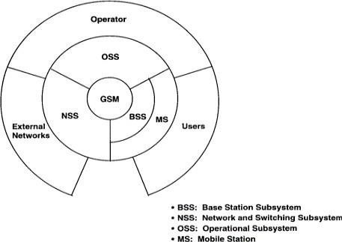

# Fig. 1: Basic Architecture

The BSS provides and manages communication paths between the MSs and the NSS. It includes management of the radio interface between MSs and the whole GSM system. The NSS has the province of managing communications and linking MSs to the relevant networks orother MS. Neither NSS is in direct contact with the MSs, nor is the BSS in direct contact with external networks. In the GSM, interaction between the subsystems can be grouped into two main parts:

1. **Operational:** External networks to or from NSS to or from BSS to or from MS to or from subscriber.
2. **Control:** OSS to or from service provider



**GSM subsystem entities:**

# Mobile Station (MS)

A Mobile Station is used by a mobile subscriber to communicate with the cellular system. GSM MSs consist of:

i. A mobile terminal

ii. A Subscriber Identity Module (SIM)

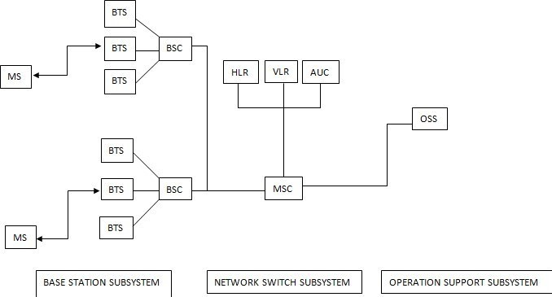

# Fig. 2: GSM Architecture

1. **Base Station Subsystem (BSS)**

BSS is the section which is responsible for handling and signaling traffic between a MS and the NSS. It consists of these two devices:

* 1. Base Transceiver System (BTS) - The BTS is the radio equipment. It handles the radio interface to the mobile station. A group of BTSs is controlled by a BSC.
  2. Base Station Controller (BSC) - The BSC is a high-capacity switch which provides all the control functions and physical links between the MSC and BTS such as handover, cell configuration data, and control of radio frequency (RF) power levels in base transceiver stations. Several BSCs are served by an MSC.

# Network Switching Subsystem (NSS)

The NSS main role is to manage the communications between GSM and other network users. Another task of it includes the main switching functions of GSM, databases required for the subscribers, and mobility management

* 1. Mobile Station Controller (MSC): The MSC is the central unit of NSS. It performs the telephony switching functions of the system. It controls the traffic among all the BSCs.



* 1. Home Location Receiver (HLR): The HLR is the functional unit used for management of mobile subscribers. The information stored in it are subscriber’s identity, location, and authentication. It acts as a permanent store for a person’s subscription information until that subscription is canceled.
  2. Visitor Location Receiver (VLR): The VLR is the functional unit which temporarily stores subscription information so that the MSC can service all the subscribers currently visiting that MSC service area. The VLR is regarded as distributed HLR because it holds a copy of the HLR information stored about the subscriber.
  3. Authentication Centre (AUC): The AUC is a database connected to the HLR which provides it with the authentication parameters and ciphering keys used to ensure network security.

# Operation Support Subsystem (OSS)

The operations and maintenance center (OMC) is connected to all equipment in the switching system and to the BSC. The implementation of OMC is called the operation support system (OSS). The OMC provides a single point for the maintenance personnel to maintain the entire system. One OMC can serve multiple MSCs.

# GSM interfaces

The interfaces between various elements of the GSM network facilitates the information interchange. It also enables the case that network elements from different manufacturers can be used.

1. Um interface: This interface is linking the Mobile Equipment (ME) and the Base Station (BTS/BSC). It exchanges information in air.
2. Abis interface: This interface is linking the BSC and a BTS, and it has not been totally standardized. It is an internal interface as the BTS and the BSC are both part of the BSS. The Abis interface allows control of the radio equipment and radio frequency allocation in the BTS.
3. A interface: This interface is linking the BSS and the MSC. This interface carriesinformation to enable the channels, timeslots. The messaging required within the network to enable handover etc. to be undertaken is carried over this interface.
4. B interface: This interface is linking the MSC and the VLR. It uses a protocol known as the MAP/B protocol, the letter “B” indicating that the protocol is used for “B” interface. This is an internal interface as the VLR is a part of the MSC. The interface is used by the MSC when it needs to access data regarding a MS located in its area.
5. C interface: This interface is linking the HLR and the MSC. The protocol used for communication is MAP/C, the letter "C" indicating that the protocol is used for the "C" interface. It helps in communication between the MSC and the HLR regarding various aspects, for example, subscriber information.
6. D interface: This interface is linking the VLR and the HLR. It uses the MAP/D protocol, the letter "D" indicating that the protocol is used for the "D" interface. It is used to exchange



the data related to the location of the Mobile Equipment and to the management of the subscriber.

1. E interface: This interface is linking two MSCs. The E interface exchanges data related to handover between the two MSCs. It uses the MAP/E protocol, the letter "E" indicating that the protocol is used for the "E" interface.
2. F interface: This interface is linking the MSC and EIR. It uses the MAP/F protocol, theletter "F" indicating that the protocol is used for the "F" interface. The communications along this interface are used to confirm the status of the International Mobile Equipment Identity (IMEI) of the Mobile Equipment (ME) gaining access to the network.
3. H interface: This interface is linking the MSC and the AUC. It uses the MAP/H protocol, the letter "H" indicating that the protocol is used for the "H" interface. It transfers short messages.

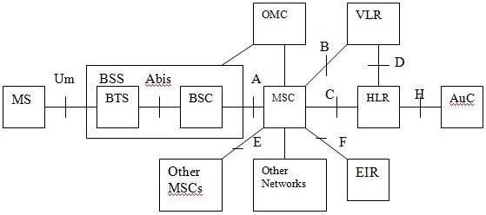

**Fig. 3: GSM Interfaces**

1. **GSM channels**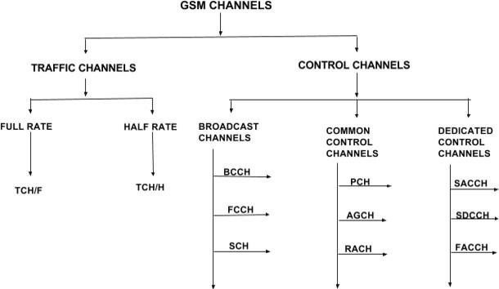

**Fig. 4: GSM Channels**



* 1. Traffic Channels (TCH): This channel carries digitally encoded user’s speech or data and has identical functions and formats on both the forward and reverse link.
     1. Full Rate Traffic Channels (TCH\F): This channel carries information at a rate of 22.8

Kbps. Kbps.

* + 1. Half Rate Traffic Channels (TCH\H): This channel carries information at a rate of 11.4
  1. Control Channels (CCH):

This channel carries control information to enable the system to operate correctly. There are three main categories of control channels in GSM which are further divided into several categories:

1. Broadcast Channels (BCH): The broadcast channel operates on the forward link of a specific Absolute Radio Frequency Channel Number (ARFCN) within each cell, and transmits data only in the first time slot (TS0) of certain GSM frames.
   1. Broadcast Control Channels (BCCH) – DOWNLINK

This channel broadcasts network and cell specific information required to identify the network and gain access.

* 1. Frequency Control Channels (FCCH) – DOWNLINK

This channel contains frequency correction bursts which are used by the mobiles for frequency correction. It bears information for frequency synchronization. It allows each subscriber unit to synchronize its internal frequency standard to the exact frequency of the base station.

* 1. Synchronization Channel (SCH) – DOWNLINK

This channel is used by the MS to learn the Base Station Information Code (BSIC) as well as the TDMA frame number (FN). There are 6 bits of BSIC which have two parts; 3 bits NCC and 3 bits BCC. NCC stands for Network Colour Code and used to identify the BTS for which measurement is made. BCC stands for Base Station Colour Code and used for a better transmission in case of interference. BICS avoids ambiguity or interference.

1. Common Control Channels (CCCH):

This channel is responsible for transferring control information between all mobiles and the BTS. It is necessary for call origination.

* 1. Paging Channel (PCH) – DOWNLINK

This channel is used for alerting to Mobile Subscribers for incoming calls, SMS, and other mobility services. Every MS in a cell periodically listens to this channel.

* 1. Random Access Channel (RACH) – UPLINK



This channel is used to send a request to the network for a dedicated resource to the MS. If the request is not granted within a specific time period by the network, the MS repeats the request on the RACH.

* 1. Access Grant Channel (AGCH) - DOWNLINK

This channel is used by a BTS to notify the MS of the assignment of a dedicated control channel.

1. Dedicated Control Channels (DCCH):

Like traffic channels, they are bidirectional and have the same format and function on both the forward and reverse links.

* 1. Standalone Dedicated Control Channel (SDCCH) – UPLINK/DOWNLINK

In response of RACH, the network allocates SDCCH over AGCH for further communication between MS and BTS. This channel is used for the Location Update, Voice Call Setup and SMS.

* 1. Fast Associated Control Channel (FACCH) – UPLINK/DOWNLINK

This channel is used to convey Handover information. There is no time slot and frame allocation dedicated to this channel. This channel can be associated with SDCCH or TCH and works on the principle of stealing. The burst of TCH is replaced by FACCH signaling when required.

* 1. Slow Associated Control Channel (SACCH) – UPLINK/DOWNLINK

This channel is always associated with TCH or SDDCH used for control and supervision of signals associated with the traffic channels.

# Call flow using channels

The call origination made by the Mobile Station (MS) is a multi-step process on the network side. First of all, broadcast channels are already being transmitted by the BTS continuously. When a number is dialed by the MS, Random Access Channels (RACH) is sent to the BSC for allocation of the channel. In respond to that Access Grant Channel (AGCH) is sendby BSC as a confirmation. Standalone Dedicated Control Channel (SDCCH) can be used for both downlinks as well as uplink. Hence, it is used for multiple purposes in this flow. It is sent by the MS to MSC with its location update information.

Through SDCCH MSC request for the International Mobile Subscriber Identity (IMSI) number and then this information is sent back to MSC by MS by SDCCH. Along with IMSI to MSC, SDCCH gives location update to HLR and information about equipment to Equipment Identity Register (EIR) which is a part of Authentication Centre (AUC). Using the same channel security and ciphering of call is done. After all, this process connection is established and ringing begins. Also, the Traffic Channel (TCH) is allocated for the call. Hence, the conversation starts between the two MS.



**IV. CONCLUSION:**

In our study, we thoroughly explored Global System for Mobile Communication (GSM). Beginning with an overview of its historical development, we examined the evolving criteria, technological advancements, and the specific needs addressed by GSM. we constructed a foundational GSM architecture, delineating its essential subsystems such as Base Station Subsystem, Network Subsystem, Operation Support Subsystem, and Mobile Stations. We also learned about interfaces like Abis and UM for information exchange and updated our architecture diagram accordingly. To understand communication better, we looked into GSM control channels, which help manage conversations between mobile phones. Finally, we learned how calls start between two phones, what information is exchanged during a call, and how the process flows through the channels.

**SIGNATURE**

**REFERENCES**:

1. “Mobile Communications” – Jochen Schiller.