| **AY**  **CLASS** | **: 2023_24**  **: BE E&TC** | **Sem**  **DATE** | **: II**  **:** |
| --- | --- | --- | --- |
| **SUBJECT ROLL NO.** | **: Mobile Computing**  **: 42314** | **EXPT. No.** | **: 04** |

**TITLE**: RAYLEIGH FADING WIRELESS CHANNEL

**OBJECTIVE:** Simulate the BER performance over Rayleigh fading wireless channel with BPSK transmission for SNR 0 to 60 dB

**SOFTWARE USED:** OS: Unix or windows 7/8/10,

Processor: i3/i5/i7, Software: MATLAB/Octave

# THEORY:

In this experiment, we will derive the theoretical equation for bit error rate (BER) with Binary Phase Shift Keying (BPSK) modulation scheme in Additive White Gaussian Noise (AWGN) channel. The BER results obtained using Matlab/Octave simulation scripts show good agreement with the derived theoretical results.

With Binary Phase Shift Keying (BPSK), the binary digits 1 and 0 maybe represented by the analog levels + and–  respectively. The system model is as shown in the Figure below.

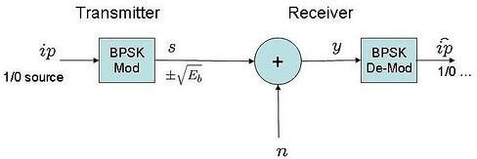

## Channel Model

The transmitted waveform gets corrupted by noise ,typically referred to as **Additive White Gaussian Noise** (AWGN) where,

**Additive**: As the noise gets ‘added’ (and not multiplied) to the received signal

**White**: The spectrum of the noise if flat for all frequencies.

**Gaussian**: The values of the noise follows the Gaussian probability distribution function as,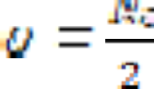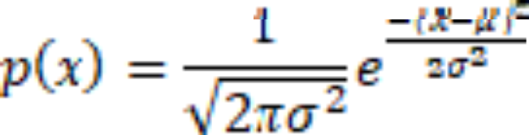

where, µ = 0 and

## Computing the probability of error

The received signal is,

when bit 1 is transmitted when bit 0 is transmitted

The conditional probability distribution function (PDF) of for the two cases are:

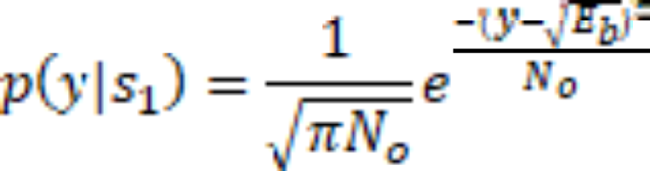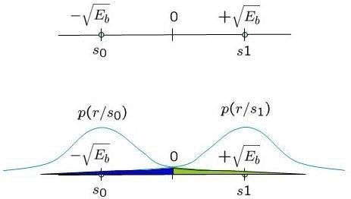

Figure: Conditional probability density function with BPSK modulation

Assuming that  and are equally probable i.e.p( ) = p( ) = 1/2 , the threshold 0 forms the optimal decision boundary.

* if the received signal, y > 0 then the receiver assumes that was transmitted.
* if the received signal, y ≤ 0 then the receiver assumes that was transmitted.

With this threshold, the probability of error given that is transmitted is (the area in blue region):





where,



Similarly, calculating for , we get,



The total probability of bit error is given as,



As it is assumed that both the bits  and  are equally probable. Hence,



## Simulation model

Matlab/Octave source code for computing the bit error rate with BPSK modulation for two cases: theoretical and simulation. Following are steps of experiments:

1. Generation of random BPSK modulated symbols +1′s and -1′s
2. Passing them through Additive White Gaussian Noise channel
3. Demodulation of the received symbol based on the location in the constellation
4. Counting the number of errors
5. Repeating the same for multiple Eb/No value.



## MATLAB code:

Clear

N = 10^6 % number of bits or symbols rand('state',100); % initializing the rand() function randn('state',200); % initializing the randn() function

% Transmitter

ip = rand(1,N)>0.5; % generating 0,1 with equal probability s = 2*ip-1; % BPSK modulation 0 -> -1; 1 -> 1

n = 1/sqrt(2)*[randn(1,N) + j*randn(1,N)]; % white gaussian noise, 0dB variance Eb_N0_dB = [-3:10]; % multiple Eb/N0 values

for ii = 1:length(Eb_N0_dB)

% Noise addition

y = s + 10^(-Eb_N0_dB(ii)/20)*n; % additive white gaussian noise

% receiver - hard decision decoding ipHat = real(y)>0;

% counting the errors

nErr(ii) = size(find([ip- ipHat]),2); end

simBer = nErr/N; % simulated ber

theoryBer = 0.5*erfc(sqrt(10.^(Eb_N0_dB/10))); % theoretical ber

% plot close all figure

semilogy(Eb_N0_dB,theoryBer,'b.-'); hold on semilogy(Eb_N0_dB,simBer,'mx-'); axis([-3 10 10^-5 0.5])

grid on

legend('theory', 'simulation'); xlabel('Eb/No, dB'); ylabel('Bit Error Rate');

title('Bit error probability curve for BPSK modulation');



# RESULT:

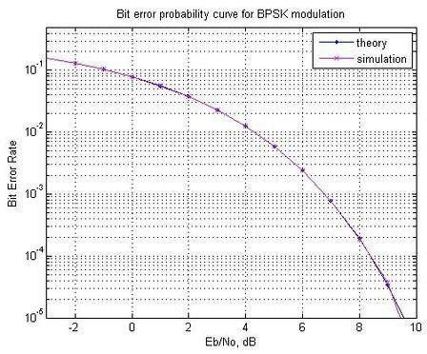

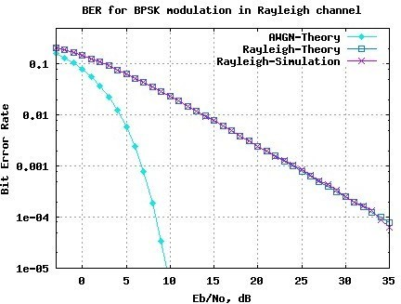

**CONCLUSION:**

In our experiment, we looked at how well data transmission performs in a wireless channel that experiences Rayleigh fading. We started by a theoretical derivation of the BER formula, predicated on the utilization of Binary Phase Shift Keying (BPSK) modulation signal in the presence of additive white Gaussian noise. Following this , we proceeded to implement the derived formula into MATLAB Octave. This involved the generation of a BPSK signal, the addition of noise to simulate real-world conditions, and the subsequent error counting process. Subsequently, we computed both the theoretical and simulated BER values. Finally, we compared our calculated predictions with the actual results, showing how well they matched up. We visualized this comparison to make it easier to understand the performance of data transmission in such wireless conditions.

# SIGNATURE

**REFERENCES**:

1. “Wireless Communications--Principles and Practice” – Rappaport, T. S.
2. “Principles of Modern Wireless Communication Systems” – Jagannathan, A. K.