座位表 -請同學填入 自己名字(有看到的提醒隔壁的同學 填寫 感謝!!

|  |  |  |  |  |  |
| --- | --- | --- | --- | --- | --- |
| **白板** | | | | | |
| 楊凱元 | 陳瑀萱 | 翁紹捷⭐ | 吳承祐 | 吳晉宇 | 助教 |
| 戴中航 | 沈咨名 | 班代:翁尉珊 | 程韋鈞 | 趙冠宇 | 譚峻 |
| 連彥鈞 | 劉樾 | 許瑀芹 | 王俐斐 | 葉濠銘 | 張雲藝 |
| 張書榜 | 王祥鈞 | 張又心 | 許媁涵 | 方俊程 | 蔡定芝 |
| $\sqrt{6 }=4$ 😂😂😂 | | 蘇煜㭿  (不愉悅) | 林苔英 | 簡緯翔 | 曾祥易 |
| 黃玟勝(+100) | 吳柏均 | 張竣豪 | 黨敏伶 |

# 

1207目標

1.登入google帳號

2.建立專案

3.cloud storage 快速複習

步驟

google cloud platform 控制台 新增專案

identity → service account → create account → Name → Role = Cloud storage & Storage Admin →

In GCP 內的範例程式碼

# 我要用python 去瀏覽桶子內有什麼檔案

# python cloud storage list all object in bucket

from google.cloud import storage

"""Lists all the blobs in the bucket."""

bucket_name = "ai-cxcxc-demo"

storage_client = storage.Client()

# Note: Client.list_blobs requires at least package version 1.17.0.

blobs = storage_client.list_blobs(bucket_name)

for blob in blobs:

print(blob.name)

------------------

# 我要用python 去瀏覽桶子內有什麼檔案

# python cloud storage list all object in bucket

from google.cloud import storage

"""Lists all the blobs in the bucket."""

bucket_name = "ai-cxcxc-demo"

storage_client = storage.Client.from_service_account_json('service_account.json')

# Note: Client.list_blobs requires at least package version 1.17.0.

blobs = storage_client.list_blobs(bucket_name)

for blob in blobs:

print(blob.name)

---

<https://github.com/BingHongLi/ai-chatbot-tutorial>

017

<https://github.com/BingHongLi/ai-chatbot-tutorial/blob/main/017_%E8%8D%8A%E7%84%A1%E5%91%BD%E7%9A%84%E5%B7%A6%E6%89%8B%E5%8A%8D.ipynb>

----

'''

跟cloud storage作互動

先建個客戶端

用客戶端去

上傳物件

瀏覽物件

下載物件

刪除物件

'''

# step1 建立客戶端

# gcp cloud storage client python example

# 017就有了啦

from google.cloud import storage

# 創建客戶端，由於在專案外，必須給一個service_account.json檔

storage_client = storage.Client.from_service_account_json('service_account.json')

# 用cloud storage的客戶端上傳物件

# python cloud storage upload object example

# 017就有了啦

# 上傳到指定的桶子內

# https://cloud.google.com/storage/docs/uploading-objects#storage-upload-object-code-sample

bucket_name='ai-cxcxc-demo'

source_file_name= '13080001127357.jpg'

# object的名子

destination_blob_name= '123/456.jpg'

# 指定桶子

bucket = storage_client.bucket(bucket_name)

# 指定本地檔案

blob = bucket.blob(destination_blob_name)

# 指定遠端位置

blob.upload_from_filename(source_file_name)

print(

"File {} uploaded to {}.".format(

source_file_name, destination_blob_name

)

)

-----

物件的權限調整

調整公開之後，物件都會有一個https連結

<https://storage.googleapis.com/ai-cxcxc-demo/123/456.jpg>

<https://storage.googleapis.com/> + bucket_name + object_name

---

刪除物件

----

機器人與cloud storage 的結合

<https://github.com/BingHongLi/ai-chatbot-tutorial/blob/main/018_GCP%E8%88%87Chatbot.ipynb>

----

gcp 調度ai的範例

[*https://colab.research.google.com/github/robeartoe/APIWorkshop/blob/master/MLWorkshop.ipynb#scrollTo=Snq8ehAu7JkD*](https://colab.research.google.com/github/robeartoe/APIWorkshop/blob/master/MLWorkshop.ipynb#scrollTo=Snq8ehAu7JkD)

*# 安裝之後，點擊重新執行階段*

*!pip install google-cloud-texttospeech*

from google.cloud import texttospeech

# Instantiates a client

client = texttospeech.TextToSpeechClient.from_service_account_json('service_account.json')

# Set the text input to be synthesized

synthesis_input = texttospeech.SynthesisInput(text="班代，每次都拍你，你是不是很開心？")

# Build the voice request, select the language code ("en-US") and the ssml

# voice gender ("neutral")

voice = texttospeech.VoiceSelectionParams(

language_code='zh-TW',

ssml_gender=texttospeech.SsmlVoiceGender.NEUTRAL)

# Select the type of audio file you want returned

audio_config = texttospeech.AudioConfig(

audio_encoding=texttospeech.AudioEncoding.LINEAR16)

# Perform the text-to-speech request on the text input with the selected

# voice parameters and audio file type

response = client.synthesize_speech(input=synthesis_input, voice=voice, audio_config=audio_config)

# The response's audio_content is binary.

with open('output.wav', 'wb') as out:

# Write the response to the output file.

out.write(response.audio_content)

print('Audio content written to file "output.wav"')

json轉換消息範例

https://github.com/BingHongLi/line_chatbot_quick_template/blob/master/app.py

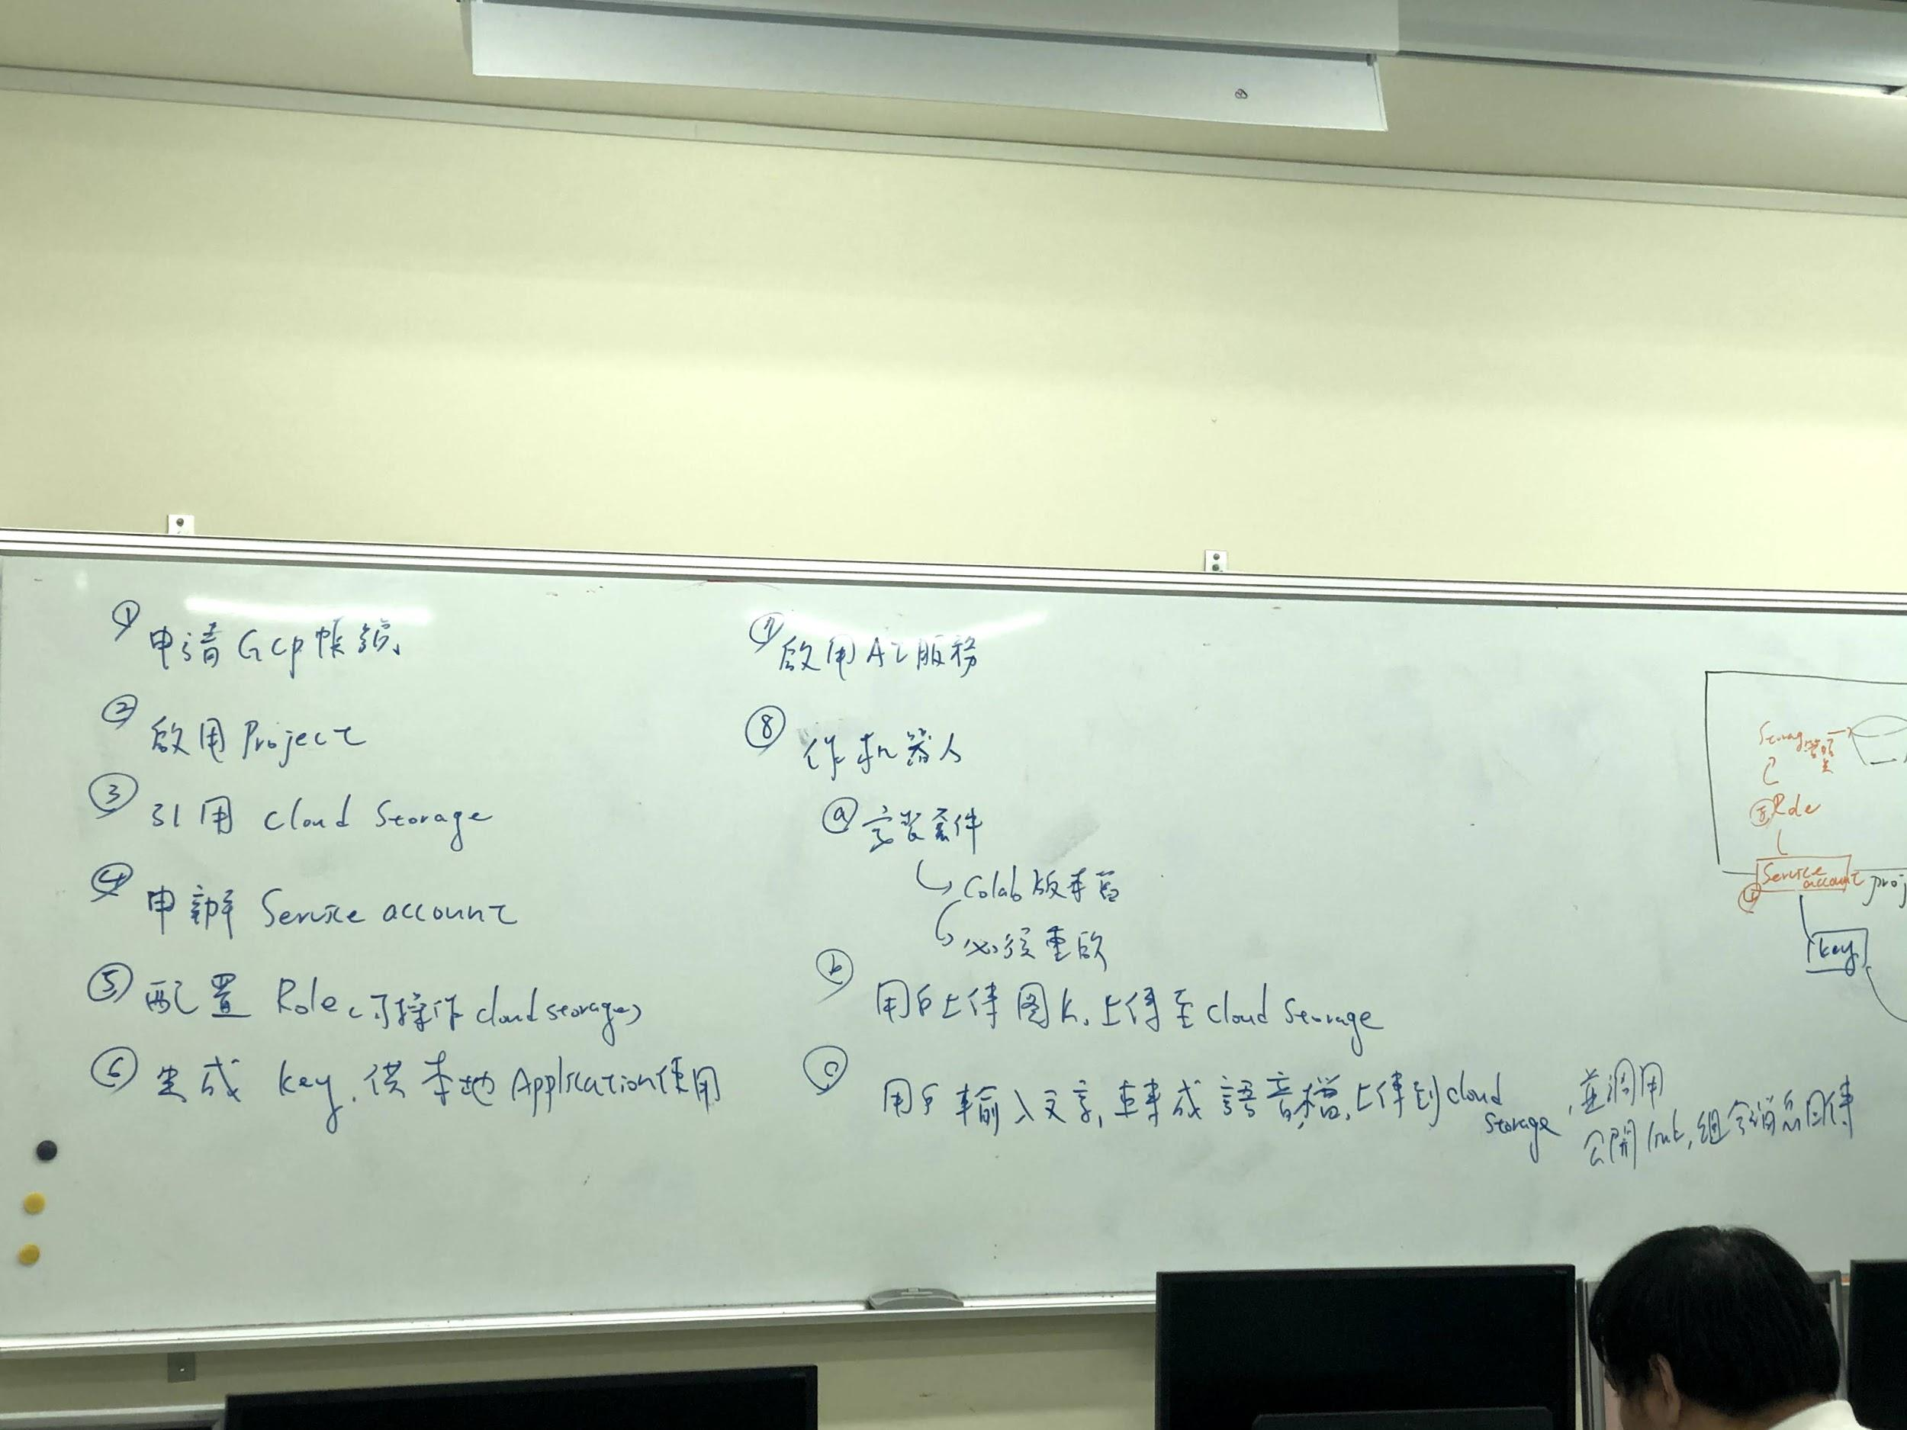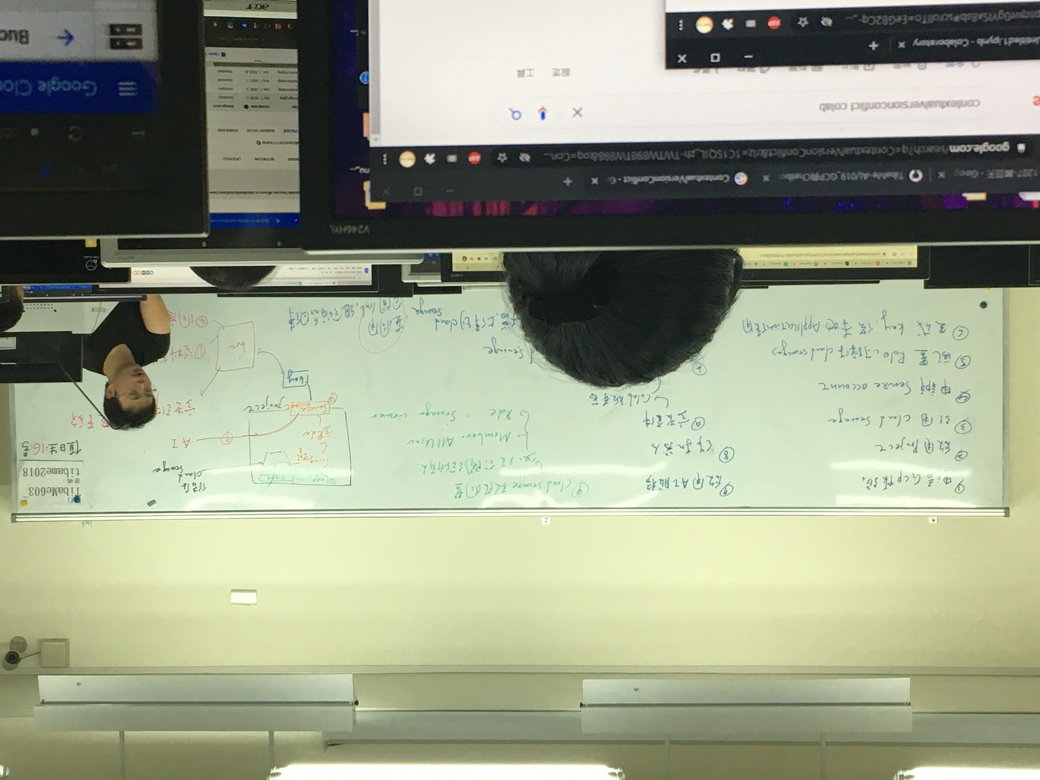

<https://github.com/GoogleCloudPlatform/python-docs-samples/>

git clone<https://github.com/GoogleCloudPlatform/python-docs-samples/>

cd python-docs-samples/

cd appengine/

cd standard_python3/

cd custom-server/

gcloud app deploy --appyaml app.yaml

GCP連 line bot 電子檔

# 