Test Case – Plan 3 for

**Inventory Management Project**

**Prepared by:**

Jerome Reed

**CMSC 495**

Test Case #3



Test Case #6



Test Case #8



Test Case#10



Test Case #11

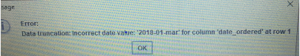

Test Case#12



Test Case# 13



Test Case #14

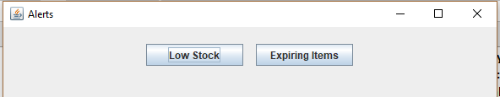

Test Case#15

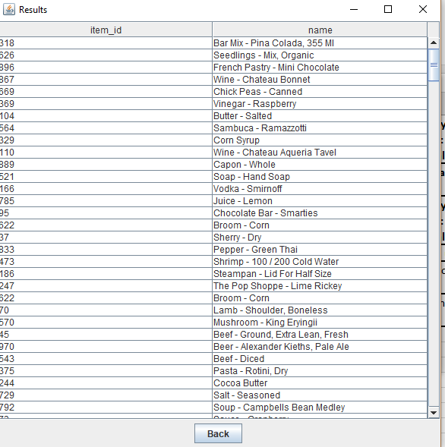

Test Case#16

