User Guide

December 13 2022

Jerome Reed, Ronald Hand, Jamie McCarthy, Arnaud Tako, Svyatoslav Mudryy

Copyright and third-party information as required.

Document Revisions

|  |  |  |
| --- | --- | --- |
| Date | Version Number | Document Changes |
| 11/15/2022 | 1.0 | Initial Draft |
| 11/30/2022 | 1.2 | Second Draft |
|  |  |  |
|  |  |  |
|  |  |  |
|  |  |  |
|  |  |  |
|  |  |  |
|  |  |  |

Contents

Introduction 5

Scope and Purpose 5

How To Install Program 6

MySQL: 6

How to Log In 7

How to Create User 7

How to Add and Edit Data In Tables 9

How to Use the Reports Function 11

How to Use the Search Function 12

How to use the Alert Functionality 14

Standard Tables 15

# 

# Introduction

## Scope and Purpose

Inventory Management is a generic inventory tracking application that will allow business managers and owners to track items in stock, orders, sales, customer information, and other relevant information. The application has enhanced search/reporting functionality as well as a threshold alerting system.

This guide assumes that user has no prior knowledge of database management and functionality. All features and usage of the application are explained in a detailed format.

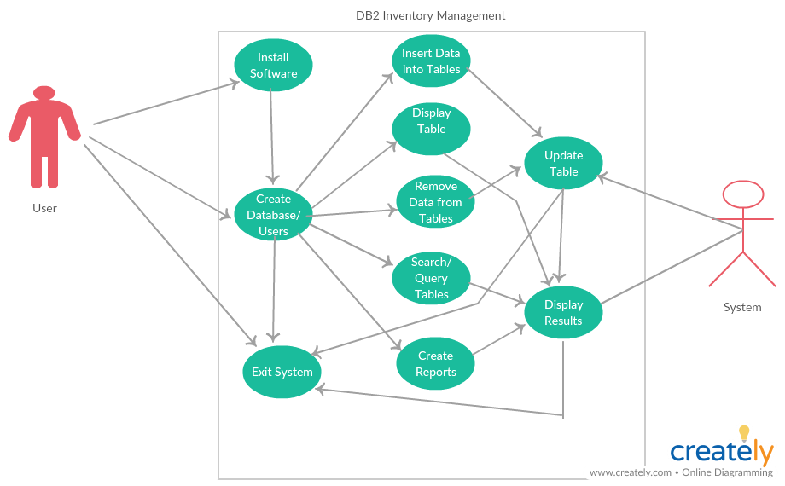

# How To Install Program

## MySQL:

1. Download software from <https://dev.mysql.com/downloads/>
2. Unzip the package.
3. Run the setup.exe file.
4. Everything should be installed in C:\mysql
5. Click Windows start icon 
6. Type run in the search bar and hit enter
7. 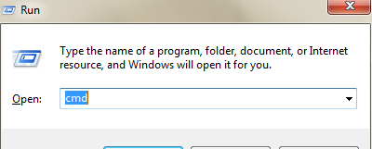The window below opens, click ok if cmd is already there if not type cmd and click ok.
8. Type “cd C:\mysql\bin” then press enter
9. Type “mysqld.exe” –console then press enter
10. Startup message should appear. You are connected.

# How to Log In

1. Inventory Management comes with a pre-programmed username of “admin” and password “password.”
2. Log into Inventory Management

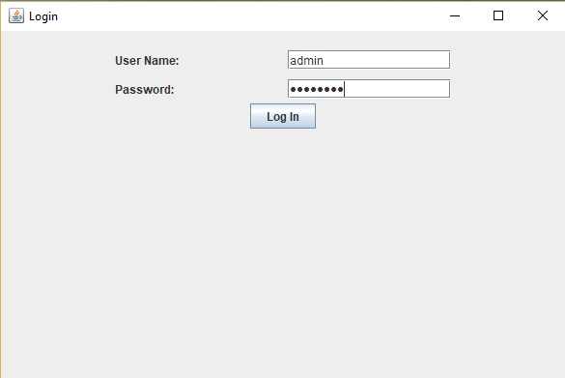

Log in Screen

# How to Create User

1. Steps to create administrator and users
2. Click on Users from the main selection window
3. Click Add
4. Enter new username and password
5. Click Add
6. Click Cancel to go back to the main selection window

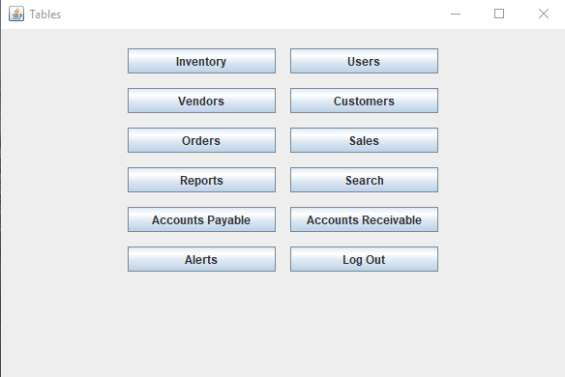

Main Selection Window

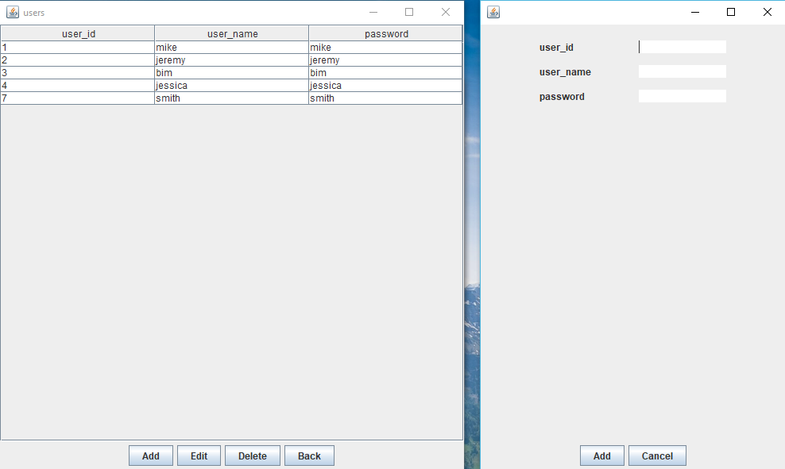

Add New Users

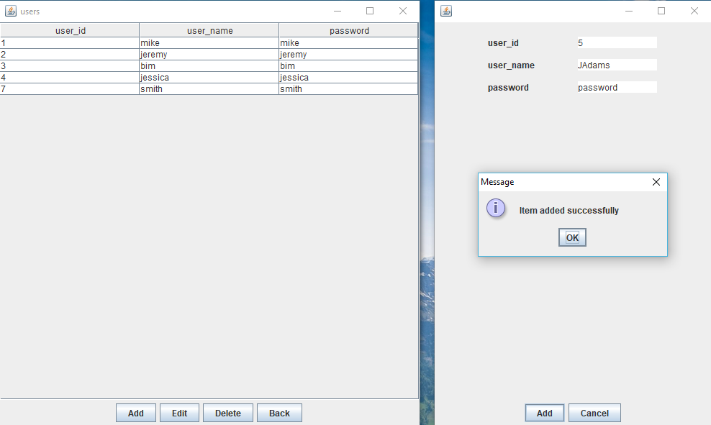

Add New Users

# How to Add and Edit Data In Tables

1. Inventory, Users, Vendors, Customers, Orders, and Sales all allow this functionality
2. Click the desired table from the main selection window
3. Click Add to add a new item or edit to edit an existing item
4. Click Add or Edit when done
5. Click Cancel to go back to the Main selection window
6. To check that new item was added click on the table again to see new or updated data

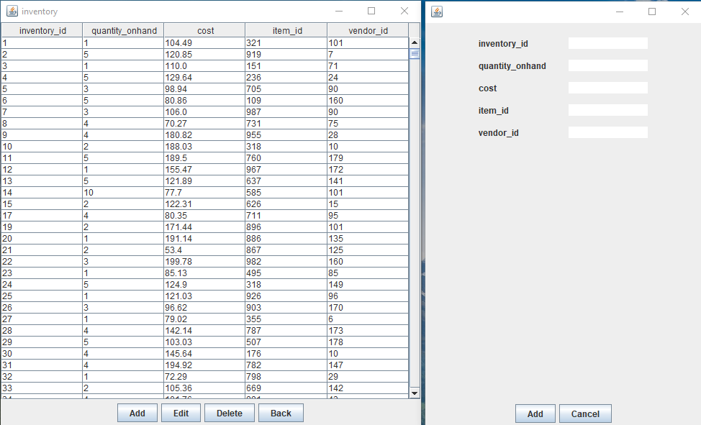

Add Inventory Items

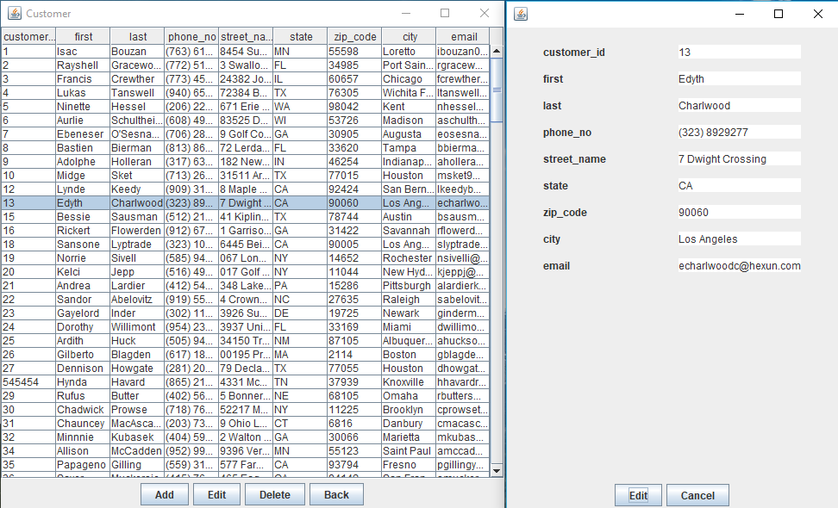

Edit Customer

# How to Use the Reports Function

1. Click Reports from the main selection window
2. Select which report type you want
3. Select window of time
4. Click Report
5. Close window to go back to Reports window

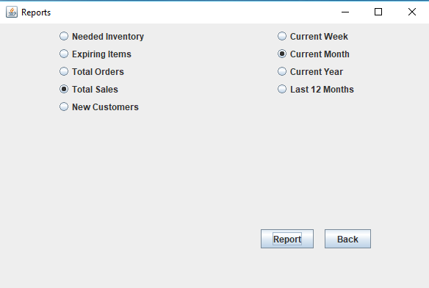

Reports

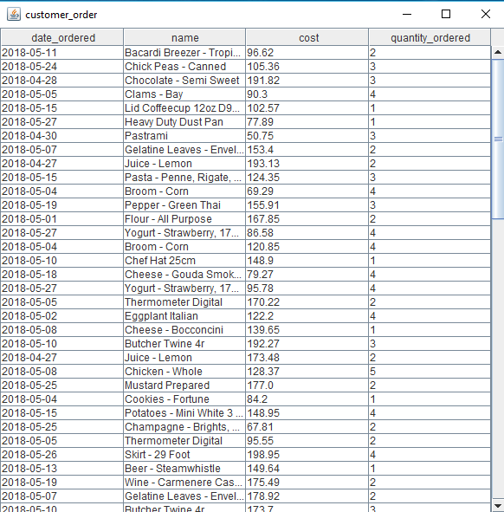

Customer Order Report

# How to Use the Search Function

1. Click Search from Main Selection Window
2. Select table you want to search in
3. Type in a search word
4. Click Search
5. Click Back to go back to the Search Window
6. The search function will search all columns of data within the selected table

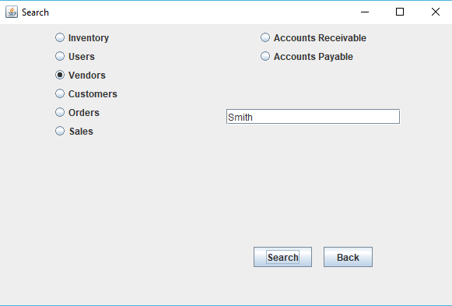

Search Window

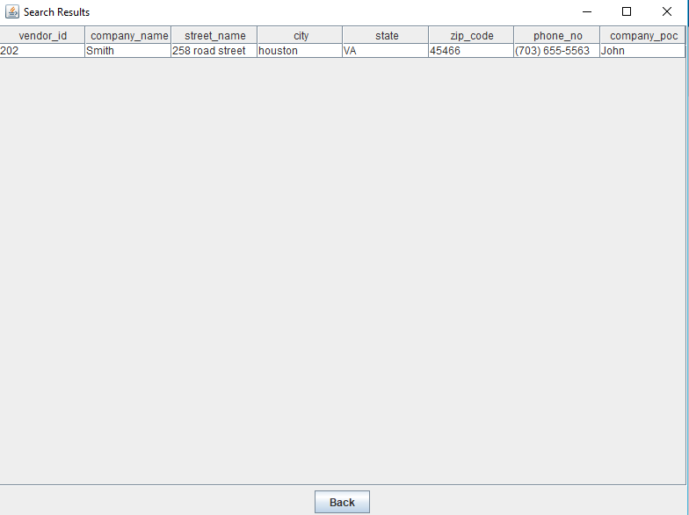

Search Results

# How to use the Alert Functionality

1. Click Alerts from the main selection window
2. Click Low Stock Button to see items that have a quantity of less than 3.
3. Click Expiring Items to see items that will expire within the next seven days.
4. Click Back to go back to the main selection window

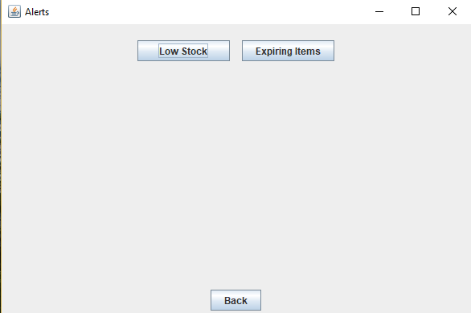

Alerts Windows

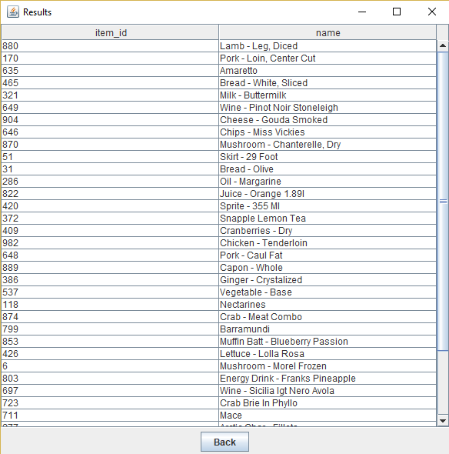

# Standard Tables

The following tables come standard with the Inventory Management Application

|  |  |
| --- | --- |
| Table | Description |
| Items | Stores information about things available in inventory such as quantity and vendor. |
| SalesDetails | Stores actual items per sale |
| Sales | Stores necessary information about sales to customers |
| OrdersDetails | Stores actual items ordered per order |
| Orders | Stores necessary information about orders made from vendors such as items ordered, date, and quantity |
| Customers | Stores information about customers such as contact information |
| Vendors | Stores information on vendors such as name, poc, and contact info |
| Invoices | Stores information about invoice details such as invoice number, order number, and date |
| Payments | Stores payment information to vendors (invoice number, vendor id, bill total, bill balance. |