Hardware Design Document (HDD)
SM2S-AM6254 Compute Module
Version: 0.1
Date: 17-06-22


5 & 6, Garden View Corporate House
Opp. Auda Garden, Bodakdev
Ahmedabad-380054, Gujarat, India
O (079) 40373760
softwebsolutions.com
avnet.com

Table of contents
1 Introduction 5
1.1 Purpose 5
1.2 Scope 5
1.3 Assumptions 5
1.4 Acronyms & Abbreviations 5
1.5 References 6
2 System Partitioning & Architecture
2.1 <$Product Name> Features 7
2.2 <$Product Name> Description 7
2.2.1 <Block1> Functions 7
2.2.2 <Block2> Functions 7
2.3 Interface Details 7
2.3.1 <$ interface one> 7
2.3.2 <$ interface two> 7
2.3.3 <$ interface three> 7
3 Design Considerations 8
3.1 Design Constraints and Guidelines 8
3.2 Component Selection Criteria 8
3.3 Signal Integrity Considerations 8
3.4 EMC & Environmental Considerations 8
3.5 Regulatory & Safety Considerations 8
3.6 DFM/DFT Considerations 8
3.7 Power Consumption Considerations 8
4 Detailed Design & Analysis 9
4.1 <$ Block/Interface One> Design 9
4.1.1 <$ Block/Interface One> Specifications 9
4.1.2 <$ Block/Interface One> Block Diagram 9
4.1.3 <$ Block/Interface One> Component Selection 9
4.1.4 <$ Block/Interface One> Design Calculations 9
4.1.5 <$ Block/Interface One> Design Analysis 9
4.1.5.1 <$ Block/Interface One> DC Analysis 9
4.1.5.2 <$ Block/Interface One> Timing Analysis 10
4.1.5.3 <$ Block/Interface One> Thermal Analysis 10
4.1.5.4 <$ Block/Interface One> Stress Analysis 10
5 Hardware-Software Interface Definition 11
5.1 Boot-up Sequence 11
5.2 Reset Logic 11
5.3 Clock Schemes 11
5.4 Interrupt Handling 11
5.5 GPIO Configuration & Default State 11
5.6 Memory Mapping 11
5.7 Indications & User Controls 11
5.7.1 LED Indications 11
5.7.2 Jumper Settings 11
5.7.3 Switches 12
6 Design Limitations & Open Issues 13
7 PCB Development Strategy 14
7.1 Layer Stack-up 14
7.2 PCB Outline 14
7.3 Placement Strategy 14
7.4 Grounding Scheme 14

List of Figures

Figure 1: <$product name> Architecture Diagram 7

List of Tables
No table of figures entries found.

Revision History
Revision | Date | Details of change | Author | Reviewer | Approver
0.1 | 17-06-22 | Initial draft

- Introduction
  - Purpose
This document presents the detailed architecture for SM2S AM6254, identifies various modules and gives detailed analysis of interfaces between them. It identifies critical parameters for component selection and presents calculations used in designing the circuit.
This document will be referred to by hardware team to create schematics for the board, create test strategy and develop test cases and to map the design elements to requirements. It will also be used by software team (if applicable) to understand the hardware design in detail, and its impact on driver development.
  - Scope
The scope of HDD is to define all design elements for specific set of requirements outlined in HRS of SM2S AM6254.
Although firmware design is not in the scope of this document, it describes hardware specific configuration settings required for programmable devices used in product. This is covered under topic ‘HW-SW Interface’. It is thus used by software team to customize software settings or hardware design.
This document, henceforth, is to be used as a direct reference by project team that implements (schematics, PCB layout, firmware) the design. <$client name> team will also use this document to review, approve and accept the hardware design before implementation begins.
  - Assumptions
<$enlist assumptions taken for design. These may include impact of any TBD/TBR items in HRS, or anything that is not fully understood or defined by client, or any deviation from the HRS, or any other assumption that affects the design and testing. The idea is to ensure any unknowns are considered while designing and agreed with client>
  - Acronyms & Abbreviations
Terms | Definition
MCU | Micro Controller Unit
DDR | Double Data Rate
eMMC | Embedded Multi-Media Card
HDMI | High-Definition Multimedia Interface
CAN | Controller Area Network
CSI | Camera Serial Interface
USB | Universal Serial Bus
UART | Universal Asynchronous Receiver/Transmitter
I2C | Inter-Integrated Circuit
SPI | Serial Peripheral Interface
RGMII | Reduced Gigabit Media Independent Interface
SDIO | Secure Digital Input Output

  - References
Reference Document Title | Provided by | Remarks
Hardware Requirements Specifications (HRS) |  | Primary reference
Query Tracking Sheet (QTS)
Requirements Traceability Matrix (RTM)

- System Partitioning & Architecture

The SM2S-AM6254 module features TI’s AM62x series which is an extension of the Sitara™ Industrial/Auto-grade family of heterogeneous Arm® processors with embedded 3D graphics acceleration, dual display interfaces and extensive peripheral and networking options. AM62x is built for a broad set of Industrial and Automotive applications.

SM2S-AM6254 offers up to four Arm® Cortex®-A53 cores with 64-bit architecture, Single-core Arm® Cortex®-R5F Device Manager subsystem, IMG AXE1-16 3D graphics module, dual-core PRU module and a Cortex®-M4F MCU module. The Cortex-A53x provide the powerful computing elements necessary for Linux applications. It provides DDR4 memory, up to 16GBit eMMC Flash memory, Gigabit Ethernet, Secondary Display (HDMI), CAN, Camera CSI, USB 2.0, an on-board Wireless Module as well as an extensive set of interfaces for embedded applications.

The module is compliant with the new SMARC™ 2.1 standard, allowing easy integration with SMARC baseboards. For evaluation and design-in of the SM2S-AM6254, MSC provides a development platform and a starter kit. Support for Linux is available (Android support on request).

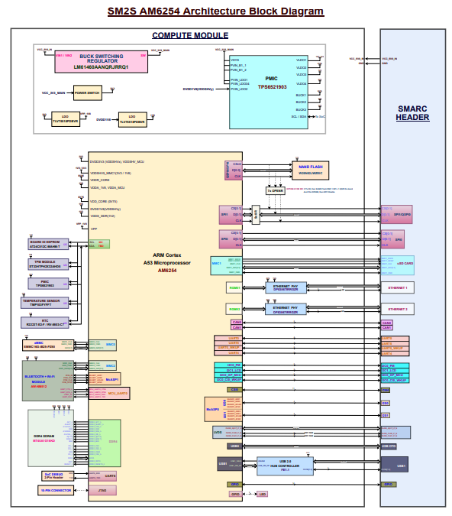
Figure 1 SM2S-AM6254 Architecture Diagram

  - SM2S-AM6254 Features

- Quad core ARM Cortex-A53 Applications Processor up to 1.4GHz
- Single-core Arm® Cortex®-M4F MCU at up to 400MHz
- Dual display support
  - 1920x1080 @ 60fps for each display
  - 1x 2048x1080 + 1x 1280x720
- Up to 2GBit DDR4 SDRAM
- Up to 16GBit eMMC Flash
- Dual-channel LVDS Interface
- 2x MIPI CSI-2 Camera Interface (2 lane & 4 lane)
- Secondary Display DPI/HDMI Interface
- 4x USB 2.0 Host interface
- 1x USB 2.0 Host/Device interface
- Up to 2x Gigabit Ethernet
- Wireless Module
- MMC/SD/SDIO interface
- 2x CAN interface
- 2x I2S Audio Interface
- UART, SPI, I2C
- SMARC 2.1 Compliant
  - SM2S-AM6254 Compute Module Description
The SM2S-AM6254 module features TI’s AM62x series which is an extension of the Sitara™ Industrial/Auto-grade family of heterogeneous Arm® processors with embedded 3D graphics acceleration, dual display interfaces and extensive peripheral and networking options. AM62x is built for a broad set of Industrial and Automotive applications.
SM2S-AM6254 offers up to four Arm® Cortex®-A53 cores with 64-bit architecture, Single-core Arm® Cortex®-R5F Device Manager subsystem, IMG AXE1-16 3D graphics module, dual-core PRU module and a Cortex®-M4F MCU module. The Cortex-A53x provide the powerful computing elements necessary for Linux applications. It provides DDR4 memory, up to 16GBit eMMC Flash memory, Gigabit Ethernet, Secondary Display (HDMI), CAN, Camera CSI, USB 2.0, an on-board Wireless Module as well as an extensive set of interfaces for embedded applications.
The module is compliant with the new SMARC™ 2.1 standard, allowing easy integration with SMARC baseboards. For evaluation and design-in of the SM2S-AM6254, MSC provides a development platform and a starter kit. Support for Linux is available (Android support on request).

    - PMIC Function:
The TPS6521903 is a power management IC PMIC designed to supply a wide range of SoCs in both portable and stationary applications.
Input voltage for the TPS6521903 is +5V and generates the output voltages like 0.75V, 1.2V, 1.8V, 0.85V and 2.5V for different Peripheral IC’s and also for the SoC and it converts 3.3V using Buck Regulator LM61460-Q1 IC.
Part Detail:
Part Description | TPS65219 Integrated Power Management IC for ARM Cortex—A53 Processors and  FPGAs
MFR P/N# | TPS6521903
MFR | Texas Instruments
Part Status | Active
Input Voltage | 5V
Output Voltage | Buck1: 0.6V to 3.4V @ 3.5A
Output Voltage | Buck2: 0.6V to 3.4V @ 2A
Output Voltage | Buck3: 0.6V to 3.4V @ 2A
Output Voltage | LDO1: 0.6V to 3.4V @ 400mA
Output Voltage | LDO2: 0.6V to 3.4V @ 400mA
Output Voltage | LDO3: 1.2V to 3.3V @ 300mA
Output Voltage | LDO4: 1.2V to 3.3V @ 300mA
Interface | I2C
Package | 32 - QFN

    - AM6254 Processor Function:
AM62x is an extension of the Sitara™ Industrial/Auto-grade family of heterogeneous Arm® processors with embedded 3D graphics acceleration, dual display interfaces and extensive peripheral and networking options.
AM6254 communicates with the peripherals using the different interfaces like I2C, I2S, SPI, USB, CAN, HDMI, RGMII Ethernet, CSI, LVDS, SDIO.
JTAG is used for the AM6254 programming.
    - DDR4 Function:
MT40A1G16KD-062E:E is used for SDRAM DDR4 memory IC which supports low power, higher performance and higher data rate transfer speeds. It communicates with the AM6254 Soc using Data line along with DQS, Address line and Clock.

Part Description | IC FLASH 16GBIT PARALLEL 96FBGA
MFR P/N# | MT40A1G16KD-062E:E
MFR | Micron Technology Inc.
Technology | SDRAM-DDR4
Memory Size | 16 Gb
Clock Frequency | 1.6 GHz
Supply Voltage | 1.14V to 1.26V
Package | 96-FBGA

    - eMMC Function:
AM6254 SoC Communicate with EMMC16G-IB29-PZ90 Flash IC, SD Card and AW-NM512 Module.

NAND Flash:
Part Description | IC FLASH 128GBIT MMC 153TFBGA
MFR P/N# | EMMC16G-IB29-PZ90
MFR | Kingston Technology
Part Status | Active
Technology | Flash - NAND
Memory Size | 128Gb (16Gx8)
Memory Interface | MMC
Supply Voltage | 2.7V to 3.6V
Package | 153-TFBGA

SD CARD Connector:
Part Description | 9 (8 + 1) Position Card Connector Secure Digital - microSD™ Surface Mount, Right Angle Gold
MFR P/N# | MEM2051-00-195-00-A
MFR | GCT
Part Status | Active

AW-NM512 Module:
Part Description | Wireless LAN and Bluetooth Module
MFR P/N# | AW-NM512
MFR | AzureWave Technology Inc.
Part Status | Active
Interface | High Speed UART and PCM for Bluetooth
Package | 47 - LGA

    - Ethernet PHY Function:
Ethernet PHY IC DP83867IRRGZ is connected to MAC using RGMII interface and MAC is integrated into AM6254 SoC.
Ethernet PHY IC DP83867IRRGZ Communicating via AM6254SoC using RGMII interface and directly connected to RJ45 Connector LPJG16314A4NL.
The DP83867 is designed for easy implementation of 10/100/1000 Mbps Ethernet LANs.
Part Description | IC ETHERNET PHY 48VQFN
MFR P/N# | DP83867IRRGZR
MFR | Texas Instruments
Part Status | Active
Protocol | Ethernet
Supply Voltage | 1.1V, 2.5V
Package | 48 - VQFN

    - USB HUB Controller Function:
A USB hub is a device that expands a single Universal Serial Bus (USB) port into several so that there are more ports available to connect devices to a host system.
FE1.1s is a highly integrated, high quality, high performance, low power consumption, yet low-cost solution for USB 2.0 High Speed 4-Port Hub. In that Upstream port supports high speed (480 MHz) and Full speed (12 MHz). As well as Downstream port supports high speed (480 MHz), Full speed (12 MHz) and Low speed (1.5 MHz).
Part Description | USB 2.0 High Speed 4-Port Hub Controller
MFR P/N# | FE1.1
MFR
Part Status | Active
Protocol | USB
Supply Voltage | 1.8V, 3.3V
Package | 28 - SSOP

    - Secondary Display LVDS Function:
LVDS (Low Voltage Differential Signaling) is a high-speed, long-distance interface for serial communication. LVDS is a specification used to transmit data at high speeds using voltage differences. The LVDS interface transmits data over four differential data pairs six or eight bits at a time.
LVDS interface for the AM6254 Soc is communication using Flex cable and it is directly connected to Smarc Connector.

    - QSPI NAND Flash Function:
The W25N02JW (2G-bit) Serial NAND Flash Memory provides a storage solution for systems with limited space, pins and power.
Part Description | NAND Flash 2G-bit Serial NAND flash
MFR P/N# | W25N02JW
MFR | Winbond
Part Status | Active
Protocol | QSPI
Supply Voltage | 1.8V
Package | 8 - WSON

    - EEPROM Function:
AT24C512C-MAHM-T EEPROM IC is communicating with the AM6254 Soc using I2C Data and CLK.
Part Description | IC EEPROM 512KBIT I2C 8UDFN
MFR P/N# | AT24C512C-MAHM-T
MFR | Microchip Technology
Part Status | Active
Protocol | I2C
Supply Voltage | 1.7V to 3.6V
Package | 8 - UDFN

    - Temperature Sensors Function:
TMP103 is a digital output temperature sensor. The TMP103 is capable of reading temperatures to a resolution of 1°C. Read the temperature by the AM6254 Soc using I2C.
Part Description | Temperature Sensor Digital, Local -40°C ~ 125°C 8 b
MFR P/N# | TMP103FYFFT
MFR | Texas Instruments
Part Status | Active
Protocol | I2C
Supply Voltage | 1.4V to 3.6V
Package | 4 - DSBGA

    - Wi-Fi + BT Module Function:
Part Description | Wireless LAN and Bluetooth Module
MFR P/N# | AW-NM512
MFR | AzureWave Technology Inc.
Interface | High Speed UART and PCM for Bluetooth
Package | 47 - LGA

    - Trusted Platform Module (TPM) Function:
AM6254 SoC communication with the ST33HTPH2X32AHD5 using I2C interface.

Part Description | Long-term evolution TPM 2.0 device with an I2C interface
MFR P/N# | ST33HTPH2X32AHD5
MFR | STMicroelectronics
Interface | I2C
Package | 32 - VQFN

    - RTC Function
<$Enter details of Block1 and how it interacts with other blocks>
  - Interface Details:
    - I2C Interface:
Board ID EEPROM:
Version and Serial number of the AM6254 are stored in the EEPROM. AT24C512C-MAHM-T will be interfaced to I2C2 port of the SOC. I2C addresses can be modified by A0, A1 and A2 pins to low.
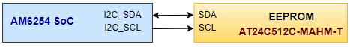

Temperature Sensor:
TMP103FYFFT is used for measuring the current. TMP103FYFFT is communicating with the AM6254 SoC using I2C2 interface.
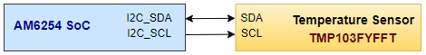

PMIC:
TPS6521903 is communicating with the AM6254 SoC using I2C2 interface.
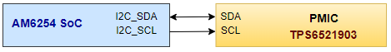

TPM Module:
TPM module ST33HTPH2X32AHD5 is communicating with the AM6254 SoC using I2C2 interface.
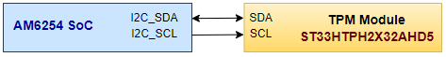

    - UART Interface:
WL1837 Module:
Wi-Fi + Bluetooth module AW-NM512 is communicating with the AM6254 SoC using MCU_UART0.
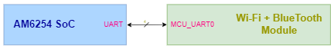

    - QSPI Interface:
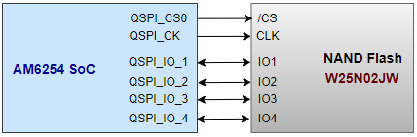

    - USB Interface:
Upstream port of the USB Hub controller IC communicating with the AM6254 SoC using USB interface. Downstream port of the USB Hub controller IC is used for the more than USB device.
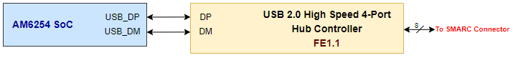

    - CAN Interface:
CAN interface from the AM6254 SoC is directly connected to SMARC Header.
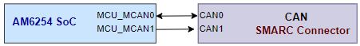

    - RGMII Ethernet Interface:
RGMII interface is dual data rate interface that consists of a transmit path, from AM6254 SoC to PHY, and a receive path, from PHY to AM6254 SoC. Both paths have an independent clock, 4 data signals and a control signal.
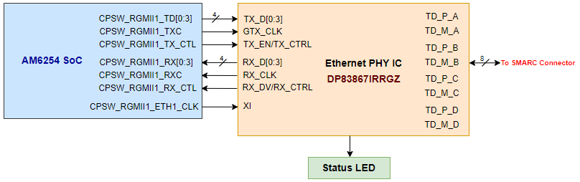
    - I2S Interface:
I2S interface from the AM6254 SoC is directly connected to SMARC Header.

    - Camera Serial Interface (CSI):
D1, D2, D3, D4 and CLK for the CSI interface is directly connected to SMARC header.

    - SDIO Interface:
Clock, Command, Write protect and 4-bit Data line from the AM6254 Soc is directly connected to SMARC Header.
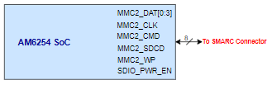

    - JTAG Programming Port:
JTAG Connector communicating with the AM6254 SoC using JTAG interface.
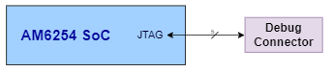

    - Device Debug Port:
Debug connector communicating with the AM6254 SoC using WKUP_UART.
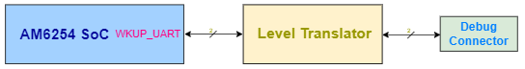

    - GPIOs:
GPIO_CM are connected to Header and GPIO_CB are directly connected to SMARC Header.

    - DDR4:
In DDR interface, each DRAM chip transferring data to/from the memory controller by means of several digital data lines. These data streams are accompanied by a strobe signal. Common clock, command, and address lines serve all DRAM chips. Because these lines control the interface's operation, they are unidirectional between the controller and the memory ICs.
We are using MT40A1G16KD-062E IT: E.

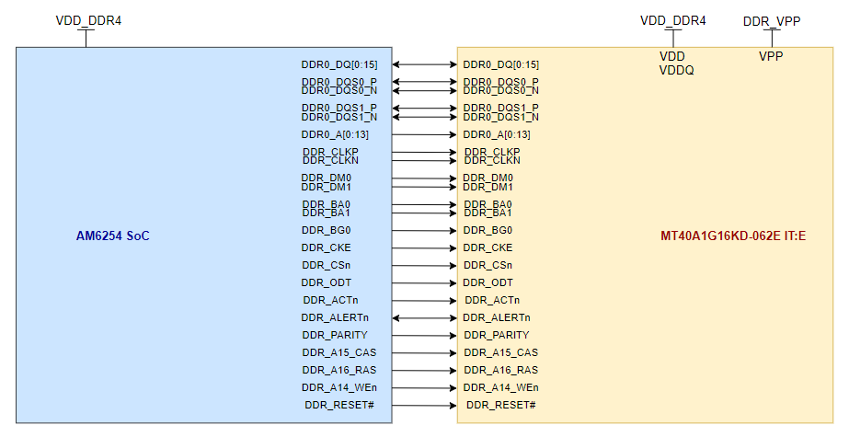

    - eMMC Interface:
In eMMC, there are Data line, Command and Clock Signal.
FLASH:
WL1837 Module:
WL1837MODGIMOCT is connected to AM6254 Soc MMC2 interface. e WL1837MOD is a Wi-Fi, dual-band, 2.4 GHz and 5 GHz module solution with two antennas supporting Industrial temperature grade. Module is connected 4-bit IO of the MMC2 interface.
The Module required two Power Supply, 3.7V for VBAT_IN and 1.8V for VIO_IN.

Design Considerations
  - Design Constraints and Guidelines

Component Selection: Based on Database Component
PCB Size: 82mm X 50mm
No. Of PCB for Proto Board: 40
Mechanical constraint: N/A
Guideline for the PCB Design: Follow the recommended Layout guideline for the PCB design as per the rules and regulation.

  - Component Selection Criteria

Micro-Processor:
MFR P/N# | AM6254
Description | Quad 64-bit Arm Cortex-A53 up to 1.4GHz
Device Management Subsystem | Single Core
Interface | SPI, I2C, UART, USB, SDIO, DDR, McASP, Ethernet, CSI, CAN, eMMC  CANcaCANCANLVDS,CAN  Ethernet
No. of GPIO | Up to 170
Package | 13mm x 13mm, 0.5mm pitch, 425-BGA (ALW)

DDR:
MFR P/N# | MT40A1G16KD-062E: E
Description | IC FLASH 16GBIT PARALLEL 96FBGA
Technology | SDRAM DDR4
Memory Size | 16Gb
Clock Frequency | 1.6GHz
Supply Voltage | 1.14V - 1.26V

Wi-Fi + Bluetooth Module:
MFR P/N# | AW-NM512
Description | Integrates Infineon solutions of CYW43439_A1 WiFi /BT/SoC
Frequency | 2.4GHz
Interface | UART, SDIO and PCM
Supply Voltage | 1.14V - 1.26V
Operating Temperature

Tempera

eMMC:
MFR P/N# | EMMC16G-IB29-PZ90
Description | IC FLASH 128GBIT MMC 153TFBGA
NAND Density | 16GB
Supply Voltage | 1.8V

Board ID EEPROM:
MFR P/N# | AT24C512C-MAHM-T
Description | IC EEPROM 512KBIT I2C 8UDFN
Memory Size | 512kb
Supply Voltage | 1.8V
Technology | EEPROM
Interface | I2C

PMIC:
MFR P/N# | TPS6521903
Description | TPS65219 Integrated Power Management IC
No. Of Buck Converter | 3
No. Of LDO | 4
No. Of GPIO | 3
Interface | I2C
Input Supply Voltage | 3.3V

Real Time Clock:
MFR P/N# | R2223T-E2-F | RV-8803-C7
Description | 2-WIRE SERIAL INTERFACE REAL | IC RTC CLK/CALENDAR I2C 8SON
Clock Output Frequency | 32.768 KHz | In built 32.768 KHz
Clock Output Frequency | 32.768 KHz | 1024 Hz
Clock Output Frequency | 32.768 KHz | 1 Hz
Accuracy | Low | High
Interface | I2C | I2C
Input Supply Voltage | 1.5V - 5.5V | 1.5V - 5.5V

NAND Flash:
MFR P/N# | W25N02JWZEIC
Description | 2G-BIT SERIAL NAND FLASH, 1.8V
Memory Size | 2Gb
Supply Voltage | 1.7V - 1.95V
Technology | EEPROM
Interface | SPI - Quad I/O

  - Power Consumption Considerations
    - Power Input:
Input Voltage +5V coming from the SMARC Module.
    - Power-Up Sequence:
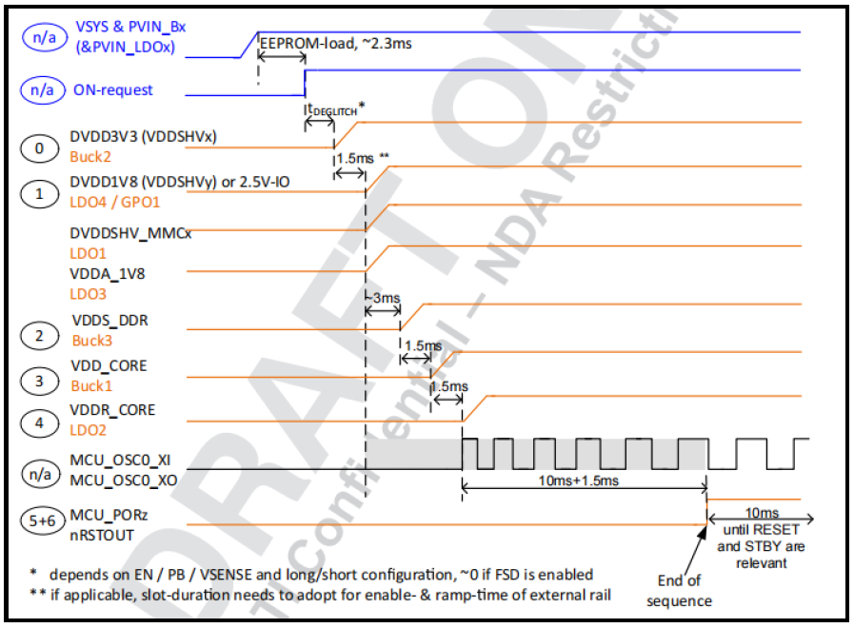
    - Power-down Sequence:
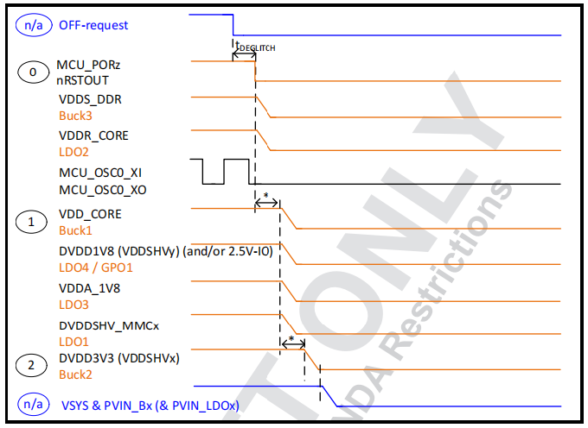

    - Power Supply:
Converting 3.3V, 1.8V, 0.85V, 2.5V, 0.75V and 1.2V using LDOs and Buck converters of the TPS6521903 IC.

Voltages | Peripherals
3.3V | PMIC, Debug Connector, USB Hub IC
2.5V | DDR, Ethernet PHY
1.8V | Board ID EEPROM, TPM Module, Temperature Sensor, RTC, eMMC, Wi-Fi + BT, Flash, DDR
1.2V | DDR
1.0V | Ethernet PHY
0.85V | DDR_CORE

    - Power Calculation:
Sr No | Part No# | Voltage |  |  |  |  |  |  | Power
Sr No | Part No# | 5 | 3.3 | 2.5 | 1.8 | 1.2 | 1 | 0.85 | Power
1 | AM6254 |  |  |  |  |  |  |  | 0.0
2 | EMMC16G-IB29-PZ90 |  | 72 |  | 123 |  |  |  | 459.0
3 | MT40A1G16KD-062E: E |  |  | 33 |  | 299 |  |  | 441.3
4 | DP83867IRRGZR |  |  | 274 | 48 |  | 216 |  | 987.4
5 | AW-NM512 |  | 331 |  | 0.22 |  |  |  | 1092.7
6 | FE1.1 | 115 |  |  |  |  |  |  | 575.0
7 | W25N02JW |  |  |  | 70 |  |  |  | 126.0
8 | ST33HTPH2X32AHD5 |  |  |  | 35 |  |  |  | 63.0
9 | RTC, LED, Temp sensor |  | 30 |  |  |  |  |  | 99.0
 | Current Subtotals-mA | 115 | 433 | 307 | 276.22 | 299 | 216 | 0 | 3843.4
 | Total Power (W) |  |  |  |  |  |  |  | 3.9

Detailed Design & Analysis
This section describes the detailed low-level design, calculations and component selection followed with design analysis for each design block. of the <$product name>.

  - <$ Block/Interface One> Design
    - <$ Block/Interface One> Specifications
<$ Briefly describe specifications of this block>

    - Block Diagram
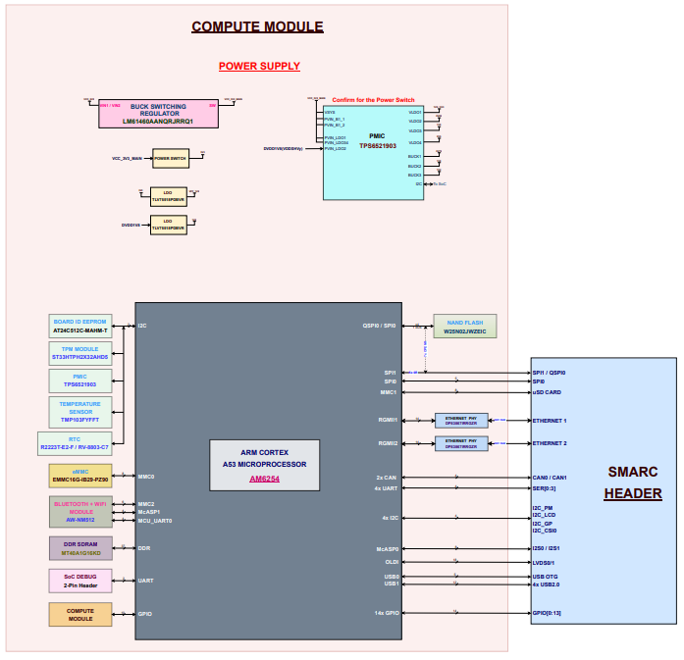
Figure 2: Block Diagram

    - Component Selection:
Sr. No. | Part Description | MFR | MFR P/N#
1 | Quad 64-bit Arm Cortex-A53 up to 1.4GHz | Texas Instruments | AM6254
2 | IC EEPROM 512KBIT I2C 8UDFN | Microchip Technology | AT24C512C-MAHM-T
3 | Long-term evolution TPM 2.0 device with an I2C interface | ST Microelectronics | ST33HTPH2X32AHD5
4 | TPS65219 Integrated Power Management IC | Texas Instruments | TPS6521903
5 | Temperature Sensor Digital | Texas Instruments | TMP103FYFFT
6 | 2-WIRE SERIAL INTERFACE REAL TIM | Nisshinbo Micro Devices IInc. | R2223T-E2-F
7 | IC RTC CLK/CALENDAR I2C 8SON | Micro Crystal AG | RV-8803-C7
8 | IC FLASH 128GBIT MMC 153TFBGA | Kingston Technology | EMMC16G-IB29-PZ90
9 | Wireless LAN and Bluetooth Module | AzureWave Technology Inc. | AW-NM512
10 | IC FLASH 16GBIT PARALLEL 96FBGA | Micron Technology Inc. | MT40A1G16KD-062E:E
11 | 2G-BIT SERIAL NAND FLASH, 1.8V | Winbond Electronics | W25N02JWZEIC
12 | IC ETHERNET PHY 48VQFN | Texas Instruments | DP83867IRRGZR
13 | Buck Switching Regulator IC Positive Adjustable 1V 1 Output 6A 14-VFQFN | Texas Instruments | LM61460AANQRJRRQ1
14 | Linear Voltage Regulator IC Positive Fixed 1 Output 500mA SOT-23-5 | Texas Instruments | TLV75518PDBVR
15 | IC PWR SWITCH N-CHAN 1:1 10WSON | Texas Instruments | TPS22954DSQR

- Hardware-Software Interface Definition
This section describes the interface between hardware and software. These details will be used by software/firmware team to derive understanding of hardware for writing device drivers, register settings, default levels and for deciding configuration parameters for programmable devices.
  - Boot-up Sequence
<$In this section, explain power-up and power-down sequence, power rails monitoring (if any) and memory boot up sequence etc. with timing values. Clearly specify using State flow diagram or Sequence in which the module needs to be initialized with time constraints, if any.>
  - Reset Logic
<$Describe board level & system level reset scheme and list the various reset signals (both Hardware and Software Reset) available with their Logic level & Active state along with reset pulse width details. Provide block diagrams and tables, if necessary.>
  - Clock Schemes
<$Describe board level & System level Clock scheme and list the various Clock signals available with their type, Speed, Logic level & Active state. Also, PLL settings, if there are any. Provide block diagrams and tables, if necessary. List down all clock registers required to be configured and monitored. Provide appropriate register values that should be configured, such as PLL settings, MCLK configuration etc.>
  - Indications & User Controls
    - LED Indications
<$List down the LEDs used in the system. Provide states & indication of the functionality in a table.>

- Design Limitations & Open Issues
<$describe if there are limitations of the design to achieve primary or secondary function of the product. Mention if there are limitations for the firmware/software to utilize the hardware modules in intended way.
<$This section should capture what is not implemented in the design with respect requirements identified in HRS – take reference from RTM that should be updated during design phase.>
<$add technical risks associated with this design and define a potential mitigation plan.>
- PCB Development Strategy
This section describes the preliminary PCB development strategy, layer stack-up planned and mechanical constraints for the SM2S AM6254.
  - Layer Stack-up:

  - PCB Outline: 82mm x 50mm

  - Placement Strategy:

  - Grounding Scheme:

