DOCUMENTATION INTERFACE
30/10/14

Milestone: C++ program (Visual Studio) working with Xbox Joystick
We have two different options to work with the joystick through a C++ program.

A) Run the program using Visual Studio:
- Open interface_v4/Test1/Test1.vcxproj.
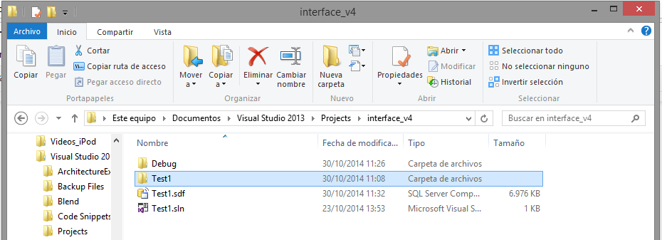
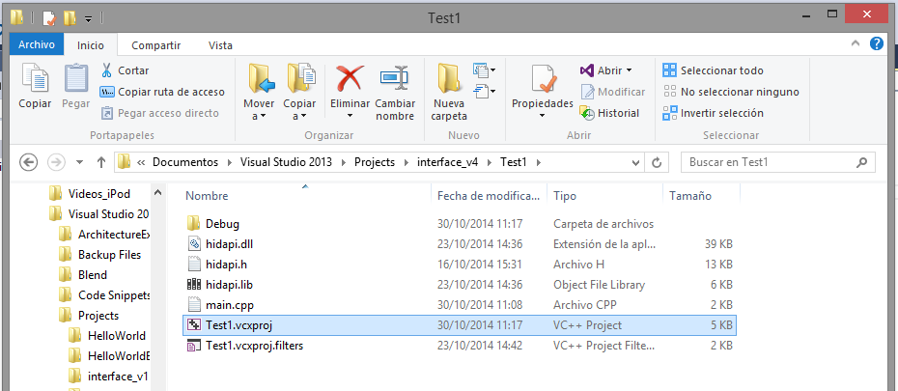
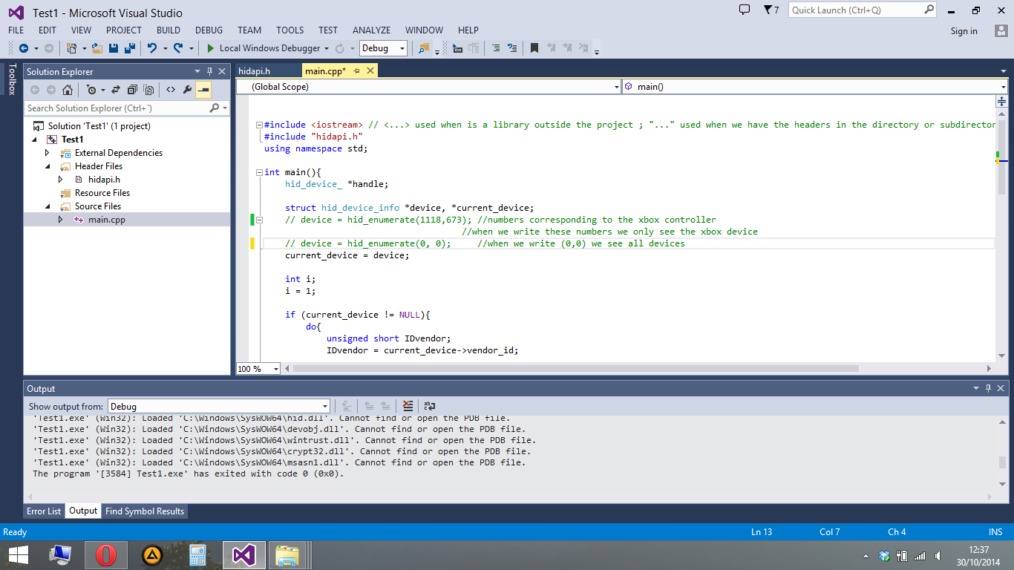

- Then we have to build the program and run it.
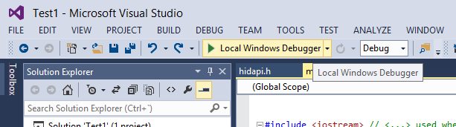

- If a prompt appears, say Yes:
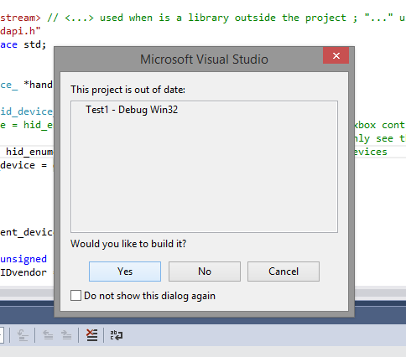

- See the results:
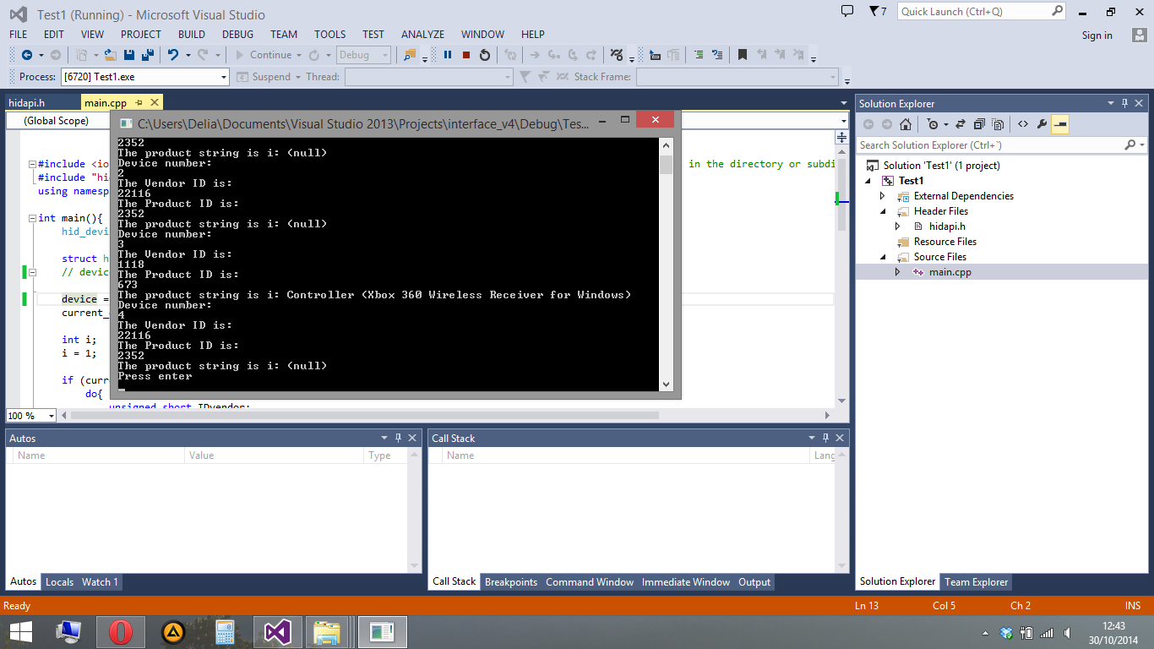

B)Executable file that works in every computer with Visual Studio installed.
- We should provide a folder which contains the .exe file (Test1.exe, in this case) and the necessary libraries (msvcr120d.dll and hidapi.dll).
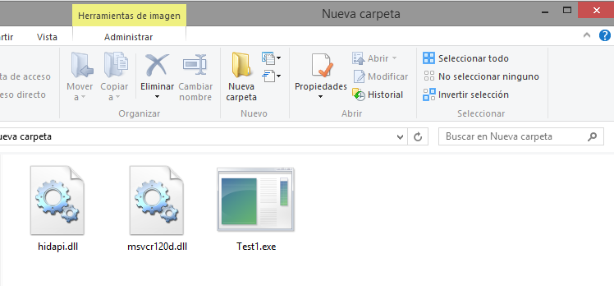
- This Test1.exe can be found in the Debug folder inside interface_v4. It is created automatically when we run the project for first time.
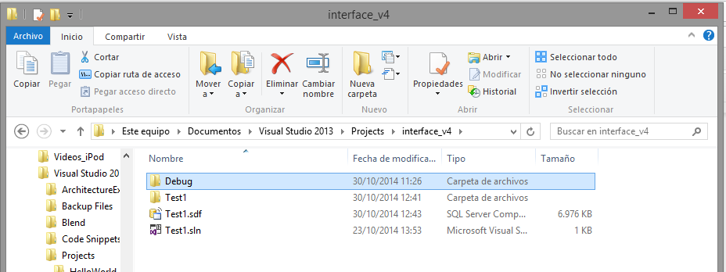
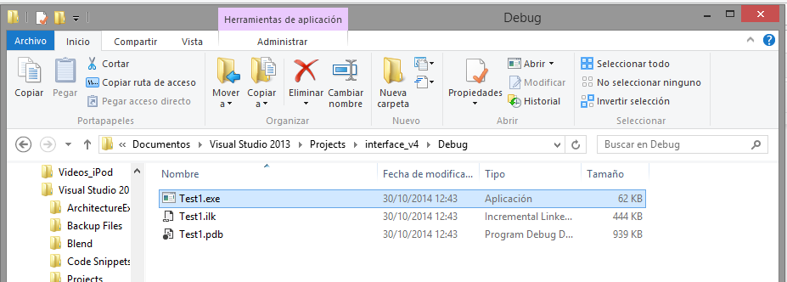

- This hidapi.dll can be found in interface_v4/Test1/:
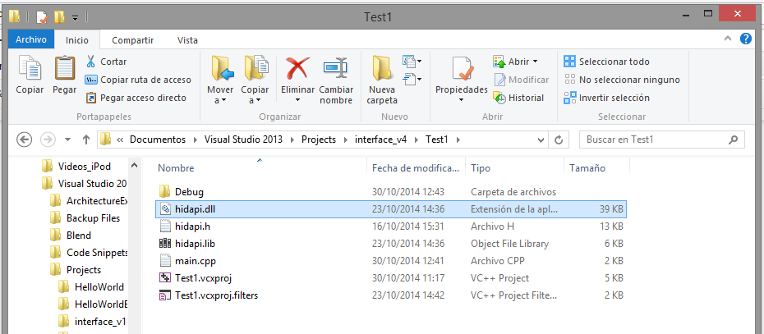
- This msvcr120d.dll can be found at /System32.
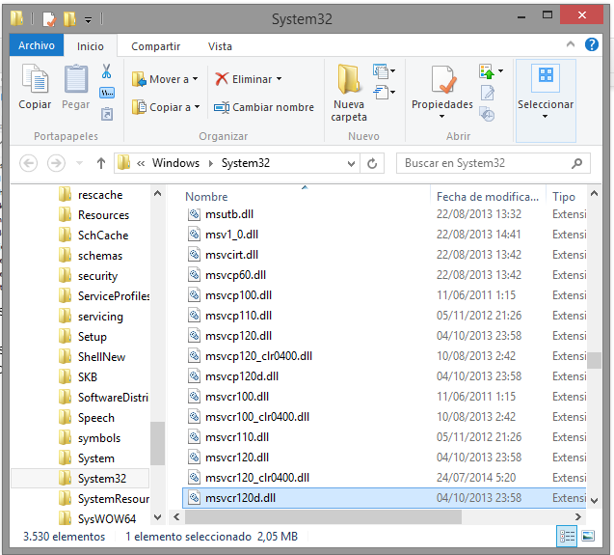
- This program will show us the information about our usb ports. It will show that Microsoft Xbox wireless controller is plugged in, if it is.

