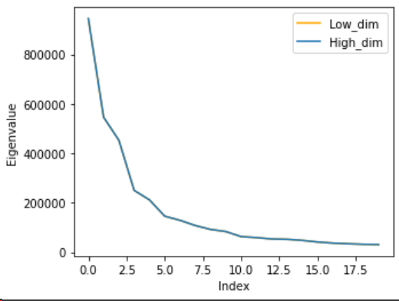
Figure 1: The values of 20 largest eigenvalues of original PCA (High-dim in figure) and low-dimensional PCA (Low-dim in figure) method. Later one is fully covered by another one.

CS492 Coursework1

Soohyun Ryu  KAIST  Institution1 address  rsoohyun@kaist.ac.kr | Sangwoo Park  KAIST  First line of institution2 address  swgger@kaist.ac.kr

Abstract

The ABSTRACT

Computationally Efficient Eigenfaces
We partitioned the face data into training and testing data with a ratio of 4:1 and implemented PCA and low-dimensional PCA methods. For detail about how we wrote the code, refer to the source code. The reconstruction error and computation time of each method are illustrated in Figure 2.

Eigenvectors and eigenvalues
As we can see in Figure 1, the eigenvalues of the two methods are the same. Also, we found that eigenvectors of two methods have the same value when those from low-dimensional computation are multiplicated with matrix A. They got opposite signs so that while running the algorithm, there is no difference between the two methods. We can find it at the output of our source code.

Pros and Cons of each method
As illustrated in Figure 2, the reconstruction error of both methods does not have a significant difference. But in terms of computation time, the low-dimensional PCA method shows notable performance. Its average computation time is about 60 times faster than the original PCA method. Since both methods compute the same result as we have shown in 1.1, we prefer to use low-dimensional PCA.
However, since the low-dimensional PCA method computes a smaller number of eigenvectors, in our case 416, than the original PCA method, in our case 2576, it might result in less accurate results. Since the low-dimensional PCA method can compute all of the influential eigenvectors, which means eigenvectors with large eigenvalues, it can result in a quite meaningful result. But since the original PCA method can use more eigenvectors for reconstruction, it can result in more accurate results.

Varying number of PCA bases learnt
The result of the PCA method depends on the number of PCA bases. As we use more PCA bases, we can get more accurate results. As we can see in Figure 2, computation time also varies, but with small fluctuation. But reconstruction error decreases continuously as we use more PCA bases. It means that each PCA base contains the feature of the train image and does its role in the performance. This also explains the advantage of the original PCA method we mentioned in 1.2.

Incremental PCA
We partitioned the face data as in 1 and also divided train data into 4 parts with the same number of each face label. Here, we ignored all other computations and just focused on eigendecomposition. For further details about the implementation, please refer to the source code.

Batch PCA
For batch PCA, we used the low-dimensional PCA method that we implemented in 1. We used 100 PCA bases since according to the experiment we did in 1.3, the slope of reconstruction error seems to be gentle when the number of PCA bases becomes larger than 100. The training time was about 0.295 sec and the reconstruction error was about 9.29e12. We computed face recognition accuracy with the NN classifier and got 0.40.

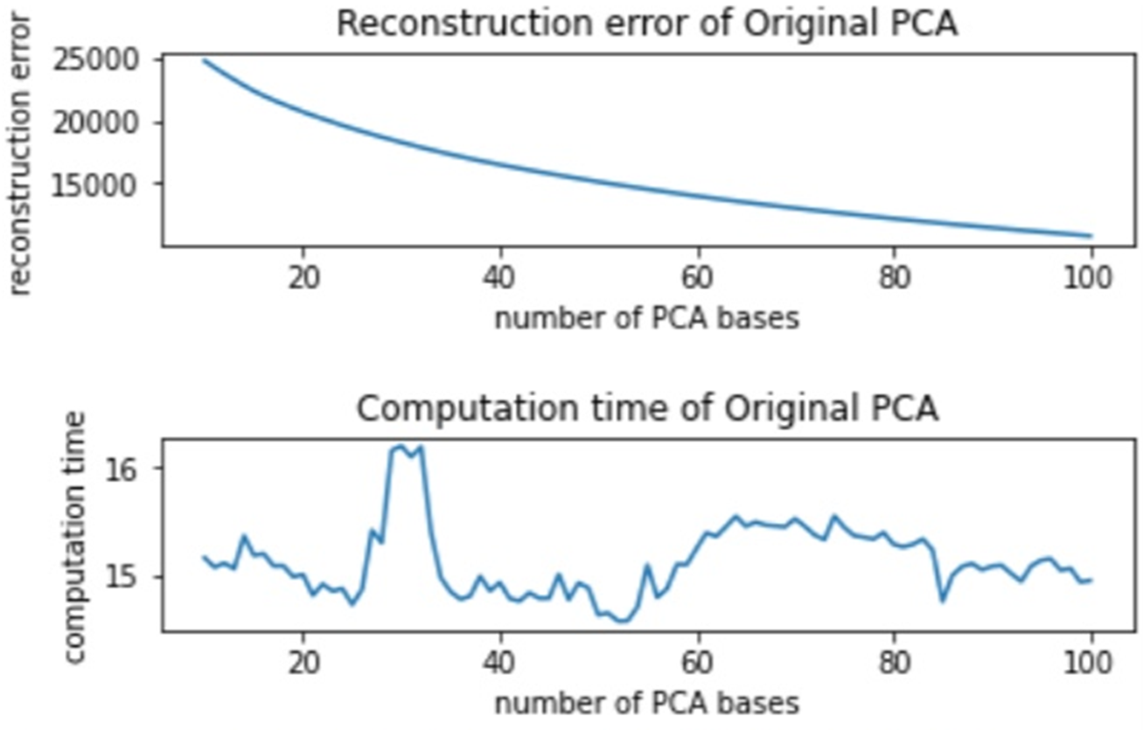
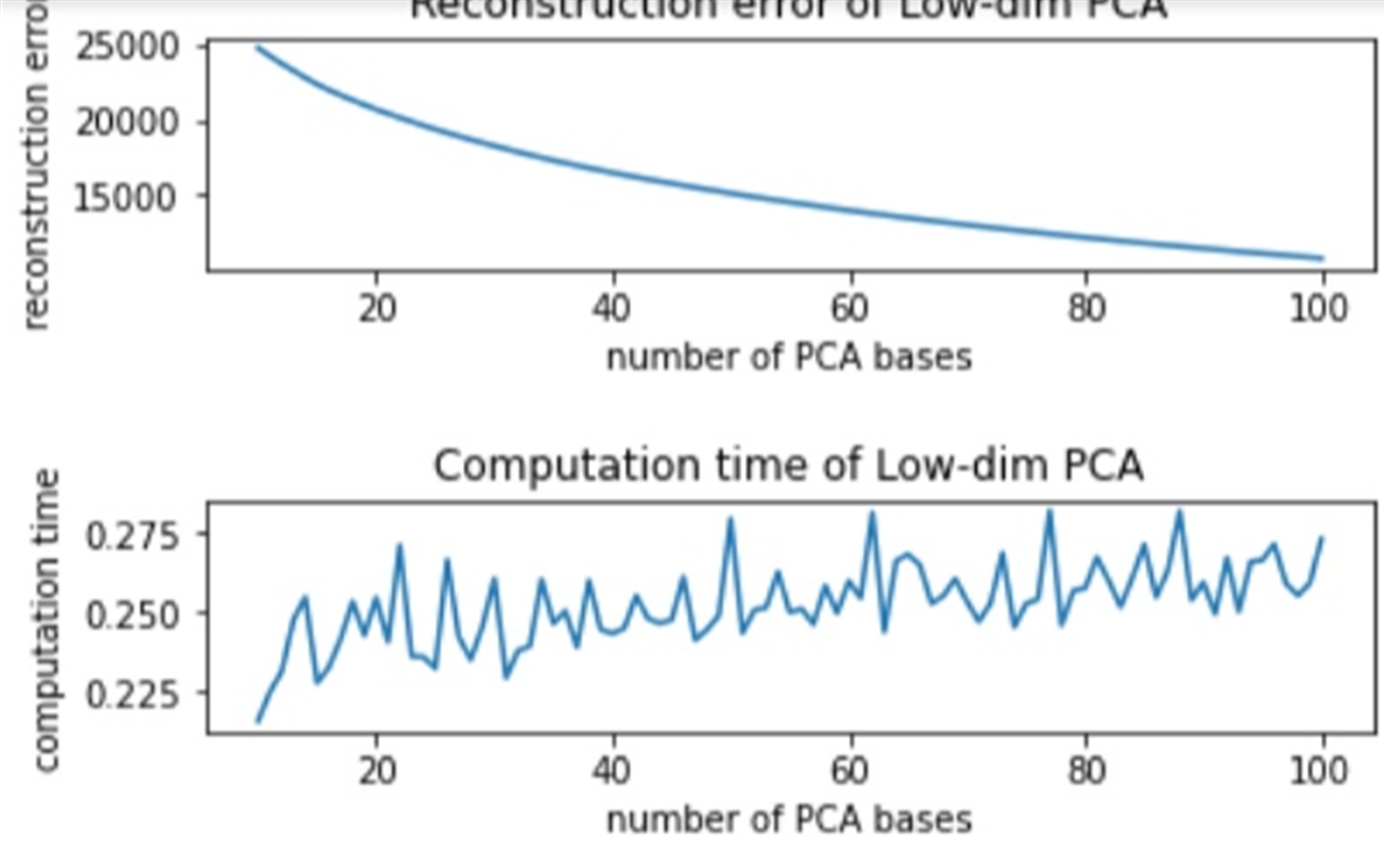
PCA trained only by the first train subset
(a) (b)
Figure 2: Reconstruction error and computation time of (a) original PCA with average computation time 15.14 sec and (b) low-dimensional PCA method with average computation time 0.25 sec.
We trained PCA only by the first train subset. We used the original PCA method at this time, for the merging process in the incremental PCA method. We used 100 PCA bases to compare this method with batch PCA and incremental PCA methods. Here, it took 14.077 sec, which is similar to the computation time of the original method that we mentioned in 1. The reconstruction error is about 8.34e3. In our opinion, it has a much smaller reconstruction error because of the smaller number of train data, and our function that calculates reconstruction error does not consider the size of train data. Face recognition accuracy with the NN classifier was about 0.029. It is very small compared to batch PCA. It is because we train the model with 4 times smaller train data. We can know that size of the train dataset has a huge effect on recognition accuracy.

Incremental PCA
We implemented the incremental PCA method as described in the lecture note. We used 25 PCA bases for each PCA model with subsets since we wanted the number of PCA bases in the incremental PCA method to be 100 after the merging process. Its computation time for merging 4 models is 0.017 sec, which is much shorter than the computation time of the original PCA method, even smaller than that of the low-dimensional PCA method. It shows that when we have models for partitioned train data, we can easily get the model that can be applied to whole train data with very small effort. The reconstruction error of this method is 1.99e7, which is way smaller than the batch PCA method. It shows that even with smaller computations, we can get a reasonable result using incremental PCA. However, its recognition accuracy is about 0.106, which is more than 4 times larger than 2.2, but almost 4 times smaller than batch PCA. We can know that with the incremental PCA method, we can get the result very fast, but accuracy may not be meaningful.

PCA-LDA for Face Recognition
Since the dimension of face data is way bigger than the cardinality, the with-in scatter matrix 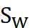 is singular in our case. To deal with it, we implemented the PCA-LDA method to find an optimal solution by reducing the dimensionality of the given data set. Here, we used the low-dimensional PCA method that we implemented in 1 and the same data set used in 1. For further details about the implementation, please refer to the source code.
Since the rank of rach scatter matrices are limited, 416-52 = 364 for , 52-1=51 for , we vary the value of hyperparameters, 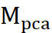 and 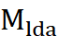, within this range. We optimized the value from 51 to 364. If is less than 51, there can be a restriction when determining . As we can see in Figure 3(a), when is 160, It shows the most accurate result. Accuracy seems to increase until 160. In our opinion, as we discussed in 1.2, as we use many PCA bases, we can get a better result. In the PCA-LDA method, 160 is the optimal value. When is larger than 160, the accuracy seems to decrease with small fluctuation. It shows that using more than using 160 PCA bases is meaningless since we can get enough information about train data with only 160 bases. Also, LDA takes less part when calculating an optimal solution, which is not desirable since the PCA method does not use class labels. Since fluctuation is not so big, we can use value 160 for .
As we varied , the number of LDA bases also affects the result. As illustrated in Figure 3(b), accuracy increases along with some fluctuation in computation time. We can see that each base has meaningful information and does its role in the classification process.
The rank of and obtained in the process of PCA-LDA with =160 and =51 are 364 and 51, respectively. This number perfectly fits the definition of their ranks.
Figure 4 shows the confusion matrix of the same case. Among 104 entries, only 7 is out of our expectations. One interesting point is that class 14 and 34 has a symmetric error which means that their data probably have similar facial information.
Figure 4: Confusion matrix when
=160 and
=51 with average precision and recall score are 0.952 and 0.933, respectively. Overall, F1 score is 0.931.
Computation time is also remarkable. The low-dimensional PCA method took 0.25 sec, however, the PCA-LDA method took 3.19 sec even though it uses the low-dimensional PCA method for its first step. Since it needs to calculate , and eigenvectors, it takes almost 13 times longer time.
Memory 부분은 조금 더 고민해볼게!

RF codebook
There are 2 ways of enabling ensemble, here we concentrate on random sampling in feature space, not bagging. Before we do randomization, we projected image data with 415 PCA bases to avoid overfitting. For the detail of the implementation, please refer to the source code.

Randomization in feature space
As we saw in Figure 3(a), 160 is the optimal value for in PCA step. Referring to this, we set , the sum of  and 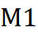, to be greater than 100 and less than 200 to get a meaningful result.

Number of base models
Content.

Error
Error of committee machine vs average error of individual models

Fusion rules
Majority voting / sum

Recognition accuracy and Confusion matrix
Figure 3: Accuracy and computation time of PCA-LDA method with (a) varying
value from 50 to 364. Average computation time is 3.24 sec and value 160 shows the highest accuracy 0.9327. (b) varying
value from 10 to 51 with fixed
value as 160. Average computation time is 3.19 sec.
Content.

K-means codebook
Vocabulary size
Bag-of-words histograms of example training/testing images
Vector quantization process (briefly explain)

RF classifier
Varying parameters - # of trees / depth of trees / degree of randomness parameter / type of weak-learner(axis-aligned / two-pixel test)

Recognition acc / confusion matrix
Example success / failure
Time-efficiency of training/testing
Impact of vocab size on classification acc

RF codebook
Content.

References
- https://github.com/sw-programmer/Coursework1
- [reference for RF classifier]
- [lecture slide]

