EDA_NDTI_MYD09GA

Sami Rifai

## Adelaide Metro. Coastline zones

oz_poly <- rnaturalearth::ne_countries(country = "Australia",  
 returnclass = "sf",   
 scale = 'large')  
amc <- sf::read_sf("data/AMC/AnalysisExtentMask_GDA94z54.shp")  
amc <- sf::st_transform(amc, sf::st_crs(oz_poly))  
amc <- amc %>% mutate(  
 fzone = factor(zone, ordered = T,  
 levels = c("North Zone","Central Zone","South Zone"),  
 labels = c("North Zone","Central Zone","South Zone")))  
  
vec_lims <- st_bbox(st_buffer(amc,10000))  
  
ggplot()+  
 geom_sf(data = oz_poly)+   
 geom_sf(data = amc, aes(fill = fzone)) +  
 coord_sf(xlim = vec_lims[c("xmin","xmax")],  
 ylim = vec_lims[c("ymin","ymax")],   
 crs = st_crs(amc),   
 ndiscr = 3,  
 lims_method = "box") +   
 scale_x_continuous(breaks = seq(  
 from = round(vec_lims["xmin"],digits=1),   
 to = round(vec_lims['xmax'],digits=1),   
 by = 0.3  
 )) +  
 scale_fill_viridis_d(option = "C", end = 0.9) +   
 labs(fill = "Zone") +   
 theme(panel.background = element_rect(fill='lightblue'))

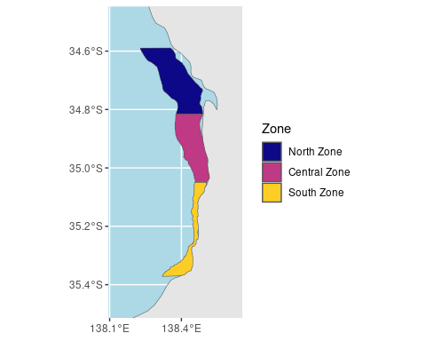

MODIS Aqua NDTI data was extracted from 2003 - 2021. There is an QA band issue that needs debugging with the imagery from 2022+.

Here we summarize all NDTI values for each zone by the median, the SD, and the number of observations.

## Observations

dat %>%   
 ggplot(aes(count, fill = fzone))+  
 geom_density(alpha = 0.7,  
 color = NA) +   
 labs(x= "Pixel Count",  
 fill = "Zone") +   
 scale_fill_viridis_d(option = "C", end = 0.9) +  
 coord_cartesian(expand = F) +   
 theme_linedraw()

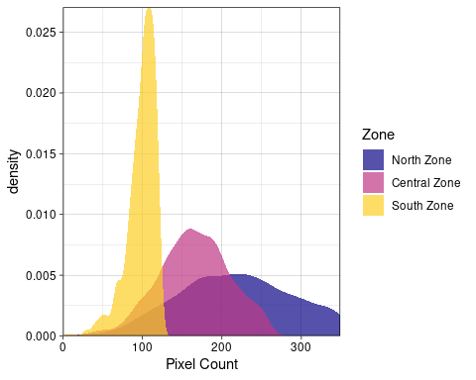

## histogram of ndti by zone

dat %>%   
 ggplot(aes(ndti, fill = fzone))+  
 geom_density(alpha = 0.7,  
 color = NA) +   
 labs(x= "NDTI",  
 fill = "Zone") +   
 scale_fill_viridis_d(option = "C", end = 0.9) +  
 coord_cartesian(expand = F) +   
 theme_linedraw()

Warning: Removed 1 rows containing non-finite values (`stat_density()`).

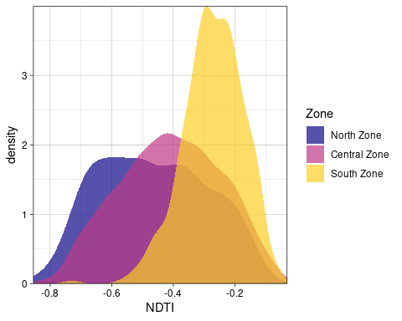

The Southern Zone has notably higher NDTI (more turbid). ***Is this plausible?***

## Standard Deviation of NDTI within zone

dat %>%   
 ggplot(aes(stdDev, fill = fzone))+  
 geom_density(alpha = 0.7,  
 color = NA) +   
 labs(x= "NDTI",  
 fill = "Zone") +   
 scale_fill_viridis_d(option = "C", end = 0.9) +  
 coord_cartesian(expand = F) +   
 theme_linedraw()

Warning: Removed 1 rows containing non-finite values (`stat_density()`).

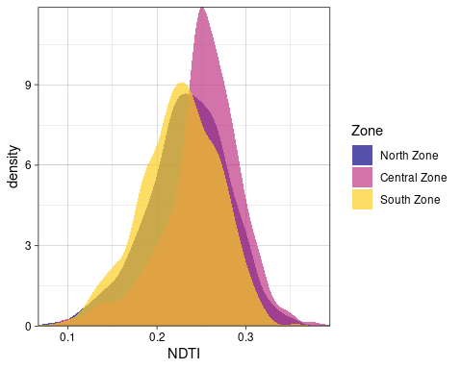

The Central zone seems slightly more variable than the others.

## zonal median by week

dat[date %between% c(ymd("2016-01-01"),ymd("2018-12-31"))] %>%   
 ggplot(aes(date, ndti, color=count))+  
 geom_hline(aes(yintercept = 0),  
 color = 'grey70')+   
 geom_ribbon(aes(ymin = ndti - stdDev,   
 ymax = ndti + stdDev),  
 alpha = 0.25,   
 color = NA) +   
 geom_line(aes(color = NULL)) +   
 geom_point(size = 1) +   
 scale_color_viridis_c() +  
 labs(x = NULL, y="NDTI",  
 color = "Pixel\nCount") +   
 coord_cartesian(expand = F) +   
 facet_wrap(~zone, ncol = 1)+  
 theme_linedraw()+  
 theme(panel.grid = element_blank())

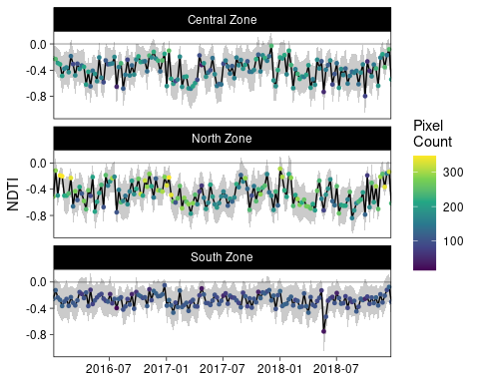

# Modeling the seasonal and yearly components

## start with seasonal component and zone

m1 <- gam(ndti ~ s(month, by = fzone,   
 bs=c('cc','fs')),   
 data=dat,   
 select = T)  
getViz(m1) %>%   
 plot() %>%   
 print(pages=1)

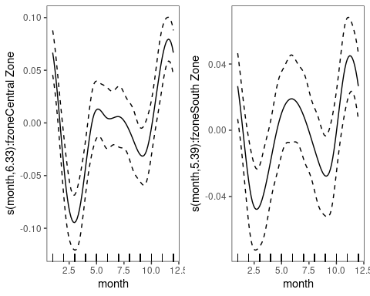

## Cyclic month and zone as a factor

m2 <- gam(ndti ~ fzone +   
 s(month,   
 bs=c('cc')),   
 data=dat,   
 select = T)  
  
bbmle::AICctab(m1,m2)

dAICc df   
m2 0.0 10.9  
m1 991.6 13.7

Lower AIC on m2 suggests that each zone does not need its own monthly smoooth.

## Add year component0

m3 <- gam(ndti ~ year +   
 fzone +   
 s(month,   
 bs=c('cc')),   
 data=dat,   
 select = T)  
bbmle::AICctab(m2, m3)

dAICc df   
m3 0.0 11.9  
m2 25.0 10.9

summary(m3)

Family: gaussian   
Link function: identity   
  
Formula:  
ndti ~ year + fzone + s(month, bs = c("cc"))  
  
Parametric coefficients:  
 Estimate Std. Error t value Pr(>|t|)   
(Intercept) -5.3384204 0.9524882 -5.605 2.28e-08 ***  
year 0.0024632 0.0004734 5.203 2.09e-07 ***  
fzone.L 0.1378612 0.0044917 30.692 < 2e-16 ***  
fzone.Q 0.0334859 0.0044909 7.456 1.16e-13 ***  
---  
Signif. codes: 0 '***' 0.001 '**' 0.01 '*' 0.05 '.' 0.1 ' ' 1  
  
Approximate significance of smooth terms:  
 edf Ref.df F p-value   
s(month) 6.91 8 42.66 <2e-16 ***  
---  
Signif. codes: 0 '***' 0.001 '**' 0.01 '*' 0.05 '.' 0.1 ' ' 1  
  
R-sq.(adj) = 0.316 Deviance explained = 31.8%  
GCV = 0.019997 Scale est. = 0.019923 n = 2963

getViz(m3) %>% plot(allTerms = T) %>% print(pages = 1)

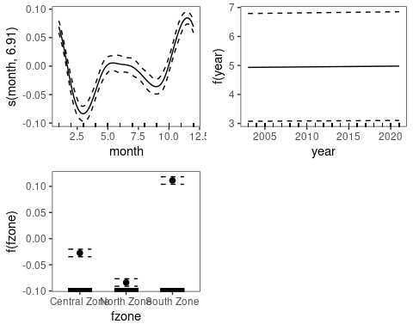

## Relative to zone differences, the linear year effect is extremely weak

## Examine year as a nonlinear effect

m4 <- gam(ndti ~   
 s(year) +   
 fzone +  
 s(month,  
 bs=c('cc')),   
 data=dat,  
 select = T)  
getViz(m4) %>% plot(allTerms = T) %>% print(pages = 1)

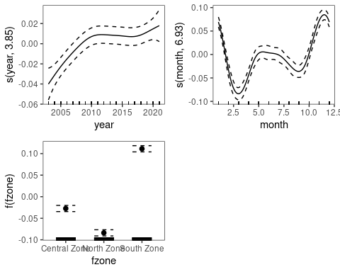

summary(m4)

Family: gaussian   
Link function: identity   
  
Formula:  
ndti ~ s(year) + fzone + s(month, bs = c("cc"))  
  
Parametric coefficients:  
 Estimate Std. Error t value Pr(>|t|)   
(Intercept) -0.382494 0.002589 -147.734 < 2e-16 ***  
fzone.L 0.137864 0.004485 30.740 < 2e-16 ***  
fzone.Q 0.033487 0.004484 7.468 1.07e-13 ***  
---  
Signif. codes: 0 '***' 0.001 '**' 0.01 '*' 0.05 '.' 0.1 ' ' 1  
  
Approximate significance of smooth terms:  
 edf Ref.df F p-value   
s(year) 3.854 9 4.213 <2e-16 ***  
s(month) 6.931 8 42.825 <2e-16 ***  
---  
Signif. codes: 0 '***' 0.001 '**' 0.01 '*' 0.05 '.' 0.1 ' ' 1  
  
R-sq.(adj) = 0.318 Deviance explained = 32.1%  
GCV = 0.019955 Scale est. = 0.019862 n = 2963

bbmle::AICctab(m3, m4)

dAICc df   
m4 0.0 14.8  
m3 6.2 11.9

## year is better modeled as a nonlinear effect, than a linear effect

## Examine nonlinear year effect by site

m5 <- gam(ndti ~   
 s(year, fzone, bs='fs') +   
 s(month,  
 bs=c('cc')),   
 data=dat,  
 select = T)  
summary(m5)

Family: gaussian   
Link function: identity   
  
Formula:  
ndti ~ s(year, fzone, bs = "fs") + s(month, bs = c("cc"))  
  
Parametric coefficients:  
 Estimate Std. Error t value Pr(>|t|)  
(Intercept) 0.2539 0.4815 0.527 0.598  
  
Approximate significance of smooth terms:  
 edf Ref.df F p-value   
s(year,fzone) 8.471 30 34.77 <2e-16 ***  
s(month) 6.912 8 42.84 <2e-16 ***  
---  
Signif. codes: 0 '***' 0.001 '**' 0.01 '*' 0.05 '.' 0.1 ' ' 1  
  
R-sq.(adj) = 0.319 Deviance explained = 32.2%  
GCV = 0.019947 Scale est. = 0.019836 n = 2963

getViz(m5) %>% plot(allTerms = T) %>% print(pages = 1)

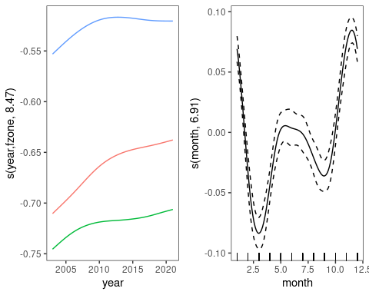

bbmle::AICctab(m4, m5)

dAICc df   
m5 0.0 17.4  
m4 1.2 14.8

Nonlinear year by site is better, but the AIC difference is very small. So we will drop the year x zone interaction.

## Examine number of knots on year

We start with an equivalent number of knots per year, and will not aggressively penalize the ‘year’ smooth.

kn <- dat$year %>% unique %>% length  
m6 <- gam(ndti ~   
 s(year, k = kn) +   
 fzone +  
 s(month,  
 bs=c('cc')),   
 data=dat,  
 select = F) # reduces penalization on smooths  
summary(m6)

Family: gaussian   
Link function: identity   
  
Formula:  
ndti ~ s(year, k = kn) + fzone + s(month, bs = c("cc"))  
  
Parametric coefficients:  
 Estimate Std. Error t value Pr(>|t|)   
(Intercept) -0.382494 0.002580 -148.243 < 2e-16 ***  
fzone.L 0.137859 0.004469 30.845 < 2e-16 ***  
fzone.Q 0.033485 0.004469 7.493 8.83e-14 ***  
---  
Signif. codes: 0 '***' 0.001 '**' 0.01 '*' 0.05 '.' 0.1 ' ' 1  
  
Approximate significance of smooth terms:  
 edf Ref.df F p-value   
s(year) 13.782 16.06 3.855 4.4e-07 ***  
s(month) 6.915 8.00 43.257 < 2e-16 ***  
---  
Signif. codes: 0 '***' 0.001 '**' 0.01 '*' 0.05 '.' 0.1 ' ' 1  
  
R-sq.(adj) = 0.322 Deviance explained = 32.8%  
GCV = 0.019885 Scale est. = 0.019726 n = 2963

getViz(m6) %>% plot(select = 1) %>% print(pages = 1)

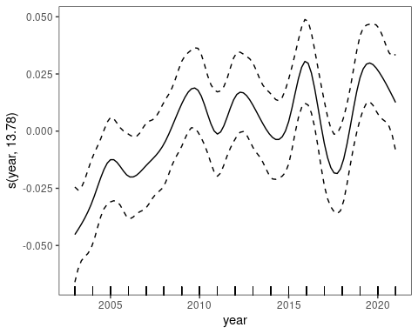

bbmle::AICctab(m5, m6)

dAICc df   
m6 0.0 24.7  
m5 9.1 17.4

##

Allowing the year effect to vary by year improves the fit.

## Try a penalized year effect

This is to help determine how real these year to year peaks are.

m7 <- gam(ndti ~   
 s(year, k = kn, bs='ts') +   
 fzone +  
 s(month,  
 bs=c('cc')),   
 data=dat,  
 select = T)  
summary(m7)

Family: gaussian   
Link function: identity   
  
Formula:  
ndti ~ s(year, k = kn, bs = "ts") + fzone + s(month, bs = c("cc"))  
  
Parametric coefficients:  
 Estimate Std. Error t value Pr(>|t|)   
(Intercept) -0.382494 0.002589 -147.719 < 2e-16 ***  
fzone.L 0.137865 0.004485 30.737 < 2e-16 ***  
fzone.Q 0.033488 0.004484 7.467 1.07e-13 ***  
---  
Signif. codes: 0 '***' 0.001 '**' 0.01 '*' 0.05 '.' 0.1 ' ' 1  
  
Approximate significance of smooth terms:  
 edf Ref.df F p-value   
s(year) 3.208 18 2.053 <2e-16 ***  
s(month) 6.470 8 41.904 <2e-16 ***  
---  
Signif. codes: 0 '***' 0.001 '**' 0.01 '*' 0.05 '.' 0.1 ' ' 1  
  
R-sq.(adj) = 0.318 Deviance explained = 32%  
GCV = 0.019951 Scale est. = 0.019866 n = 2963

getViz(m7) %>% plot(select = 1) %>% print(pages = 1)

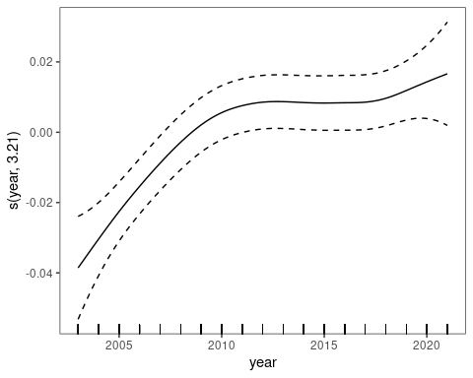

bbmle::AICctab(m6, m7)

dAICc df   
m6 0.0 24.7  
m7 9.8 13.7

##

The wiggly model is slightly better than the smoother effect.