1. Quantitative Methods for Valuation
   1. Correlation and Regression
      1. Calculate and interpret a sample covariance and a sample correlation coefficient

Covariance between two random variables is a statistical measure of the degree to which the two variables move together.

CovXY =

Correlation coefficient, r is a measure of the strength of the linear relationship between two variables.

rXY = CovXY / (Sx * Sy)

* + 1. Describe limitations to correlation analysis
* Outliers

Outliers can result in evidence that a statistically significant relationship exists when there is none in fact; or that there’s no relationship when there’s a relationship in fact.

* Spurious Correlation

It refers to the appearance of a causal linear relationship, when in fact, there’s no relationship.

* Nonlinear Relationships

Two variables may have a non-linear relationship.

* + 1. Formulate a test of the hypothesis that the population correlation coefficient equals 0 and determine whether the hypothesis is rejected at a given level of significance.

We want to test whether the correlation between the population of 2 variables is equal to 0.

H0: p = 0 versus Ha: p! = 0

We can use a t-test to determine whether the null hypothesis should be rejected.

t – statistic = , degrees of freedom: n-2. r is the sample correlation coefficient.

* + 1. Distinguish between the dependent and independent variables in a linear regression

The purpose of simple linear regression is to explain the variation in a dependent variable in terms of the variation in a single independent variable.

* + 1. Describe the assumptions underlying linear regression and interpret regression coefficients.

The following linear regression model is used to describe the relationship between two variables.

Yi = b0 + b1Xi + εi

b0 = regression intercept term

b1 = regression slope coefficient

εi = residual/disturbance term/error term for the ith observation, represents the portion of the dependent variable that cannot be explained by the independent variable.

The linear equation, often called the line of best fit, or regression line, takes the following form:

Yi = estimated value of Yi given Xi

b0 = estimated intercept term =

b1 = estimated slope coefficient = Cov (XY) / Sx^2, which is the change in the dependent variable for 1-unit change in the independent variable.

The regression line is the line for which the Sum of Squared Errors (SSE) is minimized.

SSE =, the sum of the squared vertical distances between the estimated and actual Y-values.

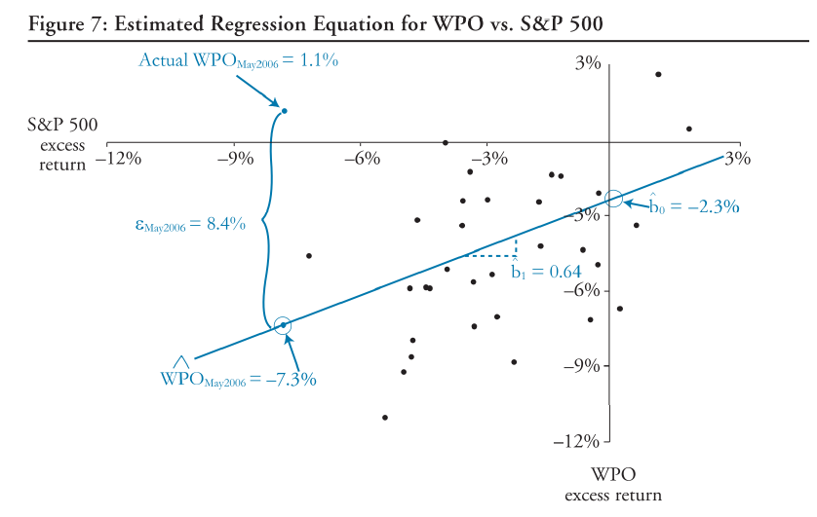

* + 1. Calculate and interpret the standard error of estimate, the coefficient of determination and a confidence interval for a regression coefficient.
* Standard error of estimate (SEE) measures the degree of variability of the actual Y-values relative to the estimated Y-values from a regression equation. The smaller the standard error, the better the fit.
* Coefficient of determination (R^2) is defined as the percentage of the total variation in the dependent variable explained by the independent variable.

For simple linear regression, R2 = r2 = square of the correlation coefficient.

* Regression Coefficient Confidence Interval:

tc is the critical two-tailed t-value for the selected confidence level with degree of freedom, n-2.

: Standard error of regression coefficient, is a function of SEE. (Will be provided)

* + 1. Formulate a null and alternative hypothesis about a population value of a regression coefficient.

A t-test may also be used to test the hypothesis that the true slope coefficient, b, is equal to some hypothesized value.

with degree of freedom n-2.

* + 1. Calculate the predicted value for the dependent variable.

Predicted values are values of the dependent variable based on the estimated regression coefficients and a prediction about the value of the independent variable.

* + 1. Calculate and interpret a confidence interval for the predicted value of the dependent variable.

tc = two-tailed critical t-value at the desired level of significance with degree of freedom = n-2

sf = standard error of the forecast (will be provided)

* + 1. Describe the use of analysis of variance (ANOVA) in regression analysis, interpret ANOVA results and calculate and interpret the F-static.

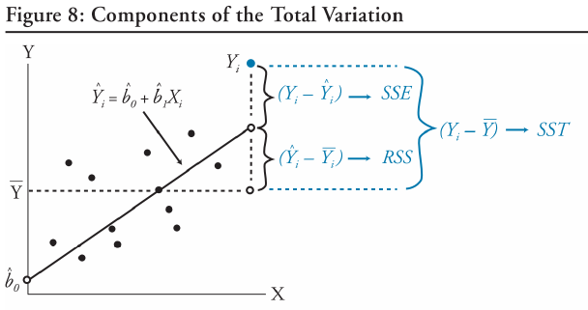

* Total sum of squares (SST) measures the total variation in the dependent variable.

SST =

* Regression sum of squares (RSS) measures the variation in the dependent variable that is explained by the independent variable.

RSS =

* Sum of squared errors (SSE) measures the unexplained variation in the dependent variable.

SST = SSE + RSS

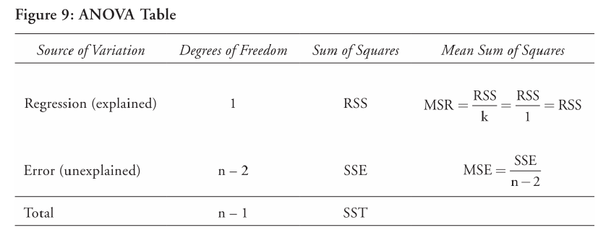

R2 = (SST – SSE)/SST = RSS/SST

SEE =

The F-test assess how well a set of independent variables, as a group, explains the variation in the dependent variable.

F = MSR/MSE = (RSS/k) / (SSE / (n-k-1)), **which is a one-tailed test**.

In simple linear regression, it tells us the same thing as the t-test of the slope coefficient (tb1)

* + 1. Describe limitations of regression analysis
* Linear relationships can change over time.
* Its usefulness in investment analysis will be limited if other market participants are also aware of and act on this evidence.
* If the assumptions underlying regression analysis do not hold, the interpretation and test may not be valid.
  1. Multiple Regression and Issues in Regression Analysis

Use a t-test to assess the significance of the individual regression parameters and an F-test to assess the effectiveness of the model as a whole in explaining the dependent variable.

* + 1. Interpret estimated regression coefficients and their p-values.
* The intercept term is the value of the dependent variable when the independent variables are 0.
* Each slope coefficient is the estimated change in the dependent variable for a one unit change in that independent variable, *holding the other independent variables constant*. Slope coefficients are also called **partial** **slope coefficients**.
* When adding new independent variables, the slope coefficients for old independent variables will probably change, unless the new and old independent variables are uncorrelated. The multiple regression equation captures this relationship among all independent variables when predicting Y.
  + 1. Formulate a hypothesis about the population value of a regression coefficient, calculate the value of the test statistic, and determine whether to reject the null hypothesis at a given level of significance.
    2. Interpret the result of hypothesis tests of regression coefficients.

The t-statistic used to test the significance of the individual coefficients in a multiple regression is calculated as follows:

t =

with n-k-1 degrees of freedom (k is the number of independent variables).

* + 1. Calculate and interpret 1) a confidence interval for the population value of a regression coefficient and 2) a predicted value for the dependent variable, given an estimated regression model and assumed values for the independent variables.

The confidence intervals for a regression coefficient is calculated as follows:

The critical t-value is a two-tailed value with n-k-1 degrees of freedom.

We can use the regression equation to make predictions about the dependent variable based on forecasted values of the independent variables.

* + 1. Explain the assumptions of a multiple regression model
    2. Calculate and interpret the F-statistic, and describe how it is used in regression analysis.

An F-test assesses how well the set of independent variables, as a group, explains the variation in the dependent variable. In other words, F-statistic is used to test whether at least one of the independent variables explains a significant portion of the variation of the dependent variable.

E.g.: if there’re 4 independent variables in the model, the hypotheses are structured as:

H0: b1 = b2 = b3 = b4 = 0 Ha: at least one bj != 0

The F-statistic, which is always a one-tailed test, is calculated as:

F = MSR/MSE = (RSS / k) / (SSE / (n-k-1))

with degrees of freedom of k and n-k-1.

* + 1. Distinguish between and interpret the R2 and adjusted R2 in multiple regression.

R2 can be used to test the overall effectiveness of the entire set of independent variables in explaining the dependent variable. An R2 of 0.63 indicates that the model, as a whole, explains 63% of the variation in the dependent variable.

R2 = RSS/SST

However, R2 by itself may not be a reliable measure, because R2 almost always increases as variables are added to the model, even if the marginal contribution of the new variables is not statistically significant. Consequently, a relatively high R2 may reflect the impact of a large set of independent variables rather than how well the set explains the dependent variable. This problem is often referred to as overestimating the regression.

The adjusted R2 value is expressed as:

Ra2 is <= R2. So while adding a new independent variable to the model will increase R2, it may either increase or decrease the Ra2. If the new variable has only a small effect on R2, the value of Ra2 may decrease. In addition, Ra2 may be less than 0 if R2 is low enough.

* + 1. Evaluate how well a regression model explains the dependent variable by analyzing the output of the regression equation and an ANOVA table.

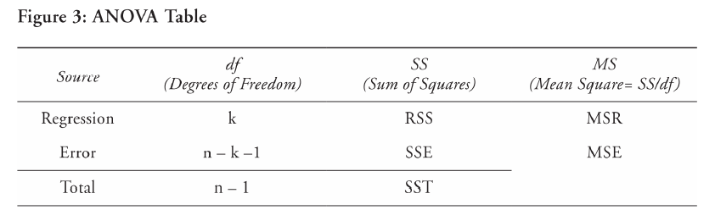

R2 = RSS/SST

F = MSR/MSE with k and n-k-1 degrees of freedom

SEE = MSE^0.5

* + 1. Formulate a multiple regression equation by using dummy variables to represent qualitative factors, and interpret the coefficients and regression results.

There’re occasions when the independent variable is binary in nature. Independent variables that fall into this category are called dummy variables and are often used to quantify the impact of qualitative events.

Dummy variables are assigned a value of 0 or 1.

For n categories, we need n-1 dummy variables.

The estimated regression coefficient for dummy variables indicates the difference in the dependent variable for the category represented by the dummy variable and the average value of the dependent variable for all classes except the dummy variable class.

* + 1. Explain the types of heteroskedasticity and how heteroskedasticity and serial correlation affect statistical inference.
* Heteroskedasticity
* What’s heteroskedasticity?

Heteroskedasticity occurs when the variance of the residuals is not the same across all observations in the sample

Unconditional heteroskedasticity occurs when it is not related to the level of the independent variables. It usually caused no major problems.

Conditional heteroskedasticity is that it is related to the level of the independent variables. For example, if the variance of the residual term increases as the value of the independent variable increases. It does cause significant problems for statistical inference.

* Effect of heteroskedasticity on regression analysis

The standard errors are usually unreliable estimates.

**The coefficient estimates aren’t affected.**

If the standard errors are too small, but the coefficient estimates aren’t affected, the t-statistics will be too large.

The F-test is also unreliable.

* Detecting Heteroskedasticity

There’re 2 methods to detect heteroskedasticity: examining scatter plot of the residuals and using the Breusch-Pagan chi-square test.

A scatter plot of the residuals versus one or more of the independent variables can reveal patterns among observations. E.g.:

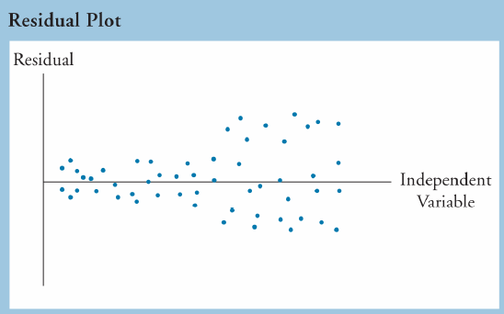

The more common way to detect conditional heteroskedasticity is the Breusch-Pagan test.

BP chi-square test = n * Rresid2 with k degrees of freedom

H0: no conditional heteroskedasticity exists.

n = number of observation

Rresid2 = R2 from a second regression of the squared residuals from the first regression of the first regression on the independent variables.

k = the number of independent variables

It’s a one-tailed χ2 test.

* Correcting Heteroskedasticity

The most common remedy is to calculate robust standard errors (also called White-corrected standard errors or heteroskedasticity-consistent standard errors and will be provided in the exam).

The second method is to use generalized least squares.

* Serial Correlation
  + What’s serial correlation

Serial correlation, also known as autocorrelation, refers to the situation in which the residual terms are correlated with one another. It’s a relatively common problem with time series data.

Positive (Negative) serial correlation exists when a positive regression error in one time period increases the probability of observing a positive (negative) regression error for the next time period.

* Effect of serial correlation

Because the data tends to cluster together from observation to observation, positive serial correlation typically results in coefficient standard errors that are too small. These small standard error terms will cause the t-statistic to be larger than they should be. The F-test will also be unreliable because the MSE will be too small.

* Detecting serial correlation

A scatter plot of residual versus time can reveal the presence of serial correlation.

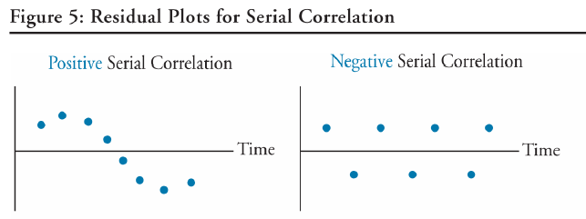

The more common method is to use the DW to detect the presence of serial correlation.

If sample size is very large

DW; r is correlation coefficient between residuals from one period and those from previous period.

If DW = 2, the error terms are homoscedastic and not serially correlated (r=0).

If DW < 2, the error terms are positively serially correlated (r > 0).

The DW-test procedure for positive serial correlation is as follows:

H0: the regression has no positive serial correlation.

If DW < d1, the error terms are positively serially correlated.

If d1 < DW < du, the test is inconclusive (neither reject or accept H0)

If DW > du, there is no evidence that the error terms are positively serially correlated.

* Correcting Serial Correlation

Adjust the coefficient standard errors using the Hansen method; or improve the specification of the model.

* + 1. Describe multicollinearity, and explain its causes and effects in regression analysis.

Multicollinearity refers to the conditions when two or more of the independent variables, are highly correlated with each other.

* Effect of Multicollinearity on Regression analysis

Coefficients tend to be unreliable. And the standard errors of the slope coefficients are too large. Hence, there is a greater probability that we make Type II error.

* Detecting Multicollinearity

When t-tests indicate that none of the individual coefficients is significantly different than zero, while the F-test is statistically significant and the R2 is high.

* Correcting Multicollinearity

The most common method to correct for multicollinearity is to omit one or more of the correlated independent variables.

* + 1. Describe how model misspecification affects the results of a regression analysis, and describe how to avoid common forms of misspecification.

Misspecification will result in biased regression coefficients and standard errors.

* The functional form
  + Important variables are omitted.
  + Variables should be transformed.
  + Data is improperly pooled.
* Explanatory variables are correlated with the error term in time series models.
  + A lagged dependent variable is used as an independent variable.
  + A function of the dependent variable is used as an independent variable.
  + Independent variables are measured with error
* Other time-series misspecifications that result in no stationarity.
  + 1. Describe models with qualitative dependent variables.

Financial analysis often calls for the use of a model that has a qualitative dependent variable, a dummy variable that takes on a value of either zero or one.

* Probit and logit models. A probit model is based on the normal distribution, while a logit model is based on the logistic distribution. Application of these models results in estimates of probability that the event occurs.
* Discriminant models generates an overall score or ranking for an observation. The scores can then be used to rank or classify observations.
  1. Time-Series Analysis
     1. Calculate and evaluate the predicted trend value for a time series, modeled as either a linear trend or a log-linear trend, given the estimated trend coefficients.

A linear trend is a time series pattern that can be graphed using a straight line.

* The simplest form of a linear trend is represented by the following linear trend model:

t = time (the independent variable); t = 1, 2, 3…

* When a series exhibits exponential growth, it can be modeled as:

We take the natural log of both sides of the equation and arrive at log-linear model:

* + 1. Describe factors that determine whether a linear or a log-linear trend should be used with a particular time series and evaluate limitations of trend models
* A linear trend model may be appropriate if the data points appear to be equally distributed above and below the regression line.
* If the data plots with a non-linear shape, then the residuals from a linear trend model will be persistently positive for a period of time (serially correlated), a log-linear trend model may be more appropriate.
* It may be the case that even a log-linear model is not appropriate in the presence of serial correlation. In this case, we will want to turn to an autoregressive model.

DW statistic is used to detect autocorrelation.

* + 1. Explain the requirement for a time series to be covariance stationary and describe the significance of a series that is not stationary.

When the dependent variable is regressed against one or more lagged values of itself, the resultant model is called as an autoregressive model.

Statistical inferences based on ordinary least squares estimates for an AR time series model may be invalid unless the time series being modeled is covariance stationary.

In auto regression model, serial correlation in the error term causes regression estimates to be inconsistent.

A time series is covariance stationary if

1. Constant and finite expected value. The expected value of the time series is constant (mean-reverting level) (11.f, 11.h, 11.j, 11.k).
2. Constant and finite variance (11.m).
3. Constant and finite covariance between values at any given lag.
   * 1. Describe the structure of an AR model of order p and calculate one- and two-period-ahead forecasts given the estimated coefficients.

An AR model of order p, is expressed as:

Chain rule of forecasting: calculate a one-step-ahead forecast before a two-step-ahead forecast.

* + 1. Explain how autocorrelations of the residuals can be used to test whether the autoregressive model fits the time series.

When an AR model is correctly specified, the residual terms will not exhibit serial correlation.

**To test serial correlation in an AR model, DW-test is invalid.**

The procedure to test whether an AR time series model is correctly specified involves:

1. Estimate the AR model being evaluated using linear regression.
2. Calculate the autocorrelations of the model’s residuals
3. Test whether the autocorrelations are significantly different from zero.

For each k lagged autocorrelation, the t-statistic is

, with (T-2) degrees of freedom

If the model is correctly specified, none of the autocorrelations will be statistically significant.

* + 1. Explain mean reversion and calculate a mean-reverting level.

A time series exhibits mean reversion if it has a tendency to move toward its mean.

If a time series is at its mean-reverting level, the model predicts that the next value of the time series will be the same as its current value.

For an AR(1) model, xt = b0 + b1xt => xt = b0/(1-b1)

All covariance stationary time series have a finite mean-reverting level.

An AR(1) model will have a finite mean-reverting level when |b1| < 1.

* + 1. Contrast in-sample and out-of-sample forecasts and compare the forecasting accuracy of different time-series models based on the root mean squared error criterion.
* In-sample forecasts are within the range of data used to estimate the model, which for a time series is known as the sample or test period.
* Out-of-sample forecasts are made outside of the sample period. We compare how accurate a model is in forecasting the y variable value for a time period outside the period used to develop the model.
* The root mean squared error criterion is used to compare the accuracy of autoregressive model in forecasting out-of-sample values.
  + 1. Describe characteristics of random walk processes and contrast them to covariance stationary processes.

Random walk: b0= 0; b1=1

Random walk with a Drift: b0! =0; b1=1

Random walk with or without a drift is not covariance stationary (no mean-reverting level) and exhibits **unit root** (b1=1).

* + 1. Describe implications of unit roots for time-series analysis, explain when unit roots are likely to occur and how to test for them, and demonstrate how a time series with a unit root can be transformed.
    2. Describe the steps of the unit root test for nonstationarity and explain the relation of the test to autoregressive time-series models.

To determine whether a time series is covariance stationary, we can:

1. An AR model is estimated and the statistical significance of the autocorrelations at various lags is examined. A stationary process will usually have residual autocorrelations insignificantly different from zero at all lags. Or
2. Dickey Fuller test:

* DF test transform the AR(1) model to run a simple regression:

=>

Then test whether the new, transformed coefficient g = (b1 -1) is different from 0 using a modified t-test. If (b1 -1) is not significantly different from 0, then b1 must be equal to 1 and the series must have a unit root.

* If the time series is a random walk, we can transform the data to a covariance stationary time series using a procedure called **first differencing**:

Then stating y in the form of an AR(1) model:

, b0 = b1 = 0

* + 1. Explain how to test and correct for seasonality in a time-series model and calculate and interpret a forecasted value using an AR model with a seasonal lag.

When seasonality is present, modeling the associated time series data would be misspecified unless the AR model incorporates the seasonality effect.

To adjust for seasonality in an AR model, an additional lag of the dependent variable is added to the original model as another independent variable.

* + 1. Explain autoregressive conditional heteroskedasticity (ARCH) and describe how ARCH models can be applied to predict the variance of a time series.

When examining a single time series, ARCH exists if the variance of the residuals in one period is dependent on the variance of the residuals in a previous period.

Using ARCH Models.

An ARCH model is used to test for autoregressive conditional heteroskedasticity. To test whether a time series is ARCH(1), εt2 are regressed:

If the coefficient a1, is statistically different from 0, the time series is ARCH(1).

If a time-series model has been determined to contain ARCH errors, regression procedures that correct for heteroskedasticity, such as *generalized least squares*, must be used in order to develop a predictive model.

However, if a time series has ARCH errors, an ARCH model can be used to predict the variance of the residuals in future periods. E.g.: if the data exhibit an ARCH(1) pattern,

* + 1. Explain how time-series variables should be analyzed for nonstationarity and/or cointegration before use in a linear regression.

Analysts sometimes run a regression using two time series:

To test whether the two time series have unit roots, the analyst first runs separate DF tests with 5 results:

1. Both are covariance stationary and the coefficients are statistically reliable.
2. Only the dependent variable time series is covariance stationary and the coefficients are statistically unreliable.
3. Only the independent variable time series is covariance stationary and the coefficients are statistically unreliable.
4. Neither time series is covariance stationary, and the two series are not cointegrated.
5. Neither time series is covariance stationary, and the two series are cointegrated.

Cointegration

Cointegration means tow time series are economically linked or follow the same trend and that relationship is not expected to change. If two time series are cointegrated, the error term from regression one on the other is covariance stationary and the t-test are reliable.

To test whether two time series are cointegrated, we regress one variable on the other using the following model:

The residuals are tested for a unit root using the DF test with critical t-values calculated by Engle and Granger (DF-EG test). If the test rejects the null hypothesis of a unit root, we say the error terms generated by the two time series are covariance stationary and the two series are cointegrated.

* 1. Probabilistic Approaches: Scenario analysis, Decision Trees, and Simulations
     1. Describe steps in running a simulation
     2. Explain 3 ways to define the probability distributions for a simulation’s variables.
     3. Describe how to treat correlation across variables in a simulation

Steps in simulations

1. Determine the probabilistic variables.
2. Define probability distributions for these variables.

There’re 3 approaches to specifying a distribution:

* Historical data
* Cross-sectional data
* Pick a distribution and estimate the parameters

1. Check for correlations among variables.

When there is a strong correlation between variables, we can either

* Allow only one of the variables to vary
* Build the rules of correlation into the simulation

1. Run the simulation.
   * 1. Describe advantages of using simulations in decision making.

* Better input quality
* Provides a distribution of expected value rather than a point estimate.
  + 1. Describe some common constraints introduced into simulations

There are 3 types of constraints:

1. Book value constraints
   * Regulatory capital requirements
   * Negative equity
2. Earnings and cash flow constraints
3. Market value constraints
   * 1. Describe issues in using simulations in risk assessments.
4. Input quality
5. Inappropriate statistical distributions
6. Non-stationary distributions (distributions may change over time).
7. Dynamic correlations

Risk-Adjusted Value

If we have already incorporated the risk of the asset in the discount rate, care should be taken to ensure that such risk is not double counted.

* + 1. Compare scenario analysis, decision trees, and simulations

|  |  |  |  |
| --- | --- | --- | --- |
| Appropriate method | Distribution of risk | Sequential? | Accommodates correlated variables? |
| Simulations | Continuous | Doesn’t matter | Yes |
| Scenario analysis | Discrete | No | Yes |
| Decision trees | Discrete | Yes | No |

1. Economics for Valuation
   1. Currency Exchange Rates: Determination and Forecasting
      1. Calculate and interpret the bid-ask spread on a spot or forward foreign currency quotation and describe the factors that affect the bid-offer spread

Foreign exchange spread quoted by the dealer depends on:

* The spread in the interbank market for the same currency pair.
* The size of the transaction.
* The relationship between the dealer and client.

The interbank spread on a currency pair depends on:

* Currencies involved. High-volume currency pairs command lower spreads.
* Time of day.
* Market volatility.
  + 1. Identify a triangular arbitrage opportunity and calculate its profit, given the bid-offer quotations for 3 currencies.

Long A/B: long/bug B and short/sell A

Rule:

Buy the base currency at ask and sell the base currency at bid.

Buy the price currency at bid and sell the price currency at ask.

Cross rates with bid-ask spreads:

(A/C)bid = (A/B)bid * (B/C)bid

(A/C)offer = (A/B)offer * (B/C)offer

(B/C)bid = 1/(C/B)offer

* + 1. Calculate the mark-to-market value of a forward contract

To calculate gain/loss for a one-year forward contact that shorts A/B with 4 months remaining, close the deal with a 4-month forward contract that longs A/B.

* + 1. Explain international parity relations.
* Covered Interest Rate Parity

When F/S * ( 1+ rb ) > ( 1 + ra)

Borrow currency a.

* Uncovered Interest Rate Parity

Uncovered interest rate parity refers to such a situation when forward currency contract are not available, or capital flows are restricted so as to prevent arbitrage.

Given a quote A/B, the base currency is expected to appreciate by RA – RB, or E(%ΔS)(A/B) = RA - RB

Covered interest rate parity derives the no-arbitrage forward rate;

Uncovered interest rate parity derives the **expected** future spot rate. Longer-term expected future spot rates based on uncovered interest rate parity are often used as forecasts of future exchange rates.

* International Fisher Relation

Rnominal = Rreal + E(inflation)

Under **real interest rate parity**, real interest rates are assumed to converge across different markets:

RnominalA – RnominalB = E(inflationA) – E(inflationB)

* Purchasing Power parity

**Absolute purchasing power parity** compares the *average* price of a representative basket of consumption good.

SA/B = CPIA / CPIB

**Relative purchasing power parity** states that changes in exchange rates should offset the price effects of any inflation differential between the two countries:

%ΔSA/B = InflationA - InflationB

**Ex-Ante version of PPP** is the same as relative PPP except that it uses expected inflation instead of actual inflation.

* + 1. Describe relations among the international parity conditions.

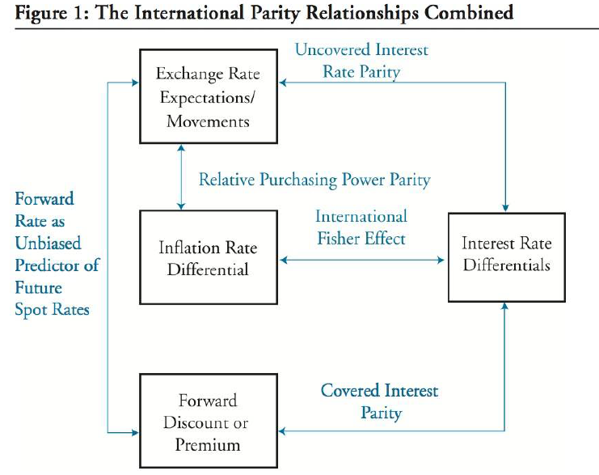

* Covered interest parity holds by arbitrage. If forward rates are unbiased predictors of future spot rates, uncovered interest rate parity also holds.
* Interest rate differentials should mirror inflation differentials (international Fisher relation)
* If ex-ante version of relative PPP as well as the international Fisher relation both hold, uncovered interest rate parity will also hold.
  + 1. Evaluate the use of the current spot rate, the forward rate, PPP, and uncovered interest parity to forecast future spot exchange rates.

Real Exchange Rate = St[CPIB]/[CPIA]

If relative PPP holds, %Real(A/B) = 0, called long-term equilibrium real exchange rate.

Since PPP seldom holds over the short term, real exchange rate fluctuate around this mean-reverting level.

* + 1. Explain how flows in the balance of payment accounts affect currency exchange rates

The BOP equation is:

current account + financial account + official reserve account = 0

Influence of BOP on exchange rates

1. Current account influences

Current account have an impact on exchange rates over the long term. Current account deficits lead to a depreciation of domestic currency via:

* Flow mechanism. As importers convert their revenues to their own local currency; increases the supply of that currency.
* Portfolio composition mechanism.
* Debt sustainability mechanism. When the debt level gets too high relative to GDP, investors may question the sustainability of this level of debt, leading to rapid depreciation.

1. Capital Account Influences

Capital account have an impact on exchange rates over the short term. As capital flows into a country, demand for that country’s currency increases, resulting in appreciation.

Real exchange rates fluctuate around the long term equilibrium real exchange rates.

real exchange rate (A/B) = equilibrium real exchange rate (A/B)

+ (real interest rateB - real interest rateA)

- (risk premiumB – risk premiumA)

Taylor Rule links the central bank’s policy rate to economic conditions and can be used to forecast exchange rates:

R = rn + π + α(π –π*) + β(y-y*)

R = Central bank policy rate implied by the Taylor rule

rn = Neutral real policy interest rate

π = current inflation rate

π* = Central bank’s target inflation rate

y = log of current level of output

y* = log of central bank’s target output

α, β = policy response coefficients

Real interest rate = r = R – π = rn + α(π –π*) + β(y-y*)

Real exchange rate (A/B) = equilibrium real exchange rate (A/B) +

Difference in neutral real policy interest rate (B – A) +

α[Difference in inflation gap(B-A)] +

β[Difference in output gap(B-A)] –

(risk premiumB – risk premiumA)

Inflation gap = current inflation – target inflation

Output gap = current output – target output

* + 1. Explain approaches to assessing the long-run fair value of an exchange rate
* Macroeconomic balance approach.
* External sustainability approach.
* Reduced-form econometric model approach.
  + 1. Describe the carry trade and its relation to uncovered interest rate parity and calculate the profit from a carry trade

Carry trade return = interest earned on investment – funding cost – currency depreciation

Risk management in Carry Trades:

* Volatility filter: Whenever implied volatility increases above a certain threshold, the carry trade positions are closed (selling investing currency and buying funding currency).
* Valuation filter. A valuation band is established for each currency based on PPP or other models. If the value of a currency falls below the band, the trader will overweight that currency.
  + 1. Describe the Mundell-Fleming model, the monetary approach, and the asset market approach to exchange rate determination
    2. Forecast the direction of the expected change in an exchange rate based on BOP, Mundell-Fleming, monetary and asset market approaches to exchange rate determination.
    3. Explain the potential effects of monetary and fiscal policy on exchange rates.

Mundell-Fleming model evaluates the impact of monetary and fiscal policies on interest rates and consequently on exchange rates.

* Flexible Exchange Rate Regimes

Rates are determined by supply and demand in the foreign exchange markets.

* High Capital Mobility

Expansionary monetary policy will reduce interest rate and depreciate domestic currency.

Expansionary fiscal policy will increase government borrowing and increase interest rates and appreciate domestic currency.

* Low Capital Mobility

The impact of trade imbalance on exchange rates (goods flow effect) is greater than the impact of interest rates (financial flows effect).

Expansionary fiscal or monetary policy increases net imports, leading to depreciation of domestic currency.

* Fixed Exchange Rate Regimes

An expansionary monetary policy would lead to depreciation of domestic currency. Government would have to purchase its own currency and reverses the expansionary policy.

An expansionary fiscal policy would lead to higher interest rate and appreciation of domestic currency. Central bank has to sell domestic currency to depreciate the currency, leading to expansionary monetary policy.

Monetary approach to exchange rate determination

We assume output is fixed.

1. Pure monetary model. PPP holds at any point in time and output is held constant.

An expansionary monetary or fiscal policy leads to an increase in prices and depreciate domestic currency.

1. Dornbusch overshooting model.

This model assumes prices are sticky in the short term and do not reflect changes in monetary policy. An expansionary monetary policy leads to a decrease in real interest rates and depreciation of the domestic currency. In the long term, exchange rates gradually increase toward their PPP implied values.

Asset market approach to exchange rate determination

This model focuses on the long-term implications of sustained fiscal policy on currency values.

If continued increases in fiscal deficits are unsustainable and investors may refuse to fund the deficits – leading to currency depreciation.

* 1. Economic Growth and the Investment Decision
     1. Compare factors favoring and limiting economic growth in developed/developing economies.

Preconditions for growth

1. Savings and investment is positively correlated with economic development.
2. Financial markets and intermediaries augment economic growth by efficiently allocating resources.
3. The political stability, rule of law and property rights environment of a country.
4. Investment in human capital.
5. Tax and regulatory systems need to be favorable for economies to develop.
6. Free trade and unrestricted capital flows are also positively related to economic growth.
   * 1. Describe the relation between the long-run rate of stock market appreciation and the sustainable growth rate of the economy.

Over the long-term, the potential GDP growth rate equals the growth rate of aggregate equity valuation.

* + 1. Explain why potential GDP and its growth rate matter for equity and fixed income investors.
* When actual GDP growth rate is higher than potential GDP growth rate, central bank is more likely to follow a restrictive monetary policy.
* Higher potential GDP growth rate reduces expected credit risk.
  + 1. Distinguish between capital deepening investment and technological progress and explain how each affects economic growth and labor productivity.

Factor inputs and economic growth

Cobb-Douglas production function:

α = the share of output allocated to capital (K) and labor (L).

T = total factor productivity

Dividing both sides by L, we obtain the output per worker.

Since α is less than 1, additional capital has a diminishing effect on productivity. Developed countries typically have a high capital to labor ratio and a lower α and gain less in increased productivity from capital deepening.

Marginal product of capital (MPK) = ΔY/ΔK = α*Y/K.

When marginal productivity of capital = 0, MPK = r (cost of capital) =>α = K*r/Y

Before marginal productivity of capital > 0, MPK > r

Marginal productivity of capital =

* + 1. Forecast potential GDP based on growth accounting relations.

The Growth in potential GDP can be expressed using the **growth accounting relation** as:

ΔY/Y = ΔT/T + α * (ΔK/K) + (1-α) * (ΔL/L)

Another approach to forecasting potential GDP growth is the **labor productivity growth accounting equation**:

growth rate in potential GDP = long-term growth rate of labor force +

long-term growth rate in labor productivity

The long-term growth rate in labor productivity reflects both capital deepening and technological progress.

* + 1. Explain how natural resources affect economic growth and evaluate the argument that limited availability of natural resources constrains economic growth.

The ‘Dutch disease’ refers to a situation where global demand for a country’s natural resources drives up the country’s currency values, making exports more expensive and making other domestic industries uncompetitive in the global markets.

* + 1. Explain how demographics, immigration and labor force participation affect the rate and sustainability of economic growth.

Labor Supply Factors

1. Demographics.
2. Labor force participation
3. Immigration
4. Average hours worked
   * 1. Explain how investment in physical capital, human capital, and technological development affects economic growth.

* Human capital: knowledge and skills individuals possess.
* Physical capital: infrastructure, computers, and telecommunications capital and non-ICT capital (machinery, transportation, and non-residential construction).
* Technological development
* Public infrastructure
  + 1. Compare classical growth theory, neoclassical growth theory, and endogenous growth theory.
* Classical Growth theory

Population growth increases when there’re increases in per capita income above subsistence level (the minimum income needed to maintain life). When real GDP per capita rises above subsistence level, a population explosion occurs and leads to diminishing marginal returns to labor, and drives GDP per capita back to subsistence level. This prevents long-term growth in per capita income.

* Neoclassical Growth Theory

Neoclassical growth theory’s primary focus is on estimating the economy’s long-term steady state growth rate.

Sustainable growth of output per capita:

g* = θ / (1 – α) θ: growth rate in technology

Assume Δy/y=Δk/kH

Sustainable growth of output

G* = θ / (1 – α) + ΔL/L ΔL: growth rate of labor

Under Neoclassical growth theory:

1. Capital deepening affects the level of output but not the growth rate in the long run.
2. In the steady state, marginal product of capital is constant, but marginal productivity is diminishing.
3. Increase in savings will only temporarily raise economic growth.
4. Developing countries (lower capital to labor ratio) will be impacted less by diminishing marginal productivity of capital.

* Endogenous Growth Theory

Technological growth emerges as a result of investment in both physical and human capital. There’s not steady state growth rate, so that increased investment can permanently increase the rate of growth.

An increase in savings will permanently increase the growth rate.

* + 1. Explain and evaluate convergence hypotheses.

Under neoclassical growth theory:

Absolute convergence hypothesis states that less developed countries will achieve equal living standards over time. The neoclassical model assumes that every country has access to the same technology which leads to countries having the same growth rates.

Conditional convergence hypothesis states that convergence in living standards will only occur for countries with the same saving rates, population growth rates and production functions.

Under club convergence, countries may be part of a ‘club’. Poorer countries that are part of the club will catch up with their richer peers. Countries can join the club by making appropriate changes. Those countries that are not part of the club may never achieve the higher standard of living.

Under endogenous growth theory:

It makes no prediction that convergence will occur.

* 1. Economics of Regulation
     1. Describe classifications of regulations and regulators.

Regulations can be classified as

* Statutes: laws made by legislative bodies
* Administrative regulations: rules issued by government agencies
* Judicial law: findings of the court

Regulators:

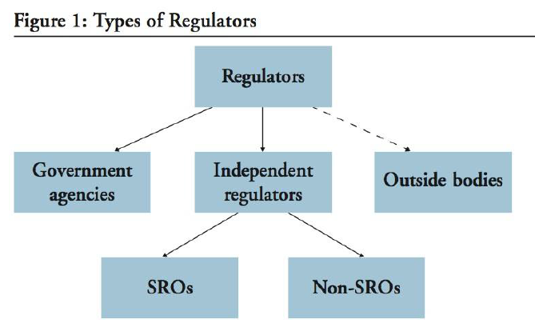

* Not all SROs (self-regulating organizations) are independent regulators (have government recognition); not all independent regulators are SROs.
* Outside bodies are not regulators but their product is referenced by regulators (FASB, IASB).
  + 1. Describe uses of SROs in financial markets.

The use of independent SROs in civil-law countries in not common; formal government agencies fulfill the role of SROs.

In common-law countries, independent SROs have historically enjoyed recognition.

* + 1. Describe the economic rationale for regulatory intervention.
* Information frictions occur when information is not equally available or distributed.
* Externalities are costs or benefits that affect a party that did not choose to incur that cost or benefit.
  + 1. Describe regulatory interdependencies and their effects.

The regulatory capture theory assumes that a regulatory body will be influenced or even possibly controlled by the industry that is being regulated.

Regulatory differences between jurisdictions can lead to *regulatory competition*, in which regulators compete to provide the most business-friendly regulatory environment.

Regulatory arbitrage occurs when businesses shop for a country that allows a specific behavior rather than changing the behavior. To avoid regulatory arbitrage, cooperation at a global level is necessary.

* + 1. Describe tools of regulatory intervention in markets.
* Price mechanisms, such as taxes and subsidies.
* Restricting/requiring certain activities.
* Provision of public goods or financing of private projects.
  + 1. Explain purposes in regulating commerce and financial markets.

Regulation of Financial Institutions

Prudential supervision refers to the monitoring and regulation of financial institutions to reduce system-wide risks and to protect investors.

* + 1. Describe benefits and costs of regulation

Regulatory burden refers to the cost of compliance for the regulated entity.

Net regulatory burden refers to regulatory burden minus the private benefits of regulation.

Many regulatory provisions include a ‘sunset clause’ that requires regulators to revisit the cost-benefit analysis based on actual outcomes before renewing the regulation.

1. Financial Reporting and Analysis
   1. Inventories: Implications for Financial Statements and Ratios
      1. Explain LIFO reserve and LIFO liquidation and their effects on financial statements and ratios.

LIFO reserve = FIFO inventory – LIFO inventory

FIFO COGS = LIFO COGS – (ending LIFO reserve – beginning LIFO reserve)

|  |  |  |  |
| --- | --- | --- | --- |
| Cash | -LIFO reserve*tax |  |  |
| Inventory | +LIFO reserve |  |  |
|  |  | Earning | +LIFO reserve*(1-tax) |

If tax rate is changed

For example, if tax rate in 20X5 is 20% and tax rate in 20X6 is 30%, cash is reduced by:

20% rate 20X5 reserve * 20%

30% rate 20X6 reserve – 20X5 reserve * 30%

A LIFO liquidation occurs when a LIFO firm’s inventory quantities are declining.

* + 1. Describe the implications of valuing inventory at NRV for financial statements and ratios

Reporting inventory above historical cost is permitted under IFRS and US GAAP in certain industries (agricultural and forest products, mineral ores, and precious metals).

Under this exception, inventory is reported at NRV, and the unrealized gains and losses are recognized in the income statement.

If an active market exists for the commodity, the market price is used to value the inventory; otherwise, recent market transactions are used.

* 1. Long-Lived Assets: Implications for Financial Statements and Ratios
     1. Explain and evaluate how capitalizing vs expensing costs in the period in which they are incurred affects financial statements and ratios.

Capitalized Interest

The interest cost is allocated to the income statement through depreciation expense (held for use) or COGS (held for sale). Capitalized interest is reported as outflow from investing activities.

If interest expense is capitalized, interest expense is lower in the first year, because it’s capitalized.

In the following year, EBIT will be lower because capitalized interest is depreciated.

Many analysts consider interest coverage ratios based on total interest expense including capitalized interest as a better measure of the solvency of the firm.

For analytical purposes, the effects of capitalizing interest can be reversed by making the following adjustments:

* Interest that was capitalized should be added to interest expense.
* Capitalized interest – accumulated depreciation should be removed from assets and equity.
* Interest that was capitalized is classified as a cash outflow from investing.

For analysis, it should be added back to CFI and removed from CFO.

* + 1. Explain and evaluate how different depreciation methods for PP&E affect financial statements and ratios.

A change in depreciation method is treated like a change in accounting estimate. The change is put into effect in the current period and prospectively. The previous periods are not affected.

Estimates are also involved when a manufacturing firm allocates depreciation expense between COGS and SG&A.

* + 1. Explain and evaluate how impairment and revaluation of PP&E and intangible assets affect financial statements and ratios.

Under IFRS, the firm must *annually* assess whether events or circumstances indicate an impairment may have occurred.

Under US GAAP, the asset is tested for impairment only when events and circumstances indicate the firm may not be able to recover the carrying value through future use.

* + 1. Analysis and interpret financial statement disclosures regarding long-lived assets.

1. Average age:

Accumulated depreciation / annual depreciation expense

1. Average depreciable life:

Ending gross investment / annual depreciation expense

1. Remaining useful life:

Ending net investment / annual depreciation expense

Ending gross investment = ending net investment + accumulated depreciation

* + 1. Explain and evaluate how finance leases and operating leases affect financial statements and ratios from the perspectives of both the lessor and the lessee.

From the lessee’s perspective, principal is a financing outflow. From the lessor’s perspective, principal is an investing inflow.

* 1. Intercorporate Investments
     1. Describe the classification, measurement, and disclosure under IFRS.
     2. Distinguish between IFRS and US GAAP in the classification measurement and disclosure of investments.
* Financial Assets

Financial Statement Reporting

|  |  |  |  |
| --- | --- | --- | --- |
|  | Held-to-Maturity | Held-for-trading | Available-for-sale |
| Balance sheet* | Amortized cost | Fair value | Fair value |
| Income statement | Interest (including amortization)  Realized Gain & Loss | Interest  Dividends  Realized/Unrealized Gain & Loss | Interest  Dividends  Realized Gain & Loss  Foreign exchanges gain or loss on debt securities (***IFRS only***) |
| Other comprehensive income |  |  | Unrealized Gain & Loss |

* Both GAAP & IFRS include transaction cost

Reclassification of Investments in financial assets

|  |  |  |
| --- | --- | --- |
| From | To | Unrealized Gain or Loss |
| Held-for-trading* | Any | Income Statement |
| Held-to-maturity | Held-for-trading* | Income Statement |
| Held-to-maturity | Available-for-sale | Other comprehensive income |
| Available-for-sale | Held-to-maturity | Amortize out of other comprehensive income |
| Available-for-sale | Held-for-trading* | Transfer out of other comprehensive income |

* Restricted under IFRS

Impairment of Financial Assets

US GAAP

For hold-to-maturity and available-for-sale securities, write down to fair value and the losses are recognized on the income statement.

A reversal of impairment losses is not allowed.

IFRS

Impairment of a debt or equity security is indicated if at least one loss event ***has occurred*** and its effect on the security’s future cash flows can be estimated ***reliably***.

Amount of loss = carry value – PV (future cash flow) discounted at original effective interest rate.

Impairment loss can be reversed to original cost only.

Losses on available-for-sale equity security cannot be reversed.

* Investments in associates

Financial statement reporting: the equity method

1. At recording date, the investment is recorded at cost as ‘Investment’/non-current asset on balance sheet.
2. In the period, the proportionate share of investee’s earnings increases investor’s ‘investment’ account on the balance sheet and recognized on investor’s income statement (equity earning).
3. In the period, the proportionate share of investee’s dividends reduce investor’s ‘investment’ account.
4. If investment account is reduced to 0, equity method is not used until the loss is reversed.
5. Both IFRS and US GAAP allows fair value option.

Under US GAAP, this option is available to all entities;

Under IFRS, its use is restricted to venture capital organizations, mutual funds, unit trusts…

The decision to use the fair value option is irrevocable and any changes in fair value are recorded in the income statement

Excess of Purchase Price over book value acquired.

1. ‘Investment account’ = Purchase price.
2. Excess of purchase price = purchase price – x% * BV (investee’s net identifiable asset)
3. Goodwill = purchase price – x% * FV (investee’s net identifiable asset)

**Goodwill is already included in the investment account.**

1. X% * (FV – BV)/n depreciation/amortization should reduce investor’s ‘investment’ account on the balance sheet and reduce ‘equity earning’ on the income statement.

Impairment of investments in associates

Under both US GAAP and IFRS, the investment asset cannot be written-up.

Under IFRS

If the entire carrying value of the investment (including goodwill) is greater than recoverable amount, the impairment loss is recognized on the income statement.

Under US GAAP

If the carrying value of the investment is greater than its fair value, the investment account is reduced to fair value.

Transactions with the investee

Proportionate share of earnings not confirmed or use is eliminated and should reduce investor’s ‘investment’ account on balance sheet and ‘equity earnings’ on income statement.

* Business combinations

Under IFRS, business combinations are not differentiated.

Under US GAAP, business combinations are categorized as:

* + Merger: The acquired firm ceases to exist.
  + Acquisition: Both entities continue to exist in a parent-subsidiary relationship.
  + Consolidation: A new entity is formed.

Financial statement reporting: the acquisition method

1. Investor’s new account on balance sheet/income statement = BV(investor’s old account) + 100% * FV(investee’s account)
2. Equity is not combined.
3. Partial minority interest = (1-x)% * FV (investee’s equity)

(1-x)% * Minority interest reduces investor’s income statement

Minority interest can be classified as equity, liability or mezzanine.

1. Partial goodwill = Purchase price – x% * FV (investee’s net identifiable assets)
2. Full goodwill = partial goodwill / x%
3. Full minority interest = Partial goodwill + (Full goodwill – partial goodwill)

* US GAAP requires full goodwill; IFRS permits both full/partial goodwill

Impairment of goodwill

Under IFRS, if the carrying amount of the corporate exceeds the ***recoverable amount***, an impairment loss is recognized.

If loss > goodwill, the remainder is allocated to other assets.

Under US GAAP

1. If the carrying value of the corporate exceeds the ***fair*** value of the corporate unit, an impairment exists.
2. The loss is measured as the difference between the carrying value of the goodwill and the implied fair value of the goodwill.

If loss > goodwill, goodwill is reduced to 0.

* Bargain purchase

If purchase price < the fair value of net assets, both IFRS and US GAAP require that the difference be recognized as a gain in the income statement.

* Joint Ventures

Both US GAAP and IFRS require the equity method for joint ventures.

In rare circumstances, the proportionate consolidation method may be allowed under both US GAAP and IFRS.

1. Investor’s new account on balance sheet/income statement = BV(investor’s old account) + x% * FV(investee’s account)
2. Equity is not combined.
3. No minority interest

* Special Purpose and Variable Interest Entities

Under IFRS, the sponsoring entity must consolidate if it controls the SPE.

Under US GAAP, If an SPE is considered a VIE, it must be consolidated by the primary beneficiary.

* + 1. Analyze how different methods used to account for intercorporate investments affect financial statements and ratios

Equity method Acquisition method

Asset <

Equity* <

Net Income =

EBIT <

* If minority interest is classified as equity; otherwise, both methods result in the same equity.

* 1. Employee Compensation: Post-Employment and Share-Based
     1. Explain and calculate measures of a defined benefit pension obligation and net pension liability.

|  |  |
| --- | --- |
| Plan Assets | PBO |
| Fair value at the beginning of the year | PBO at the beginning of the year |
| + Contributions | + Current service cost |
| + Actual return | + Interest cost |
| - Benefits paid | + Past service cost |
| = Fair value at the end of the year | +/- Actuarial losses/gains |
|  | - Benefits paid |
|  | = PBO at the end of the year |
| Difference is funded status of the plan. | |

* Current service cost is the PV of benefits earned by the employees during the current period.
* Interest cost is PBO at the beginning of the year * discount rate
* Past service cost are retroactive benefits when a plan is initiated or amended.
* Actuarial losses/gains are the gains and losses result from changes in variables. Gains will decrease PBO while losses will increase PBO.
  + 1. Describe the components of a company’s defined benefit pension costs.

Under US GAAP

Periodic pension cost = Current service cost + Interest cost (r * PBO) – Expected return on asset

-/+ amortization of deferred gains and loss

-/+ amortization of past service cost

Amortization of deferred gains and loss:

1. (Actual Return – Expected Return) are recorded in OCI and are amortized.
2. Actuarial losses/gains are recorded in OCI and are amortized.

Both 1 and 2 are amortized using corridor approach.

Corridor approach:

Only when accumulated deferred gains and loss exceeds 10% * max (PBO, plan assets), the excess is amortized.

Amortization of past service cost: recorded in OCI and amortized over employee’s service life.

Under IFRS

Periodic pension cost = Current service cost + Interest cost (r * (PBO – asset))1 – Past service cost

1: Interest cost under IFRS equals to (Interest cost – expected return on asset) under US GAAP, except that the expected return is different.

Actuarial gains/losses are recorded in OCI. No amortization.

Under both IFRS and US GAAP

Total Periodic pension cost = employer contribution – (ending funded status – beginning funded status)

Total Periodic pension cost = Periodic pension cost (in P/L) + Periodic pension cost in OCI

* + 1. Explain and calculate how adjusting for items of pension and other post-employment benefits that are reported in the notes to the financial statements affects financial statements and ratios.

Differences due to classification in the income statement:

Under US GAAP, the entire pension cost is shown as an operating expense.

Under IFRS, the components of pension cost can be included in various line items.

Interest cost is shown in the pension cost prior to EBIT. From CFA’s point of view, it should have been included in interest expense after EBIT.

From CFA’s point of view, expected return should be removed while actual return should be included in other income after operating income.

* + 1. Interpret pension plan note disclosures including cash flow related information.

Under GAAP, contributions and benefits paid are classified as CFO outflow.

From CFA’s point of view, if contributions > total period pension cost, (1 – tax rate) * (contributions - total period pension cost) should increase CFO, reduce CFF.

* + 1. Explain how accounting for stock grants and stock options affects financial statements, and the importance of companies’ assumptions in valuing these grants and options.

Stock Option

* Characteristics: No cash transaction; Increase expense and reduce earnings.
* Disadvantages:
  + Employee has limited influence over share price.
  + Increase employee’s share ownership.
  + Existing shareholder’s ownership is diluted.
  + Disclosures are required.
* Valuation method:
  + Market value
  + Black-Scholes Model*
  + Binominal model
  + Monte Carlo simulation

Stock grants: Compensation expense is based on the fair value of the stock on the grant date. The expense is allocated over the employee’s service period.

Stock appreciation rights: it gives the employee the right to receive compensation based on the increase in the price of the firm’s stock.

* Advantages: Avoid dilution; Less risk aversion
* Disadvantage: Cash outflows

Phantom stock: Phantom stock is similar to stock appreciation rights except the payoff is based on the performance of hypothetical stock instead of the firm’s actual share.

* 1. Multinational Operations
     1. Distinguish among presentation currency, functional currency and local currency.
* The local currency is the currency of the country being referred to.
* The functional currency, determined by management, is the currency of the primary economic environment in which the entity operates.
* The presentation currency is the currency in which the parent company prepares its financial statements.
  + 1. Describe foreign currency transaction exposure, including accounting for and disclosures about foreign currency transaction gains and losses

Both realized and unrealized gains/losses are recognized in the income statement.

* + 1. Analyze how changes in exchange rates affect the translated sales of the subsidiary and parent company.
    2. Compare the current rate method and the temporal method, evaluate how each affects the parent company’s balance sheet and income statement, and determine which method is appropriate in various scenarios.

Which method is appropriate?

When remeasuring from local to functional currency, use the temporal method.

When translating from functional to presentation currency, use the current rate method.

Applying the current rate method:

* Balance sheet: all assets and liabilities are translated at the current rate.
* Balance sheet: common stocks, beginning retained earnings are translated at the historical rate.
* Income statement: all accounts are translated at the average rate.
* Dividends are translated at the historical rate.
* Translation gain or loss is reported in shareholders’ equity as a part of the CTA.

Applying the Temporal Method:

* Balance sheet: Monetary assets and liabilities are measured using the current rate, including cash, receivables, payables, and short-term and long-term debt.
* Balance sheet: Non-monetary assets and liabilities are re-measured at the historical rate
* Balance sheet: Non-monetary assets and liabilities at fair value are remeasured at current rate.
* Balance sheet: common stocks, beginning retained earnings are translated at the historical rate.
* Income statement: expenses related to non-monetary assets are remeasured at historical rates.
* Income statement: Revenues and all other expenses are remeasured at average rate.
* Dividends are translated at the historical rate.
* Remeasurement gain or loss is recognized in the income statement.

Exposure to exchanging exchange rates

Under the current method, the appreciation of foreign currency usually results in foreign currency translation gains, because asset > liability in general.

Under the temporal method, the appreciation of foreign currency usually results in foreign currency translation losses, because monetary asset < monetary liability in general.

* + 1. Analyze how alternative translation methods for subsidiaries operating in hyperinflationary economies affect financial statements and ratios.

Under US GAAP, temporal method is used.

Under IFRS, the statements are restated for inflation and then translated using the current exchange rate. (Not the current rate method, so there’s no CTA item).

1. Alternative Investments
   1. Private Real Estate Investments
      1. Describe commercial property types, including their distinctive investment characteristics.

**Retail**

**Percentage lease / Percentage rent**: Retail tenants are often required to pay additional rent once sales reach a certain level. The lease will also specify a minimum amount of rent to be paid without regard to sales.

* + 1. Estimate and interpret the inputs to the direct capitalization and DCF valuation methods.
    2. Calculate the value of a property using the direct capitalization and DCF valuation methods.

**Net Operating Income:**

Rental income if fully occupied

+ Other income

= Potential gross income

- Vacancy and collection loss

= Effective gross income

- Operating expense

= Net operating income

**Capitalization rate** = discount rate – growth rate

**Direct capitalization method:**

V0 = NOI1 / cap rate

**Discounted Cash Flow Method**

V0 = NOI1 / (r – g)

* + 1. Calculate the value of a property using the cost and sales comparison approaches.

**Cost Approach:**

V0 = Market value of land + building’s replacement cost – depreciation including physical deterioration, functional obsolescence, locational obsolescence and economic obsolescence.

Physical deterioration can be curable or incurable. An item is curable if the benefit of fixing the problem is at least as much as the cost to cure. The cost of fixing curable items is subtracted from the replacement cost.

An item is incurable if the problem is not economically feasible to remedy. Since it would not be fixed, depreciation can be estimated based on the effective age of the property relative to its total economic life.

**Sales Comparison Approach**

The premise of this approach is that a buyer would pay no more for a property than others are paying for similar properties in the current market.

* + 1. Discuss private equity real estate investment indices, including their construction and potential biases.

**Appraisal-Based Indices**

Return = (NOI – capital expenditures + end market value – beginning market value) / beginning market value

Appraisal-based indices tend to lag actual transactions because actual transactions occur before appraisals are performed. Also they tend to smooth the index or reduce its volatility. Also it’ll reduce its correlation with other asset classes.

**Transaction-Based Indices**

A repeat-sales index relies on repeat sales of the same property.

A hedonic index requires only one sale. A regression is developed to control for differences in property characteristics.

* + 1. Calculate and interpret financial ratios used to analyze and evaluate private real estate investments.

Debt service coverage ratio = NOI1 / debt service

Equity dividend rate = CF1 (NOI1 – debt service payment) / equity

The maximum amount of debt that an investor can obtain on commercial real estate is usually the minimum (Loan-to-value * appraised value, maximum debt service / mortgage rate).

* 1. Publicly Traded Real Estate Securities
     1. Explain advantages and disadvantages of investing in real estate through publicly traded securities.

REIT-Specific Advantages

* Exemption from taxation.
* Predictable earnings & high yield: To maintain their tax-advantage status, REITs are obligated to pay out most of their taxable income as dividends.

REIT-Specific Disadvantages: Lack of flexibility.

* + 1. Justify the use of NAVPS in REIT valuation and estimate NAVPS on forecasted cash net operating income.

NAVPS is the difference between a real estate company’s assets and its liabilities, all taken at **current market values** instead of accounting values, divided by the number of shares outstanding.

Last 12-months NOI

- Non-cash rents

+ Full-year adjustment for acquisitions

+ Next year growth in NOI (NOI0 * growth rate)

= Estimated next year cash NOI

/ cap rate

= Estimated value of operating real estate

+ Cash and equivalents/Land held for development/Acct. Receivable/other assets (excluding intangibles)

- Debt and other liabilities

= Net asset value

* + 1. Describe the use of FFO and adjusted FFO in REIT valuation.

Accounting net income

+ Depreciation expense

+ Deferred tax expenses

-/+ Gain/loss from sales of PP&E and debt restructuring

= Funds from operations

AFFO = FFO – Non-cash rent adjustment – recurring maintenance-type capital expenditures and leasing commissions.

AFFO is a better measurement but relies on more estimates and is considered more subjective.

* 1. Private Equity Valuation
     1. Explain how private equity firms align their interests with those of the managers of portfolio companies.

Tag-alone: Minority shareholder has the right to sell with majority holder at the same price.

Drag-alone: Minority shareholder must sell with majority holder.

Earn-outs: Earn-outs tie the acquisition price paid by the PE firm to the portfolio company’s future performance over a specified period.

* + 1. Explain PE fund structures, terms, valuation, and due diligence in the context of an analysis of PE fund returns

**Management fees** are paid to GP on an annual basis as a percent of committed capital or paid-in capital or NAV.

**Carried interest** is GP’s share of the fund profits and is usually 20% of profit after management fees.

**Ratchet** specifies the allocation of equity between stockholders and management of the portfolio company and allows management to increase their allocation depending on the performance.

**Vintage** is the year the fund was started and facilitates performance comparisons with other funds.

* + 1. Explain risks and costs of investing in PE.

Placement fees: Placement agents who raise funds for PE firms may charge up-front fees or annual trailer fees as a percent of funds raised through LPs.

* + 1. Interpret and compare financial performance of PE funds from the perspective of an investor.

Internal Rate of Return

The return metric recommended for private equity by the GIPS is the IRR. The IRR is a cash-weighted return measure.

Quantitative Measures

Paid-in-capital, Distributed to paid-in capital, Residual value to paid-in capital, total value to paid-in capital.

* + 1. Calculate management fees, carried interest, net asset value, DPI, RVPI and TVPI of a PE fund.

NAV after distributions at the end of previous year

+ Capital Called down

- Management fees

+/- operating results (gain/loss)

= NAV before distributions this year

- Carried interest

- Distribution

= NAV after distributions this year

* + 1. Calculate pre-money valuation, post-money valuation, ownership fraction, and price per share applying the venture capital method with single and multiple financing rounds and in terms of IRR.

Post-money value = pre-money value + VC investment = Present value of exit value.

* 1. A Primer on Commodity Investing
     1. Explain the convenience yield and how it relates to the stock of a commodity.

Convenience yield reflects the markets’ expectation about future availability of a nonrenewable commodity. Commodities that are expected to be in short supply in the future will have higher convenience yield.

There’s an inverse relationship between inventory level and convenience yield.

* + 1. Describe the components of return to a commodity futures and a portfolio of commodity futures.

1. Spot return
2. Roll return is the income generated as we close out maturing futures contracts and replace them with newer futures contracts.

When the term structure is in backwardation, roll return will be positive.

1. Collateral return
2. Rebalancing return
3. Portfolio Management
   1. An Introduction to Multifactor Models
4. Arbitrage Pricing Theory

= the return to asset i

= the expected return of asset i

= the sensitivity of the return on asset i to the return to factor k, k = 1, 2, ..., K

= the return to factor k

= the error term with zero mean that cannot be explained by the model

According to APT, if assumptions hold, the following equation holds:

A portfolio with sensitivity of 1 to factor j and 0 to all other factor is called a pure factor portfolio for factor j.

1. Multifactor Models: Types
   1. The structure of Macroeconomic Factor Models

General equation:

F = the surprise in the factor k. For example, a surprise in GDP growth

In macroeconomic factor models, the time series of factor surprises are constructed first; Regression analysis is then used to estimate asset’s sensitivities to the factors.

* 1. The structure of Fundamental Factor Models

General equation:

, called standardized beta

In fundamental factor model, we specify the factor sensitivities (beta) first and then estimate the factor return () through regression.

We can place the factors of most fundamental factor models for equity into 3 groups:

* Company fundamental factors: There are factors relating to company’s performance, including earning growth, earning variability and leverage.
* Company share-related factors: These factors directly incorporate investors’ expectation, including earning/dividend yield, book-to-market.
* Macroeconomic factors.

1. Multifactor Models: Selected Application
   1. Return attribution

Active return =, which can be rewritten as

* 1. Risk attribution

Active risk can be represented by standard deviation of active return, also called tracking error (TE), tracking risk.

Information ratio is a tool for evaluating mean active return per unit of active risk.

In analyzing risk, it’s more convenient to use variances rather than standard deviation because variances of uncorrelated variables are additive.

Active risk squared = active factor risk squared + active specific risk squared

Active factor risk results from different-from-benchmark exposure relative to factors in the model.

Active specific risk or security selection risk measures the residual risk

Active specific risk =