Table of Contents
ABSTRACT 2
INTRODUCTION 3
RATIONABLE 4
PROBLEM DESCRIPTION 4
BACKGROUND OF THE PROBLEM 5
COMMUNITY IMPACT 6
COMPUTATIONAL THINKING PROCESS 6
ALGORITHM DESIGN 7
SUSTAINABLE DEVELOPMENT GOAL (SDG) ALIGNMENT 8
DIGITAL PUBLIC GOODS JUSTIFCATION 8
PSUEDOCODE 10
FLOWCHART 11
FUNCTIONAL MODULES OF THE FLOOD REPORTING SYSTEM 12
EXPECTED OUTPUT 13
GITHUB 14
REFERENCE 15

ABSTRACT
Flooding is a serious environmental problem that can damage homes, destroy property, block roads, and put human lives at risk. In Sierra Leone, communities affected by heavy rainfall need reliable ways to report flooding so that the responsible authorities can identify dangerous areas and plan appropriate responses. This project focuses on designing a Flood Reporting System that uses programming logic to make the reporting of flood incidents more organized, simple, and efficient.
The main aim of the project is to develop a logical design for a system that allows community members to report flooding by providing important information, such as the location of the flood, a description of the situation, and the level of danger. The system will check the information, record valid reports, classify incidents according to their reported level of danger, and provide confirmation that a report has been submitted. These steps will help organize flood information and make it easier for authorized personnel to identify incidents that may require urgent attention.
The project applies key programming concepts, including computational thinking, algorithms, pseudocode, flowcharts, decision-making structures, repetition, and modular design. These concepts explain how a problem can be broken into smaller steps and solved logically. The project also considers how the proposed system can support Sustainable Development Goal 11: Sustainable Cities and Communities, which promotes safer and more sustainable places to live.
In conclusion, the proposed Flood Reporting System demonstrates how programming logic can be used to address a real-life community problem in Sierra Leone. By providing a structured way to collect and organize flood reports, the system could support better communication, improve awareness of dangerous locations, and help authorities make more informed decisions. Although the system cannot prevent flooding or guarantee an immediate emergency response, it offers a practical technological approach to improving flood reporting and community preparedness.

INTRODUCTION
Flooding is one of the environmental challenges that can affect people’s lives, homes, businesses, roads, and other important facilities. In Sierra Leone, heavy rainfall can cause water to collect in residential areas, damage property, and make movement difficult. When flooding occurs, it is important for people to report the situation quickly so that the responsible authorities can identify affected areas and plan suitable responses. However, when flood information is delayed, incomplete, or poorly organized, it may become more difficult to identify dangerous locations and determine which incidents require urgent attention.
Technology can provide practical ways to address some of these challenges. This project focuses on the design of a Flood Reporting System for Communities in Sierra Leone, which is intended to help residents report flood incidents in a simple and organized manner. The proposed system will allow users to provide important details, including the location of the flood, a description of the situation, and its level of danger. It will then check the information, record valid reports, classify incidents according to their reported severity, and display a confirmation after a successful submission. This process will help organize information and make it easier for authorized personnel to review reported incidents.
The project applies the principles of programming logic and design to demonstrate how a real-life problem can be solved through a clear sequence of instructions. It uses computational thinking to break the problem into smaller and more manageable parts. It also applies algorithms, pseudocode, flowcharts, decision-making structures, repetition, and modular design to explain how the proposed system should operate. These techniques help ensure that the system follows a logical process, handles information consistently, and produces the expected results.
Furthermore, the project supports the objectives of Sustainable Development Goal 11 (SDG 11): Sustainable Cities and Communities, which encourages safer, more resilient, and sustainable communities. By improving the organization of flood reports, the proposed system could contribute to better communication, increased awareness of flood-prone locations, and more informed decisions by relevant authorities.
In conclusion, the Flood Reporting System demonstrates how programming logic can be applied to a community problem in Sierra Leone. Although the system cannot prevent flooding or guarantee an immediate emergency response, it provides a practical design for collecting and organizing flood information. Its overall goal is to support community preparedness and help relevant authorities identify and review reported flood incidents more effectively.

RATIONABLE

PROBLEM DESCRIPTION
Flooding is a major environmental problem that can affect communities across Sierra Leone, especially during periods of heavy rainfall. It can damage houses, destroy personal belongings, block roads, disrupt businesses, and put human lives at risk. When flooding occurs, residents need a reliable way to report the situation so that the responsible authorities can identify affected areas and understand the seriousness of the problem.
However, flood information may sometimes be shared through informal methods, making it difficult to collect, organize, and review reports efficiently. Some reports may lack important details, such as the exact location of the incident or the level of danger. Delayed or incomplete information can make it harder to identify areas that may require urgent attention.
To address this challenge, this project proposes a Flood Reporting System for Communities in Sierra Leone. The system will allow residents to submit reports by providing the location of the flood, a description of the situation, and the level of danger. It will check that the required information is complete, record valid reports, and classify incidents according to their reported severity. It will also provide a confirmation message when a report has been successfully submitted.
The main purpose of the proposed system is to make flood reporting more organized, consistent, and easier to manage. By collecting important information in a structured format, the system could help relevant authorities review reported incidents and identify affected locations more effectively. Although the system cannot prevent flooding or guarantee an immediate response, it provides a practical way to use programming logic to address a real-life community problem.

BACKGROUND OF THE PROBLEM
Flooding is an environmental challenge that occurs when water covers land that is normally dry. It can happen because of heavy rainfall, overflowing rivers, poor drainage systems, blocked gutters, and other factors that prevent water from flowing away properly. In Sierra Leone, heavy rainfall can cause water to accumulate in residential areas, making life difficult for people and damaging homes, roads, businesses, and other important facilities.
When flooding occurs, the effects can be serious, particularly for people living in areas that are more vulnerable to floods. Families may lose valuable belongings, students may find it difficult to reach school, and workers and business owners may experience disruptions to their daily activities. Floodwater can also create health and safety risks, especially when it mixes with waste or makes roads and pathways dangerous to use. For these reasons, identifying affected locations and sharing accurate information about flood incidents are important steps in managing the problem.
One challenge during flooding is ensuring that information about affected areas is collected and organized properly. Residents may report incidents through phone calls, messages, or direct communication with other people. Although these methods can help share information, reports may sometimes be incomplete, delayed, or difficult to keep track of. Important details, such as the location of the flood, the seriousness of the situation, and the extent of the damage, may not always be recorded in a consistent way.
With the development of information and communication technology, computer-based systems can help organize information and make it easier to access. A digital reporting system can guide users to provide the necessary details in a standard format and check whether important information is missing before accepting a report. This can make the reporting process more structured and reduce confusion when reviewing submitted information.
Based on this need, the project proposes a Flood Reporting System for Communities in Sierra Leone. The system will allow residents to enter the location of a flood incident, describe the situation, and select its level of danger. It will validate the information, record complete reports, classify incidents according to their reported severity, and display a confirmation message after submission.
The project applies programming logic and design principles to show how technology can be used to address a real-life community problem. By organizing flood reports in a consistent manner, the proposed system could help relevant authorities review information and identify locations that may need attention. However, its effectiveness would depend on proper development, accurate information from users, and the involvement of the relevant authorities. The system is intended to support flood reporting and community preparedness, rather than prevent flooding or replace emergency services.

COMMUNITY IMPACT
Flooding can have serious effects on communities in Sierra Leone, affecting people’s homes, health, education, businesses, and daily activities. During heavy rainfall, floodwater can damage houses, destroy valuable belongings, block roads, and make it difficult for residents to move safely from one place to another. These problems can create financial difficulties for families, interrupt students’ education, and affect the activities of small businesses. Floodwater may also contain waste and harmful substances, creating health risks for people living in affected areas.
Another major challenge is the difficulty of collecting and organizing information about flood incidents. When residents report flooding through informal methods, important details about the location and seriousness of the situation may be missed or delayed. This can make it harder for the responsible authorities to understand the extent of the problem and identify areas that may need urgent attention.
The proposed Flood Reporting System could help address this challenge by providing residents with a structured way to report flood incidents. Users would enter the location, describe the situation, and indicate the level of danger. The system would check the information, record valid reports, and organize them according to their reported severity. This could make flood information easier to review and help relevant personnel identify reported incidents more efficiently.
Furthermore, the system could improve community awareness by encouraging residents to report flooding with clear and useful information. If properly developed and used alongside the work of relevant authorities, it could support better communication, improve the organization of flood reports, and contribute to community preparedness.
In conclusion, flooding affects communities socially, economically, and environmentally. The proposed system cannot stop floods or guarantee an immediate response, but it could provide a practical technological method for organizing reports and supporting better decision-making about flood incidents in Sierra Leone.
PROPOSED SOLUTION
To address the challenges associated with flood reporting in Sierra Leone, this project proposes the development of a Flood Reporting System that will provide a simple and organized way for community members to report flood incidents. The system will allow users to enter important information, including the location of the flood, a description of the situation, and the level of danger.
The system will check whether all required information has been provided. If any important details are missing, the user will be asked to complete them before submitting the report. Once the information is complete, the system will record the report, classify the incident according to the reported danger level, and display a confirmation message.
The proposed system will use programming logic, algorithms, pseudocode, and flowcharts to explain how each step will work. Its main purpose is to improve the organization of flood information, reduce incomplete reports, and make submitted information easier to review.
In conclusion, the Flood Reporting System offers a practical technological approach to addressing flood reporting challenges in Sierra Leone. Although it cannot prevent flooding or guarantee an immediate emergency response, it could support better communication, improve the management of flood reports, and help relevant authorities make more informed decisions.

COMPUTATIONAL THINKING PROCESS
Computational thinking is a problem-solving method that involves breaking a problem into smaller parts and developing clear steps to solve it. In the proposed Flood Reporting System, computational thinking will help organize the reporting process and explain how the system should work. It consists of four main components: decomposition, pattern recognition, abstraction, and algorithm design.
1. Decomposition
Decomposition means breaking a large problem into smaller, manageable parts. In this project, the flood reporting process is divided into several steps: collecting flood information, checking the information, recording valid reports, classifying the danger level, and displaying a confirmation message. Breaking the process into smaller tasks makes the system easier to design, understand, and test.
2. Pattern Recognition
Pattern recognition means identifying similarities or repeated features in different situations. Flood reports may contain similar information, such as the location of the flood, a description of the incident, and its level of danger. Recognizing these common details allows the system to follow a consistent reporting format for every incident.
3. Abstraction
Abstraction means focusing on the most important information while leaving out unnecessary details. In this project, the system will focus on information needed to understand and record a flood incident. These details include the location, description, and reported danger level. This keeps the reporting process simple and helps users provide relevant information without unnecessary complications.
4. Algorithm Design
Algorithm design involves arranging instructions in a logical order to solve a problem. For the Flood Reporting System, the algorithm will guide users to enter the required information, check whether the information is complete, record valid reports, classify the reported danger level, and display a confirmation message. If required information is missing, the system will ask the user to provide it before continuing.
Conclusion
The four components of computational thinking will help ensure that the proposed Flood Reporting System follows a clear and organized process. By applying these principles, the project demonstrates how a real-life community problem can be divided into manageable tasks and addressed through logical computer-based instructions.

ALGORITHM DESIGN
1. START
2. Display the flood reporting form.
3. Enter the flood location.
4. Enter a description of the flood incident.
5. Select the reported danger level.
6. Check whether all required information is complete.
7. IF information is missing, display a message requesting the missing details and return to Step 3.
8. ELSE, record the flood report.
9. Classify the report according to the selected danger level.
10. Display a message confirming successful submission.
11. Ask the user whether they want to submit another report.
12. IF YES, return to Step 2.
13. ELSE, END.

SUSTAINABLE DEVELOPMENT GOAL (SDG) ALIGNMENT
The proposed Flood Reporting System is connected to Sustainable Development Goal 11 (SDG 11): Sustainable Cities and Communities, established by the United Nations. This goal aims to make cities and human settlements safer, more inclusive, resilient, and sustainable.
Flooding can threaten human lives, damage property, disrupt transportation, and affect people’s daily activities. Therefore, communities need effective ways to share information about flood incidents and identify areas that may be at risk. The proposed system will provide a structured method for residents to report flooding by entering the location, describing the situation, and selecting the reported danger level.
The system could support SDG 11 by helping organize information about affected locations and making reports easier for relevant authorities to review. This information could contribute to improved awareness, community preparedness, and better-informed decisions when planning responses to flooding.
Furthermore, the project demonstrates how technology and programming logic can be applied to address environmental challenges. By developing a simple and accessible reporting system, the project aims to support safer and more resilient communities in Sierra Leone.
In conclusion, the Flood Reporting System supports the objectives of SDG 11 by promoting organized flood reporting and improved community preparedness. However, the system alone cannot prevent flooding or guarantee emergency assistance. Its potential impact will depend on accurate reports, proper implementation, and cooperation with the relevant authorities.
OPEN SOURCE JUSTIFIATION
Open-source software refers to software whose source code is made available for people to study, use, modify, and share according to its licence. The proposed Flood Reporting System could follow an open-source approach to encourage learning, collaboration, and continuous improvement.
By making the system’s source code available on a platform such as GitHub, students, programmers, and other interested individuals could examine how the system works and suggest improvements. For example, developers could add features that display reported flood locations on a map, improve the validation of submitted information, or make the reporting process easier for users.
An open-source approach would also make it easier for other communities in Sierra Leone to study the project and adapt its design to their needs. This could reduce the effort required to develop similar systems from the beginning and encourage the sharing of useful programming knowledge.
Furthermore, open access to the source code would allow other developers to identify errors, test the system, and contribute to its improvement. However, any public version must protect users’ private information and follow the conditions of its chosen open-source licence.
In conclusion, an open-source approach could make the Flood Reporting System easier to study, improve, and adapt for different communities. It would support collaboration and demonstrate how programming knowledge can be used to address a real-life community problem.

DIGITAL PUBLIC GOODS JUSTIFCATION
Digital public goods are digital resources, such as software, data, and other technological tools, that can provide benefits to the public and support social and economic development. When developed responsibly and shared under suitable conditions, these resources can be used or adapted to address challenges in different communities.
The proposed Flood Reporting System could serve as a useful digital resource by providing an organized method for reporting flood incidents in Sierra Leone. It is designed to allow community members to submit important information, including the location of a flood, a description of the incident, and the reported level of danger. This information could help improve the organization of flood reports and make them easier for relevant authorities to review.
Making the system’s source code available to the public under an appropriate licence could allow students, developers, and organizations to study it, contribute improvements, and adapt it for other communities. For example, the system could be modified to support additional local languages or include a map showing reported flood locations. Such improvements could make the system more useful to different groups of people.
The project could also support education by demonstrating how programming logic and design can be applied to solve a real-life problem. Students could use it to learn about algorithms, pseudocode, flowcharts, data validation, and modular programming while developing a practical technological solution.
However, for the system to provide meaningful public benefits, it would need to be properly developed, tested, maintained, and made accessible to its intended users. It would also need appropriate privacy and security measures to protect information submitted by residents.
In conclusion, the proposed Flood Reporting System has the potential to become a useful digital resource that supports community flood reporting, technology education, and collaboration. Its public value would depend on responsible development, appropriate licensing, and effective use by the communities it is designed to serve.

PSUEDOCODE
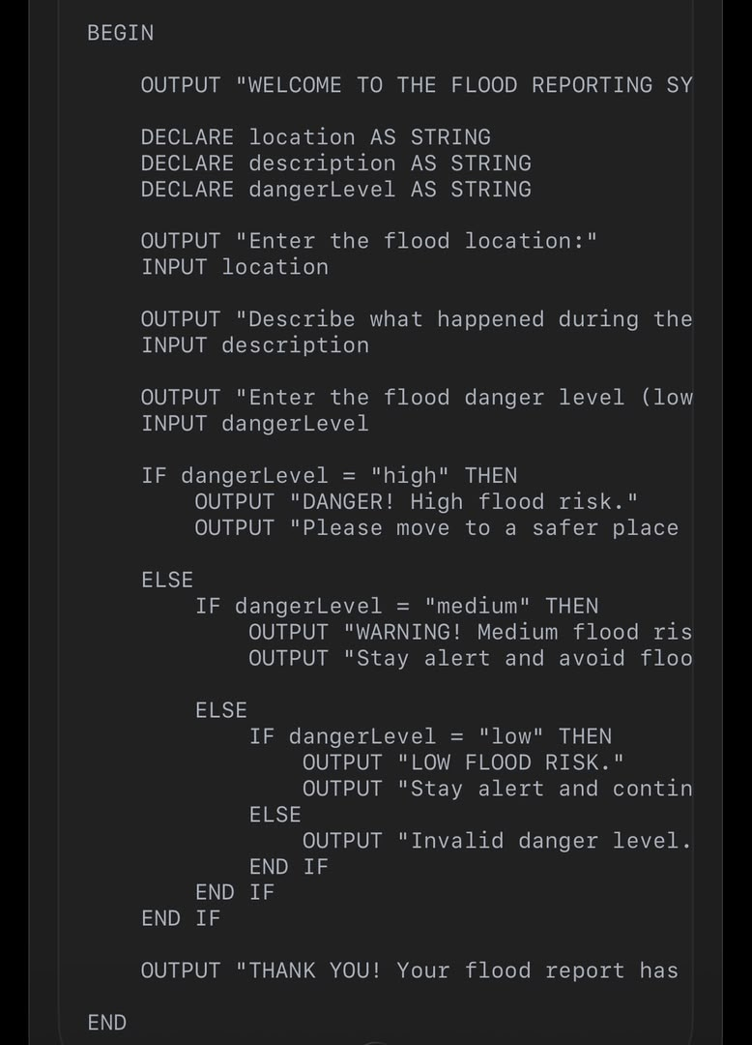

FLOWCHART
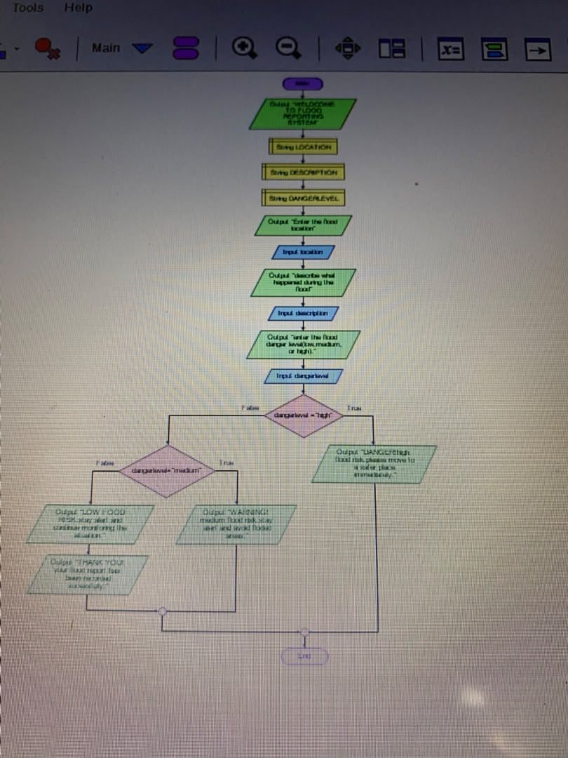

FUNCTIONAL MODULES OF THE FLOOD REPORTING SYSTEM
The Flood Reporting System is designed to help community members report flooding quickly and provide important information about flood incidents. The system is divided into different functional modules, with each module performing a specific task. These modules work together to make flood reporting simple, organized, and effective.
Flood Report Registration Module
This module allows users to register a flood incident by entering the location where the flooding has occurred. It collects essential information, such as the flood location and a description of the incident.
This helps the system identify the affected area and understand the nature of the problem. Flood Information Input Module
This module collects information about the reported flood. Users enter details such as the location, description of the flooding, and danger level. The information helps the system understand the seriousness of the situation.
Danger Level Assessment Module
This module determines the danger level of the reported flood. Based on the information entered, the system classifies the flood as Low, Moderate, or High. A high danger level indicates that the situation may require urgent attention, while a low danger level indicates a less serious situation.
Flood Report Processing Module
This module processes the information entered by the user. It checks the provided details and organizes them for reporting. The system uses the information to produce an appropriate response based on the selected danger level.
Flood Alert and Response Module
This module displays a message based on the danger level of the flood. For example, a high danger level may produce an urgent warning advising people to move away from the affected area and seek assistance. A moderate danger level may display a caution message, while a low danger level may display a general warning to remain careful.
Report Display Module
This module displays the flood report after the information has been processed. The displayed report may include the flood location, incident description, danger level, and recommended action. This allows the user to review the information entered into the system.
System Termination Module
This module ends the program after the flood report has been processed and displayed. It ensures that the system completes its operations in an organized manner.
Summary
The functional modules divide the Flood Reporting System into smaller tasks, making the program easier to understand, develop, test, and maintain. Each module performs a particular function, from collecting flood information to assessing danger levels and displaying warnings. Together, these modules provide a simple way to organize flood reports and communicate potential risks to community members.

EXPECTED OUTPUT
The expected output of the flood reporting system is to display an organized flood report based on the information entered by the user. The system receives the flood location, incident description, and danger level, processes the information, and displays a suitable warning message. when the program runs successfully, it is expected to perform the following tasks:
1.ask the user to enter the location of the flood.
2.request the description of the flooding incident.
3.ask the user to provide the flood danger level
4.process the information entered by the user
5.display the flood location, description, and danger level.
6.display the appropriate warning message based on the selected danger level.
7.end the program after displaying the report.
This is a clear example of what the program may display
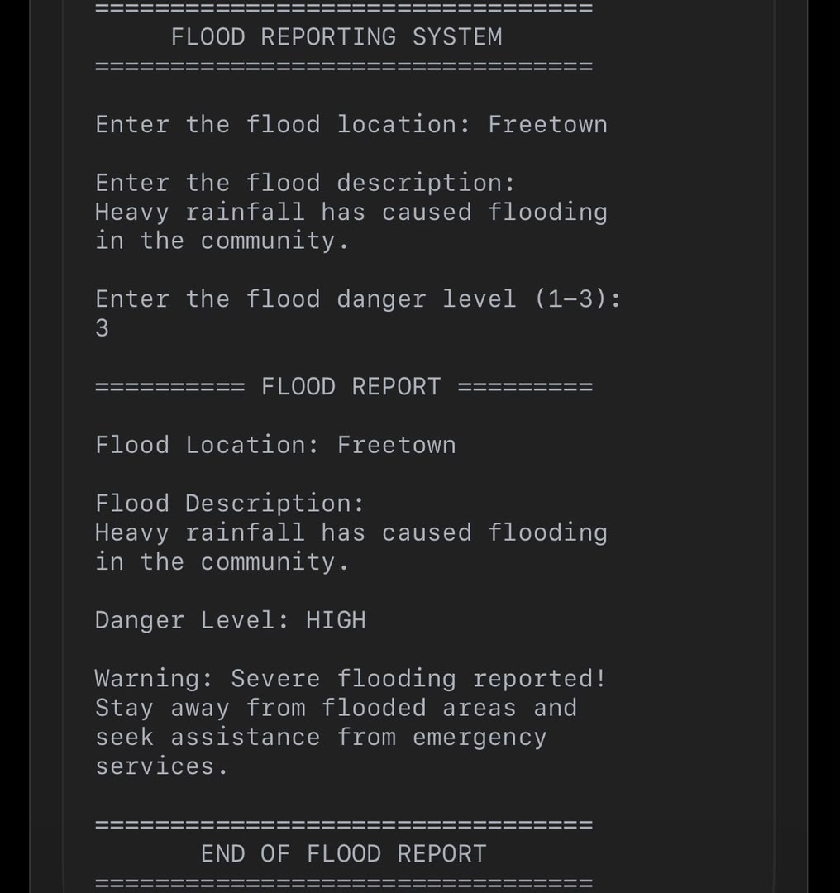

GITHUB REPOSITORY AND EVIDENCE
https://github.com/sw9675162-droid/PROG101_ASSINMENT_VICTORIOUS-S-D-WILLIAMS_905006165.git
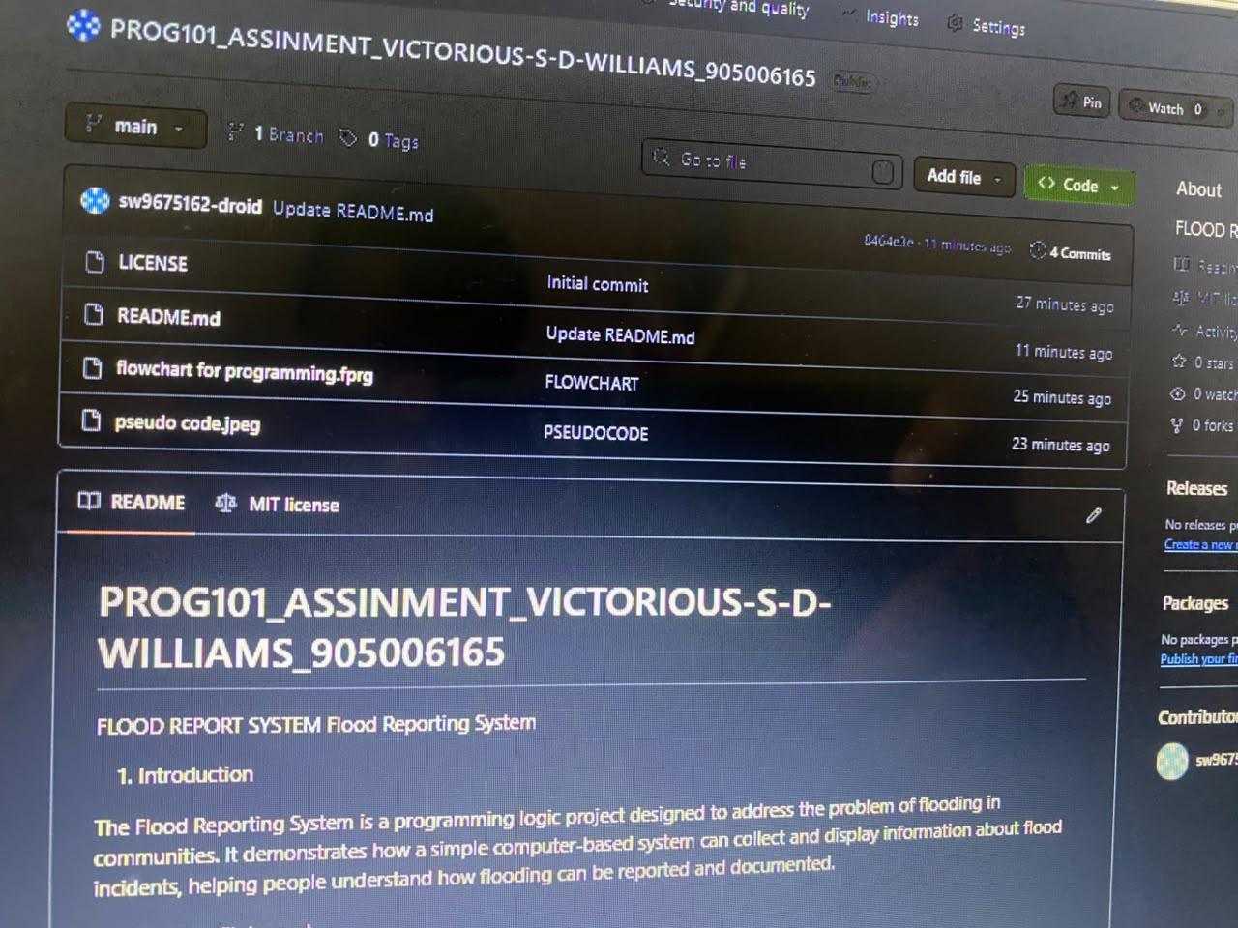

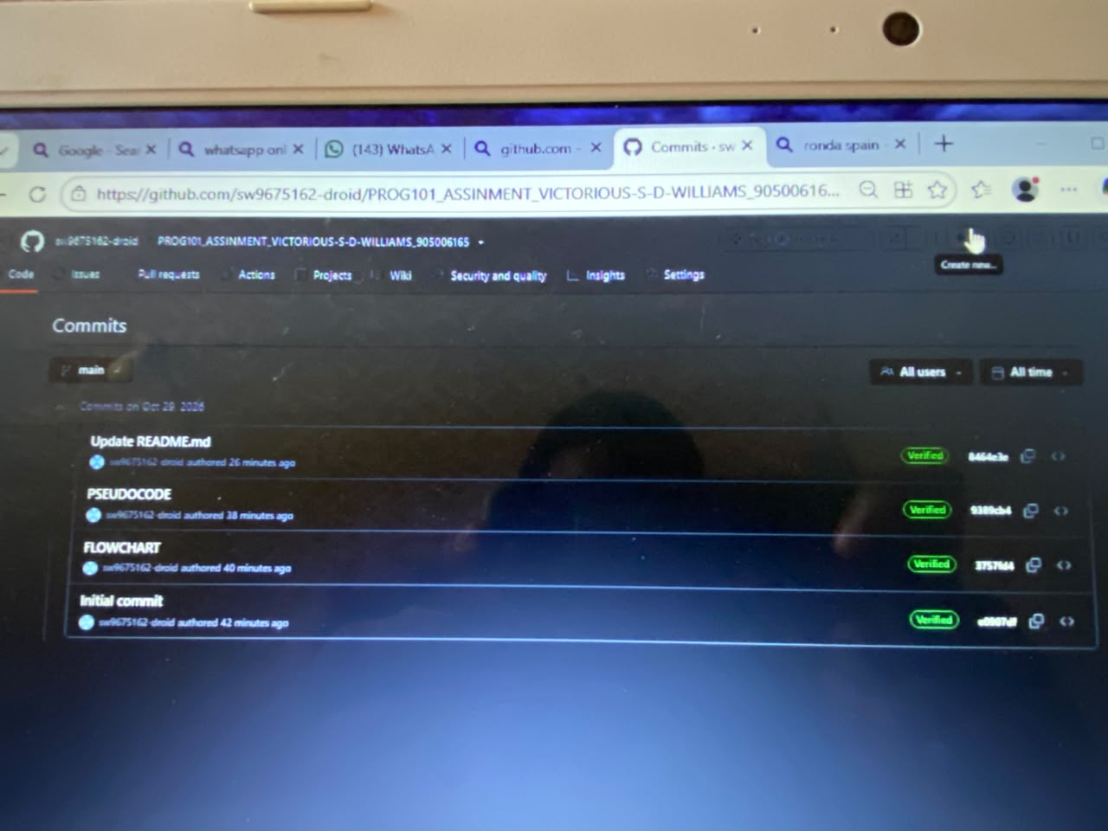

REFERENCE
1. Python Software Foundation. (n.d.). Python documentation. https://docs.python.org/3/
2. GitHub. (n.d.). GitHub documentation. https://docs.github.com/
3. Flowgorithm. (n.d.). Flowgorithm: Flowchart programming language. http://www.flowgorithm.org/
4. Federal Emergency Management Agency. (n.d.). Floods. https://www.fema.gov/floods
5. National Oceanic and Atmospheric Administration. (n.d.). Floods. https://www.noaa.gov/education/resource-collections/weather-atmosphere/floods
6. World Meteorological Organization. (n.d.). Early warnings for all. https://wmo.int/activities/early-warnings-all

