Unit Testing in React :

Topics to be covered today :

1.How to do unit testing in react basics. ( We will be seeing one Login Component unit testing ).
2.Configurations needed.
3.How to check unit testing coverage.

There are two things:

React testing library : It is used to test our components.
Jest: This is a test runner.

Whenever we need to use react testing library in our project then do we have to install some dependencies , no we don’t have to install any external dependencies.
These dependencies are by default embedded when we create a new react application.

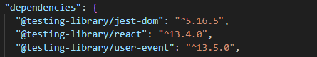 =>In package.json

React testing library: https://testing-library.com/docs/

The testing library helps you test UI components in a user-centric way.

We want to test all the rendering that are happening on the browser or whatever the changes a user is able to see on the browser.
So react testing library offers you DOM testing library. So you have an access on the DOM element and based on that when you find the DOM elements on the page you can assert them.
This is not a test runner or a framework.

Jest :

Jest is the test runner.
What is a test runner?

Whenever we fire npm test, it will go and search for all the files that are associated with test.js and then it will run all the tests and prepare the report for which tests are passed and for which tests are failed.

Now we will be doing unit testing for Login Component of our Project.

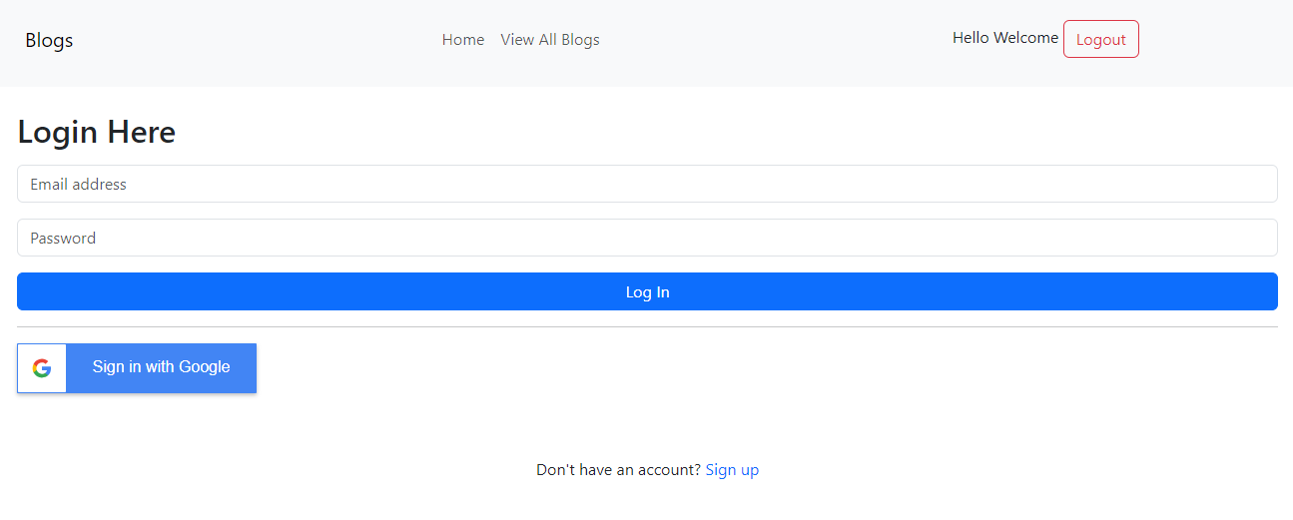

Login Component (login.jsx)

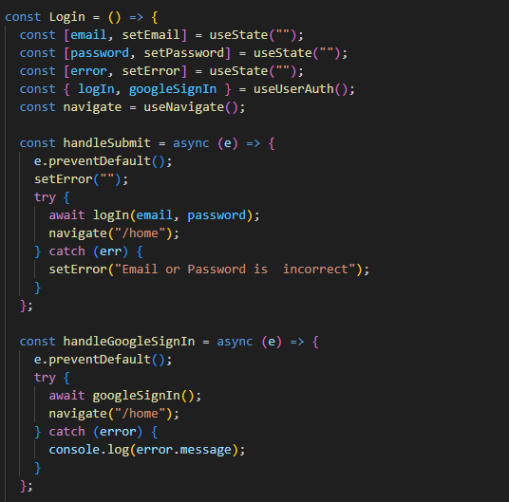
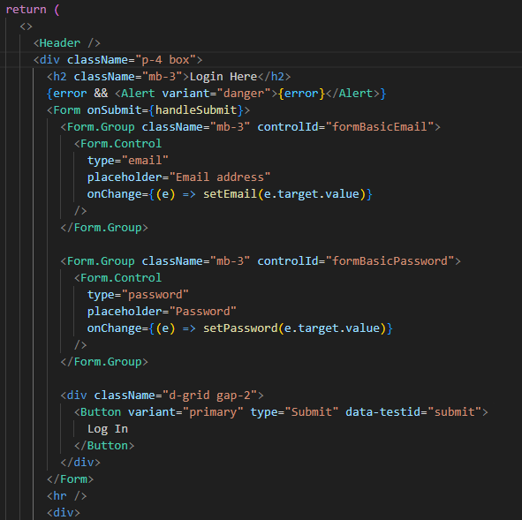

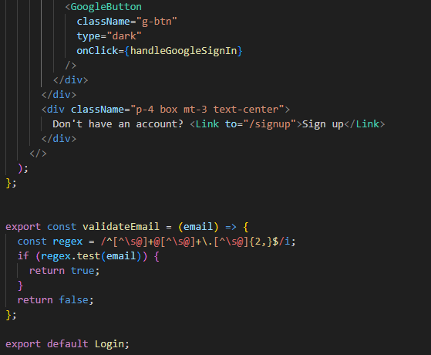

Unit testing for the above shown Login Component:

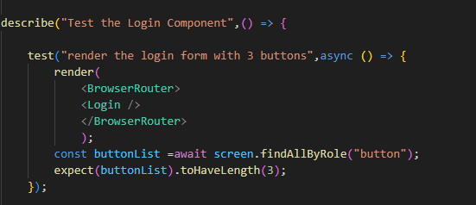

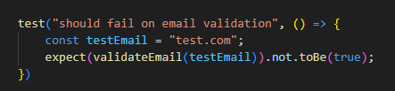

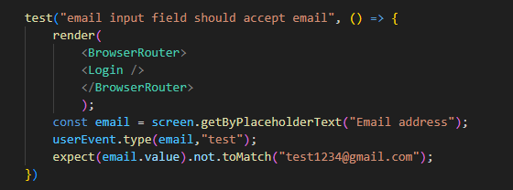

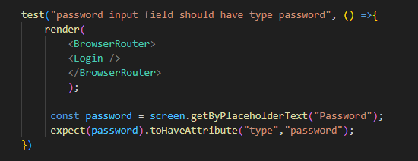

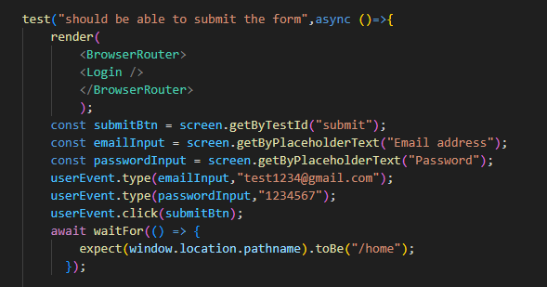

This is how the terminal will look when we will run the test cases.
Command : npm test


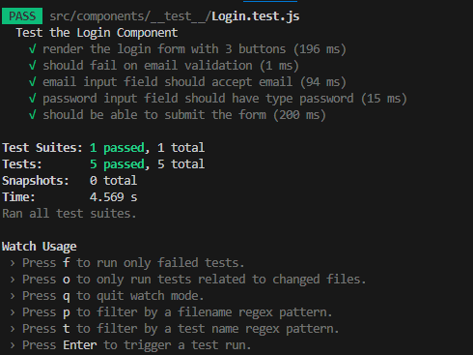
This terminal shows all the names of the test cases of the Login Component.
It shows how many tests are passed and how many are failed.

Now if you want to see the whole coverage of unit testing in your application then you need to some configuration change in package.json. You need to add coverage line in it.

"coverage": "npm test -- --coverage --watchAll --collectCoverageFrom='src/components/**/*.{ts,js,tsx,jsx}' "

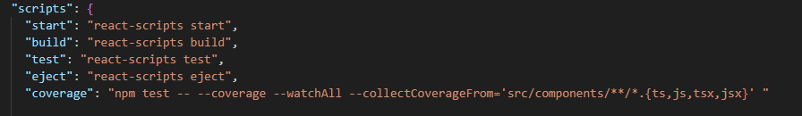

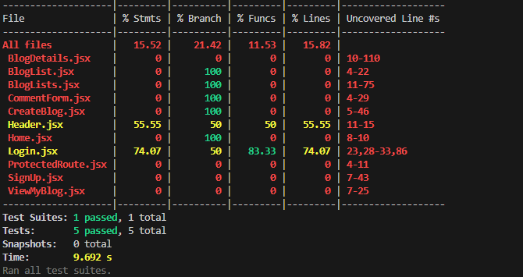

Also you can see the coverage in the browser.

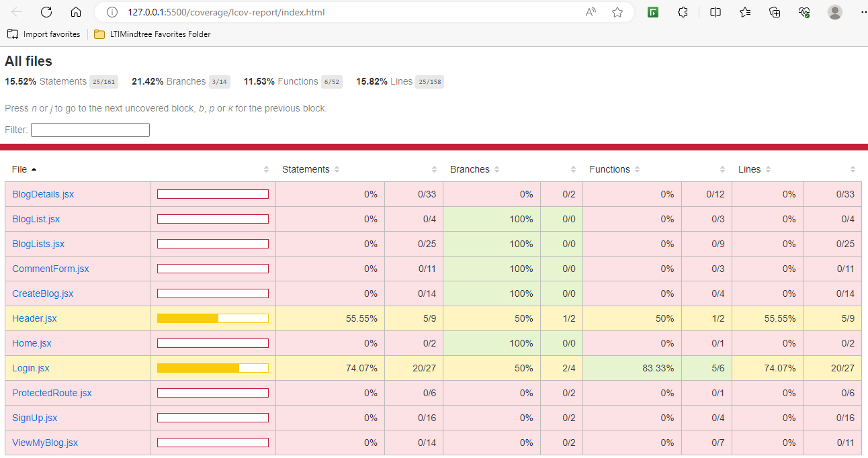

Commands:

Npm test : to run the test cases
Npm run coverage : to show the coverage report

"coverage": "npm test -- --coverage --watchAll --collectCoverageFrom='src/components/**/*.{ts,js,tsx,jsx}' "

