LOGICMONITOR | CUSTOMER HEALTH CHECK

EXAMPLE CORP / INFOSYS

LM Envision Customer Health Check
Portal health check | example.logicmonitor.com
AMBER | Overall condition: Platform footprint of 147 resources with coverage gaps, constrained by alert noise, collector governance, Service Insights maturity and synthetic coverage.

Primary conclusion
This is primarily an operationalisation and governance problem, with monitoring hygiene to fix alongside it. The portal is collecting substantial telemetry, but alert noise, collector governance and LogicModule governance limit how much of it turns into lower effort, better service context and automated response.

Assessment date 20 October 2026
Operating model Example Corp environment managed by Infosys
Portal example.logicmonitor.com (read-only REST API v3 collection at 10:00 IST)
Prepared by Infosys LogicMonitor Practice
Classification Internal account planning

Executive summary
Current-state assessment, strategic context and immediate direction
Example Corp has a focused LM Envision deployment within the Infosys-managed service. Core adoption: 147 resources, 55,300 instances, 22 dashboards, 6 services, 276 LogicModules, 10 collectors and 9 reports generated in the last 24 hours. This creates meaningful platform dependency and a credible base for service-level AIOps. ^{[1]}
Maturity is uneven. The portal generated 372 alerts in the previous day and holds 130 open alerts. Dependent alert mapping and dynamic thresholds are not evidenced. 1 of 10 collectors is down and 2 carry resources without failover. LM Logs and LM Uptime consumption are not exposed through the REST API and must be confirmed from the portal Usage page. The environment is telemetry-rich but insight- and automation-poor. ^{[1]}
[Consultant to complete: strategic context - Example Corp's expectations, the Infosys commercial position and how LogicMonitor should be positioned (operational data and AIOps foundation, not another monitoring tool).] ^{[2]}
The principal platform risk evidenced by portal data is alert noise (Alerting health: RED). [Consultant to complete: account and execution risks, such as outstanding health-check actions or POV status.] ^{[1,3]}

Health at a glance
147  Devices  5 dead; 4 ungrouped | 55,300  Instances  Approximately 376 per device | 372  Alerts in prior day  Approximately 11k over 30 days
130  Open alerts  33.8% acknowledged | 6  Services  Service Insights footprint present | 10  Collectors  1 down; 2 without failover

Immediate direction
1. Stabilise the foundation: close the collector, alert-hygiene, alert-routing, topology and discovery, LogicModule governance and access backlog before using AI to mask platform debt.
2. Lock the Edwin business case: select two or three incident categories and agree baseline metrics for alert reduction, triage effort, MTTR, SLA risk and engineering capacity.
3. Operationalise existing entitlements: turn Logs, Service Insights and LM Uptime into repeatable workflows rather than passive data stores or unused capacity.
4. Create an Infosys operating model: named owners, dated actions, executive checkpoints and a clear production decision following the POV playback.

Portal adoption and health scorecard
Real-time portal metrics may differ from billed usage
Area | Status | Evidence and implication
Core resource adoption | UNKNOWN | 147 monitored resources. Contracted entitlement and rolling month-to-date billed usage are not exposed through the REST API. [Consultant to complete: contracted resources and billed usage from the portal Usage page.]
Device footprint | AMBER | 147 resources (131 standard, 10 AWS and 6 Azure). 5 are dead (3.4%), 4 sit only in the root group, 3 have alerting disabled and 5 have auto-discovery data older than 14 days. Coverage hygiene needs attention before the data is used for correlation.
Telemetry depth | GREEN | 55,300 monitored instances, approximately 376 per resource. DataSource definitions hold 276 datapoints. Total and complex datapoint counts are not exposed through the REST API. [Consultant to complete: datapoint totals from Settings > Account Information.]
Monthly datapoint collection | UNKNOWN | Monthly datapoint collection usage and entitlement are shown on the portal Usage page and are not exposed through the REST API. [Consultant to complete: collections used versus contracted.]
Alerting health | RED | 372 alerts in the previous day, equivalent to 16 per hour or 0.3 per minute, 2.5 per resource, with 130 open alerts (33.8% acknowledged). No alerts carry a dependent alert mapping role and no dynamic thresholds are defined in DataSource definitions.
Dashboards and reporting | GREEN / AMBER | 22 dashboards, 264 widgets (12.0 per dashboard) and 9 of 15 reports generated in the last 24 hours. Configuration is visible, but dashboard views, report recipients' use and decision usage are not exposed through the API.
Service Insights | AMBER | 6 services are configured. Coverage, ownership, criticality, service health, topology quality and operational adoption are not visible through the API.
LM Logs | UNKNOWN | 4 LogSources are configured. Logs ingestion volume, partitions, LogAlerts and tracked queries are not exposed through the REST API endpoints used. [Consultant to complete: Logs usage versus entitlement from the portal Usage page.]
LM Uptime | UNKNOWN | LM Uptime checks executed versus contracted are not exposed through the REST API. 6 external and 4 internal website checks are configured. [Consultant to complete: Uptime usage versus entitlement from the portal Usage page.]
Websites | AMBER | 10 website checks (7 web, 3 ping; 6 external). 1 has monitoring stopped and 1 is currently alerting. Business journeys and geographic coverage need validation.
Collectors | AMBER / RED | 10 collectors: 1 down, 2 carrying resources without failover (2 protected by auto-balanced groups), 0 at or above 90% of sizing capacity, 5 behind the newest version in the portal (37.200), 1 ungrouped and 1 custom-sized. Instance load ranges from 600 to 23,800 per collector (busiest is 9.2x the median).
LogicModules | AMBER | 276 LogicModules (140 SNMP SysOID maps, 60 DataSources, 25 PropertySources, 18 EventSources). 10 DataSources are locally authored and 4 are modified from their Exchange origin. 5 modules have clone-like names; 2 of 4 checked are not applied to any resource. Update availability is shown in the Modules Toolbox and is not exposed through the API.
Config monitoring | UNKNOWN | 6 ConfigSources are installed. The number of resources with configuration collection is not exposed through the REST API. [Consultant to complete: Config Devices count and coverage of network infrastructure.]
Cloud / SaaS / Kubernetes | GREEN | 16 cloud resources (AWS 10, Azure 6, GCP 0) and 0 Kubernetes resources are monitored. SaaS and OpenTelemetry scope must be validated.
Alert routing and escalation | AMBER | 5 alert rules and 5 escalation chains. 0 rules route to a missing chain or a chain with no destinations, 1 priority is shared by more than one rule and 1 of 5 chains uses rate limiting. ITSM integrations: servicenow.
Scheduled downtime (SDT) | AMBER | 4 SDT entries (2 active now). 1 is open-ended and 1 runs for more than 30 days. Long or open-ended downtime silences monitoring without review.
Access governance | AMBER | 30 users (26 active, 3 API-only, 4 with administrator roles). 5 active users have not logged in for 90+ days, 4 active users do not use two-factor authentication. 7 roles are defined. 5 of 6 API tokens are enabled and 2 enabled tokens have been unused for 90+ days.
Discovery and change activity | AMBER | 5 NetScans (3 scheduled). The audit log holds 420 entries over the last 168 hours; 62.1% relate to ActiveDiscovery or instance changes. This indicates discovery churn that can weaken topology and correlation.

Scorecard interpretation
Core coverage needs attention. The value leakage is concentrated in alert noise, collector governance, monitoring hygiene, Service Insights maturity, synthetic coverage and LogicModule governance. 5 areas are UNKNOWN because the data is not exposed through the REST API or could not be read; complete them from the portal before customer use.

What is good, what is weak and what is missing
Assessment focused on business value, platform stickiness and expansion readiness
WHAT IS GOOD  • LogicMonitor is embedded in the managed service through 147 resources, 22 dashboards, 15 reports, 6 services and 10 collectors.  • 10 locally authored DataSources create process dependency and meaningful switching friction.  • An ITSM integration (servicenow) gives a path for incident enrichment.  • Telemetry depth of 55,300 instances supports cross-domain investigation and correlation. | WHAT IS WEAK  • Alert volume is operationally unsustainable: 372 alerts in the previous day (2.5 per resource) and 130 open.  • Dependent alert mapping and dynamic thresholds are not evidenced in the portal data.  • Collector health, sizing, failover and load distribution need governance: 1 down, 2 without failover, 0 over capacity.  • 5 LogicModules have clone-like names, adding supportability and lifecycle risk.  • Alert routing gaps: 1 priority shared between rules.  • The audit log is dominated by ActiveDiscovery instance changes (62.1%), indicating discovery churn that can weaken topology and correlation. | WHAT IS MISSING  • Verified dashboard, report and user adoption data - configuration count does not prove consumption.  • Named ownership, criticality and service-level objectives for the 6 Service Insights services.  • LM Logs usage, tracked investigations, standard query packs, retention governance and cost controls.  • Confirmed LM Uptime usage against the contracted check entitlement.  • A reconciled baseline for alerts, tickets, workforce, MTTD/MTTR, SLA and cost per incident.

Stickiness and account economics
Existing anchors  • SLA and custom reporting (15 reports)  • Locally authored LogicModules (10)  • Collector and discovery architecture (10 collectors, 5 NetScans)  • 6 service models  • Dashboard and escalation workflows (22 dashboards, 5 chains)  • ITSM integration (servicenow) | Expansion layers  • Edwin Event Intelligence and investigation  • Logs operationalisation  • LM Uptime for digital journeys  • ITSM/CMDB enrichment depth  • Service Insights maturity  • Config and OpenTelemetry expansion | Retention risks  • Unimplemented health-check actions  • Alert fatigue eroding trust in the platform  • Collector and module supportability debt  • Logs or Uptime spend without value proof  • AI promise without measurable criteria  • [Consultant to complete: stakeholder, commercial and delivery risks]

Module and capability usage
Observed adoption versus value-realisation opportunity
Capability | Observed usage | Health | Value motion
Core resources | 147 devices and 55,300 instances. | Developing | Protect the foundation, remove stale objects and improve coverage quality before adding more volume.
Dashboards / reports | 22 dashboards, 264 widgets and 9 reports in the previous 24 hours. | Developing | Rationalise by persona: NOC, service owner, Infosys delivery executive, SLA governance and customer leadership. Measure views and recipient use.
Service Insights | 6 services configured; service quality and operational usage are not exposed through the API. | Developing | Attach owner, criticality, SLA/SLO, business impact and change control. Use service context in incident prioritisation and Edwin investigations.
LM Logs | 4 LogSources configured; ingestion volume, LogAlerts and tracked queries: [Consultant to complete: from the portal Usage and Logs pages.] | Unknown | Review top consumers, retention and partitions; build tracked investigations and high-value alerts; link logs to service and incident workflows.
Edwin AI | [Consultant to complete: current Edwin AI usage or POV status.] | Unknown | Proceed only through a gated POV with two or three use cases, signed baselines, technical readiness checks and a production decision.
LM Uptime | Checks executed versus contracted are not exposed through the API. [Consultant to complete: Uptime usage.] | Unknown | Activate external synthetic monitoring for the highest-value digital journeys and use results in service and SLA reporting.
Websites | 10 website checks (6 external, 1 alerting). | Developing | Validate journey coverage and add geographic, dependency and business-impact context. Complement internal checks with Uptime.
Config monitoring | 6 ConfigSources installed; Config Devices count: [Consultant to complete: from Settings > Account Information.] | Unknown | Assess configuration backup, drift, compliance and change-correlation coverage across network infrastructure.
Cloud / Kubernetes / OTel | 16 cloud and 0 Kubernetes resources; OpenTelemetry scope is not evidenced. | Strong | Confirm whether scope exists elsewhere. Where appropriate, extend hybrid observability and use OpenTelemetry to enrich services and Edwin context.
Collectors / LogicModules | 10 collectors and 276 LogicModules; 1 down, 5 clone-like modules. | At risk | Create a formal governance register, standardise sizing and failover, remediate discovery churn, and retire unsupported or unused clones.

Edwin AI POV recommendation
Proceed conditionally - do not launch an open-ended AI exercise
AMBER | Recommendation: Proceed with a tightly scoped, value-led POV after the entry criteria are locked. The existing telemetry, alert volume, Logs footprint and Service Insights estate provide a credible proving ground, but the baseline and operating conditions are not yet sufficiently controlled.

Why the opportunity is credible
- The portal generated 372 alerts in the previous day across 147 resources, a measurable baseline for event grouping and noise reduction.
- Telemetry depth of 55,300 instances and 6 services supports a meaningful investigation and correlation exercise.
- An ITSM integration (servicenow) already exists, giving a path for incident enrichment.
- [Consultant to complete: the customer's mandate for AI-enabled service improvement and the Infosys economic incentive (L0/L1 effort, SLA performance, margin).]

Entry criteria that must be completed
- Reconcile alerts, incidents/tickets, duplicate handling, workforce effort, MTTD/MTTR, SLA performance and cost-per-ticket baselines.
- Freeze two or three incident categories and define exactly which signals are required for Example Corp SLA reporting versus operational response.
- Resolve critical collector, topology, metadata and ActiveDiscovery stability issues in the selected scope.
- Confirm data flow, RBAC, security, LogicMonitor access and the ITSM/CMDB integration path.
- Agree POV success criteria, exit criteria, executive sponsors and the production-commercial gate before activation.

Recommended use cases and evidence
Use case | Purpose | Evidence to capture
Wireless / AP alert correlation | Retain every signal required for SLA reporting while grouping duplicate and related warnings into operationally meaningful situations. Portal evidence: 77 prior-day alerts (21%) from Wireless_AP_Clients. | Raw alerts vs grouped insights; duplicate-ticket reduction; NOC minutes saved; reporting integrity preserved.
Network and collector incident correlation | Associate parent infrastructure, collector, interface, tunnel and downstream symptoms to reduce floods and shorten initial triage. Portal evidence: 176 prior-day alerts (47%) from SNMP_Network_Interfaces, Ping and BGP. | Related-event grouping; engineers engaged; time to probable cause; escalation rate; MTTD/MTTR.
ServiceNow incident enrichment and RCA | Pass affected service, probable cause, related alerts, logs and investigation context into the incident workflow. | Ticket quality; handoff time; RCA consistency; escalation avoidance; restoration time.

Three-week execution model
Horizon | Priority actions | Exit evidence
Week 0 - readiness | Lock scope, baseline, technical access, RBAC, architecture, owners and exit criteria. | Signed start checklist and approved POV charter.
Week 1 - connect | Connect Edwin to the existing LM environment, validate data quality and select representative alert clusters. | Verified data flow and accepted test set.
Week 2 - assess and tune | Run event grouping and investigations, tune models and compare results with manual operations. | Measured quality, time and workload evidence.
Week 3 - playback | Quantify workload, MTTR, incident quality and SLA impact; present findings to Example Corp and Infosys. | Production decision, scope and commercial gate.

Core success measures
Alert-to-insight  Noise reduction  Raw events grouped without losing SLA evidence | Minutes saved  Triage efficiency  Manual investigation time reclaimed | MTTR / SLA  Service performance  Priority-level improvement and risk reduction
Ticket quality  ITSM enrichment  Better context, handoff and RCA consistency | Hours / FTE  Capacity reclaimed  Engineering effort redirected to higher-value work | Go / no-go  Production gate  Evidence-based scope and commercial decision

30 / 60 / 90-day action plan
Sequence foundational optimisation before broader AIOps scale
Horizon | Priority actions | Exit evidence
0-30 days | Assign one accountable Infosys owner per health-check action; establish signed operational baselines; classify the top alert sources (SNMP_Network_Interfaces and Wireless_AP_Clients); remediate collector down states, failover gaps and sizing exceptions; pilot dependent alert mapping; pilot dynamic thresholds on suitable metrics; close open-ended SDTs; confirm Logs and Uptime usage against entitlement. | Named owners and dates; baseline pack; first alert-noise and collector-health improvements; entitlement usage confirmed.
31-60 days | Rationalise cloned and unused LogicModules; review alert-rule priorities and escalation rate limiting; validate service ownership and criticality; rationalise dashboards by persona; remove inactive users and idle API tokens; complete ITSM/CMDB readiness; freeze Edwin scope and success criteria. | Governance register; persona dashboard catalogue; service-quality map; approved POV charter and technical readiness.
61-90 days | Run the three-week Edwin POV; compare evidence with baseline; produce executive value playback; agree production scope, operating model, enablement and commercial ownership; package the outcome as an Infosys repeatable proposition. | Validated business case; production decision; rollout plan; reusable Infosys reference architecture and value model.

Decisions required at the onsite
1. Which single business KPI will unlock Infosys funding: FTE capacity, cost per ticket, MTTR, SLA-risk reduction, or an agreed combination?
2. Which two or three incident categories will be used for the Edwin POV?
3. Which alerts must remain for Example Corp contractual reporting, and which are expected to drive operational action?
4. Who owns each outstanding health-check recommendation, with committed completion dates?
5. What technical readiness evidence is required before Edwin activation, including collector health, topology, metadata, RBAC and ITSM access?
6. What is the production decision gate after the POV playback, and who has authority to approve it?

Recommended customer positioning
LogicMonitor is already embedded in the Example Corp service across 147 monitored resources. The opportunity is not to add more monitoring. It is to convert the telemetry already being collected into fewer actionable situations, faster investigation, measurable SLA improvement and lower cost-to-serve for Infosys.

Sources, assumptions and validation points
Evidence used for this internal health check
[1] | LM Envision REST API v3 - example.logicmonitor.com  Read-only collection on 20 October 2026 at 10:00 IST covering 28 of 28 endpoints (devices, collectors, alerts, alert rules, escalation chains, LogicModules, dashboards, reports, websites, users, API tokens, NetScans, SDTs and audit log). Metrics are point-in-time; real-time usage may differ from billed usage.
[2] | [Consultant to complete: customer account plan or executive presentation]  [Consultant to complete: title, owner and date of the source document.]
[3] | [Consultant to complete: internal account updates]  [Consultant to complete: channel or document, period covered and key points.]

Validation points before customer use
- A configuration count does not prove active adoption. Dashboard views, report recipients, service usage, query execution and user activity are not exposed through the API.
- Statuses and findings are rule-based (report_rules.json and the Operations Portal Maintenance standards). Review every RAG rating and consultant placeholder before customer use.
- The portal metrics are a current operational snapshot. Contract, billing and renewal decisions should use the formal usage reports and commercial system of record.

Appendix A - Portal evidence
Selected charts supporting the key usage and risk observations
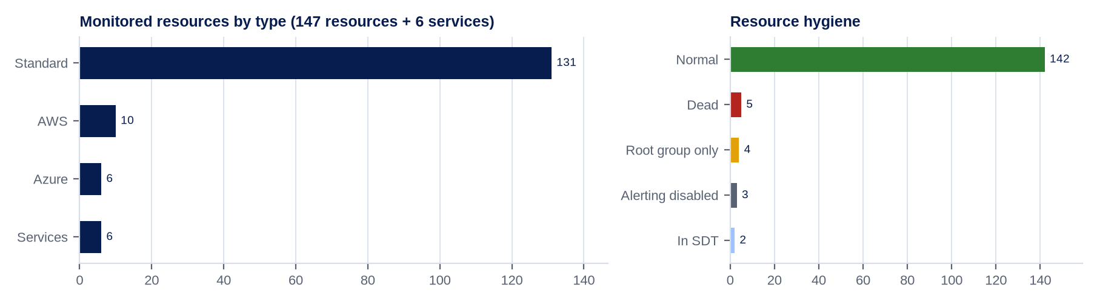
Figure A1. Resource footprint: 147 monitored resources by type and hygiene state.
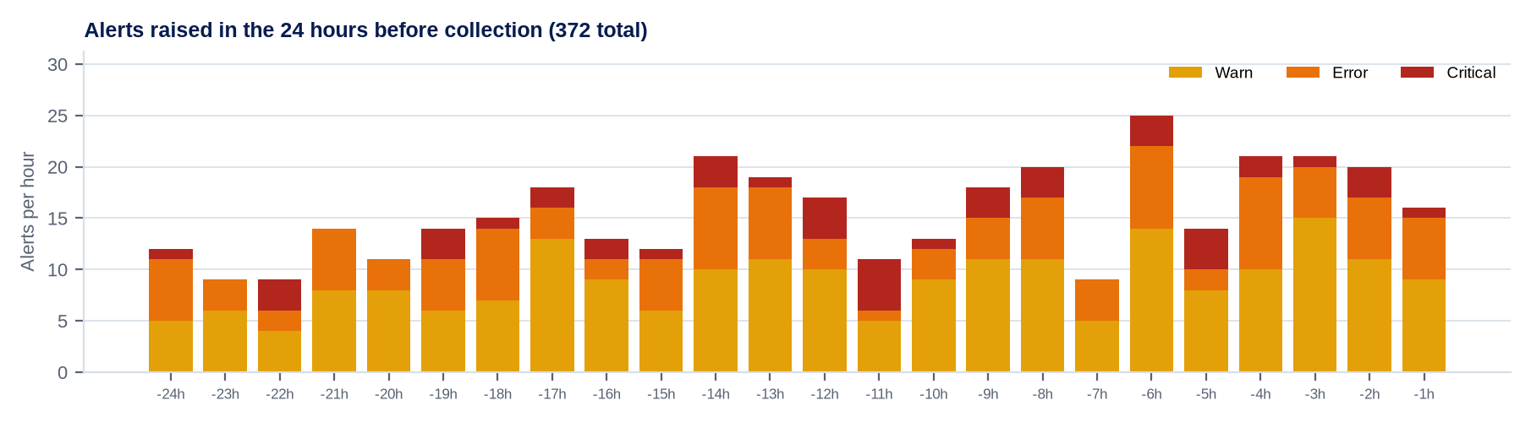
Figure A2. Alert volume: 372 alerts raised in the 24 hours before collection, by severity.

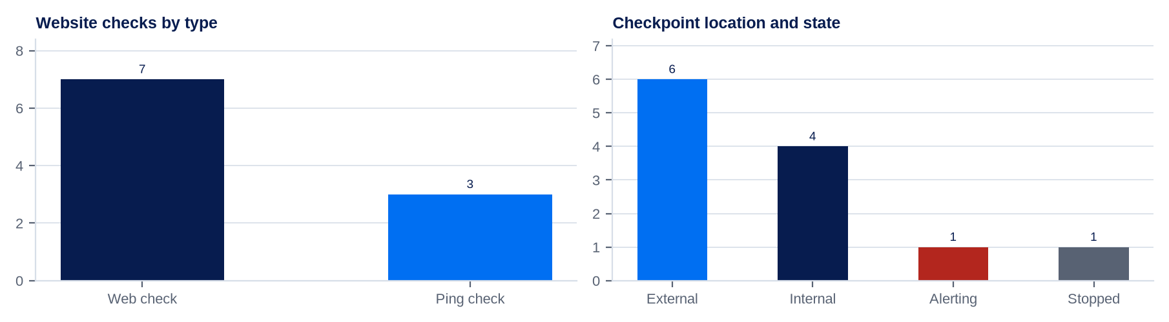
Figure A3. Website and synthetic checks: 10 checks, 6 from external locations.
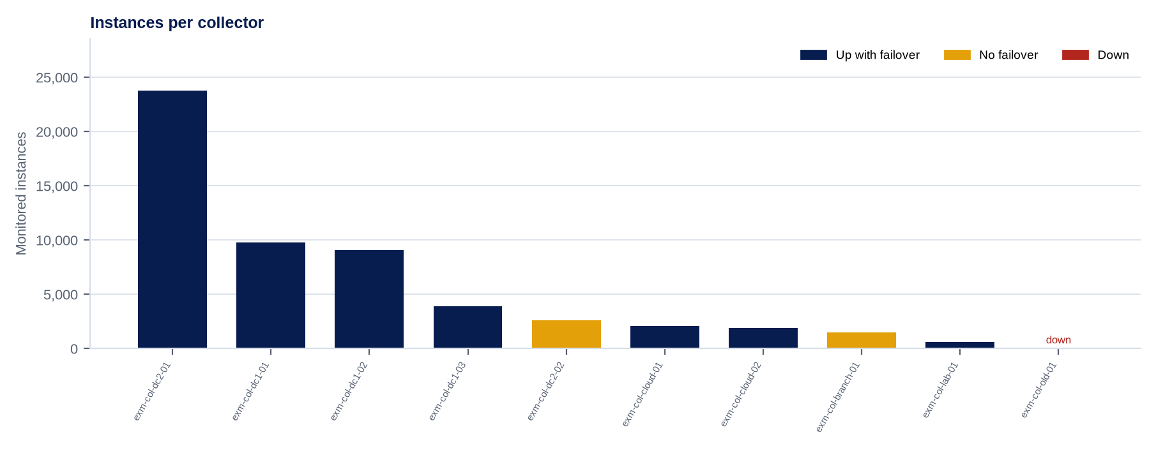
Figure A4. Collector estate: 10 collectors, 1 down and 2 carrying resources without failover.
LM Logs and LM Uptime usage charts from the portal Usage page are not available through the REST API. [Consultant to complete: add Usage page screenshots if required.]

Appendix B - Supporting data
Detail behind the alerting and collector findings

Top alert sources in the prior 24 hours
DataSource / alert type | Alerts | Share | Most affected resource
SNMP_Network_Interfaces | 108 | 29.0% | EXM-SW-022
Wireless_AP_Clients | 77 | 20.7% | EXM-AP-024
Ping | 39 | 10.5% | EXM-RTR-004
WinCPU | 37 | 9.9% | exm-win-010
Linux_SSH_Filesystems | 34 | 9.1% | exm-lnx-005
BGP | 29 | 7.8% | EXM-RTR-005
WinVolumeUsage | 23 | 6.2% | exm-win-019
HostStatus | 13 | 3.5% | EXM-SW-026
AWS_EC2 | 12 | 3.2% | exm-aws-app-02

Collector exceptions
Collector | Status | Size | Resources | Instances | Findings
exm-col-dc2-01 | AMBER | large | 26 | 23,800 | At 79.3% of LogicMonitor large capacity
exm-col-dc1-03 | AMBER | medium | 18 | 3,900 | Behind newest in portal (37.200)
exm-col-dc2-02 | AMBER | medium | 14 | 2,600 | 3 major versions behind 37.200; No failover collector assigned
exm-col-branch-01 | AMBER | custom | 8 | 1,500 | Behind newest in portal (37.200); No failover collector assigned
exm-col-lab-01 | AMBER | small | 4 | 600 | Behind newest in portal (37.200)
exm-col-old-01 | RED | small | 0 | 0 | Collector is down; Behind newest in portal (37.200)

Appendix C - Data collection log
Read-only REST API v3 endpoints queried for this report
Dataset | Endpoint (GET) | Records | Status
Devices | /device/devices | 153 | OK
Device groups | /device/groups | 12 | OK
Collectors | /setting/collector/collectors | 10 | OK
Collector groups | /setting/collector/groups | 4 | OK
Open alerts | /alert/alerts | 130 | OK
Alerts in prior 24 h | /alert/alerts | 372 | OK
Alert rules | /setting/alert/rules | 5 | OK
Escalation chains | /setting/alert/chains | 5 | OK
Integrations | /setting/integrations | 3 | OK
DataSources | /setting/datasources | 60 | OK
EventSources | /setting/eventsources | 18 | OK
ConfigSources | /setting/configsources | 6 | OK
PropertySources | /setting/propertyrules | 25 | OK
TopologySources | /setting/topologysources | 12 | OK
JobMonitors | /setting/batchjobs | 2 | OK
LogSources | /setting/logsources | 4 | OK
AppliesTo functions | /setting/functions | 9 | OK
SNMP SysOID maps | /setting/oids | 140 | OK
Dashboards | /dashboard/dashboards | 22 | OK
Dashboard widgets | /dashboard/widgets | 264 | OK
Reports | /report/reports | 15 | OK
Websites | /website/websites | 10 | OK
Users | /setting/admins | 30 | OK
Roles | /setting/roles | 7 | OK
API tokens | /setting/admins/apitokens | 6 | OK
NetScans | /setting/netscans | 5 | OK
SDTs | /sdt/sdts | 4 | OK
Audit log | /setting/accesslogs | 420 | OK

