ST. XAVIER'S UNIVERSITY, KOLKATA
Department of Statistics
M.Sc. in Statistics — Internship Project Report

Surveillance of Culture-Positive Infections and Antimicrobial Resistance in a Tertiary-Care Hospital
A Retrospective Analysis of a 14-Month Microbiology Register with an Interactive Surveillance Dashboard
Submitted by
Swachchho Gun
Host organisation
Apollo Multispeciality Hospitals, Kolkata
Study period: April 2025 – May 2026
October 2026

DECLARATION
I hereby declare that this project report is my own original work. All sources of information and data have been duly acknowledged. The analyses were performed by me; where computational scripts were prepared with the assistance of software tools, I specified the analyses, verified all outputs, and am responsible for their interpretation. All data used are aggregate and de-identified, and contain no patient- or clinician-level identifiers.

Swachchho Gun
M.Sc. Statistics, St. Xavier’s University, Kolkata

ACKNOWLEDGEMENTS
I express my sincere gratitude to the Department of Microbiology at Apollo Multispeciality Hospitals, Kolkata, for the opportunity to undertake this internship and for access to the microbiology surveillance data that made this work possible. I also thank the infection-control team for their insights into how surveillance data is used in practice, and my family and peers for their encouragement.

ABSTRACT
Background. Infections picked up in hospital (healthcare-associated infections, or HAI) and bacteria that no longer respond to antibiotics (antimicrobial resistance, or AMR) are two of the biggest threats to patient safety. To manage them, a hospital needs to know which organisms it is dealing with, how resistant they are, and whether the picture is changing. That is what surveillance of positive cultures provides.
Aim. To clean and analyse a 14-month culture-positive microbiology register from a tertiary-care hospital, characterise the infection and resistance burden, identify the factors associated with resistance, and deliver decision-support tools for the infection-control team.
Methods. A retrospective analysis was performed on 10,943 culture-positive samples (12,188 isolates) from 5,311 patients recorded between April 2025 and May 2026. The register was standardised and cleaned; descriptive epidemiology was conducted in Excel and Python. Inferential work comprises bivariate association analysis, a multivariable logistic-regression model of documented resistance used for both inference and prediction, and a statistical process-control chart, complemented by an interactive Power BI dashboard.
Key findings. Gram-negative bacteria made up most of the isolates (63%), led by Klebsiella pneumoniae and Escherichia coli, with a large number of fungal isolates as well. Nearly half of culture-positive samples were classified as healthcare-associated (46.8%), concentrated in intensive-care units, while 39.5% of samples carried a recognised resistance mechanism, notably carbapenem resistance. Monthly monitoring indicated a declining HAI trend over the period.
Conclusion. The analysis provides a consolidated, evidence-based picture of the hospital’s infection landscape and a set of tools to support targeted infection control and antimicrobial stewardship.
Keywords: healthcare-associated infection; antimicrobial resistance; surveillance; resistance phenotype profile; logistic regression; statistical process control.

TABLE OF CONTENTS

Declaration ii
Acknowledgements iii
Abstract iv
Chapter 1 Introduction 1
Chapter 2 Background and Literature Review 3
Chapter 3 Materials and Methods 6
Chapter 4 Results I - Descriptive Epidemiology 10
Chapter 5 Results II - Statistical Analysis 21
Chapter 6 Results III - Interactive Surveillance Dashboard 35
Chapter 7 Discussion 41
Chapter 8 Limitations 45
Chapter 9 Conclusions and Recommendations 47
References 50
Appendix A Organism applicability audit 51
Appendix B Data-quality anomalies 51
Appendix C Supplementary materials 52

LIST OF FIGURES
Figure 4.1 Distribution of culture-positive samples by microbiological category
Figure 4.2 Distribution of culture-positive samples by specimen type
Figure 4.3 Leading organisms by number of positive samples
Figure 4.4 Distribution of samples by hospital unit
Figure 4.5 Antimicrobial-resistance mechanisms
Figure 4.6 Healthcare-associated versus community-origin infections
Figure 4.7 Healthcare-associated infections by unit
Figure 4.8 Monthly culture-positive volume and HAI rate
Figure 5.1 Documented resistance by organism group
Figure 5.2 Documented resistance by specimen type
Figure 5.3 Effect sizes (Cramér’s V) for the four associations tested
Figure 5.4 Adjusted odds ratios (forest plot)
Figure 5.5 ROC curve on the held-out test set
Figure 5.6 Calibration plot
Figure 5.7 p-chart of monthly HAI proportion with control limits
Figure 6.1 Dashboard page 1 — Overview
Figure 6.2 Dashboard page 2 — Organisms
Figure 6.3 Dashboard page 3 — Antimicrobial resistance
Figure 6.4 Dashboard page 4 — Hospital units
Figure 6.5 Dashboard page 5 — Monthly surveillance

LIST OF TABLES
Table 3.1 Study variables (data dictionary)
Table 4.1 Overview of the study population
Table 4.2 Specimen-type distribution
Table 4.3 Organism distribution (top 20)
Table 4.4 Distribution by hospital unit (top 20)
Table 4.5 Predominant specimen types by unit
Table 4.6 Predominant organisms by specimen type
Table 4.7 Predominant organisms by unit
Table 4.8 Antimicrobial-resistance summary
Table 4.9 Healthcare-associated infection by unit
Table 5.1 Chi-square tests of association with documented resistance
Table 5.2 Sensitivity analysis for clustering within samples
Table 5.3 Adjusted odds ratios for documented resistance

LIST OF ABBREVIATIONS
Abbreviation | Full form
AMR | Antimicrobial resistance
AUC | Area under the (ROC) curve
CI | Confidence interval
CLSI | Clinical and Laboratory Standards Institute
CoNS | Coagulase-negative staphylococci
CRE | Carbapenem-resistant Enterobacterales
ESBL | Extended-spectrum beta-lactamase
HAI | Healthcare-associated infection
ICU | Intensive-care unit
MDR | Multidrug-resistant
MRSA | Methicillin-resistant Staphylococcus aureus
MSSA | Methicillin-sensitive Staphylococcus aureus
OR | Odds ratio
SPC | Statistical process control
VRE | Vancomycin-resistant enterococci

Chapter 1 Introduction

1.1 Background
Infections acquired in the course of receiving healthcare — termed healthcare-associated infections (HAI) — represent one of the most significant, and most preventable, threats to patient safety worldwide. They prolong hospital stays, increase mortality and morbidity, and impose a substantial economic burden on health systems. In parallel, the global rise of antimicrobial resistance (AMR) — the ability of micro-organisms to survive the drugs designed to kill them — has progressively eroded the effectiveness of standard therapy, so that infections which were once routinely treatable are increasingly difficult, and occasionally impossible, to cure.
These two phenomena are closely intertwined in the hospital setting. Critically ill patients, invasive devices, and the intensive use of broad-spectrum antibiotics create an environment in which resistant organisms can emerge and spread. Understanding the local pattern of infecting organisms and their resistance profile is therefore not merely an academic exercise: it directly informs empirical prescribing, infection-control priorities, and antimicrobial-stewardship policy.
The primary instrument for this understanding is the microbiology culture register — the systematic record of every specimen that yields a positive culture, the organism identified, and its susceptibility. When such a register is cleaned, consolidated, and analysed, it becomes a powerful surveillance resource. This report describes exactly such an exercise, applied to fourteen months of data from a tertiary-care hospital.

1.2 The study setting
The work was conducted during an internship with the Department of Microbiology at a large tertiary-care multispecialty hospital. Such institutions manage a heterogeneous patient population across numerous specialised units — including multiple intensive-care and high-dependency units, oncology and transplant wards, and general medical and surgical wards — each with its own case-mix and infection risk. This diversity makes the hospital an informative setting in which to study the distribution of infections and resistance, but it also makes the underlying data complex and, in its raw form, difficult to interpret.

1.3 Problem statement
At the outset of the project, the hospital held a large volume of culture-positive records spanning fourteen months, but these were maintained in a form that was not readily analysable. Organism names were recorded inconsistently, specimen types and ward information were not standardised, and derived indicators such as resistance status and infection origin were not consolidated. Consequently, no unified view existed of which organisms were most prevalent, where infections concentrated, how heavy the resistance burden was, or whether the situation was improving or deteriorating over time. The absence of such a view limited the ability of the infection-control team to target its efforts and to guide empirical therapy on the basis of local evidence.

1.4 Aims and objectives
The overall aim of this project was to transform the raw culture-positive register into a clean, analysable dataset and to derive from it a comprehensive, evidence-based understanding of the hospital’s infection and resistance landscape, supported by practical decision-making tools. The specific objectives were:
- To clean and standardise the fourteen-month culture-positive register into a reliable, analysis-ready dataset.
- To describe the burden of infection by organism, specimen type, and hospital unit.
- To quantify and characterise the antimicrobial-resistance burden across the institution.
- To identify the factors independently associated with antimicrobial resistance.
- To profile documented resistance phenotypes by organism and to monitor the healthcare-associated infection proportion over time using statistical process control.
- To deliver an interactive dashboard consolidating the surveillance information for routine use.

1.5 Scope and structure of the report
This report addresses the full analytical pipeline from raw data to decision-support tools. Chapter 2 reviews the relevant background on HAI, AMR, and the surveillance tools employed. Chapter 3 details the data, the cleaning process, and the analytical methods, together with the rationale for the methods chosen and those deliberately excluded. Chapter 4 presents the descriptive epidemiology of the study population. The subsequent chapters (presented separately) develop the statistical analysis, the interactive dashboard, and the discussion, limitations, and recommendations that follow from the findings.

Chapter 2 Background and Literature Review

2.1 Healthcare-associated infections
A healthcare-associated infection is an infection that is acquired by a patient during the process of receiving care, and that was neither present nor incubating at the time of admission. Common forms include bloodstream infections, urinary-tract infections (frequently associated with catheters), hospital-acquired and ventilator-associated pneumonia, and surgical-site infections. HAI is widely used as an indicator of the quality and safety of hospital care, because a substantial proportion of such infections are preventable through hygiene, aseptic technique, device care, and effective infection-control practice.
The burden of HAI is greatest in areas where patients are most vulnerable and where invasive interventions are most frequent — above all the intensive-care units. Quantifying the HAI rate, and identifying the units and organisms that contribute most to it, is therefore a central task of hospital surveillance and the point of departure for targeted intervention.

2.2 Antimicrobial resistance
Antimicrobial resistance arises when micro-organisms evolve mechanisms that allow them to survive exposure to antimicrobial agents. Resistance may be intrinsic to a species or acquired through mutation or the horizontal transfer of resistance genes. Its clinical consequence is that first-line agents fail, obliging clinicians to resort to broader-spectrum, more toxic, or more costly alternatives — and, in the most serious cases, exhausting the available options altogether.
Several resistance phenotypes are of particular clinical importance and recur throughout this report. Extended-spectrum beta-lactamase (ESBL) production confers resistance to many penicillins and cephalosporins. Carbapenem-resistant Enterobacterales (CRE) are resistant to carbapenems, which are among the last-line agents for serious Gram-negative infection; CRE is consequently regarded as a critical-priority threat. Multidrug resistance (MDR) denotes non-susceptibility to agents in three or more antimicrobial classes. Among Gram-positive organisms, methicillin-resistant Staphylococcus aureus (MRSA) and vancomycin-resistant enterococci (VRE) are the principal resistant phenotypes of concern. It is important to distinguish resistant phenotypes from susceptible ones that carry similar-looking labels: methicillin-sensitive Staphylococcus aureus (MSSA), for example, remains treatable with standard agents and is not counted as resistant in this analysis.

2.3 Principal pathogens
The organisms encountered in hospital cultures span several broad groups. The Gram-negative bacteria — notably the Enterobacterales Klebsiella pneumoniae and Escherichia coli, and the non-fermenting bacilli Pseudomonas aeruginosa and Acinetobacter species — are the predominant causes of hospital infection and the principal reservoirs of the resistance mechanisms described above. Gram-positive organisms, chiefly staphylococci, streptococci, and enterococci, contribute a smaller but clinically significant share. Fungal pathogens, especially Candida species, are an increasingly important cause of hospital infection, particularly bloodstream and urinary infection in critically ill patients.
Among the fungi, Candida auris warrants specific mention. First described in 2009, it has emerged as a globally significant nosocomial pathogen: it is frequently multidrug-resistant, persists on environmental surfaces, and spreads readily within healthcare facilities, prompting heightened surveillance and stringent infection-control measures wherever it is identified.

2.4 Surveillance tools
Two established surveillance instruments feature in the analytical design of this project. The first is the cumulative antibiogram — a periodic summary, conventionally produced at least annually, that tabulates the percentage of each organism that remains susceptible to each antimicrobial agent. The antibiogram is the standard reference by which clinicians select empirical therapy before an individual susceptibility result becomes available, and its construction follows recognised methodological guidance, including the suppression of organisms represented by too few isolates to yield a reliable estimate. It should be noted that the register available for this study recorded resistance phenotypes rather than a systematic organism-by-antimicrobial susceptibility matrix; a conventional cumulative antibiogram could not therefore be constructed, and resistance phenotypes were instead profiled by organism (Section 3.4).
The second is statistical process control (SPC), a methodology for distinguishing genuine, actionable change in a monitored rate from the random variation inherent in any process. Applied to infection surveillance, an SPC control chart plots a rate over time together with a centre line and statistically derived control limits, enabling the infection-control team to react to true signals while disregarding ordinary noise. Both tools are widely used in clinical microbiology and are therefore appropriate, recognised choices for this analysis.

2.5 Rationale for the present study
While the individual concepts above are well established, their value to a specific hospital depends on the systematic analysis of that hospital’s own data. The present study was motivated by the absence of a consolidated, analysed view of the institution’s culture-positive register. By cleaning the data, characterising the burden, testing the associations that raw tabulation cannot resolve, and delivering practical tools, this project aims to convert an underused record into actionable surveillance intelligence.
The following chapter sets out how the register was assembled, cleaned and analysed, and the reasoning behind the methods chosen.

Chapter 3 Materials and Methods

3.1 Study design and setting
This was a retrospective, observational analysis of routinely collected microbiology surveillance data from a tertiary-care multispecialty hospital. The study period spanned fourteen consecutive months, from April 2025 to May 2026. The unit of analysis was the individual culture-positive sample; where a single sample yielded more than one organism, each organism was retained as a separate isolate for organism-level tabulation, while sample-level indicators were derived per distinct sample.

3.2 Data source and study population
The data source was the hospital’s culture-positive microbiology register for the study period. After cleaning (Section 3.5), the dataset comprised 10,943 distinct culture-positive samples, corresponding to 12,188 organism isolates, from 5,311 patients. Records with unmappable unit information or non-organism results (for example, entries indicating no growth) were excluded from the relevant analyses, as detailed below. All analyses were performed on aggregate, de-identified data.

3.3 Study variables
The variables used in the analysis, together with their meaning and type, are summarised in Table 3.1. The full data dictionary is provided in the Appendix.
Table 3.1 Study variables (data dictionary).
Variable | Description | Type
Sample identifier | Unique identifier for each culture-positive sample | Identifier
Patient identifier | De-identified unique patient reference | Identifier
Hospital unit | Standardised ward / unit of origin | Categorical
Specimen type | Standardised specimen category (e.g. urine, blood) | Categorical
Organism | Standardised organism name | Categorical
Resistance / strain | Recorded resistance mechanism or strain marker | Categorical
Infection origin | Healthcare-associated or community / outside | Binary
Month | Calendar month of the sample | Ordered

3.4 Operational definitions
Healthcare-associated infection (HAI) was defined according to the infection-origin flag recorded in the register, which classified each sample as healthcare-associated or as community / outside in origin.
Antimicrobial resistance was measured at two distinct levels, kept separate throughout this report. For the descriptive burden estimates in Chapter 4 it was summarised at the sample level: a sample was counted as resistant if any of its isolates carried a recognised resistance marker — specifically carbapenem-resistant Enterobacterales (CRE), extended-spectrum beta-lactamase production (ESBL), multidrug resistance (MDR), vancomycin-resistant enterococci (VRE), methicillin-resistant Staphylococcus aureus (MRSA), or methicillin-resistant coagulase-negative staphylococci. For the statistical analyses in Chapter 5 the outcome was defined at the organism level as a documented applicable resistance phenotype: an isolate was classified as resistant only where a recognised phenotype was both recorded in the register and microbiologically applicable to that organism's class. Susceptible phenotypes, including methicillin-sensitive Staphylococcus aureus (MSSA), were never counted as resistant. A blank resistance field denotes the absence of a documented phenotype rather than laboratory-confirmed susceptibility, and this is stated as a limitation. An earlier naive count that treated any non-blank strain label as resistant over-estimated the burden and was corrected.

3.5 Data cleaning and preparation
The raw register required substantial cleaning before analysis, and this preparation constituted a major part of the project. The principal steps were as follows.
- Organism standardisation. Organism names, which were recorded with numerous spelling and formatting variants, were mapped to a consistent standardised nomenclature so that isolates of the same organism could be aggregated reliably.
- Unit mapping. Ward and bed information was mapped to a standardised set of hospital units, enabling consistent unit-level tabulation and the identification of intensive-care and high-dependency areas.
- Specimen categorisation. Specimen descriptions were consolidated into standard categories (for example, urine, blood, respiratory specimens, pus, and tissue), and misplaced or malformed specimen entries were corrected against supporting fields.
- Derivation of indicators. Sample-level resistance status and infection origin were derived from the underlying records according to the operational definitions in Section 3.4.
- Handling of blanks and duplicates. Blank, placeholder, and non-organism entries were identified and excluded from the relevant analyses; duplicate rows were reconciled so that distinct samples were counted once.
Analytical scripts used in cleaning and analysis were prepared with the assistance of computational tools; the analyses were specified by the author, and all outputs were independently verified — including a spreadsheet reconstruction of key calculations — before being reported.

3.6 Software and tools
Data cleaning and tabulation were carried out using Microsoft Excel (including pivot tables) and the Python programming language with the pandas library. Statistical analysis used the SciPy and statsmodels libraries. The interactive dashboard was developed in Microsoft Power BI. Figures were produced using the Matplotlib library.

3.7 Statistical methods
The analysis proceeded in two stages. The first, presented in Chapter 4, was descriptive: frequencies and proportions were computed for each categorical variable, cross-tabulations were constructed to examine the relationships between unit, specimen, and organism, and monthly figures were derived to describe temporal patterns. The second stage, presented subsequently, comprises the inferential and decision-support analyses, each selected to answer a specific question that descriptive tabulation cannot resolve: a resistance phenotype profile by organism; bivariate association analysis using contingency tables, chi-square tests and Cramer's V; a multivariable logistic-regression model used for both inference and prediction, with standard errors clustered by sample to account for multiple isolates from the same specimen; and a statistical process-control chart monitoring the monthly proportion of culture-positive samples classified as healthcare-associated.
Because the dataset is large, statistical significance is readily attained even for differences of little practical importance; effect sizes (such as odds ratios and Cramér’s V) are therefore reported alongside p-values throughout, and interpretation is based on practical as well as statistical significance. Where multiple comparisons are made, correction for the family-wise error rate is applied. The choice of methods was dictated by the categorical nature of the data. Because the outcome variables were categorical rather than continuous, the analysis was based on proportions and categorical tests rather than on the t-test or analysis of variance; and because the resistance outcome was binary, logistic rather than linear regression was used.

3.8 Ethical considerations
The project used routinely collected, aggregate, de-identified surveillance data and did not involve any patient contact or intervention. No patient names, unique hospital identifiers, admission or discharge dates, bed numbers, or clinician identifiers were used in the analysis or appear in this report. The work was undertaken with the permission of the host institution as part of an approved internship, in keeping with standard practice for the secondary analysis of anonymised surveillance data.
The results are presented in three chapters. This first results chapter describes what the register contains: the organisms, specimens and units that make up the infection burden. The statistical analysis that tests these patterns follows in Chapter 5, and the dashboard that delivers them in Chapter 6.

Chapter 4 Results I — Descriptive Epidemiology
This chapter characterises the study population — the organisms cultured, the specimens from which they were isolated, the units in which they arose, the resistance they carried, and their distribution over time. It establishes the empirical picture on which the statistical analysis of subsequent chapters is built.

4.1 Overview of the study population
Over the fourteen-month study period, the cleaned register comprised 10,943 distinct culture-positive samples, yielding 12,188 organism isolates, from 5,311 patients. A minority of samples (1,073; 9.8%) were polymicrobial, yielding more than one organism. The headline characteristics of the study population are summarised in Table 4.1.
Table 4.1 Overview of the study population.
Characteristic | Value
Study period | April 2025 – May 2026 (14 months)
Distinct culture-positive samples | 10,943
Organism isolates | 12,188
Patients | 5,311
Polymicrobial samples | 1,073 (9.8%)
Healthcare-associated samples | 5,116 (46.8%)
Samples with a resistant organism | 4,325 (39.5%)

4.2 Distribution by microbiological category
Grouping organisms into broad microbiological categories gives an initial overview of the infection landscape (Figure 4.1). Counts here are distinct samples: a sample that grew organisms from two categories is counted in both, so the categories sum to more than the total. Gram-negative bacteria were overwhelmingly predominant, accounting for the largest share of samples, followed by fungi and then Gram-positive bacteria. Viruses, mycobacteria, and parasites together made up a smaller proportion. The prominence of the fungal category is notable and is examined further in the organism profile below.
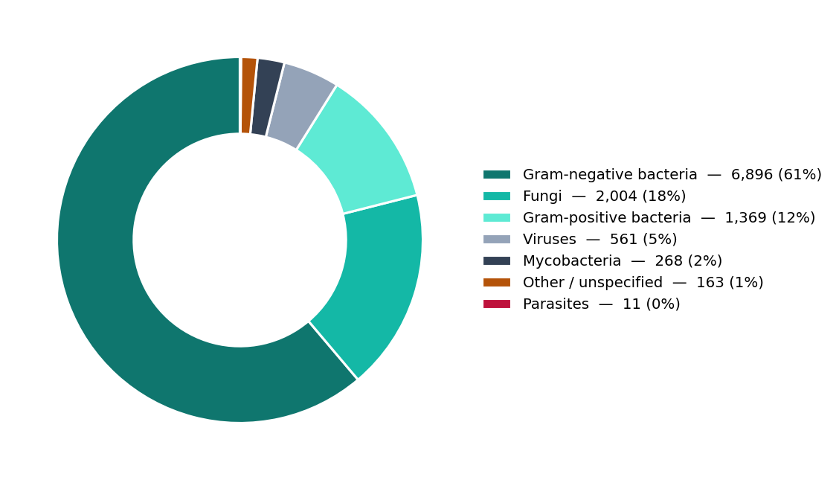
Figure 4.1 Distribution of culture-positive samples by microbiological category. A sample yielding organisms from more than one category is counted in each.

4.3 Specimen distribution
Culture-positive samples were drawn from 30 distinct specimen categories. Urine and blood were by far the most frequent specimen types, together accounting for approximately half of all samples, followed by respiratory specimens and wound- and abscess-related specimens (Figure 4.2, Table 4.2). This distribution reflects the clinical importance of urinary-tract and bloodstream infection in the hospital population, together with a substantial respiratory contribution consistent with the intensive-care case-mix.
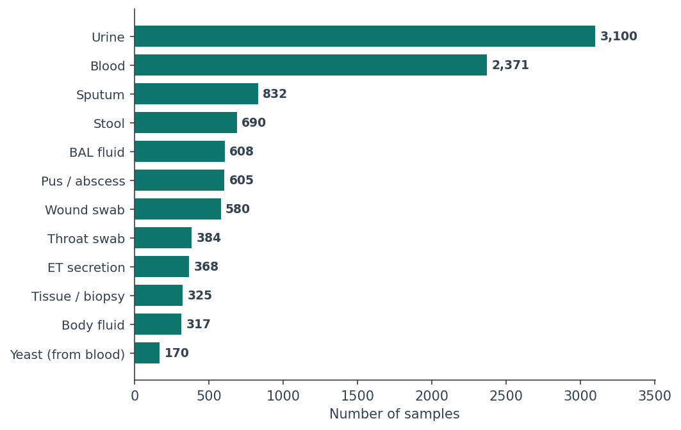
Figure 4.2 Distribution of culture-positive samples by specimen type (leading categories).
Table 4.2 Specimen-type distribution.
Specimen type | Samples | % of samples
Urine | 3,100 | 28.3%
Blood | 2,371 | 21.7%
Sputum | 832 | 7.6%
Stool | 690 | 6.3%
BAL fluid | 608 | 5.6%
Pus / abscess | 605 | 5.5%
Wound swab | 580 | 5.3%
Throat swab | 384 | 3.5%
ET secretion | 368 | 3.4%
Tissue / biopsy | 325 | 3%
Body fluid | 317 | 2.9%
Yeast (from blood) | 170 | 1.6%
Yeast (from urine) | 131 | 1.2%
Device / catheter tip | 107 | 1%
CSF | 101 | 0.9%

4.4 Organism profile
A total of 134 distinct organisms were identified. Klebsiella pneumoniae and Escherichia coli were the two leading pathogens, together constituting a substantial fraction of all isolates, followed by non-albicans Candida, Pseudomonas aeruginosa, and Acinetobacter species (Figure 4.3, Table 4.3). The prominence of non-albicans Candida among the leading organisms confirms the significant fungal burden noted in Section 4.2. Also present were organisms of wider public-health significance, including influenza viruses, Mycobacterium tuberculosis, and typhoidal Salmonella.
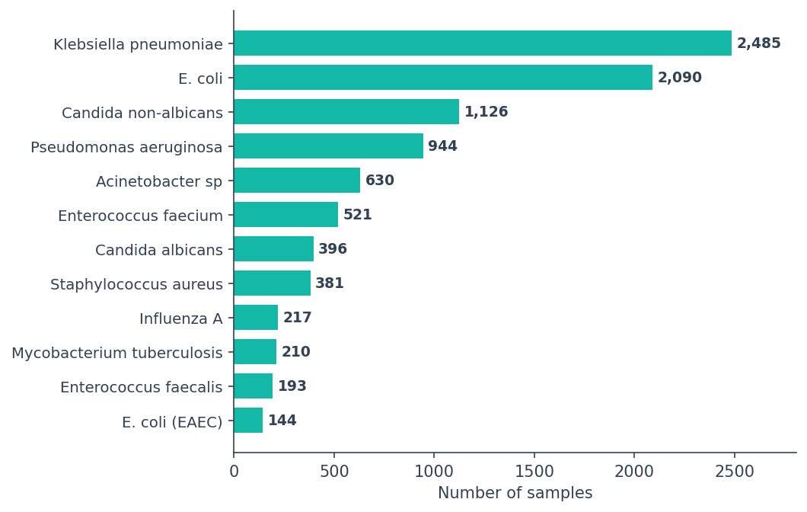
Figure 4.3 Leading organisms by number of positive samples.
Table 4.3 Organism distribution (top 20).
Organism | Samples | % of samples
Klebsiella pneumoniae | 2,485 | 22.7%
E. coli | 2,090 | 19.1%
Candida non-albicans | 1,126 | 10.3%
Pseudomonas aeruginosa | 944 | 8.6%
Acinetobacter sp | 630 | 5.8%
Enterococcus faecium | 521 | 4.8%
Candida albicans | 396 | 3.6%
Staphylococcus aureus | 381 | 3.5%
Influenza A | 217 | 2%
Mycobacterium tuberculosis | 210 | 1.9%
Enterococcus faecalis | 193 | 1.8%
E. coli (EAEC) | 144 | 1.3%
Salmonella Typhi | 139 | 1.3%
E. coli (EPEC) | 127 | 1.2%
Salmonella Sp | 124 | 1.1%
Proteus mirabilis | 122 | 1.1%
Clostridium difficile | 117 | 1.1%
Candida auris | 111 | 1%
Aspergillus fumigatus | 105 | 1%
Adenovirus | 91 | 0.8%

4.5 Distribution by hospital unit
Samples originated from 52 mapped hospital units (a further group of records could not be mapped to a named unit and is excluded from unit-level analyses). Table 4.4 and Figure 4.4 present the highest-volume units. General wards contributed the largest absolute numbers of samples by virtue of their size, while the intensive-care and high-dependency units, though smaller, accounted for a disproportionate share of infection relative to their capacity — a pattern examined in detail in the analysis of healthcare-associated infection (Section 4.8).
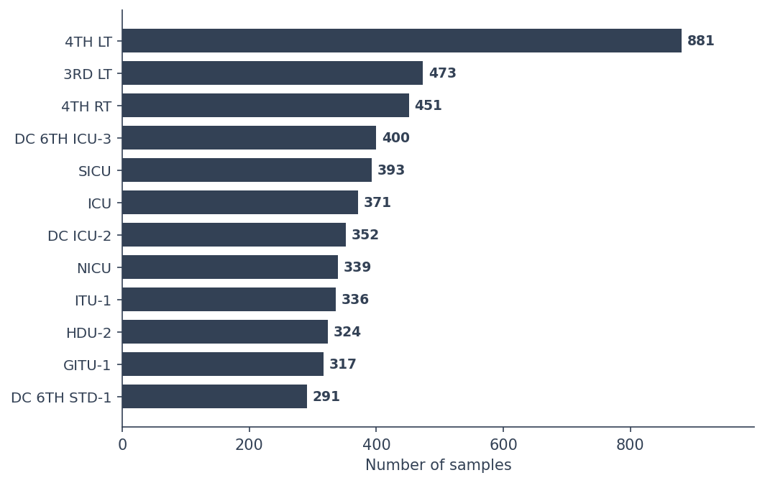
Figure 4.4 Distribution of samples by hospital unit (highest-volume units).
Table 4.4 Distribution by hospital unit (top 20).
Unit | Samples | % of samples
4TH LT | 881 | 8.1%
3RD LT | 473 | 4.3%
4TH RT | 451 | 4.1%
DC 6TH ICU-3 | 400 | 3.7%
SICU | 393 | 3.6%
ICU | 371 | 3.4%
DC ICU-2 | 352 | 3.2%
NICU | 339 | 3.1%
ITU-1 | 336 | 3.1%
HDU-2 | 324 | 3%
GITU-1 | 317 | 2.9%
DC 6TH STD-1 | 291 | 2.7%
DC ICU-1 | 287 | 2.6%
PSW | 284 | 2.6%
ITU-2 | 269 | 2.5%
HDI-1 | 268 | 2.4%
TRACHEOSTOMY WARD - 5TH FLOOR | 259 | 2.4%
ONCO ICU | 255 | 2.3%
DCCP HDU | 247 | 2.3%
2ND STANDARD | 224 | 2%

4.6 Cross-tabulation of unit, specimen and organism
To examine the relationships between the three principal categorical dimensions, cross-tabulations were constructed showing, for each unit and specimen, its most frequent associated categories. Tables 4.5 to 4.7 summarise these relationships for the highest-volume units and specimens; the complete cross-tabulations are provided in the Appendix.
Table 4.5 Predominant specimen types by unit (top 15 units).
Unit | Most common (n) | 2nd (n) | 3rd (n) | Total
4TH LT | Urine (289) | Blood (163) | Pus / abscess (86) | 881
3RD LT | Urine (149) | Blood (77) | Pus / abscess (55) | 472
4TH RT | Urine (127) | Blood (71) | Wound swab (53) | 448
DC 6TH ICU-3 | Urine (139) | Blood (109) | Stool (31) | 399
SICU | Blood (122) | Urine (88) | Tissue / biopsy (29) | 392
ICU | Blood (126) | Urine (98) | BAL fluid (31) | 371
DC ICU-2 | Blood (119) | Urine (96) | BAL fluid (48) | 352
NICU | Sputum (119) | Urine (61) | Blood (54) | 335
ITU-1 | Urine (93) | Blood (75) | BAL fluid (60) | 335
HDU-2 | Urine (120) | Blood (67) | Sputum (26) | 322
GITU-1 | Blood (92) | Urine (88) | Body fluid (25) | 317
DC 6TH STD-1 | Urine (69) | Blood (62) | Pus / abscess (28) | 290
DC ICU-1 | Urine (100) | Blood (68) | BAL fluid (26) | 285
PSW | Blood (60) | Throat swab (55) | Stool (47) | 284
ITU-2 | Blood (86) | Urine (66) | BAL fluid (46) | 269
Within each unit, the specimen mix reflects its clinical function — for example, respiratory specimens predominate in ventilated intensive-care patients, whereas urine and blood dominate in general wards (Table 4.5). At the specimen level, the organism profile is likewise characteristic: urinary and bloodstream specimens are led by the Enterobacterales and Candida, while respiratory specimens are dominated by the Gram-negative non-fermenters (Table 4.6).
Table 4.6 Predominant organisms by specimen type (top 15 specimens).
Specimen | Most common (n) | 2nd (n) | 3rd (n) | Total
Urine | E. coli (964) | Klebsiella pneumoniae (752) | Candida non-albicans (723) | 3097
Blood | E. coli (495) | Klebsiella pneumoniae (385) | Candida non-albicans (311) | 2371
Sputum | Klebsiella pneumoniae (341) | Pseudomonas aeruginosa (204) | Acinetobacter sp (175) | 832
Stool | E. coli (EAEC) (144) | E. coli (EPEC) (126) | Clostridium difficile (117) | 687
BAL fluid | Klebsiella pneumoniae (185) | Mycobacterium tuberculosis (93) | Pseudomonas aeruginosa (87) | 608
Pus / abscess | E. coli (192) | Klebsiella pneumoniae (173) | Staphylococcus aureus (98) | 597
Wound swab | Klebsiella pneumoniae (192) | Pseudomonas aeruginosa (128) | E. coli (83) | 568
Throat swab | Influenza A (194) | Adenovirus (80) | Rhinovirus/Enterovirus (47) | 383
ET secretion | Klebsiella pneumoniae (139) | Pseudomonas aeruginosa (103) | Acinetobacter sp (66) | 365
Body fluid | Klebsiella pneumoniae (138) | E. coli (77) | Enterococcus faecium (41) | 317
Tissue / biopsy | Klebsiella pneumoniae (73) | Mycobacterium tuberculosis (58) | E. coli (46) | 315
Yeast (from blood) | Candida auris (75) | Candida parapsilosis (23) | Candida albicans (22) | 170
Yeast (from urine) | Candida tropicalis (59) | Candida auris (28) | Candida albicans (22) | 131
Device / catheter tip | Enterococcus faecium (23) | Staph. (coag.-negative) (22) | Klebsiella pneumoniae (18) | 107
CSF | Human Herpes Virus 6 (Hhv-6) (22) | Streptococcus Pneumoniae (17) | Mycobacterium tuberculosis (15) | 101
Table 4.7 Predominant organisms by unit (top 15 units).
Unit | Most common (n) | 2nd (n) | 3rd (n) | Total
4TH LT | E. coli (268) | Klebsiella pneumoniae (217) | Pseudomonas aeruginosa (76) | 876
3RD LT | E. coli (120) | Klebsiella pneumoniae (86) | Staphylococcus aureus (35) | 472
4TH RT | E. coli (111) | Klebsiella pneumoniae (103) | Pseudomonas aeruginosa (33) | 439
DC 6TH ICU-3 | E. coli (81) | Klebsiella pneumoniae (78) | Candida non-albicans (56) | 400
SICU | Candida non-albicans (66) | E. coli (53) | Klebsiella pneumoniae (52) | 391
ICU | Candida non-albicans (95) | Klebsiella pneumoniae (70) | E. coli (37) | 371
DC ICU-2 | Klebsiella pneumoniae (70) | Candida non-albicans (53) | Pseudomonas aeruginosa (48) | 350
NICU | Klebsiella pneumoniae (122) | Acinetobacter sp (55) | Pseudomonas aeruginosa (50) | 338
ITU-1 | Klebsiella pneumoniae (65) | Candida non-albicans (52) | E. coli (35) | 336
HDU-2 | Klebsiella pneumoniae (73) | E. coli (57) | Candida non-albicans (45) | 323
GITU-1 | Klebsiella pneumoniae (74) | Candida non-albicans (67) | E. coli (40) | 317
DC 6TH STD-1 | Klebsiella pneumoniae (80) | E. coli (64) | Candida non-albicans (28) | 291
DC ICU-1 | Candida non-albicans (69) | Klebsiella pneumoniae (50) | E. coli (27) | 287
PSW | E. coli (46) | Salmonella Typhi (31) | Staphylococcus aureus (29) | 282
ITU-2 | Klebsiella pneumoniae (72) | E. coli (40) | Candida non-albicans (32) | 269

4.7 Antimicrobial-resistance profile
Overall, 4,325 samples (39.5%) carried an organism with a recognised resistance mechanism. The distribution across mechanisms is shown in Figure 4.5 and Table 4.8. Carbapenem-resistant Enterobacterales (CRE) constituted the single largest group, which is of particular concern given the last-line status of the carbapenems, followed by ESBL-producing and multidrug-resistant organisms. Vancomycin-resistant enterococci and methicillin-resistant Staphylococcus aureus were present in smaller numbers.
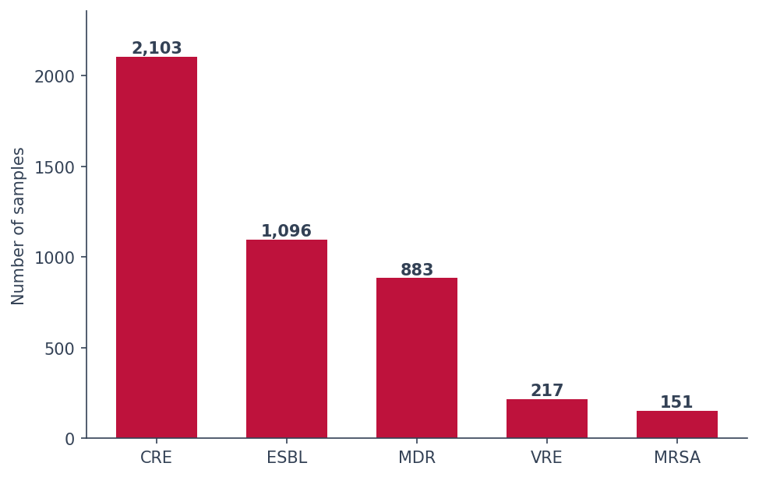
Figure 4.5 Antimicrobial-resistance mechanisms (number of samples).
Table 4.8 Antimicrobial-resistance summary.
Resistance mechanism | Samples | % of all samples
CRE | 2,103 | 19.2%
ESBL | 1,096 | 10%
MDR | 883 | 8.1%
VRE | 217 | 2%
MRSA | 151 | 1.4%

4.8 Healthcare-associated infection
Of all culture-positive samples, 5,116 (46.8%) were classified as healthcare-associated, affecting 2,234 patients; the remainder (52.8%) were of community or outside origin (Figure 4.6). These do not sum to 100% because origin was not recorded for 51 samples (0.5%). Nearly half of culture-positive samples were therefore classified as healthcare-associated — an indicator of considerable importance for infection control. This is the share of positive cultures, not an infection incidence rate.
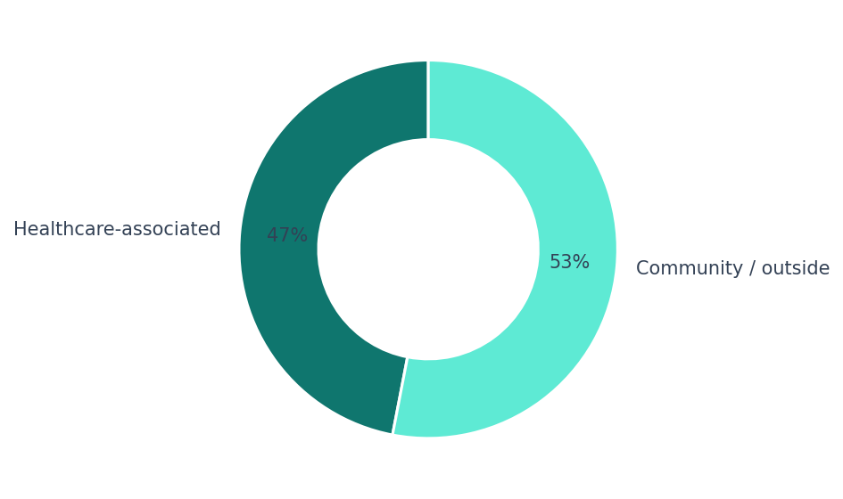
Figure 4.6 Healthcare-associated versus community-origin infections.
The distribution of HAI across units is highly uneven (Figure 4.7, Table 4.9). When expressed as the proportion of a unit’s own culture-positive samples that were healthcare-associated, the intensive-care and high-dependency units stand out markedly, with several exceeding 70–80% — far above the hospital average. This concentration identifies the units in which infection-control effort is likely to yield the greatest return, and provides the motivation for the formal statistical analysis of unit-level risk in the following chapter.
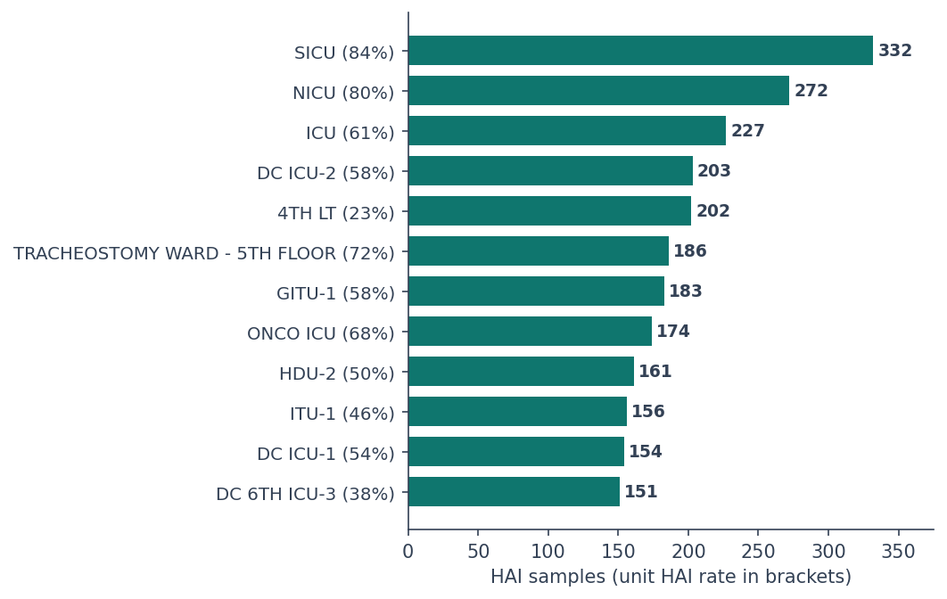
Figure 4.7 Healthcare-associated infections by unit (leading units; unit HAI rate shown in brackets).
Table 4.9 Healthcare-associated infection by unit (top 15 by HAI count).
Unit | HAI samples | Total samples | HAI rate
SICU | 332 | 393 | 84%
NICU | 272 | 339 | 80%
ICU | 227 | 371 | 61%
DC ICU-2 | 203 | 352 | 58%
4TH LT | 202 | 881 | 23%
TRACHEOSTOMY WARD - 5TH FLOOR | 186 | 259 | 72%
GITU-1 | 183 | 317 | 58%
ONCO ICU | 174 | 255 | 68%
HDU-2 | 161 | 324 | 50%
ITU-1 | 156 | 336 | 46%
DC ICU-1 | 154 | 287 | 54%
DC 6TH ICU-3 | 151 | 400 | 38%
OPD | 137 | 162 | 85%
ICU EXT | 136 | 209 | 65%
HDI-1 | 133 | 268 | 50%

4.9 Temporal patterns
Monthly culture-positive volume was broadly stable across the study period, indicating consistent sampling (Figure 4.8). The healthcare-associated proportion fluctuated from month to month within a band, and displayed an overall tendency to decline towards the end of the period. Whether this apparent decline represents a genuine, statistically significant trend — as opposed to ordinary month-to-month variation — is a question that descriptive inspection cannot settle, and it is addressed formally using trend testing and statistical process control in the subsequent chapter. The most recent months should be interpreted with some caution, as late-arriving results may render them incomplete.
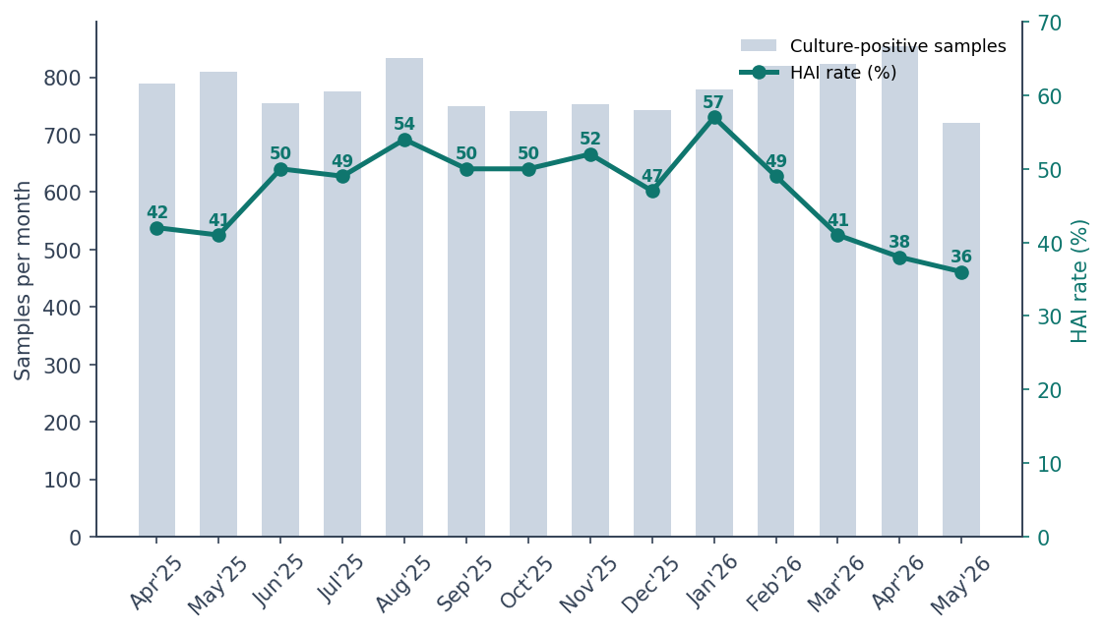
Figure 4.8 Monthly culture-positive volume (bars) and healthcare-associated infection rate (line).

4.10 Summary of descriptive findings
In summary, the descriptive analysis reveals an infection landscape dominated by Gram-negative bacteria, principally Klebsiella pneumoniae and Escherichia coli, together with a substantial and clinically significant fungal burden. Urine and blood are the predominant specimens, and infection — particularly healthcare-associated infection — is concentrated in the intensive-care and high-dependency units. A considerable proportion of samples carry a resistant organism, most importantly carbapenem-resistant Enterobacterales. These descriptive observations raise several questions that tabulation alone cannot answer — in particular, whether the apparent unit-level differences and temporal trends are statistically robust, and what factors are independently associated with resistance. These questions are taken up in the statistical analysis that follows.

Chapter 5 Results II — Statistical Analysis
This chapter moves beyond description to formal statistical analysis. Section 5.1 examines the unadjusted associations between the principal categorical variables and documented resistance; the adjusted analysis and temporal surveillance follow in subsequent sections.

5.1 Bivariate associations with documented resistance

5.1.1 Analytical population and outcome definition
The analyses in this section were performed on the eligible bacterial population defined in Chapter 3. An organism was considered eligible only where at least one of the resistance phenotypes under study (CRE, ESBL, MDR, VRE, MRSA or MR-CoNS) is a recognised, routinely assigned phenotype for that organism class. This criterion was applied a priori on microbiological grounds, before any examination of the observed resistance data. Fungi, viruses, mycobacteria, parasites, enteric-specific pathogens and organisms for which none of the study phenotypes is defined were therefore excluded from this analysis, although they remain part of the descriptive account in Chapter 4.
The resulting analytical population comprised 8,162 organism-level isolates originating from 7,336 distinct samples, of which 4,491 (55.0%) carried a documented applicable resistance phenotype. Throughout, a phenotype was counted towards the outcome only where it was both recorded in the register and applicable to the organism concerned; incompatible combinations were treated as data-quality anomalies and are reported separately.

5.1.2 Statistical approach
Unadjusted associations between each categorical predictor and the binary resistance outcome were examined using contingency tables and chi-square tests of independence, with Cramér’s V used to quantify the strength of association. The minimum expected cell count exceeded five in every contingency table constructed, so the chi-square approximation was valid throughout and Fisher’s exact test was not required. Because a single sample may yield more than one isolate, these observations are not fully independent and the independence assumption is only approximately satisfied; the bivariate results are therefore treated as exploratory and serve to motivate the multivariable model in Section 5.2, in which clustering by sample is formally accounted for through cluster-robust standard errors. This matters because the dataset is large. With thousands of isolates, almost any difference becomes statistically significant, even one too small to be of practical use. A p-value tells you whether a difference is real; the effect size tells you whether it is big enough to matter. Both are reported throughout. Because four tests were run, a Holm–Bonferroni correction was applied, which guards against finding a false positive by chance when running several tests.

5.1.3 Resistance by organism group
Documented resistance varied markedly across organism groups (Figure 5.1, Table 5.1). Acinetobacter species (79.8%) and Klebsiella pneumoniae (77.8%) exhibited the highest proportions, followed by Escherichia coli (60.0%). At the opposite extreme, the residual enterococci (1.4%) and coagulase-negative staphylococci (6.6%) showed very low proportions. The association was highly significant and, importantly, of moderate magnitude (χ² = 1,824.97, df = 9, p < 0.001, Cramér’s V = 0.473) — by a considerable margin the strongest association observed in this analysis.
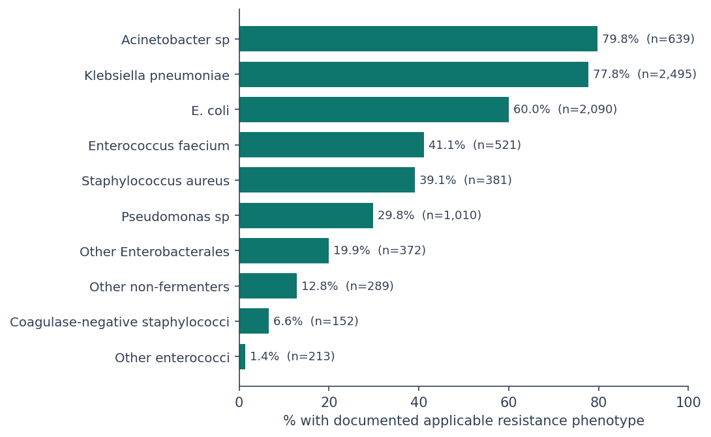
Figure 5.1 Proportion of isolates with a documented applicable resistance phenotype, by organism group.

5.1.4 Resistance by specimen type
Resistance also differed by specimen type (Figure 5.2), being highest in urine (63.6%) and in respiratory specimens — sputum (62.0%) and bronchoalveolar lavage fluid (61.9%) — and lowest in pus and abscess samples (42.1%) and wound swabs (46.4%). Although statistically significant, the association was of small magnitude (χ² = 179.87, df = 6, p < 0.001, Cramér’s V = 0.149), and is plausibly explained in part by differences in the organism mix isolated from each specimen type rather than by the specimen itself.
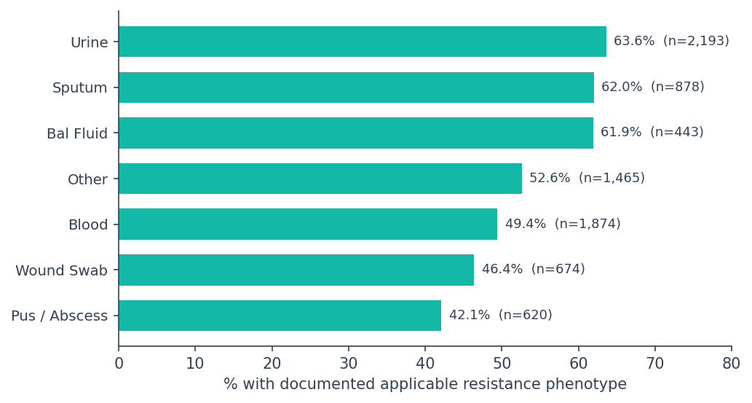
Figure 5.2 Proportion of isolates with a documented applicable resistance phenotype, by specimen type.

5.1.5 Resistance by hospital unit type and infection origin
Isolates from critical-care areas showed a slightly higher proportion of documented resistance than those from general wards (57.3% versus 52.9%). The association reached statistical significance (χ² = 15.61, df = 1, p < 0.001) but the effect size was negligible (Cramér’s V = 0.044). This is a substantively important observation: it indicates that the resistance burden was distributed broadly across the institution rather than being concentrated in intensive care, and it carries the implication that antimicrobial stewardship should be pursued hospital-wide rather than as a critical-care-specific intervention.
A similar pattern was observed for infection origin. Healthcare-associated isolates carried documented resistance more often than those of community or outside origin (59.9% versus 50.9%; χ² = 65.33, df = 1, p < 0.001), but again the effect size was negligible (Cramér’s V = 0.089).

5.1.6 Comparison of effect sizes
All four associations were statistically significant (Table 5.1). How much they matter, however, differs sharply (Figure 5.3). Organism group had a moderate effect (V = 0.473). Specimen type had a small one (V = 0.149). Unit type (0.044) and HAI status (0.089) were negligible. This is the clearest illustration of why effect sizes belong next to p-values: with over eight thousand isolates, a four-point difference between critical care and general wards reaches p < 0.001 while explaining almost none of the variation in resistance.
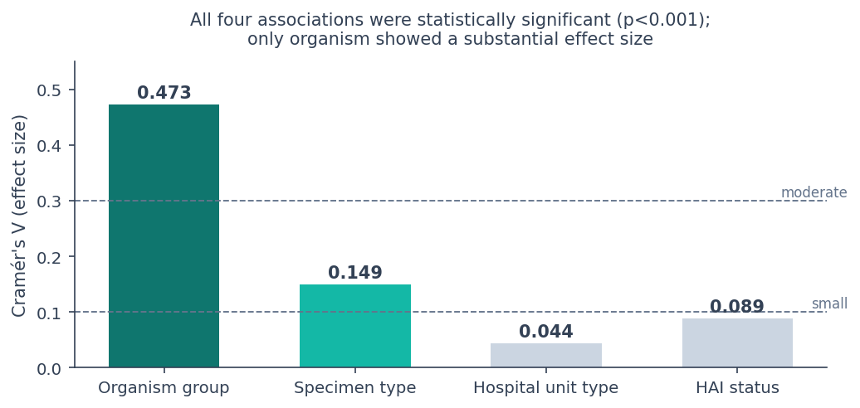
Figure 5.3 Effect sizes (Cramér’s V) for the four associations tested.

Table 5.1 Chi-square tests of association with documented applicable resistance phenotype.
Variable | Categories | n | χ² | df | p (Holm) | Cramér’s V | Strength
Organism group | 10 | 8,162 | 1,824.97 | 9 | <0.001 | 0.473 | Moderate
Specimen type | 7 | 8,147 | 179.87 | 6 | <0.001 | 0.149 | Small
HAI status | 2 | 8,162 | 65.33 | 1 | <0.001 | 0.089 | Negligible
Hospital unit type | 2 | 8,162 | 15.61 | 1 | <0.001 | 0.044 | Negligible

5.1.7 Sensitivity analysis for clustering within samples
Because 764 samples (10.4% of the eligible total) yielded more than one isolate, accounting for 1,590 isolates (19.5%), the independence assumption underlying the chi-square analysis is only approximately satisfied. The intraclass correlation of the outcome within samples was estimated at 0.18, which — given a mean cluster size of 1.11 — corresponds to a design effect of approximately 1.02 and an effective sample size of about 7,997 rather than 8,162.
As a sensitivity analysis, a single isolate was selected at random from each sample and the four associations were recalculated; this procedure was repeated 200 times. The resulting effect sizes were highly stable (organism group, mean Cramér’s V = 0.473; specimen type, 0.148; HAI status, 0.094; unit type, 0.048), and all four associations remained statistically significant in every one of the 200 replicates. The chi-square statistics were modestly smaller than in the full dataset, as expected when clustered observations are removed. These findings do not demonstrate that the dependence is immaterial, but they indicate that the substantive conclusions are robust to it. The bivariate results are nevertheless interpreted as exploratory, with formal inference deferred to the multivariable model of Section 5.2, in which clustering by sample is addressed directly through cluster-robust standard errors.
Table 5.2 Sensitivity analysis: effect sizes in the full dataset and under random selection of one isolate per sample (200 replicates).
Variable | Cramér’s V (full) | Cramér’s V (one per sample, mean) | Replicates significant
Organism group | 0.473 | 0.473 | 200/200
Specimen type | 0.149 | 0.148 | 200/200
HAI status | 0.089 | 0.094 | 200/200
Hospital unit type | 0.044 | 0.048 | 200/200

5.1.8 Interpretation and limitations of the bivariate analysis
Taken together, these results indicate that the organism itself is by far the strongest correlate of documented resistance, while the ward of origin contributes very little once magnitude rather than significance is considered. Two caveats apply. First, these are unadjusted associations: because organism distribution varies by specimen type and by unit, the apparent effects of specimen and unit may partly reflect the underlying organism mix. Disentangling these requires the multivariable analysis presented in the next section. Second, isolates recovered from the same sample are not fully independent observations; this clustering is accounted for in the regression through cluster-robust standard errors.

5.2 Multivariable logistic regression
Section 5.1 showed that the organism matters far more than anything else. But it could not answer a further question: do specimen type, unit and infection origin matter in their own right, or do they only appear to matter because different organisms are found in different places? Testing one factor at a time cannot separate these. This section uses logistic regression, which looks at all four factors together, and then checks how well the model estimates resistance for isolates it has not seen before.

5.2.1 Model specification and rationale
The outcome is yes or no: does this isolate have a documented applicable resistance phenotype? Because the answer is binary, logistic regression is the right model. Ordinary linear regression would be wrong here, since it could predict values below 0 or above 1, which make no sense for a yes/no outcome. The model uses four predictors: organism group, specimen type, unit type and infection origin. Each predictor needs a baseline category to compare against. We used E. coli for organism, urine for specimen, general ward for unit, and community origin for infection source. Every odds ratio below therefore means “compared with that baseline, holding the other three factors constant”.
One sample can yield more than one isolate, so the observations are not fully independent. To allow for this, the standard errors were calculated using a cluster-robust method, grouping isolates by their sample. This stops the model treating two organisms from the same specimen as though they were two unrelated cases.

5.2.2 Model diagnostics
Three checks were run before fitting the model, each testing a way the model could fail. The first looked for separation, which happens when a category is 0% or 100% resistant and makes the model impossible to fit; none was found, with organism groups ranging from 1.4% to 79.8%. The second checked whether there were enough resistant cases to support the number of predictors: the ratio was 264 events per parameter, far above the usual minimum of ten. The third checked whether any predictors overlapped so heavily that their effects could not be separated, using variance inflation factors; the highest was 4.77, below the usual threshold of five. All three checks passed, so the model can be fitted and read with confidence.
A comparison of naive and cluster-robust standard errors showed negligible differences in confidence-interval width, consistent with the small design effect reported in Section 5.1.7. The clustering correction was nevertheless retained as the methodologically appropriate specification.

5.2.3 Adjusted associations
The fitted model comprised 8,147 isolates from 7,322 samples (McFadden pseudo-R² = 0.197; likelihood-ratio test p < 0.001). All seventeen coefficients reached statistical significance. The adjusted odds ratios are presented in Figure 5.4 and Table 5.3.
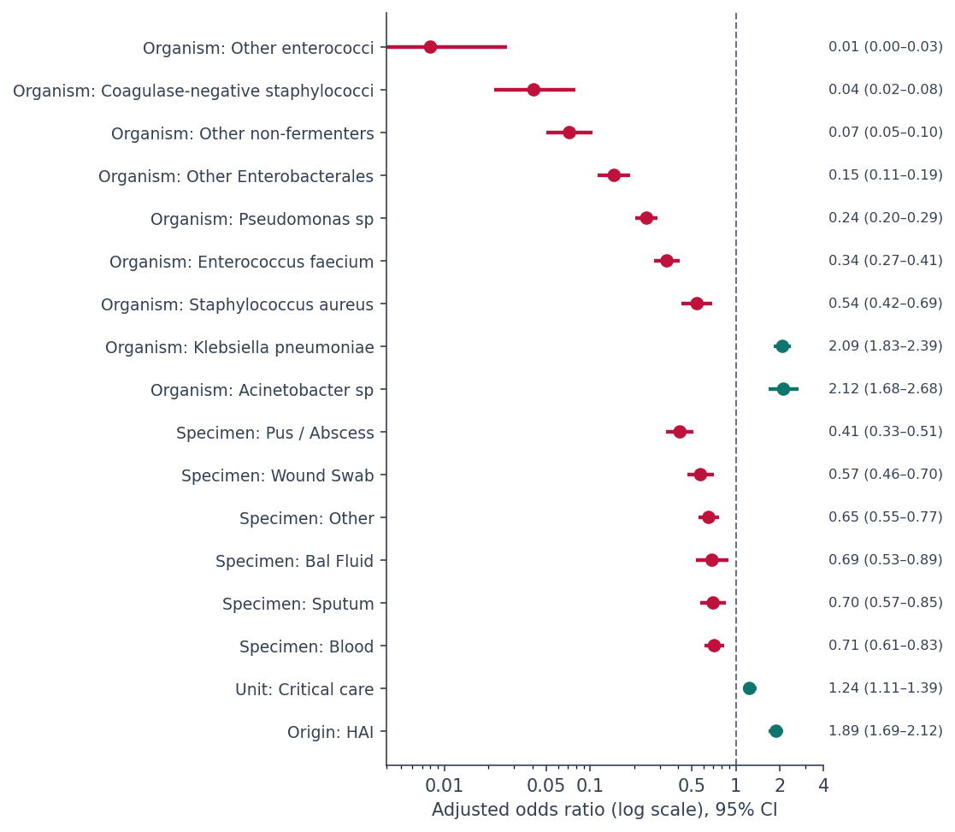
Figure 5.4 Adjusted odds ratios with 95% confidence intervals (cluster-robust), plotted on a logarithmic scale. The reference categories are E. coli, urine, general ward and community origin.
The organism mattered most by a wide margin. Compared with E. coli, the odds of documented resistance were about twice as high for Acinetobacter species (adjusted OR 2.12, 95% CI 1.68–2.68) and Klebsiella pneumoniae (2.09, 1.83–2.39). They were much lower for Pseudomonas species (0.24), other Enterobacterales (0.15), other non-fermenters (0.07), coagulase-negative staphylococci (0.04) and the remaining enterococci (0.01). These estimates range from 0.01 to 2.12, a spread far wider than any other predictor produced. Which organism it is remains the factor most strongly associated with whether resistance is documented.
Specimen type still mattered, though much less. Compared with urine, every other specimen had lower odds of resistance, from 0.41 for pus and abscess samples to 0.71 for blood. Because these effects survive adjustment for organism, specimen type does carry some information of its own — but the effects are small next to the organism effects.
Two results are worth dwelling on. Infection origin remained strongly associated with resistance even after adjustment: healthcare-associated isolates had 1.89 times the odds of documented resistance compared with those from the community (95% CI 1.69–2.12). Unit type also stayed significant, but its effect was much smaller (1.24, 1.11–1.39). The contrast between the two is the interesting part. Where the patient was treated matters far less than how the infection was acquired. An infection picked up during care is more likely to be resistant, and this holds whether it happened in intensive care or on a general ward.

Table 5.3 Adjusted odds ratios for documented applicable resistance phenotype (cluster-robust 95% confidence intervals).
Predictor (reference) | Adjusted OR | 95% CI | p
Acinetobacter sp (vs E. coli) | 2.12 | 1.68 – 2.68 | <0.001
Klebsiella pneumoniae (vs E. coli) | 2.09 | 1.83 – 2.39 | <0.001
Staphylococcus aureus (vs E. coli) | 0.54 | 0.42 – 0.69 | <0.001
Enterococcus faecium (vs E. coli) | 0.34 | 0.27 – 0.41 | <0.001
Pseudomonas sp (vs E. coli) | 0.24 | 0.20 – 0.29 | <0.001
Other Enterobacterales (vs E. coli) | 0.15 | 0.11 – 0.19 | <0.001
Other non-fermenters (vs E. coli) | 0.07 | 0.05 – 0.10 | <0.001
Coagulase-negative staphylococci (vs E. coli) | 0.04 | 0.02 – 0.08 | <0.001
Other enterococci (vs E. coli) | 0.01 | 0.00 – 0.03 | <0.001
Blood (vs urine) | 0.71 | 0.61 – 0.83 | <0.001
Sputum (vs urine) | 0.70 | 0.57 – 0.85 | <0.001
BAL fluid (vs urine) | 0.69 | 0.53 – 0.89 | 0.004
Other specimen (vs urine) | 0.65 | 0.55 – 0.77 | <0.001
Wound swab (vs urine) | 0.57 | 0.46 – 0.70 | <0.001
Pus / abscess (vs urine) | 0.41 | 0.33 – 0.51 | <0.001
Critical care (vs general ward) | 1.24 | 1.11 – 1.39 | <0.001
Healthcare-associated (vs community) | 1.89 | 1.69 – 2.12 | <0.001

5.2.4 Predictive performance
The same model was then tested as a prediction tool. The data were split into two parts: 75% to build the model and 25% held back to test it. Crucially, the split was made by sample rather than by isolate, so that all organisms from one specimen stayed together on the same side. Splitting by isolate would let the model see part of a specimen while training and then be tested on the rest of it, which would flatter its performance. The training set had 6,115 isolates from 5,491 samples and the test set 2,032 isolates from 1,831 samples, with no sample appearing in both.
On the held-back data the model achieved an AUC of 0.778 (Figure 5.5). AUC measures how well the model separates resistant from non-resistant isolates: 0.5 would be a coin flip and 1.0 would be perfect, so 0.778 is moderate. The Brier score, which measures the accuracy of the predicted probabilities, was 0.190 against 0.25 for a model carrying no information. Repeating the exercise five times with different held-back portions gave a mean AUC of 0.781 with very little variation (SD 0.009), so the result is not an accident of one lucky split.
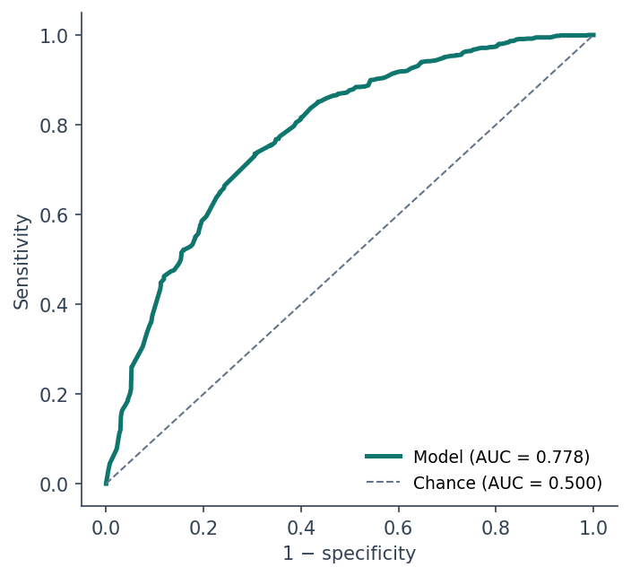
Figure 5.5 Receiver operating characteristic curve for the held-out test partition.
Table 5.4 presents classification performance across a range of probability thresholds. At the conventional cut-off of 0.5 the model achieved 81.6% sensitivity and 60.0% specificity, with an overall accuracy of 71.9%. It should be emphasised that 0.5 is a conventional rather than a clinically optimised threshold; the appropriate operating point would depend on the relative cost of failing to identify a resistant isolate against that of over-calling resistance, and is presented here for descriptive purposes only.
Table 5.4 Classification performance across probability thresholds (held-out test partition).
Threshold | Sensitivity | Specificity | PPV | Accuracy
0.30 | 0.940 | 0.353 | 0.638 | 0.675
0.40 | 0.879 | 0.493 | 0.678 | 0.705
0.50 | 0.816 | 0.600 | 0.712 | 0.719
0.60 | 0.735 | 0.695 | 0.745 | 0.717
0.70 | 0.557 | 0.812 | 0.782 | 0.672
Calibration was assessed by dividing the test partition into deciles of predicted probability and comparing the mean predicted probability with the observed proportion resistant in each decile (Figure 5.6). Predicted and observed values corresponded closely across the range, indicating reasonably good calibration: the estimated probabilities are meaningful in absolute terms and not merely useful for ranking. Calibration was assessed graphically by decile rather than by a formal calibration slope and intercept, so this should be read as an informal assessment.
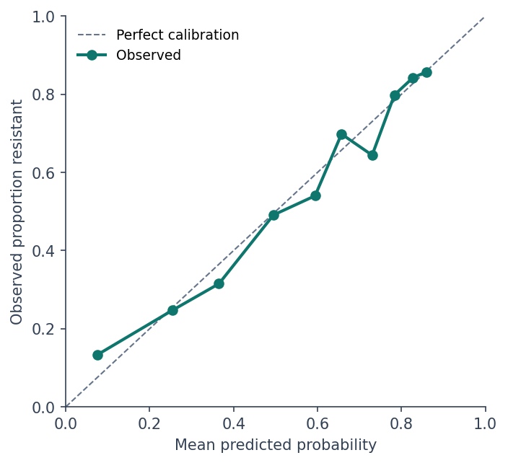
Figure 5.6 Calibration plot: mean predicted probability against observed proportion resistant, by decile of predicted risk.

5.2.5 Interpretation and limitations
The model provides two distinct contributions. As an inferential tool it establishes that organism identity was the factor most strongly associated with documented resistance, that healthcare-associated origin carries a substantial independent association, and that unit type contributes only modestly once organism and specimen are taken into account. As a predictive tool it discriminates moderately well (AUC ≈ 0.78) and showed reasonably good calibration, indicating that the routinely available characteristics of an isolate carry appreciable information about the probability of documented resistance.
Several limitations qualify these findings. The pseudo-R² of 0.197 indicates that the model explains only a modest share of the variation, which is unsurprising given the absence of patient-level covariates such as prior antimicrobial exposure, device use, length of stay and comorbidity — variables not recorded in the register. The analysis is retrospective and observational, so the associations reported should not be interpreted causally; the language of association is used throughout. The outcome measures documented resistance phenotypes rather than laboratory-confirmed susceptibility, and the model is internally validated only. It should therefore be regarded as an exploratory analytical model rather than a validated clinical decision tool, and external validation on an independent dataset would be required before any clinical application.
Sections 5.1 and 5.2 have examined which factors are associated with resistance at a point in time. The remaining question is whether the burden of infection changed over the fourteen months of the study, and that is addressed next.

5.3 Temporal surveillance: statistical process control
The preceding sections examined which factors are associated with resistance. This section addresses a different question: whether the burden of healthcare-associated infection changed over the fourteen-month study period, and whether any observed movement represents a genuine shift or merely the random variation inherent in any monitored process.

5.3.1 The monitored statistic
The statistic monitored was the monthly proportion of culture-positive samples classified as healthcare-associated. The unit of analysis is the distinct sample rather than the isolate; HAI status was verified to be identical across all isolates originating from a given sample, so this aggregation is exact. All 10,943 culture-positive samples contribute, not only the bacterial subset used for the regression, since the question concerns the overall infection burden.
It is important to state precisely what this proportion does and does not represent. It is the share of positive cultures attributable to healthcare-associated infection; it is not a hospital-wide HAI incidence rate. A true incidence rate would require a denominator of patient-days or device-days, which the register does not contain. The measure is therefore appropriate for monitoring the composition of the culture-positive population over time, and is interpreted strictly in those terms.

5.3.2 Construction of the control chart
A p-chart was constructed, this being the standard control chart for a monitored proportion. The centre line is the overall proportion across the study period, 46.8% (5,116 of 10,943 samples). Control limits were placed at three standard errors either side of the centre line, following the conventional formulation in which the standard error for month t is the square root of p(1−p)/nₜ.
The number of samples changed each month, from 721 to 854. Since the standard error depends on that count, the control limits are not the same width every month, and they were calculated separately for each one. This is why they appear as a stepped band in Figure 5.7 rather than two straight lines. A month with fewer samples gets wider limits, because its estimate is less certain. If a process is stable, points should almost never fall outside three-sigma limits — so when they do, something has genuinely changed.

5.3.3 Results
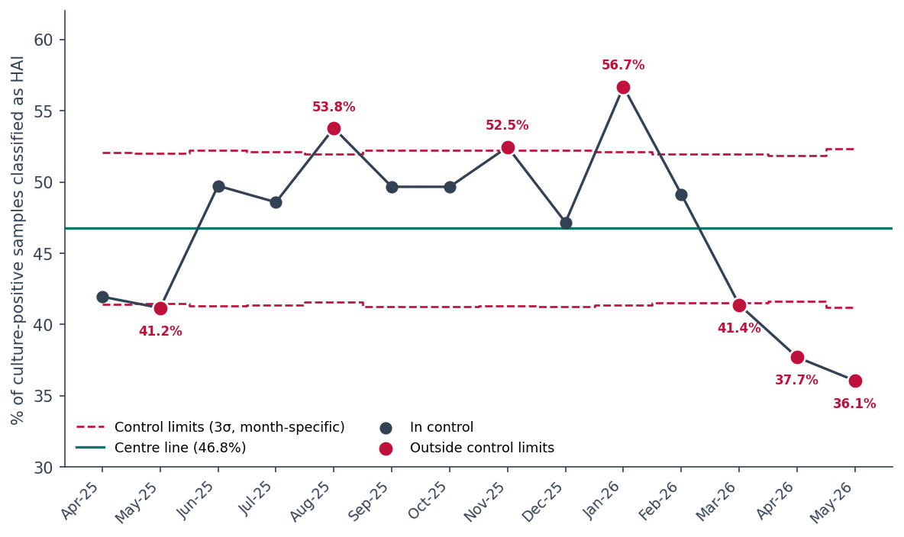
Figure 5.7 p-chart of the monthly proportion of culture-positive samples classified as healthcare-associated, with month-specific three-sigma control limits.
The chart indicates that the process was not in statistical control over the study period. Seven of the fourteen months fell outside the control limits. Three months lay above the upper limit — August 2025 (53.8%), November 2025 (52.5%) and January 2026 (56.7%) — and four fell below the lower limit: May 2025 (41.2%), March 2026 (41.4%), April 2026 (37.7%) and May 2026 (36.1%).
In addition to these individual points, a run-based signal was present. The proportion remained above the centre line for nine consecutive months, from June 2025 through February 2026. A run of eight or more consecutive points on one side of the centre line is a recognised indicator of special-cause variation, since such a sequence is very unlikely to arise by chance in a stable process. Taken together with the pattern of the out-of-limit points, this indicates a sustained period of elevated healthcare-associated infection during the middle of the study period, followed by a marked decline in the final quarter.
A Cochran–Armitage test for trend, applied as a supporting analysis across the ordered months, confirmed a statistically significant downward trend over the period as a whole (Z = −3.23, p = 0.001).

Table 5.5 Monthly HAI proportion with month-specific control limits.
Month | Samples | HAI | HAI % | LCL % | UCL % | Signal
Apr-25 | 789 | 331 | 42.0 | 41.4 | 52.1 | —
May-25 | 809 | 333 | 41.2 | 41.5 | 52.0 | Below LCL
Jun-25 | 754 | 375 | 49.7 | 41.3 | 52.2 | —
Jul-25 | 776 | 377 | 48.6 | 41.4 | 52.1 | —
Aug-25 | 833 | 448 | 53.8 | 41.6 | 51.9 | Above UCL
Sep-25 | 749 | 372 | 49.7 | 41.3 | 52.2 | —
Oct-25 | 741 | 368 | 49.7 | 41.3 | 52.3 | —
Nov-25 | 753 | 395 | 52.5 | 41.3 | 52.2 | Above UCL
Dec-25 | 742 | 350 | 47.2 | 41.3 | 52.2 | —
Jan-26 | 778 | 441 | 56.7 | 41.4 | 52.1 | Above UCL
Feb-26 | 820 | 403 | 49.1 | 41.5 | 52.0 | —
Mar-26 | 824 | 341 | 41.4 | 41.5 | 52.0 | Below LCL
Apr-26 | 854 | 322 | 37.7 | 41.6 | 51.9 | Below LCL
May-26 | 721 | 260 | 36.1 | 41.2 | 52.3 | Below LCL

5.3.4 Interpretation and limitations
The usefulness of the chart is that it separates movement worth acting on from movement that is just noise. July, September, October and December 2025, and February 2026, all show visible ups and downs, but every one sits inside the limits and none would justify a response. August and November 2025, January 2026, and the long run above the centre line are different: these are genuine signals and would justify reviewing infection-control practice for that period. In routine use the chart would be updated each month and new points checked against the same limits.
Three limitations apply. First, as noted above, the monitored statistic is a proportion of culture-positive samples and not a population incidence rate; a change may reflect altered sampling or testing practice as well as a genuine change in infection burden. Second, the apparent improvement in the final three months should be interpreted with caution, since late-arriving results may render the most recent months incomplete; confirmation would require a further period of observation. Third, with fourteen monthly observations the series is too short to support formal time-series modelling such as ARIMA or seasonal decomposition, and no attempt was made to apply such methods or to forecast future values; trend testing together with process control is the appropriate analytical depth for a series of this length.
The analysis is now complete. What remains is to make it usable. The following chapter describes the interactive dashboard built for that purpose.

Chapter 6 Results III — Interactive Surveillance Dashboard
The analyses presented in Chapters 4 and 5 characterise the infection and resistance landscape at a fixed point in time. For the findings to support routine practice, however, they must be accessible to the staff who make day-to-day decisions, and must update as new data accrue. This chapter describes the interactive dashboard developed for that purpose. It is presented here as a delivered product rather than as a further set of results; analytical findings already reported are referenced rather than repeated.

6.1 Purpose and intended users
The dashboard was designed to serve three groups. The infection-control team requires unit-level information on where healthcare-associated infection concentrates and whether the pattern is changing. Clinicians and the antimicrobial stewardship committee require organism-level resistance information to inform empirical prescribing policy. Hospital administration requires summary indicators of the overall burden. A single tool serves all three through a common data model, with filtering allowing each user to reach the view relevant to them.

6.2 Data model and derived measures
The dashboard is built on the cleaned register described in Chapter 3, comprising 12,188 organism-level records. Several fields were derived in advance rather than computed within the reporting layer, so that the dashboard and the statistical analysis apply identical definitions: organism class and the associated phenotype-applicability rule, eligibility for the resistance analysis, the documented applicable resistance flag, unit type, and infection origin.
Two features of the data model warrant explanation, as both are potential sources of error. First, because the register holds one record per organism rather than per sample, all sample-level indicators are computed as distinct counts of the sample identifier; a simple row count would report 12,188 rather than the correct 10,943 and would inflate every sample-level figure. Second, every resistance measure is restricted to the eligible bacterial population, since the phenotypes under study are not defined for fungi, viruses or mycobacteria; without this restriction the denominator would be inflated and the resistance rate correspondingly understated.
Measures were implemented in DAX and include sample, patient and isolate counts, healthcare-associated infection counts and rates, eligible and resistant isolate counts, the resistance rate, and counts for each resistance phenotype restricted to the organism class to which it applies. Period-level reference measures were also defined so that monthly values can be displayed against the fourteen-month average.

6.3 Dashboard structure
The dashboard comprises five pages, each addressing a distinct question. A consistent filter panel — unit, specimen, infection origin and month — appears on every page and is synchronised across them, so that a selection made anywhere persists as the user navigates.

6.3.1 Overview
The opening page (Figure 6.1) presents the headline indicators: 10,943 samples from 5,311 patients yielding 12,188 isolates, a healthcare-associated infection rate of 46.8%, and a documented resistance rate of 55.0% among eligible isolates. Beneath these, the monthly HAI rate is plotted against the fourteen-month average, giving immediate visibility of the temporal pattern described in Section 5.3. The remaining visuals summarise the microbiological composition of the register and the distribution of leading organisms and specimen types.
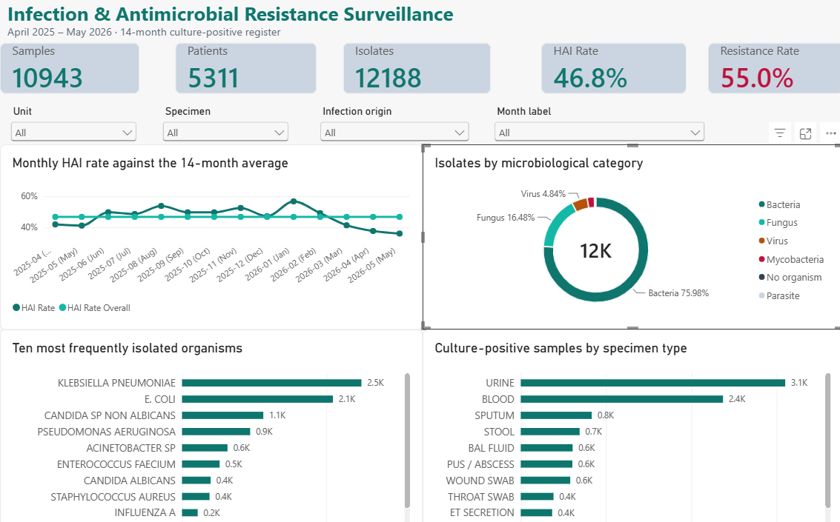
Figure 6.1 Dashboard page 1 — Overview.

6.3.2 Organisms
The second page (Figure 6.2) addresses the organism profile. The principal visual ranks organism groups by documented resistance rate, reproducing in interactive form the finding of Section 5.1.3 that Acinetobacter species and Klebsiella pneumoniae carry the highest resistance burden. It is deliberately paired with a volume chart, since a high rate in a small group and a high rate in a large group carry different operational weight. The supporting matrix gives, for each organism group, the eligible isolate count, resistance rate and phenotype-specific counts, with conditional formatting drawing attention to the highest values.
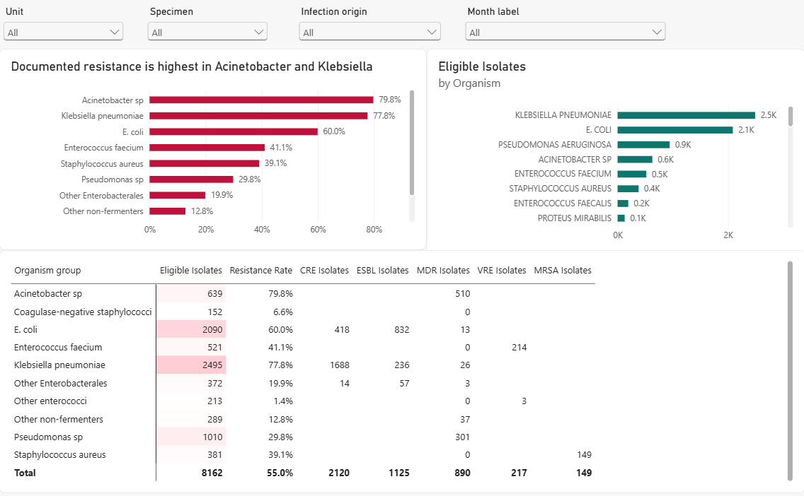
Figure 6.2 Dashboard page 2 — Organisms and resistance profile.

6.3.3 Antimicrobial resistance
The third page (Figure 6.3) presents the resistance mechanisms. Summary indicators report 2,120 CRE, 1,125 ESBL, 890 MDR, 217 VRE, 149 MRSA and 10 MR-CoNS isolates. The accompanying chart shows the distribution of phenotypes across organism groups and makes visible a distinction of direct clinical relevance: Klebsiella pneumoniae is predominantly carbapenem-resistant whereas Escherichia coli is predominantly ESBL-producing, notwithstanding that both belong to the Enterobacterales. Resistance is also displayed by unit and over time.
A minimum-count threshold of forty eligible isolates is applied to the unit-level resistance chart. Without such a threshold, units contributing very few isolates produce extreme percentages that are statistically unreliable but visually dominant; one unit with six eligible isolates would otherwise have appeared at the head of the chart.
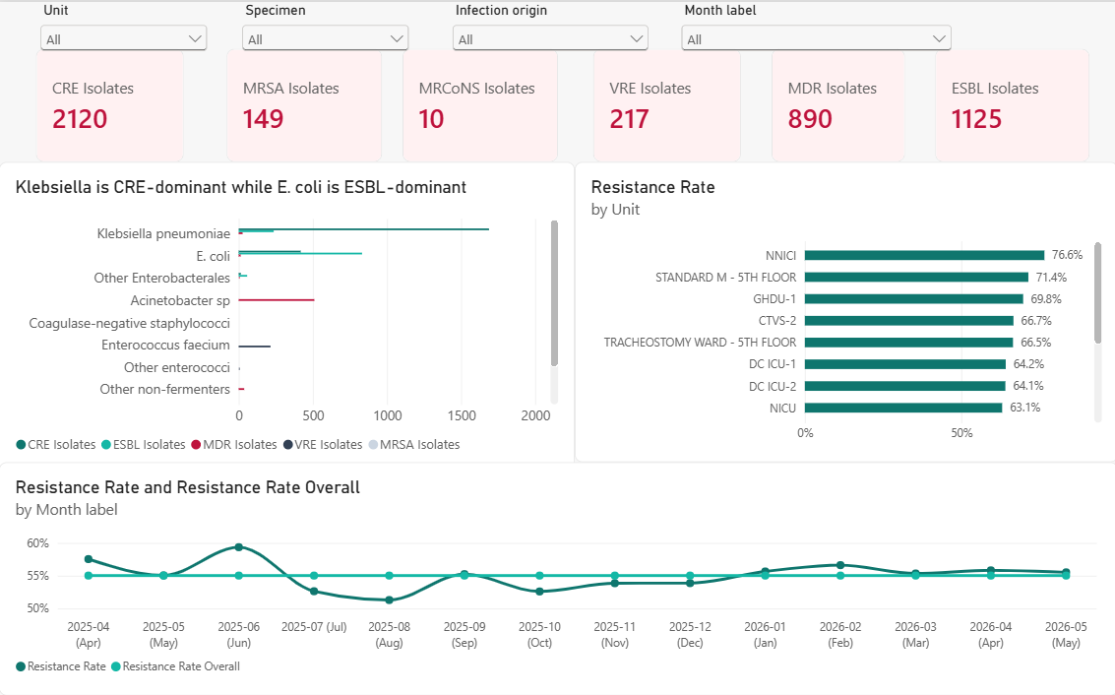
Figure 6.3 Dashboard page 3 — Antimicrobial resistance.

6.3.4 Hospital units
The fourth page (Figure 6.4) addresses the distribution of infection across the hospital. The leading visual contrasts critical care with general wards on two measures simultaneously and conveys one of the principal findings of this study: healthcare-associated infection differs markedly between the two settings (55.8% against 37.7%) whereas documented resistance differs comparatively little (57.3% against 52.9%). Two further charts present healthcare-associated infection by unit, once by volume and once by rate, since these answer different operational questions — where the greatest number of cases arise, and where the proportional risk is highest. A unit-by-specimen matrix completes the page.
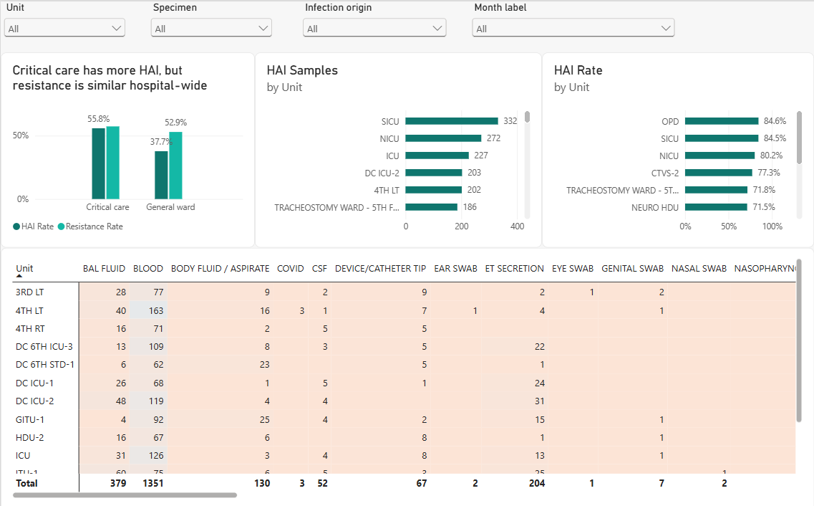
Figure 6.4 Dashboard page 4 — Hospital units.

6.3.5 Monthly surveillance
The final page (Figure 6.5) supports ongoing monitoring. The monthly healthcare-associated infection rate is plotted against the period average, accompanied by monthly sampling volume — included so that users can confirm that changes in the rate are not artefacts of changing sample numbers — and a tabular summary giving, for each month, the sample count, healthcare-associated count and rate, and the eligible isolate count and resistance rate.
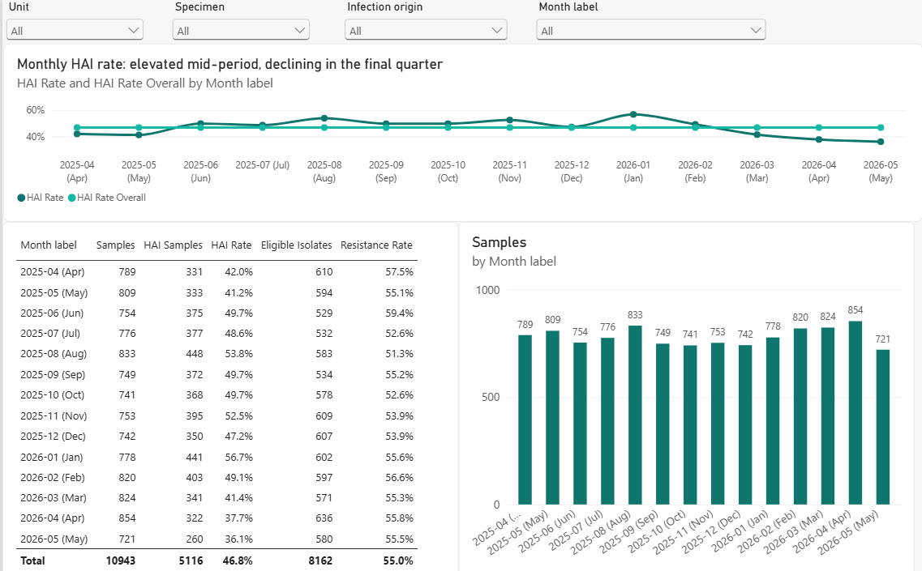
Figure 6.5 Dashboard page 5 — Monthly surveillance.

6.4 Interactivity
The value of the dashboard over static reporting lies in filtering. A worked example illustrates its use. An infection-control practitioner reviewing the neonatal intensive care unit selects that unit in the filter panel; every visual across all five pages updates to that unit alone, showing its organism profile, its resistance pattern, its specimen mix and its monthly trajectory. The equivalent enquiry conducted against the static tables of Chapter 4 would require reference to several separate tables and manual cross-referencing. Filters may be combined — for example a single unit within a single month, restricted to healthcare-associated isolates — and a reset control restores the unfiltered view.

6.5 Role within surveillance practice
The dashboard operationalises the analysis. The descriptive findings of Chapter 4 become a view that can be filtered to any unit or period; the resistance profile of Section 5.1 becomes a reference for stewardship discussion; and the temporal analysis of Section 5.3 becomes a monitoring page that can be updated as each month closes. Its purpose is not to replace the formal analysis but to make its findings available at the point at which decisions are taken.
The preceding three chapters have set out what the data show, which of those patterns are statistically robust, and how the findings are delivered to users. The following chapter considers what they mean.

Chapter 7 Discussion

7.1 Principal findings
This study analysed fourteen months of culture-positive microbiology data from a tertiary-care hospital, comprising 10,943 samples from 5,311 patients and yielding 12,188 organism isolates. Five findings emerge.
First, the infection landscape is dominated by Gram-negative bacteria, which accounted for the majority of isolates, led by Klebsiella pneumoniae and Escherichia coli. Second, a substantial fungal burden was present, with Candida species collectively forming the third-largest microbiological category. Third, healthcare-associated infection accounted for 46.8% of culture-positive samples and was strongly concentrated in critical-care areas. Fourth, documented resistance was present in 55.0% of eligible bacterial isolates, was determined principally by the identity of the organism, and — in contrast to healthcare-associated infection — was distributed broadly across the institution rather than concentrated in intensive care. Fifth, the healthcare-associated infection rate showed a statistically significant declining trend over the period, although the process was not in statistical control and exhibited a sustained elevated phase in the middle of the study.

7.2 Organism identity as the strongest correlate of resistance
The clearest result of the whole analysis is how much the organism matters. Testing one factor at a time, organism group gave a Cramér’s V of 0.473, roughly ten times the effect size of specimen type, infection origin or unit type. Testing all four together, the organism still dominated, with odds ratios spanning 0.01 to 2.12 — a far wider range than any other factor produced.
This is consistent with the biology of resistance. The phenotypes examined are not equally available to all organisms: carbapenem resistance in Enterobacterales, ESBL production, multidrug resistance in non-fermenting Gram-negative bacilli, vancomycin resistance in enterococci and methicillin resistance in staphylococci each arise through distinct genetic mechanisms with differing distributions. That Acinetobacter species (79.8%) and Klebsiella pneumoniae (77.8%) show the highest documented resistance, while coagulase-negative staphylococci (6.6%) and the residual enterococci (1.4%) show the lowest, reflects established differences in the epidemiology of these organisms rather than any property of the units in which they were isolated.
A related observation concerns the two leading Enterobacterales. Klebsiella pneumoniae was predominantly carbapenem-resistant (67.7% CRE) whereas Escherichia coli was predominantly an ESBL producer (39.8% ESBL, 20.0% CRE). Although both organisms belong to the same order and are frequently considered together, their resistance profiles differ materially, and empirical therapy directed at one may be inappropriate for the other.

7.3 Distribution of healthcare-associated infection
That healthcare-associated infection concentrates in critical care is expected and is consistent with the recognised risk factors for such infection: severity of underlying illness, prolonged length of stay, and exposure to invasive devices including central venous catheters, urinary catheters and mechanical ventilation. The magnitude of the difference observed here — 55.8% of culture-positive samples in critical care compared with 37.7% on general wards — is nonetheless substantial, and the unit-level analysis identified several areas in which the great majority of positive cultures were healthcare-associated.
The specimen distribution supports this interpretation. Urine and blood together accounted for approximately half of all culture-positive samples, consistent with catheter-associated urinary tract infection and central-line-associated bloodstream infection being major contributors to the healthcare-associated burden. Respiratory specimens — sputum, bronchoalveolar lavage fluid and endotracheal secretions — collectively formed a further substantial group, consistent with ventilator-associated pneumonia in the critical-care population.

7.4 Resistance as an institution-wide phenomenon
The most useful finding of this study is that healthcare-associated infection and resistance are spread differently across the hospital. Critical-care areas had an HAI rate eighteen percentage points higher than general wards — a large gap. For resistance the gap was only about four percentage points. That difference was still statistically significant (p < 0.001), but its effect size was 0.044, which is negligible.
This matters for what the hospital should do. If resistance were concentrated in intensive care, focusing a stewardship programme there would deal with most of the problem. These data say otherwise: resistant organisms turned up at much the same rate everywhere. Antimicrobial stewardship therefore needs to run hospital-wide. Infection-prevention work aimed at stopping transmission, by contrast, can reasonably be concentrated in the critical-care units where HAI is concentrated. The two halves of an infection-control strategy should be aimed at different targets.
This also shows why effect sizes were reported next to every p-value. With more than eight thousand isolates, even a four-point difference comes out highly significant while explaining almost none of the variation. Reading the p-value alone would suggest unit type matters. The effect size shows that in practice it does not.

7.5 Temporal pattern
The control chart demonstrated that the monthly healthcare-associated infection proportion was not in statistical control. Seven of fourteen months fell outside three-sigma limits, and the proportion remained above the centre line for nine consecutive months from June 2025 to February 2026 — a run length that is very unlikely to arise from chance variation. The subsequent decline, to 36.1% by May 2026, was reflected in a statistically significant downward trend across the period as a whole.
There are two possible explanations and this data cannot separate them. The decline may be real, whether from infection-control work or a change in the patients being treated. Or the last few months may simply be incomplete, since results arriving after the data was extracted would lower the counts. Which of these is true changes what should be done about it, and only a further period of data will settle it. Raising exactly this kind of question is what the control chart is for: it flags movement worth investigating without claiming to know the cause.

7.6 Comparison with the wider literature
The organism distribution observed here — predominance of Klebsiella pneumoniae, Escherichia coli, Pseudomonas aeruginosa and Acinetobacter species — corresponds to the pattern widely reported from tertiary-care centres in South Asia, where Gram-negative organisms constitute the majority of healthcare-associated isolates. This contrasts with the greater relative contribution of Gram-positive organisms reported historically from some Western settings, and is consistent with regional surveillance describing high rates of carbapenem resistance among Enterobacterales.
The carbapenem-resistance burden documented here is of particular concern. Carbapenems occupy a last-line position in the treatment of serious Gram-negative infection, and resistance to them substantially restricts therapeutic options. The identification of 2,120 CRE isolates over fourteen months, concentrated in Klebsiella pneumoniae, is consistent with the designation of carbapenem-resistant Enterobacterales as a critical-priority pathogen group in international assessments of antimicrobial resistance.
The fungal burden also merits comment. Candida species collectively formed a substantial proportion of isolates, and the predominance of non-albicans species over Candida albicans is consistent with the shift reported in recent years, which carries implications for antifungal selection given the reduced azole susceptibility of several non-albicans species. The presence of Candida auris in the register is noteworthy: this organism has emerged internationally as a healthcare-associated pathogen characterised by multidrug resistance, environmental persistence and nosocomial transmission, and its identification supports continued vigilance and adherence to isolation protocols.
It should be noted that this comparison is drawn at the level of general pattern. Direct numerical comparison with published surveillance is complicated by differences in case definition, specimen-collection practice and denominator; the present study reports the proportion of culture-positive samples classified as healthcare-associated, which is not equivalent to an incidence rate expressed per patient-day.

7.7 Strengths
The study has several strengths. It draws on a complete fourteen-month register from a single institution, providing a substantial dataset and a coherent picture of local epidemiology. The cleaning and standardisation of that register, described in Chapter 3, was extensive and is documented in sufficient detail to be reproduced. The analytical approach was specified in advance, with eligibility for the resistance analysis determined on microbiological grounds before any examination of outcome data, avoiding selection on the dependent variable. Effect sizes accompany all significance tests, clustering of isolates within samples is addressed both by sensitivity analysis and by cluster-robust inference, and the predictive component uses grouped partitioning to prevent information leakage. Finally, the analysis is delivered in a form usable by the institution rather than remaining a static document.
These interpretations must be read alongside the constraints of the data and the design, which the following chapter sets out.

Chapter 8 Limitations
Several limitations qualify the findings of this study and should be considered in their interpretation.

8.1 Nature of the resistance outcome
The register recorded resistance phenotypes — CRE, ESBL, MDR, VRE, MRSA and MR-CoNS — rather than organism-by-antimicrobial susceptibility results. Two consequences follow. First, a conventional cumulative antibiogram could not be constructed, and the resistance analysis is necessarily a profile of documented phenotypes rather than a susceptibility summary. Second, and more importantly, the absence of a recorded phenotype denotes only that no recognised phenotype was documented; it does not constitute laboratory-confirmed susceptibility. The outcome analysed throughout is therefore documented applicable resistance, and rates should be read as documentation rates rather than as true resistance prevalence.

8.2 Absence of patient-level covariates
The register does not record prior antimicrobial exposure, device use, length of stay, comorbidity or severity of illness. These are established determinants of both healthcare-associated infection and resistance, and their absence has two effects. It limits the explanatory power of the regression model, which accounted for approximately twenty per cent of the variation in the outcome as measured by McFadden’s pseudo-R², and it raises the possibility of residual confounding in the associations reported. The adjusted odds ratios should accordingly be interpreted as associations conditional on the variables available, not as estimates of causal effect.

8.3 Denominator and the interpretation of rates
All rates reported are expressed relative to culture-positive samples. The healthcare-associated infection rate is the proportion of positive cultures so classified, and is not an incidence rate: patient-day and device-day denominators were not available. A change in this proportion may therefore reflect a change in sampling or testing practice as well as a change in the underlying infection burden, and the figure is not directly comparable with published incidence rates.

8.4 Study design
This was a retrospective observational analysis of routinely collected data. The classification of infection origin was taken as recorded in the register and was not independently adjudicated against clinical criteria. No causal inference is warranted, and the language of association has been used throughout.

8.5 Data quality
A quality audit identified forty-eight records in which a resistance phenotype was recorded against an organism for which that phenotype is not defined — for example carbapenem resistance recorded as CRE for Pseudomonas species, or methicillin resistance recorded as MRSA for a coagulase-negative staphylococcus. These were treated as data-quality anomalies and excluded from the outcome rather than counted, and are documented in the appendix. Although few in number relative to the dataset, their presence indicates that some coding inconsistency exists in the source register. A small number of records with unusable specimen or unit information were similarly excluded.

8.6 Statistical considerations
Isolates recovered from the same sample are not fully independent observations, which the bivariate chi-square analysis assumes. The intraclass correlation was estimated at 0.18, corresponding to a design effect of approximately 1.02 given the observed cluster sizes; a sensitivity analysis restricting the data to one isolate per sample produced effectively unchanged effect sizes, and the multivariable analysis employed cluster-robust standard errors. The bivariate results are nonetheless reported as exploratory. Separately, the fourteen-month series is too short to support formal time-series modelling, and no forecasting was attempted.

8.7 Generalisability and validation
The findings describe a single tertiary-care institution over a defined period and may not generalise to other settings with different case mix, formulary or infection-control practice. The predictive model was validated internally, by grouped partitioning and cross-validation, but not against an external dataset; it should therefore be regarded as an exploratory analytical model rather than a validated clinical decision tool.
Despite these constraints, the analysis supports a number of clear conclusions and practical recommendations, which are set out below.

Chapter 9 Conclusions and Recommendations

9.1 Conclusions
The objectives set out in Chapter 1 are addressed as follows.
Cleaning and standardisation. The fourteen-month culture-positive register was cleaned and standardised into an analysis-ready dataset of 12,188 organism-level records from 10,943 samples, with organism nomenclature, specimen categories and hospital units mapped to consistent classifications and derived indicators constructed according to explicit definitions.
Description of the infection burden. The burden is dominated by Gram-negative bacteria, principally Klebsiella pneumoniae and Escherichia coli, with a substantial contribution from Candida species. Urine and blood are the predominant specimen types, and infection concentrates in the critical-care and high-dependency units.
Quantification of resistance. Documented applicable resistance was present in 4,491 of 8,162 eligible bacterial isolates (55.0%). Carbapenem resistance in Enterobacterales was the single largest phenotype, at 2,120 isolates.
Factors associated with resistance. Organism identity was the factor most strongly associated with documented resistance, both unadjusted and after adjustment. Healthcare-associated origin carries a substantial independent association (adjusted odds ratio 1.89); unit type retains only a modest association (1.24) once organism and specimen are accounted for.
Estimation of resistance probability. A logistic-regression model using routinely available characteristics discriminated moderately well on held-out data (area under the curve 0.778; cross-validated 0.781) and showed reasonably good calibration, indicating that these characteristics carry appreciable information about the probability of documented resistance.
Temporal monitoring. Statistical process control demonstrated that the monthly healthcare-associated infection proportion was not in statistical control, with seven months outside three-sigma limits and a sustained nine-month elevated phase, followed by a significant decline over the period as a whole.
Dashboard. An interactive five-page dashboard was developed, presenting the findings in filterable form for use by infection-control, stewardship and administrative staff.

9.2 Recommendations
The following recommendations follow from the findings.
- Pursue antimicrobial stewardship hospital-wide rather than as a critical-care initiative. Documented resistance was distributed broadly across the institution, with only a negligible difference between critical care and general wards. A stewardship programme confined to intensive care would address only part of the burden.
- Prioritise infection-prevention effort in the units with the highest healthcare-associated infection rates. Healthcare-associated infection, unlike resistance, is strongly concentrated. Several critical-care units recorded rates above eighty per cent of their positive cultures, and these represent the areas in which transmission-interruption measures are likely to yield the greatest return.
- Differentiate empirical therapy for Klebsiella pneumoniae and Escherichia coli. Although both are Enterobacterales, the former is predominantly carbapenem-resistant and the latter predominantly an ESBL producer. Empirical regimens should reflect this difference rather than treating the group uniformly.
- Maintain antifungal stewardship and Candida auris precautions. The fungal burden was substantial and dominated by non-albicans Candida species, for which azole susceptibility is less reliable. The presence of Candida auris warrants continued screening and isolation practice.
- Adopt statistical process control for routine monitoring. The control chart distinguishes signals warranting investigation from ordinary variation. Updating it monthly would allow the infection-control team to respond to genuine changes without reacting to random fluctuation.
- Record antimicrobial susceptibility results in structured form. The absence of organism-by-antimicrobial results prevented construction of a cumulative antibiogram, which is the standard instrument for guiding empirical therapy. Capturing these results in a structured field would enable one to be produced and would materially increase the value of the register.
- Capture patient-day denominators. Recording admissions and patient-days would permit calculation of standardised infection rates comparable with published surveillance, in place of proportions of culture-positive samples.
- Introduce validation at the point of data entry. The quality audit identified organism–phenotype combinations that are microbiologically impossible. Simple validation rules would prevent such entries at source.

9.3 Directions for further work
Several extensions would strengthen the surveillance capability established here. Incorporating patient-day and device-day denominators would permit calculation of true incidence rates and of device-associated infection rates. Structured susceptibility data would allow a conventional cumulative antibiogram to be produced and updated annually. A longer series would support formal time-series modelling and, potentially, short-term forecasting, neither of which is appropriate with fourteen observations. Linkage to admission records would provide the patient-level covariates whose absence limits the present model. Finally, external validation of the predictive model against data from a subsequent period, or from another institution, would establish whether its performance is transportable.

9.4 Concluding remarks
This project turned a large but unused microbiology register into a working surveillance resource. Its main finding is that healthcare-associated infection and antimicrobial resistance, though related, are spread differently across this hospital. HAI concentrates in critical care. Resistance is most strongly associated with which organism is involved, and is found throughout the hospital. That difference points to a two-part strategy: measures to stop transmission aimed at the highest-risk units, and antimicrobial stewardship applied hospital-wide. The dashboard exists so that these findings stay available, and stay current, in day-to-day practice.

References
The following sources inform the background and discussion. Citations should be formatted and supplemented in accordance with the requirements of the Department before submission.
[1] World Health Organization. Global Antimicrobial Resistance and Use Surveillance System (GLASS) Report. Geneva: World Health Organization.
[2] World Health Organization. WHO priority pathogens list for research and development of new antibiotics. Geneva: World Health Organization.
[3] World Health Organization. Report on the burden of endemic health care-associated infection worldwide. Geneva: World Health Organization.
[4] Indian Council of Medical Research. Annual Report: Antimicrobial Resistance Research and Surveillance Network. New Delhi: ICMR.
[5] National Centre for Disease Control. National Programme on Containment of Antimicrobial Resistance. New Delhi: NCDC.
[6] Centers for Disease Control and Prevention. Antibiotic Resistance Threats in the United States. Atlanta: CDC.
[7] Centers for Disease Control and Prevention. Candida auris: information for healthcare professionals. Atlanta: CDC.
[8] Clinical and Laboratory Standards Institute. M39: Analysis and Presentation of Cumulative Antimicrobial Susceptibility Test Data. Wayne, PA: CLSI.
[9] Magiorakos AP, Srinivasan A, Carey RB, et al. Multidrug-resistant, extensively drug-resistant and pandrug-resistant bacteria: an international expert proposal for interim standard definitions for acquired resistance. Clinical Microbiology and Infection.
[10] Benneyan JC, Lloyd RC, Plsek PE. Statistical process control as a tool for research and healthcare improvement. Quality and Safety in Health Care.
[11] Hosmer DW, Lemeshow S, Sturdivant RX. Applied Logistic Regression. 3rd ed. Hoboken: Wiley.
[12] Agresti A. Categorical Data Analysis. 3rd ed. Hoboken: Wiley.
[13] Cohen J. Statistical Power Analysis for the Behavioral Sciences. 2nd ed. Hillsdale: Lawrence Erlbaum.
[14] Holm S. A simple sequentially rejective multiple test procedure. Scandinavian Journal of Statistics.

Appendices

Appendix A Organism applicability audit
All 136 standardised organism categories present in the register were classified into microbiological groups, and the resistance phenotypes applicable to each group were specified a priori. The classification and the resulting applicability rule are as follows.
Organism class | Applicable phenotypes | Rationale
Enterobacterales | CRE, ESBL, MDR | Carbapenem resistance in this order is designated CRE; ESBL production is defined for these organisms
Non-fermenting Gram-negative bacilli | MDR | Carbapenem resistance occurs but is not designated CRE, which is specific to Enterobacterales
Enterococcus species | VRE | Vancomycin resistance is the phenotype defined for this genus
Staphylococcus aureus | MRSA | Methicillin resistance in S. aureus
Coagulase-negative staphylococci | MR-CoNS | Methicillin resistance in coagulase-negative species
Fungi, viruses, mycobacteria, parasites, enteric pathogens | None applicable | The phenotypes under study are not defined or not routinely assigned for these organisms; excluded from the resistance analysis
The full audit, listing each of the 136 organisms with its assigned class, applicable phenotypes, observed phenotypes and any anomalies, is provided as a supplementary workbook.

Appendix B Data-quality anomalies
Forty-eight records were identified in which a resistance phenotype was recorded against an organism for which that phenotype is not defined. These were excluded from the analytical outcome and retained for documentation. Representative examples are given below; the complete listing is provided as a supplementary workbook.
Organism | Phenotype recorded | Why incompatible
Acinetobacter species | CRE | CRE is specific to Enterobacterales
Pseudomonas aeruginosa | CRE, ESBL | Non-fermenter; neither phenotype is assigned to this organism
Escherichia coli | VRE | Vancomycin resistance is an enterococcal phenotype
Staphylococcus aureus | CRE, ESBL, MR-CoNS | Gram-positive; these are Gram-negative or coagulase-negative phenotypes
Staphylococcus epidermidis | MRSA | A coagulase-negative species; the corresponding phenotype is MR-CoNS
Enterococcus faecalis | ESBL | ESBL production is not defined for enterococci

Appendix C Supplementary materials
The following materials accompany this report:
- Organism applicability audit — All 136 organisms with class, applicable and observed phenotypes, and anomaly flags.
- Resistance phenotype profile — Organism group by phenotype, with applicability distinguished from non-observation.
- Bivariate association results — Contingency tables, chi-square statistics, effect sizes and the sensitivity analysis.
- Logistic regression output — Adjusted odds ratios, diagnostics, classification performance and calibration.
- Control chart data — Monthly proportions with month-specific control limits and signal flags.
- Analysis code — The complete reproducible analysis pipeline.

