|  |  |  |  |  |  |  |  |  |  |
| --- | --- | --- | --- | --- | --- | --- | --- | --- | --- |
| **SCHOOL OF COMPUTER SCIENCE AND ARTIFICIAL INTELLIGENCE** | | | | | **DEPARTMENT OF COMPUTER SCIENCE ENGINEERING** | | | | |
| **ProgramName:**B. Tech | | | | **Assignment Type: Lab** | | | **AcademicYear:**2025-2026 | | |
| **CourseCoordinatorName** | | | | Venkataramana Veeramsetty | | | | | |
| **Instructor(s)Name** | | | | |  | | --- | | Dr. V. Venkataramana (Co-ordinator) | | Dr. T. Sampath Kumar | | Dr. Pramoda Patro | | Dr. Brij Kishor Tiwari | | Dr.J.Ravichander | | Dr. Mohammand Ali Shaik | | Dr. Anirodh Kumar | | Mr. S.Naresh Kumar | | Dr. RAJESH VELPULA | | Mr. Kundhan Kumar | | Ms. Ch.Rajitha | | Mr. M Prakash | | Mr. B.Raju | | Intern 1 (Dharma teja) | | Intern 2 (Sai Prasad) | | Intern 3 (Sowmya) | | NS_2 ( Mounika) | | | | | | |
| **CourseCode** | | | 24CS002PC215 | **CourseTitle** | | AI Assisted Coding | | | |
| **Year/Sem** | | | II/I | **Regulation** | | R24 | | | |
| **Date and Day**  **of Assignment** | | | Week2 - Wednesday | **Time(s)** | |  | | | |
| **Duration** | | | 2 Hours | **Applicableto**  **Batches** | |  | | | |
| **AssignmentNumber:4.3**(Present assignment number)/**24**(Total number of assignments) | | | | | | | | | |
|  | | | | | | | | | |
|  | **Q.No.** | **Question** | | | | | | ***ExpectedTime***  ***to complete*** |  |
|  | 1 | Lab 4: Advanced Prompt Engineering – Zero-shot, One-shot, and Few-shot Techniques  **Lab Objectives:**   * To explore and apply different levels of prompt examples in AI-assisted code generation. * To understand how zero-shot, one-shot, and few-shot prompting affect AI output quality. * To evaluate the impact of context richness and example quantity on AI performance. * To build awareness of prompt strategy effectiveness for different problem types.   **Lab Outcomes (LOs):**  After completing this lab, students will be able to:   * Use zero-shot prompting to instruct AI with minimal context. * Use one-shot prompting with a single example to guide AI code generation. * Apply few-shot prompting using multiple examples to improve AI responses. * Compare AI outputs across the three prompting strategies.   **Task Description#1**   * Zero-shot: Prompt AI to write a function that checks whether a given year is a leap year.   **Expected Output#1**   * AI-generated function with no examples provided   **Task Description#2**   * One-shot: Give one input-output example to guide AI in writing a function that converts centimeters to inches.   **Expected Output#2**   * Function with correct conversion logic   **Task Description#3**   * Few-shot: Provide 2–3 examples to generate a function that formats full names as “Last, First”.   **Expected Output#3**   * Well-structured function respecting the examples   **Task Description#4**   * Compare zero-shot and few-shot prompts for writing a function that counts the number of vowels in a string.   **Expected Output#4**   * Functional output and comparative reflection   **Task Description#5**   * Use few-shot prompting to generate a function that reads a .txt file and returns the number of lines.   **Expected Output#5**   * Working file-processing function with AI-guided logic   **Note: Report should be submitted a word document for all tasks in a single document with prompts, comments & code explanation, and output and if required, screenshots**  **Evaluation Criteria:**   | **Criteria** | **Max Marks** | | --- | --- | | Zero Shot (Task #1) | 0.5 | | One Shot (Task#2) | 0.5 | | Few Shot (Task#3 & Task #5) | 1.0 | | Comparison (Task#4) | 0.5 | | **Total** | **2.5 Marks** | | | | | | | Week2 - Wednesday |  |

**Task Description#1**

* Zero-shot: Prompt AI to write a function that checks whether a given year is a leap year.

**Expected Output#1**

* AI-generated function with no examples provided

Prompt:

Write a python code using functions to check the given year is a leap year.

VS Code:

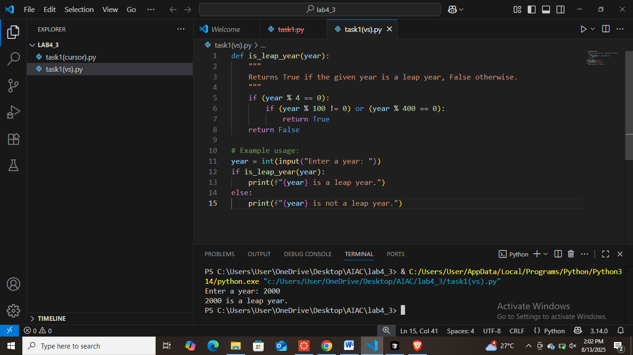

Cursor:

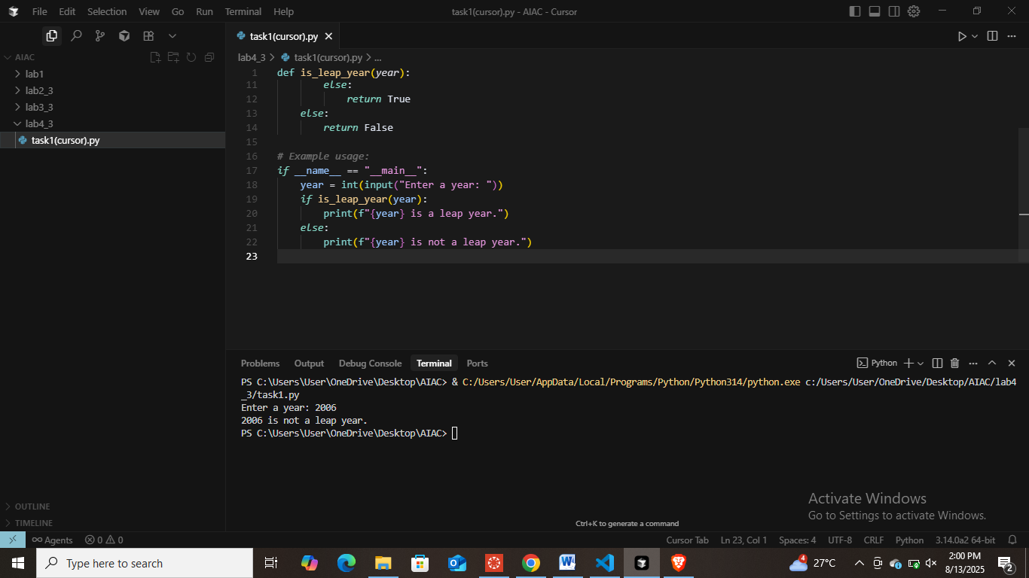

Google Collab:

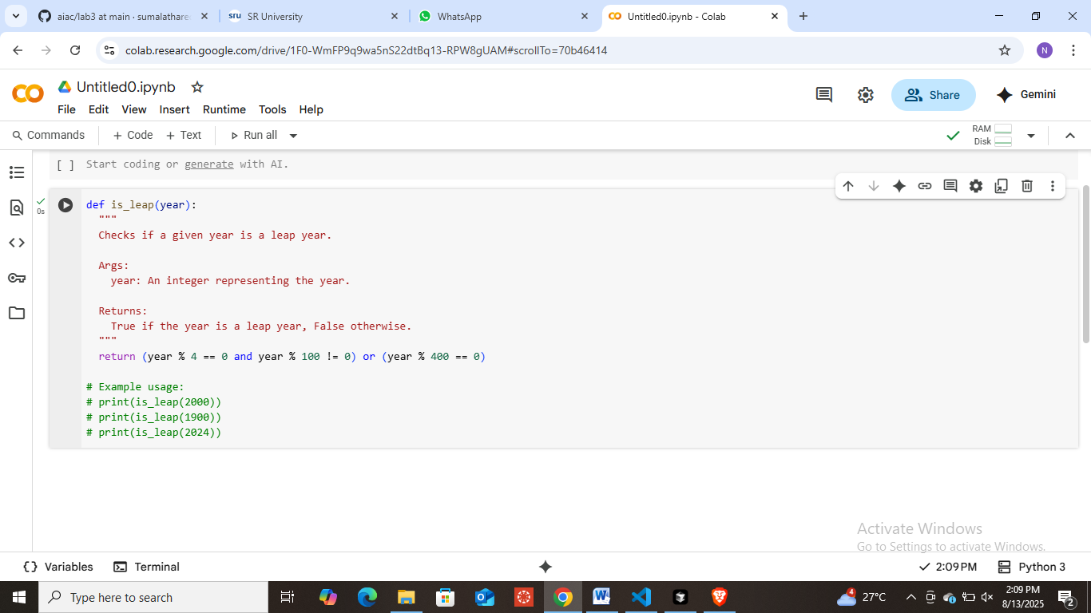

**Task Description#2**

* One-shot: Give one input-output example to guide AI in writing a function that converts centimeters to inches.

**Expected Output#2**

* Function with correct conversion logic

Prompt:

Write a python code by using functions that converts centimeters to inches.

Example: **Input:** centimeters_to_inches(10)  
 **Output:** 3.937

Write a python code using the values like in the above example.

VS Code:

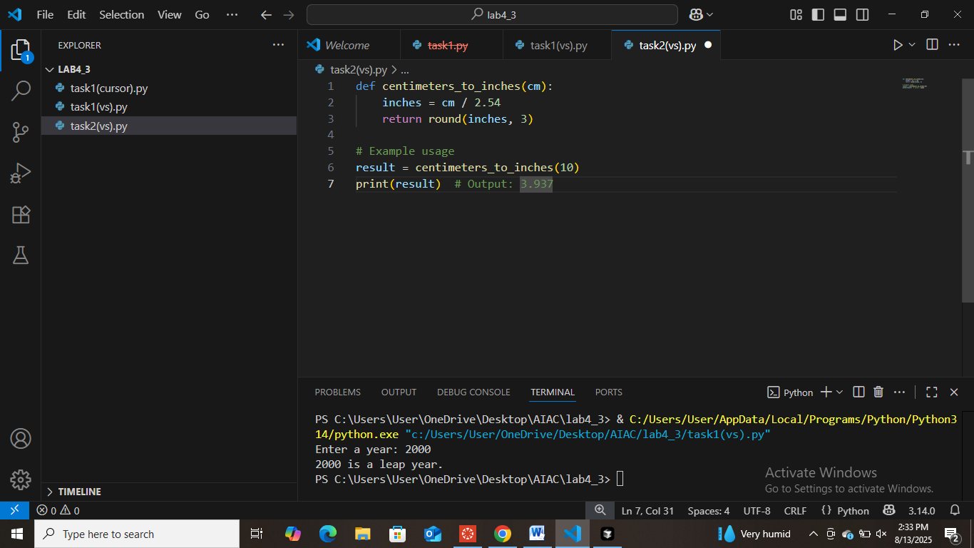

Cursor:

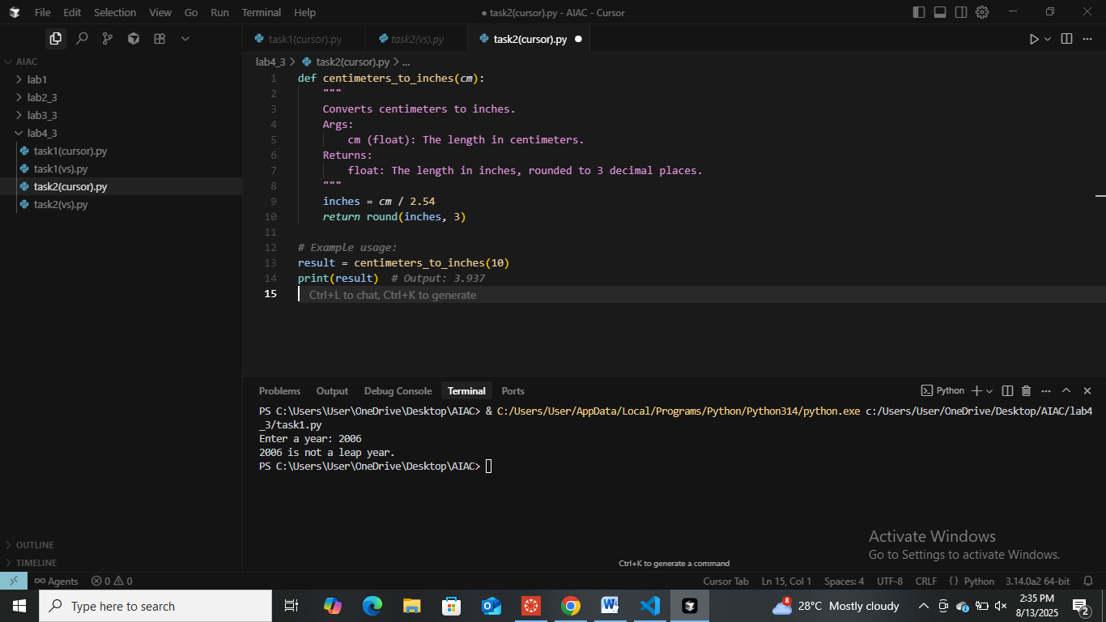

Google Collab:

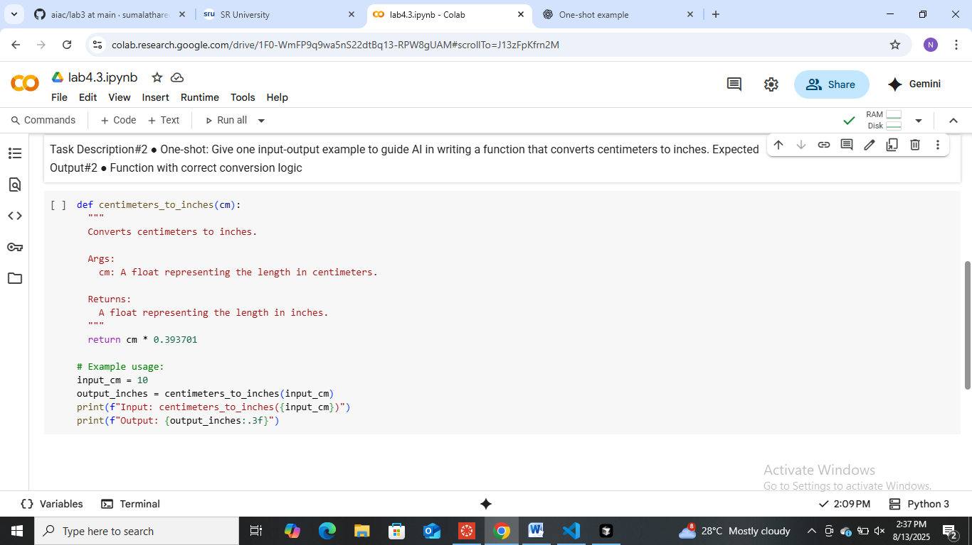

**Task Description#3**

* Few-shot: Provide 2–3 examples to generate a function that formats full names as “Last, First”.

**Expected Output#3**

* Well-structured function respecting the examples

Prompt:

Write a python code using functions to generate a function that formats full names as “Last,first”.

Ex1:

format_name("Nandhini", "Rakesh") # Expected output: "Rakesh, Nandhini"

Ex2:

format_name("Siri", "krupa") # Expected output: "Krupa, Siri"

Ex3:

format_name("Suma", "Swadha") # Expected output: "Swadha, Suma"

VS Code:

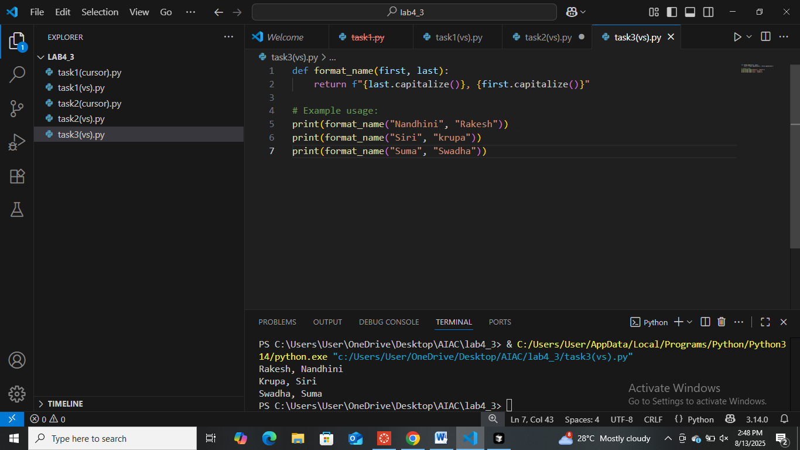

Cursor:

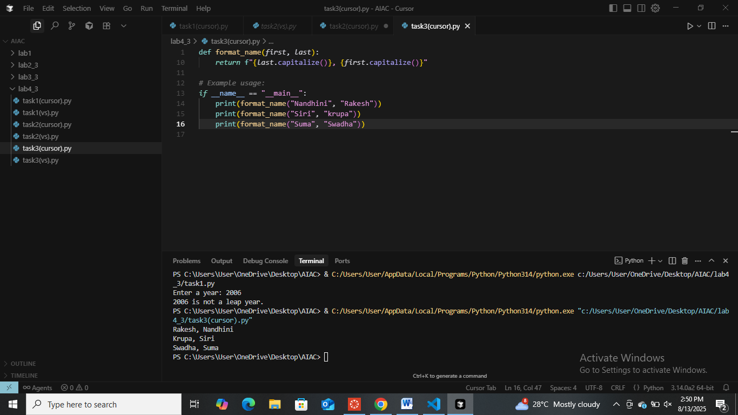

Google Collab:

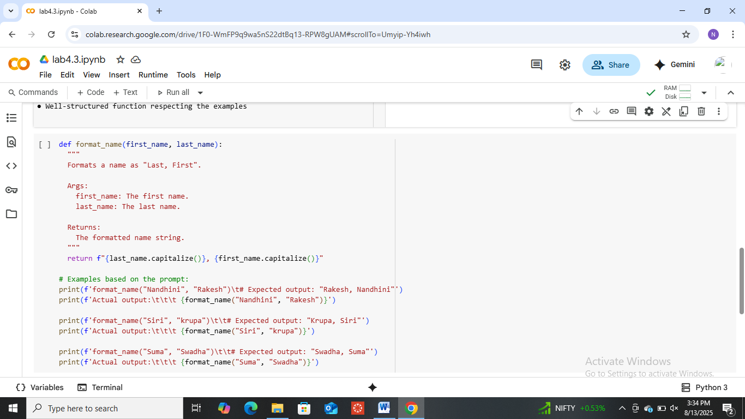

**Task Description#4**

* Compare zero-shot and few-shot prompts for writing a function that counts the number of vowels in a string.

**Expected Output#4**

* Functional output and comparative reflection

Zero Shot Prompt:

Write a python Code by using functions to count the number of vowels in a string.

VS Code:

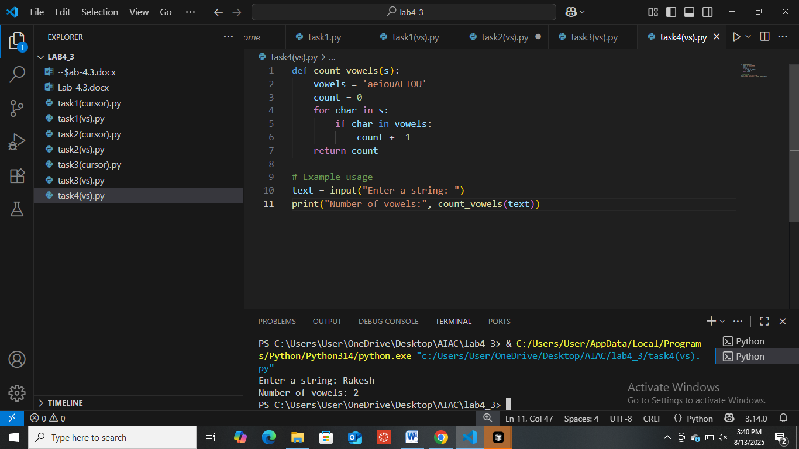

Cursor:

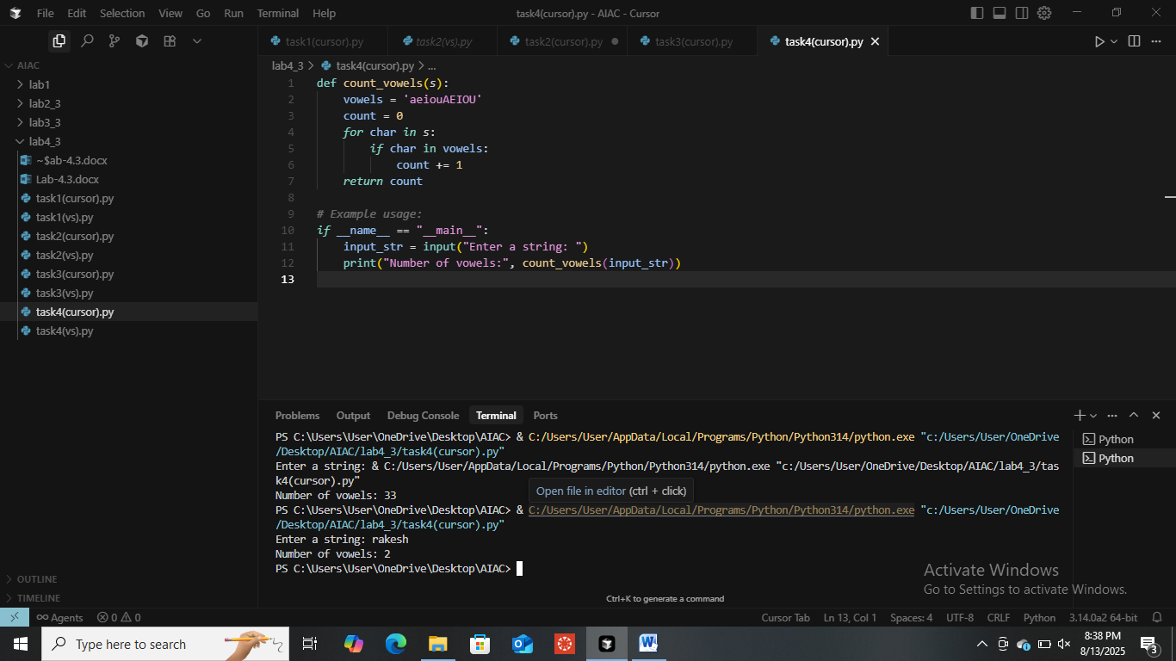

Google Collab:

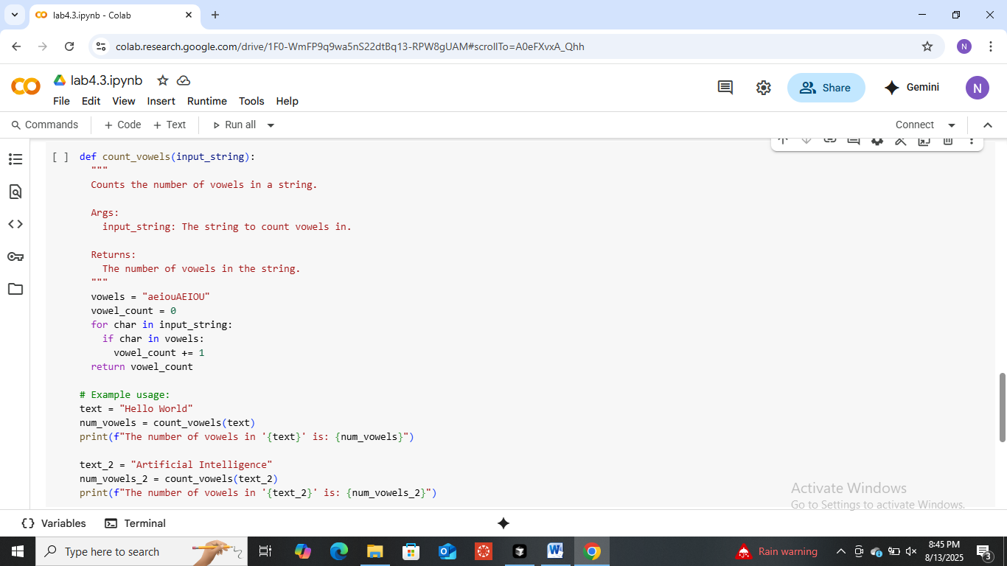

Few Shots Prompt:

Write a python Code by using functions to count the number of vowels in a string.

Example 1:

Input:”NICY:

Output:1

Example 2:

Input:’Union”

Output/;”3”

Example 3:

Input:”Sathwik”

Output:2

VS Code:

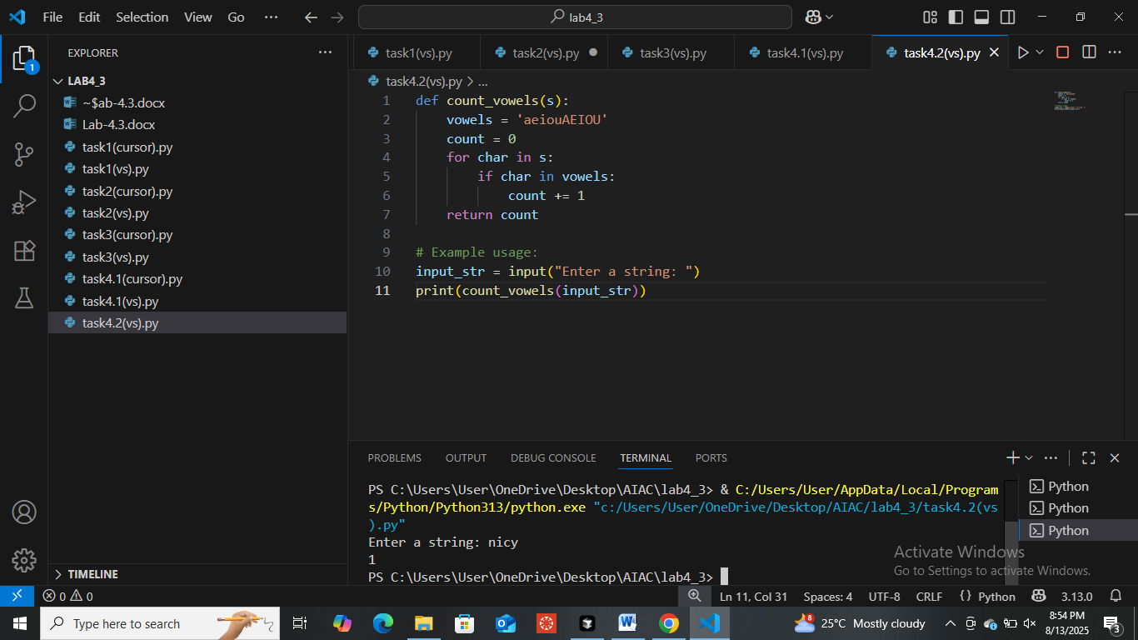

Cursor:

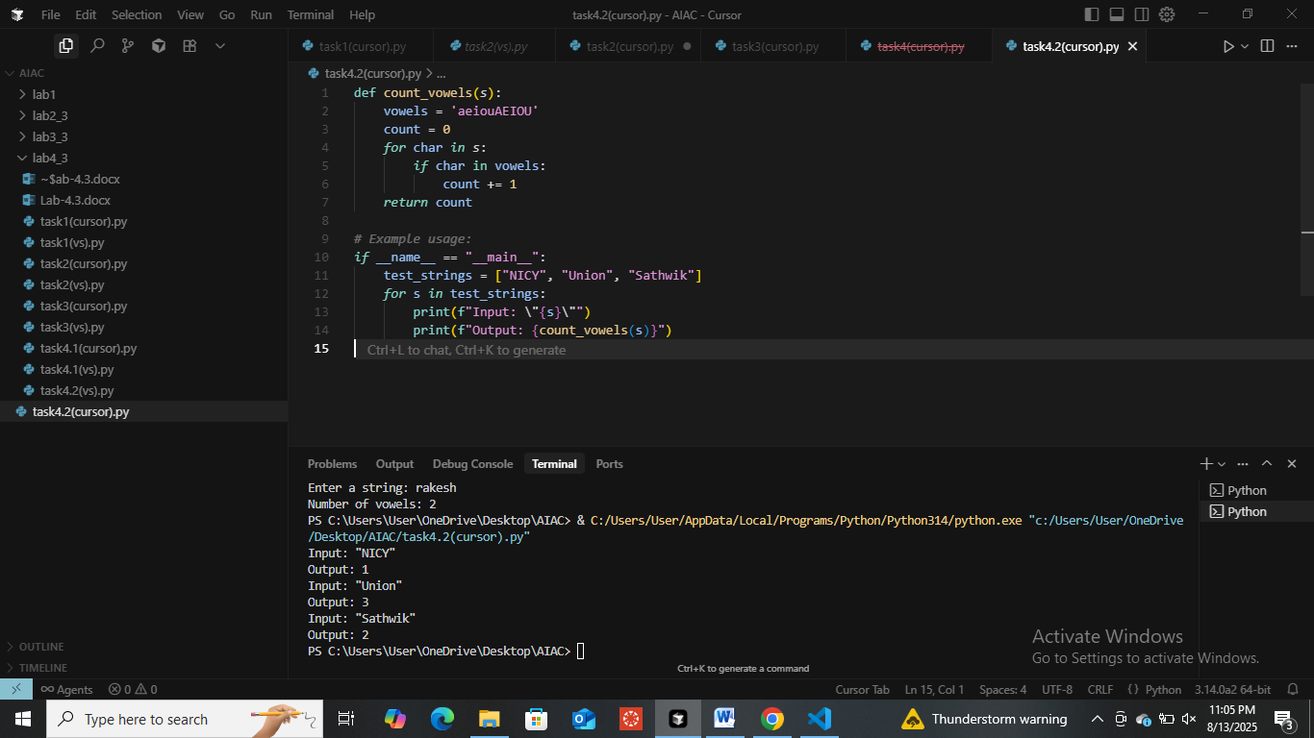

Google Collab:

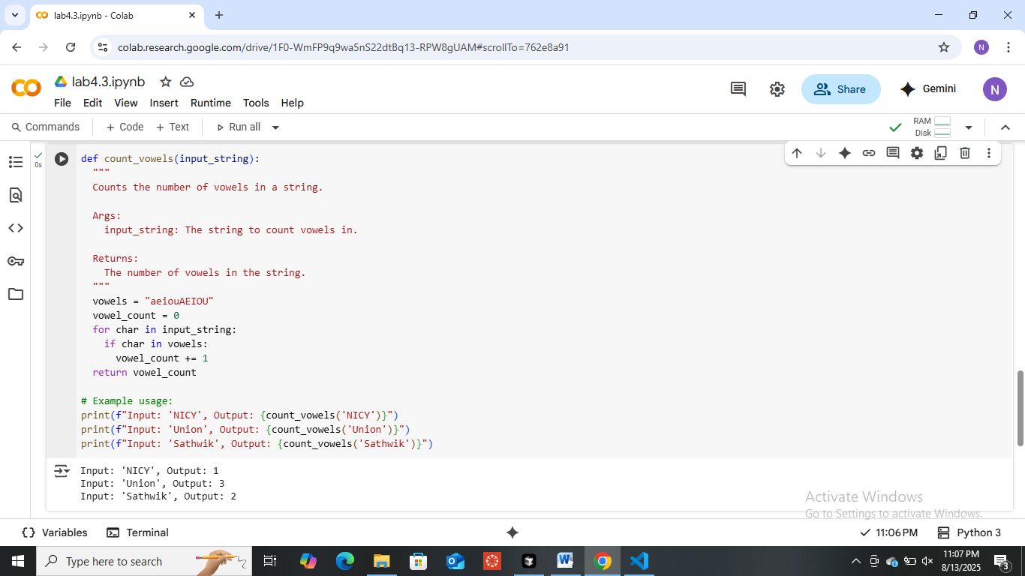

**Task Description#5**

* Use few-shot prompting to generate a function that reads a .txt file and returns the number of lines.

**Expected Output#5**

* Working file-processing function with AI-guided logic

Prompt:

**Example 1:**  
Input: "sample1.txt" (File contents: 3 lines of text)  
Output: 3

**Example 2:**  
Input: "notes.txt" (File contents: 7 lines of text)  
Output: 7

**Example 3:**  
Input: "empty.txt" (File contents: 0 lines)  
Output: 0

Now, write a Python function that reads a .txt file and returns the number of lines.

VS Code:

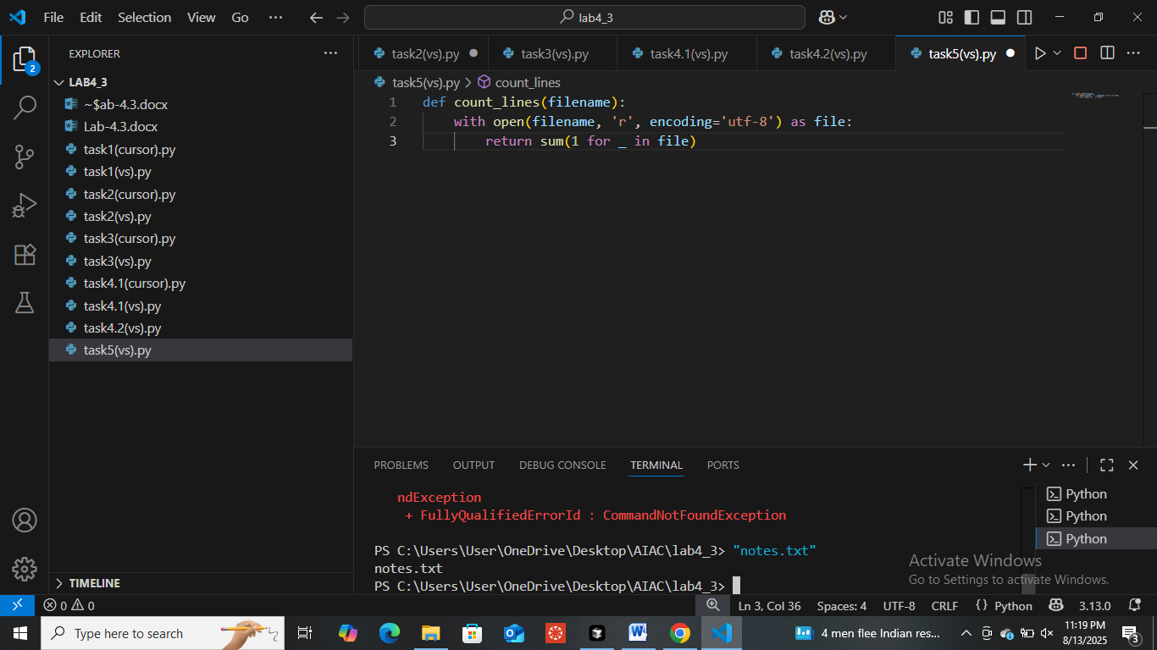

Cursor:

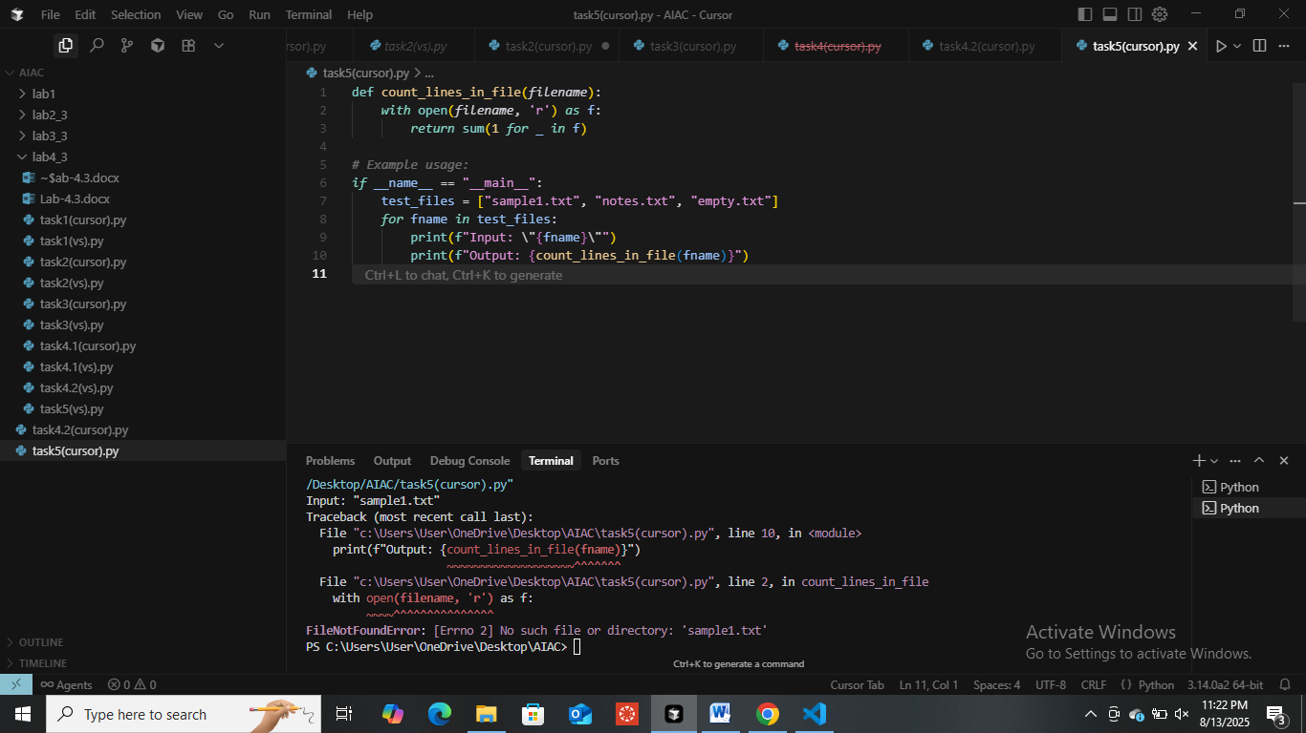

Google Collab:

