

SUMMER INTERNSHIP PROJECT REPORT
on
CUSTOMER REVENUE INTELLIGENCE: AN INTERACTIVE DATA SCIENCE PLATFORM FOR CUSTOMER SEGMENTATION, REVENUE PREDICTION AND BUSINESS GROWTH
Submitted in partial fulfilment of the requirements for the award of the degree of
MASTER OF BUSINESS ADMINISTRATION
(MBA - Data Science and AI)

Submitted by
Swagata Das
UID: [UID]
MBA - Data Science and AI, 3rd Semester

Under the guidance of
Kuldeep Dubey

Apex Institute of Management
CHANDIGARH UNIVERSITY
MBA 2023-25
BONAFIDE CERTIFICATE
This is to certify that Swagata Das, a student of Master of Business Administration - MBA - Data Science and AI in the 3rd semester at Apex Institute of Management - Chandigarh University, has completed a summer internship from 1st June to 12th July at Tutorsuite Technologies LLP, located at 1625/A, Rajdanga Main Road, opposite Siemens Office, Sector E, Kasba, Kolkata, West Bengal 700107.
During this period, Swagata Das was engaged in “Customer Revenue Intelligence: An Interactive Data Science Platform for Customer Segmentation, Revenue Prediction and Business Growth”, under the guidance of Kuldeep Dubey. The work completed by the student was satisfactory.
We wish Swagata Das all the best in their future endeavours.

Signature | Signature
(Head of the Department) | (Supervisor)
Apex Institute of Management | Apex Institute of Management

Submitted for the project viva-voce examination held on ____________________.

Internal Examiner | External Examiner
This page reproduces the wording of the bonafide certificate issued for the internship. Signature lines are left blank for signing; no signature is reproduced or simulated in this document.
ACKNOWLEDGEMENT
I wish to record my sincere gratitude to Tutorsuite Technologies LLP, Kolkata, for hosting my summer internship from 1st June to 12th July and for the opportunity to carry out an end-to-end analytics project within a professional setting.
I am deeply grateful to my guide, Kuldeep Dubey, for continuous direction through the internship, for reviewing the analytical choices made at each stage, and for insisting that every result presented be traceable to a reproducible computation rather than to assertion.
I thank Apex Institute of Management, Chandigarh University, for the academic framework, the coursework in data analytics, machine learning and business intelligence that formed the technical foundation of this work, and the reporting standards that shaped this document. I also thank the faculty members and peers whose questions on model validation, on the distinction between correlation and causation, and on the honest reporting of forecast uncertainty materially improved the final platform.
Finally, I acknowledge the open-source community whose libraries - pandas, NumPy, scikit-learn, statsmodels, Matplotlib, Plotly, Streamlit and SQLite - made a project of this scope achievable within an internship timeline.

Swagata Das
UID: [UID]
MBA - Data Science and AI, 3rd Semester
TABLE OF CONTENTS
BONAFIDE CERTIFICATE ii
ACKNOWLEDGEMENT iii
ABSTRACT vii
GRAPHICAL ABSTRACT viii
ABBREVIATIONS ix
SYMBOLS ix
CHAPTER-1: INTRODUCTION 1
1.1 Background and Client Identification 1
1.2 Problem Identification 1
1.3 Objectives 2
1.4 Scope and Significance 3
1.5 Organisation of the Report 3
CHAPTER-2: LITERATURE REVIEW 4
2.1 Customer Segmentation and RFM Analysis 4
2.2 Unsupervised Clustering 4
2.3 Customer Lifetime Value 4
2.4 Supervised Prediction and Time-Series Forecasting 5
2.5 Data Modelling, Business Intelligence and Tooling 5
2.6 Research Gap and Problem Definition 6
CHAPTER-3: DESIGN FLOW AND METHODOLOGY 7
3.1 System Architecture 7
3.2 Dataset Description 8
3.3 Data Preprocessing and Exploratory Analysis 8
3.4 RFM Segmentation 9
3.5 K-Means Clustering 9
3.6 Customer Value and Revenue Prediction 10
3.7 Revenue Forecasting 10
3.8 SQL Analytical Layer 11
3.9 Power BI Semantic Model 11
3.10 Streamlit Application 11
3.11 Design Constraints and Alternative Designs 11
3.12 Implementation Flowchart 12
CHAPTER-4: RESULTS, ANALYSIS AND VALIDATION 14
4.1 Data Quality Results 14
4.2 Exploratory Data Analysis Results 14
4.3 RFM Segmentation Results 15
4.4 K-Means Segmentation Results 16
4.5 Customer Value Results 17
4.6 Revenue Prediction Results 18
4.7 Forecasting Results 18
4.8 SQL Analytics Results 19
4.9 Power BI Semantic Model Results 20
4.10 Streamlit Application Results 20
4.11 Validation 21
4.12 Findings and Recommendations 22
CHAPTER-5: CONCLUSION AND FUTURE WORK 24
5.1 Conclusion 24
5.2 Deviation from Expected Results 24
5.3 Limitations 25
5.4 Future Scope 25
REFERENCES 26
APPENDIX 28
USER MANUAL 29
ACHIEVEMENTS 31
LIST OF FIGURES
Figure No. Title Page
Figure 1.1 Stage-wise execution timeline of the project and the deliverable produced at each stage 3
Figure 3.1 Solution architecture, from the data source through the analytical and model layers to the three delivery surfaces 7
Figure 3.2 Implementation flowchart of the project lifecycle, from data generation to business decision support, including the three validation gates 13
Figure 4.1 Monthly delivered revenue across the 36-month observation window 14
Figure 4.2 Revenue contribution by RFM segment 16
Figure 4.3 Customer clusters projected onto the first two principal components 17
Figure 4.4 Historical monthly revenue with the six-month forecast and its prediction intervals 19
Figure 4.5 Power BI executive overview page - design mockup rendered from the project data, not a Power BI Desktop screenshot 20
Figure 4.6 Streamlit application: Executive Overview page, a screenshot of the running application 21
LIST OF TABLES
Table No. Title Page
Table 2.1 Comparison of the principal literature informing each stage of the project 6
Table 3.1 Composition of the dataset used throughout the project 8
Table 3.2 Business-rule validation before and after cleaning 8
Table 3.3 Alternative designs considered at each decision point and the option selected 12
Table 4.1 Headline performance of the delivered revenue base 14
Table 4.2 Revenue, profit and margin by product category 14
Table 4.3 Customer count, revenue and behaviour by RFM segment 15
Table 4.4 Profile of the four customer clusters 16
Table 4.5 Forward-value model comparison on the out-of-time test split 17
Table 4.6 Revenue prediction: candidate models and baselines on the out-of-time test split 18
Table 4.7 Six-month revenue forecast with prediction intervals 19
Table 4.8 Principal business findings computed independently in SQL 19
Table 4.9 Validation position of every component of the platform 21
Table 4.10 Business recommendations with their supporting evidence and analytical source 22
Table 5.1 Configuration of the persisted model artefacts 28
Table 5.2 Pages of the application and what each is used for 29
ABSTRACT
Retail firms record transactions faster than they convert them into decisions: revenue is reported in aggregate while the questions that drive growth are customer-level and forward-looking. This project builds a platform that answers them. The dataset used throughout this project is synthetic. It was generated programmatically for academic demonstration and does not describe any real company, customer or transaction, including the internship host organisation. Its 18,819 raw order lines clean to 18,670 validated lines covering 1,984 customers, 61 products and 5 regions over 36 months. Using Python, scikit-learn, statsmodels, SQL, DAX and Streamlit, it performs cleaning, exploratory analysis, RFM scoring, K-Means segmentation, customer value analysis, revenue prediction, forecasting and SQL analytics.
Delivered revenue is ₹6.01 Cr at a 23.35% margin; the top 20% of customers hold 64.33% of it and the Champions segment alone 53.83%. K-Means selected K = 4 and recovered the same group independently. Revenue prediction reached a test R² of 0.0557 - above its baselines but weak - and forecasting a backtest MAPE of 14.56%. Delivery is via 84 DAX measures, 57 reconciled SQL queries and a 12-page application carrying eighteen evidence-linked recommendations. Limitations: synthetic data, a short history and a univariate forecast.
Keywords: customer analytics; RFM; K-Means; customer lifetime value; revenue prediction; forecasting.
GRAPHICAL ABSTRACT
The diagram below summarises the analytical pipeline implemented in this project, from raw customer transactions through to the business decisions the platform is designed to support. Each stage is a separate, re-runnable module whose output is the input of the next.
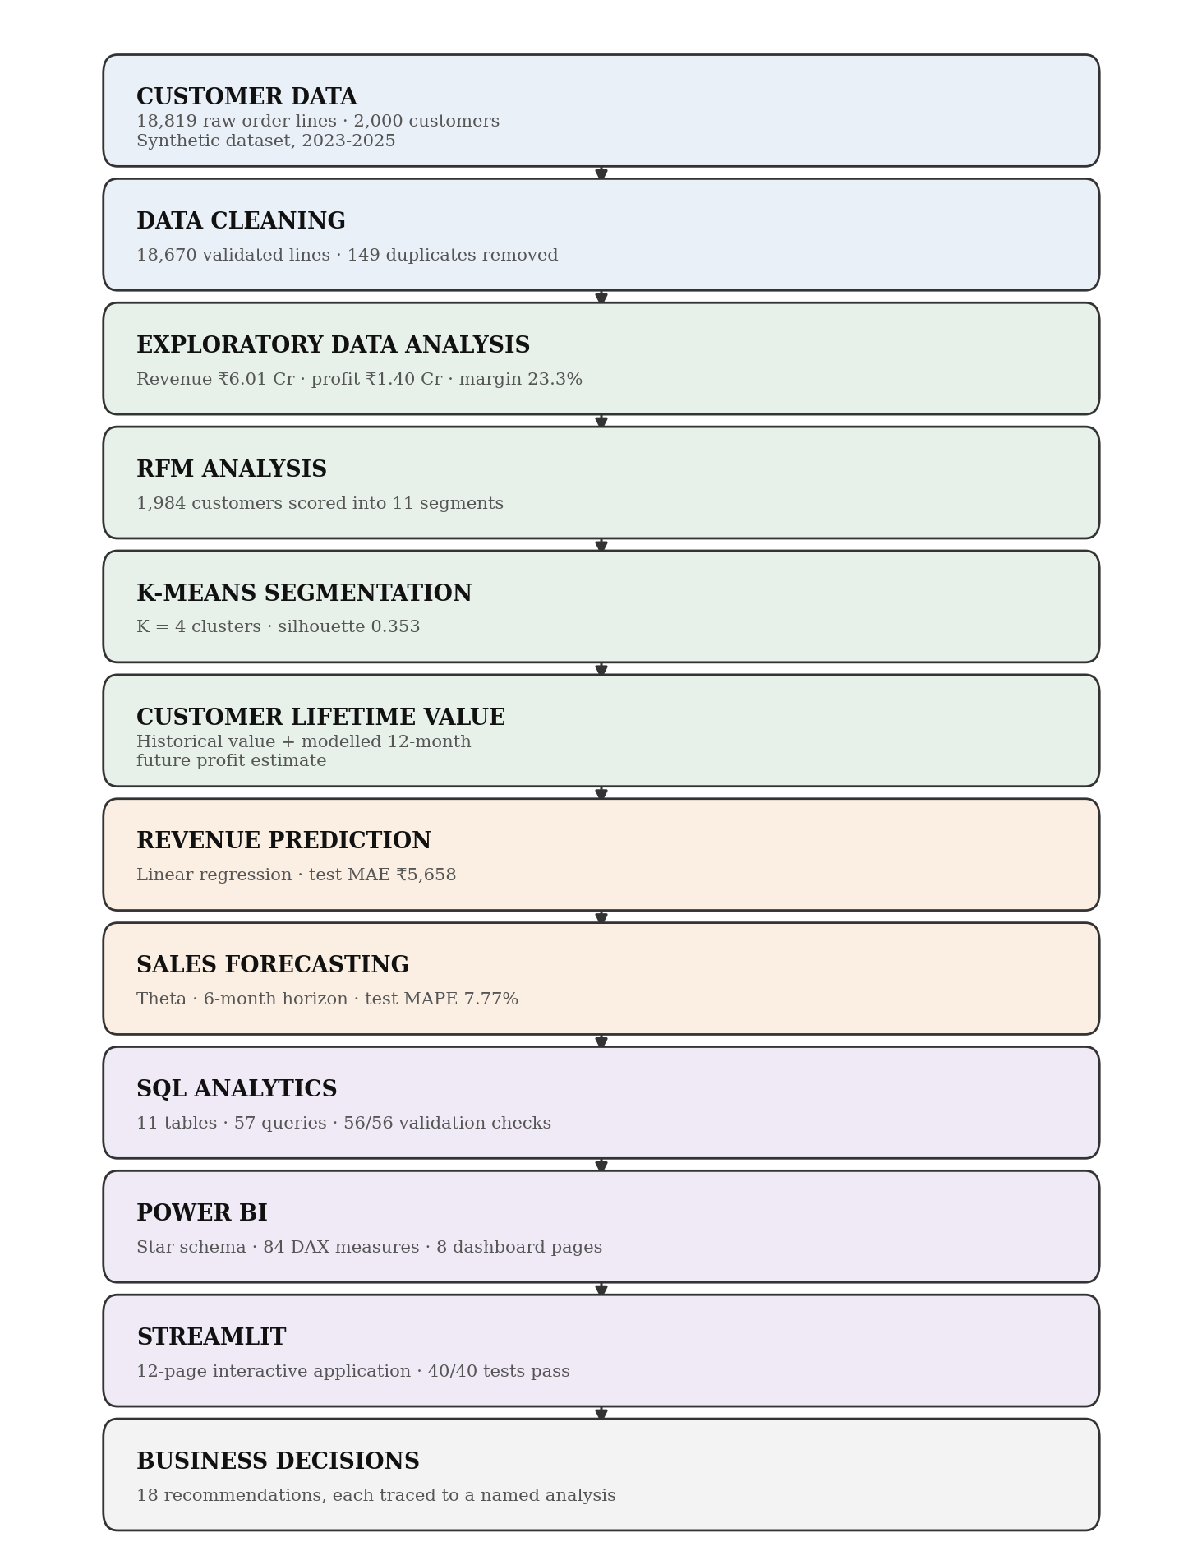
ABBREVIATIONS
AOV | Average Order Value
ARI | Adjusted Rand Index
BI | Business Intelligence
CLV | Customer Lifetime Value
DAX | Data Analysis Expressions
EDA | Exploratory Data Analysis
KPI | Key Performance Indicator
MAE | Mean Absolute Error
MAPE | Mean Absolute Percentage Error
ML | Machine Learning
PCA | Principal Component Analysis
RFM | Recency, Frequency, Monetary
RMSE | Root Mean Squared Error
SQL | Structured Query Language
WAPE | Weighted Absolute Percentage Error
SYMBOLS
μ | Arithmetic mean of a variable
σ | Standard deviation of a variable
R² | Coefficient of determination
K | Number of clusters in K-Means
α | Level smoothing parameter of the Theta model
₹ | Indian Rupee, the unit of all monetary values reported

CHAPTER-1
INTRODUCTION
1.1 Background and Client Identification
This summer internship was carried out at Tutorsuite Technologies LLP, 1625/A, Rajdanga Main Road, opposite Siemens Office, Sector E, Kasba, Kolkata, West Bengal 700107, from 1st June to 12th July, under the guidance of Kuldeep Dubey, as part of the MBA - Data Science and AI programme at Apex Institute of Management, Chandigarh University. The brief was to build a working customer analytics capability end to end rather than to produce an isolated model or a static report.
Retail and e-commerce businesses accumulate transaction records far faster than they convert them into decisions. Revenue is reported in aggregate - by month, by category, by region - while the questions that drive growth are customer-level and forward-looking: which customers matter most, which are going quiet, what each is likely to spend next quarter, and what the next two quarters will bring in total. Answering them requires segmentation, value analysis, supervised prediction and forecasting to operate on one consistent definition of revenue, and requires the results to reach a decision-maker in a form they can interrogate.
The dataset used throughout this project is synthetic. It was generated programmatically for academic demonstration and does not describe any real company, customer or transaction, including the internship host organisation. Building on synthetic data removes any confidentiality constraint while preserving the full analytical problem, because the generator reproduces the structural features that make retail data difficult: skewed customer value, seasonality, discounting, returns and cancellations, and missing or malformed fields.
1.2 Problem Identification
Four specific gaps define the problem addressed here.
• Aggregate reporting hides the customer. Monthly revenue totals cannot distinguish a month carried by a few large customers from one built on a broad base, so they cannot guide retention effort.
• Value and activity are treated as one thing. A customer who spends heavily but has not ordered for six months needs a different response from one who orders frequently for small amounts, yet a single revenue ranking places them together.
• Planning is backward-looking. Without a forecast carrying prediction intervals, next-quarter planning rests on the last observed month, which is the weakest available estimator.
• Analysis does not reach the decision-maker. Results that live in notebooks are not usable by a non-technical reader, and numbers recomputed by hand for a slide deck drift from the pipeline that produced them.
1.3 Objectives
The project set eight objectives, each of which is answered by an identified section of Chapter 4.
1. Generate and validate a realistic retail transaction dataset, and clean it against explicit business rules with a before-and-after audit trail.
2. Characterise the revenue base across time, product, geography, discount and customer dimensions.
3. Segment every purchasing customer by rule-based RFM scoring and, independently, by unsupervised clustering, and measure the agreement between the two schemes.
4. Quantify each customer's historical value and estimate forward twelve-month value, reporting the two as distinct quantities.
5. Predict customer revenue for the following quarter using only information available before that quarter began.
6. Forecast company-level monthly revenue over a six-month horizon with prediction intervals.
7. Reproduce the principal metrics independently in SQL and reconcile them against the Python pipeline.
8. Deliver the results through a Power BI semantic model and an interactive multi-page application.
1.4 Scope and Significance
The scope covers 18,670 validated order lines, 1,984 purchasing customers, 61 products in 6 categories and 5 regions over 36 months from 01 January 2023 to 31 December 2025, carrying ₹6.01 Cr of delivered revenue. It excludes real customer data, real-time streaming, recommendation engines, pricing optimisation and any causal claim: the platform measures association and reports it as such.
The significance is integration and traceability. Each technique used here is established individually; what is delivered is a single pipeline in which one validated dataset and one revenue definition flow through every stage, in which the outputs are reconciled against an independent SQL implementation, and in which every number printed in this report is read from the file the pipeline wrote rather than transcribed by hand.
1.5 Organisation of the Report
Chapter 2 reviews the literature underpinning each stage and states the research gap. Chapter 3 presents the design: the architecture, the dataset, the preprocessing rules, the analytical and predictive methods, the delivery layer, the design constraints and the alternatives considered. Chapter 4 reports the results of every stage with their validation. Chapter 5 concludes, records where results deviated from expectation, states the limitations and sets out the future scope. The References, Appendix, User Manual and Achievements sections follow.
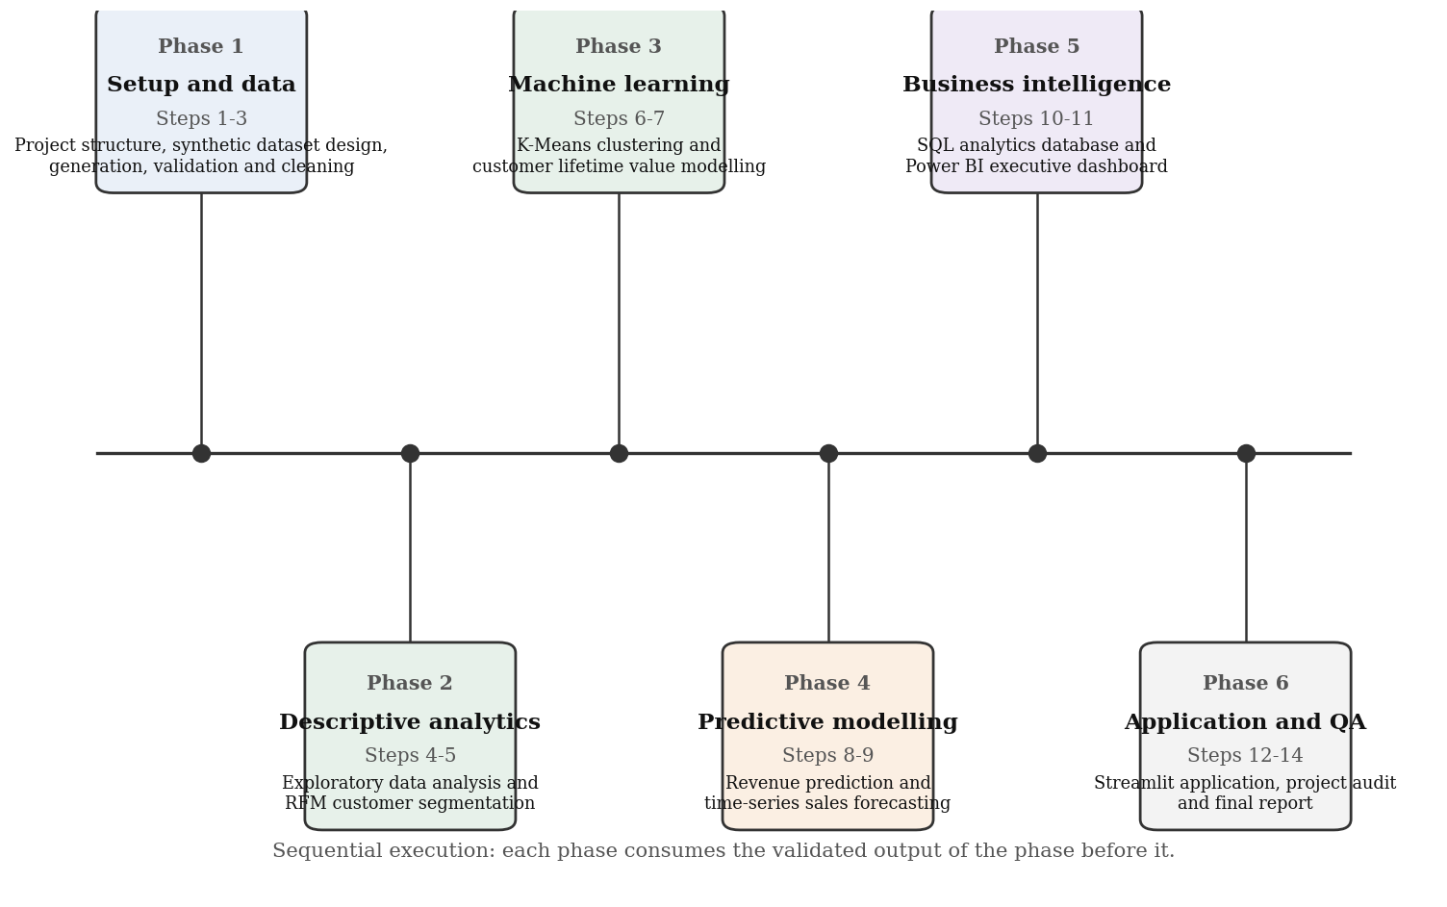
Figure 1.1: Stage-wise execution timeline of the project and the deliverable produced at each stage
CHAPTER-2
LITERATURE REVIEW
2.1 Customer Segmentation and RFM Analysis
Market segmentation theory distinguishes a priori segmentation, which groups customers on attributes chosen in advance, from post hoc segmentation, which derives groups from observed behaviour. Wedel and Kamakura (2000) [38] review both and report that behavioural bases generally outperform demographic ones for marketing response, while cautioning that segment membership is not stable over time. RFM analysis, formalised for database marketing by Hughes (1994) [18], scores each customer on recency, frequency and monetary value and is valued for being auditable: a business user can see why a customer landed in a segment. Fader, Hardie and Lee (2005) [12] relate RFM directly to customer value through iso-value curves, showing that the three variables carry most of the information needed to rank a customer base. The limitation carried into this project is that quintile cut-offs are dataset-relative, so a segment label describes a position within this base rather than an absolute standard.
2.2 Unsupervised Clustering
K-Means, introduced by MacQueen (1967) [26] and given its least-squares formulation by Lloyd (1982) [25], partitions observations to minimise within-cluster variance. Arthur and Vassilvitskii (2007) [1] show that k-means++ initialisation materially improves both solution quality and stability. Because the algorithm requires K to be fixed in advance, the literature supplies diagnostics rather than a decision rule: Thorndike (1953) [36] gives the elbow heuristic, Rousseeuw (1987) [31] the silhouette coefficient, Calinski and Harabasz (1974) [5] and Davies and Bouldin (1979) [9] their respective indices, and Hubert and Arabie (1985) [17] the Adjusted Rand Index for comparing two partitions. Jolliffe (2002) [23] provides the principal component analysis used here for visualisation only. The methodological lesson taken from this body of work is that K must be selected against rules fixed before the results are seen, which is what Section 3.5 does.
2.3 Customer Lifetime Value
Gupta et al. (2006) [14] survey the modelling of customer lifetime value and distinguish historical value, which is measured, from predicted value, which is estimated with error. Schmittlein, Morrison and Colombo (1987) [32] introduced the Pareto/NBD model for non-contractual settings, and Fader, Hardie and Lee (2005) [11] the more tractable BG/NBD alternative. These probabilistic models assume a purchasing process that continues until an unobserved dropout, which is precisely the assumption a short synthetic history cannot support well; this project therefore reports historical value as measured and forward value as an estimate from a supervised model, and keeps the two quantities separately named throughout.
2.4 Supervised Prediction and Time-Series Forecasting
Hastie, Tibshirani and Friedman (2009) [16] set out the bias-variance trade-off and the discipline of out-of-sample evaluation that governs Sections 3.6 and 3.7; Breiman (2001) [4] introduced random forests, used here as one of the candidate value models. For time series, Box et al. (2015) [3] provide the ARIMA framework and Dickey and Fuller (1979) [10] the unit-root test used to check stationarity; Assimakopoulos and Nikolopoulos (2000) [2] introduced the Theta method, whose equivalence to simple exponential smoothing with drift was established by Hyndman and Billah (2003) [21]. Hyndman and Athanasopoulos (2021) [20] argue that a forecast must beat a naive benchmark to be worth using and that rolling-origin evaluation is the honest test, while Hyndman and Koehler (2006) [22] show that percentage errors are unreliable near zero. Both cautions are implemented as hard selection rules in Section 3.7.
2.5 Data Modelling, Business Intelligence and Tooling
Codd (1970) [8] established the relational model and Chen (1976) [6] entity-relationship modelling, which together underpin the normalised database of Section 3.8. Kimball and Ross (2013) [24] set out the star schema used for the semantic model in Section 3.9, whose measures are written in DAX [28]. Chen, Chiang and Storey (2012) [7] survey business intelligence and observe that the constraint on value realisation is usually organisational delivery rather than analytical technique. Few (2006) [13] gives the dashboard design principles applied to both delivery surfaces, with the caveat that design effectiveness can only be confirmed by user testing, which was outside the scope of this internship. Tukey (1977) [37] defines the exploratory posture of Section 3.3. The implementation rests on pandas [27], NumPy [15], scikit-learn [29], statsmodels [33], Matplotlib [19], Plotly [30], SQLite [34] and Streamlit [35].
Table 2.1: Comparison of the principal literature informing each stage of the project
Author / Year | Topic | Key finding (as reported in that work) | Limitation | Used in
Hughes (1994) [18]; Fader et al. (2005) [12] | RFM segmentation | Behavioural scores rank a customer base effectively and stay interpretable | Cut-offs are relative to the dataset analysed | 3.4, 4.3
MacQueen (1967) [26]; Rousseeuw (1987) [31] | Unsupervised clustering | Compact clusters can be recovered without labels; K must be chosen by diagnostics | No single index determines K | 3.5, 4.4
Gupta et al. (2006) [14]; Fader et al. (2005) [11] | Customer lifetime value | Historical and predicted value are distinct quantities | Probabilistic models need a longer history than is available here | 3.6, 4.5
Hastie et al. (2009) [16]; Breiman (2001) [4] | Supervised prediction | Model choice must be made on validation data, not training fit | Individual-level outcomes remain largely unexplained | 3.6, 4.6
Hyndman & Athanasopoulos (2021) [20]; Assimakopoulos & Nikolopoulos (2000) [2] | Time-series forecasting | A forecast is only useful if it beats a naive benchmark | Percentage errors are unstable near zero | 3.7, 4.7
Kimball & Ross (2013) [24]; Few (2006) [13] | Dimensional modelling and dashboard design | A conformed model and a clear hierarchy make analysis self-service | Effectiveness requires user testing to confirm | 3.9, 3.10, 4.9

The Key Finding column summarises the cited work only. It contains no result produced by this project; project results are reported in Chapter 4.
2.6 Research Gap and Problem Definition
Each area above is individually well developed and this project claims no novelty in any of them. The gap it addresses is integration and traceability at the scale of a single reproducible project: in most teaching material these techniques are demonstrated in isolation - one notebook scores RFM, another clusters customers, a third fits a forecast - and what is rarely shown end to end is a single pipeline in which one validated dataset and one revenue definition flow through every stage, the outputs are reconciled against an independent SQL implementation, and the results reach a semantic model and an application whose numbers agree with the pipeline that produced them.
Formally, given a transaction dataset of order lines carrying customer, product, geography, pricing, discount, cost and order-status attributes, the platform must clean the records against explicit business rules, characterise the revenue base, assign every customer to both a rule-based segment and an unsupervised cluster and quantify their agreement, separate measured historical value from estimated forward value, predict next-quarter customer revenue out of time, forecast monthly revenue with backtested prediction intervals, reconcile the metrics against a relational implementation, and deliver the results through a semantic model and an application. The success criterion is not the accuracy of any single model but that the outputs are complete, consistent, independently reconciled and reproducible.
CHAPTER-3
DESIGN FLOW AND METHODOLOGY
3.1 System Architecture
The platform is built as five layers. The data layer generates, validates and cleans the transaction records. The analytical layer performs exploratory analysis, RFM scoring, clustering and customer value analysis. The model layer fits and evaluates the supervised revenue model and the time-series forecast. The database layer reproduces the principal metrics independently in SQL. The delivery layer exposes the results through a Power BI semantic model and an interactive Streamlit application. Every stage is a separate Python module with a single entry point, reads only the persisted output of the stage before it and writes its own outputs to disk, so any stage can be re-run without re-running the whole pipeline.
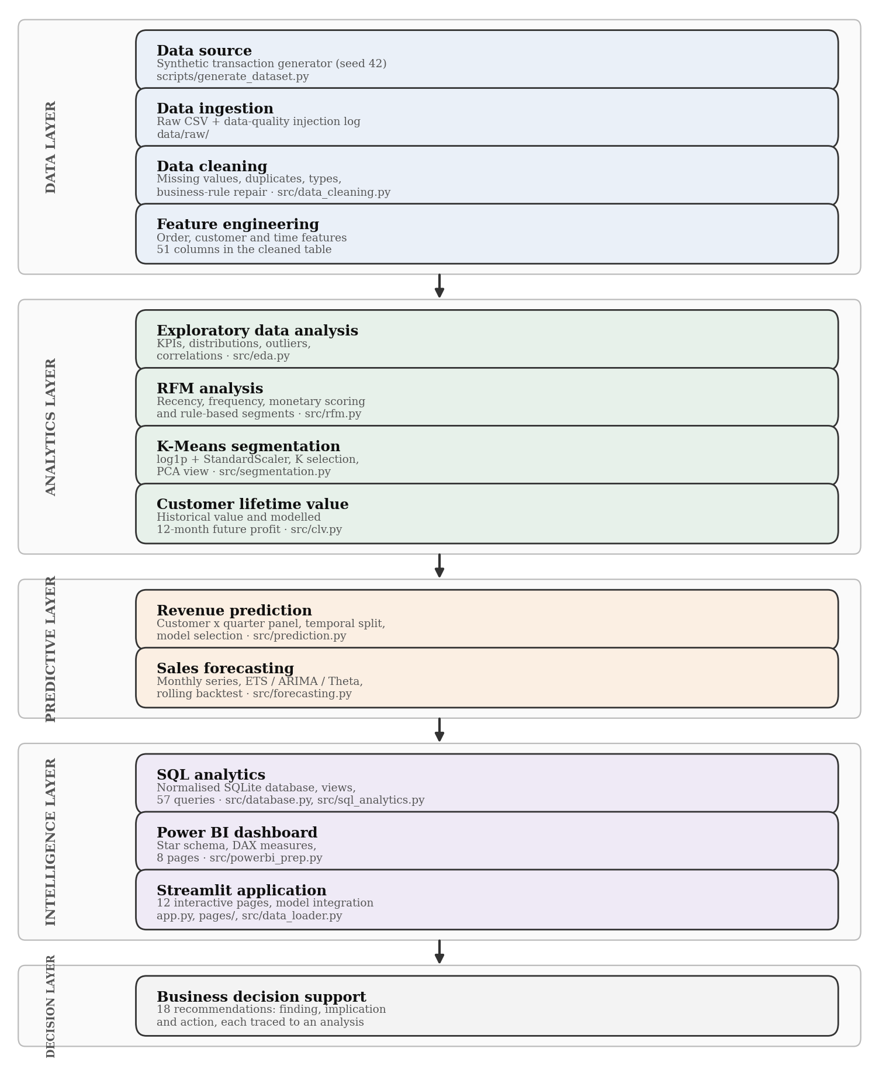
Figure 3.1: Solution architecture, from the data source through the analytical and model layers to the three delivery surfaces
3.2 Dataset Description
The dataset used throughout this project is synthetic. It was generated programmatically for academic demonstration and does not describe any real company, customer or transaction, including the internship host organisation. The generator is seeded at 42, so the dataset is reproducible byte for byte. It writes 18,819 raw order lines across 23 columns, deliberately injecting the defects a real extract carries - missing values, non-ISO dates, numbers stored as text, out-of-range discounts, invalid category labels and duplicate rows - so that cleaning has real work to do and can be audited against a known ground truth.
Table 3.1: Composition of the dataset used throughout the project
Property | Value
Nature of the data | Synthetic, generated programmatically (seed 42); not real customer data
Raw extract | 18,819 order lines, 23 columns
Cleaned dataset | 18,670 order lines, 51 columns (149 duplicates removed)
Observation window | 01 January 2023 to 31 December 2025 (36 months)
Customers | 2,000 registered, 1,984 with at least one delivered order
Products and geography | 61 products in 6 categories and 26 sub-categories; 35 cities, 21 states, 5 regions
Order-line status | 16,860 delivered, 1,101 returned, 709 cancelled
Privacy treatment | Analytical outputs identify customers by Customer_ID only; no customer name is used in any result

One definition governs the whole project: revenue, profit and order counts are computed on delivered order lines only. Returned and cancelled lines are retained in the dataset and analysed separately as lost value, but they never enter a revenue figure. Applying this rule identically in Python, in SQL and in DAX is what makes the three implementations reconcilable.
3.3 Data Preprocessing and Exploratory Analysis
Cleaning is rule-driven rather than discretionary. Every rule is evaluated on the raw extract, the count of offending rows is logged, a treatment is applied, and the rule is re-evaluated on the cleaned dataset. A rule that does not return zero after treatment is a failure of the cleaning stage, not an acceptable residue. Table 3.2 gives the before-and-after position for every rule; the result is reported in Section 4.1.
Table 3.2: Business-rule validation before and after cleaning
Validation rule | Rows failing before | Rows failing after
Missing value | 941 | 0
Non iso or invalid date | 566 | 0
Non numeric value | 93 | 0
Quantity not positive | 9 | 0
Price not positive | 0 | 0
Discount out of range | 38 | 0
Negative sales or cost | 0 | 0
Revenue mismatch | 56 | 0
Profit mismatch | 0 | 0
Age out of range | 19 | 0
Invalid category value | 794 | 0

Exploratory analysis then characterises the revenue base across time, product, geography, discount, payment method and customer dimensions, using descriptive statistics, distribution analysis, the 1.5 interquartile-range outlier rule and correlation analysis. Outliers are flagged and inspected, not removed: a large order from a genuine high-value customer is a fact about the business, not an error.
3.4 RFM Segmentation
Every customer with at least one delivered order is scored on recency (reference_date - last delivered purchase date, in days), frequency (distinct Order_ID with >= 1 Delivered line) and monetary value (sum of Sales (INR, after discount) on Delivered lines) at the reference date 2026-01-01, which is max(Order_Date) + 1 day. Each dimension is scored 1-5 on quintiles, with recency reversed so that a higher score always means a better customer, and the quintile cut is replaced by a tie-aware percentile rank where the edges are not unique. The combined score places each of the 1,984 scored customers into one of 11 named segments by fixed rules - Champions, for example, requires a recency score of 4-5 and a combined frequency-monetary score of at least 4.5. The rules are published with the results so that any segment assignment can be checked by hand. This stage is rule-based and is not machine learning.
3.5 K-Means Clustering
The same three behavioural variables are then clustered without labels, as an independent check on the rule-based scheme. Because recency, frequency and monetary value are heavily skewed and are measured on different scales, the features pass through a persisted scikit-learn pipeline of log1p followed by standard scaling. K is not chosen after inspecting the results: three rules were fixed in advance - at least 3 clusters, no cluster smaller than 5% of the base, and a bootstrap stability of Adjusted Rand Index at least 0.90 - after which the eligible K with the highest silhouette coefficient is taken. Principal component analysis is used for visualisation only and never as an input to the model.
3.6 Customer Value and Revenue Prediction
Customer value is reported as two separate quantities. Historical value is measured: the delivered profit a customer has already generated. Forward value is estimated: a supervised model trained on an out-of-time split, with eight behavioural features drawn from one twelve-month window predicting delivered profit in the following twelve months. A ridge baseline, a random forest and a gradient-boosted ensemble are compared against naive and formula baselines, and the winner is chosen by the rule fixed in advance: lowest mean 5-fold CV RMSE on the training cutoff (test year not used).
Revenue prediction operates on a different unit. A panel of 10,393 customer-quarter rows is built, each row carrying 24 features (19 numeric and 5 categorical) computed strictly from data available before the target quarter began, and the target is that customer's delivered revenue in the quarter that follows. The split is out-of-time, not random: 4,788 training rows (features 2023-01-01..2024-09-30 -> targets 2024-01-01..2024-12-31), 2,692 validation rows (targets 2025-01-01..2025-06-30) and 2,913 test rows (targets 2025-07-01..2025-12-31). A leakage audit recomputes the features of a sample of rows directly from the transaction table to confirm that no post-cutoff information reaches the model. The model is selected by the rule simplest model within 2% of the best validation RMSE (fixed in advance), which is why a linear regression was chosen over more flexible alternatives.
3.7 Revenue Forecasting
Forecasting operates at company level on monthly delivered revenue over 36 months. The series is first characterised for stationarity, autocorrelation structure and seasonality. Candidate families are naive and seasonal naive baselines, exponential smoothing, ARIMA and SARIMA, and the Theta method; selection follows a rule fixed in advance: lowest mean backtest MAPE; must beat naive and seasonal naive on test MAE; within 5% -> simpler family. The chosen model is refit on the full 2023-01 to 2025-12 (36 months) history and forecasts 6 months ahead with 80% and 95% prediction intervals.
3.8 SQL Analytical Layer
The cleaned data is loaded into a normalised SQLite database of 11 tables and 2 views, with primary and foreign keys enforced and indexes on the join and filter columns. 57 analytical queries - 37 analysis queries and 20 business queries - reproduce the principal metrics using window functions, common table expressions, self-joins and conditional aggregation. This layer exists to be an independent implementation: it is written against the same definitions but in a different language, so agreement between it and the Python pipeline is evidence rather than tautology.
3.9 Power BI Semantic Model
The Power BI layer is a star schema of 13 tables joined by 9 single-direction relationships, with 84 DAX measures organised into 10 display folders, a marked date dimension, Power Query M scripts for each table and a JSON theme. Every measure carries an explicit filter on delivered lines so that the model cannot silently report a different revenue definition from the pipeline.
Power BI Desktop is a Windows application and could not be run in the Linux environment used for this project. The semantic model, the measures, the Power Query scripts, the theme and a build guide were produced and validated against SQL; the page layouts were rendered from the real data as design mockups and are labelled as such wherever they appear. No Power BI Desktop screenshot is presented in this report.
3.10 Streamlit Application
The application is a 12-page Streamlit interface covering executive overview, revenue, customers, segmentation, products, regions, prediction, forecasting, recommendations, a data explorer and project documentation. It loads from the SQLite database where available and falls back to the processed CSV files, caches data and model artefacts, and loads the persisted models rather than refitting anything. It computes no metric of its own: every number it displays comes from the pipeline's outputs or from the shared module the pipeline itself uses.
3.11 Design Constraints and Alternative Designs
Four constraints shaped the design. The data had to be synthetic, because no real customer data could be used in an academic deliverable. The whole pipeline had to be reproducible from a fixed seed on a single machine with no paid service. Power BI Desktop was unavailable on the build platform. And every reported figure had to be traceable to the file that produced it, which ruled out any hand-transcribed number in the reporting layer.
Table 3.3: Alternative designs considered at each decision point and the option selected
Decision point | Alternatives considered | Basis of comparison | Selected
Customer segmentation | (a) RFM rules only; (b) K-Means only; (c) both, compared | A rule-based scheme is explainable; an unsupervised one is unbiased by rules | (c) both, with the agreement between them quantified by Adjusted Rand Index
Number of clusters K | (a) elbow alone; (b) silhouette alone; (c) pre-declared rules then silhouette | A single index can be read to suit the desired answer | (c) rules fixed before results, then the highest silhouette among eligible K
Customer value | (a) historical value only; (b) BG/NBD probabilistic model; (c) supervised out-of-time regression | History length; whether the estimate can be validated | (c) supervised regression, validated out of time, reported alongside measured historical value
Revenue prediction model | (a) linear regression; (b) random forest; (c) gradient boosting | Validation RMSE, with the simplest model within 2% preferred | (a) linear regression, which met the rule and is interpretable
Forecasting model | (a) ETS; (b) ARIMA / SARIMA; (c) Theta; (d) naive baselines | Rolling-origin backtest MAPE; must beat both naive baselines | (c) Theta, lowest backtest error and the simpler family within 5%
Application delivery | (a) static HTML report; (b) notebook dashboard; (c) Streamlit application | Must be operable by a non-technical user and load the real persisted models | (c) Streamlit, supporting multi-page navigation and direct model loading

3.12 Implementation Flowchart
Figure 3.2 shows the implementation as executed, including the three gates at which a stage can reject its own output and return to an earlier step: the business-rule gate after cleaning, which must return zero failing rows; the K-selection gate, which rejects any K failing the pre-declared rules; and the baseline gate, which rejects any forecast model that does not beat both naive baselines.
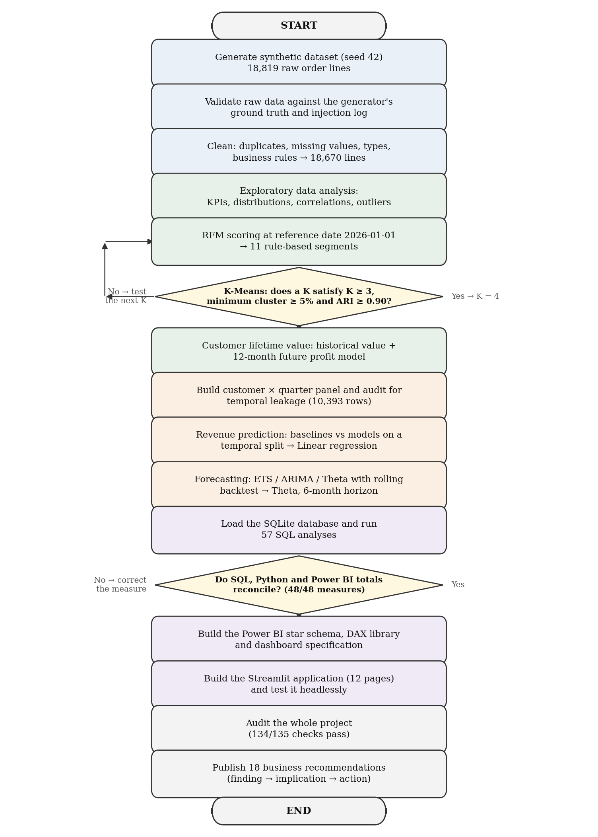
Figure 3.2: Implementation flowchart of the project lifecycle, from data generation to business decision support, including the three validation gates
CHAPTER-4
RESULTS, ANALYSIS AND VALIDATION
4.1 Data Quality Results
Cleaning reduced 18,819 raw order lines to 18,670 validated lines, removing 149 exact duplicates and treating 941 rows that failed at least one business rule. After treatment, 0 rules fail: every rule listed in Table 3.2 returns zero. The cleaned dataset carries 51 columns, of which 28 are engineered - calendar attributes, the delivered flag, revenue, profit and margin, discount and age bands, outlier flags and the reconciliation checks that confirm each line's revenue equals its own price, quantity and discount.
4.2 Exploratory Data Analysis Results
Table 4.1: Headline performance of the delivered revenue base
Indicator | Value | Indicator | Value
Delivered revenue | ₹6.01 Cr | Delivered orders | 12,212
Delivered profit | ₹1.40 Cr | Units sold | 22,772
Profit margin | 23.35% | Average order value | ₹4,917.83
Purchasing customers | 1,984 | Revenue per customer | ₹30,270
Booked value (all statuses) | ₹6.63 Cr | Profit per order | ₹1,148
Value lost to returns and cancellations | ₹62.55 L | Share of booked value lost | 9.43%

Revenue grew from ₹1.31 Cr in 2023 to ₹2.72 Cr in 2025 - 51.4% then 37.7% - while margin moved from 22.65% to 23.90%, so growth is not being bought with margin. Monthly revenue ranges from ₹5.73 L to ₹30.98 L, and October is the strongest month in all three years - the clearest seasonal signal the series carries.
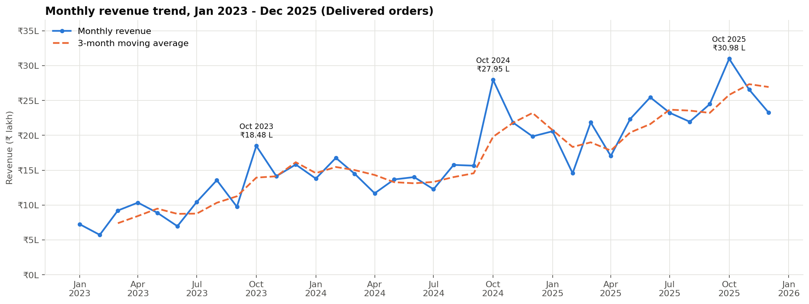
Figure 4.1: Monthly delivered revenue across the 36-month observation window
Table 4.2: Revenue, profit and margin by product category
Category | Products | Revenue | Revenue % | Profit | Margin %
Electronics | 13 | ₹3.01 Cr | 50.10% | ₹32.66 L | 10.85%
Fashion | 11 | ₹1.21 Cr | 20.08% | ₹51.58 L | 42.77%
Home & Kitchen | 11 | ₹1.04 Cr | 17.28% | ₹29.26 L | 28.20%
Beauty | 9 | ₹0.34 Cr | 5.66% | ₹15.82 L | 46.49%
Sports | 9 | ₹0.30 Cr | 4.98% | ₹7.65 L | 25.56%
Books | 8 | ₹0.11 Cr | 1.89% | ₹3.27 L | 28.72%

Electronics is the volume leader with 50.10% of revenue but only 23.29% of profit, because its 10.85% margin is the lowest in the catalogue, while Beauty carries the highest at 46.49%. The two are different kinds of asset and should not carry the same target.
Revenue is spread evenly across the 5 regions: the largest, South, holds 27.02% and the smallest 12.39%. A systematic test of all 30 region-category pairs found 0 pair more than two percentage points below the national margin for its category, so there is no regional margin problem to fix.
Discount matters more than expected: the 0% band carries a margin of 29.31% against 20.43% in the 31-40% band, and returns the best margin in 6 of the 6 categories tested. This is an association measured on observed orders, not a causal claim: the data cannot say what those orders would have done at a different discount.
The base is concentrated: the top 10% of customers produce 45.39% of revenue and the top 20% 64.33%. Repeat customers are 89.42% of the base and 98.59% of revenue, averaging ₹33,378 each against ₹4,019 for single-order customers. The median gap between consecutive orders is 54 days - the natural basis for an inactivity threshold.
4.3 RFM Segmentation Results
Table 4.3: Customer count, revenue and behaviour by RFM segment
Segment | Customers | Cust. % | Revenue | Rev. % | Avg recency (days) | Avg frequency | Avg monetary
Champions | 334 | 16.8% | ₹323.3 L | 53.8% | 32.6 | 15.4 | ₹96,797
Loyal Customers | 240 | 12.1% | ₹85.8 L | 14.3% | 91.2 | 7.2 | ₹35,745
Potential Loyalists | 152 | 7.7% | ₹21.9 L | 3.6% | 46.6 | 4.2 | ₹14,418
Recent Customers | 91 | 4.6% | ₹4.9 L | 0.8% | 17.8 | 2.2 | ₹5,369
Promising | 110 | 5.5% | ₹5.6 L | 0.9% | 59.4 | 2.2 | ₹5,117
Needs Attention | 123 | 6.2% | ₹15.5 L | 2.6% | 120.7 | 4.5 | ₹12,633
About to Sleep | 143 | 7.2% | ₹6.1 L | 1.0% | 115.4 | 2.1 | ₹4,233
Can't Lose Them | 79 | 4.0% | ₹42.9 L | 7.1% | 228.3 | 9.8 | ₹54,244
At Risk | 263 | 13.3% | ₹67.6 L | 11.3% | 259.3 | 5.9 | ₹25,717
Hibernating | 148 | 7.5% | ₹9.8 L | 1.6% | 199.0 | 3.1 | ₹6,593
Lost | 301 | 15.2% | ₹17.2 L | 2.9% | 731.6 | 2.1 | ₹5,717

Of 1,984 scored customers, the Champions segment is 16.84% of the base and 53.83% of revenue - an average of ₹96,797 each at an average recency of 32.6 days. The finding that matters operationally is at the opposite end of the table: the At Risk and Can't Lose Them segments together hold 18.40% of historical revenue in customers who have gone quiet. That is inactivity, not churn: the dataset defines no churn event, and no result in this report describes one.
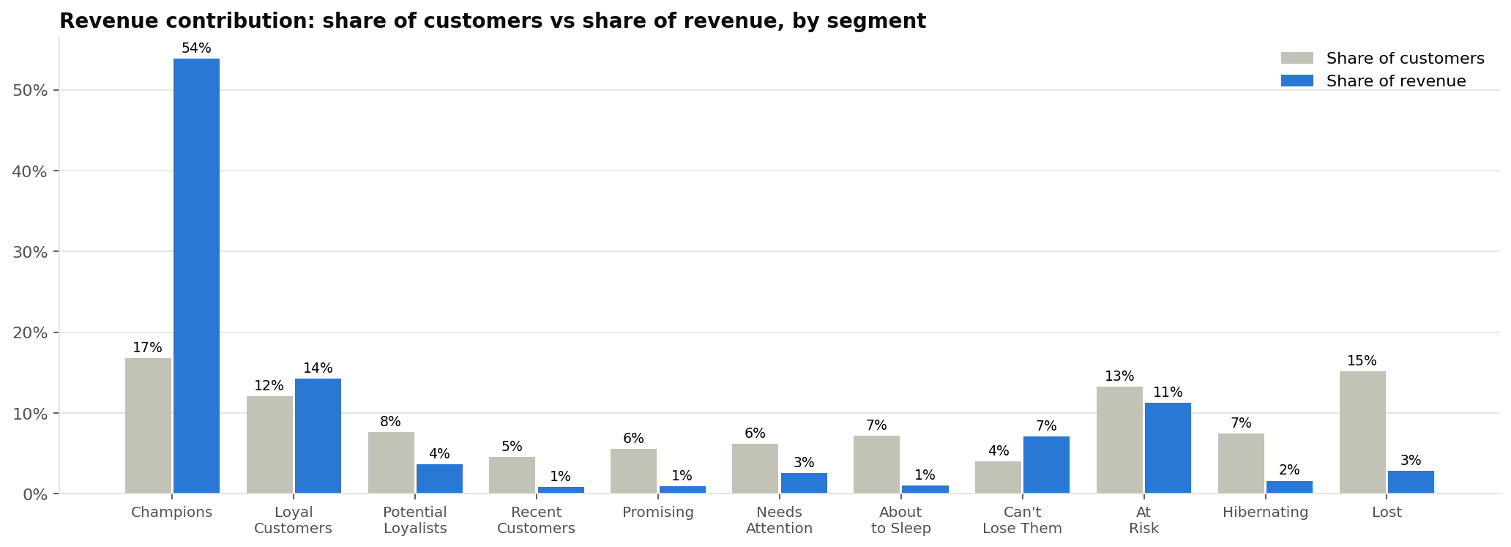
Figure 4.2: Revenue contribution by RFM segment
4.4 K-Means Segmentation Results
Of the values of K evaluated, 1 satisfied all three pre-declared rules, and K = 4 was selected with a silhouette coefficient of 0.3534. The two retained principal components explain 71.50% and 23.59% of the variance in the scaled feature space, so the projection in Figure 4.7 is a faithful picture of the clustering rather than a lossy one.
Table 4.4: Profile of the four customer clusters
Cluster | Label | Customers | Cust. % | Avg recency | Avg frequency | Avg monetary | Revenue %
0 | High-Value, Active | 364 | 18.35% | 31.7 | 14.9 | ₹91,851 | 55.67%
1 | Low-Value, Active | 453 | 22.83% | 63.9 | 2.8 | ₹6,658 | 5.02%
2 | Mid-Value, Lapsing | 753 | 37.95% | 173.0 | 6.2 | ₹28,229 | 35.39%
3 | Low-Value, Inactive | 414 | 20.87% | 590.6 | 2.1 | ₹5,677 | 3.91%

Cluster 0 - High-Value, Active - is 18.35% of customers and 55.67% of revenue, which is the same concentration the rule-based scheme found by a different route. The Adjusted Rand Index between the two schemes is 0.3952: substantial agreement on the high-value group, and genuine disagreement in the middle of the base, where the rules impose boundaries that the geometry of the data does not. Reporting both schemes is therefore more informative than reporting either alone.
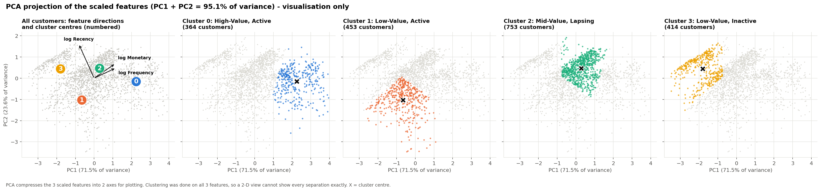
Figure 4.3: Customer clusters projected onto the first two principal components
4.5 Customer Value Results
Measured historical value across the base is ₹1.40 Cr of delivered profit on ₹6.01 Cr of revenue: a mean of ₹7,068 against a median of ₹3,893 per customer, the gap being the skew that makes averages misleading in this domain.
Table 4.5: Forward-value model comparison on the out-of-time test split
Model | Type | MAE | RMSE | R² | Spearman ρ | Selected
Ridge regression (baseline) | ML model | ₹2,853 | ₹4,469 | 0.2007 | 0.4779
Random forest | ML model | ₹2,793 | ₹4,269 | 0.2705 | 0.4869 | Yes
Gradient boosting | ML model | ₹2,982 | ₹4,323 | 0.2520 | 0.4960
Naive: last-12-month profit repeats | Benchmark | ₹2,947 | ₹4,648 | 0.1354 | 0.4402
Simplified formula (AOV x F x margin x P(repeat)) | Benchmark | ₹2,859 | ₹4,606 | 0.1509 | 0.4641
BG/NBD orders x avg profit per order | Benchmark | ₹2,693 | ₹4,356 | 0.2405 | 0.4899

The random forest was selected by the rule fixed in advance. Its test R² of 0.2705 means the model explains roughly a quarter of the variance in individual twelve-month profit, and its Spearman correlation of 0.4869 means it ranks customers considerably better than it predicts their exact value, which is its honest use: a ranking instrument for prioritising attention, not a forecast of any individual customer's spend. Of 1,984 customers, 1,716 were scored by the model and 268 by group average, because they had no order in the feature window. 52 customers are flagged as high-value and inactive for 180 days or more, holding ₹26.51 L of historical revenue between them.
4.6 Revenue Prediction Results
Table 4.6: Revenue prediction: candidate models and baselines on the out-of-time test split
Model | Type | MAE | RMSE | R² | WAPE % | Selected
Baseline: previous quarter (naive) | Baseline | ₹6,423 | ₹14,483 | -0.5700 | 145.1%
Baseline: same quarter last year (seasonal naive) | Baseline | ₹5,880 | ₹13,557 | -0.3756 | 132.9%
Baseline: 12-month quarterly mean | Baseline | ₹5,436 | ₹11,466 | 0.0160 | 122.8%
Linear regression | ML model | ₹5,658 | ₹11,232 | 0.0557 | 127.8% | Yes
Random forest | ML model | ₹5,762 | ₹11,265 | 0.0502 | 130.2%
Gradient boosting | ML model | ₹5,845 | ₹11,383 | 0.0302 | 132.1%
Random forest (tuned) | ML model | ₹5,554 | ₹11,148 | 0.0698 | 125.5%

The selected linear regression reaches a test MAE of ₹5,658, an RMSE of ₹11,232 and an R² of 0.0557, against ₹6,423 MAE and an R² of -0.5700 for the naive previous-quarter baseline. The model is therefore better than the baseline and still weak in absolute terms: it explains about 5.6% of the variance in individual outcomes at a WAPE of 127.8%. The reason is visible in the panel itself - 53.0% of customer-quarters have a zero actual value, so the target is dominated by whether a customer orders at all rather than by how much they spend. Total bias is 1.12%, so the model is close to unbiased in aggregate even though individual predictions are poor. Used at portfolio level it is informative; used to promise a number for one customer it would mislead, and the platform does not present it that way.
4.7 Forecasting Results
The Augmented Dickey-Fuller test on the revenue level gives a p-value of 0.2015, so the null of a unit root is not rejected and the series is treated as non-stationary in level. Across 7 rolling-origin folds the Theta: Theta (seasonality auto-tested) model returned the lowest mean backtest MAPE and beat both naive baselines on test MAE, so it was selected. On the held-out test window its MAE is ₹213,179 and its MAPE 7.77%; the mean backtest MAPE of 14.56% is the figure this report treats as the expected error, because a single favourable split is not evidence of accuracy.
Table 4.7: Six-month revenue forecast with prediction intervals
Month | Forecast | Lower 80% | Upper 80% | Lower 95% | Upper 95%
2026-01 | ₹25.67 L | ₹20.78 L | ₹30.56 L | ₹18.19 L | ₹33.14 L
2026-02 | ₹25.93 L | ₹18.56 L | ₹33.30 L | ₹14.66 L | ₹37.20 L
2026-03 | ₹26.20 L | ₹16.99 L | ₹35.40 L | ₹12.12 L | ₹40.27 L
2026-04 | ₹26.46 L | ₹15.73 L | ₹37.19 L | ₹10.05 L | ₹42.87 L
2026-05 | ₹26.73 L | ₹14.66 L | ₹38.79 L | ₹8.28 L | ₹45.18 L
2026-06 | ₹26.99 L | ₹13.73 L | ₹40.26 L | ₹6.70 L | ₹47.28 L

The 6 forecast months total ₹1.58 Cr, with an 80% interval from ₹1.00 Cr to ₹2.16 Cr, against ₹1.50 Cr actually delivered in the preceding six months. The interval is wide, and deliberately so: at this history length the honest statement is the interval, not the point estimate. The forecast is univariate - it uses no price, promotion, holiday or macroeconomic input - so it extrapolates the revenue series alone and would not anticipate a change driven by anything outside it.
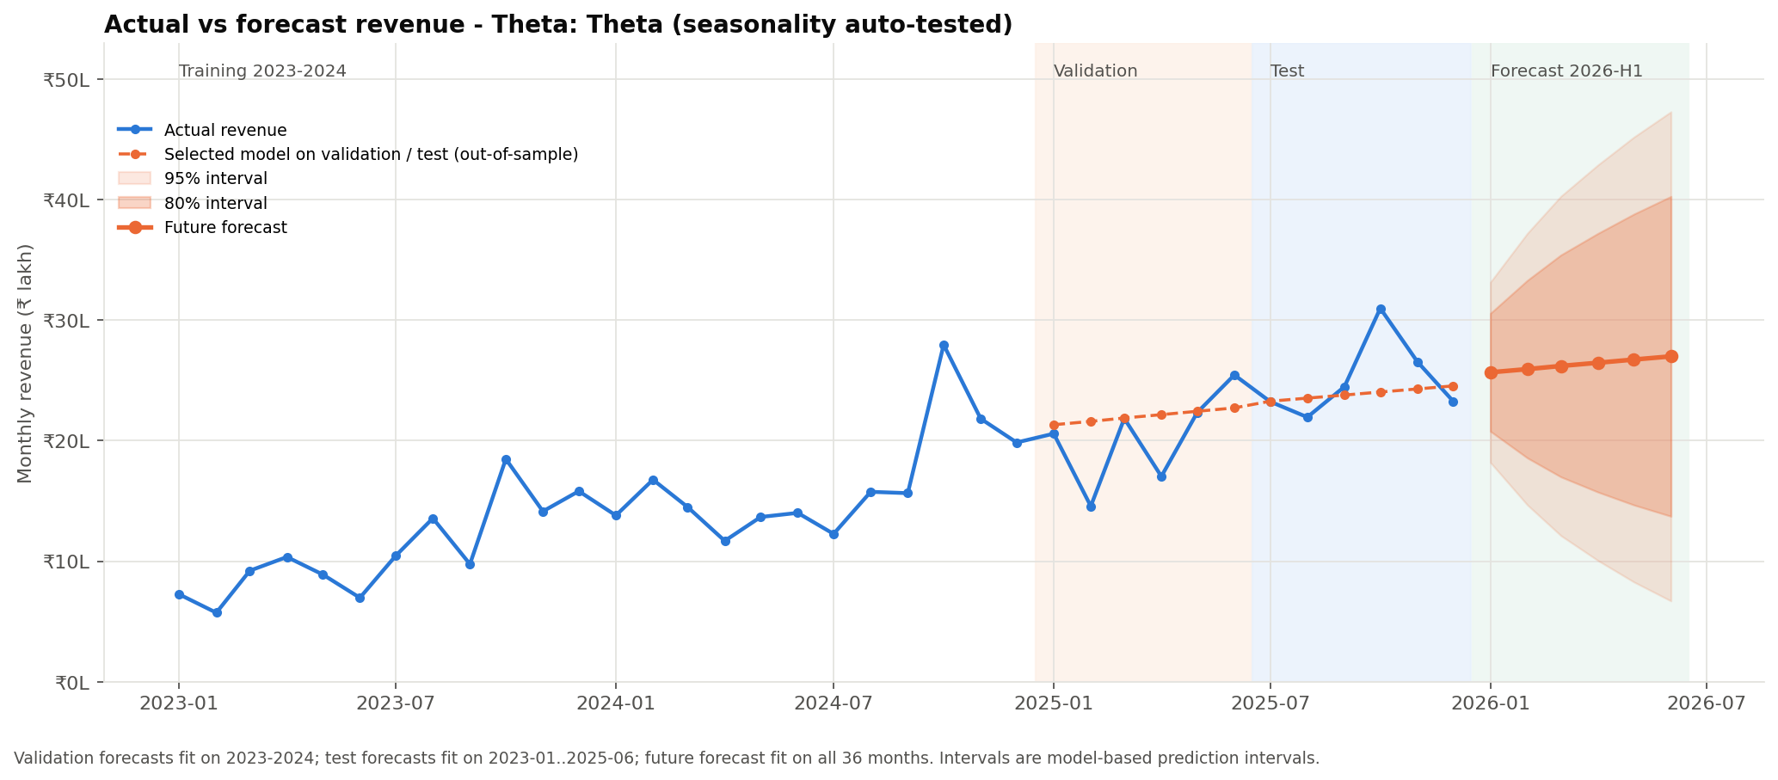
Figure 4.4: Historical monthly revenue with the six-month forecast and its prediction intervals
4.8 SQL Analytics Results
The database holds 11 tables and 2 views. All 56 referential and business-rule validation checks pass, as do 20 data-quality checks, and the 57 analytical queries reproduce the pipeline's metrics. The value of this layer is the reconciliation: revenue, profit, margin, order count, customer count and AOV computed independently in SQL agree with the Python pipeline to the paisa, which is what allows the two to be quoted interchangeably in the delivery layer.
Table 4.8: Principal business findings computed independently in SQL
Area | Finding (computed by SQL) | Source query
Revenue | Delivered revenue ₹6.01 Cr, profit ₹1.40 Cr (23.35% margin), 12,212 orders, 1,984 customers, AOV ₹4,918. | rev_kpi_summary
Growth | Revenue growth 2024: +51.4%, 2025: +37.7%; margin 22.65% -> 23.05% -> 23.90%. | rev_by_year
Customer concentration | Top 20% of customers = 64.33% of revenue; top 1% = 9.05%. | cust_concentration_summary
Repeat purchasing | Repeat customers are 89.4% of customers and 98.6% of revenue. | BQ12
Retention | Retained / active last year: 2024: 73.0%, 2025: 93.3%; new customers per year 2023: 1,137, 2024: 498, 2025: 349. | BQ15
RFM segments | Champions: 16.8% of customers, 53.8% of revenue; At Risk + Can't Lose Them: 18.4% of revenue. | seg_rfm_summary

4.9 Power BI Semantic Model Results
The semantic model comprises 13 tables, 9 relationships and 84 DAX measures. All 48 measure validations match their SQL equivalents and all 32 cross-surface consistency checks pass, so the model would report the same figures as the pipeline when opened in Power BI Desktop.
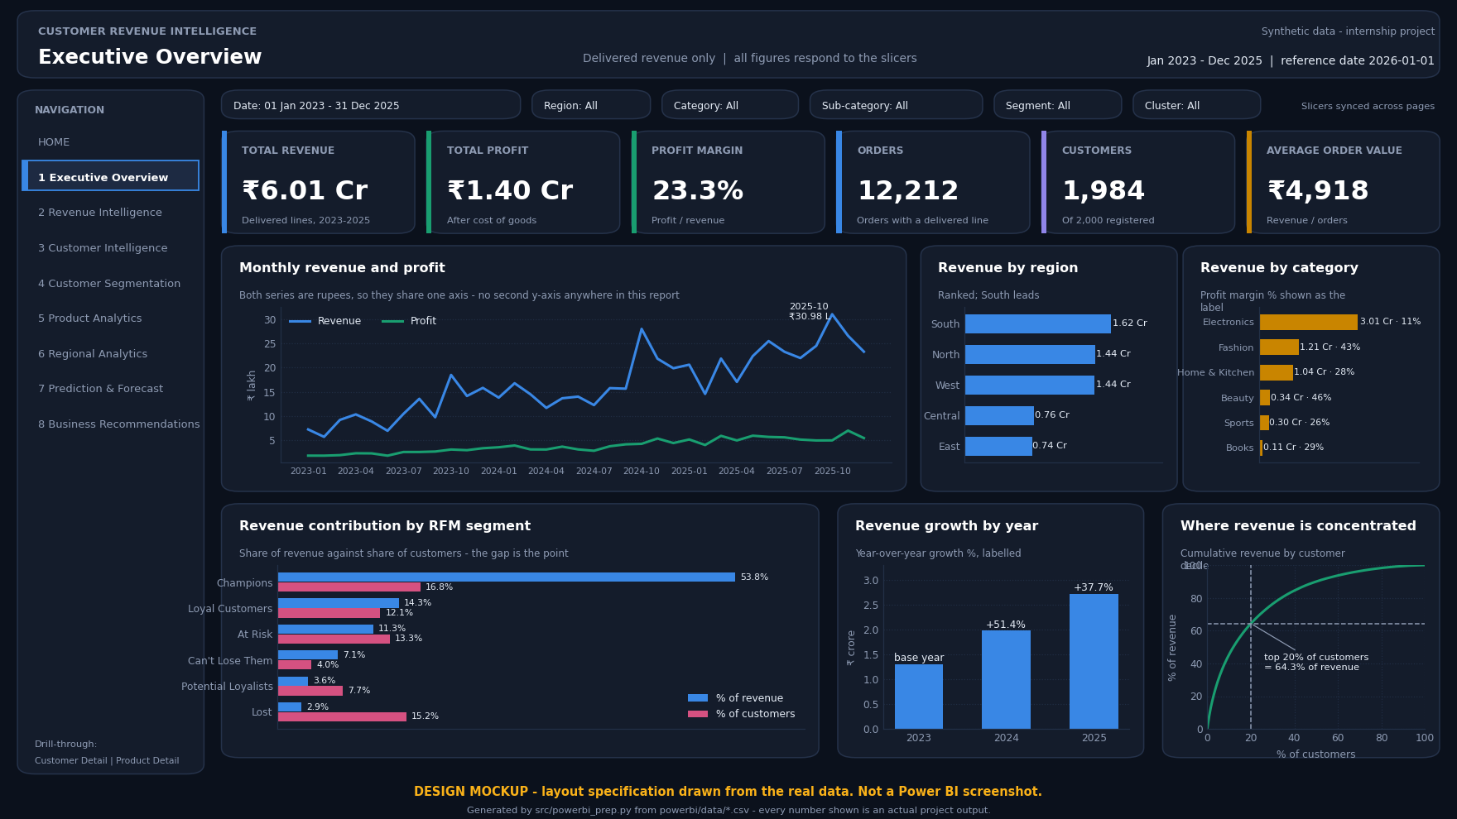
Figure 4.5: Power BI executive overview page - design mockup rendered from the project data, not a Power BI Desktop screenshot
Power BI Desktop is Windows-only and was unavailable in the build environment, so no screenshot of it exists or is claimed. The figure above and the eight further page designs in the project repository are mockups rendered from the real data and are labelled as mockups wherever they appear.
4.10 Streamlit Application Results
The application runs with 12 pages and passes 40 of 40 headless tests covering launch, navigation, every page's load, the filters, the model loading path, the download controls, the file-upload validation and the graceful-degradation behaviour when an artefact is missing. Figure 4.8 is a screenshot of the running application.
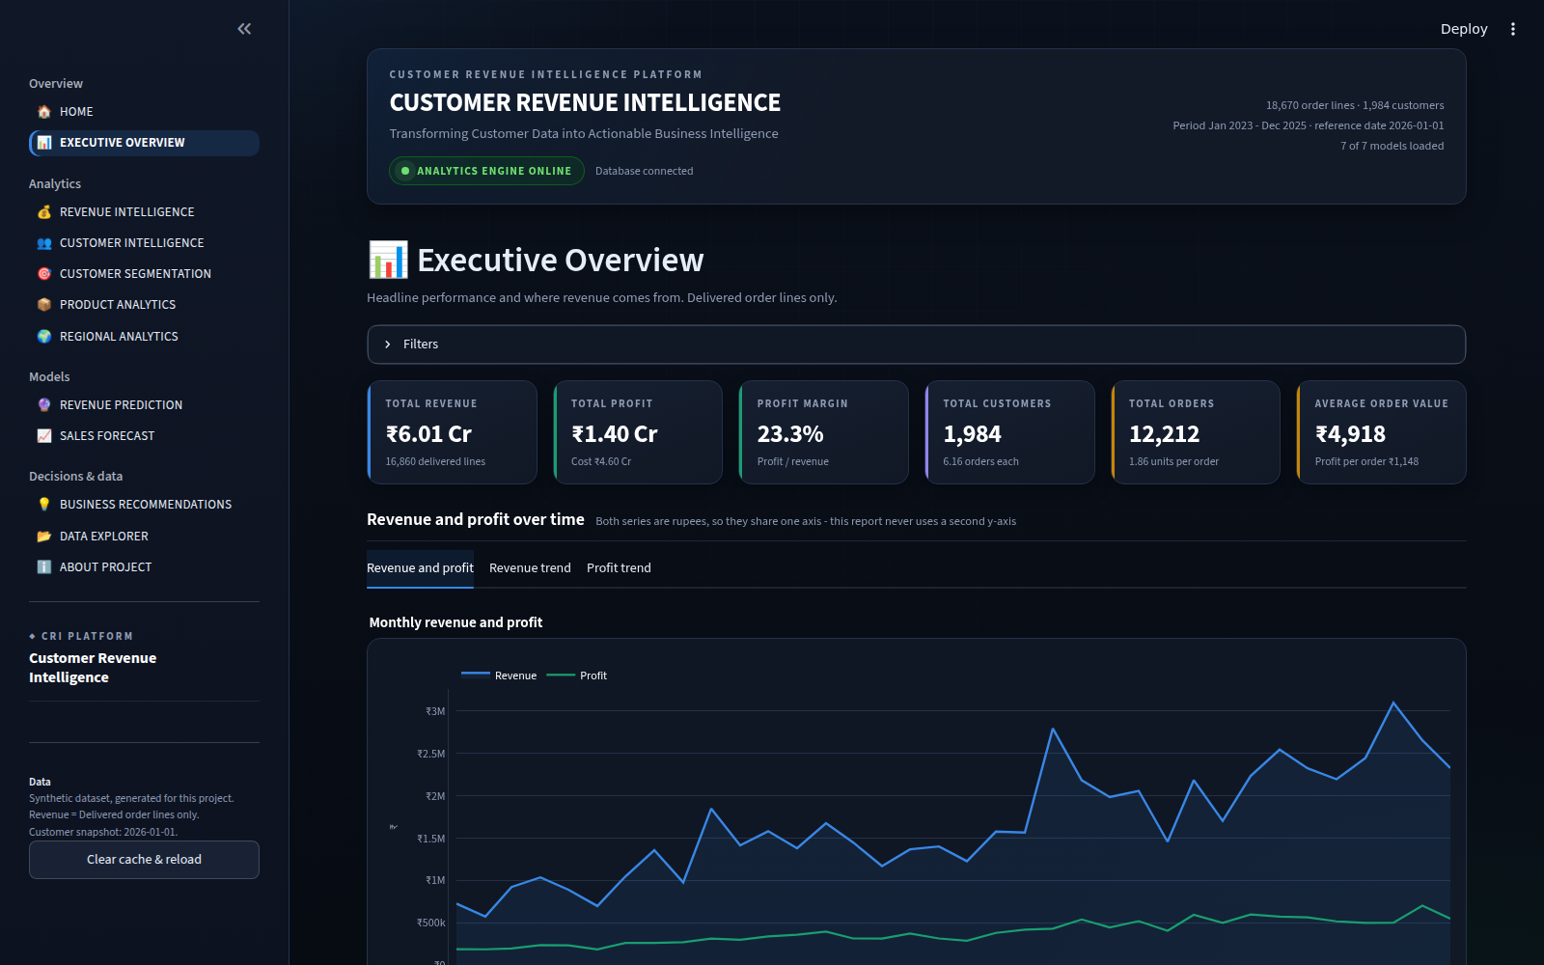
Figure 4.6: Streamlit application: Executive Overview page, a screenshot of the running application
4.11 Validation
Table 4.9: Validation position of every component of the platform
Component | Validation performed | Result
Raw data | Generator ground truth and injection log compared against the extract | Matched
Cleaning | Every business rule re-evaluated after treatment | 0 rules failing
RFM segmentation | Segment revenue totals reconciled to the delivered revenue base | Reconciled
K-Means | Cluster labels reproduced from the persisted scaler and model | 100% reproduced
Customer value | Out-of-time validation against three alternatives and a naive baseline | Selected model R² 0.2705
Revenue prediction | Leakage audit recomputing sampled feature rows from the transaction table | No leakage found
Forecasting | Rolling-origin backtest against naive and seasonal naive baselines | Mean MAPE 14.56%
SQL layer | Referential, business-rule and data-quality checks | 56/56 and 20/20 pass
Power BI model | Every DAX measure compared against its SQL equivalent | 48/48 match
Streamlit application | Headless functional tests | 40/40 pass
Whole project | End-to-end audit of structure, pipeline dependencies, cross-dataset consistency, model reproducibility and integration | 134/135 pass, 0 fail

4.12 Findings and Recommendations
Each recommendation below is stated with the evidence that produced it, the analytical stage that computed that evidence and the action it implies. None is an opinion added at the reporting stage: every one is generated from the pipeline's own outputs and is reproduced in the application's recommendations page.
Table 4.10: Business recommendations with their supporting evidence and analytical source
# | Area | Recommendation | Supporting metric | Value | Source
1 | Customer | Protect the top revenue decile before chasing new customers | Top-20% revenue share | 64.33% | SQL cust_concentration_summary (Step 10)
2 | Customer | Contact the 52 high-value customers who have not bought for 180+ days | Potentially at-risk high-value customers | 52 | Step 7 customer_value flags
3 | Customer | Convert single-purchase buyers: they are 10.6% of customers but 1.4% of revenue | Revenue per repeat customer vs single-purchase | ₹33,378 vs ₹4,019 | SQL BQ12, BQ17 (Step 10)
4 | Customer | Treat Champions as a retention job, not an acquisition one | Champions revenue share | 53.83% | Step 5 rfm_segment_summary
5 | Product | Stop judging Electronics on revenue alone | Electronics revenue share vs profit share | 50.10% vs 23.29% | SQL prod_category_performance, BQ04 (Step 10)
6 | Product | Review the 10 products the margin and returns rules flag | Products flagged | 10 | SQL prod_investigate, BQ03 (Step 10)
7 | Product | Treat discounting as a margin decision, not a volume lever | Categories where the 0% band has the best margin | 6 of 6 | SQL prod_discount_bands, BQ08 (Step 10)
8 | Product | Attack Fashion returns: 14.44% of booked value is lost | Fashion booked value lost | 14.44% | SQL BQ14 (Step 10)
9 | Regional | Grow Central and East on their margin, not on their size | Central margin vs South margin | 25.26% vs 22.80% | SQL reg_performance, BQ05 (Step 10)
10 | Regional | Do not build a region-specific pricing story - the differences are category mix | Region-category pairs more than 2pp below national margin | 0 of 30 | SQL BQ16, reg_category_matrix (Step 10)
11 | Regional | Route the customer-level actions by region, because value concentration is not uniform | Revenue per customer, highest vs lowest region | ₹32,434 vs ₹28,394 | SQL reg_performance (Step 10)
12 | Revenue | Plan capacity around the October-December peak | October share of an average year | 12.9% | SQL time_month_of_year, time_best_worst_months (Step 10)
13 | Revenue | Hold margin while growth continues | Revenue growth 2025 / margin 2025 | 37.72% / 23.90% | SQL rev_by_year (Step 10)
14 | Revenue | Recover part of the 9.43% of booked value lost to returns and cancellations | Booked value not realised | 9.43% | Step 4 eda_kpis
15 | Forecasting & Planning | Plan the next two quarters on ₹1.58 Cr of forecast revenue, with the interval shown | 6-month forecast (80% interval) | ₹1.58 Cr (₹1.00 Cr - ₹2.16 Cr) | Step 9 forecast_future, models/forecasting_metadata.json
16 | Forecasting & Planning | Trust the monthly forecast at about ±7.8% and no further | Forecast test MAPE | 7.77% | Step 9 forecast_model_comparison, forecasting_metadata.json
17 | Forecasting & Planning | Use the customer-level revenue prediction for ranking, not for rupee commitments | Prediction test R² / MAE | 0.056 / ₹5,658 | Step 8 revenue_model_comparison, models/revenue_model_metadata.json
18 | Forecasting & Planning | Re-run the pipeline before each planning cycle | Reference date / forecast fit window | 2026-01-01 / 2023-01 to 2025-12 (36 months) | Steps 5-9 metadata

Four carry most of the available value. Protecting the top revenue decile matters more than acquisition, because 45.39% of revenue sits there. The 52 high-value customers inactive for 180 days or more are a working list, not a statistic. The margin gap between Electronics and the best-margin category is a mix question the business can act on without changing a price. And the zero-discount band's margin advantage justifies a controlled test, which is the correct next step because the present evidence is associative.
CHAPTER-5
CONCLUSION AND FUTURE WORK
5.1 Conclusion
The project delivers what it set out to build: a platform carrying one validated dataset of 18,670 order lines through cleaning, exploratory analysis, dual segmentation, customer value analysis, supervised prediction, forecasting, an independent SQL implementation and two delivery surfaces, every stage re-runnable from a fixed seed. All eight objectives in Section 1.3 are met.
Three results are worth restating. Value is concentrated: the top 20% of customers carry 64.33% of ₹6.01 Cr in delivered revenue, and two independent methods identify substantially the same high-value group. The volume leader and the margin leader are different categories, making category strategy a mix question. And reliability differs sharply by horizon: monthly company revenue forecasts to a backtest MAPE of 14.56% while individual customer revenue predicts weakly - the report states both.
The integration claim is tested rather than asserted: an end-to-end audit of 135 checks covering structure, pipeline dependencies, cross-dataset consistency, model reproducibility, leakage and integration returns 134 passes and 0 failures across 39 Python modules and 9 executed notebooks.
5.2 Deviation from Expected Results
• Customer-level prediction was expected to be moderately accurate; it is weak. The test R² is 0.0557, because 53.0% of customer-quarters have a zero actual value and the target is dominated by whether a customer orders at all.
• A more flexible model was expected to win; a linear regression did. Under the pre-declared rule the ensembles bought no material accuracy, so the interpretable model was kept.
• Strong seasonality was expected; the Theta test found none. October is the highest month in all three years, but at 36 observations the test does not confirm a stable pattern, so no seasonal model was imposed to match expectation.
• The two segmentation schemes were expected to agree closely; they agree substantially but not fully. The Adjusted Rand Index is 0.3952: they converge on the high-value group and diverge in the middle, which is itself a finding about where rule boundaries are arbitrary.
5.3 Limitations
• Synthetic data. Every result describes a generated dataset. The methods transfer; the numbers describe no real business, including the internship host organisation.
• Short history. 36 months supports trend analysis but is thin for seasonal estimation, and the customer-quarter model is usable at portfolio level but not for an individual customer.
• Univariate forecast. No price, promotion or holiday input enters the forecast, so it cannot anticipate a change driven by anything outside the revenue series.
• Association, not causation, and no churn label. Every relationship reported here is measured on observed orders; establishing causation requires an experiment the data cannot substitute for. The dataset also defines no churn event, so recency-based inactivity is reported instead and the word churn never describes a result.
• Power BI not rendered in Desktop, and no user testing. The semantic model and measures were built and validated, but the page layouts are design mockups because Power BI Desktop is Windows-only; no screenshot of it is claimed. The interface design follows published principles but was not tested with users.
5.4 Future Scope
• Validate the pipeline on a real transaction dataset under an appropriate data-protection agreement, comparing the segment structure that emerges with the one reported here.
• Define an operational inactivity label with the business and convert the recency flag into a supervised model evaluated against it, and reframe next-quarter prediction as a two-stage problem - will the customer order at all, and if so how much - to address the zero-inflation limiting the present model.
• Extend the forecast with external regressors - promotion calendar, price index and holiday effects - and test the discount-margin association experimentally.
• Operationalise the pipeline with scheduled re-runs and drift monitoring, and complete the Power BI build on Windows.
REFERENCES
Entries are cited in the text by the bracketed number shown against each. Every entry is a published work, a standard textbook or the official documentation of software actually used in this project.
[1] Arthur, D., & Vassilvitskii, S. (2007). k-means++: The advantages of careful seeding. In Proceedings of the Eighteenth Annual ACM-SIAM Symposium on Discrete Algorithms (pp. 1027-1035). SIAM.
[2] Assimakopoulos, V., & Nikolopoulos, K. (2000). The theta model: A decomposition approach to forecasting. International Journal of Forecasting, 16(4), 521-530.
[3] Box, G. E. P., Jenkins, G. M., Reinsel, G. C., & Ljung, G. M. (2015). Time series analysis: Forecasting and control (5th ed.). Wiley.
[4] Breiman, L. (2001). Random forests. Machine Learning, 45(1), 5-32.
[5] Calinski, T., & Harabasz, J. (1974). A dendrite method for cluster analysis. Communications in Statistics, 3(1), 1-27.
[6] Chen, P. P.-S. (1976). The entity-relationship model: Toward a unified view of data. ACM Transactions on Database Systems, 1(1), 9-36.
[7] Chen, H., Chiang, R. H. L., & Storey, V. C. (2012). Business intelligence and analytics: From big data to big impact. MIS Quarterly, 36(4), 1165-1188.
[8] Codd, E. F. (1970). A relational model of data for large shared data banks. Communications of the ACM, 13(6), 377-387.
[9] Davies, D. L., & Bouldin, D. W. (1979). A cluster separation measure. IEEE Transactions on Pattern Analysis and Machine Intelligence, 1(2), 224-227.
[10] Dickey, D. A., & Fuller, W. A. (1979). Distribution of the estimators for autoregressive time series with a unit root. Journal of the American Statistical Association, 74(366), 427-431.
[11] Fader, P. S., Hardie, B. G. S., & Lee, K. L. (2005). “Counting your customers” the easy way: An alternative to the Pareto/NBD model. Marketing Science, 24(2), 275-284.
[12] Fader, P. S., Hardie, B. G. S., & Lee, K. L. (2005). RFM and CLV: Using iso-value curves for customer base analysis. Journal of Marketing Research, 42(4), 415-430.
[13] Few, S. (2006). Information dashboard design: The effective visual communication of data. O'Reilly Media.
[14] Gupta, S., Hanssens, D., Hardie, B., Kahn, W., Kumar, V., Lin, N., Ravishanker, N., & Sriram, S. (2006). Modeling customer lifetime value. Journal of Service Research, 9(2), 139-155.
[15] Harris, C. R., Millman, K. J., van der Walt, S. J., Gommers, R., Virtanen, P., Cournapeau, D., et al. (2020). Array programming with NumPy. Nature, 585(7825), 357-362.
[16] Hastie, T., Tibshirani, R., & Friedman, J. (2009). The elements of statistical learning: Data mining, inference, and prediction (2nd ed.). Springer.
[17] Hubert, L., & Arabie, P. (1985). Comparing partitions. Journal of Classification, 2(1), 193-218.
[18] Hughes, A. M. (1994). Strategic database marketing. Probus Publishing.
[19] Hunter, J. D. (2007). Matplotlib: A 2D graphics environment. Computing in Science & Engineering, 9(3), 90-95.
[20] Hyndman, R. J., & Athanasopoulos, G. (2021). Forecasting: Principles and practice (3rd ed.). OTexts. https://otexts.com/fpp3/
[21] Hyndman, R. J., & Billah, B. (2003). Unmasking the Theta method. International Journal of Forecasting, 19(2), 287-290.
[22] Hyndman, R. J., & Koehler, A. B. (2006). Another look at measures of forecast accuracy. International Journal of Forecasting, 22(4), 679-688.
[23] Jolliffe, I. T. (2002). Principal component analysis (2nd ed.). Springer.
[24] Kimball, R., & Ross, M. (2013). The data warehouse toolkit: The definitive guide to dimensional modeling (3rd ed.). Wiley.
[25] Lloyd, S. P. (1982). Least squares quantization in PCM. IEEE Transactions on Information Theory, 28(2), 129-137.
[26] MacQueen, J. (1967). Some methods for classification and analysis of multivariate observations. In Proceedings of the Fifth Berkeley Symposium on Mathematical Statistics and Probability (Vol. 1, pp. 281-297). University of California Press.
[27] McKinney, W. (2010). Data structures for statistical computing in Python. In Proceedings of the 9th Python in Science Conference (pp. 56-61).
[28] Microsoft. (n.d.). Data Analysis Expressions (DAX) reference. Microsoft Learn. https://learn.microsoft.com/en-us/dax/
[29] Pedregosa, F., Varoquaux, G., Gramfort, A., Michel, V., Thirion, B., Grisel, O., et al. (2011). Scikit-learn: Machine learning in Python. Journal of Machine Learning Research, 12, 2825-2830.
[30] Plotly Technologies Inc. (n.d.). Plotly Python graphing library documentation. https://plotly.com/python/
[31] Rousseeuw, P. J. (1987). Silhouettes: A graphical aid to the interpretation and validation of cluster analysis. Journal of Computational and Applied Mathematics, 20, 53-65.
[32] Schmittlein, D. C., Morrison, D. G., & Colombo, R. (1987). Counting your customers: Who are they and what will they do next? Management Science, 33(1), 1-24.
[33] Seabold, S., & Perktold, J. (2010). Statsmodels: Econometric and statistical modeling with Python. In Proceedings of the 9th Python in Science Conference (pp. 92-96).
[34] SQLite Consortium. (n.d.). SQLite documentation. https://www.sqlite.org/docs.html
[35] Streamlit Inc. (n.d.). Streamlit documentation. https://docs.streamlit.io/
[36] Thorndike, R. L. (1953). Who belongs in the family? Psychometrika, 18(4), 267-276.
[37] Tukey, J. W. (1977). Exploratory data analysis. Addison-Wesley.
[38] Wedel, M., & Kamakura, W. A. (2000). Market segmentation: Conceptual and methodological foundations (2nd ed.). Kluwer Academic Publishers.
APPENDIX
The appendix records the configuration needed to reproduce the results. The full source code is not reproduced here; it is held in the project repository across 39 Python modules (25,118 lines), 4 SQL files and 9 executed notebooks.
A.1 Model configuration
Table 5.1: Configuration of the persisted model artefacts
Artefact | Specification | Selection rule
kmeans_customer_segmentation.pkl | KMeans(n_clusters=4, random_state=42, n_init='auto') | K chosen by rules fixed in advance, then the highest silhouette among eligible K
rfm_scaler.pkl | log1p -> StandardScaler (sklearn Pipeline saved in rfm_scaler.pkl) | Fixed by the skew of the input features
clv_model.pkl | RandomForestRegressor(min_samples_leaf=10, n_estimators=300, n_jobs=-1, random_state=42) | lowest mean 5-fold CV RMSE on the training cutoff (test year not used)
revenue_prediction_model.pkl | Linear regression on 24 features (19 numeric, 5 categorical) | simplest model within 2% of the best validation RMSE (fixed in advance)
forecasting_model.pkl | Theta: Theta (seasonality auto-tested), alpha = 0.4772 | lowest mean backtest MAPE; must beat naive and seasonal naive on test MAE; within 5% -> simpler family

A.2 Selected SQL
The revenue KPI query below is the reconciliation anchor: the Python pipeline, the DAX measure set and this query must return the same figures, and Section 4.8 confirms that they do.
SELECT COUNT(DISTINCT o.order_id) AS orders,
COUNT(DISTINCT o.customer_id) AS customers,
ROUND(SUM(oi.sales), 2) AS revenue,
ROUND(SUM(oi.net_profit), 2) AS profit,
ROUND(100.0 * SUM(oi.net_profit)
/ SUM(oi.sales), 2) AS margin_pct,
ROUND(SUM(oi.sales)
/ COUNT(DISTINCT o.order_id), 2) AS aov
FROM order_items oi
JOIN orders o ON o.order_id = oi.order_id
WHERE oi.order_status = 'Delivered';
USER MANUAL
The platform is used through the Streamlit application. The steps below are the complete path from a clean machine to a running application.
1. Install Python 3.11 and clone or copy the project folder.
2. Create and activate a virtual environment: python -m venv .venv, then source .venv/bin/activate (Scripts\activate on Windows).
3. Install the dependencies: pip install -r requirements.txt.
4. If the processed data and model files are not present, run the pipeline stages below in order; each writes its own outputs and reads only the persisted output of the stage before it.
5. Start the application: streamlit run app.py, then open the local URL it prints (http://localhost:8501 by default).
python scripts/generate_dataset.py # synthetic data (seed 42)
python scripts/validate_dataset.py # generator ground truth
python -c "from src.data_cleaning import run_pipeline; run_pipeline()"
python -c "from src.eda import run_eda; run_eda()"
python -c "from src.rfm import run_rfm; run_rfm()"
python -c "from src.segmentation import run_segmentation; run_segmentation()"
python -c "from src.clv import run_clv; run_clv()"
python -c "from src.prediction import run_prediction; run_prediction()"
python -c "from src.forecasting import run_forecasting; run_forecasting()"
python -c "from src.sql_analytics import run_sql_workflow; run_sql_workflow()"
python -c "from src.powerbi_prep import run_powerbi_prep; run_powerbi_prep()"
python scripts/audit_project.py # 135-check project audit
The sidebar carries the page navigation, grouped into Overview, Analytics, Intelligence and Reference, and a control that clears the cache and reloads the data. Filters appear at the top of each analytical page and apply to every chart on that page. Tables can be downloaded as CSV from the control beneath them.
Table 5.2: Pages of the application and what each is used for
Page | Use
Home | Entry point: dataset status, what the platform contains and how to navigate it
Executive Overview | Headline KPIs, revenue trend and the top-line position in one screen
Revenue Intelligence | Revenue and profit over time, by category, by discount band and by payment method
Customer Intelligence | Concentration, repeat behaviour, tenure and value distribution
Customer Segmentation | RFM segments and K-Means clusters side by side, with the at-risk high-value list
Product Analytics | Category, sub-category and product performance on revenue, profit and margin
Regional Analytics | Region, state and city performance and the region-category margin test
Revenue Prediction | Next-quarter predictions with the model's own accuracy stated alongside them
Sales Forecast | Six-month forecast with prediction intervals and the backtest position
Business Recommendations | The eighteen recommendations, each with its evidence and source
Data Explorer | Filterable access to the underlying tables with CSV download
About the Project | Methodology, model metadata, limitations and reproduction instructions

If a page reports that a model artefact is missing, the corresponding pipeline stage in step 4 above has not been run; run it and use the sidebar control to clear the cache. If the database is absent the application falls back to the processed CSV files automatically and states which source it is using.
ACHIEVEMENTS
Each statement below is supported by a project artefact and by the validation recorded in Section 4.11.
• Built an end-to-end analytics platform spanning data generation, cleaning, exploratory analysis, dual segmentation, customer value analysis, supervised prediction, forecasting, SQL analytics, a Power BI semantic model and a 12-page application.
• Generated and validated an 18,819-line synthetic transaction dataset against its own generator ground truth, and cleaned it to 18,670 validated lines with zero business rules failing.
• Segmented 1,984 customers by two independent methods and quantified their agreement rather than assuming it.
• Selected every model by a rule fixed before the results were seen, and reported the weak results as weak.
• Reconciled 57 SQL queries and 84 DAX measures against the Python pipeline, with 48/48 measure validations matching.
• Tested the application headlessly, with 40/40 checks passing.
• Built a repeatable project audit of 135 checks covering structure, pipeline dependencies, cross-dataset consistency, model reproducibility and integration, of which 134 pass and 0 fail.
• Produced a reproducible project of 39 Python modules (25,118 lines), 4 SQL files, 9 executed notebooks, 144 figures and 238 output tables.
• Maintained an honest reporting standard throughout: weak model results are reported as weak, an association is not described as causation, inactivity is not described as churn, and design mockups are not described as screenshots.

