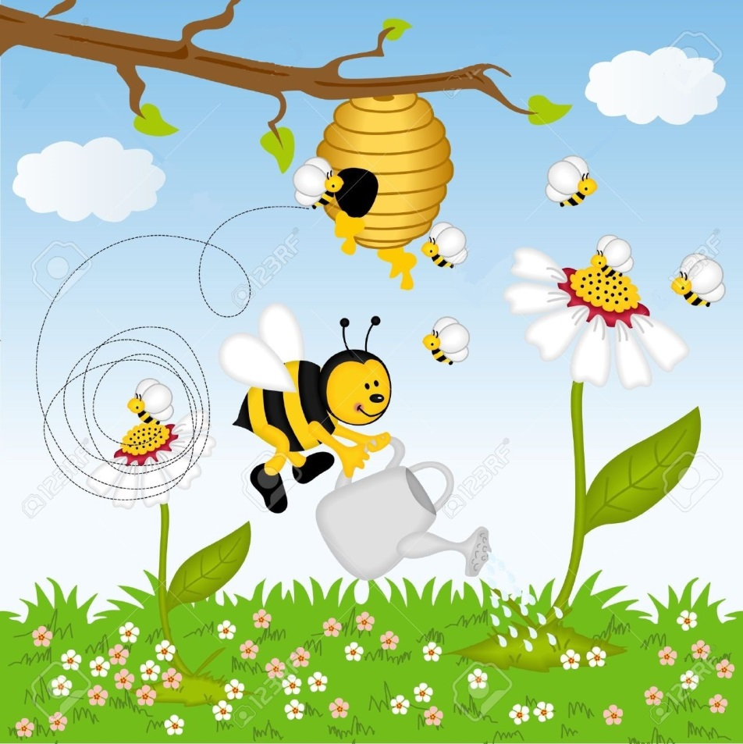Welcome to Bee Spree!

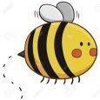Move the bee around the garden with your arrow keys to collect pollen from the flowers 

When you collect enough pollen, deposit it in the hive 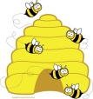

But be careful! If you run into a cloud of toxic green pollutants  or a screaming child , it’s game over!

Remember to go around the buildings that pop up around the screen as you navigate.