1.

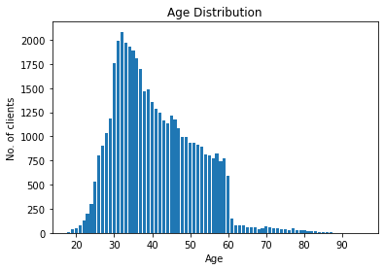

2.

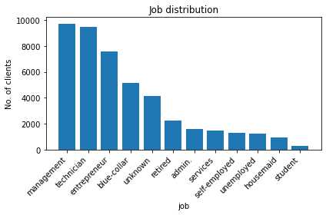

3.

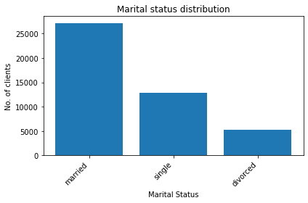

4.

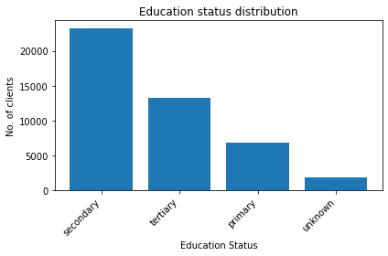

5.

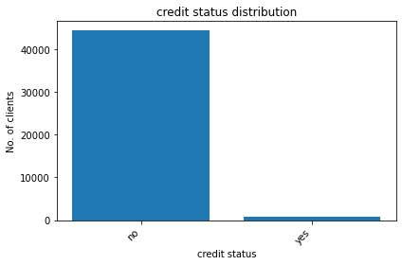

6.

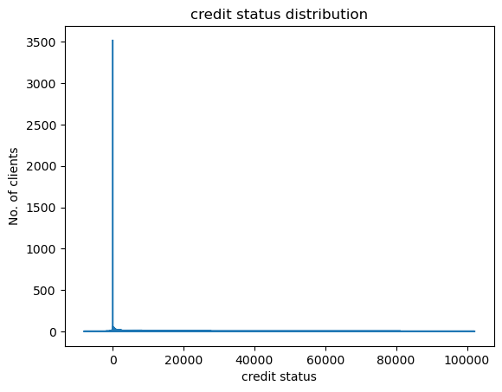

7.

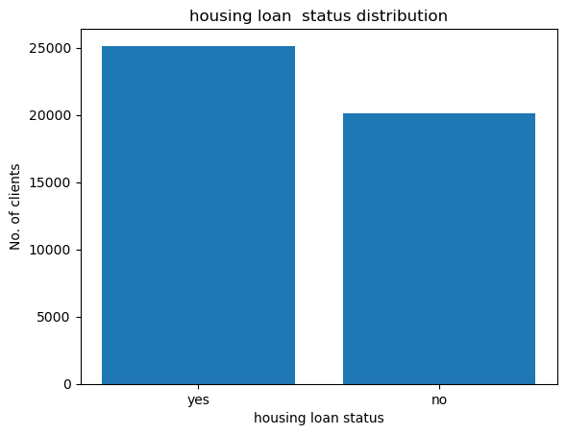

8.

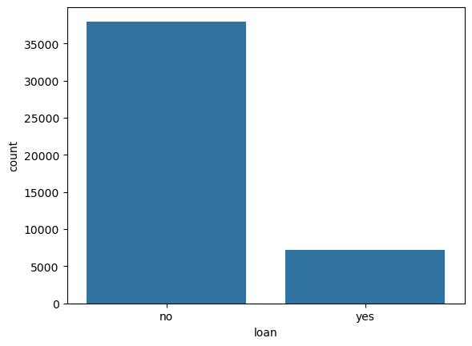

9.

['unknown' 'cellular' 'telephone']

10.

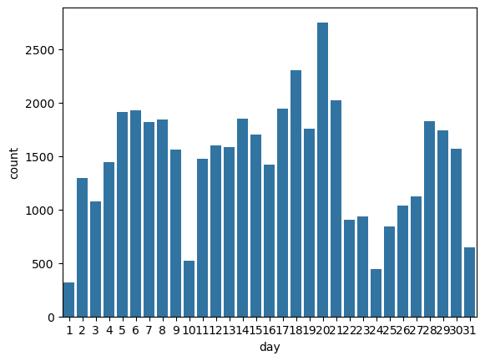

11.

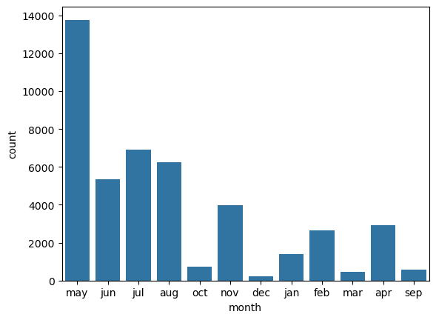

12.

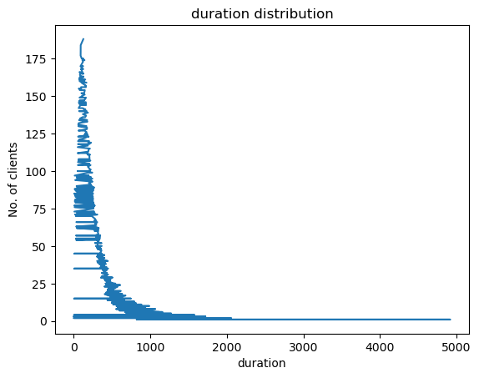

13.

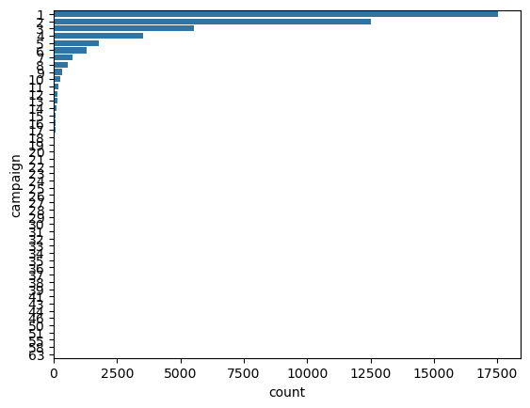

0 1

1 1

2 1

3 1

4 1

..

45211 1

45212 1

45213 1

45214 1

45215 2

Name: campaign, Length: 45216, dtype: int64

14.

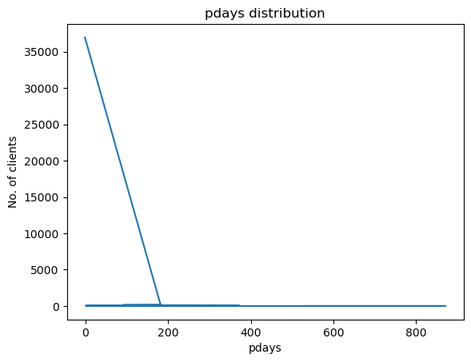

15.

0 1

1 1

2 1

3 1

4 1

..

45211 1

45212 1

45213 1

45214 1

45215 2

Name: campaign, Length: 45216, dtype: int64

16.

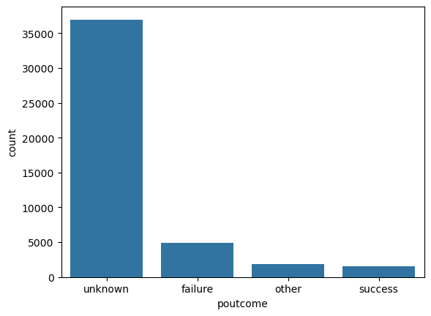

17.

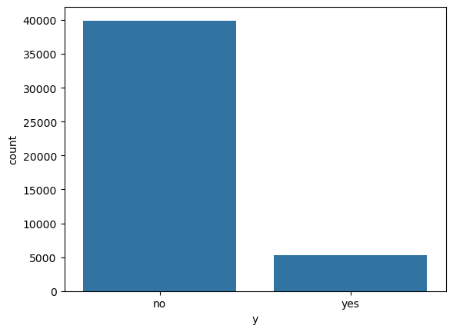

18.

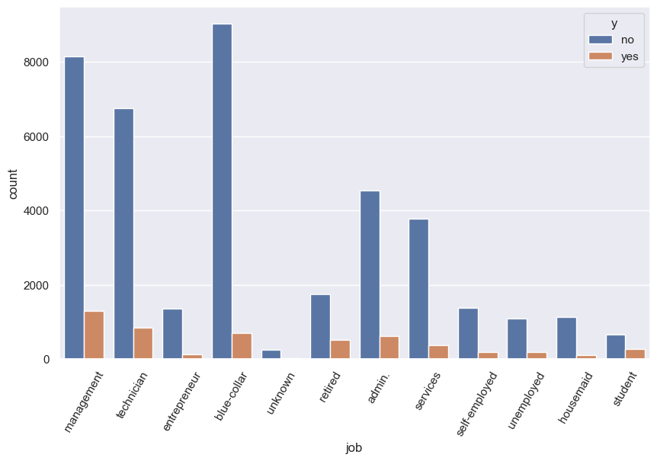

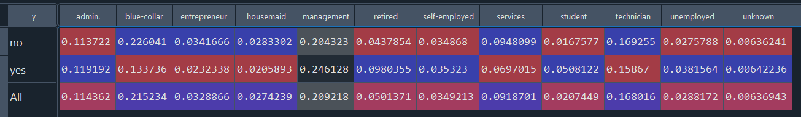

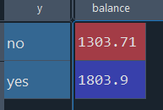

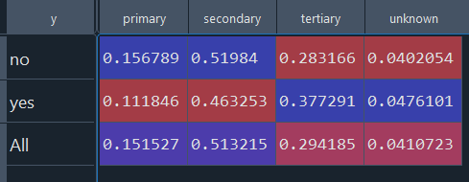

duration 0.342511

poutcome_success 0.307083

previous 0.169408

pdays 0.154260

balance 0.100468

job_retired 0.079928

job_student 0.076821

education_tertiary 0.066374

marital_status_single 0.063460

marital_single 0.063460

job_management 0.033044

poutcome_other 0.031879

job_unemployed 0.020329

education_unknown 0.011985

job_self-employed 0.000797

job_unknown 0.000242

age -0.008444

job_technician -0.009102

job_housemaid -0.015240

job_entrepreneur -0.019710

default_yes -0.022451

job_services -0.027949

education_secondary -0.036439

marital_married -0.060216

marital_status_married -0.060216

loan_yes -0.068289

job_blue-collar -0.072211

campaign -0.084277

housing_yes -0.139445

poutcome_unknown -0.167284