Quantum-safe cryptography: the quiet migration reshaping digital sovereignty
A companion report to the QSC Atlas
Companion to the QSC Atlas (qsc-atlas.vercel.app). Research note, June 2026. [Author and affiliation]
Abstract. The QSC Atlas maps, country by country, how governments are rebuilding public-key cryptography against the prospect of a quantum computer able to break it. This report explains what the Atlas is, the standards-governance principles it rests on, and how to read its categories. It sets out a two-axis classification: a coordination posture, the collective transition a state belongs to, and a standards role, the state's relationship to the algorithms themselves. It explains what it means for a state to have transitioned as a setter, a contextualiser, a taker, or a sovereign developer, and why the coordination method and standards choice of each country carry theoretical, methodological, and geopolitical weight. The report documents the method behind the Atlas, including its use of AI assistance and its design for continuous updating, and classifies the 54 countries currently recorded.

1. The instrument and its question
Public-key cryptography secures most of what the digital economy runs on, from interbank settlement to the authentication of government systems. A sufficiently powerful quantum computer would break the asymmetric algorithms that work depends on. No such machine exists, and the date of its arrival cannot be known. Governments, regulators, standards bodies and technology firms are nonetheless already rebuilding the cryptographic foundations of the digital economy against the anticipated threat. The QSC Atlas records that rebuilding as it happens.
Two features make the transition hard to read from any single vantage point. The first is that cryptographic protocols are infrastructure in the precise sense Star (1999) gives the term: they become visible only on breakdown, and they are migrated, not switched. The second is that no single authority governs the transition. Coordination happens, but it is scattered across national agencies, regional roadmaps and transnational standards bodies. The Atlas is built to show that scattered structure rather than to assume a centre that does not exist.
The map answers two questions that are easy to confuse and that matter for different reasons. The first is which collective transition a country belongs to: whose roadmap, timeline and rules it works to. The second is what the country does with the algorithms themselves: whether it writes them, adapts them, adopts them, or builds its own. The first is the map colour; the second is shown on each country profile. Keeping them apart is the central design decision, and section 3 sets out why.

2. Theoretical principles
The Atlas rests on the standards-governance literature, which treats technical standards as instruments of power with distributional consequences rather than neutral specifications. Buthe and Mattli (2011) show how first-mover advantage, institutional access and technical capacity determine whose preferences become embedded in global rules: a body that issues a technically mature proposal before competitors can mount an alternative sets the text around which others negotiate. Yates and Murphy (2019) trace the same pattern across a century of voluntary consensus standard-setting, in which widely adopted committee standards became de facto global norms without formal imposition.
The post-quantum case reproduces that pattern. When the United States National Institute of Standards and Technology published its first three post-quantum standards in 2024 (NIST, 2024), a contested question about which algorithms count as quantum-safe became a settled technical fact that other jurisdictions either adopt or must interoperate with. Standards perform distinct economic functions, compatibility, quality, variety reduction, and information (Blind, 2013), and the post-quantum standards act chiefly as compatibility and quality standards. The comparative vocabulary the Atlas uses, standard-setter, standard-contextualiser, and standard-taker, follows from the power asymmetry that Buthe and Mattli (2011) describe rather than from a single published typology: a state can set the baseline, adopt it as given, or occupy an intermediate position of contextualisation. Bradford's (2020) account of the Brussels Effect, in which European regulation diffuses globally through market access, is the instructive contrast: in cryptography the direction reverses, because the standards originate in Washington and travel through the global deployment of United States technology firms, while European institutions contextualise rather than set.
Sitting beneath the standards reading is the governance-of-expectations literature (Borup et al., 2006). It explains how shared expectations about an uncertain future coordinate action when settled knowledge is unavailable (Konrad, 2006), and how that coordination can harden into binding commitment while remaining revisable (Budde and Konrad, 2019). Because the quantum threat's timing is genuinely unknowable, the governance of the transition does not consolidate in the way the standards literature alone would predict; it stays provisional. Carlsson's (2006) work on the internationalisation of innovation systems frames the cross-border circulation that results. Together these strands give the Atlas its categories and its central claim: that a leaderless, systemic migration is being coordinated through expectations, standards and regulation rather than through any global authority.

3. The two-axis classification
Every recorded country is described on two dimensions. The coordination posture answers which collective transition the country belongs to, and takes one of four values: the EU coordinated roadmap, the NIST-led bloc, a sovereign bloc, or engaged but unaligned. The standards role answers the country's relationship to the algorithms, and takes one of four values: standard-setter, standard-contextualiser, standard-taker, or sovereign developer. The posture is the map colour; the role is a profile badge.
The two are kept separate because one label cannot carry both without losing information. An EU member coordinates through the European roadmap, yet the algorithms it deploys are the NIST standards, since no European alternative exists. Describing it with a single camp forces a choice between the club it belongs to and the technology it runs. Figure 1 shows the pattern across the 54 countries. The sovereign bloc and the engaged group each sit on a single role, but the NIST and EU blocs split across roles: the United States is the lone setter inside the NIST bloc, France and Germany contextualise within the EU roadmap, and the majority of EU members are takers. That split is precisely what a one-colour scheme would hide.
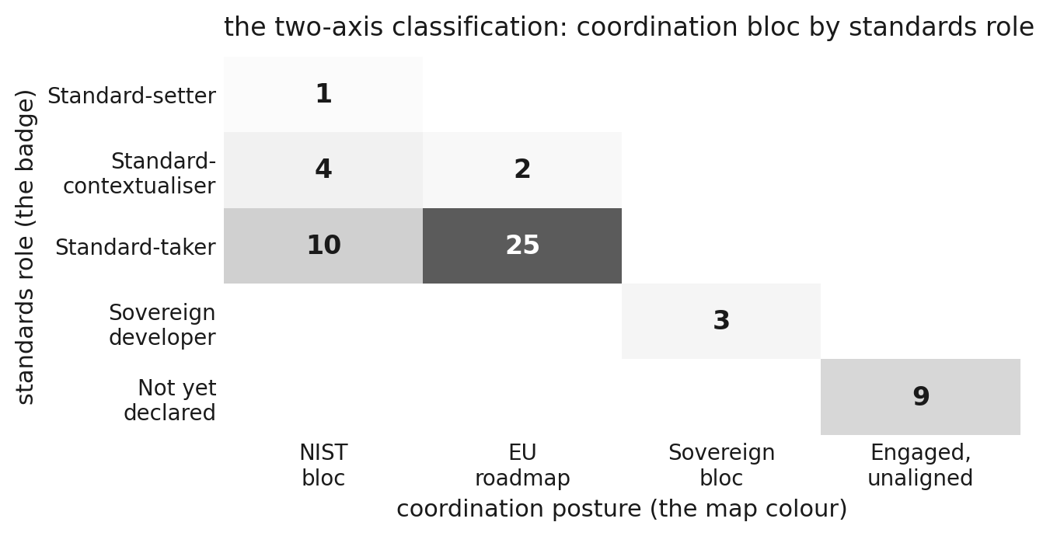
Figure 1. The two-axis classification: coordination bloc by standards role (54 countries).
Each value carries a plain meaning. A setter writes the baseline others adopt. A contextualiser accepts that baseline but adds national requirements, such as mandatory hybridisation, larger key sizes, or independent certification. A taker adopts the baseline broadly as published. A sovereign developer designs and mandates its own algorithms. On the coordination side, the EU roadmap is a coordination commitment under a shared timeline, the NIST-led bloc works to the United States cadence, the sovereign bloc runs an independent track, and the engaged-but-unaligned group is active on the transition without having committed to a bloc, a standard, or a timeline.

4. Method
The Atlas is built from institutional sources only: government bodies, national agencies and standards organisations. Each country's classification is traceable to the documents on its profile, and a country with no institutional source recedes as no-data rather than being assigned a camp by inference. Classification follows a single rubric applied in a fixed order. The sovereign test comes first and is strict: a state is sovereign only where it develops or mandates its own national post-quantum algorithm, not where it issues a national policy or programme that adopts the international baseline. EU membership in the coordinated roadmap is next, then adoption of the NIST suite, then a mixed national-plus-NIST position. A state that is active but has named no standard is recorded as engaged but unaligned rather than defaulted into the largest bloc.
Two further fields make the picture usable for policy. A confidence grade (high, medium, low) drives the opacity of each country on the map, so that soft calls read as soft, and a verification status records whether a claim has been checked against its source. A regulatory layer then records, for each country, the main governing instrument, its legal status, and the plain obligation it places on regulated entities. The legal status separates a binding instrument from soft law and from agency guidance, a distinction without which a recommendation and a statute would read alike. Figure 4 shows the distribution: most recorded countries carry at least one binding instrument, a single case rests on soft law alone, and nine have no governing instrument on record.
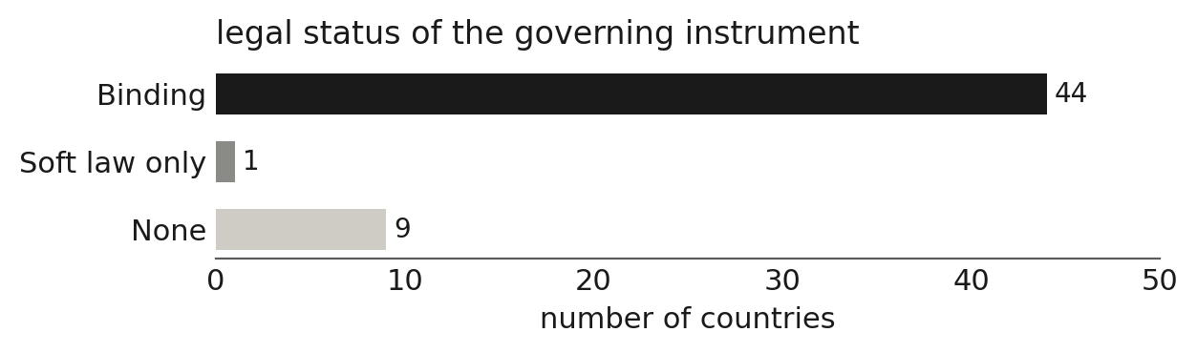
Figure 4. Legal status of the governing instrument across the recorded countries.

AI assistance and continuous updating
The corpus was gathered and provisionally classified with AI assistance under a documented protocol. Source discovery, extraction and a first-pass classification were produced with model support; each classification was then checked against its institutional source in an adversarial verification pass that flagged misattributions and low-confidence defaults for correction. Analytical authority rests with the researcher: contested codings are decided by hand, and stakeholder material from the CEPS Task Force is used only as anonymised aggregate findings, with no participant identification. The result is an audit trail in which every published claim can be traced to a source and a decision.
The Atlas is a static site with a real geographic map. Country data is held in a version-controlled store mirrored to a working database, and the site is rebuilt as new institutional documents appear, so it reflects the current public record rather than a single snapshot. Because the transition is unfinished, this design matters: the classification is provisional by construction, and the instrument is meant to move as the evidence does.

5. What the map shows
Read by coordination bloc, the 54 recorded countries fall into four groups of very different size (Figure 2). The EU coordinated roadmap is the largest at 27 members, the NIST-led bloc follows at 15, nine countries are engaged but unaligned, and three form the sovereign bloc. Read by standards role (Figure 3), the asymmetry is sharper still: one country sets the baseline, six contextualise it, 35 take it, three build their own, and nine have not yet declared a role.
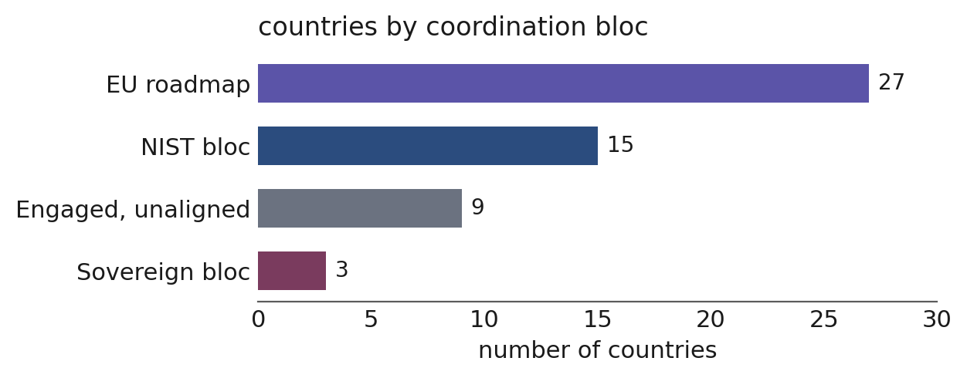
Figure 2. Countries by coordination bloc.
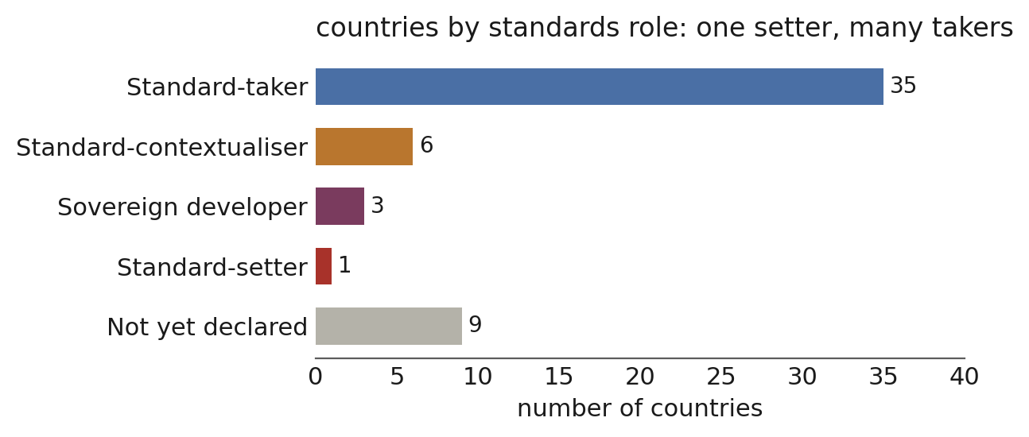
Figure 3. Countries by standards role: one setter, many takers.
The United States is the sole standard-setter. To have transitioned as a setter is to write the algorithms the rest of the world references and to bind one's own agencies to them, while the private sector follows through procurement and global product deployment rather than a single mandate. The EU coordinated roadmap is a coordination bloc, not a standards bloc: France and Germany contextualise the baseline through national certification and technical guidance, while the majority of members are takers. To have transitioned as an EU taker is to be bound by the Union's general obligations under NIS2 and DORA, to migrate on the shared 2030 and 2035 timeline, and to run the NIST algorithms with little national overlay.
The NIST-led bloc gathers the adopters outside the European coordination, including the United Kingdom and Canada. Four of its members contextualise rather than simply take: India, Japan and Singapore add national certification and sectoral guidance, and South Korea runs its own national competition that selects algorithms cognate with the NIST suite while keeping interoperability with it. The sovereign bloc is the small group that genuinely forks the baseline. China, Russia and Vietnam develop and mandate their own algorithms, and to have transitioned this way is to accept the interoperability and market-access costs of a parallel standards track in exchange for cryptographic independence. The nine engaged-but-unaligned states are active on the transition but have named no standard or timeline; recording them as undecided keeps the size of each committed bloc honest rather than inflating the NIST orbit with countries that have not chosen.

6. Why the stances matter
The theoretical interest is that the case extends governance-of-expectations and standards-governance accounts into a transnational, multi-level setting they have not previously addressed. Expectations generated within one national system, the United States, acquire binding force elsewhere through market mechanisms and institutional referencing rather than formal agreement (Buthe and Mattli, 2011). The internationalisation of innovation systems describes that cross-border circulation (Carlsson, 2006). Reading each country's posture and role is how that circulation becomes visible as data rather than assertion.
The methodological interest is that separating coordination from role avoids a bloc illusion. Without the split, the EU reads as a rival standards camp, when on the algorithm axis it runs the same baseline as the NIST bloc under a regulatory wrapper. The sources-only rule and the confidence grade keep the claims defensible, and the regulatory layer prevents a soft recommendation from being read as a binding rule. These choices are what allow the map to say only what the evidence supports.
The geopolitical interest is the most direct. Whoever sets the baseline holds structural power over the terms on which everyone else secures their systems (Buthe and Mattli, 2011), which is why the single-setter finding is the central fact of the field rather than a detail. The sovereign fork raises the prospect of competing spheres of cryptographic interoperability, where divergence in the underlying standards becomes a barrier to market access. Trade agreements have themselves extended into regulatory territory in ways that distribute advantage to the already established (Rodrik, 2018). The European position as contextualiser, and the contested middle of states that have not yet chosen, are where the shape of the next few years will be decided.

7. Conclusion
The QSC Atlas is a living instrument for a transition that has not finished and may not finish on any predictable schedule, since no cryptographically relevant quantum computer yet exists. Its contribution is to make the structure of a leaderless migration legible: which collective each country coordinates with, whose algorithms it runs, what binds it, and how confident the reading is. The classification recorded here is provisional, and the instrument is designed to move as institutional sources appear. The appendix sets out the current position for all 54 recorded countries.

Appendix A. Country classification (54 recorded countries)
Coordination bloc and standards role from the QSC Atlas; main regulation, legal status and obligation from its regulatory layer. Source for all entries: institutional documents on each country profile.
Country | Bloc | Role | Legal | Main regulation | Obligation
Argentina | Engaged, unaligned | Not yet declared | None | None on record | No binding post-quantum obligation is on record. Engagement to date is limited to awareness or research activity, with no national standard, instrument, or migration timeline adopted.
Australia | NIST bloc | Standard-taker | Binding | PSPF Policy 11 (Robust ICT systems) applying the Information Security Manual; Security of Critical Infrastructure Act 2018 (risk management programme); ASD/ACSC post-quantum cryptography guidance | Non-corporate Commonwealth entities must, under PSPF Policy 11, secure their ICT systems by applying the cyber security principles and risk-based approach of the Australian Government Information Security Manual, which the PSPF makes mandatory under the Public Governance, Performance and Accountability Act 2013; responsible entities for critical infrastructure assets must also maintain a risk management programme addressing cyber and information security hazards under the Security of Critical Infrastructure Act 2018. Neither instrument compels post-quantum migration: PQC is addressed through ASD/ACSC guidance aligned to the NIST algorithms, on an indicative timeline to 2030, with no binding obligation.
Austria | EU roadmap | Standard-taker | Binding | NIS2 Directive (EU) 2022/2555, Art. 21(2)(h); DORA, Regulation (EU) 2022/2554 (financial sector); Commission Recommendation (EU) 2024/1101 on a coordinated PQC roadmap; NIS Cooperation Group Coordinated Implementation Roadmap (2026/2030/2035) | Essential and important entities must use state-of-the-art cryptography under NIS2, transposed into national law, and financial entities face equivalent duties under DORA; neither yet names post-quantum algorithms specifically. Migration follows the EU coordinated roadmap, with high-risk use cases targeted for 2030 and full migration by 2035, which is encouraged rather than mandated.
Bahrain | Engaged, unaligned | Not yet declared | None | None on record | No binding post-quantum obligation is on record. Engagement to date is limited to awareness or research activity, with no national standard, instrument, or migration timeline adopted.
Belgium | EU roadmap | Standard-taker | Binding | NIS2 Directive (EU) 2022/2555, Art. 21(2)(h); DORA, Regulation (EU) 2022/2554 (financial sector); Commission Recommendation (EU) 2024/1101 on a coordinated PQC roadmap; NIS Cooperation Group Coordinated Implementation Roadmap (2026/2030/2035) | Essential and important entities must use state-of-the-art cryptography under NIS2, transposed into national law, and financial entities face equivalent duties under DORA; neither yet names post-quantum algorithms specifically. Migration follows the EU coordinated roadmap, with high-risk use cases targeted for 2030 and full migration by 2035, which is encouraged rather than mandated.
Brazil | NIST bloc | Standard-taker | Binding | ITI Normative Instruction No. 35/2026 (DOC-ICP-01.01), post-quantum algorithms in ICP-Brasil; GSI OSIC 15/2024 emerging-technologies cybersecurity guidance | Entities operating within the national public-key infrastructure (ICP-Brasil) and the GOV.BR advanced electronic signature must follow the cryptographic standards in ITI Normative Instruction No. 35/2026, which introduces the NIST post-quantum algorithms ML-DSA (FIPS 204) and ML-KEM into the accepted suites. The obligation is scoped to participants in the official PKI rather than the whole economy. Institutional Security Office guidance recommending wider post-quantum migration planning is advisory.
Brunei | Engaged, unaligned | Not yet declared | None | None on record | No binding post-quantum obligation is on record. Engagement to date is limited to awareness or research activity, with no national standard, instrument, or migration timeline adopted.
Bulgaria | EU roadmap | Standard-taker | Binding | NIS2 Directive (EU) 2022/2555, Art. 21(2)(h); DORA, Regulation (EU) 2022/2554 (financial sector); Commission Recommendation (EU) 2024/1101 on a coordinated PQC roadmap; NIS Cooperation Group Coordinated Implementation Roadmap (2026/2030/2035) | Essential and important entities must use state-of-the-art cryptography under NIS2, transposed into national law, and financial entities face equivalent duties under DORA; neither yet names post-quantum algorithms specifically. Migration follows the EU coordinated roadmap, with high-risk use cases targeted for 2030 and full migration by 2035, which is encouraged rather than mandated.
Canada | NIST bloc | Standard-taker | Binding | Treasury Board Security Policy Implementation Notice: Migrating the Government of Canada to Post-Quantum Cryptography (2025); Canadian Centre for Cyber Security roadmap ITSM.40.001 and guidance ITSAP.00.017 | Federal departments only: the Treasury Board Security Policy Implementation Notice, effective 9 October 2025 under the Policy on Government Security and the Policy on Service and Digital, requires Government of Canada systems that use cryptography to migrate to post-quantum cryptography, with a high-level migration plan due by April 2026, high-priority systems migrated by the end of 2031 and all remaining systems by 2035. The Cyber Centre roadmap (ITSM.40.001) and quantum-threat guidance (ITSAP.00.017) set the recommended method and align to the NIST standards. There is no economy-wide mandate on private organisations.
Chile | Engaged, unaligned | Not yet declared | None | None on record | No binding post-quantum obligation is on record. Engagement to date is limited to awareness or research activity, with no national standard, instrument, or migration timeline adopted.
China | Sovereign bloc | Sovereign developer | Binding | Cryptography Law of the PRC (2020); SM-series (SM2/SM3/SM4/SM9) commercial cryptography standards; Multi-Level Protection Scheme, level 3+ domestic algorithms; NGCC programme for sovereign PQC standards (2025) | Critical information infrastructure operators must use domestic (SM-series) algorithms under the Cryptography Law and the Multi-Level Protection Scheme; sovereign post-quantum standards are in development through the NGCC programme and not yet mandated.
Croatia | EU roadmap | Standard-taker | Binding | NIS2 Directive (EU) 2022/2555, Art. 21(2)(h); DORA, Regulation (EU) 2022/2554 (financial sector); Commission Recommendation (EU) 2024/1101 on a coordinated PQC roadmap; NIS Cooperation Group Coordinated Implementation Roadmap (2026/2030/2035) | Essential and important entities must use state-of-the-art cryptography under NIS2, transposed into national law, and financial entities face equivalent duties under DORA; neither yet names post-quantum algorithms specifically. Migration follows the EU coordinated roadmap, with high-risk use cases targeted for 2030 and full migration by 2035, which is encouraged rather than mandated.
Cyprus | EU roadmap | Standard-taker | Binding | NIS2 Directive (EU) 2022/2555, Art. 21(2)(h); DORA, Regulation (EU) 2022/2554 (financial sector); Commission Recommendation (EU) 2024/1101 on a coordinated PQC roadmap; NIS Cooperation Group Coordinated Implementation Roadmap (2026/2030/2035) | Essential and important entities must use state-of-the-art cryptography under NIS2, transposed into national law, and financial entities face equivalent duties under DORA; neither yet names post-quantum algorithms specifically. Migration follows the EU coordinated roadmap, with high-risk use cases targeted for 2030 and full migration by 2035, which is encouraged rather than mandated.
Czechia | EU roadmap | Standard-taker | Binding | NIS2 Directive (EU) 2022/2555, Art. 21(2)(h); DORA, Regulation (EU) 2022/2554 (financial sector); Commission Recommendation (EU) 2024/1101 on a coordinated PQC roadmap; NIS Cooperation Group Coordinated Implementation Roadmap (2026/2030/2035) | Essential and important entities must use state-of-the-art cryptography under NIS2, transposed into national law, and financial entities face equivalent duties under DORA; neither yet names post-quantum algorithms specifically. Migration follows the EU coordinated roadmap, with high-risk use cases targeted for 2030 and full migration by 2035, which is encouraged rather than mandated.
Denmark | EU roadmap | Standard-taker | Binding | NIS2 Directive (EU) 2022/2555, Art. 21(2)(h); DORA, Regulation (EU) 2022/2554 (financial sector); Commission Recommendation (EU) 2024/1101 on a coordinated PQC roadmap; NIS Cooperation Group Coordinated Implementation Roadmap (2026/2030/2035) | Essential and important entities must use state-of-the-art cryptography under NIS2, transposed into national law, and financial entities face equivalent duties under DORA; neither yet names post-quantum algorithms specifically. Migration follows the EU coordinated roadmap, with high-risk use cases targeted for 2030 and full migration by 2035, which is encouraged rather than mandated.
Djibouti | Engaged, unaligned | Not yet declared | None | None on record | No binding post-quantum obligation is on record. Engagement to date is limited to awareness or research activity, with no national standard, instrument, or migration timeline adopted.
Estonia | EU roadmap | Standard-taker | Binding | NIS2 Directive (EU) 2022/2555, Art. 21(2)(h); DORA, Regulation (EU) 2022/2554 (financial sector); Commission Recommendation (EU) 2024/1101 on a coordinated PQC roadmap; NIS Cooperation Group Coordinated Implementation Roadmap (2026/2030/2035) | Essential and important entities must use state-of-the-art cryptography under NIS2, transposed into national law, and financial entities face equivalent duties under DORA; neither yet names post-quantum algorithms specifically. Migration follows the EU coordinated roadmap, with high-risk use cases targeted for 2030 and full migration by 2035, which is encouraged rather than mandated.
Finland | EU roadmap | Standard-taker | Binding | NIS2 Directive (EU) 2022/2555, Art. 21(2)(h); DORA, Regulation (EU) 2022/2554 (financial sector); Commission Recommendation (EU) 2024/1101 on a coordinated PQC roadmap; NIS Cooperation Group Coordinated Implementation Roadmap (2026/2030/2035) | Essential and important entities must use state-of-the-art cryptography under NIS2, transposed into national law, and financial entities face equivalent duties under DORA; neither yet names post-quantum algorithms specifically. Migration follows the EU coordinated roadmap, with high-risk use cases targeted for 2030 and full migration by 2035, which is encouraged rather than mandated.
France | EU roadmap | Standard-contextualiser | Binding | NIS2 Directive (EU) 2022/2555, Art. 21(2)(h); DORA, Regulation (EU) 2022/2554 (financial sector); ANSSI PQC migration roadmap (2022; phases 2025/2030/2035); ANSSI Common Criteria security visa, PQC requirements | Essential and important entities must use state-of-the-art cryptography under NIS2; products seeking ANSSI certification must meet its PQC requirements, including mandatory hybridisation, by the visa deadlines (2027 sensitive products, 2030 all certified products).
Germany | EU roadmap | Standard-contextualiser | Binding | NIS2 Directive (EU) 2022/2555, Art. 21(2)(h); DORA, Regulation (EU) 2022/2554 (financial sector); BSI TR-02102 technical guidelines; BSI migration roadmap and recommendations | Essential and important entities must use state-of-the-art cryptography under NIS2; the BSI technical guidelines (TR-02102) set the recommended algorithms and hybrid deployment that public-sector procurement and certification follow, though the guidelines are not themselves statute.
Greece | EU roadmap | Standard-taker | Binding | NIS2 Directive (EU) 2022/2555, Art. 21(2)(h); DORA, Regulation (EU) 2022/2554 (financial sector); Commission Recommendation (EU) 2024/1101 on a coordinated PQC roadmap; NIS Cooperation Group Coordinated Implementation Roadmap (2026/2030/2035) | Essential and important entities must use state-of-the-art cryptography under NIS2, transposed into national law, and financial entities face equivalent duties under DORA; neither yet names post-quantum algorithms specifically. Migration follows the EU coordinated roadmap, with high-risk use cases targeted for 2030 and full migration by 2035, which is encouraged rather than mandated.
Hungary | EU roadmap | Standard-taker | Binding | NIS2 Directive (EU) 2022/2555, Art. 21(2)(h); DORA, Regulation (EU) 2022/2554 (financial sector); Commission Recommendation (EU) 2024/1101 on a coordinated PQC roadmap; NIS Cooperation Group Coordinated Implementation Roadmap (2026/2030/2035) | Essential and important entities must use state-of-the-art cryptography under NIS2, transposed into national law, and financial entities face equivalent duties under DORA; neither yet names post-quantum algorithms specifically. Migration follows the EU coordinated roadmap, with high-risk use cases targeted for 2030 and full migration by 2035, which is encouraged rather than mandated.
India | NIST bloc | Standard-contextualiser | Binding | SEBI Cybersecurity and Cyber Resilience Framework (CSCRF) for Regulated Entities; CERT-In Directions of 28 April 2022 under section 70B(6) of the IT Act 2000; CERT-In / MeitY / TEC post-quantum migration roadmap and technical reports | Entities regulated by SEBI (stock exchanges, depositories, brokers, asset managers and other market intermediaries) must comply with the CSCRF, which is mandatory and includes maintaining a cryptographic-asset inventory and conducting post-quantum risk assessment. Separately, CERT-In's 2022 Directions impose legally binding general cyber security and incident-reporting duties across the economy. The wider move to the NIST post-quantum baseline is set out in the CERT-In, MeitY and TEC roadmap and technical reports, which are guidance rather than binding rules.
Indonesia | Engaged, unaligned | Not yet declared | None | None on record | No binding post-quantum obligation is on record. National agencies have stated an ambition for cryptographic self-reliance and are preparing for migration, but no instrument or adopted standard is yet in place.
Ireland | EU roadmap | Standard-taker | Binding | NIS2 Directive (EU) 2022/2555, Art. 21(2)(h); DORA, Regulation (EU) 2022/2554 (financial sector); Commission Recommendation (EU) 2024/1101 on a coordinated PQC roadmap; NIS Cooperation Group Coordinated Implementation Roadmap (2026/2030/2035) | Essential and important entities must use state-of-the-art cryptography under NIS2, transposed into national law, and financial entities face equivalent duties under DORA; neither yet names post-quantum algorithms specifically. Migration follows the EU coordinated roadmap, with high-risk use cases targeted for 2030 and full migration by 2035, which is encouraged rather than mandated.
Israel | NIST bloc | Standard-taker | Binding | Bank of Israel Banking Supervision letter on quantum-era preparedness (7 January 2025); INCD Organizational Cyber Readiness to the Post-Quantum Age (best practices) | Supervised banking corporations must assess the suitability of their infrastructure for post-quantum encryption, map their cryptographic inventory and submit an initial preparedness plan with board-level approval to the Banking Supervision Department, within a year of the January 2025 letter. This obligation is confined to the banking sector. Israel National Cyber Directorate material applies economy-wide but is advisory, and no specific post-quantum algorithm is mandated nationally.
Italy | EU roadmap | Standard-taker | Binding | NIS2 Directive (EU) 2022/2555, Art. 21(2)(h); DORA, Regulation (EU) 2022/2554 (financial sector); Commission Recommendation (EU) 2024/1101 on a coordinated PQC roadmap; NIS Cooperation Group Coordinated Implementation Roadmap (2026/2030/2035) | Essential and important entities must use state-of-the-art cryptography under NIS2, transposed into national law, and financial entities face equivalent duties under DORA; neither yet names post-quantum algorithms specifically. Migration follows the EU coordinated roadmap, with high-risk use cases targeted for 2030 and full migration by 2035, which is encouraged rather than mandated.
Japan | NIST bloc | Standard-contextualiser | Binding | CRYPTREC Ciphers List for e-Government procurement (LS-0001-2022R2); Common Standards for Cybersecurity Measures for Government Agencies; CRYPTREC Cryptographic Technology Guideline on Post-Quantum Cryptography (FY2024 edition); Liaison Council on the Use of Post-Quantum Cryptography in Government Agencies | Government agencies procuring information systems must, under the Common Standards set by the Cybersecurity Strategic Headquarters, specify ciphers from the CRYPTREC Ciphers List in their procurement requirements, which makes the list binding by market access for government suppliers. This currently governs cryptography generally rather than mandating post-quantum algorithms; CRYPTREC has evaluated and is adding the NIST post-quantum algorithms (ML-KEM and others), and its post-quantum guideline remains advisory. There is no general post-quantum obligation on the private sector.
Latvia | EU roadmap | Standard-taker | Binding | NIS2 Directive (EU) 2022/2555, Art. 21(2)(h); DORA, Regulation (EU) 2022/2554 (financial sector); Commission Recommendation (EU) 2024/1101 on a coordinated PQC roadmap; NIS Cooperation Group Coordinated Implementation Roadmap (2026/2030/2035) | Essential and important entities must use state-of-the-art cryptography under NIS2, transposed into national law, and financial entities face equivalent duties under DORA; neither yet names post-quantum algorithms specifically. Migration follows the EU coordinated roadmap, with high-risk use cases targeted for 2030 and full migration by 2035, which is encouraged rather than mandated.
Lithuania | EU roadmap | Standard-taker | Binding | NIS2 Directive (EU) 2022/2555, Art. 21(2)(h); DORA, Regulation (EU) 2022/2554 (financial sector); Commission Recommendation (EU) 2024/1101 on a coordinated PQC roadmap; NIS Cooperation Group Coordinated Implementation Roadmap (2026/2030/2035) | Essential and important entities must use state-of-the-art cryptography under NIS2, transposed into national law, and financial entities face equivalent duties under DORA; neither yet names post-quantum algorithms specifically. Migration follows the EU coordinated roadmap, with high-risk use cases targeted for 2030 and full migration by 2035, which is encouraged rather than mandated.
Luxembourg | EU roadmap | Standard-taker | Binding | NIS2 Directive (EU) 2022/2555, Art. 21(2)(h); DORA, Regulation (EU) 2022/2554 (financial sector); Commission Recommendation (EU) 2024/1101 on a coordinated PQC roadmap; NIS Cooperation Group Coordinated Implementation Roadmap (2026/2030/2035) | Essential and important entities must use state-of-the-art cryptography under NIS2, transposed into national law, and financial entities face equivalent duties under DORA; neither yet names post-quantum algorithms specifically. Migration follows the EU coordinated roadmap, with high-risk use cases targeted for 2030 and full migration by 2035, which is encouraged rather than mandated.
Malaysia | NIST bloc | Standard-taker | Binding | Cyber Security Act 2024 (Act 854); CyberSecurity Malaysia / NACSA Post-Quantum Cryptography Migration Framework | The Cyber Security Act 2024, in force since 26 August 2024, places binding cyber security duties on designated national critical information infrastructure entities, including risk assessment, audit and incident reporting, but it does not mandate post-quantum cryptography specifically. Migration to the NIST post-quantum baseline is set out in the CyberSecurity Malaysia and NACSA Migration Framework, which is technical guidance and is not in itself legally binding.
Malta | EU roadmap | Standard-taker | Binding | NIS2 Directive (EU) 2022/2555, Art. 21(2)(h); DORA, Regulation (EU) 2022/2554 (financial sector); Commission Recommendation (EU) 2024/1101 on a coordinated PQC roadmap; NIS Cooperation Group Coordinated Implementation Roadmap (2026/2030/2035) | Essential and important entities must use state-of-the-art cryptography under NIS2, transposed into national law, and financial entities face equivalent duties under DORA; neither yet names post-quantum algorithms specifically. Migration follows the EU coordinated roadmap, with high-risk use cases targeted for 2030 and full migration by 2035, which is encouraged rather than mandated.
Netherlands | EU roadmap | Standard-taker | Binding | NIS2 Directive (EU) 2022/2555, Art. 21(2)(h); DORA, Regulation (EU) 2022/2554 (financial sector); NCSC-NL TLS guidelines; PQC Migration Handbook (AIVD, CWI, TNO, 2024) | Essential and important entities must use state-of-the-art cryptography under NIS2; national guidance (NCSC TLS guidelines, the PQC Migration Handbook) sets the recommended approach and the government-wide QvC-Rijk programme coordinates public-sector migration.
New Zealand | NIST bloc | Standard-taker | Binding | Protective Security Requirements (PSR) mandatory requirements; New Zealand Information Security Manual (NZISM) post-quantum preparation guidance (Section 2.4) | Government agencies covered by the Protective Security Requirements (a Cabinet direction binding on public service departments and other mandated agencies, not a statute) must manage information security in line with the PSR's mandatory requirements and report annually on compliance. The post-quantum element is advisory only: NZISM Section 2.4 directs agencies to inventory cryptographically protected assets and plan migration to post-quantum standards referencing the NIST work, and compliance with the NZISM is not required as a matter of law. No obligation falls on the wider economy.
Norway | NIST bloc | Standard-taker | Binding | Cryptographic Security Regulation (Forskrift om kryptosikkerhet, 2018, no. 2055) under the National Security Act (sikkerhetsloven); Digital Security Act (Digitalsikkerhetsloven), implementing the NIS Directive (EU) 2016/1148, in force 1 October 2025; NSM quantum migration programme and Cryptographic Recommendations | Binding law governs Norway's cryptographic and cyber posture: under the Security Act and its Cryptographic Security Regulation, NSM approves the cryptographic systems that protect classified information, and the Digital Security Act imposes cyber-risk duties on essential and digital service providers. Neither instrument mandates post-quantum cryptography specifically; the PQC content sits in NSM's quantum migration programme and Cryptographic Recommendations, which advise organisations to plan and carry out migration to quantum-resistant cryptography but attach no legal obligation. As an EEA state, Norway has adopted the NIS1 framework as national law and tracks NIS2 for future incorporation.
Poland | EU roadmap | Standard-taker | Binding | NIS2 Directive (EU) 2022/2555, Art. 21(2)(h); DORA, Regulation (EU) 2022/2554 (financial sector); Commission Recommendation (EU) 2024/1101 on a coordinated PQC roadmap; NIS Cooperation Group Coordinated Implementation Roadmap (2026/2030/2035) | Essential and important entities must use state-of-the-art cryptography under NIS2, transposed into national law, and financial entities face equivalent duties under DORA; neither yet names post-quantum algorithms specifically. Migration follows the EU coordinated roadmap, with high-risk use cases targeted for 2030 and full migration by 2035, which is encouraged rather than mandated.
Portugal | EU roadmap | Standard-taker | Binding | NIS2 Directive (EU) 2022/2555, Art. 21(2)(h); DORA, Regulation (EU) 2022/2554 (financial sector); Commission Recommendation (EU) 2024/1101 on a coordinated PQC roadmap; NIS Cooperation Group Coordinated Implementation Roadmap (2026/2030/2035) | Essential and important entities must use state-of-the-art cryptography under NIS2, transposed into national law, and financial entities face equivalent duties under DORA; neither yet names post-quantum algorithms specifically. Migration follows the EU coordinated roadmap, with high-risk use cases targeted for 2030 and full migration by 2035, which is encouraged rather than mandated.
Romania | EU roadmap | Standard-taker | Binding | NIS2 Directive (EU) 2022/2555, Art. 21(2)(h); DORA, Regulation (EU) 2022/2554 (financial sector); Commission Recommendation (EU) 2024/1101 on a coordinated PQC roadmap; NIS Cooperation Group Coordinated Implementation Roadmap (2026/2030/2035) | Essential and important entities must use state-of-the-art cryptography under NIS2, transposed into national law, and financial entities face equivalent duties under DORA; neither yet names post-quantum algorithms specifically. Migration follows the EU coordinated roadmap, with high-risk use cases targeted for 2030 and full migration by 2035, which is encouraged rather than mandated.
Russia | Sovereign bloc | Sovereign developer | Binding | GOST R 34.10-2012 / 34.12-2015 national cryptographic standards; FSB / TC26 cryptographic regulation; Indigenous PQC candidates (Shipovnik, Hypericum, Codiaeum) | State and regulated systems must use the national GOST cryptographic suite certified under FSB oversight; post-quantum GOST standardisation is in progress and not yet mandated.
Saudi Arabia | NIST bloc | Standard-taker | Binding | NCA National Cryptographic Standards (NCS-1:2020); NCA consultation adding post-quantum algorithms, RNGs and QKD to the NCS; CST Securing Data in the Quantum Computing Era (ICT sector) | Government entities and critical national infrastructure must meet the National Cybersecurity Authority's minimum cryptographic requirements set in the National Cryptographic Standards (NCS-1:2020), which the NCA is mandated to enforce. The standard already carries a post-quantum cryptography appendix, and the NCA has run a public consultation to add post-quantum algorithms; until that update is finalised, no specific post-quantum algorithm is yet mandated. Communications, Space and Technology Commission material for the ICT sector is advisory only.
Singapore | NIST bloc | Standard-contextualiser | Soft law only | CSA Quantum-Safe Handbook and Quantum Readiness Index; MAS Advisory on Addressing the Cybersecurity Risks Associated with Quantum (MAS/TCRS/2024/01); IMDA reference specifications for quantum-safe and QKD networks (draft) | No organisation in Singapore is legally required to adopt post-quantum cryptography. The CSA Quantum-Safe Handbook advises critical information infrastructure owners and government agencies to inventory cryptographic assets and plan migration to the NIST post-quantum baseline, and the MAS advisory makes the same recommendations to financial institutions, but both are advisory only and carry no enforceable obligation.
Slovakia | EU roadmap | Standard-taker | Binding | NIS2 Directive (EU) 2022/2555, Art. 21(2)(h); DORA, Regulation (EU) 2022/2554 (financial sector); Commission Recommendation (EU) 2024/1101 on a coordinated PQC roadmap; NIS Cooperation Group Coordinated Implementation Roadmap (2026/2030/2035) | Essential and important entities must use state-of-the-art cryptography under NIS2, transposed into national law, and financial entities face equivalent duties under DORA; neither yet names post-quantum algorithms specifically. Migration follows the EU coordinated roadmap, with high-risk use cases targeted for 2030 and full migration by 2035, which is encouraged rather than mandated.
Slovenia | EU roadmap | Standard-taker | Binding | NIS2 Directive (EU) 2022/2555, Art. 21(2)(h); DORA, Regulation (EU) 2022/2554 (financial sector); Commission Recommendation (EU) 2024/1101 on a coordinated PQC roadmap; NIS Cooperation Group Coordinated Implementation Roadmap (2026/2030/2035) | Essential and important entities must use state-of-the-art cryptography under NIS2, transposed into national law, and financial entities face equivalent duties under DORA; neither yet names post-quantum algorithms specifically. Migration follows the EU coordinated roadmap, with high-risk use cases targeted for 2030 and full migration by 2035, which is encouraged rather than mandated.
South Korea | NIST bloc | Standard-contextualiser | Binding | KCMVP cryptographic module validation (government); KpqC national algorithm selections (2025: NTRU+, SMAUG-T, AIMer, HAETAE); MSIT national PQC transition programme (2025-2035) | Government cryptographic modules must pass KCMVP validation, which selects the national KpqC algorithms; the MSIT programme runs phased sector pilots to 2035. There is no economy-wide statutory mandate.
Spain | EU roadmap | Standard-taker | Binding | NIS2 Directive (EU) 2022/2555, Art. 21(2)(h); DORA, Regulation (EU) 2022/2554 (financial sector); Commission Recommendation (EU) 2024/1101 on a coordinated PQC roadmap; NIS Cooperation Group Coordinated Implementation Roadmap (2026/2030/2035) | Essential and important entities must use state-of-the-art cryptography under NIS2, transposed into national law, and financial entities face equivalent duties under DORA; neither yet names post-quantum algorithms specifically. Migration follows the EU coordinated roadmap, with high-risk use cases targeted for 2030 and full migration by 2035, which is encouraged rather than mandated.
Sweden | EU roadmap | Standard-taker | Binding | NIS2 Directive (EU) 2022/2555, Art. 21(2)(h); DORA, Regulation (EU) 2022/2554 (financial sector); Commission Recommendation (EU) 2024/1101 on a coordinated PQC roadmap; NIS Cooperation Group Coordinated Implementation Roadmap (2026/2030/2035) | Essential and important entities must use state-of-the-art cryptography under NIS2, transposed into national law, and financial entities face equivalent duties under DORA; neither yet names post-quantum algorithms specifically. Migration follows the EU coordinated roadmap, with high-risk use cases targeted for 2030 and full migration by 2035, which is encouraged rather than mandated.
Thailand | Engaged, unaligned | Not yet declared | None | None on record | No binding post-quantum obligation is on record. Engagement to date is limited to awareness or research activity, with no national standard, instrument, or migration timeline adopted.
Türkiye | Engaged, unaligned | Not yet declared | None | None on record | No binding PQC obligation; activity is a national authority awareness programme only.
Ukraine | Engaged, unaligned | Not yet declared | None | None on record | No binding post-quantum obligation is on record. Engagement to date is academic and convening activity, with no national standard, instrument, or migration timeline adopted.
United Arab Emirates | NIST bloc | Standard-taker | Binding | National Encryption Policy and its executive regulation; National Post-Quantum Migration Programme and national Crypto Discovery Tool; DESC Post-Quantum Cryptography Guideline (Dubai) | Government entities must hold formally approved plans to migrate from traditional encryption (RSA, ECC and similar) to post-quantum cryptography under the National Encryption Policy and its executive regulation, approved in November 2025, and are expected to maintain an inventory of cryptographic assets and build crypto-agility into new systems. The mandate is a migration obligation overseen by the Cyber Security Council, not the adoption of a national algorithm. The Dubai Electronic Security Center guideline applies within the emirate of Dubai and is advisory.
United Kingdom | NIST bloc | Standard-taker | Binding | Network and Information Systems Regulations 2018; Cyber Assessment Framework (CAF); NCSC post-quantum cryptography migration timelines and guidance (to 2035) | There is no economy-wide post-quantum statute and no binding PQC mandate. The NIS Regulations 2018 place binding cyber security and resilience duties on designated operators of essential services and relevant digital service providers, assessed by sector regulators against the NCSC Cyber Assessment Framework, but these are technology-neutral and do not require post-quantum migration. PQC itself is addressed only through NCSC guidance, which directs migration to the NIST FIPS 203/204/205 algorithms on a phased national timeline to 2035 and carries no legal obligation.
United States | NIST bloc | Standard-setter | Binding | NSM-10 (2022); OMB M-23-02 cryptographic inventory (2022); Executive Order 14144 (2025; amended by EO 14306); FIPS 203/204/205 via CMVP validation for federal procurement; CNSA 2.0 for national security systems | Federal agencies must inventory their cryptography, report annually, and migrate to the NIST FIPS algorithms on the mandated timelines; national security systems follow CNSA 2.0. There is no economy-wide private-sector mandate.
Vietnam | Sovereign bloc | Sovereign developer | Binding | Law on Cipher 2011 (Law No. 05/2011/QH13); Law on Cybersecurity 2025 (Law No. 116/2025/QH15), in force 1 July 2026; Government Cipher Committee post-quantum research programme and VN-PQSign indigenous signature work | Binding law governs Vietnam's cryptographic posture: the Law on Cipher 2011 establishes the Government Cipher Committee as the national cryptographic agency, and the Law on Cybersecurity 2025 sets cryptographic protection duties for critical information infrastructure operators from 1 July 2026. Neither instrument mandates post-quantum cryptography specifically. Vietnam's PQC work is indigenous research led by the Government Cipher Committee, including the domestic VN-PQSign signature scheme and proposed national quantum-resistant standards, which remains developmental and advisory rather than a mandated national suite.

References
Blind, K. (2013). The impact of standardization and standards on innovation (Nesta Working Paper No. 13/15). Nesta.
Borup, M., Brown, N., Konrad, K., & van Lente, H. (2006). The sociology of expectations in science and technology. Technology Analysis & Strategic Management, 18(3-4), 285-298.
Bradford, A. (2020). The Brussels effect: How the European Union rules the world. Oxford University Press.
Budde, B., & Konrad, K. (2019). Tentative governing of fuel cell innovation in a dynamic network of expectations. Research Policy, 48(5), 1098-1112.
Buthe, T., & Mattli, W. (2011). The new global rulers: The privatization of regulation in the world economy. Princeton University Press.
Carlsson, B. (2006). Internationalization of innovation systems: A survey of the literature. Research Policy, 35(1), 56-67.
European Commission. (2024). Commission Recommendation (EU) 2024/1101 on a coordinated implementation roadmap for the transition to post-quantum cryptography.
European Parliament and Council. (2022a). Directive (EU) 2022/2555 (NIS2).
European Parliament and Council. (2022b). Regulation (EU) 2022/2554 (DORA).
Konrad, K. (2006). The social dynamics of expectations. Technology Analysis & Strategic Management, 18(3-4), 429-444.
NIS Cooperation Group. (2025). Coordinated implementation roadmap for the transition to post-quantum cryptography.
NIST. (2024). FIPS 203, FIPS 204 and FIPS 205: Post-quantum cryptography standards. National Institute of Standards and Technology.
Rodrik, D. (2018). What do trade agreements really do? Journal of Economic Perspectives, 32(2), 73-90.
Star, S. L. (1999). The ethnography of infrastructure. American Behavioral Scientist, 43(3), 377-391.
Yates, J., & Murphy, C. N. (2019). Engineering rules: Global standard setting since 1880. Johns Hopkins University Press.

