Assignment 3 Unsupervised Learning and Dimensionality Reduction

Lujia Zhang
CS7641
Lzhang341@gatech.edu

1. Introduction
The purpose of this assignment is to explore 2 clustering algorithms.
- K-means clustering
- Expectation Maximization
4 dimensionality reduction algorithms.
- PCA
- ICA
- Randomized Projections
- Decision Tree Feature Importance
These algorithms will be implemented and applied to two data set Hotel booking demand data and UCI adult salary data for multiple experiments.
Implementation of the code can be found at: https://github.com/swagluke/CS7641-HW3

2. Data Set

2.1. Hotel Booking Demand Data
The Hotel booking demand data [1] contains 31 different features/attributes with cancellation label for each reservation record. Data set was collected the 1st of July of 2015 and the 31st of August 2017.
What makes this data set interesting
This data set is interesting for 3 reasons.
1. Size of the data set (11k+ rows), this is significant enough of data to generalize a machine learning model that uses all attributes to classify labels.
2. Imbalance of the data set. For the target labels, after data cleaning, there is 62953 rows of not cancel reservations versus 23987 rows of cancel reservations. That is an imbalance data distribution with 2.6x as many not cancel reservations as cancel reservations.

This can cause the classification model to have a strong bias toward predicting majority target label (not cancel), thus producing a bad performance for the minority target label (cancel). Stratified sampling is used to solve the imbalance data set problem.
3. Curse of Dimensionality, there are 19 numerical features and 10 categorical features. Too many features can lead the model to suffer from curse of dimensionality, which cause the model to perform badly. Dimensionality Reduction Algorithms can help with this issue.

2.2. UCI Adult Salary Data
UCI Adult Salary Data [2] is a data set from UCI where data was extracted from the 1994 census database. It has 32561 rows of record with 13 different attributes/features with over 50k salary as a classification label. <=50k has been converted from a category label into a binary numerical target label, 0 stands for more than 50k (>50k), 1 stands for less than 50k(<50k).
What makes this data set interesting
This data set is also interesting for 3 reasons.
1. Size of the data set (32k+ rows), this data set is even bigger than the hotel booking data set. With more data set to train and test, it can make the classification model more generalized or more biased depending on the quality of the data set. If the data set quality is bad, more data set can also create more noise for the model, thus decrease the model performance.
2. Imbalance of the data set. For the target labels, there is 24698 rows of <=50k salary records versus 7839 rows of >50k salary records. That is an imbalance data distribution with 3.1x as many more <=50k salary records as >50k salary records.
This data set even is more imbalance compare to the hotel data set, which makes stratified sampling even more important during train/test split and k-fold cross validation since imbalance data set negatively impact the model.
3. Curse of Dimensionality. Unlike the 29 features hotel data set has, with adult data set’s 13 attributes/features, it can still lead to the curse of dimensionality, which will can benefit greatly from the dimensionality reduction algorithms.

3. Clustering Algorithm

3.1. K-Means Clustering
K-Means Clustering algorithm is a common clustering algorithm that uses distance between points and cluster centroid to partition point into k different clusters[3]. The value of k is set as an input to the algorithm. Clusters are spherical shapes.
Select k – Elbow Method
Since K is such an important part of the k-means algorithm, Elbow method is implemented to help select the best possible value. Elbow method is used since it’s most well-known and easy to use. For different k values, It calculate the within-cluster-sum of squared errors to capture the diminishing return of the increasing k value.
Two different scoring metrics were used to evaluate the clusters in Elbow method. Distortion is the mean sum of squared distances from points to center. This is a good metric to check since it provides the most straight forward distance score.
Silhouette is the mean ratio of intra-cluster and nearest-cluster. This is a good metric as well since it provides a ratio between clusters, it tends to provide a good overview. It does favor more sparse clusters being space out more. Result graphs show below where x-axis is the value of k. For blue line, y axis is the value of either Distortion or Silhouette score. For green line, y axis is the algorithm fitting time.
Elbow Method – Distortion – Adult Data
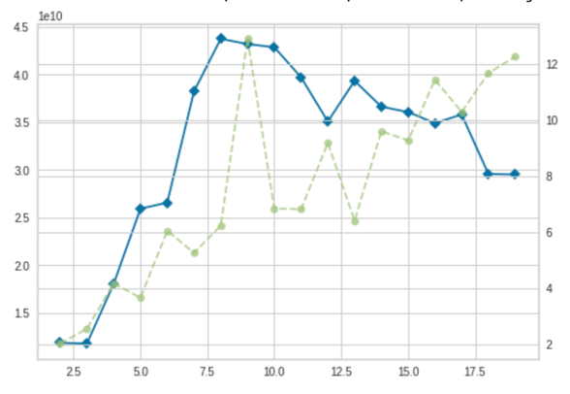
Elbow Method – Silhouette – Adult Data

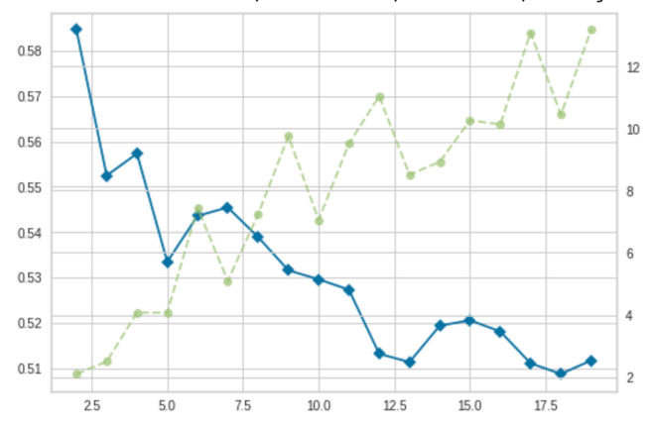
Elbow Method – Distortion – Hotel Data
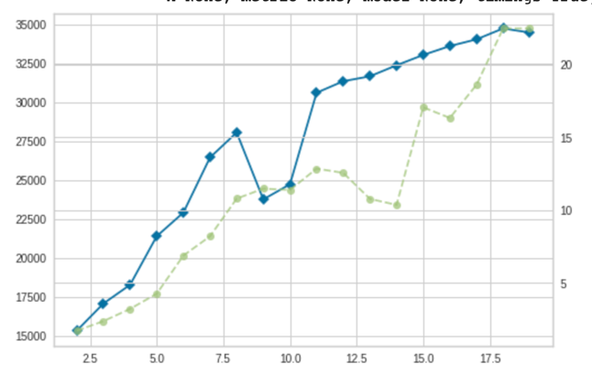
Elbow Method – Silhouette – Hotel Data
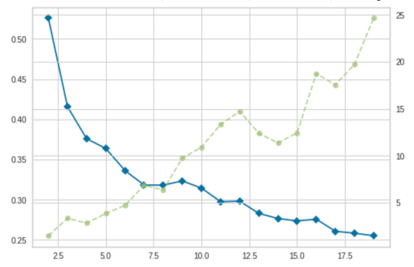
Best K value – Scoring Metric Result
 | K Value | Sihouette Score | Distortion Score
Adult | 6 | 0.546 | 39.4
Hotel | 6 | 0.327 | 27345
Elbow Method Result/Graph Analysis
A k value shows up when we observe diminishing decrease return in Sihouette and Distortion Score. On the graph, it’s the tipping point where the line starts to flat out. For unknown reason, the Distortion graph look weird with the score keep increasing but the tipping point methodology should still apply to help pick up k value. It turns out 6 is a best K value for both Adult and Hotel data set after comparing the results and graphs from Elbow Method. Table above shows the scoring metric result for k equals 6.
K-Means Analysis
Two more analysis are performed to further evaluate the K-Means algorithm. Cluster Measurement and Silhouette Analysis with Data Visualization.
1.Cluster Measurement – k = 6
 | Normalized Mutual Information | Homogeneity Score | Completeness Score
Adult | 0.138 | 0.207 | 0.138
Hotel | 0.189 | 0.236 | 0.158
Table above shows the Normalized Mutual Information, Homogeneity Score and Completeness Score of Adult and Hotel data set using 6 clusters. I suspect the classification label has little to no relationship with the clusters. Most of the features has no strong correlations between each other as well. And that’s verified from the low scores from table above.
2.Silhouette Analysis – Visualization
Silhouette Analysis – Data Visualization - Adult
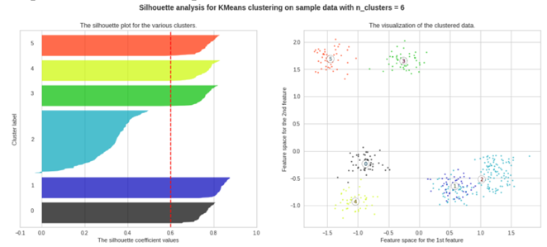
Silhouette Analysis – Data Visualization - Hotel
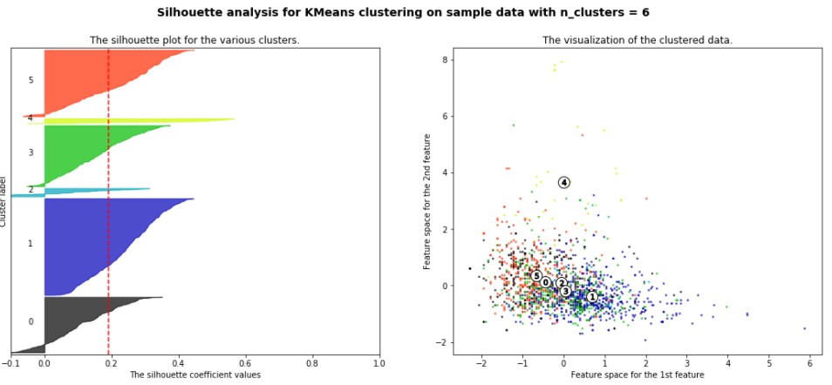
From Silhouette Analysis for both Adult and Hotel data set, we can see that 6 is a good choice for k since the clusters all have above average silhouette score.
Kind of Clusters
From the 2D Data Visualization graph, it’s easy to spot that 6 clusters from the Adult Data Set with each cluster separate out well from each other. Since K-means algorithm tends to create spherical shape cluster, adult data set visualization demonstrates that. However, it’s hard to make the same statement for the Hotel data set. Cluster seems like to be all over the place, which doesn’t has any shape or pattern. It’s possible that clusters are formed with higher dimension than 2D, yet our Data Visualization only in 2D. Therefore, it makes it hard to see the clusters.
Why did we get such Clusters
For the adult data set, the spherical shape cluster makes a lot of sense since the features of the data set has decent correlation to the final label – salary and other features. For example, age can correlate to more senior position, thus lead to higher salary. That’s why we see a clear cluster visualization of the adult data set. Clusters do line up for the label but it’s unsure whether it’s the vertical separating line or horizontal separating line to represent as the cutting line of the salary label (>50k).
For hotel data set, since hotel booking records are a lot more complicated with tons more features. It seems like there is no strong correlation between features, thus make the cluster unclear. Like the previous section state, it’s possible that cluster are observed in a higher dimension instead of 2D. From the current visualization graph, it’s unclear that whether the clusters are lined up with the classification labels or not.
K-mean clusters improvements
1. Use other ways to verify the selection of k can potentially improve the cluster performance.
2. Dimensionality reduction should help k-means clusters to focus more on the important features and get rid of the noise, which will help with the performance.

3.2. Expectation Maximization
Expectation Maximization is used to find the maximum likelihood estimate of the given parameter in a model[4] Unlike K-means clustering algorithm, Expectation Maximization generally allows cluster to have more than spherical shapes.
Expectation Maximization Analysis
Two methods of analysis are used to judge the performance of the Expectation Maximization. AIC/BIC graph and Cluster Measurement are used.
AIC/BIC
Akaike Information Criterion (AIC) and Bayesian Information Criterion (BIC) are plotted. Since different n estimator generates different clustering model, AIC is able to provide the error prediction and the mean for different estimator model selections. BIC serves the similar purpose but the score suffers a larger penalty when the estimator value is too large.
Unlike the Elbow method tipping point being the point where the curve starting to be flat. Due to the difference between AIC and BIC. AIC gets affected less by large estimator value, BIC gets affected more. The best estimator value comes from where AIC and BIC curve start to diverge and separate apart. In the graph, the tipping point is where the gap starts to get huge.
AIC/BIC – Adult Data
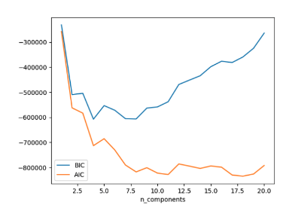
AIC/BIC – Adult Data
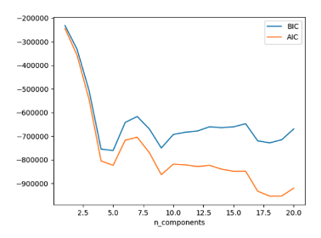Cluster Measurement – estimators = 6
 | Normalized Mutual Information | Homogeneity Score | Completeness Score
Adult | 0.135 | 0.135 | 0.135
Hotel | 0.208 | 0.253 | 0.169
From the AIC/BIC graph, we can see that AIC/BIC curve follows very similar pattern with almost the same value in the beginning, then the tipping point of huge gap comes when estimator = 6, which is the almost the result from the Elbow method k value selection. Cluster Measurement is recorded for estimator = 6 and it produces similar result like the cluster measurement from Elbow method k = 6. For Adult data set, Expectation Maximization didn’t perform as well as k-means, this indicates that the clusters in adult data are mostly spherical shapes. For Hotel data, Expectation Maximization does perform better, which means the Hotel data set cluster aren’t limited to just spherical shapes. The data set should have a better independent distribution than Adult data set. Consider all normalized mutual information, homogeneity score and completeness score are still very close to 0, it shows that each cluster is dependent of each other, not very complete.

3.3 Cluster Algorithm Comparison
1. For the same data set, K-means and Expectation Maximization have similar k and components.
2. There is a trade off between run time and accuracy.
3. K-means achieves slightly higher performance but have to scarifies slower run time.
4. EM runs faster but has lower performance.
5. Picking a good k and component value are super important for K-means and EM.
6. Data set effects the cluster performance a lot. With data point has features correlated to each other, the cluster look more separated.

4. Dimensionality Reduction Algorithms
When a data set has multiple features/attributes, it becomes easier to separate data points in higher dimension. However, as assignment 1 and assignment 2 shown that both Adult and Hotel data set suffer from curse of dimensionality since there are too many features/attributes in the data set yet not enough data. Such curse can cause model take longer to run, bring in noise to hurt the model performance. Thus, dimensionality reduction algorithms are used to help solve the curse of dimensionality.

4.1. Principle Component Analysis (PCA)
PCA is a fast dimensionality reduction algorithm that project data point as vector onto the principal axes. By doing so, it preserves as much info as data point can provided while reducing the dimensionality. It finds the correlation of the features by maximizing the variance then form a component.
PCA Results
Transformed Feature Projection – Adult Data
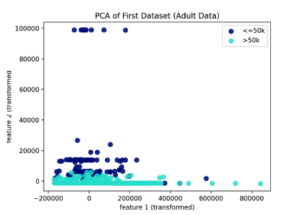
PCA Component Make Up – Adult Data
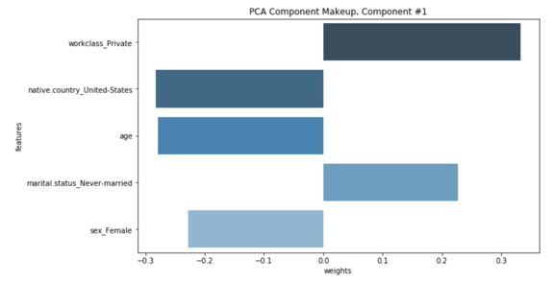
Transformed Feature Projection – Hotel Data
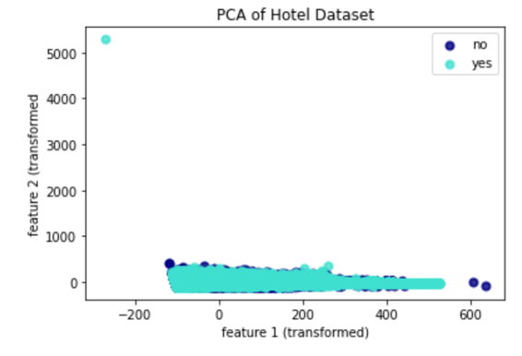
PCA Component Make Up – Hotel Data
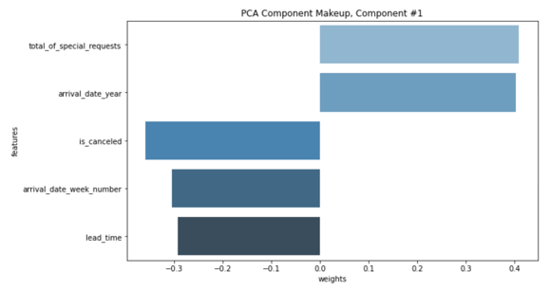
PCA Analysis
In order to find the best value for number of components for PCA, multiple experiments were conducted with different number of components.
PCA Eigenvalue Distribution
Then, eigenvalues, pca.explained_variance_ratio_ and variance were recorded to compare. Smallest component values were picked when pca.explained_variance_ratio is greater than 90% and variance close to 100%. For Adult data set, it only requires 2 components with 5 features. From the transformed feature projections and component make up graph, it clearly shows that how each feature within the same component is valued in terms of weight. And the eigenvalue is small, which suggest the data points aren’t as close to each other. Even with the largest eigen value, it’s only represents less than 10% of the total data set information, which means the adult data set doesn’t have much noisy and useless features. For Hotel data set, it requires 4 components. From the Component Make up graph, it states that the total of special request and arrival date carry the most weight. Eigenvalue are large, which implies that data points are located close to each other. This double verifies our finding from previous data visualization of hotel data set from section 3.1.

4. 2 Independent Components Analysis (ICA)
Independent Components Analysis is used to find mutually exclusive features in the data set. By doing so, each feature is independent with each other, thus provide the most useful information of the data set.
ICA Results
Kurtosis – RC Error – Adult Data
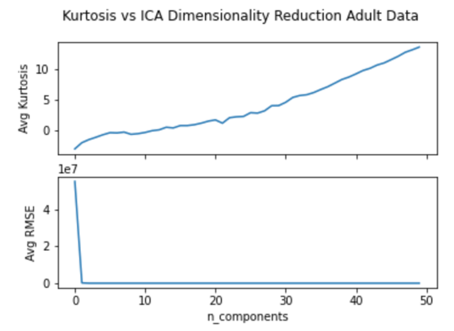
ICA Component Make Up – Adult Data
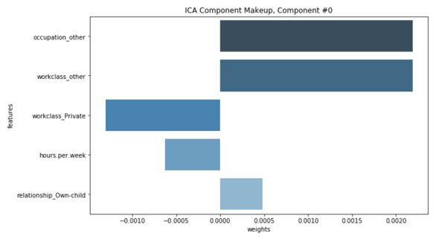
Kurtosis – RC Error – Hotel Data
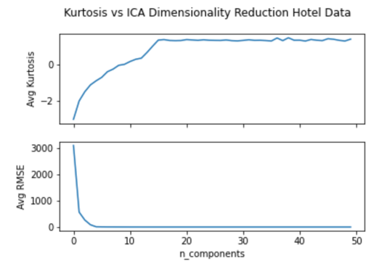
ICA Component Make Up – Hotel Data
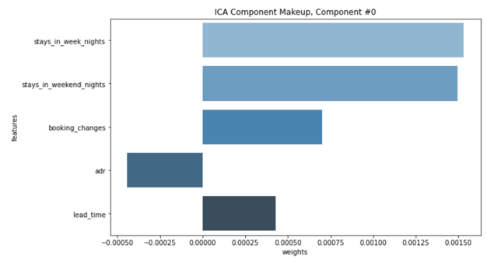
ICA Analysis
Similar to PCA, number of components matters a lot for ICA. Thus, Kurtosis, reconstruction error (mean square error) were picked to better select the value of components.
ICA Kurtosis Distribution
With a standard normal distribution, Kurtosis should be 3, it shows the extreme values were spotted in a distribution curve. Reconstruction error shows that distance between original data point and projected data point, it gives a good representation of whether a transformed data set can still have similar distribution like original data set. For Adult data set, from the Kurtosis and RC graph, it shows that as number of components increases, the Kurtosis keeps increasing and quickly came above 3 yet the RC Error decreased quickly and got close to 0. It suggested that n = 2 is a good option, which is the same result from PCA as well.
ICA Meaning Projection axes
From the ICA Component Make Up – Adult Data, it shows that Occupation and workclass have the most weights in the most important component. With almost near to 0 RC error, this is an evidence that by reducing the dimensionality with less features, it will still be able to provide the same distribution as the original data set.
For Hotel data set, it surprises me to see the Kurtosis starts out with negative value but quickly increase above 0 as number of components increase. RC score decreases quickly to 0 as well. It suggested that 7 is a good component value where stay in week nights and stays in weekend nights are important features of the first component.

4. 3 Randomized Projections
Randomized Projections is another dimensionality reduction algorithm, it randomly selects features so it can preserve the pairwise distance between data points from higher dimensions. By doing so, it reduces processing time by only using smaller set of features instead of whole feature set.
Randomized Projections Results
Randomized Projections RC-Error-Adult Data
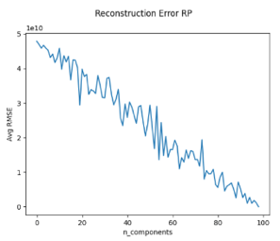

Randomized Projections RC-Error-Hotel Data
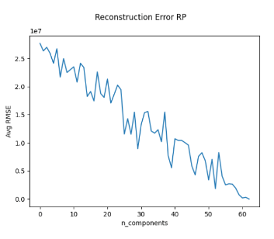
Randomized Projections Run Time
 | PCA | ICA | RP
Adult | 0.164 | 0.268 | 0.017
Hotel | 0.375 | 0.425 | 0.024
Randomized Projections Analysis
In order to judge the performance of randomized projections and figure out the best components value, Reconstruction Error graphs are plotted with Root Mean Square Error between Gaussian transformed data matrix and original data set matrix. Such experiments were run 10 times to get the average error for different number of components. Since randomized projections randomly select features, it’s reasonable to see that the avg RMSE go up and down with slight difference of the component value. However, for both Adult and Hotel data set, the Avg RMSE has a trend of going down as number of component increases. This means that Randomized Projection will likely need large number of components unlike PCA and ICA since RP randomly picks features. I ended up choosing 25 components for Adult data set and 20 for Hotel Data set.
One benefit of the randomized projection is simplicity, which leads to fast algorithm run time. As the run time table above shows that randomized projection on average is 10 time faster than PCA and 20 time faster than ICA since the algorithm only requires to do a random feature selections to reduce dimensionality.
Randomized Projections Variation
After running RP multiple times, it seems like there isn’t crazy variation even though it’s a randomized process. But the results are consistent.

4. 4 Decision Tree Feature Importance
Since Decision Tree does a great job selecting features as deciding nodes, it performs well to figure out the importance of each feature, thus makes it a great feature selection algorithm. By fitting a decision tree to a data set, we can observe the weight of each feature and figure out the importance of each feature.
Plus, don’t we all love decision tree?

Decision Tree Feature Importance – Adult Data
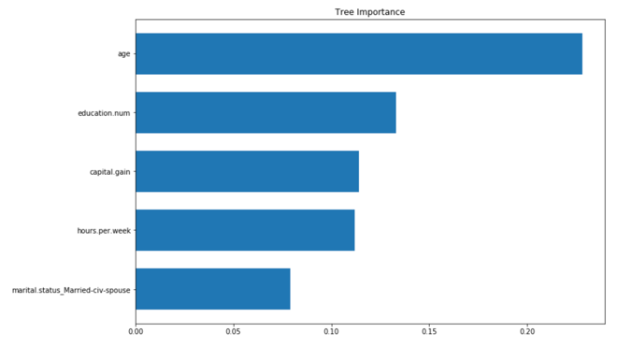 Decision Tree Feature Importance – Hotel Data
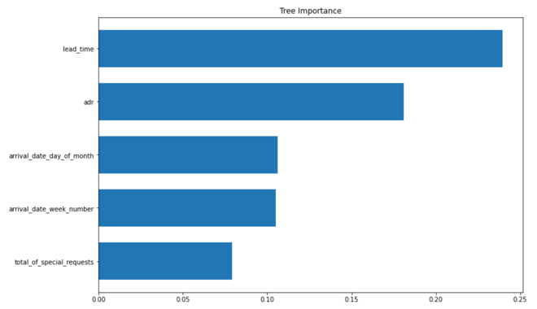
Decision Tree Feature Importance Analysis
For decision tree, Gini index is used since it provides better results from assignment 1 when a classification model is built. After fitting both adult and hotel data set with decision tree, only features with top 20% feature importance score were kept.
Top 5 highest features importance were plotted to better visualize the results of decision tree feature importance. From both Adult and Hotel data set, several of the features are the same as previous PCA, ICA feature selections.

5. Dimensionality Reduced Data Set Cluster
As we observe from the previous assignments and experiments, both Adult and Hotel data set suffers curse of dimensionality issue since they have too many features and not enough data. Previous sections on dimensionality reduce has shown very positive results on reducing features while maintain good representation of the data set. Therefore, 16 combinations of datasets, dimensionality reduction and clustering method experiments were performed here to further look into the effect on dimensionality reduce helping clustering algorithm to better cluster data set.
different variation of routes go from point to point. And each of route can represent the local optima. Since this is a NP-Hard problem
Select k – Elbow Method

ICA – Elbow - Adult
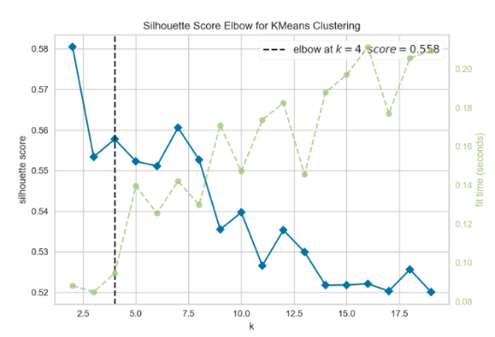 Silhouette Analysis – Data Visualization - Adult
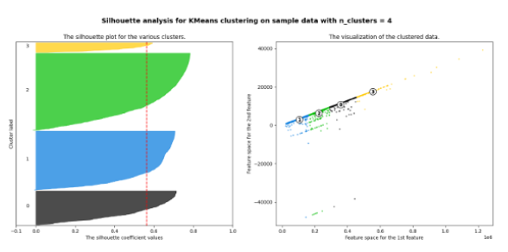
ICA – Elbow - Hotel
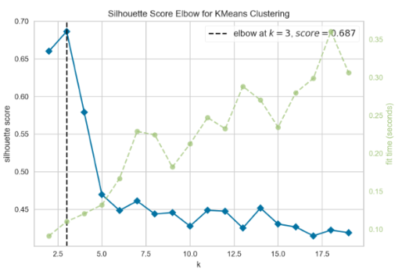 Silhouette Analysis – Data Visualization - Hotel
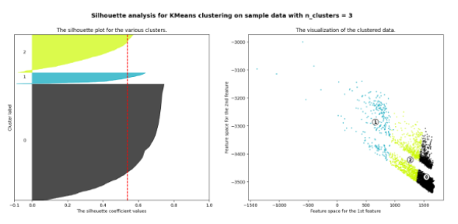

Expectation Maximization – AIC – Hotel Data
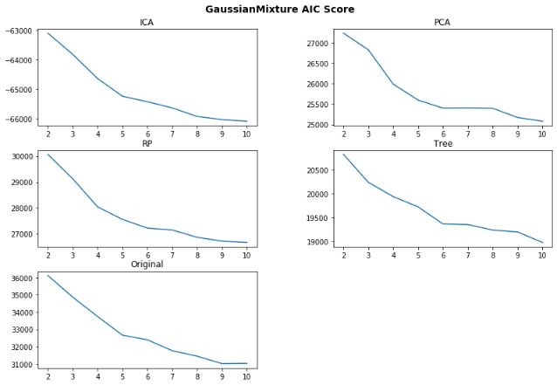
Different Clusters
It’s easy to see that with reduced feature, the cluster seems completely different from what we ran previous. This is caused by now algorithm uses less feature to cluster and points are separated better.
Less Feature – Less Clusters
It’s not a surprise to see that all 4 dimensionality reduced data set did help with the cluster algorithm, k values have decreases since there are less feature from the data set. From the ICA elbow graph for adult data, the k value has decreased from 6 to 4. For hotel data using ICA, it went from 6 to 3. It seems like there is a direct and positive relationship between features size and cluster number. More features will lead to more clusters. Less features lead to less clusters.
More Separated Data Point - Better Cluster
From the data visualization, we can also see that with dimensionality reduced data set, the clusters look more separated from each other. Especially for the hotel data set, if you compare the original visualization with dimensionality reduced data visualization, the visual difference is huge.
Better Cluster Measurement Score
 | Avg Normalized Mutual Information | Avg Homogeneity Score | Avg Completeness Score
Adult | 0.195 | 0.185 | 0.185
Hotel | 0.308 | 0.353 | 0.269
With all dimensionality reduced algorithm, it also increases the cluster measurement score. Above table is the average Normalized Mutual Information, Avg Homogeneity Score and Avg Completeness Score. Compare with the original cluster measurement score using original data set, all scores have increased, which is a proof that reduced data points are cluster better. I suspect these benefits from more separated cluster with each cluster has data point more close to center of the cluster center. Silhouette Analysis also shows that silhouette scores are improved with dimensionality reduce data set.

6. Neural Networks with Dimensionality Reduction
Adult data set is picked and run with dimensionality reduction algorithm to transform into a newly projected/reduced data set. Then Neural network learner is trained and built using this new data set to compare the results with assignment 1 neural network learner.
Time Complexity
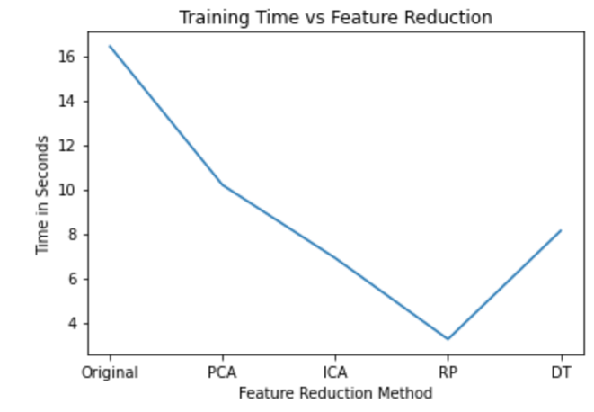

 | Original | PCA | ICA | RP | DT
Time | 16.42 | 10.18 | 6.89 | 3.24 | 8.12

As the time complexity graph and table show that Randomized Projections reduced the most training time for neural network, which benefits from algorithm’s simplicity. All dimensionality reduction algorithms help to reduce the training time of the neural network since there are less feature/attribute to train, which makes the process go much faster. The training time of the neural network also has a direct/positive relationship with the complexity of the dimensionality reduction algorithm. More training time is required when the dimensionality reduction algorithm is more complex.
Model Performance
Learning Curves – RP – Neural Network
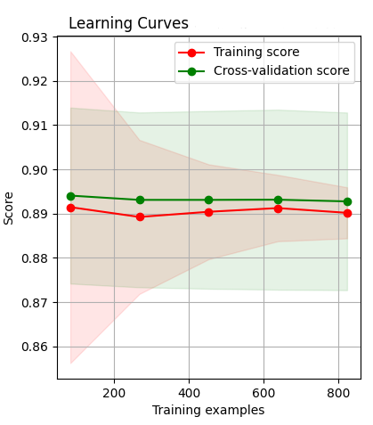

Scalability Curve – RP – Neural Network 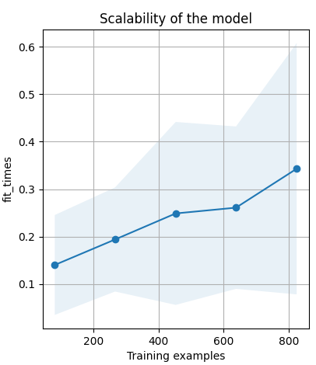
Performance Curves – RP – Neural Network 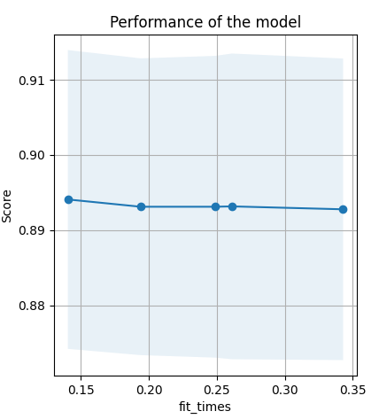
 | Original | PCA | ICA | RP | DT
Accuracy | 0.884 | 0.877 | 0.853 | 0.891 | 0.899
Precision | 0.823 | 0.867 | 0.823 | 0.843 | 0.877
Recall | 0.832 | 0.844 | 0.838 | 0.849 | 0.851
F1-Score | 0.824 | 0.858 | 0.843 | 0.867 | 0.862

Learning curve, Scalability curve and Performance Curves were plotted for all experiments. Here, I showed the ones from Randomized Projections since it has the fastest run time. Accuracy, precision, recall and F1-score table were listed above for comparison as well. It seems like dimensionality algorithm doesn’t help with the neural network performance, especially with PCA and ICA, the performance was even worse than the original neural network. This can be caused due to the fact that neural network’s hidden layers have acted similarly like PCA and ICA by putting weights on different nodes and linearly combining the results from activation function output. Decision Tree Selection and Randomized Projects have slightly better performance than the original neural network, which means the features those two algorithms selected are good representations of the data set.
Scalability and Performance curves seem consistent among all experiments. With more training examples and fitting time, the model seem to scale better and maintain similar performance.
Since dimensionality reduce algorithms have boosted the training speed by having less feature/attribute, it’s reasonable to observe the neural network model performance slightly worse.

7. Neural Networks with Dimensionality Reduction and Cluster
Similar experiment like the previous section, but this time adding two clustering algorithm’s clusters as extra features.
Time Complexity
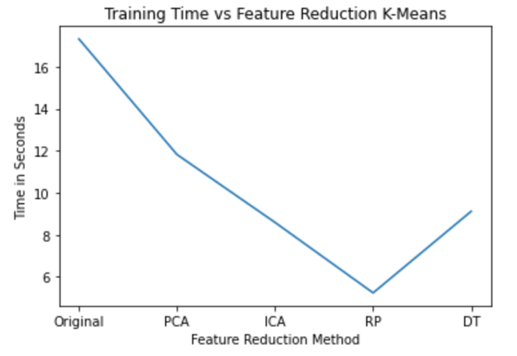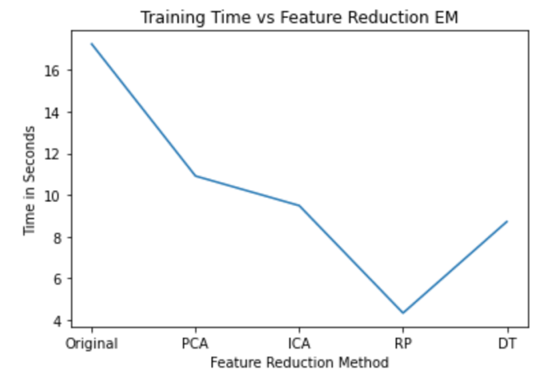

 | Original | PCA | ICA | RP | DT
Time with K-means | 17.32 | 11.82 | 8.59 | 5.24 | 9.12
Time with EM | 17.24 | 10.91 | 9.49 | 4.34 | 8.71

 | Original | PCA | ICA | RP | DT
Accuracy K-means | 0.880 | 0.873 | 0.850 | 0.890 | 0.883
Accuracy EM | 0.883 | 0.867 | 0.862 | 0.889 | 0.879
Very Similar results with K-Means and Expectation Maximization adding clusters as features. Since both only added a few clusters (3 and 4), the model running time doesn’t increase by a lot. I suspect this can definitely change if cluster algorithms ended up producing tons of clusters, then adding clusters as extra feature will slow down the run time.
Model Performance
Learning Curves – RP – Cluster
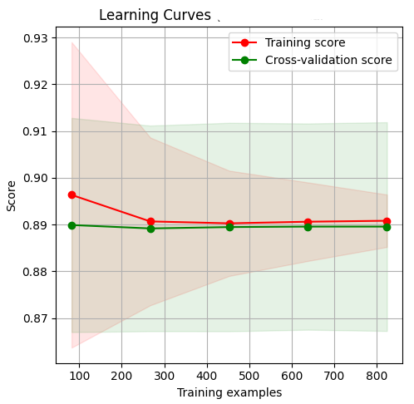

Scalability Curve – RP – Cluster 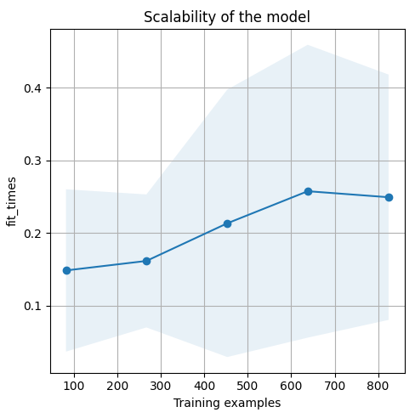Performance Curves – RP – Cluster 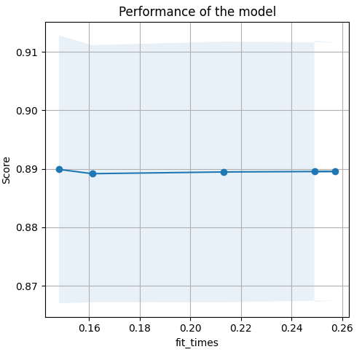

I was disappointed to see the perfromance result. It turns out that adding cluster as extra feature doesn’t help
with neural network’s performance. Logically speaking, neural network model should recognize such highly related feature and utilize this information to boost the model performance. However, that’s not the case at all here. All accuracy results are really similar to the results from previous experiments. Since neural network is a bit of black box machine learning model, it’s possible that the model has already figured out such corrleation and no need to use cluster number as extra feature.
Similar learning curve like previous experiment as well. But scalability curve has flat out after 700 training examples, even experience some decrease in fit time when training example hits 800.

9. Conclusion
After running all the experiments for this assignment, here is the summary of all my findings.
1. For the same data set, K-means and Expectation Maximization have similar k and components.
2. K-means achieves slightly higher performance but have to scarifies slower run time.
3. EM runs faster but has lower performance. But it allows cluster to have more than spherical clusters.
4. Data set effects the cluster performance a lot. With data point has features correlated to each other, the cluster look more separated.
5. Expectation Maximization works really well when data set has a good independent distribution.
6. All dimensionality algorithms do a good job reducing feature from a data set while maintaining a good representation of the data set.
7. Less feature leads to less cluster.
8. Dimensionality algorithms help to produce better clusters.
9. Adding cluster as extra feature for neural network doesn’t help with the model performance.
10. Less feature leads to faster neural network running time.

10. References

[1] “Hotel Booking Demand Datasets,” Nuno Antonio, Ana de Almeida,LuisNunes.[Online].Available: https://www.sciencedirect.com/science/article/pii/S2352340918315191\#f0010. [Accessed: 30-Mar-2021].

[2] “UCI Adult Data Set”, [Online].Available: https://archive.ics.uci.edu/ml/datasets/adult. [Accessed: 30-Mar-2021].

[3] “K-means clustering algorithm”, Wikipedia.[Online].Available: https://en.wikipedia.org/wiki/K-means_clustering [Accessed: 30-Mar-2021].

[4]“Expectation-max-Information-Maximizing”,
Available:https://en.wikipedia.org/wiki/Expectation%E2%80%93maximization_algorithm [Accessed: 14-Mar-2021].

