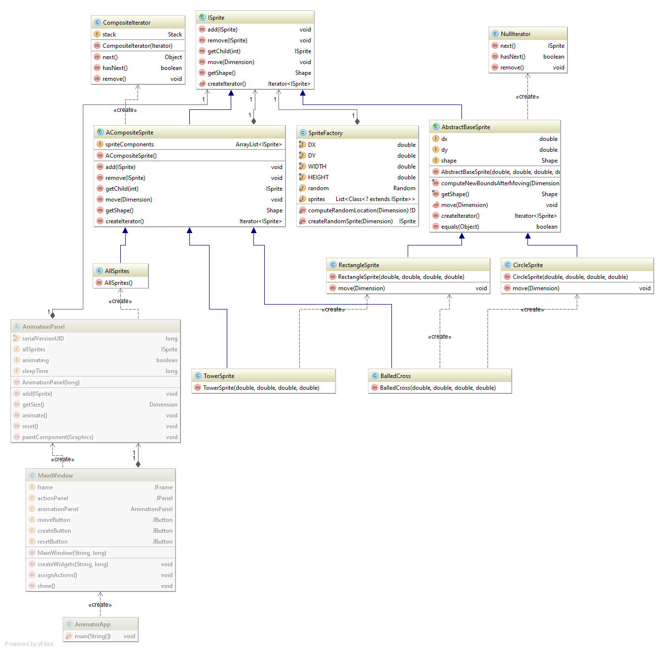

This uses the composite pattern. ISprite is the component. AbstractBaseSprite is the leaf. ACompositeSprite is the composite. I added 2 iterators, the null iterator for leafs, and a composite iterator for the composite. I replaced the list of ISprites with a composite sprite called AllSprites, it just holds all of the sprites