Content 1 – Hannah, Dajana
Story:

Der User bekommt via Mail eine Erinnerung an die Benutzung von PM Tools. Diese findet er als Buttons auf seinem Laptop und füllt diese aus wie folgt...[siehe einzelne PM Tools/Kategorien].

Dear Mr./Mrs. XXX,
did you already think of the tools of project management? For example the risk analysis is very important for this project and needs to be done as quickly as possible!
Click the button below to do the risk analysis.
Kindly regards,
Mr. XXX

Anschließend wird er diese an seinen Chef zur Prüfung schicken und bekommt ein Feedback darüber wie gut er diese Risiken eingeschätzt hat. Das selbe macht er auch mit den Stakeholdern. Der Chef gibt Tipps welche Stakeholder vielleicht doch wichtiger sind und welche nicht oder welche Risiken doch zu LOW eingeschätzt worden sind. Die Entscheidung des Users hat trotzdem Auswirkungen auf den Verlauf des Projektes.

Initiierung:

Risikoanalyse

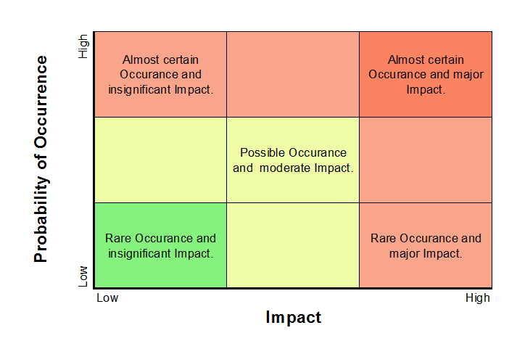
Mögliche Stakeholdern sind in Matrix eingetragen. User muss angeben, welcher Feldeintrag korrekt ist.
Exchange of Human Resources, because of absence (e.g. sickness, vacation,…). | Unexpected new customer requirements occur regarding the CRM Software during the development/implementation phase. | Traffic Jam on the way to work for employees.
Project is out of scope. It faces delays regarding milestones and time. Budged is out of scope. | Lack of communication within the Team | The requirements of the security of information and data protection is not complied (Governmental requirements)
The requirements definition is incomplete, insufficient and changes appear in the course of the project. | Key Contacts are not specifically defined or do not have enough time for their tasks. | Customer’s IT department is not ready for CRM implementation.

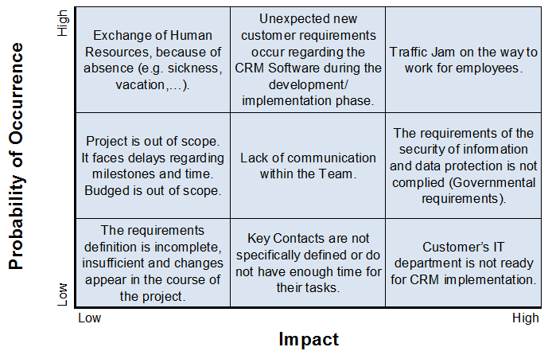

Exchange of Human Resources, because of absence (e.g. sickness, vacation,…). | The requirements definition is incomplete, insufficient and changes appear in the course of the project. | Customer’s IT department is not ready for CRM implementation.
The requirements of the security of information and data protection is not complied (Governmental requirements) | Lack of communication within the Team | Project is out of scope.  It faces delays regarding milestones and time.  Budged is out of scope.
Unexpected new customer requirements occur regarding the CRM Software during the development/implementation phase. | Key Contacts are not specifically defined or do not have enough time for their tasks. | Traffic Jam on the way to work for employees.

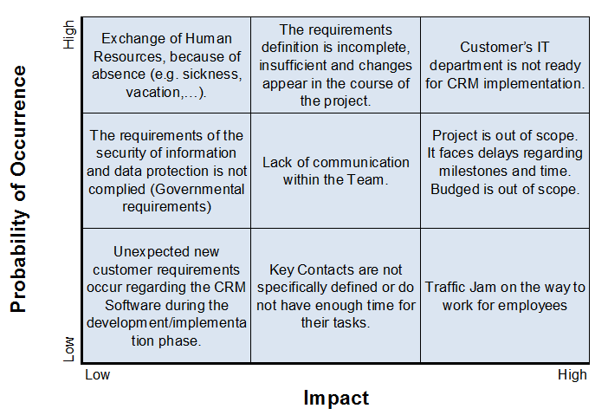

Exchange of Human Resources, because of absence (e.g. sickness, vacation,…). | The requirements definition is incomplete, insufficient and changes appear in the course of the project. | Project is out of scope.  It faces delays regarding milestones and time.  Budged is out of scope.
Traffic Jam on the way to work for employees. | Lack of communication within the Team | The requirements of the security of information and data protection is not complied (Governmental requirements)
Unexpected new customer requirements occur regarding the CRM Software during the testing phase. | Key Contacts are not specifically defined or do not have enough time for their tasks. | Customer’s IT department is not ready for CRM implementation.

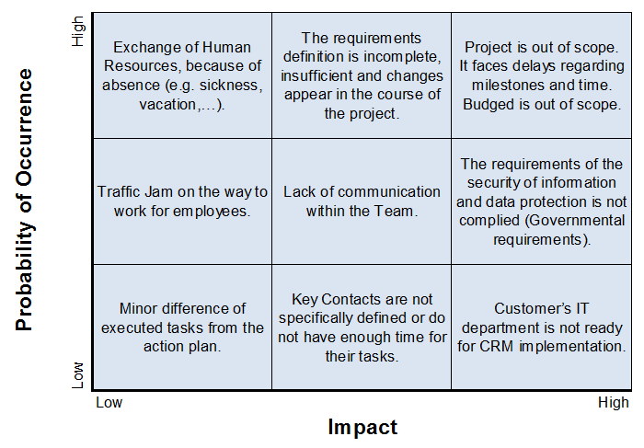
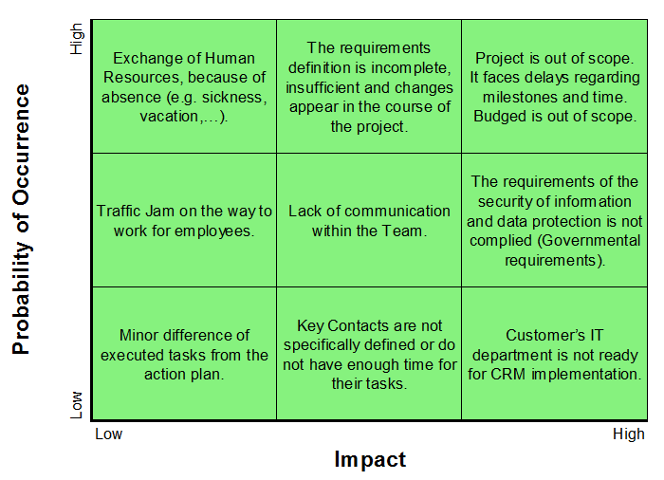
9 felder : y - Achse = Probability of Occurrence
X – Achse = Impact
1-2-3
4-5-6
7-8-9
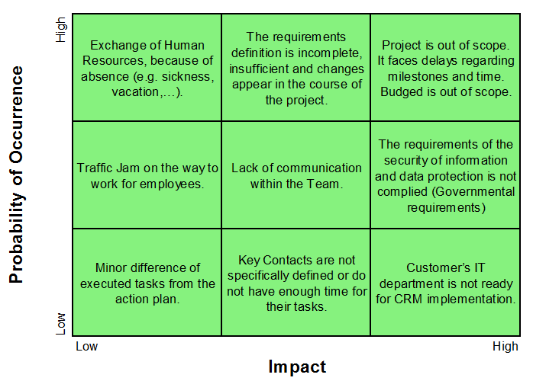

1: Exchange of HR / personal
2: New requirement requests regarding CRM SW
The requirements definition is incomplete,
insufficient and / or changes appear in the course of the project
3: Delays in Milestones / time Out Of Scope
4: Traffic Jam on the way to work
5: Lack/ bad of communication within the Team
6: Budged Out Of Scope
7: Copy machine has paper jam
8: Power blackout
9: Long absence of key figure

- The technical environment is insufficient
- The users "refuse" a constructive cooperation
8 key Contacts are not defined specific or do not have enough Time for their tasks
2 Cultural differences
6 Governmental requirements/ The requirements of the security of information and data protection is not complied
- Customer Interfaces
- inadequate planning

Categories
– Kaufmännische Risiken
– Technische Risiken
– Terminrisiken
– Ressourcenrisiken
– "Politische Risiken"

Maßnahmen definieren:
vermeiden: Anforderungen mit hohem Risiko aus dem Lastenheft streichen
begrenzen: Die Folgen eines Schadens gering halten, Redundanzen
verlagern: abwälzen, bspw. Versicherung, Lieferant
vermindern: Eintrittswahrscheinlichkeit durch Vorbeugung verringern
akzeptieren: keine Vorsorge

- - Staffing sufficient personnel,
- Holidays representative or replacement,
- Replacement for sick leave people
- New recruitment of personnel during the project
- An agile (Scrum) approach
- Frequent, regularly communication with the customer /radical and drastic changes
- -Implement Time buffers in the project schedule
-Well structured Project Plan
- Detailed estimation of time for the work products
- - Communication of traffic forecasts (low risk for the project) Akzeptieren
- – Clear Communication Structure -> publish and spread within the Team
- Regular communication (Mails,Meetings,Calls) with the team
- Regular status reports
- Forming of a project team and establishing a project owner
- -Plan Budget precisely
-Establish cost centers for detailed cost estimation
- Regular maintenance of the printer
- Power Blackout: a) deploy an emergency power generator
- Long absence of key figure: a) employ always a pair (one as key figure, one as vice key figure / substitute) b) always interview possible back-up people c) keep documentation high to enforce quick replacement
- The technical environment is insufficient: a) implement in parallel new systems b) check common used technical environment to prevent surprises
- The users "refuse" a constructive cooperation: a) set up a clear communication plan (and escalation plan) b) be flexible in employing people (to exchange them quickly) c) test possible team-members on teamwork /ask earlier manager on member’s character
- key Contacts are not defined specific or do not have enough Time for their tasks: a) specify tasks clearly b) set up a detailed work package plan c) include “buffer” time while planning activities
- Cultural differences: a) train employees on cultural communication b) employ a cultural differences expert to be available for difficult situations c) prepare escalation plan for cultural issues
- Governmental requirements/ The requirements of the security of information and data protection is not complied: a) set up a clear set of rules to be followed according to security issues b)deploy a pre-development phase where employees are educated on security rules and behavior

Stakeholderanalyse
Mögliche Stakeholdern sind in Matrix eingetragen. User muss angeben, welcher Feldeintrag korrekt ist.
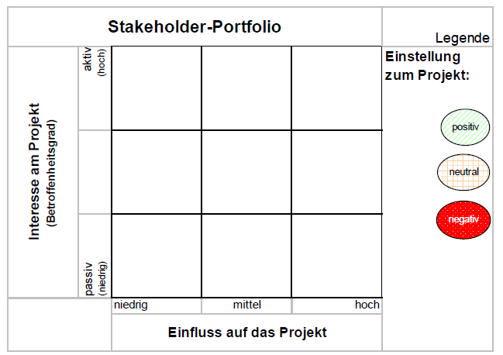

Future Users of the CRM Software (Employees of customer and sales representatives) | Customer’s CIO;  IT Manager “Avinash (Avi) Gupta” and the assistant from India “Rajesh Ananat” | Customer’s CEO;  Chief of TopSim “Thomas Zimmermann”;  Customers Project Manager “Reginald (Reggie) Oaks”
Competitive companies | IT Specialists;  Consultants;  Customer’s Sales Director “Billy-Ray Stylus” | Sponsors of the customers
Customer’s customer | Governmental organization | Person in charge for data security

CFO
Name: Gundula Eberle
Assistant 1
Name: Bimal Jones
Assistant 2
Name: Nadja Schuster
Assistant 3
Name: Martin Heinemann

Person in charge for data security | Customer’s CIO;  IT Manager and the assistant from India | Customer’s customer
Competitive companies | Team members;  Software engineers;  Consultants | Sponsors of the customers
Customer’s CEO;  Chief of TopSim “Thomas Zimmermann”;  Customers Project Manager “Reginald (Reggie) Oaks” | Governmental organization | Future Users of the CRM Software (Employees of customer and sales representatives)

Future Users of the CRM Software (Employees of customer and sales representatives) | Governmental organization | Competitive companies
Customer’s CEO;  Chief of TopSim “Thomas Zimmermann”;  Customers Project Manager “Reginald (Reggie) Oaks” | Team members;  Software engineers;  Consultants | Sponsors of the customers
Customer’s customer | Customer’s CIO;  IT Manager and the assistant from India | Person in charge for data security

1: Zukünftige Anwender (Mitarbeiter des Kunden), Vertriebsmitarbeiter
3: Auftraggeber
5: Konkurrierende Unternehmen
6: Kapitalgeber des Kunden
7: Kunden des Auftraggebers
8: Gesetzgeber
9: Datenschutzverantwortlicher

- 5 Teammitglieder, Software Engineers, Consultants
- 3 Our chef
- 3 CIO vom Kunden
- 3 IT Manager und Assistent aus Indien
- Indien Government ? USA Government ?
CRM‐Verantwortlicher (sollte idealerweise durch den Projektleiter besetzt werden)
Geschäftsführung
Prozess‐ und Qualitätsverantwortlicher (i. d. R. eine Stelle)
IT‐Verantwortlicher
Logistikverantwortlicher
Marketingverantwortlicher
Vertriebsverantwortlicher
Kundenservice als Schnittstelle

Resourcen-/Kostenplanung
- Aufwandplanung (Arbeitspackete mit entsprechender Zeitaufwand)
- Pro aufwand = Kosten/Stundensätze verbinden
- Zeit & Kosten ermitteln / planen
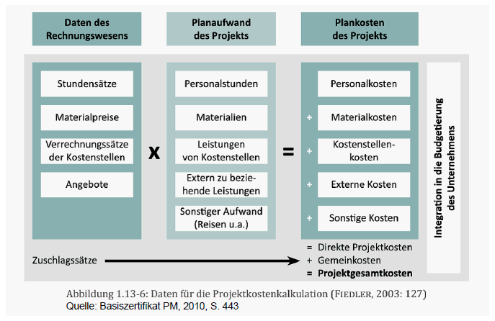
Spieler errechnet Resourcen & Kosten eigenständig. Bei Abfrage gibt er die Zahlen ein und System sagt richtig oder Falsch mit richtigem Ergebnis

Planung:
- (feine) Terminplanung, mit Arbeitspaketen, - Kommunikationsplanung
→ Kalendertemplate mit vorgegebenen wöchentlichen Meetings
→ Meilensteine festgelegt
→ Termine definieren von wann bis wann

