Riskanalysis
Dear Mr./Mrs. XXX,
did you already think of the tools of project management? For example the risk analysis is very important for this project and needs to be done as quickly as possible!
Keep in mind how the risk matrix is arranged – here a generic example.
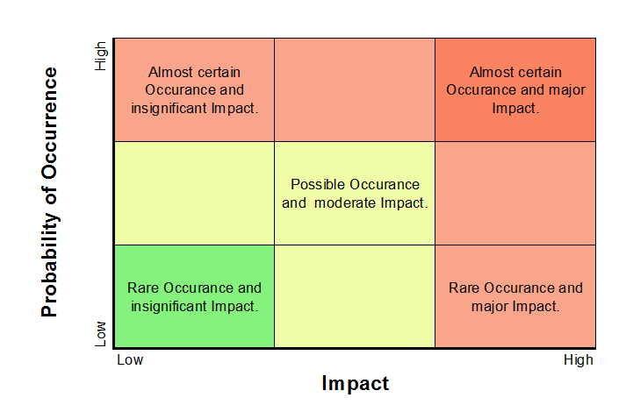
Click the button below to perform the risk analysis.

Kind regards,
Thomas Zimmermann
[BUTTON]

Mögliche Risiken sind in Matrix eingetragen. User muss angeben, welches Bild korrekt ist.
Choice 1 (Wrong):
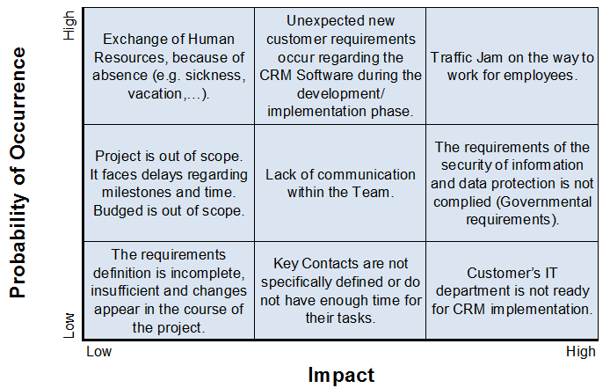
Choice 2 (Wrong):
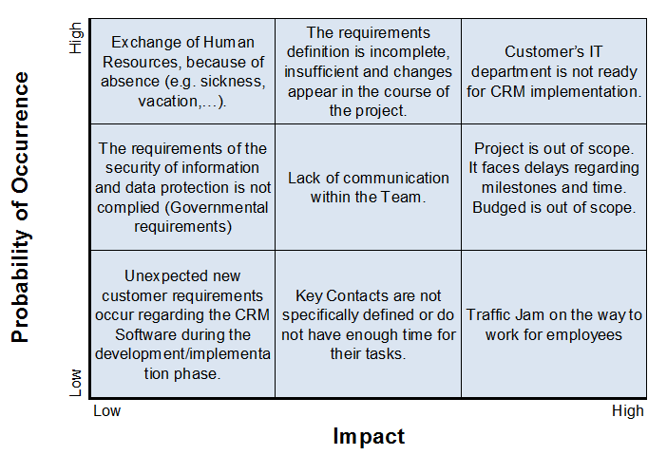
Choice 3 (Right):
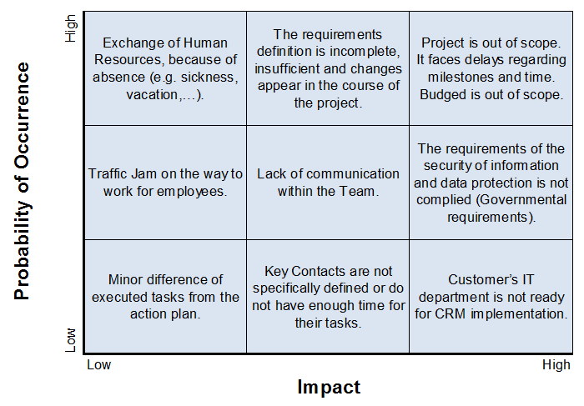
Solution:
Wrong answer:
Dear Mr. XXX,
Thanks for your risk analysis. After taking a look at it I noticed that you made some mistakes. Please take a look the correct matrix below.
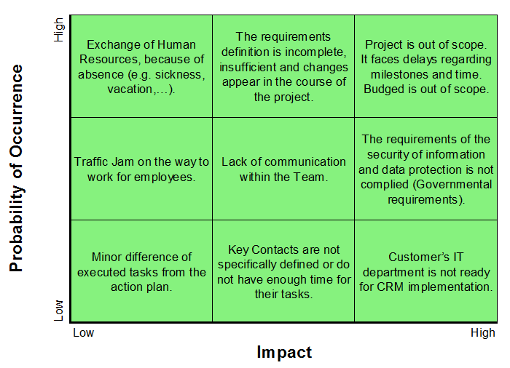

After accessing the possible risks, please also make sure to provide necessary measurements for those.

Kind regards,
Thomas Zimmermann

Right answer:
Dear Mr. XXX,

Thanks for your risk analysis. You did a great job on that one!
After accessing the possible risks, please also make sure to provide necessary measurements for those.

Kind regards,
Thomas Zimmermann

Measurements

Von User zu Chef:
Dear Mr. Zimmermann

Please find below the necessary measurements for the major risks.

a) Use an agile project management approach such as Scrum. This enables us to adapt new requirements easily and to encourage frequent, regularly communication with the customer. Regarding time concerns we should implement enough time buffers within the project schedule and provide a well structured project plan as well as a precise budged plan.
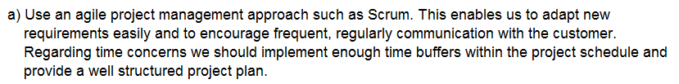

b) Always displaying a forecast of the daily traffic jam to prevent loss of time for the team members. Using an sequential project management approach such as the waterfall model. This enables us to document the project steps in detail and assures a static process.
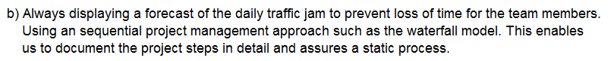

c) Use an incremental project management approach such as the spiral model. This way the time on documenting can be kept low and the customer is periodically involved. By executing this method the project manager does not need a well structured plan. To prevent defect printers we provide regular maintenance on them.
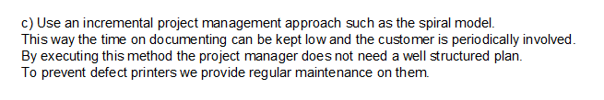

Kind regards,
Mr. XXX

Solution:
Dear Mr. XX
Great job! I think you are really the perfect Project Manager for this project.
All measurements are right! Keep this work up.

Kind regards
Mr. Zimmermann

If solution is wrong
Dear Mr. XX
I think you should review your decision. The measurements are good but there are some measurements missing. I completed them for you. Please check them below.

Kind regards
Mr. Zimmermann

