Stakeholderanalyse

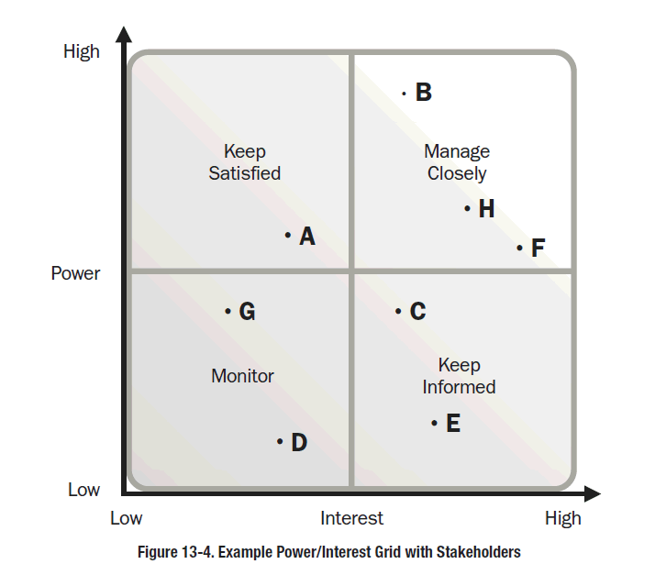
Dajana: Eigene umformung der 3*3 matrix – je ecke siehe oben

Stakeholderanalyse
Mögliche Stakeholdern sind in Matrix eingetragen. User muss angeben, welcher Feldeintrag korrekt ist.
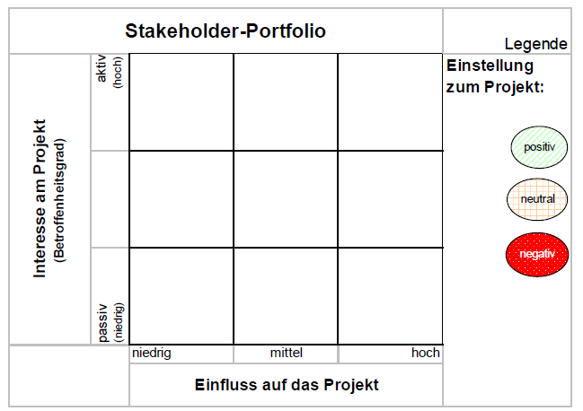

Future Users of the CRM Software (Employees of customer and sales representatives) | Customer’s CIO;  IT Manager “Avinash (Avi) Gupta” and the assistant from India “Rajesh Ananat” | Customer’s CEO;  Chief of TopSim “Thomas Zimmermann”;  Customers Project Manager “Reginald (Reggie) Oaks”
Competitive companies | IT Specialists;  Consultants;  Customer’s Sales Director “Billy-Ray Stylus” | Sponsors of the customers
Customer’s customer | Governmental organization | Person in charge for data security

CFO
Name: Gundula Eberle
Assistant 1
Name: Bimal Jones
Assistant 2
Name: Nadja Schuster
Assistant 3
Name: Martin Heinemann

Person in charge for data security | Customer’s CIO;  IT Manager and the assistant from India | Customer’s customer
Competitive companies | Team members;  Software engineers;  Consultants | Sponsors of the customers
Customer’s CEO;  Chief of TopSim “Thomas Zimmermann”;  Customers Project Manager “Reginald (Reggie) Oaks” | Governmental organization | Future Users of the CRM Software (Employees of customer and sales representatives)

Future Users of the CRM Software (Employees of customer and sales representatives) | Governmental organization | Competitive companies
Customer’s CEO;  Chief of TopSim “Thomas Zimmermann”;  Customers Project Manager “Reginald (Reggie) Oaks” | Team members;  Software engineers;  Consultants | Sponsors of the customers
Customer’s customer | Customer’s CIO;  IT Manager and the assistant from India | Person in charge for data security

1: Zukünftige Anwender (Mitarbeiter des Kunden), Vertriebsmitarbeiter
3: Auftraggeber
5: Konkurrierende Unternehmen
6: Kapitalgeber des Kunden
7: Kunden des Auftraggebers
8: Gesetzgeber
9: Datenschutzverantwortlicher

- 5 Teammitglieder, Software Engineers, Consultants
- 3 Our chef
- 3 CIO vom Kunden
- 3 IT Manager und Assistent aus Indien
- Indien Government ? USA Government ?
CRM‐Verantwortlicher (sollte idealerweise durch den Projektleiter besetzt werden)
Geschäftsführung
Prozess‐ und Qualitätsverantwortlicher (i. d. R. eine Stelle)
IT‐Verantwortlicher
Logistikverantwortlicher
Marketingverantwortlicher
Vertriebsverantwortlicher
Kundenservice als Schnittstelle

