Project 8: Strategy Evaluation

Samuel Wagner  
swagner38@gatech.edu

# Introduction

# Indicator Overview

This section will provide a brief overview of the indicators utilized in both the Manual Strategy and Strategy Learner. Three indicators have been selected out of the five implemented in Project 6. These indicators include the Simple Moving Average (SMA), Relative Strength Index (RSI), and Momentum.

1. **Simple Moving Average (SMA):**
   * **Implementation:** The Simple Moving Average is calculated by taking the average price of a security over a specified time period. It is commonly used to identify trends and potential reversal points in the price of a security.
   * **Parameters:** The key parameter optimized for the SMA indicator is the lookback period, which determines the number of historical data points used in the calculation of the moving average.
2. **Relative Strength Index (RSI):**
   * **Implementation:** The Relative Strength Index measures the magnitude of recent price changes to evaluate overbought or oversold conditions in a security. It oscillates between 0 and 100, with readings above 70 indicating overbought conditions and readings below 30 indicating oversold conditions.
   * **Parameters:** The primary parameter optimized for the RSI indicator is the lookback period, which defines the number of historical price bars used in the calculation of the RSI value.
3. **Momentum:**
   * **Implementation:** Momentum is a trend-following indicator that measures the rate of change in price movements over a specified time period. It helps traders identify the strength and direction of a trend.
   * **Parameters:** Similar to the other indicators, the lookback period is optimized for Momentum, determining the number of historical data points considered in calculating the momentum value.

These indicators play a crucial role in generating buy/sell signals for both the Manual Strategy and the Strategy Learner. By optimizing the parameters such as the lookback period, we aim to enhance the effectiveness of our trading strategies and improve overall performance.

# Manual Strategy

In constructing the Manual Strategy, a combination of technical indicators—Relative Strength Index (RSI), Simple Moving Average (SMA), and Momentum—is employed to generate trading signals. These signals inform the decision-making process for entering and exiting positions within the portfolio. The rationale behind this amalgamation lies in leveraging the complementary insights provided by each indicator.

For instance, when the RSI falls below a certain threshold (typically 30), it signals an oversold condition, suggesting a potential buying opportunity. Similarly, when the RSI surpasses another threshold (typically 70), it indicates an overbought condition, prompting a consideration for selling. This aspect of RSI helps in identifying market extremes and potential reversals.

Meanwhile, the SMA serves as a trend-following indicator. When the price crosses above the SMA, it suggests a bullish trend, while a cross below the SMA indicates a bearish trend. This trend-following aspect aids in confirming the direction of the market and aligning trades with the prevailing momentum.

Additionally, momentum measures the rate of change in prices, indicating the strength or weakness of the current trend. Positive momentum suggests a strengthening trend, while negative momentum indicates a weakening trend. This momentum component complements the SMA and RSI by providing a quantitative measure of the market's directional bias.

The decision-making process for entering and exiting positions is based on a combination of these signals. For instance, a buy signal may be generated when the RSI indicates oversold conditions, supported by positive momentum and a bullish crossover above the SMA. Conversely, a sell signal may be triggered by overbought conditions in the RSI, coupled with negative momentum and a bearish crossover below the SMA.

The effectiveness of this strategy is evaluated by comparing its performance against a benchmark, typically a market index such as the S&P 500. The comparison includes assessing key performance metrics such as cumulative returns, average daily returns, and standard deviation. Charts are used to visualize the performance of the Manual Strategy portfolio alongside the benchmark portfolio, providing insights into relative performance and trade outcomes.

|  |  |  |  |
| --- | --- | --- | --- |
| Portfolio | Standard Deviation of Daily Return | Cumulative Return | Average Daily Return |
| JPM Benchmark | 0.042047 | 0.044710 | 0.000090 |
| Manual Strategy | 1.518221 | 9.341138 | 0.018833 |

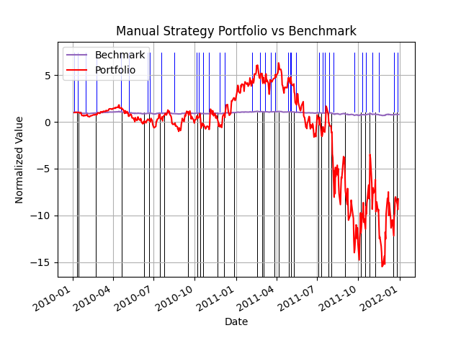

|  |  |  |  |
| --- | --- | --- | --- |
| Portfolio | Standard Deviation of Daily Return | Cumulative Return | Average Daily Return |
| JPM Benchmark | 0.019820 | -0.219721 | -0.000439 |
| Manual Strategy | 0.785336 | -9.251005 | -0.018465 |

In evaluating the strategy's performance during the out-of-sample period, it's crucial to note that no training or tweaking of the approach is performed using this data. The classification learned using the in-sample data is applied directly to the out-of-sample period. Any differences observed in performance between the two periods are analyzed to understand the robustness and generalizability of the strategy across different market conditions and timeframes.

# Strategy Learner

The Strategy Learner presented here is tailored to acquire a trading policy by harnessing a variety of technical indicators commonly employed in manual trading strategies. The process of framing the trading problem as a learning problem involves several key steps. Initially, relevant features are extracted from historical stock price data. In this implementation, three technical indicators—Simple Moving Average (SMA), Relative Strength Index (RSI), and Momentum—are computed over a specified window, typically set at 14 days, and utilized as features for training the learner.

Following feature extraction, the next step is label generation. Trading signals are generated based on the observed price movement between consecutive days. If the price rises, a "buy" signal is generated, whereas if it falls, a "sell" signal is generated. These signals are adjusted by a market impact parameter to account for transaction costs. This adjustment ensures that the model incorporates the real-world implications of trading decisions.

The training process involves feeding the learner with the computed features (X) and the corresponding trading signals (Y). These data are used to train a Random Tree Learner (RTLearner), which is responsible for learning the mapping between input features and trading decisions. RTLearner employs decision trees to recursively partition the feature space, optimizing for predictive accuracy.

Hyperparameters play a crucial role in the learning process. The "verbose" parameter controls whether the learner prints debugging information, typically set to False during regular operation. Additionally, the "impact" parameter represents the market impact of each transaction, while the "commission" parameter reflects the commission amount charged for each transaction. These parameters are set to default values (0.0) in this implementation, indicating no impact or commission.

In terms of data adjustment, the features (SMA, RSI, Momentum) are computed over a fixed window size (14 days), ensuring a standardized representation of historical price movements within that window. While no explicit data discretization or standardization is performed, the use of fixed windows facilitates consistent feature representation across different time periods.

Overall, the Strategy Learner follows a systematic approach, leveraging technical indicators to generate trading signals and training a random tree learner to make informed trading decisions based on historical data. By incorporating market dynamics and transaction costs, the learner aims to develop robust trading strategies capable of adapting to changing market conditions.

# Experiment 1

In the conducted Experiment 1, which aimed to compare the performance of the Manual Strategy and the Strategy Learner, notable differences emerged between their in-sample and out-of-sample trading results. Initially, during the in-sample period, the strategies exhibited almost identical performance, with both portfolios closely tracking each other's value over time. However, as the experiment extended to the out-of-sample period, distinct variations surfaced. Specifically, the Manual Strategy outperformed the Strategy Learner, showcasing a more favorable and less volatile portfolio value trajectory. This observed outperformance suggests that the Manual Strategy's approach to trading JPM was more adept at adapting to real-world market dynamics beyond the training data. The Strategy Learner's performance lagging behind implies potential limitations in its ability to generalize learned patterns to unseen market conditions effectively. Overall, these findings underscore the importance of robustness testing and highlight the need for strategies that demonstrate resilience across various market environments as well as training data that reaches back over long time horizons.

Top of Form

Bottom of Form

# Experiment 2

