Visual Intelligence Assistant
Image Captioning and Visual Question Answering System

Final Project Report
Course: Digital Image Processing
Date: May 7, 2026

Abstract
This project implements a multimodal visual intelligence assistant capable of analyzing input images to produce natural-language captions, answer visual questions, detect objects, extract readable text, and generate accessibility-style alt text. The main training work focuses on image captioning: a BLIP captioning model was fine-tuned on the project caption dataset and compared against the original pretrained BLIP baseline. Pretrained BLIP VQA, DETR, and TrOCR models were used as supporting modules for question answering, object localization, and OCR so the trained captioning model could be integrated into a complete visual intelligence system. A Streamlit application provides an interactive interface while a FastAPI service exposes functionality through HTTP endpoints.

The project was evaluated on a Flickr-style image-caption dataset containing 8,091 images and 40,455 captions. The captioning model was trained on the training split and evaluated on the validation split using BLEU scores. On the full validation-derived pseudo-VQA set of 9,231 questions across 1,605 images, the VQA system achieved 47.47% exact accuracy and 52.37% relaxed accuracy.

1. Introduction
Image captioning is the task of generating a natural-language description for an image, bridging computer vision and natural language processing by requiring a model to identify visual content and express it as readable text. Visual question answering (VQA) extends this concept by allowing users to pose natural-language questions about an image and receive direct answers.

Traditional image-processing systems typically operate at low-level or mid-level features such as edges, color histograms, keypoints, or detected objects. This project advances toward semantic image understanding by employing transformer-based models that connect visual features with language. The resulting assistant has broad applicability across accessibility, image search, content organization, e-commerce product description, and interactive visual inspection.

2. Objectives
The main objectives of this project were:
1. Fine-tune a BLIP-based image captioning model that generates descriptive captions for uploaded images.
2. Add visual question answering so users can ask questions about image content.
3. Detect visible objects and display bounding boxes.
4. Extract readable text from images using OCR.
5. Generate alt text and searchable tags from the combined analysis.
6. Store previous image analyses in a local searchable history.
7. Provide both a user-facing web application and a programmatic API.
8. Evaluate captioning and VQA performance using measurable metrics.

3. Dataset
The project uses a Flickr-style caption dataset stored in data/, containing image files under data/Images/ with caption annotations in data/captions.txt. Each image has multiple human-written captions, reflecting the inherent diversity of natural language description.

3.1 Dataset Summary
Split / File | Rows | Unique Images | Description
data/captions.txt | 40,455 | 8,091 | Full caption annotation file
data/train.csv | 32,360 | 6,472 | Training split
data/val.csv | 8,095 | 1,619 | Validation / evaluation split
data/vqa_test.csv | 50 | 17 | Small pseudo-VQA sanity test
data/vqa_val_full.csv | 9,231 | 1,605 | Full validation pseudo-VQA test set

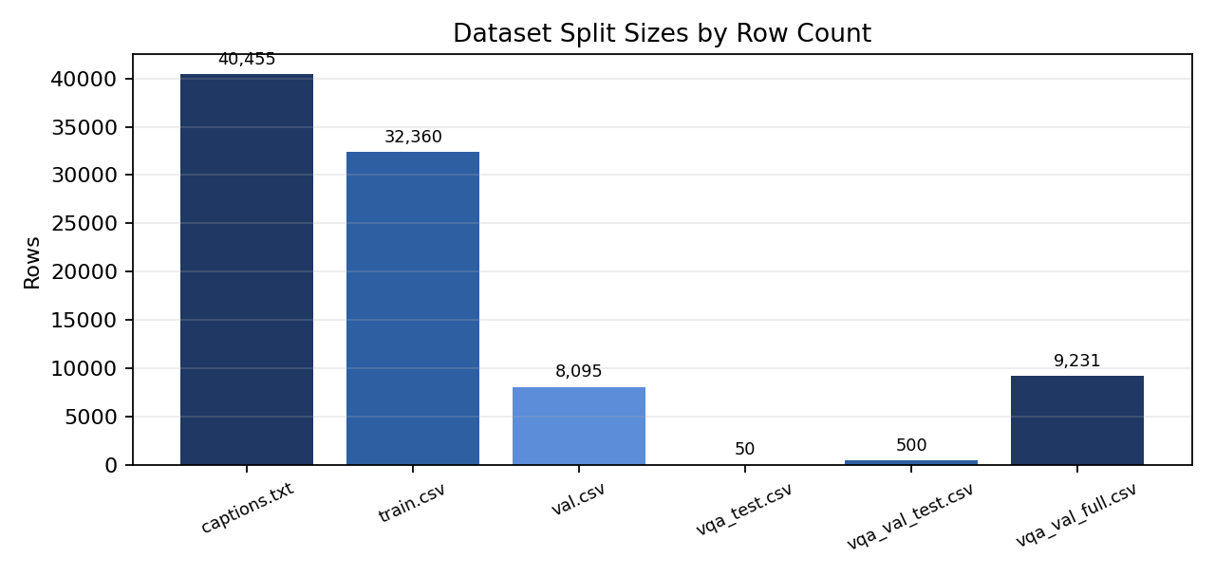
Figure 1 - Dataset Split Sizes by Row Count

3.2 VQA Test Set
The original dataset contains captions, not manually annotated visual questions. To evaluate VQA, pseudo-VQA datasets were generated from captions using build_vqa_from_captions.py. The full validation-derived file (data/vqa_val_full.csv) provides the strongest empirical coverage across five question categories.
Question Type | Question Count
Action | 1,301
Color | 768
Count | 3,214
Object | 2,802
Scene | 1,146

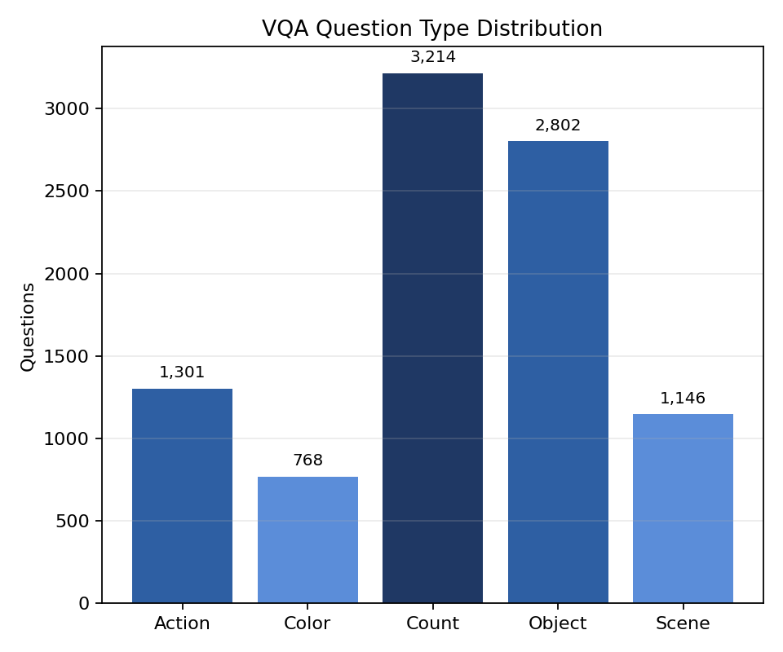
Figure 2 - VQA Question Type Distribution (9,231 Questions)
Because VQA questions are generated from captions, this evaluation should be treated as a practical project evaluation rather than a fully human-annotated benchmark. The larger validation-derived set improves empirical strength by increasing coverage, but inherits noise from caption wording and automatic question generation.

4. System Design
The system is organized as a modular Python project. Each major capability is implemented in a separate module, then combined in the Streamlit application and FastAPI service.

4.1 Main Components
Component | File | Purpose
Caption generation | image_captioning/captioner.py | Generates captions using the trained BLIP captioning checkpoint
Visual question answering | image_captioning/vqa.py | Answers questions about an image using pretrained BLIP VQA
Object detection, OCR, tags | image_captioning/intelligence.py | Combines trained captioner with pretrained DETR, TrOCR, tags, alt text
History storage | image_captioning/history.py | Saves analyses and supports local search
Web application | app.py | Streamlit interface for upload, analysis, VQA, and history
API service | api.py | FastAPI endpoints for captioning, VQA, analysis, and history
Caption evaluation | evaluate_captions.py | Computes BLEU metrics
VQA evaluation | evaluate_vqa.py | Computes exact and relaxed VQA accuracy
VQA data generation | build_vqa_from_captions.py | Builds pseudo-VQA questions from captions

4.2 Processing Pipeline
The image-processing pipeline operates as follows:
• The user uploads an image through the Streamlit app or sends it to the API.
• The image is loaded with PIL and converted to RGB.
• The fine-tuned BLIP captioning model generates a natural-language caption.
• The pretrained DETR detector identifies objects, returning labels, confidence scores, and bounding boxes.
• The OCR module extracts readable text from the image using TrOCR.
• Searchable tags are generated from the caption, detected objects, and OCR output.
• Alt text is generated by combining caption, object labels, and OCR text.
• The user can ask a question; OCR output is used as context for text-related questions before falling back to BLIP VQA.
• The analysis can be saved to local history and searched later.

5. Models and Methods

5.1 BLIP for Image Captioning
BLIP is the primary model for image captioning, combining visual representation learning with language generation. In this project, the captioning task extends beyond direct pretrained inference: the pretrained Hugging Face BLIP captioning model (Salesforce/blip-image-captioning-base) was used as the starting checkpoint and then fine-tuned on the project caption dataset to produce a trained image-captioning model. The original pretrained BLIP model was retained as a baseline for comparison.
The ImageCaptioner class wraps the BLIP captioning model and exposes methods for normal captions, product-style descriptions, and batch caption generation. The model accepts an RGB image and an optional text prompt, then generates a text sequence using beam search, a decoding strategy that considers multiple candidate sequences simultaneously rather than greedily selecting the most likely next token at each step.

5.2 BLIP VQA for Visual Question Answering
The VQA module uses Salesforce/blip-vqa-base as a pretrained supporting model. This component handles visual question answering and accuracy evaluation, while the primary trained model in the project is the fine-tuned BLIP captioner. The VQA model receives an image and a natural-language question and generates a direct answer. An OCR-aware pathway handles text-reading questions: when a user asks about visible text, the system first checks whether TrOCR extracted text, returning that directly because OCR is typically more reliable for printed text than a general VQA model.

5.3 DETR for Object Detection
DETR (Detection Transformer) is used as a pretrained object detection support model. Unlike traditional detectors that rely on anchor boxes and non-maximum suppression, DETR formulates detection as a direct set prediction problem. The model returns object labels, confidence scores, and bounding boxes, which are drawn on the uploaded image in the Streamlit interface for visual inspection.

5.4 TrOCR for Optical Character Recognition
TrOCR is used for OCR text extraction as a supporting component. The project includes a training script (train_ocr.py) for fine-tuning TrOCR when OCR-specific training data is available. The runtime defaults to a local fine-tuned checkpoint if checkpoints/trocr-ocr exists; otherwise it uses microsoft/trocr-base-printed. OCR output is incorporated into generated alt text, searchable tags, and VQA text-question handling.

5.5 History Search
The local history module stores each uploaded image and its analysis in outputs/history/. A JSON file stores metadata, captions, tags, objects, OCR text, and generated alt text. The Streamlit application supports searching previous analyses by caption content, tag, object name, or OCR text.

6. Implementation

6.1 Model Training
The main trained model in this project is the BLIP image-captioning model. The train_blip.py script fine-tunes Salesforce/blip-image-captioning-base on data/train.csv, validates it using data/val.csv, and saves the trained checkpoint to checkpoints/blip-captioner. The Streamlit app and FastAPI service use this checkpoint as the default captioning model, while the original pretrained BLIP model is retained as a baseline for evaluation comparison.
The project also includes train_ocr.py for optional TrOCR fine-tuning when OCR-specific training data is available. In the current system design, VQA, object detection, and OCR are supporting components built around the trained captioning model.

6.2 Streamlit Application
The Streamlit application provides image upload; caption generation; detected-object visualization with bounding boxes; OCR text display; VQA question input; generated alt text; searchable tags; and local history search. Model objects are cached using st.cache_resource to prevent large transformer models from being reloaded on every user interaction.

6.3 FastAPI Service
The API exposes endpoints for /caption, /vqa, /analyze, /product-description, /live/analyze, /history, and /history/search. It validates image type, image size, and upload size before inference, and uses run_in_threadpool to prevent model inference from blocking the async request handler.

6.4 Evaluation Scripts
Two evaluation scripts are included: evaluate_captions.py computes BLEU-1 and BLEU-4 for generated captions; evaluate_vqa.py computes exact and relaxed accuracy for VQA. The relaxed VQA metric accepts semantically close answers, such as matching numeric values or allowing a short expected answer to appear within a longer predicted answer.

7. Experimental Results

7.1 Captioning Results
The captioning experiment evaluated the fine-tuned BLIP captioning checkpoint against the original pretrained BLIP baseline across 8,095 validation caption rows. BLEU-1 measures unigram overlap; BLEU-4 measures longer phrase overlap and is inherently lower because valid captions can use different vocabulary to describe the same scene. The BLEU values below are strict single-reference row-wise scores: each generated caption is compared against one reference caption row at a time.
Model Run | Prediction File | Rows | BLEU-1 | BLEU-4 | Notes
Pretrained BLIP (baseline) | outputs/eval_predictions.csv | 8,095 | 0.4345 | 0.1166 | Baseline
Fine-tuned BLIP (trained) | outputs/eval_finetuned_predictions.csv | 8,095 | 0.4183 | 0.1149 | Trained

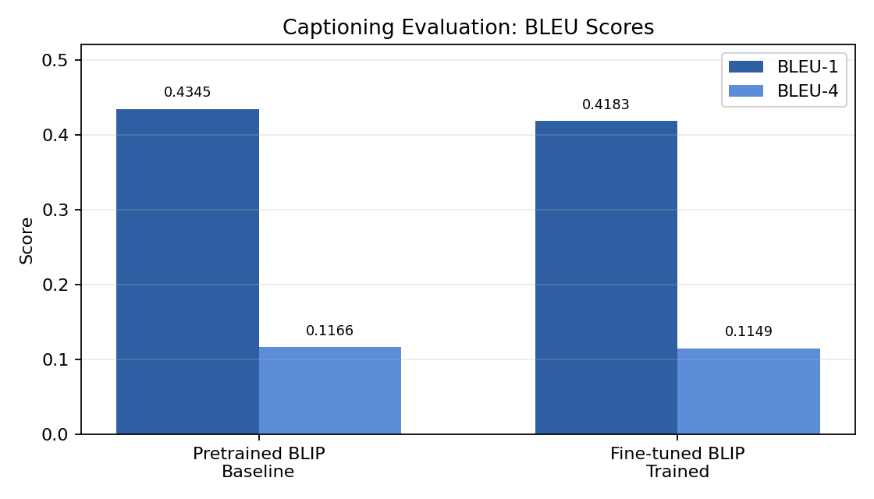
Figure 3 - BLEU-1 and BLEU-4 Scores: Pretrained vs. Fine-tuned BLIP
The fine-tuned captioner received BLEU-1 of 0.4183 and BLEU-4 of 0.1149, while the pretrained baseline scored 0.4345 and 0.1166. The baseline remained slightly higher in this run. This does not mean no training was performed; it means the completed fine-tuning run did not improve over the strong pretrained BLIP baseline under these settings. Possible reasons include limited training epochs, hyperparameter settings, dataset size, or the base model already being well-adapted to general image-caption data. In the aggregate multi-reference evaluation, the baseline achieved BLEU-1 of 0.7388 and BLEU-4 of 0.3229.

7.2 VQA Results
The VQA accuracy results are for the pretrained BLIP VQA supporting component. The main VQA evaluation was conducted on the full validation-derived pseudo-VQA set. For execution stability, the 9,231 questions were evaluated in chunks and merged into outputs/vqa_val_full_eval_predictions.csv.
Test File | Questions | Unique Images | Exact Acc. | Relaxed Acc.
data/vqa_test.csv | 50 | 17 | 0.5600 | 0.6000
data/vqa_val_test.csv | 500 | 251 | 0.4940 | 0.5880
data/vqa_val_full.csv | 9,231 | 1,605 | 0.4747 | 0.5237

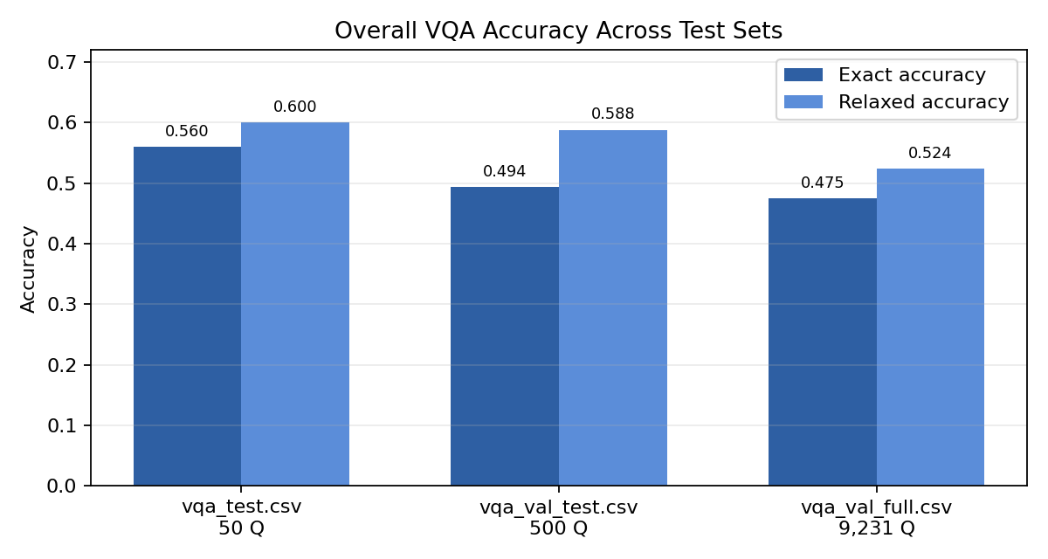
Figure 4 - Overall VQA Accuracy Across Test Sets
Per-question-type results on the full validation-derived set are shown below. The pretrained VQA component performed best on color and count questions. Object and action questions were more challenging. Scene questions performed poorly because generated labels tend to be narrow (e.g., road, grass) while model predictions often use broader descriptions such as outside or on road, indicating a need for synonym-aware scoring.
Question Type | Questions | Exact Accuracy | Relaxed Accuracy | Performance
Action | 1,301 | 0.3812 | 0.4650 | Moderate
Color | 768 | 0.6927 | 0.7682 | Strong
Count | 3,214 | 0.6217 | 0.6217 | Strong
Object | 2,802 | 0.4383 | 0.4568 | Moderate
Scene | 1,146 | 0.1117 | 0.3150 | Weak

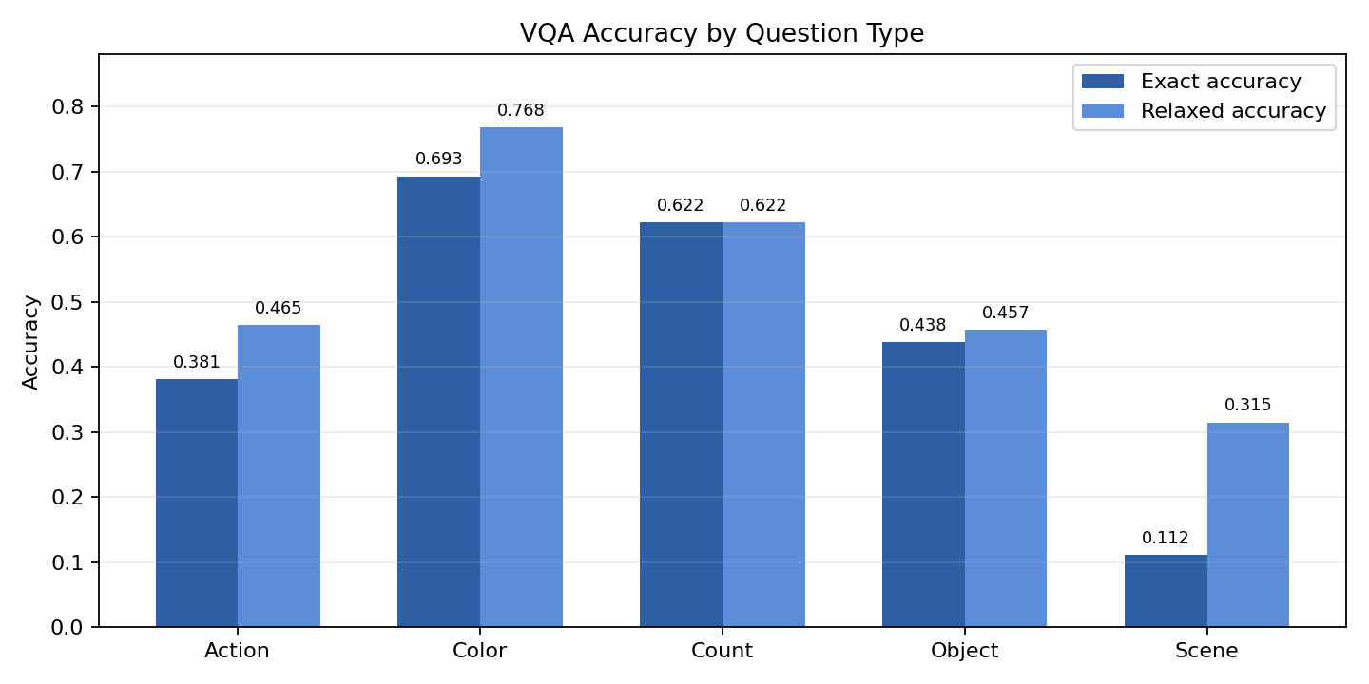
Figure 5 - VQA Exact and Relaxed Accuracy by Question Type

8. Discussion
The project demonstrates that a trained captioning model can be successfully integrated into a larger vision-language assistant. The most successful components are image captioning, color and object VQA, object detection with visual overlay, and searchable image history. The supporting pretrained modules each add distinct practical capabilities: VQA provides question-answering accuracy, DETR provides object localization, and OCR adds text extraction. The bounding box visualization significantly improves interpretability, enabling users to see what the detector found rather than reading labels in isolation.
The OCR-aware VQA pathway is a meaningful practical improvement. General VQA models frequently struggle to read text accurately, especially when it is small or stylized. Routing text-related questions through TrOCR output provides more reliable answers for signs, labels, and printed words.
Evaluation results also illuminate limitations. BLEU scores do not always align with human judgment because a caption can be semantically correct while using different vocabulary than the reference. Similarly, the pseudo-VQA dataset is useful for testing but is not equivalent to a manually annotated benchmark. The low scene-question score highlights that caption-derived labels can be excessively strict as evaluation targets.

9. Limitations
• The VQA test set is generated from captions rather than manually annotated by human evaluators.
• Scene questions are difficult to score accurately because many semantically equivalent answers can be correct.
• BLEU can penalize valid captions that do not match reference wording.
• OCR performance degrades with small text, unusual orientations, or low image quality.
• DETR detects only object categories present in its pretrained label set.
• Inference is slow on CPU due to concurrent loading of multiple transformer models.
• The local JSON history is adequate for demonstration but is not designed for production-scale usage.

10. Future Work
1. Create a manually reviewed VQA test set with reliable, human-annotated labels.
2. Implement synonym-aware scoring for scene and action questions.
3. Continue fine-tuning the captioning model for more epochs and systematically compare training configurations.
4. Add image segmentation to identify object regions with greater precision.
5. Improve OCR by cropping detected text regions before passing them to TrOCR.
6. Migrate history storage from JSON to SQLite for improved search performance and scalability.
7. Add a report export feature saving captions, objects, OCR text, and VQA answers as a PDF.
8. Evaluate newer multimodal models given access to stronger GPU resources.

11. Conclusion
This project successfully implements a visual intelligence assistant centered on a fine-tuned BLIP image-captioning model. By integrating the trained caption generator with supporting visual question answering, object detection, OCR, alt-text generation, tag generation, history search, a Streamlit interface, and a FastAPI service, the system provides a complete and modular image-understanding application.
The fine-tuned captioning model achieved BLEU-1 of 0.4183 and BLEU-4 of 0.1149 on the saved validation run, while the pretrained BLIP baseline achieved 0.4345 and 0.1166. For the pretrained VQA supporting component, the system achieved 47.47% exact accuracy and 52.37% relaxed accuracy on the full 9,231-question VQA benchmark. The strongest VQA performance was on color and count questions; scene questions remain the most challenging
Overall, the project demonstrates how a fine-tuned captioning model can be trained, evaluated, and integrated with pretrained support models to create a complete image-understanding application with measurable evaluation results.

References
1. Junnan Li, Dongxu Li, Caiming Xiong, and Steven Hoi. "BLIP: Bootstrapping Language-Image Pre-training for Unified Vision-Language Understanding and Generation." arXiv:2201.12086, 2022.
2. Nicolas Carion, Francisco Massa, Gabriel Synnaeve, Nicolas Usunier, Alexander Kirillov, and Sergey Zagoruyko. "End-to-End Object Detection with Transformers." ECCV, 2020.
3. Minghao Li et al. "TrOCR: Transformer-based Optical Character Recognition with Pre-trained Models." AAAI, 2023.
4. Micah Hodosh, Peter Young, and Julia Hockenmaier. "Framing Image Description as a Ranking Task: Data, Models and Evaluation Metrics." Journal of Artificial Intelligence Research, 2013.

