Credit Suisse, FoB Hackathon 2020, ML Challenge

Team: Fantastic Five

**The Use Case**

* Create an AI/ML based platform to enable identification of potential

prospects for Wealth Management leveraging News & Social Analytics.

* Using NLP & Clustering Techniques to identify topic of interests for a group of prospects
* Profiling the prospects thus identified to arrive at indicative portfolio size.
* Identify the Degree of Affinity of the prospects to ESG Trends.

**The ML Motivation**

* Utilize the affluence of data & soaring social footprints of wealth creators, machine learning can be the motive force to gauge Social, Cognitive, Behavioural & Cultural elements of individuals who could be our future prospects.
* Drastically reduce the manual task of identification, analysis, profiling and segmentation of the leads generated.

**The Data Strategy**

* Global Knowledge Graph (GKG): Starting point to filter data as per time series, countries, themes, etc eventually
* Data Segmentation: Confirm data metrics, data scale-up and segment variable definition. followed by Profiling and interpretation.
* Profiling: Building a profile map and perform social and news analytics

**The ML Model**

* NLP : Stop Word Removal, Tokenisation, Stemming, Lemmatisation, Frequency & Sentiment Analysis, N-Gram Modelling, TF-IDF to find out high frequency n-grams
* ML : Kmeans Clustering, GMM Clustering

**The Pipeline**

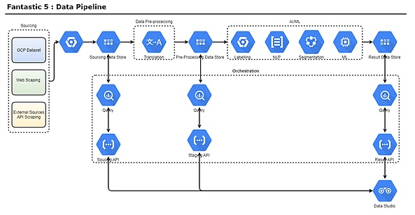

**The Outcome**

* Visualisation techniques availed to exemplify user insights derived from the process and analysis at every stage for potent Lead Generation.