# User Guide

**Partner Management Portal (PMP) is used by both; PMS Admin and Partner User.**

* Partner Administrator: Partner Admin
* Partners: Partner User

## What all activities does a 'Partner Admin' perform for Device Provider?

Being a ‘Partner Admin’ you can perform following 3 activities to complete the end to end functionality pertaining to Device Provider.

* Upload Root CA and Sub CA Certificates
* Approve/Reject SBI
* Approve/ Reject associated devices of an SBI

### Upload Root CA and Sub CA

Only after Partner Admin ‘Upload Root CA and Sub CA Certificates’ that a Partner will then be able to 'Upload CA signed Partner Certificate.

As a process of Partner onboarding onto PMP after successful registration, Partner is required to **Upload CA signed Partner Certificate** on behalf of their organisation which would be used to build a trust store in MOSIP to cryptographically validate that they are from a trusted organisation.

A **Certificate Authority (CA)** is an organization that acts to validate the identities of entities (in this case, a partner organisation) and bind them to cryptographic keys through the issuance of electronic documents known as digital certificates. A country needs to onboard valid CAs before onboarding any partner as MOSIP will only accept certificates which are signed only by a Trusted CA.

#### Upload Root CA and Sub CA Certificates

1. Go to **PMS Portal and login as PARTNER ADMIN**. Click on **Certificate Trust Store** in Admin dashboard

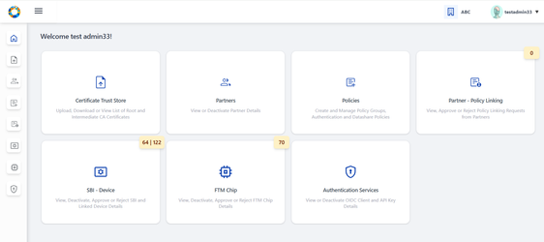

1. Within Root CA tab- click on **Upload Trust Certificate** button on the top-right of the screen.

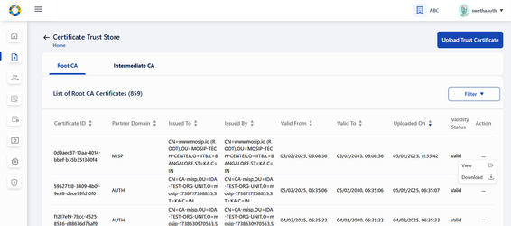

1. Select the Partner Domain. (AUTH)

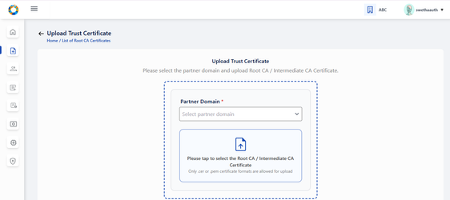

1. Choose the **Root CA Certificate** to upload (only files with extensions as .cer or .pem).

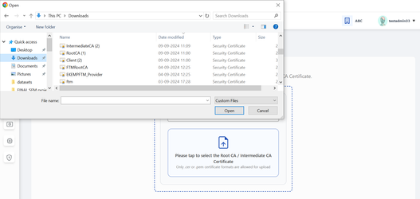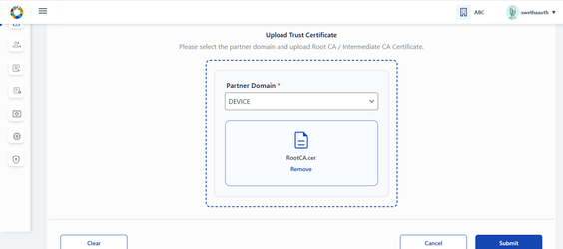

1. Click Submit and an appropriate success message appears.

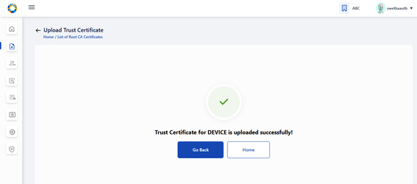

1. Similarly, sub/intermediate CA certificate should be uploaded by following the above steps (2-4) by navigating to **Upload Intermediate CA Certificate** button provided within Intermediate Root CA tab.



## DEVICE PROVIDER USER FLOW

To be able to access the services by PMP and to validate that the partner is from a trusted organisation, undergoing self registration on PMP and uploading CA signed certificate is necessary'.

* Self Register on PMS Interface
* Upload CA signed Certificate

### Self-Register on PMP as Device Provider

1. The Device Provider can register themselves on MOSIP PMS portal by clicking **Register** on the Login Page, a form comes up.
2. Enter the Authentication Partner details:
   1. Partner type (Device Provider)
   2. First and Last name
   3. Organization Name
   4. Address, Phone number
   5. e-mail, Username and password

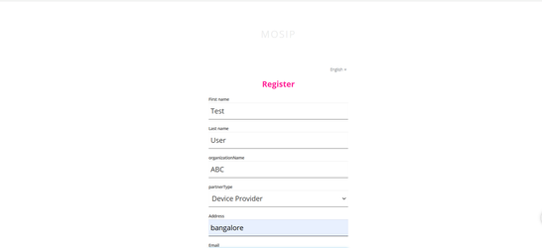

1. **On successful registration, you** will be asked to read through ‘**Terms and Conditions**’ and having carefully read through it you can agree and accept it.

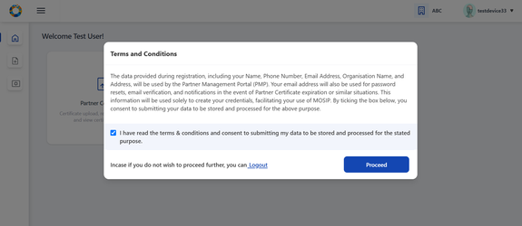

**Validations**:

* Terms & Conditions: Partner consent refers to voluntary and informed agreement provided by a partner user on behalf of the Partner Organisation, to a specific action or process where the users have a clear understanding of what they are consenting to. User consent is important to ensure data privacy, where it is compliant to obtain explicit consent from partners before collecting, processing, or sharing their personal/ organisation level data.
* A detailed description explaining which of their personal and organisation data is used and for what purposes it will be used in PMP will be informed while seeking user consent.

### c) Login:

* For existing partner users who are already registered in Partner Management Portal, they can login to the portal through their email / username and password.
* On logging in, he will be navigated to Partner Dashboard (considering the pre-requisites such as policy group selection and consent are already completed)

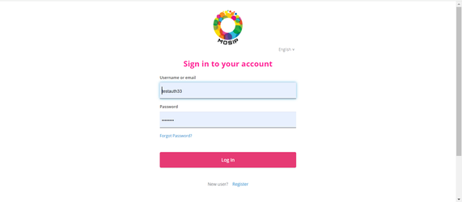

### d) Forgot Password:

* Partner user has an option to reset his password , if he forgets it or wants to change his password after a certain duration.

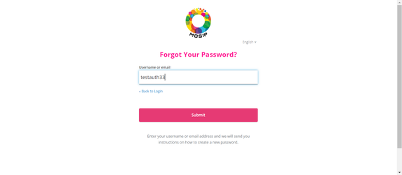

### CA Signed Partner Certificate Upload / Download or Re-Upload

User is now in [**Home Page/Dashboard**](https://docs.mosip.io/1.2.0/modules/partner-management-services/pms-revamp/functional-overview/auth-partner/end-user-guide#interface-overview)where the following features are provided to Device Provider: 1) Partner Certificate, 2) Device Provider Services: SBI and Device creation.

These features can also be accessed by clicking on side panel (in the form of icons) or clicking on the hamburger menu on the top left which is available across all screens of PMP to help user to easily navigate.

Once registered, as a process of Partner onboarding onto PMP after successful registration, user is required to perform upload CA signed Partner Certificate on behalf of their organisation which would be used to build a trust store in MOSIP to cryptographically validate that they are from a trusted organisation

**Tips**:

Later when required a Partner can also ‘Download Certificate’ and ‘Re-Upload Certificate’ (As the need may be).

Important:

Before a Partner can upload a ‘CA Signed Certificate’ it is prerequisite that the ‘Partner Admin’ should have already had uploaded the **Root CA** and **Intermediate CA** certificates.

#### To Upload CA signed Certificate

1. Go to **Device Provider -**> **Dashboard.**

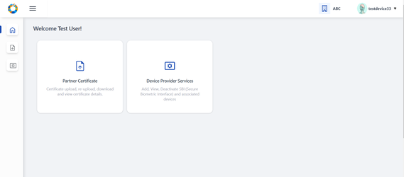

1. Click on **Partner Certificate** option, Click on the **Upload** button to upload the partner certificate signed by CA.

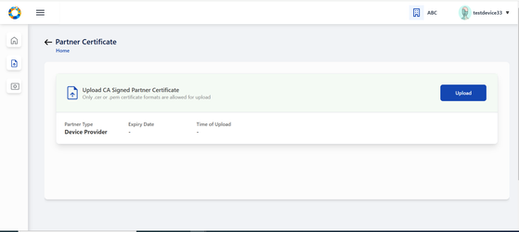

1. Select the CA signed partner certificate from local system by tapping on the upload section (blue area).

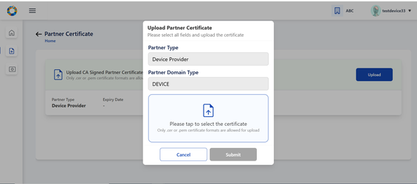

1. Certificate is successfully fetched from local system.

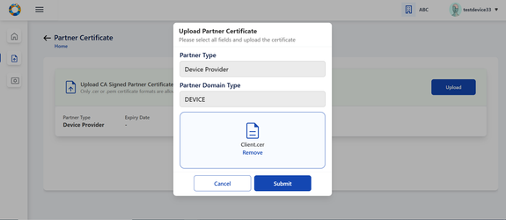

1. Click on **Submit**, Partner Certificate is uploaded successfully.

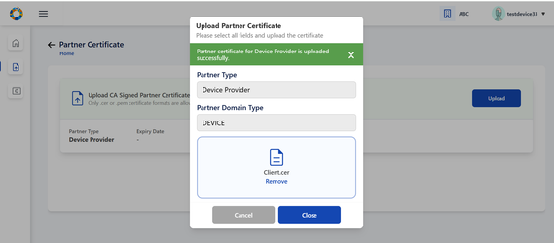

1. On closing the popup, The user can view the uploaded certificate details in the form of a list view.

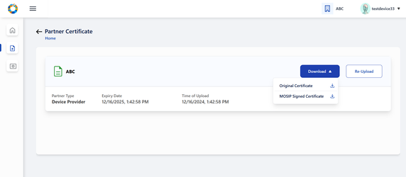

#### Download Certificate

There is also an option to download initially uploaded CA signed certificate and also the MOSIP Signed Certificate.

#### Re-Upload Certificate

Re-uploading certificate is required in cases when MOSIP Signed Certificate gets expired after one year.

**Note:**

'MOSIP Signed Certificate has a validity of 1 year from the time of Partner Certificate Upload.

You must ensure that you re-upload the partner certificate again so that new MOSIP signed certificate can be generated and other functionalities such as Device Provider Services (SBI, Devices) can function.

## Device Provider Services

After the partner has uploaded partner certificate, he can now perform 'Device Provider Services':

* SBI: Add SBI and the request is sent to admin for approval.
* Devices : After approval of a given SBI, devices can be added within it which is then sent to admin for approval.

### ****Add SBI:****

Details of Secure Biometric Interface (SBI) can be added by clicking on ‘Add SBI’ button which navigates to ‘Add SBI Details’ screen.

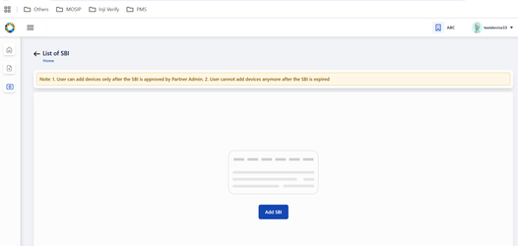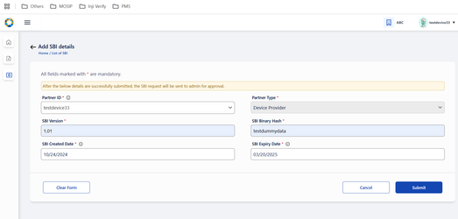

The SBI details thus submitted is sent to admin for approval and is displayed for the partner in **‘List of SBI’** page.

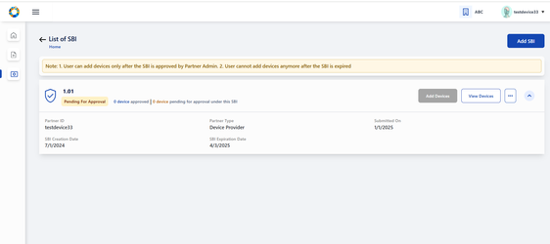

The partner can add devices only if the corresponding SBI has been approved by admin.

**Note: 1. User can add devices only after the SBI is approved by Partner Admin.**

**2. User cannot add devices anymore after the SBI is expired**

1. **If SBI has expired, then it is still visible for Partner Admin for approval/rejection.**
2. **If the SBI version is both deactivated and expired, deactivation will take more precedence.**

**Partner Admin’s portal:( to approve/ reject SBI)**

The SBI can be approved or rejected by partner admin by going to Dashboard → SBI-Device → List of SBIs.

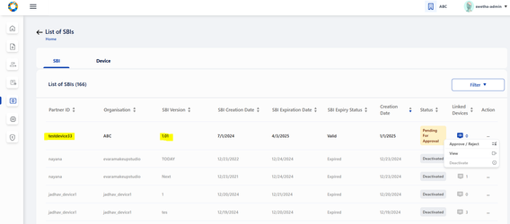

The admin selects on Approve/ Reject option from the given record and chooses appropriate action.

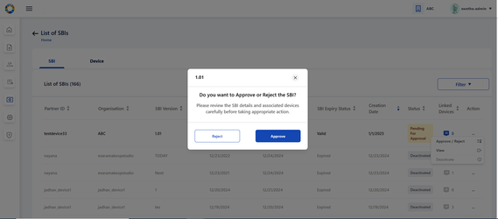

On approval, the status changes to ‘Approved’ and on rejection, the status changes to ‘Rejected’

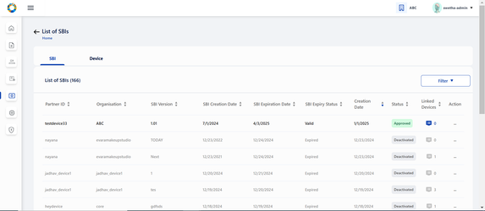

**Partner’s portal- (ADD DEVICES)**

To **add devices** under a given SBI, click on ‘Add Devices’.

Option to Add device/s is only provided if the SBI is in Approved status.

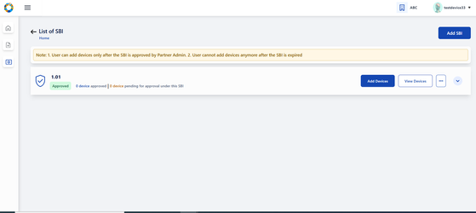

Each device detail added gets submitted for admin approval.

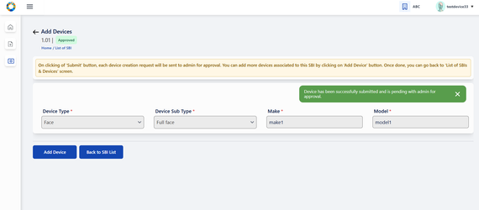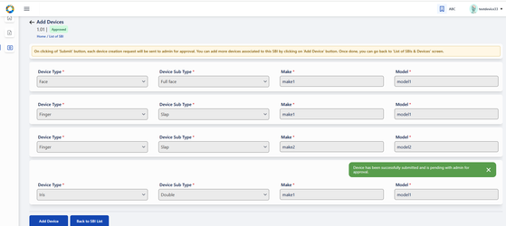

A maximum of 25 devices can be added and viewed at once within this page.

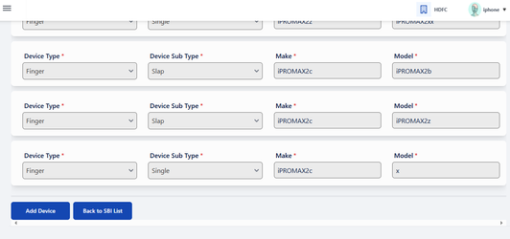

On clicking Add Device button after submitting 25 devices , a warning popup is displayed as following- Maximum of 25 devices can be added at a time. Click **Confirm** to refresh this page and add more devices. Please note that all the previously submitted devices will not be visible upon refreshing but can be viewed in List of Devices Page.

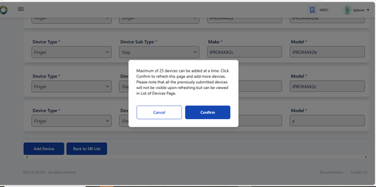

To add more than the stated number (25 devices), the user confirms by clicking on the popup , the page undergoes automatic refresh with all the previously submitted devices not displayed anymore as shown in the below screenshot and then the devices can be added sequentially.

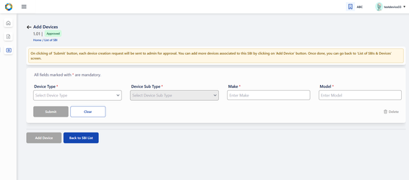

Once all the required devices are submitted, Clicking on ‘Back to SBI List’ button navigates to ‘List of SBIs’ page.

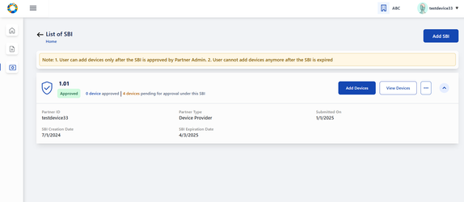

All devices pertaining to a given SBI can be viewed in a tabular structure by clicking on View Devices provided in each SBI card of List of SBIs page.

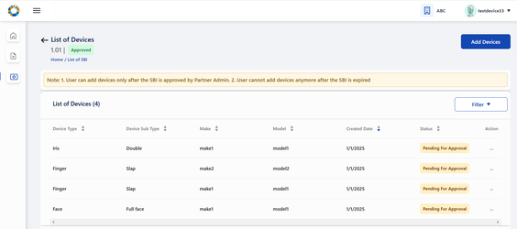

Each device record can be viewed individually (in both Partner and Partner Admin portal) by clicking on record itself or on clicking View option in action menu of the corresponding device. The partner/ partner admin is navigated to **‘View Device Details’** for detailed view.

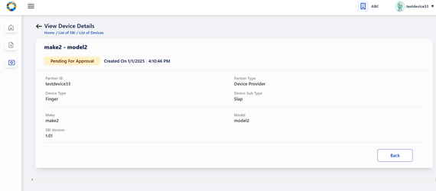

**Partner Admin portal for approval/rejection of devices:**

To approve/ reject a device, admin clicks on SBI -Device card in his homepage.

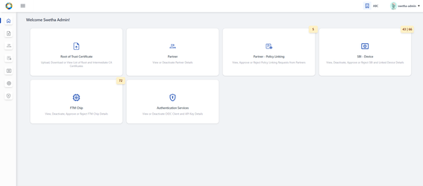

On clicking ‘Devices’ tab, **List of all Devices** submitted so far are displayed.

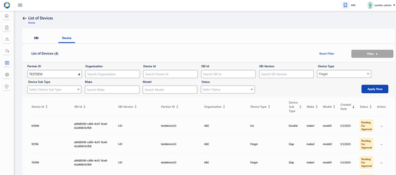

On clicking the action menu of the respective device record, an option ‘Approve/ Reject’ is provided

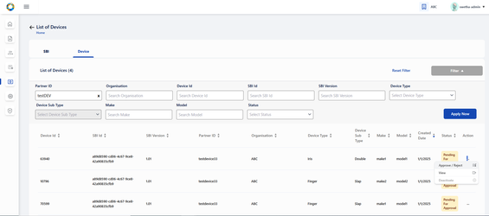

A popup window appears for the admin to take appropriate action- APPROVE/ REJECT and select the respective button

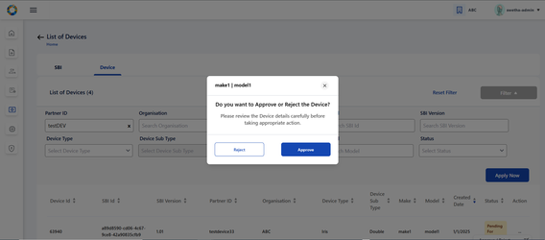

The status is thus updated accordingly in **List of Devices** Page as Approved/ Rejected based on the above action.

'Pending for Approval' status is displayed when the device request is pending with admin for approval and no action has been taken by admin yet.

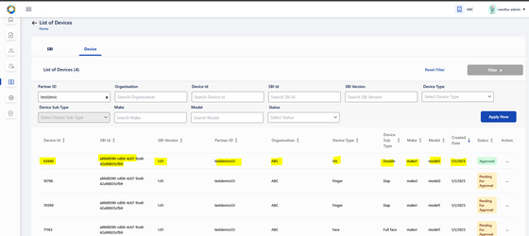

**Deactivate Device:**

Partner / Partner Admin can deactivate an active device any time provided it is in ‘Approved’ status. To perform deactivation, click on ‘Deactivate’ option in the action menu of the given Device in ‘List of Device’ page.

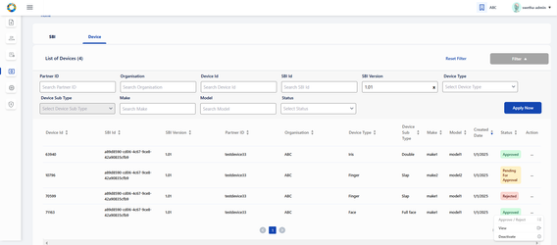

On clicking Deactivate option, a popup window appears seeking for confirmation.

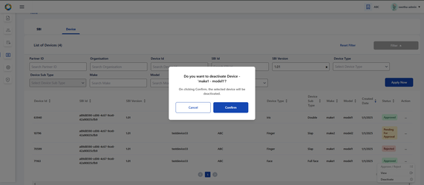

On clicking Confirm, the status of the device changes to ‘Deactivated’ and the record is greyed out in the List of Devices page.

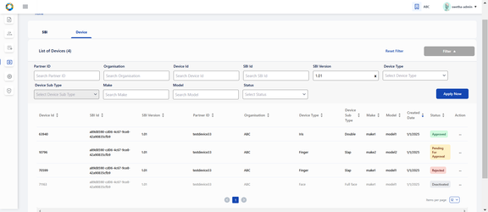

**Deactivate SBI:**

Partner / Partner Admin can deactivate an active SBI any time provided it is in ‘Approved’ status. To perform deactivation, click on ‘Deactivate’ option in the action menu of the given SBI in ‘List of SBI’ page.

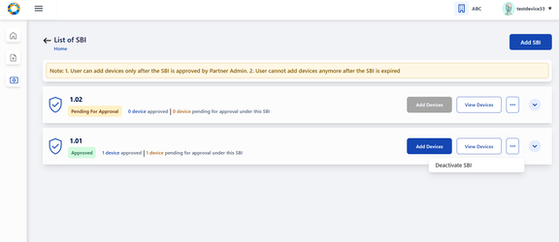

On clicking ‘Deactivate SBI’, a popup window appears seeking for confirmation and displaying an info text clearly stating out the impact on associated devices.

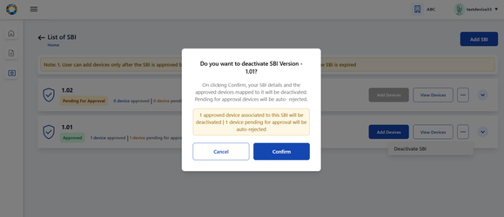

On deactivation of SBI- the devices associated to it gets impacted as below:

* All **approved** device records are displayed in **‘Deactivated'** status and those row items being greyed out.
* The devices whose status was **‘Pending for Approval**’ before SBI deactivation will now be displayed with **‘Rejected’** status, which means devices get auto-rejected.
* **Rejected** devices will continue to remain in the same status even after SBI deactivation.

The SBI record is greyed out and devices cannot be added anymore within it.

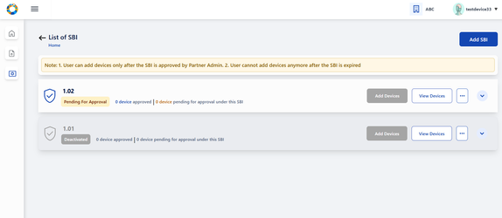

**Status of Devices before SBI Deactivation:**

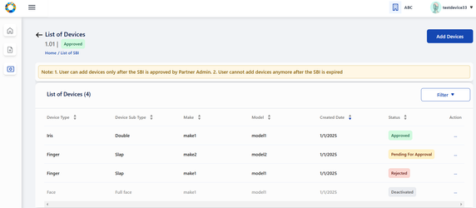

* Previously **approved** device records are displayed in **‘Deactivated'** status and those row items being greyed out.
* Devices which were **‘Pending for Approval**’ before SBI deactivation will now be displayed with **‘Rejected’** status, which means devices get auto-rejected.
* Devices which were earlier **rejected** continue to remain in the same status even after SBI deactivation.

**Impact on status of Devices after SBI Deactivation:**

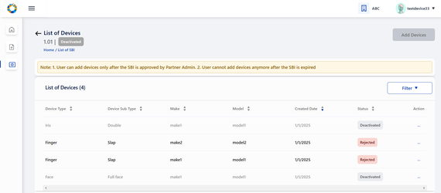

Option to deactivate an SBI is also available to Partner Admin by clicking on ‘Deactivate option’ in action menu of approved SBIs in List of SBI page.

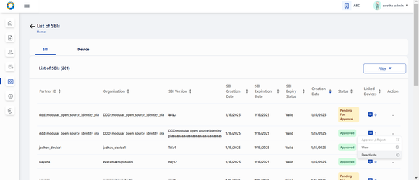

**Filter section in Partner portal:**

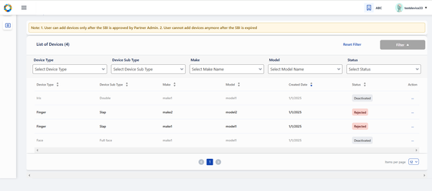

* It displays an expandable and collapsible filter section on consecutive clicks.
* Here each filter field is a drop-down and the tabular results dynamically updates based on the drop-down item selected.
* Once the filter section is expanded, the filter button thus becomes disabled.
* On applying filters, the ( ) beside ‘List of Devices’ title should display the total number of filtered results.
* User will have to use Reset Filterto remove the Filters. On clicking it, page will reload and the entire results are displayed in the tabular view , instead of filtered results..