# End User Guide

**Partner Management Portal (PMP) is used by both; PMS Admin and Partner User.**

* Partner Administrator: Partner Admin
* Partners: Partner User

## What all activities does a 'Partner Admin' perform for FTM Chip Provider?

Being a ‘Partner Admin’ you can perform following 3 activities to complete the end to end functionality pertaining to Device Provider.

* Upload Root CA and Sub CA Certificates
* Approve/Reject FTM Chip

### Upload Root CA and Sub CA

Only after Partner Admin ‘Upload Root CA and Sub CA Certificates’ that a Partner will then be able to 'Upload CA signed Partner Certificate.

As a process of Partner onboarding onto PMP after successful registration, Partner is required to **Upload CA signed Partner Certificate** on behalf of their organisation which would be used to build a trust store in MOSIP to cryptographically validate that they are from a trusted organisation.

#### ****Certificate Authority (CA)**** is an organization that acts to validate the identities of entities (in this case, a partner organisation) and bind them to cryptographic keys through the issuance of electronic documents known as digital certificates. A country needs to onboard valid CAs before onboarding any partner as MOSIP will only accept certificates which are signed only by a Trusted CA.

#### Upload Root CA and Sub CA Certificates

1. Go to **PMS Portal and login as PARTNER ADMIN**. Click on **Certificate Trust Store** in Admin dashboard

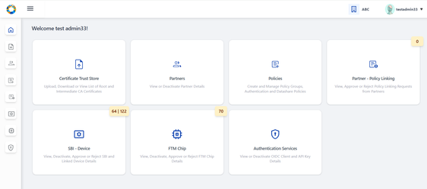

1. Within Root CA tab- click on **Upload Trust Certificate** button on the top-right of the screen.

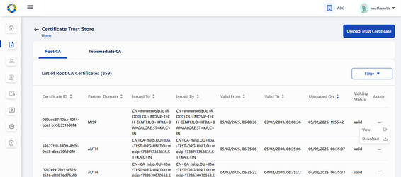

1. Select the Partner Domain. (FTM)

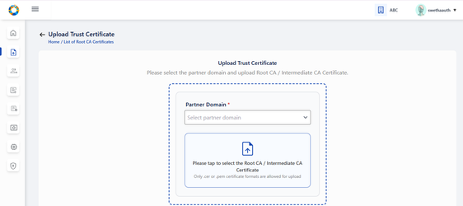

1. Choose the **Root CA Certificate** to upload (only files with extensions as .cer or .pem).

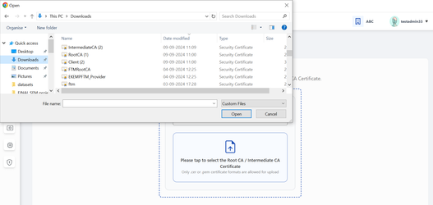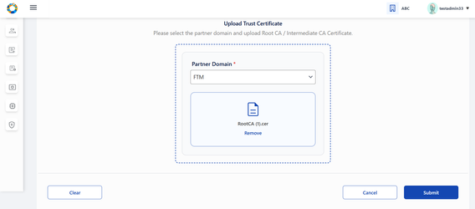

1. Click Submit and an appropriate success message appears.
2. Similarly, sub/intermediate CA certificate should be uploaded by following the above steps (2-4) by navigating to **Upload Intermediate CA Certificate** button provided within Intermediate Root CA tab.



## FTM Chip Provider Workflow

To be able to access the services by PMP and to validate that the partner is from a trusted organisation, undergoing self registration on PMP and uploading CA signed certificate is necessary'.

* Self Register on PMS Interface
* Upload CA signed Certificate

### Self-Register on PMP as FTM Chip Provider

1. The FTM Chip Provider can register themselves on MOSIP PMS portal by clicking **Register** on the Login Page, a form comes up.
2. Enter the FTM Chip Provider details:
   1. Partner type (FTM Provider)
   2. First and Last name
   3. Organization Name
   4. Address, Phone number
   5. e-mail, Username and password

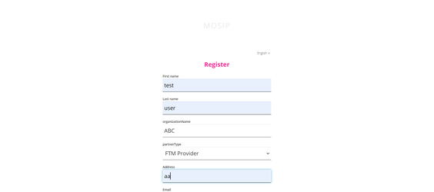

1. **On successful registration, you** will be asked to read through ‘**Terms and Conditions**’ and having carefully read through it you can agree and accept it.

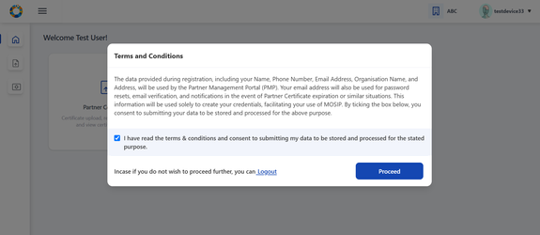

**Validations**:

* Terms & Conditions: Partner consent refers to voluntary and informed agreement provided by a partner user on behalf of the Partner Organisation, to a specific action or process where the users have a clear understanding of what they are consenting to. User consent is important to ensure data privacy, where it is compliant to obtain explicit consent from partners before collecting, processing, or sharing their personal/ organisation level data.
* A detailed description explaining which of their personal and organisation data is used and for what purposes it will be used in PMP will be informed while seeking user consent.

### c) Login:

* For existing partner users who are already registered in Partner Management Portal, they can login to the portal through their email / username and password.
* On logging in, he will be navigated to Partner Dashboard (considering the pre-requisites such as policy group selection and consent are already completed)

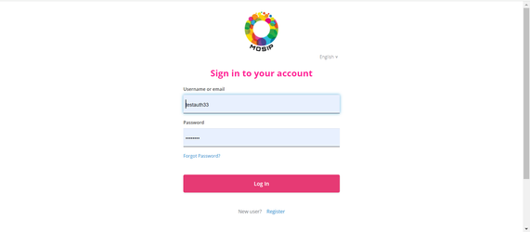

### d) Forgot Password:

* Partner user has an option to reset his password , if he forgets it or wants to change his password after a certain duration.

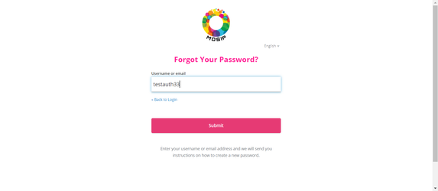

### CA Signed Partner Certificate Upload / Download or Re-Upload

User is now in [**Home Page/Dashboard**](https://docs.mosip.io/1.2.0/modules/partner-management-services/pms-revamp/functional-overview/auth-partner/end-user-guide#interface-overview)where the following features are provided to FTM Chip Provider: 1) Partner Certificate, 2) FTM Chip Provider Services.

These features can also be accessed by clicking on side panel (in the form of icons) or clicking on the hamburger menu on the top left which is available across all screens of PMP to help user to easily navigate.

Once registered, as a process of Partner onboarding onto PMP after successful registration, user is required to perform upload CA signed Partner Certificate on behalf of their organisation which would be used to build a trust store in MOSIP to cryptographically validate that they are from a trusted organisation……..

**Tips**:

Later when required a Partner can also ‘Download Certificate’ and ‘Re-Upload Certificate’ (As the need may be).

Important:

Before a Partner can upload a ‘CA Signed Certificate’ it is prerequisite that the ‘Partner Admin’ should have already had uploaded the **Root CA** and **Intermediate CA** certificates.

#### To Upload CA signed Certificate

1. Go to **FTM Provider -**> **Dashboard.**

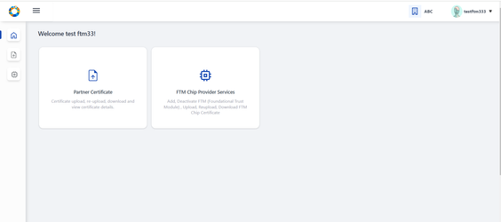

1. Click on **Partner Certificate** option, Click on the **Upload** button to upload the partner certificate signed by CA.

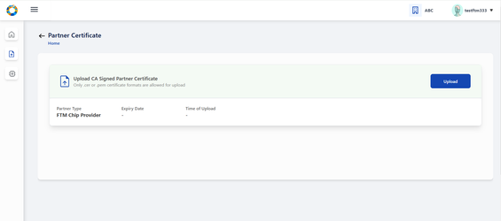

1. Select the CA signed partner certificate from local system by tapping on the upload section (blue area).

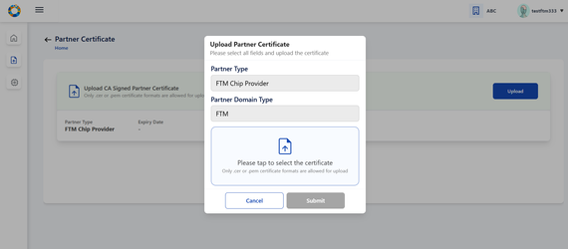

1. The required certificate is selected from the local system.

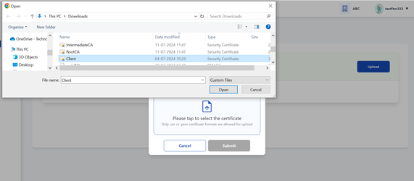

1. Certificate is successfully fetched from local system.

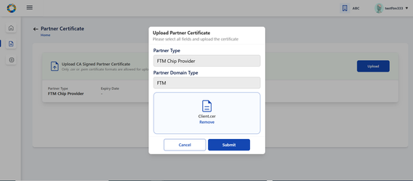

1. Click on **Submit**, Partner Certificate is uploaded successfully.

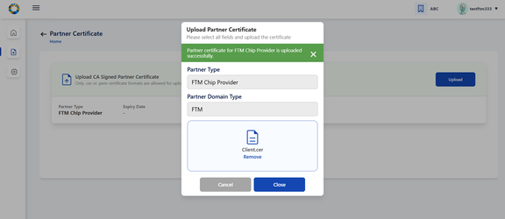

1. On closing the popup, The user can view the uploaded certificate details in the form of a list view.

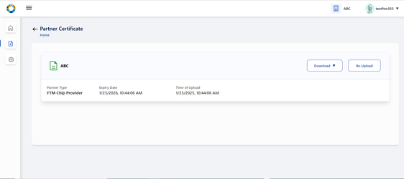

#### Download Certificate

There is also an option to download initially uploaded CA signed certificate and also the MOSIP Signed Certificate.

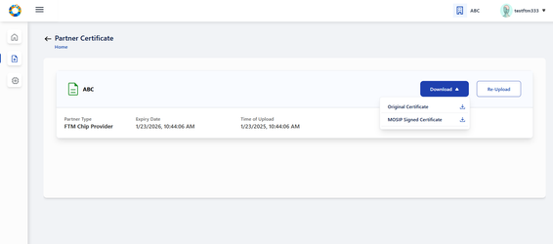

Success Message is displayed on successful download of Originally uploaded certificate/ MOSIP Signed Certificate.

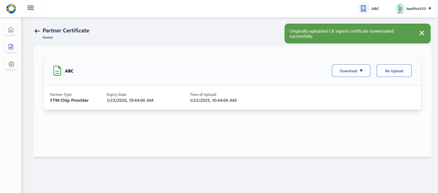

On closing the popup, The user can view the uploaded certificate details in the form of a list view.

#### Download Certificate

There is also an option to download initially uploaded CA signed certificate and also the MOSIP Signed Certificate.

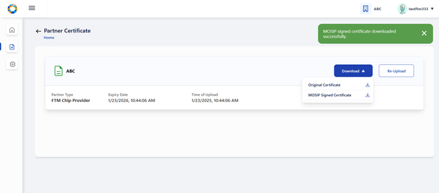

#### Re-Upload Certificate

Re-uploading certificate is required in cases when MOSIP Signed Certificate gets expired after one year.

**Note:**

'MOSIP Signed Certificate has a validity of 1 year from the time of Partner Certificate Upload.

You must ensure that you re-upload the partner certificate again so that new MOSIP signed certificate can be generated and other functionalities such as FTM Chip Provider Services can function.

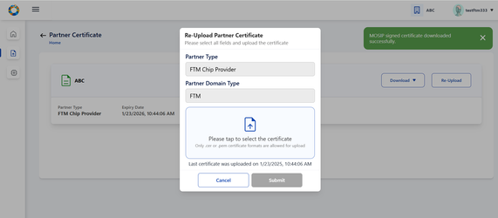

The rest of the steps is same as covered in Upload Certificate flow (Step 3-7)

## FTM Chip Provider Services

After the partner has uploaded partner certificate, he can now perform 'FTM Chip Provider Services':

* **Add** FTM Chip details and **upload** the FTM Chip certificate for the request to be sent to partner admin for approval.
* **Deactivate** FTM details.
* **Re- upload** and **download** FTM Chip Certificate.

### ****Add FTM Chip:****

Details of Foundational Trust Module (FTM) Chip can be added by clicking on ‘Add FTM Chip’ button which navigates to ‘Add FTM Chip Details’ screen.

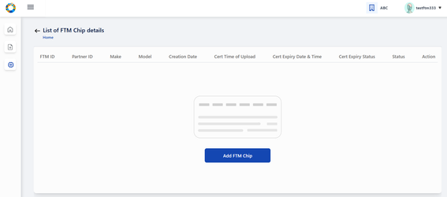

The partner is expected to enter the make and model of FTM Chip and submit the details.

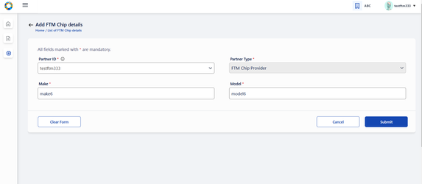

After successful submission of FTM Chip details, the partner is prompted to click on ‘Upload FTM Chip Certificate’ to proceed further.

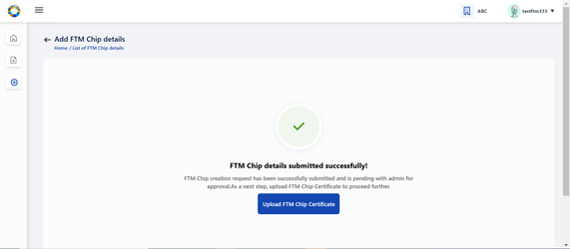

The partner clicks on the Upload section to select the FTM Chip Certificate from local system.

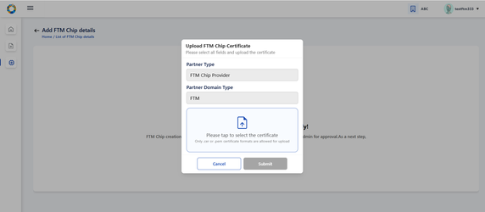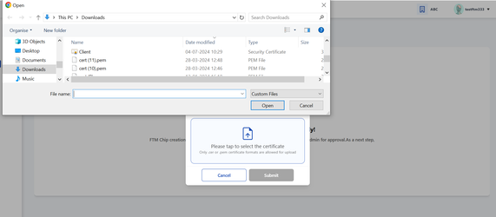

After selection, the uploaded certificate is displayed on screen which the partner has to submit.

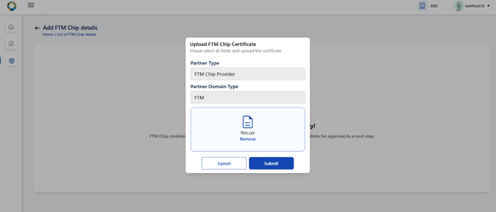

A success message on successful submission is displayed on the screen.

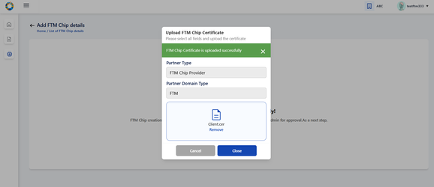

On click of Close, the user is navigated to List of FTM Chip details page where the status of the record is in ‘Pending for Approval status’.

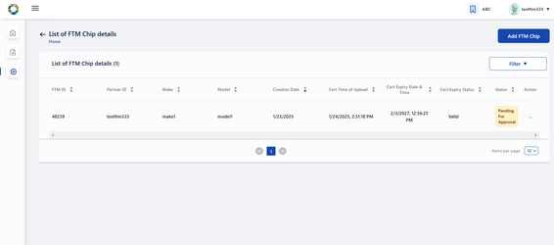

Lets assume, the certificate upload process was not carried out after adding FTM details due to a technical issue/ unexpected closing of of the PMS portal. At such instances, while navigating to FTM **Chip Services Dashboard** → List of FTM Chip details, the given record is found to be in ‘Pending for Certificate Upload’ status. Which means that without the certificate upload, the record will not go to admin for approval..

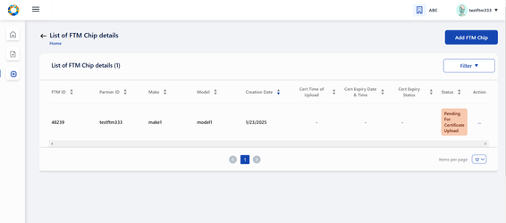

To upload the FTM Chip certificate, select the Manage Certificate option from action menu.

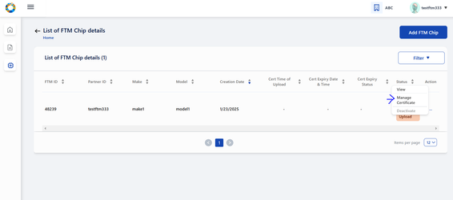

The partner is navigated to Manage FTM Chip certificate page where on clicking upload button, the partner can upload the certificate by following the same steps as mentioned above.

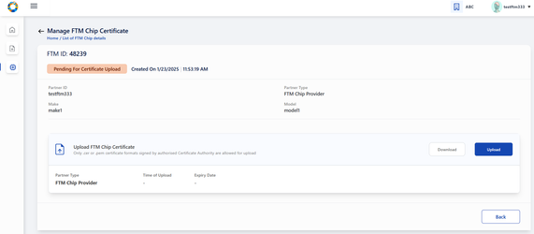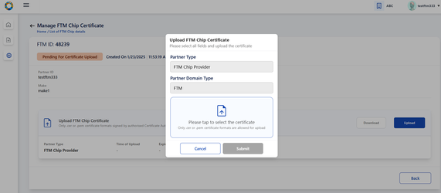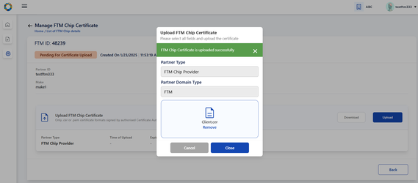

Once the upload is complete - the record moves to ‘Pending for Approval’ status where the Partner Admin can take appropriate action by approving / rejecting this entry.



### Partner Admin

To approve/ reject an FTM Chip, admin clicks on ‘FTM Chip’ card in his homepage.

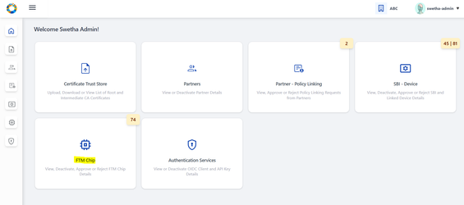

The admin navigates to ‘List of FTM Chip details’ page where list of all FTM Chip records submitted so far by different FTM Chip providers are displayed.

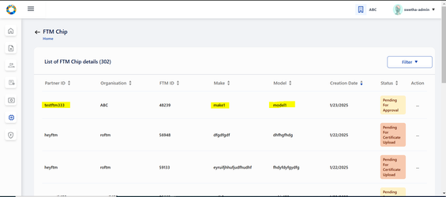

On clicking the action menu of the respective FTM Chip record, an option ‘Approve/ Reject’ is provided

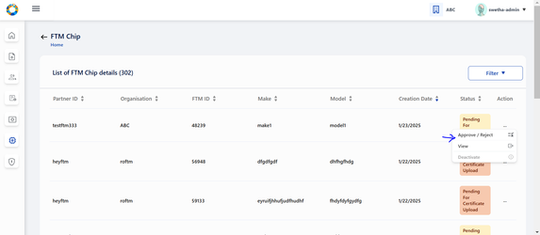

A popup window appears for the admin to take appropriate action- APPROVE/ REJECT and select the respective button

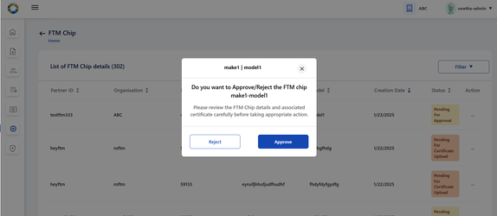

The status is thus updated accordingly in **List of Devices** Page as Approved/ Rejected based on the above action.

Note: 'Pending for Approval' status is displayed when the FTM Chip request is pending with admin for approval and no action has been taken by admin yet.

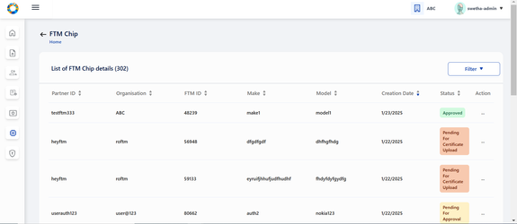

### Manage Certificate for approved records

Once the FTM Chip record is approved, FTM Chip Provider can click on Manage Certificate option in action menu so that the partner can download/ reupload the FTM Chip certificate in Manage FTM Chip Certificate page.

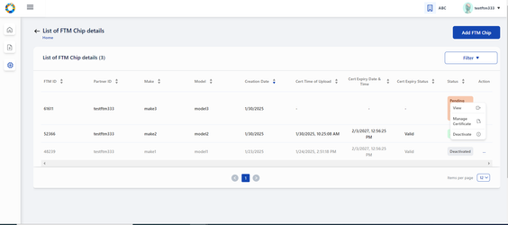

To re-upload certificate after expiry or otherwise, click on Re-Upload button.

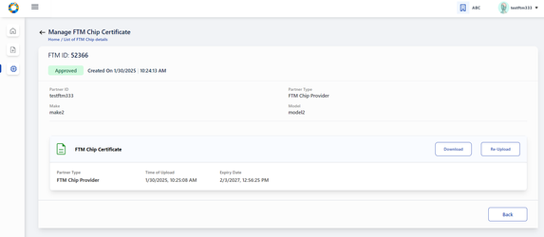

Follow the same steps as upload flow to perform the reupload functionality.

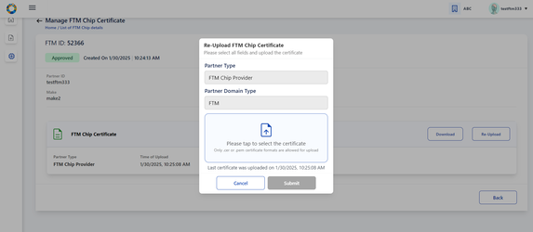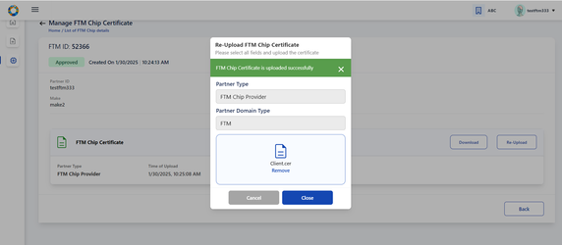

After reupload of certificate is successfully completed, the status again changes to ‘Pending for Approval’ as the renewed certificate needed to go through admin check for the FTM Chip record to be validated.

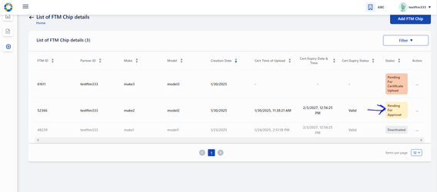

Every Approved FTM Chip record has a download option provided to download the FTM Chip certificate at any given time.

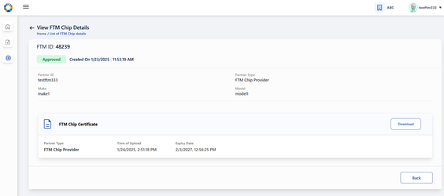

on click of download button, a success message is displayed on the screen.

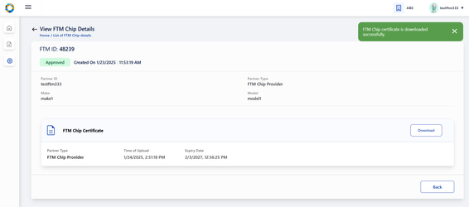

### Deactivate FTM Chip

Partner / Partner Admin can deactivate an active FTM Chip any time provided it is in ‘Approved’ status. To perform deactivation, click on ‘Deactivate’ option in the action menu of the given FTM Chip in ‘List of FTM Chip details’ page.

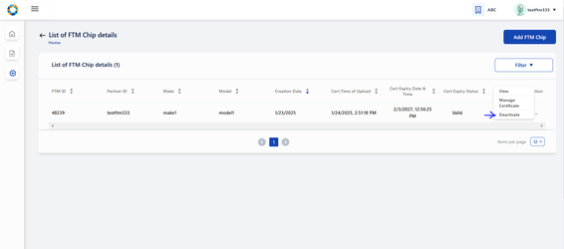

On clicking ‘Deactivate’, a popup window appears seeking for confirmation and appropriate info text is displayed.

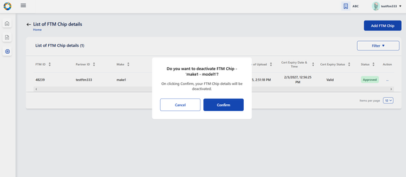

on deactivation , the status changes to ‘Deactivated’ status.

