1. HelloWorld Program
2. class helloWorld {
3. public static void main(String[] args) {
4. System.out.println("hello world");
5. }
6. }

Output :

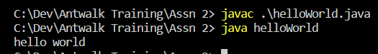

2) Rectangle area

import java.util.\*;

public class area {

    public static void main(String[] args) {

        Scanner in = new Scanner(System.in);

        float length = in.nextFloat();

        float breadth = in.nextFloat();

        System.out.format("The area is %f\n", length \* breadth);

        in.close();

    }

}

Output :

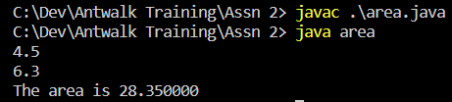

3) Enhanced for loop to find sum of array elements

public class enhancedForLoop {

    public static void main(String[] args) {

        int[] a = { 1, 2, 3, 4, 5 };

        int sum = 0;

        for (int val : a) {

            sum += val;

        }

        System.out.println(sum);

    }

}

Output :

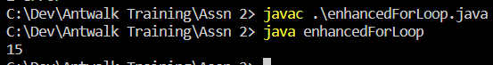

4) Pattern

import java.util.\*;;

public class pattern {

    public static void main(String[] args) {

        Scanner in = new Scanner(System.in);

        int n = in.nextInt();

        for (int i = 0; i < n; i++) {

            for (int sp = 0; sp < i; sp++) {

                System.out.print(" ");

            }

            for (int j = n; j > i; j--) {

                System.out.print("\* ");

            }

            System.out.println();

        }

        in.close();

    }

}

Output :

