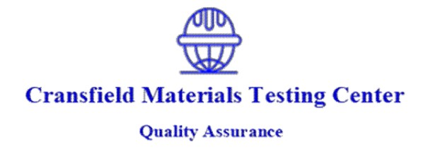 | Cransfield Materials Testing Center  P.O. Box 59401 – 00200, Nairobi, Kenya  Runda Grove House No. 278  Tel: +254 703 410 973 / +254 721 740 587  Email: info@cmtc.co.ke · Website: www.cmtc.co.ke

COMPRESSIVE STRENGTH OF CONCRETE CUBES
BS EN 12390-3 : 2002
PROJECT | Proposed Residential Development in Kamakis
CLIENT | Kamau
COUNTY | Nairobi | CONCRETE CLASS | C25 | DATE CAST | 19-Oct-26
CONTRACTOR | N/A | SECTION | Slab | LAB REF | —
MADE BY | Contractor | CLIENT REF | — | SLUMP | N/A
REPORT NO. | — | DATE RECEIVED | — | CURING | —

CUBE MARK | DATE OF CAST | DATE OF TEST | AGE (DAYS) | CUBE DIMENSIONS (mm) |  |  | MASS OF CUBE (g) | DENSITY (kg/m³) | MAX LOAD AT FAILURE (kN) | COMPRESSIVE STRENGTH (N/mm²) | % OF TARGET | REMARKS
 |  |  |  | L | W | H
— | 19-Oct-26 | 29-Oct-26 | 10 | 150 | 150 | 150 | 8,250.0 | 2,444 | 463.7 | 20.6 | 82% | Satisfactory

MODE OF FAILURE | —
COMMENT | Strength at 10 days is 82% of the specified 25 N/mm², consistent with normal strength development. Compliance with the specified class should be confirmed on 28-day results.
Reports and Certificates by Cransfield Labs are issued subject to the following terms and conditions:
1. Results herein are a true representation of the cubes submitted to our lab, to the best of our knowledge.
2. Any correction or addition to these test results will make this report invalid.
3. Once this report is transmitted or released it is final; no corrections pertaining to incorrect information submitted by the client will be accepted or considered.
4. This report should not be reproduced or published, in full or in part, without prior written approval from our lab.
5. All photocopies of test reports not signed by our Technical Director should be considered invalid.
6. All results released to the client are treated as strictly confidential and will only be released to other parties on written instruction from the client.
7. A legal contract between the client and Cransfield Lab is deemed constituted upon receipt of the test results by the client, whether sent electronically or collected by the client's representative.

TESTED BY: | Contractor | REPORTED ON: |  | CHECKED BY: |  | 
RECEIVED BY: |  | DATE: |  | SIGNATURE:

Specialists in: Non-Destructive Testing, Materials Testing and Inspection, Quality Assurance, Failure Investigations Page 1 of 1

