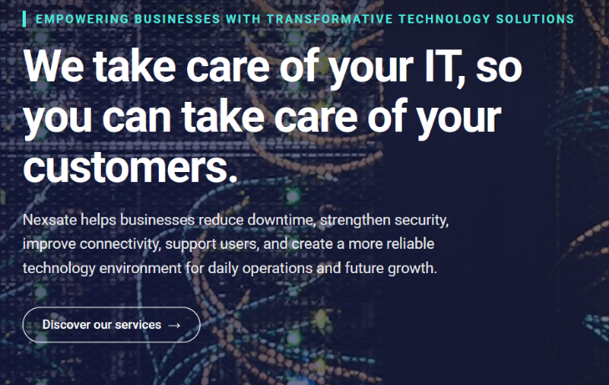
Change: MANAGED SERVICES

We take care of your IT, so you can take care of your customers.

From everyday user support to proactive monitoring, maintenance, and security, Nexsate takes responsibility for keeping your IT environment running smoothly. We help resolve issues before they disrupt operations, giving your people the support they need to stay focused on their work.

Discover Our Services
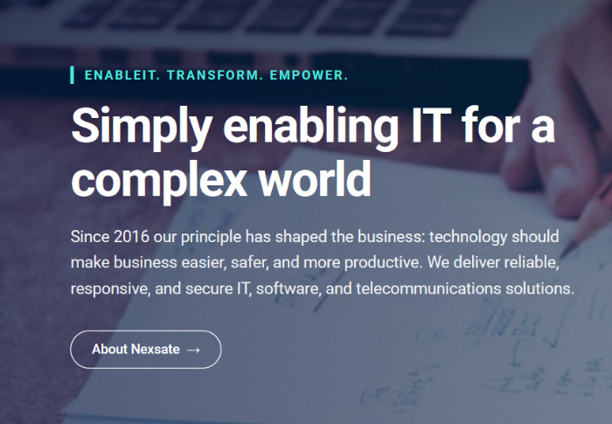
Retain: ENABLE. TRANSFORM. EMPOWER

Simplifying IT for a complex world

We believe technology should make business easier, safer, and more productive. At Nexsate, that belief shapes everything we do, from how we understand our customers' needs to how we design, deliver, and support technology that works for their business.

Explore Services
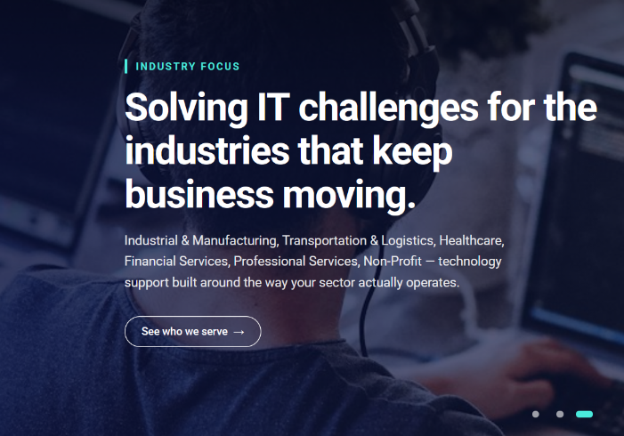
Retain: INDUSTRY FOCUS

Technology solutions build around the industries we serve.

Different industries depend on technology in different ways. From keeping production systems connected to supporting healthcare teams and business-critical operations, Nexsate delivers IT solutions that reflect the demands, workflows, and priorities of each sector.

Explore Industries

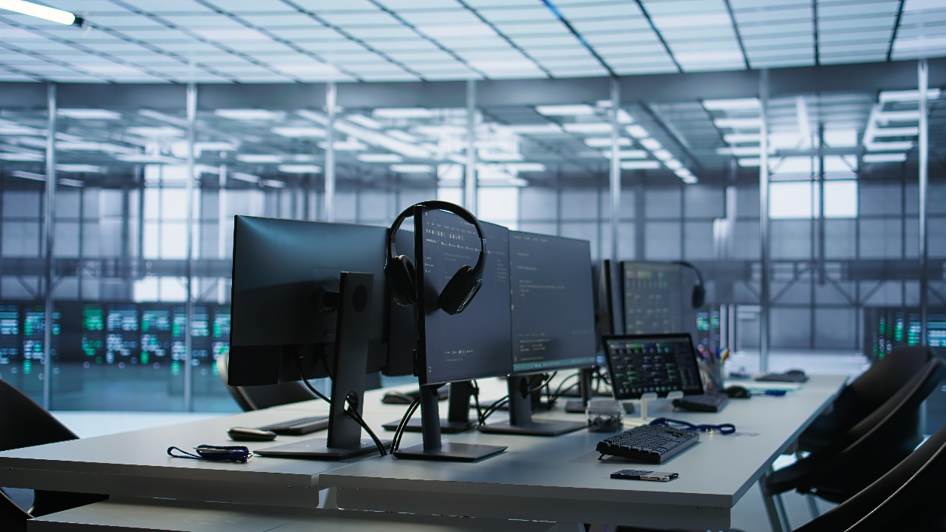



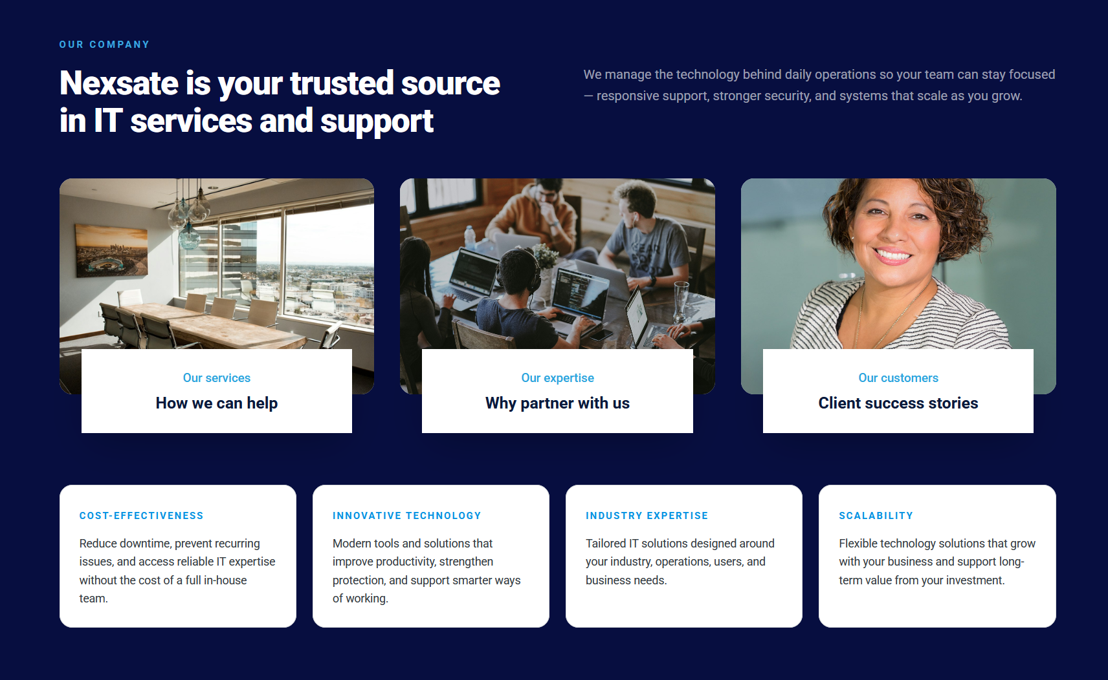

Nexsate is your trusted source for IT services and support.
Nexsate brings together managed IT, cloud infrastructure, cybersecurity, networking, software development, and systems integration under one roof, providing businesses with a single, accountable partner for their technology needs.

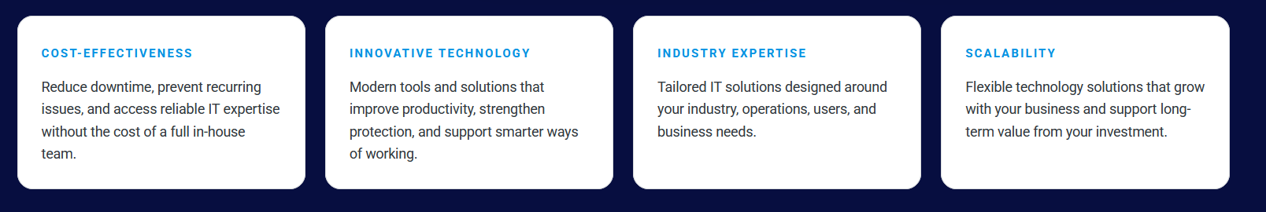

ACCOUNTABILITY | FORESIGHT | PRACTICALITY | FLEXIBILITY
One team, one point of contact. We take ownership of your IT needs and see issues through to resolution. | We identify recurring issues, anticipate challenges, and recommend improvements for long-term reliability. | We focus on what works. Technology that solves real problems without unnecessary cost or complexity. | We work with your existing IT environment, adapt as your needs change, and provide specialist expertise where it matters most.

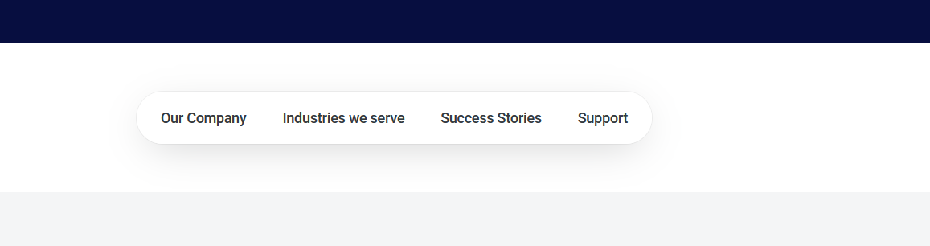
This is a lot of space. The menu just needs to be a floating menu between the two sections without adding an extra section.

This needs to be removed and retain scroll arrows.
Insert these arrows to scroll left or right without blue. It should however be highlighted based on the page presented on the screen.


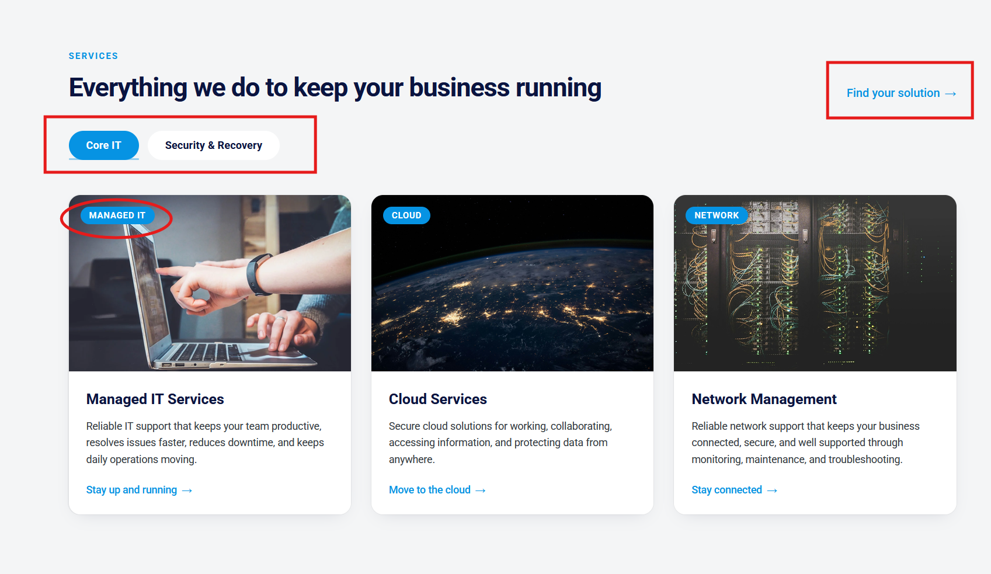
IT SUPPORT
Discover our services

Managed IT Services | Cloud Services | Network Management
A coordinated helpdesk for user requests, backed by device management, updates, and system maintenance. We track issues through resolution and keep your everyday IT administration organized. | We design, migrate, and manage cloud environments, business applications, and data across public, private, and hybrid platforms, covering storage, access, integration, and ongoing administration. | We design, configure, and maintain network switches, firewalls, Wi-Fi, and remote access, monitoring performance and investigating connectivity faults across your offices, sites, and remote teams.
Stay up and running | Move to Cloud | Stay connected

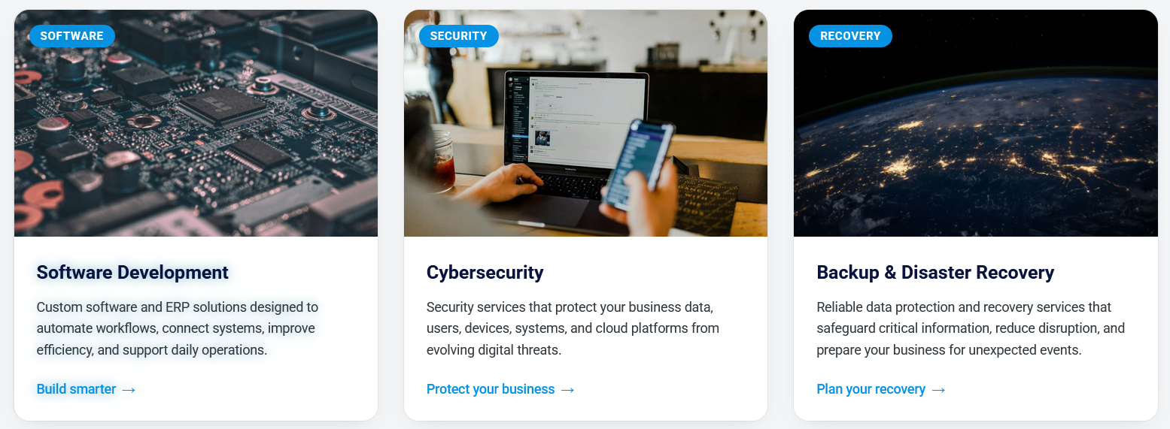

Software Development | Cybersecurity | Backup & Disaster Recovery
We develop business applications, implement ERP systems, automate workflows, and integrate software platforms to improve data flow, reduce manual tasks, and simplify business operations. | We protect networks, systems, applications, and data through threat monitoring, access controls, vulnerability management, and incident response to strengthen your organization's security. | We manage backups, test recovery procedures, and plan for restoring critical data and systems, helping businesses recover from outages, data loss, and unexpected disruptions.
Build smarter | Protect your business | Plan your recovery
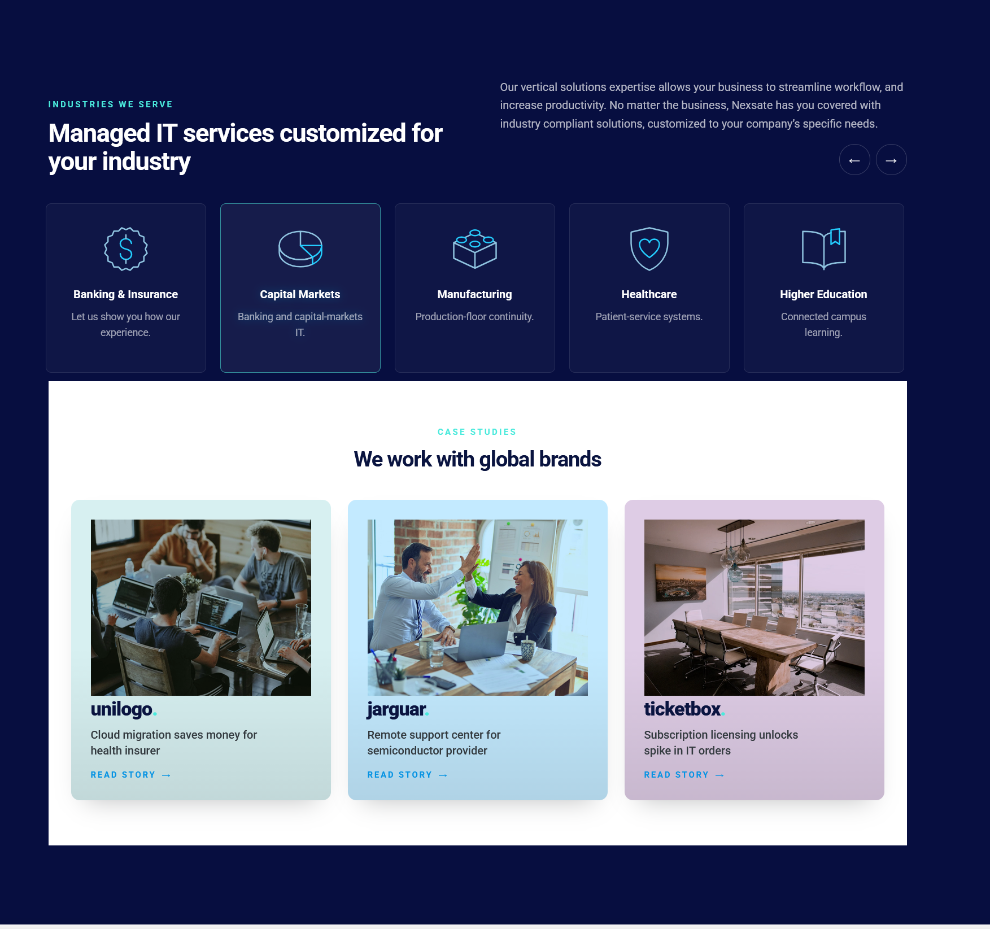
Text to be on level
Blue should reach this level
They are moving slight up and down. Please animate the icons. We could change the icons to similar ones even in different colors.
Blue should reach this level

Delivering industry-specific technology solutions
Behind every industry are critical processes, specialized applications, and people who depend on them. Nexsate considers these operational priorities when developing, implementing, and supporting technology across different business environments.

Industries order:

- Manufacturing
- Healthcare
- Banking and Finance
- Education
- Transport & Logistics
- Industrial
- Education
- Professional services
- Public Sector
- Non-Profit

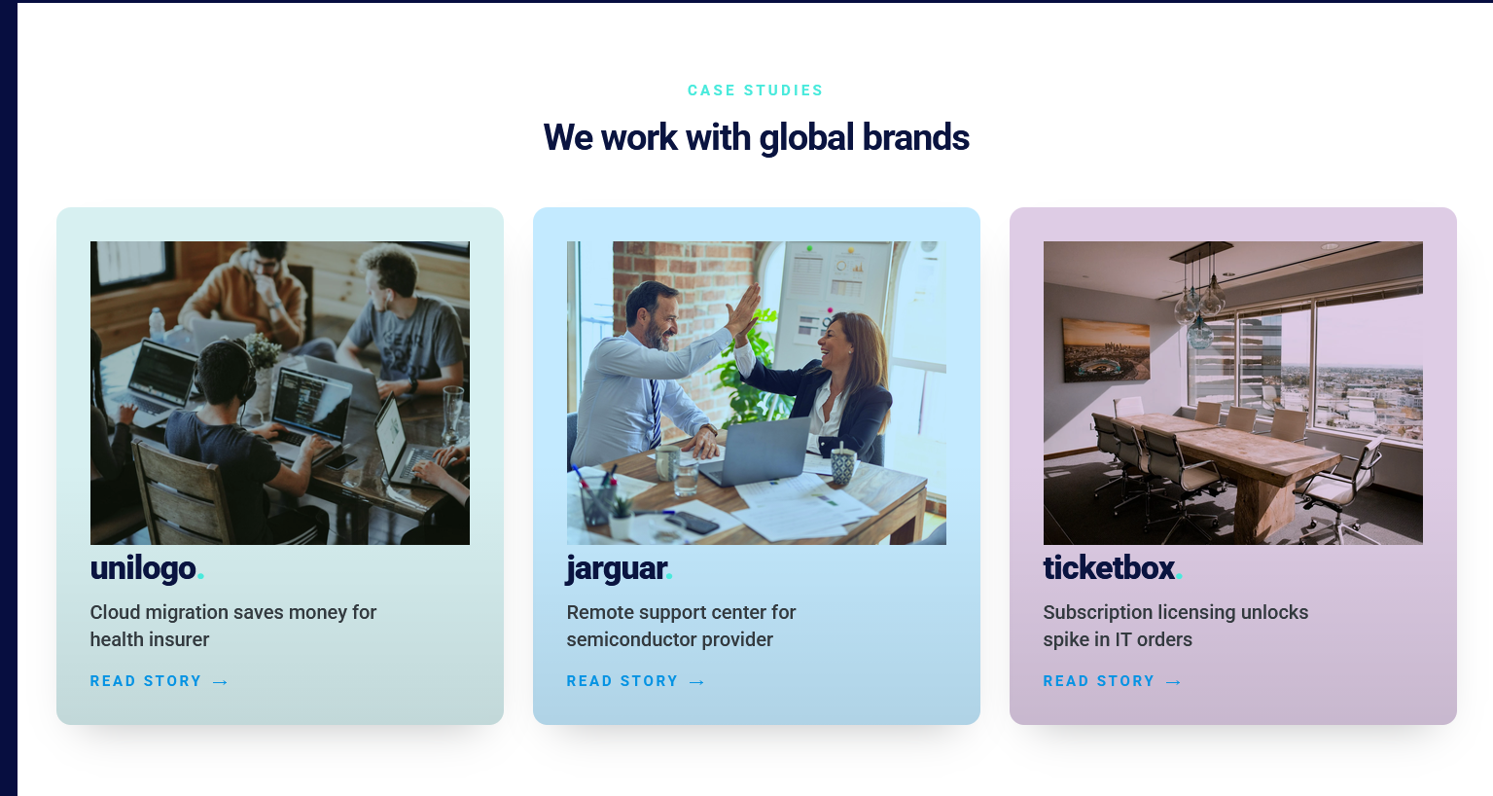

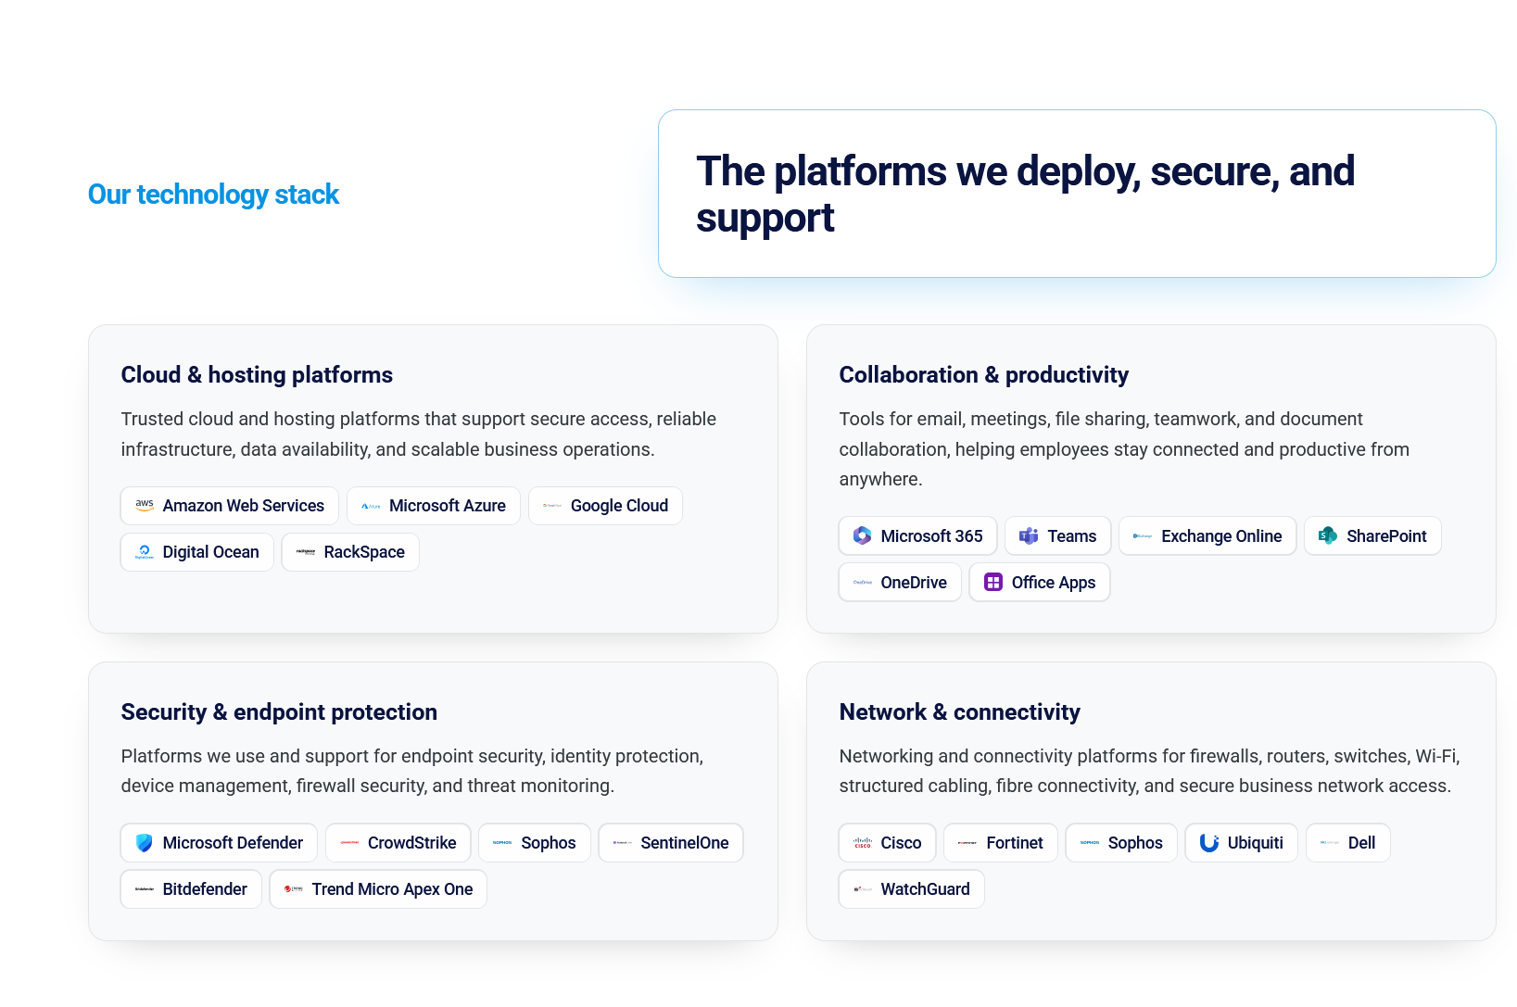

Use this format from our current website but on a white background
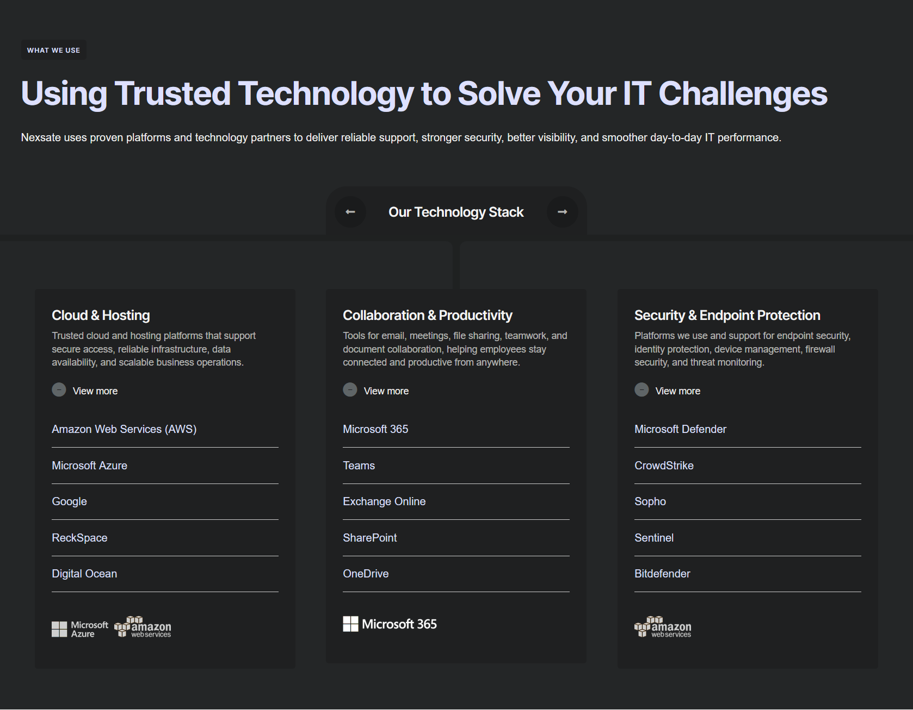

Revert/restore to the previous

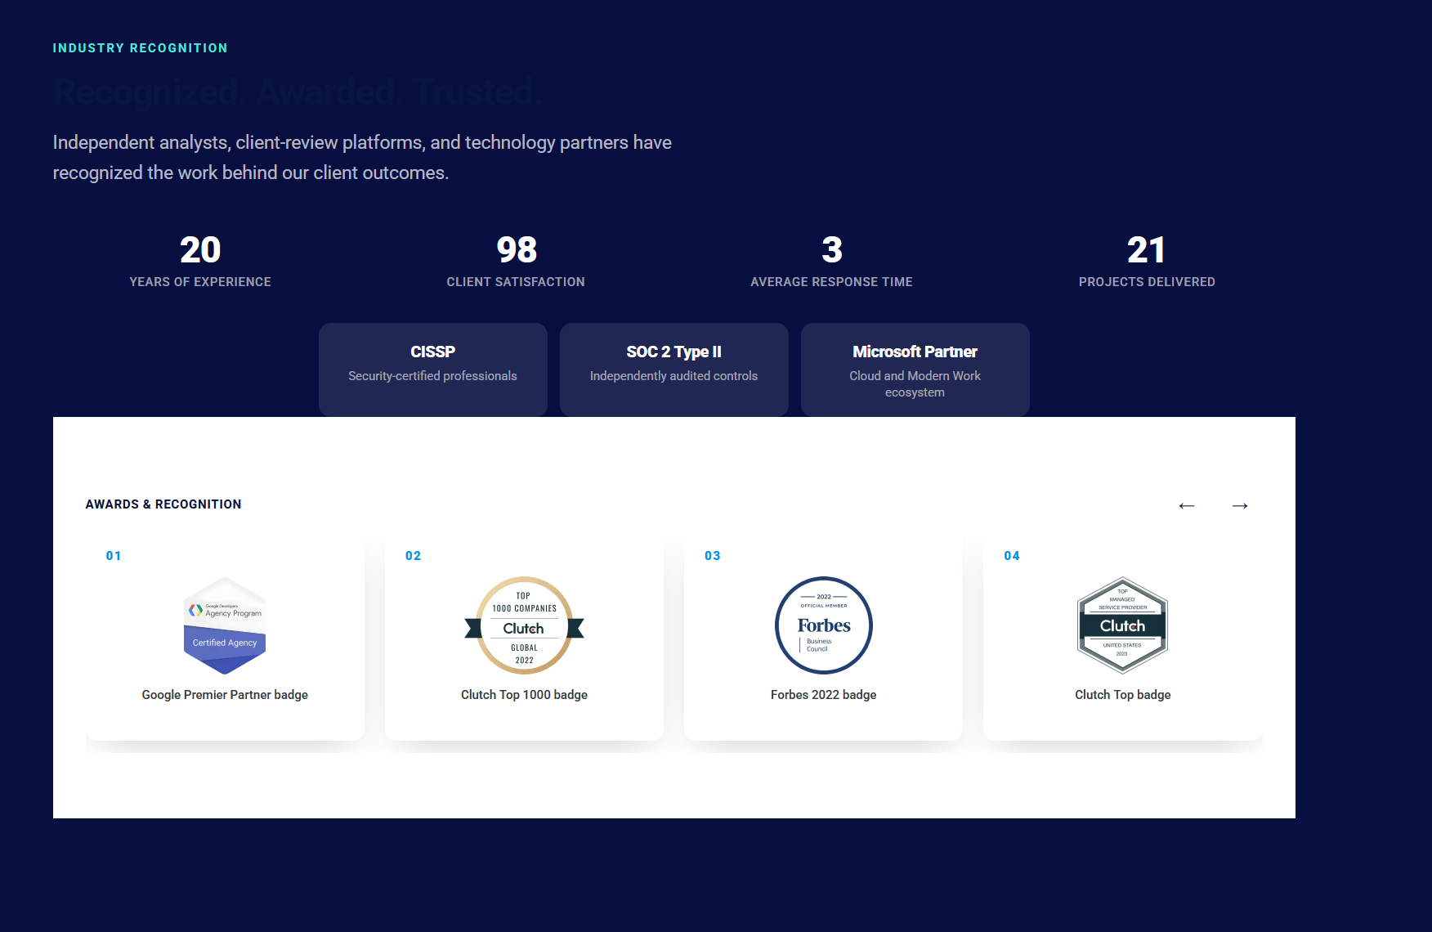
No need for the buttons. Auto scroll will work just fine. There will also be no page for partners.
Only partner logos to auto scroll
Revert/restore to the previous:
No auto scroll. The right and left buttons will work
Blue should reach this level

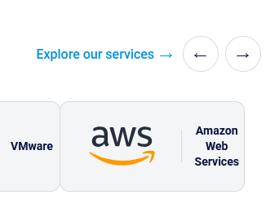


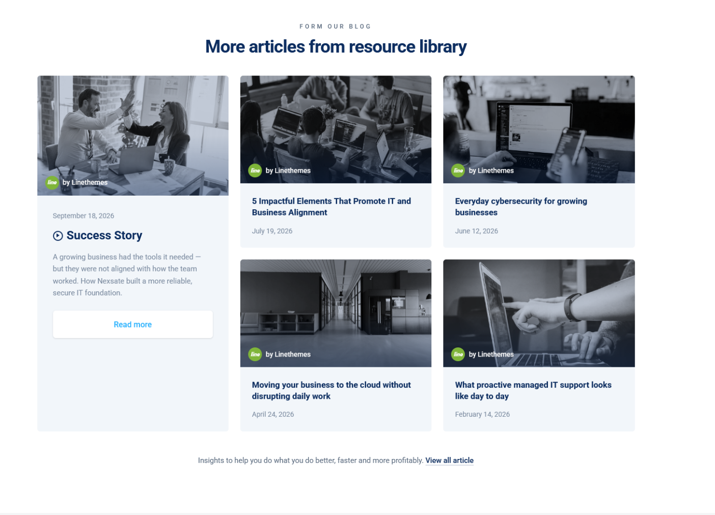
Implement this below

