Steven Wallace
Professor Ewaisha
EEE 419
19 February 2026
Project 2: Machine Learning Mine vs Rock
The second project for EEE 419 involved optimizing a machine learning algorithm to predict whether an obstacle encountered by a submarine was a harmless rock or a lethal mine. Since colliding with a mine is likely to result in death, it was better to mistakenly identify a rock as a mine than vice versa. The highest test accuracy of 0.905 occurred when making use of 58 features, where the algorithm resulted in 6 false positives and 0 false negatives (Figure 1). In this case, the program missed 0 real mines, which is exactly what we wanted. Since the number of features for the optimal accuracy was 58, this means it was advantageous to drop some features before training the model. Those features were likely correlated with each other and contained redundant information which only confused the model. However, discarding too much information would also degrade the accuracy of the model, meaning there is an optimal value between the two extremes. The plot created (Figure 2) looks slightly different each time, but it shows a trend upwards until it reaches a kind of asymptote. In some iterations, the accuracy falls back down after the maximum, and in others the accuracy is nearly constant until the last data point. In order to find that optimal value, it was necessary to first discover the best combination of arguments for the MLP classifier. To accomplish this, I ran a GridSearchCV test with the parameters listed in Figure 3. The optimal arguments were a ReLU activation function, an alpha value of 0.0001, a hidden layer size of 100, 2000 max iterations, the sgd solver, and a tolerance of 1e-05 (Figure 4). Once those arguments were plugged into the code, the optimal model obtained a maximum accuracy of 0.905 when using 58 input features. Based on these results, the odds of surviving a real mine field are about 91%.
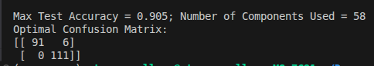Figure 1: Results for the Maximum Test Accuracy

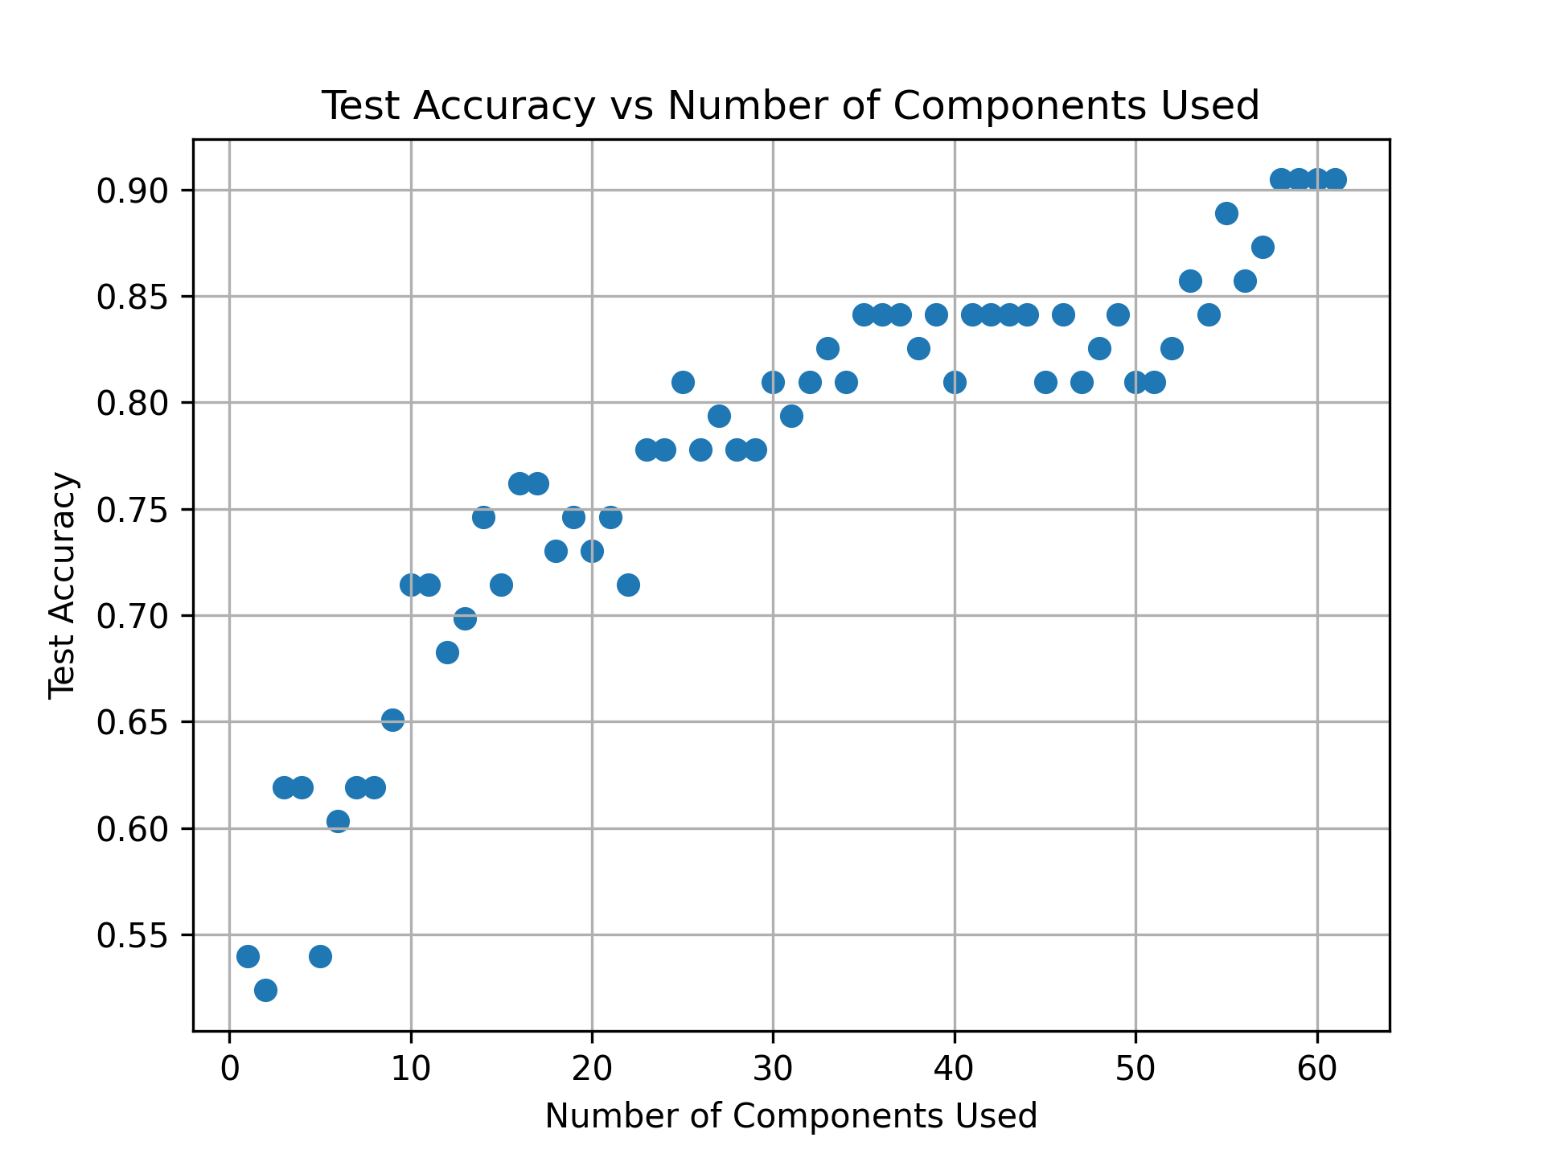Figure 2: Test Accuracy vs Number of Components Used

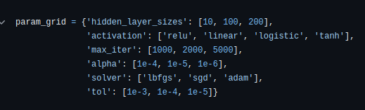Figure 3: Options Tested for the MLP Classifier
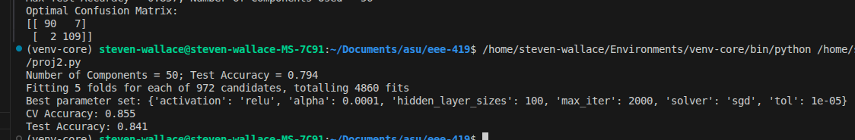Figure 4: Results of the GridSearchCV Analysis

